Table of Contents

Introduction……………………………page 2
Findings………………………………….page 3
Conclusion……………………………...page 14
References……………………………….page 15
Appendices………………………………page 16

Introduction

Entire my life I have been concentrated on my professional career. I consider professional career very important for everyone who wants a higher education. And the same important is professional career development. Like A. Maund said:
‘ Effective learning and development throughout your career-is key to long term employability.’
To have success in career I think I should have self awareness skills. I found an interesting definition of self-awareness by S. Jeffrey:
‘ While awareness is knowing what’s happening around you, self-awareness is knowing what you are experiencing. Self-awareness is the ability to know what are doing as we do it and understand why we are doing it. Consciousness is another word for self-awareness.’
By D.Goleman: ‘Self-awareness means having a deep understanding of one’s emotions, strengths, weaknesses, needs, and drives.’
To achieve personal employment and my career goals I am at the right place; that means this year I will learn six modules in the Skills for the Work place course at the university. After only several weeks I started learning new things about me. Like in Johari Window, Unknown area become Known to myself.
Findings

- Highlight personal SMART career goal

My highlight personal SMART career goal is to know myself better, that means to develop self-awareness skills. I would like to become a SMART Manager.
Specific: learning six modules in Skills for the Work place course at university is a great opportunity to become a good manager.
Measurable: feedback from every module
Reflection after every result
Achievable: attending how many classes I can
I am very motivated and determined to reach this goal
Realistic: studying this course:
- I develop many skills
- I will have a thorough knowledge
- I will have a Certificate in Higher Education
Time bond: September 2020
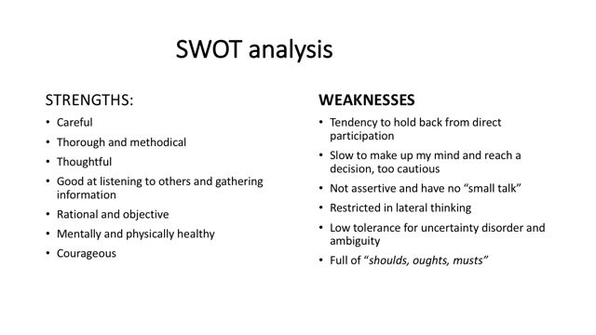
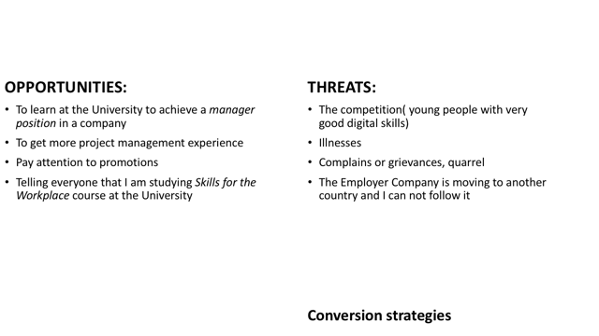
Let have a look if I can change some weaknesses in strengths :

- Tendency to hold back from direct participation-> by developing new skill like presentation skills and practicing speaking to an audience, it would not be a weakness.
- Too cautious, slow to make up my mind and reach a decision -> one of my strengths is courage I will learn to take the risk
- Full of “ shoulds”,”oughts”,”musts”-> I will take any task like a thing I like doing it.
It seems I did a good job here; I did conversion for a half of weaknesses. They left only three. Excellent
I will do the same with threats and opportunities:
- The competition: young people very good in digital skills-> I will do my best developing my digital skills and practicing and my experience could make a balance
- Complaints or grievance-> strong arguments to annihilate
Completing Learning Style Questionnaire designed by Peter Honey and Alan Mumford I found out news strengths and some weaknesses.
For the second time I return to Johari Window and discover unknown things about me.

- Go MAD Thinking Framework

This thinking model system was developed in 2001 by
Andy Gilbert- a managing director of Go MAD. He helped businesses by improving leadership thinking
Ian Chakravorty- a math teacher.
Step1
Time Mangement Skills – my goal
Disciplined
Organized
This keep me awake at night
Self belief

Step2
I defined my goal :
to develop my Time Management Skills
and I wrote down my reasons:
to be disciplined
to be organized
it keep me awake at night
Evaluating how strong are my reasons they are 8 on a scale 1-10.

Step3
I identified at least two strengths: thorough and methodical.These will help me to achieve my goal . So my goal is achievable 9 ( on a scale 1 – 10).
For checking and measuring what I have done I will use tools like Time Management Matrix (S.C.)
It is a priority for me.

Step4
Self belief
Because my goal to develop my Time Management Skills is an urgent and important things I haven’t to do I evaluated Self Belief with 10 (on a scale 1 – 10)
I took the decision to learn how to manage the best my time to achieve other goals. For example in my life I quit twice smoking.When I decided to quit smoking,I started a mental training process by myself. With a great will I succeed.
Now I have high goals to achieve and the first thing I have to do is prioritizing them and to have time to do everything to achieve my goals.
Even some years passed I have the courage and the determination to succeed.
If you’re asked me what is the probability of success I could tell you 99%.
What I have to do for this?
First of all I do a daily list with activities which I want to do and how long will take. The next day I could check out what I did and what I did not.
I will follow and I will measure my improvements with Time Management Matrix (S.C.).
To achieve this goal I am ready!

External Triangle

For achieve my goal I need more time. I will involve other people, like my partner. He would understand to give me more time and place because this I is very important and urgent to me.

Plan and Priorities
Identifying all things I need to succeed:
- Daily list with activities I have to do and for* how long
- To respect doing the daily list *
- To be on time
- To be disciplined *
- Could happen accidents
- Or could come illnesses
- For a good process I have to be calm
I prioritized three things which I have to do:
First of all I want to do is the daily list with activities to organize my time and my life in a way to become a routine. This is the most important and urgent to me.
To achieve my goal at the right time I will involve other people to be close to me. I found my partner to help me. He should understand my priorities and he will give me time and space for this.
The deadline for this goal is 10-th December 2019.

Maslow’s theory of needs
This theory is named‘Hierarchy of Needs’ and was discovered by Abraham Maslow in 1943.
He gave a number of hierarchical levels to explain motivation. There are four needs:
- Physiological needs ( food, drink)
- Safety and Security needs
- Belonging with other people
- Esteem needs
With his theory Maslow identified six levels of skills we have to achieve. Basic concept Maslow is to reach next level of motivation the previous level would need to be satisfied.
Level 2 Understanding/ Comprehension
This is the ability to explain something to another person in other words to understand the ideas.

Level 3 Application
This is for apply my understanding (knowledge +understanding) to give examples ideas work in practice. For example people want a safe place to live.

Level 4 Analysis
This is a level of’ why’
Why do things happen?
Why they work like that?
Asking WHY until I know ‘the HOW’.

Level 5 Synthesis/ Create
This is a level where we meet the third need, that of belonging.

Level 6 Evaluation
Finally at this level I have to identify what was true, untrue, unclear.
This is the most important skill.

Additional with Maslow’s theory there are other theories, like:
Herzberg Theory (1959)
He named the needs “hygiene factors “. In his theory these factors do indeed have an impact on motivation.

Another theory is
R.A. Thompson (2008)
He found that the needs of a country might come before the needs of any particular individual.

Johari Self-awareness Window
This model was discovered by Luft and Ingham in 1955
This model looks like a square with four areas:

Know to self. Unknown to self

Open/free  Area | Blind  Area
Hidden  Area | Unknown  Area

Open/ free area (Area) is the place where there are our skills we know about them and the others know as well.
Hidden Area (Façade)
We know about our skills and they do not know. We keep hidden behavior from others .
Blind area ( Blindspot )
We have skills but we are not aware we have them
We should ask feedback to become awareness about them.

Unknown Area
We are exploring our skills
Only with observation, sharing and discovering we can become awareness about these unknown skills. For example learning about different methods and styles of how to learn I could find out new strengths and weaknesses.

Kolb’s Experiential Learning Cycle (Appendinces page. )
This model has four steps:
- Experience
- Observation and Reflection on Experience
- Theorizing and Development of Concepts
- Testing the new Concepts
Experience is what we have to do
b)Observation is a process considering what we do,how we do, discuss with others reflecting on our performance. We are evaluating how well we think we have done.
c)Theorizing means what happened and why happened to understand how we should do better.
d) Testing the new Concepts
After a good reflection we should ask:
What are we going to do differently next time?

Time Management Matrix
(S.Covey1989)

Urgency
High Low
1  Crises | 3  Planning
2  Unscheduled  Interruptions | 4  Escapes and  Routine

Across we can see Urgency High/ Low
Vertical we can see Importance High/Low
Urgent means-“Now “
Importance means we have to do with results

Crises we all live our lives dealing with the urgent and important things. Life constantly seems “on edge”

Unscheduled interruptions are the most common reason consuming time

Escapes and Routine means unimportant and non urgent activities with very little energy.

Planning means all activities we have to do.
Conclusion

In conclusion my expectations from Skills for Work place Course were far below what it offered me.
For only several weeks I have learned so many theories, learning styles,like as:
Johari Self-awareness Window
Maslow’s theory of Needs
Kolb’s Experiential Learning Cycle
Go MAD Thinking model system
This is a very good opportunity for me to learn achieve my goals developing new skills and make everything goes better and better.

References
- Cottrell S.(2003) Skills for Success-the Personal Development Planning Handbook. 2-rd Ed.
- Cottrell S.(2010) The Palgrave Student Planner (new edition) Basingstoke,Palgrave, Macmillan
- D.Goleman,R.Kaplan Self-awareness (HBREmotional Intelligence Series) Harvard Business Press
- Honey and Mumford’s Learning Style Questionnaires (1986)
- Kolb , David A.(2015) Experimental Learning Experience as a Source of Learning and Development 2-nd Ed. Pearson Education New York
- P. Morgan(2017) The Business Student’s Guide to Study and Employability Sage London
- Moon,J. (2004) A Handbook of Reflective Learning Theory and Practice - Routledge Falmer London
- Routledge, C. and Carmichael J, (2007) Personal Development and Management Skills London
- Scale, Band Fowlie, J. 2009) How to Succeed at University: An Essential Guide to Academic Skills London Sage
- Taylor R and Humphrey (2002) Fast Track to the Top: Skills for Career Success London Kogan Page



