

UWTSD Business School

Oliver James

April 8th 2025

—

Independent Module

—

Robyn Griffiths

Improving Fan Engagement and Local Community Support in Welsh Football League Clubs Through Strategic Marketing and Digital Media

Introduction
Football in Wales has grown massively in popularity and visibility over the last decade, especially following the success of the Welsh national team in tournaments such as UEFA Euro 2016 and the 2022 FIFA World Cup. These achievements helped create a stronger sense of national pride and identity, while also bringing more international attention to Welsh football as a whole. However, despite the progress made at international level, many clubs within the Welsh domestic football league system still face ongoing challenges when it comes to fan engagement, match attendance, commercial growth, and online visibility.

Compared to larger football leagues across Europe and the rest of the United Kingdom, Welsh football clubs often work with smaller budgets, receive less media coverage, and have smaller supporter bases. Because of this, many clubs struggle to market themselves effectively within their local communities or build long-term relationships with supporters. In today’s digital world, social media and modern marketing strategies have become increasingly important for helping sports clubs connect with fans, grow their brand, and remain financially sustainable.

This research project will investigate how Welsh football league clubs can improve fan engagement and strengthen support within their local communities through marketing and digital media strategies. The study will explore how clubs currently promote themselves, how supporters view Welsh domestic football, and how digital platforms such as social media can be used more effectively to increase engagement. It will also examine whether the recent success of the Welsh national team has had an influence on domestic football culture in Wales. The overall aim of the research is to provide practical recommendations that could help support the long-term growth and sustainability of Welsh football clubs.

Research Problem
Although Welsh football has gained a higher international profile in recent years, many clubs within the Welsh domestic league system still struggle with low attendances, inconsistent fan engagement, and limited commercial exposure. A large number of Welsh football supporters continue to follow English clubs and leagues more closely than their local Welsh teams, which creates a gap between national football identity and support for domestic football.

In addition, Welsh football clubs often have limited marketing budgets and receive far less media attention than clubs in larger football markets. This makes it difficult for them to build strong online communities, attract younger audiences, and maintain consistent supporter engagement. While social media offers clubs a relatively low-cost way of connecting with fans and promoting their brand, there is currently limited academic research focused specifically on how Welsh football clubs use digital marketing and community engagement strategies.

The research problem therefore focuses on understanding how Welsh football clubs can improve supporter engagement and strengthen local support through more effective marketing strategies. It will also explore whether the success and cultural identity linked to the Welsh national team can be used more effectively to encourage greater interest and support for domestic Welsh football.

Research Aim
The aim of this research is to investigate how Welsh football league clubs can improve fan engagement and strengthen local community support through the use of marketing and digital media strategies. The study will explore how clubs currently engage with supporters both online and offline, while also examining how effective social media, branding, and community initiatives are in increasing attendance and supporter loyalty.
In addition, the research will analyse whether the recent success and growing cultural importance of the Welsh national football team can be used to help improve engagement with domestic football clubs. The project ultimately aims to provide practical marketing recommendations that could support the long-term growth and sustainability of Welsh football clubs.

Research Objectives

- Analysis of the present-day marketing efforts of the Welsh football league teams.
- To study of the effect of the use of digital media on fan behavior.
- Research on the link between the success of the Welsh national football team and football fandom in the country.
- To detect factors that inhibit community involvement in Welsh football.
- The development of recommendations to boost fan engagement and attendance in Welsh football leagues.

Rationale

The background behind this study rests in the increasing significance of digital marketing and community relations in the field of modern sport management. Football teams more and more frequently find themselves relying on the loyalty of their supporters, their presence online and community spirit in order to secure commercial viability and success. Despite the amount of literature devoted to top-flight football teams and European leagues, the attention to Welsh football and its marketing problems can be considered insufficient.

The relevance of the research can be explained by the recently achieved success of the national football team of Wales that has led to the increase of national self-respect among the population of the country, as well as recognition abroad. There also seems to be some gap between the fans of the national team and those who support domestic teams from Wales. This knowledge might be useful when considering issues related to sports marketing and sports fandom.

This project is also highly practical and can bring benefits for the studied football teams. The results can be useful when trying to improve the numbers of attendances at games, digital strategy of the clubs, relationship with the local community, etc.

Furthermore, the increasing digitalisation of the sports industry has transformed the ways in which football clubs communicate with supporters and build long-term relationships with local communities. Smaller football organisations are now expected to compete for audience attention within highly saturated digital environments dominated by elite football clubs and global sports brands. As a result, Welsh football clubs face additional challenges in developing sustainable supporter bases and maintaining relevance within local communities. This research therefore contributes not only towards discussions surrounding Welsh football specifically, but also wider academic debates regarding sports marketing, digital fan engagement, and the commercial sustainability of smaller football organisations operating within competitive modern football environments.

Initial Literature Review

Fan engagement has become an increasingly important area of research within sports marketing and sport management literature. Modern football clubs are no longer solely dependent on matchday attendance and traditional advertising methods, but instead rely heavily on building emotional connections and long-term relationships with supporters. According to sports consumer behaviour theories, supporters often develop strong psychological attachments to football clubs through emotional investment, identity, and social belonging. (Bauer et al. 2005) argue that fan loyalty is heavily influenced by emotional attachment and identification with a sports organisation, while Funk and (James, 2001) suggest that supporters gradually develop deeper levels of psychological commitment through repeated interaction and engagement with clubs. These theories are particularly relevant within football due to the emotional and cultural significance associated with clubs and communities.

Relationship marketing theory also plays a significant role within sports marketing research. (Morgan and Hunt 1994) describe relationship marketing as the process of establishing and maintaining long-term relationships between organisations and consumers. Within football, this can include supporter engagement strategies, community initiatives, personalised communication, and digital interaction. Maintaining strong relationships with supporters is particularly important for smaller football clubs that may not possess the financial advantages or global recognition of elite organisations. Supporter retention and long-term loyalty are often considered more valuable than short-term commercial success, especially within domestic football environments where clubs depend heavily on local communities and recurring attendance.

The growth of digital media has transformed the ways in which football clubs communicate with supporters. Social media platforms such as Instagram, TikTok, X, and Facebook now allow clubs to interact directly with fans, promote club identity, and strengthen brand awareness. (Pegoraro, 2010) suggests that social media has significantly changed communication within sport by allowing supporters to engage more personally with clubs and athletes. Furthermore, (Vale and Fernandes 2018) found that digital interaction can strengthen fan engagement and emotional attachment through interactive content, storytelling, and behind-the-scenes access. For smaller football clubs, digital marketing may provide a cost-effective method of increasing visibility and attracting younger audiences. However, research also suggests that many smaller clubs struggle to maximise digital opportunities due to limited resources, staffing, and strategic planning.

Sports branding literature further highlights the importance of identity and emotional connection within football marketing. Football clubs are increasingly viewed as brands that represent values, culture, and community identity rather than simply sporting organisations. (Keller 1993) argues that strong brand equity is developed through consistent positive associations and emotional attachment among consumers. In football, branding can be influenced by club history, local identity, supporter culture, and storytelling. Emotional storytelling has become increasingly important within modern sports marketing, as supporters are more likely to engage with content that creates authenticity and personal connection. This may be particularly relevant within Welsh football, where clubs often possess strong regional and cultural identities.

Community identity and national belonging also represent important themes within this research. The recent success of the Welsh national football team has contributed towards increased national pride and international recognition of Welsh football culture. Social identity theory suggests that individuals often develop a sense of belonging through identification with social groups, including sports teams and national communities. While the Welsh national team has successfully developed a strong national identity through campaigns such as “Together Stronger” and “Gorau Chwarae Cyd Chwarae,” there appears to be limited research examining whether this identity has positively influenced support for domestic Welsh football clubs. Therefore, this study aims to explore how Welsh football clubs may utilise community identity, digital engagement, and strategic marketing practices to strengthen local support and improve fan engagement.

Proposed Methodology

This research will use a mixed methods approach to investigate fan engagement and marketing within Welsh football league clubs. A mixed methods design is appropriate because it allows both numerical data and personal opinions to be explored together, helping to build a wider understanding of supporter behaviour and club engagement strategies.

The quantitative side of the research will involve an online survey distributed through social media and Welsh football communities. The survey will focus on supporter attendance habits, engagement with Welsh football clubs, social media usage, and opinions surrounding domestic Welsh football. Most questions will use closed responses and Likert scales to help identify trends in supporter behaviour. The research aims to collect around 100–200 responses to provide enough data for basic statistical analysis.

The qualitative aspect of the study will involve semi-structured interviews with individuals connected to Welsh football, including supporters, club staff, and members of the media. This interview style was chosen because it allows participants to speak in more detail while still keeping discussions focused on topics such as fan engagement, digital marketing, and community identity. Around 5–10 interviews are expected to be carried out depending on availability.

Survey findings will be analysed using descriptive statistics to identify patterns and common trends. Interview responses will then be examined through thematic analysis in order to identify recurring themes and opinions. The findings from both methods will then be compared to develop a clearer understanding of how Welsh football clubs currently engage with supporters and local communities.

Ethical Considerations

This research will follow university ethical guidelines throughout the study. All participants will be informed about the purpose of the research before taking part, and informed consent will be obtained. Participation will be voluntary, and participants will have the right to withdraw from the research at any time. Any personal information collected will remain anonymous and confidential in line with data protection regulations. The study will aim to ensure that participants are treated fairly and respectfully throughout the research process.

Timeline:

Stage | Estimated Completion
Proposal & topic approval | October
Literature review | November
Survey/interviews | December–January
Data analysis | February
Writing findings/discussion | March
Final editing & submission | March

Introduction

Football has become one of the most commercially important and widely followed sports in the world. As well as being a form of entertainment, football now plays a major role in areas such as business, media, tourism, and community identity. Over the last few decades, the sport has transformed significantly, particularly through the growth of commercialisation and digital media (Andrews and Jackson, 2001). Football clubs are no longer judged only by performances on the pitch, but also by how well they connect with supporters online, promote their brand, and build long-term relationships with fans. Because of this, marketing and digital engagement have become increasingly important within modern football (Pegoraro, 2010).

In Wales, football has grown significantly in popularity and visibility over the past decade. However, Welsh domestic football has traditionally struggled to compete with larger football markets, especially English football. Many Welsh supporters continue to follow clubs in the English Premier League and English Football League due to their larger fanbases, greater media coverage, and global popularity (Giulianotti, 1999). As a result, clubs within the Welsh football league system often receive less attention, lower attendances, and fewer commercial opportunities compared to larger leagues across Europe and the UK. Many clubs within the Cymru Premier also operate with smaller budgets and limited media exposure, making long-term growth more difficult (FAW, 2021).
Despite this, the success of the Welsh national football team has helped raise the profile of Welsh football both nationally and internationally. Wales qualifying for UEFA Euro 2016 was a major moment for Welsh football, as it was the country’s first major international tournament since the 1958 FIFA World Cup (UEFA, 2016). The team’s run to the semi-finals created a substantial sense of national pride and brought increased attention towards Welsh football culture. This success continued with qualification for UEFA Euro 2020 and the 2022 FIFA World Cup under manager Rob Page. During this period, the national team built a strong identity based around unity, passion, and national pride. Campaigns such as “Together Stronger” helped create emotional connections between supporters and the team, while also strengthening football’s role within modern Welsh identity (FAW, 2021).

However, despite the success of the national team, many domestic Welsh football clubs still face ongoing challenges. Attendances within the Cymru Premier remain relatively low, while many clubs struggle with sponsorship, media coverage, and supporter engagement. The rise of elite football and global broadcasting has also made it harder for smaller clubs to compete for attention (Giulianotti and Robertson, 2009). Many supporters now consume football mainly through television, social media, and global football brands, which can reduce interest in local domestic football. Because of this, Welsh football clubs now have to compete for supporter attention within a crowded digital and entertainment environment.

Marketing is another challenge for many Welsh football clubs. Smaller clubs often have limited budgets, smaller staff teams, and fewer commercial resources than larger football organisations. This can lead to inconsistent social media activity, weaker promotional campaigns, and lower levels of online engagement with supporters. In modern football, platforms such as Instagram, TikTok, X, and Facebook are now essential tools for communication and fan interaction (Vale and Fernandes, 2018). Supporters increasingly expect regular content, behind-the-scenes access, interaction with players and staff, and a stronger sense of connection with clubs online (Pegoraro, 2010). For smaller clubs, digital media can provide a low-cost way of improving visibility and strengthening relationships with local communities. However, many Welsh clubs may not currently have the resources or long-term strategy needed to fully take advantage of these opportunities.

Fan engagement has become a major topic within sports marketing research. Modern football supporters are more involved with clubs than ever before and are often seen as active members of football communities rather than just spectators. Strong relationships with supporters can help clubs improve attendance, increase merchandise sales, attract sponsorship, and build long-term sustainability (Bauer et al., 2005). Football clubs can also play an important role within local communities by contributing towards regional identity, social inclusion, and cultural representation. This is especially relevant within Welsh football, where many clubs are closely linked to local communities and Welsh cultural identity. (Funk and James 2001) argue that supporters often develop psychological attachment and emotional loyalty towards sports organisations through repeated engagement and identity formation.

Another issue within Welsh football is the gap between support for the Welsh national team and support for domestic Welsh clubs. International matches involving Wales regularly attract strong national backing and emotional support, but this enthusiasm does not always transfer to domestic league football. Understanding why supporters strongly connect with the national team while showing lower levels of engagement with Welsh domestic clubs is an important area of research. It may also provide useful insight into supporter behaviour, community identity, and sports marketing within smaller football nations. Research surrounding social identity theory suggests that supporters often form emotional connections with teams that represent wider cultural or national identities (Smith and Porter, 2004).

Although there is already a large amount of academic research on sports marketing, fan engagement, and digital media within elite football, there is still limited research focused specifically on Welsh domestic football clubs. Much of the existing literature focuses on globally recognised leagues and financially dominant clubs, meaning smaller football markets such as Wales are often overlooked (Anagnostopoulos et al., 2018). Because of this, this research aims to develop a better understanding of fan engagement and community support within Welsh football by exploring how marketing and digital media strategies could help clubs improve supporter engagement and local attendance.

The aim of this research is to investigate how Welsh football league clubs can improve fan engagement and strengthen local community support through strategic marketing and digital media. The objectives of the research are to analyse current marketing strategies used by Welsh football clubs, examine how digital media influences supporter behaviour, explore the relationship between national team success and domestic football support, identify barriers preventing stronger community engagement, and provide recommendations to improve supporter engagement within Welsh football.

This dissertation is divided into six parts. Following this introduction, Part Two reviews literature relating to fan engagement, sports branding, relationship marketing, digital media, and community identity within football. Part Three explains the research methodology, including the use of surveys and semi-structured interviews. Part Four presents the findings collected during the research process, while Part Five discusses these findings in relation to existing research and theory. Finally, Part Six provides conclusions and recommendations for improving fan engagement and marketing strategies within Welsh football league clubs.

Literature Review

Introduction to Literature Review

This part of the book looks at what other people have written about fan engagement, sports marketing, digital media, branding and community identity in football. The goal is to understand the ideas that help explain why fans behave in certain ways and how football clubs interact with their communities. It also tries to find gaps in research especially when it comes to football in Wales.
In todays football world clubs need to engage with their fans and use media to stay financially stable and build strong relationships with supporters. Because of this things like media marketing, branding, emotional attachment and community identity have become very important in sports management research. This part explores how these ideas apply to football in the context of Welsh football clubs.

The review focuses on key themes, including fan engagement theory, relationship marketing, social media marketing, sports branding, national identity and factors that influence how many people attend football matches. Throughout the part these ideas are connected to Welsh football to understand how domestic clubs can improve engagement and build stronger relationships with their local communities.

Fan Engagement Theory

Fan engagement is an area of study in sports marketing and management. These days football fans are not just seen as people who watch matches. As active members of the football community who form emotional bonds with clubs through identity, loyalty and shared experiences. Strong supporter engagement is essential because it can affect how many people attend matches buy merchandise and support the club in the run.

One influential theory related to fan engagement is Social Identity Theory, developed by Tajfel and Turner. This theory says that people form part of their identity by belonging to groups. In football fans often strongly identify with clubs because they represent communities, values and culture. Supporting a football club can become a part of a persons identity, rather than just something they do for fun. These emotional connections are often strengthened by family traditions, local pride and shared experiences with fans.

Another important theory is the Psychological Continuum Model, developed by Funk and James. This model explains how fans develop psychological relationships with sports organizations over time. According to the model fans go through four stages: awareness, attraction, attachment and allegiance. People may first become aware of a club before developing an interest in it. Over time they can become more attached and loyal.

Some researchers argue that emotional attachment plays a role in supporter loyalty, especially in football. This is because emotional experiences can strongly influence behavior. Similarly other researchers suggest that fans who are highly identified with a club are more likely to remain loyal even when the team is not doing well. This shows how emotional identity and psychological attachment can create long-term commitment among fans.

These theories are particularly relevant to Welsh football. Many Welsh clubs operate in markets and compete with bigger English clubs. Because of this building attachment and long-term loyalty may be more challenging. Welsh clubs may need to focus on community identity, supporter interaction and emotional connection to strengthen fan engagement.

Relationship Marketing

Relationship marketing is about building and maintaining long-term relationships between organizations and consumers. In football this is especially important because clubs rely heavily on supporters. One influential theory in relationship marketing is the Commitment-Trust Theory, which argues that trust and commitment are essential for creating long-term relationships.

In football relationship marketing can include things like supporter communication, fan events, community projects, social media interaction and personalized engagement strategies. Modern fans expect clubs to interact with them directly through platforms and community initiatives. Developing these relationships can strengthen bonds and increase loyalty.

This is particularly important for Welsh football clubs. Unlike clubs many Welsh clubs do not have large commercial budgets or global fanbases. As a result they rely heavily on local communities and repeat supporters for financial stability. Developing relationships with supporters may be more valuable than expensive marketing campaigns.

Social Media Marketing

The growth of media has changed the way football clubs communicate with supporters. Social media platforms like Instagram, TikTok and Facebook now play a role in football marketing, fan interaction and brand development. Clubs can communicate directly with supporters across national and global audiences.

Some researchers argue that social media has changed communication in sports by creating direct and interactive relationships between clubs, athletes and supporters. Supporters can engage with clubs through comments, shares and interactive content. This can strengthen attachment and make supporters feel more connected to clubs and players.

Social media also enables football clubs to strengthen their branding and storytelling. Behind-the-scenes content, matchday experiences and community-focused campaigns can help supporters feel emotionally invested in clubs. This type of storytelling has become increasingly important because supporters engage more strongly with authentic and emotionally driven content.

However social media marketing also creates challenges for football clubs. Many Welsh clubs operate with staffing, smaller budgets and inconsistent digital strategies. Maintaining high-quality content and strong online engagement can be difficult. Smaller clubs must also compete with clubs that dominate digital spaces.

A good example is Wrexham A.F.C., which has gained international attention through documentary storytelling and digital branding. The clubs online presence focuses heavily on storytelling, community identity and emotional engagement. This shows how digital media and narrative marketing can increase visibility and supporter engagement in Welsh football.

Community Identity Theory

Community identity is an area of study in football research. Football clubs often act as symbols of culture regional pride and social belonging. Supporters may feel emotionally connected to clubs because they represent culture, shared history and regional identity.

Social Identity Theory suggests that people develop a sense of belonging through identification with groups. In football supporters may feel emotionally connected to clubs because they represent culture and community. This is particularly relevant in Welsh football, where clubs often have links to local communities and Welsh cultural identity.

Some researchers argue that sport can play a role in shaping national and regional identity especially in smaller nations. Football clubs may represent more than just sporting organizations; they can act as symbols of community identity and local belonging.

This idea is especially significant in Wales, where football is closely linked to identity. Welsh football clubs may have opportunities to strengthen engagement by promoting community culture, regional pride and local identity. Creating emotional links between clubs and communities can encourage greater long-term support and attendance.

Sports Branding
Sports branding has become increasingly important in modern football. Clubs are now viewed not as sporting organizations but also as commercial brands. Strong branding can help clubs develop connections with supporters improve recognition and increase commercial value.

One influential theory in sports branding is Brand Equity Theory, which suggests that strong brands are built through associations, emotional attachment and consistent identity. In football branding may involve club history, supporter culture, values, visual identity and storytelling. Successful football brands often create connections that encourage loyalty and long-term supporter engagement.
Emotional branding has become particularly important in football marketing. Supporters are more likely to engage with clubs that appear authentic and emotionally connected to their communities. Branding extends beyond logos and merchandise focusing on identity, storytelling and supporter experience.

Many Welsh football clubs may struggle with branding due to commercial resources and lower visibility. Some clubs may lack marketing strategies or clear digital identities making it harder to attract younger audiences and build wider engagement. However the branding success of the Welsh team and clubs like Wrexham A.F.C. Shows how emotional storytelling and identity-focused branding can strengthen supporter relationships and improve visibility.

National Identity and Football

Football is often closely connected to national identity especially in smaller nations. In Wales football has become a part of national identity especially after the success of the Wales national football team in recent international tournaments.
Campaigns like " Stronger" created strong emotional connections between supporters and the national team by promoting unity, passion and national pride. International tournaments, like UEFA Euro 2016 created shared experiences that strengthened footballs cultural importance in Wales.
National team success can make people feel like they belong and have an emotional connection to the team because supporters really identify with national teams as symbols of who they are as a people. But there is an issue in Welsh football. People loving the national team does not always mean they care about the local teams.

This makes us wonder why people do not support the teams as much as the national team. Many people feel a connection to the national team but the local Welsh teams do not get as many people coming to watch them play and are not as well known. Figuring out why this happens can help us understand football culture what makes a community and how to market sports in countries.

Sports Attendance Factors

How many people come to watch football games is still a deal because it helps teams make money creates a good atmosphere and helps them survive in the long run. Research shows that many things can affect how many people come to games including how much people care about the team, ticket prices, how fun the game is, how easy it is to get to the stadium and what the overall experiences like.
People are more likely to come to games when they feel connected to the team. Think it will be a fun or social experience. The atmosphere in the stadium rivalries with teams, the culture of the supporters and how involved the community is can all make people more likely to come to games. At the time practical things like ticket prices how to get to the stadium when games are scheduled and how convenient it is can also affect whether people come to games.

Nowadays people can easily watch football on TV and online which might make them less interested in going to local games. This can be a problem for teams that are trying to get people to come to their games.

Welsh football teams might have a harder time because not as many people know about them, they do not get as much money from sponsors and they have to compete with bigger leagues. Some teams might also struggle to make games fun to watch because they do not have a lot of money and their stadiums are small. So, to get more people to come to games Welsh teams might need to focus on making their supporters happy connecting with the community and making games fun to watch.

Research Gap and Literature Review

This part of the book looked at what other people have written about how fans get involved with teams how teams’ market themselves digital media, sports branding, community identity and how many people come to games. The other research shows that how much people care about a team, how they identify with the team and how they use media are all important for teams to be successful now. It also shows that social media, branding and community relationships are becoming more important for teams to connect with their supporters.

Most of the research is about big teams and popular leagues. Not much research has been done on Welsh football or smaller leagues. There is also not a lot of research on how people in Wales feel about their team and how that affects their support, for local teams.
So this research wants to help us understand Welsh football better by looking at how teams can use marketing, digital media and community involvement

Methodology

Methodology

This part is about the research methodology used to investigate engagement, digital marketing and community identity within Welsh football clubs. It explains the research methods used why they were chosen and how they were applied throughout the study. The goal is to understand behaviour and engagement within Welsh football.

A mixed methods approach was used, (Creswell, 2014) combining both qualitative and quantitative research methods. This approach helps to gain a more detailed understanding of supporter behaviour and engagement within Welsh football. Quantitative data was collected through surveys to identify patterns and trends among supporters. Qualitative data was gathered through semi-structured interviews to explore experiences, opinions and perceptions in greater depth. (Saunders et al., 2019)

The part also discusses the research philosophy, data collection methods, data analysis techniques, ethical considerations and limitations associated with the study.

Research Philosophy and Approach

The research philosophy is the set of beliefs and assumptions that guide the research process and influence how knowledge is gathered and interpreted (Saunders et al., 2019) For this study a pragmatic research philosophy was considered the appropriate approach. Pragmatism focuses on outcomes and allows researchers to combine different research methods. (Bryman, 2016)

This philosophy was suitable because the study aimed to investigate real-world issues surrounding engagement within Welsh football. The research used both qualitative data collection methods. Pragmatism supports this combination by recognising that no single method can fully explain social issues such as football fandom, identity and community engagement.

The study also used both deductive and inductive reasoning. Deductive reasoning was used through existing theories relating to fan engagement, branding and social identity. However the research was primarily inductive because it aimed to explore experiences and identify themes and patterns emerging directly from the collected data.

Research Strategy – Mixed Methods

This research used a mixed methods strategy combining qualitative research techniques. A mixed methods approach was considered appropriate because fan engagement involves both behaviours and deeper emotional or social experiences. (Creswell, 2014)

Quantitative research provided breadth by allowing the researcher to gather data from a number of participants. It helped identify patterns in supporter behaviour, attendance habits and digital engagement. Qualitative research provided depth by allowing participants to discuss experiences, opinions and emotional connections in greater detail.

Combining both methods strengthened the reliability and validity of the research. It allowed the researcher to compare findings and improve the credibility of results. Using both qualitative methods enabled the researcher to capture both statistical trends and personal perspectives. (Saunders et al., 2019)

Quantitative Research – Survey

The quantitative element of this research involved the use of a survey. The survey was designed to gather data relating to supporter engagement, attendance behaviour, social media usage and perceptions of Welsh football clubs. Surveys were considered appropriate due to their ability to collect amounts of data efficiently. (Bryman, 2016)

The target participants for the survey included Welsh football supporters, local community members and individuals who engage with football-related content through platforms and social media. The survey was distributed through social media platforms, football supporter groups and online football communities.

A non-probability convenience sampling method was used because participants were selected based on accessibility and willingness to participate. (Saunders et al., 2019) The survey included a mixture of question types, including multiple-choice questions Likert scale questions and demographic questions.

The use of surveys was beneficial because it allowed the researcher to collect data from a relatively large audience within a limited timeframe. The findings provided insights into supporter behaviours and opinions.

Qualitative Research – Interviews

The element of this research involved semi-structured interviews conducted with individuals connected to Welsh football. Participants included football supporters, club media staff, community workers and individuals involved in football development or governance.

Semi-structured interviews were considered appropriate because they allowed flexibility within discussions. They enabled the researcher to guide conversations around research themes. This method was particularly useful for exploring topics such as emotional attachment, identity, community belonging and supporter relationships.

Interview questions focused on topics such as engagement strategies, social media communication, community relationships, attendance challenges and perceptions of Welsh football culture. Interviews were conducted either online or in person depending on availability and accessibility.

The qualitative approach provided insight into the emotional and social factors influencing supporter behaviour. It helped contextualise the survey findings by exploring the experiences and perspectives behind broader statistical patterns identified within the research.

Data Analysis

The data collected during the research was analysed using both quantitative and qualitative analysis techniques. Quantitative survey data was analysed using statistics to identify patterns, percentages and trends relating to supporter behaviour, attendance, digital engagement and perceptions of Welsh football clubs.

Qualitative interview data was analysed using thematic analysis. Thematic analysis involves identifying recurring themes, (Braun and Clarke, 2006) ideas and patterns within responses. Interview transcripts were reviewed several times to identify key themes relating to supporter identity, community engagement, digital media and football culture.

The use of both qualitative analysis techniques allowed the research findings to be compared and connected. This helped improve the reliability of the research while ensuring that the analysis remained closely linked to the research objectives and questions.

Ethical Considerations

Ethical considerations were a part of the research process due to the involvement of human participants. Ethical approval was obtained in accordance with university guidelines prior to data collection taking place.

Participants were provided with information regarding the purpose of the research and were required to provide informed consent before participating in either surveys or interviews. Participation was entirely voluntary. Individuals were informed of their right to withdraw from the research at any stage without consequence.

Confidentiality and anonymity were also maintained throughout the study. Information and participant identities were protected and any identifiable data was removed from the final research findings unless explicit permission had been granted.

The researcher also ensured that interview questions remained appropriate, respectful and relevant to the research objectives. Ethical considerations were important in ensuring the research was conducted responsibly while protecting the rights, privacy and wellbeing of all participants involved in the study.

Limitations

Several limitations were identified within this research. One limitation involved the small sample size, which may reduce the overall generalisability of findings across all Welsh football supporters. Time constraints also limited the amount of data that could be collected and analysed during the research process.

The use of convenience sampling may have introduced response bias as participants who are already engaged with Welsh football may have been more likely to complete the survey or participate in interviews. In addition Welsh domestic football represents a niche area of research meaning accessibility to certain participant groups and organisations may have been limited.

Despite these limitations the mixed methods approach helped improve the depth and reliability of the findings by combining sources of data and perspectives relating to supporter engagement, within Welsh football.

Findings and Analysis

This part presents the findings from both surveys and interviews about supporter engagement in Welsh football. The findings are organised around themes, including attendance behaviour, digital engagement, community identity and perceptions about Welsh domestic football.
The part combines survey data with interview responses to provide both insights and deeper supporter perspectives. Survey findings are presented through percentages, tables and descriptive analysis while interview findings are organised into recurring themes supported by quotations. The purpose of this part is to present the findings before discussing their wider significance in part Five.

Survey Findings

Demographic Findings

The survey collected responses from Welsh football supporters of different ages and levels of engagement. 64% Of respondents were between 18 and 34 years old showing that younger audiences made up a significant part of the research sample.
The findings also showed varying levels of engagement with Welsh football. Around 41% of respondents said they regularly attended Cymru Premier or lower-league Welsh football matches while 59% mainly followed football through television broadcasts, digital media platforms or support for English football clubs.

Additionally 82% of participants reported following the Wales national football team compared to only 38% who said they regularly engaged with Welsh domestic league football. This showed a difference between support for the national team and engagement with domestic clubs.

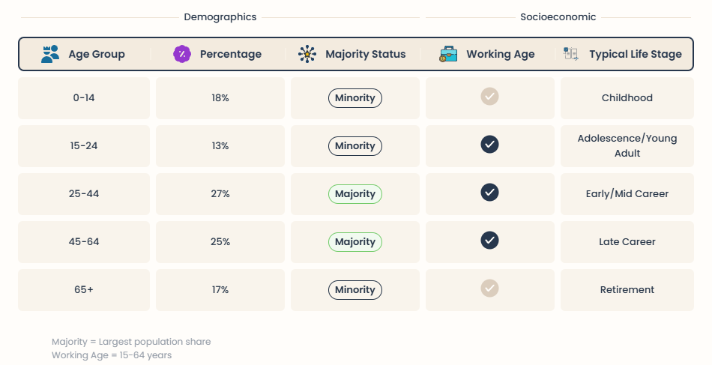

Attendance Habits

Survey findings showed attendance patterns among supporters of Welsh domestic football. 27% Of respondents said they attended matches regularly while 49% described themselves as occasional attendees. A further 24% reported rarely or never attending domestic Welsh football matches.
Several barriers to attendance were consistently identified. The common factors included limited awareness of fixtures, travel distance, scheduling issues and competition from televised elite football leagues.

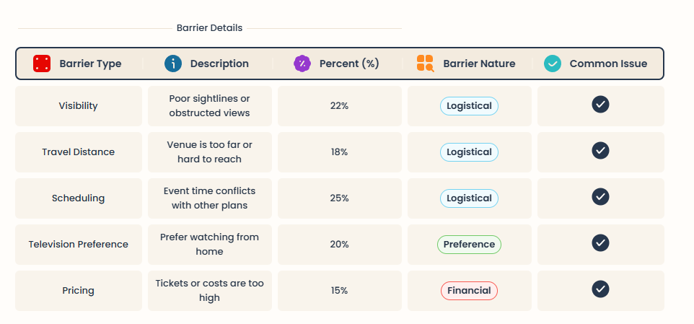

The findings also suggested that emotional attachment and community connection influenced attendance behaviour. Respondents who identified connections with local communities or grassroots football culture were more likely to attend matches regularly.
Younger supporters showed engagement with clubs that maintained active social media platforms and consistent digital communication. This suggested that online visibility may play an important role in influencing supporter attendance and engagement.
Overall the survey findings indicated that Welsh football clubs face difficulties generating sustained matchday attendance due to competition from football organisations and limited mainstream exposure.

Social Media Engagement
Survey findings indicated that social media plays a role in supporter engagement within Welsh football. 76% Of respondents said that digital media platforms were important in maintaining their connection with football clubs and football-related content.
Among supporters, Instagram and TikTok emerged as the most popular platforms for football engagement.

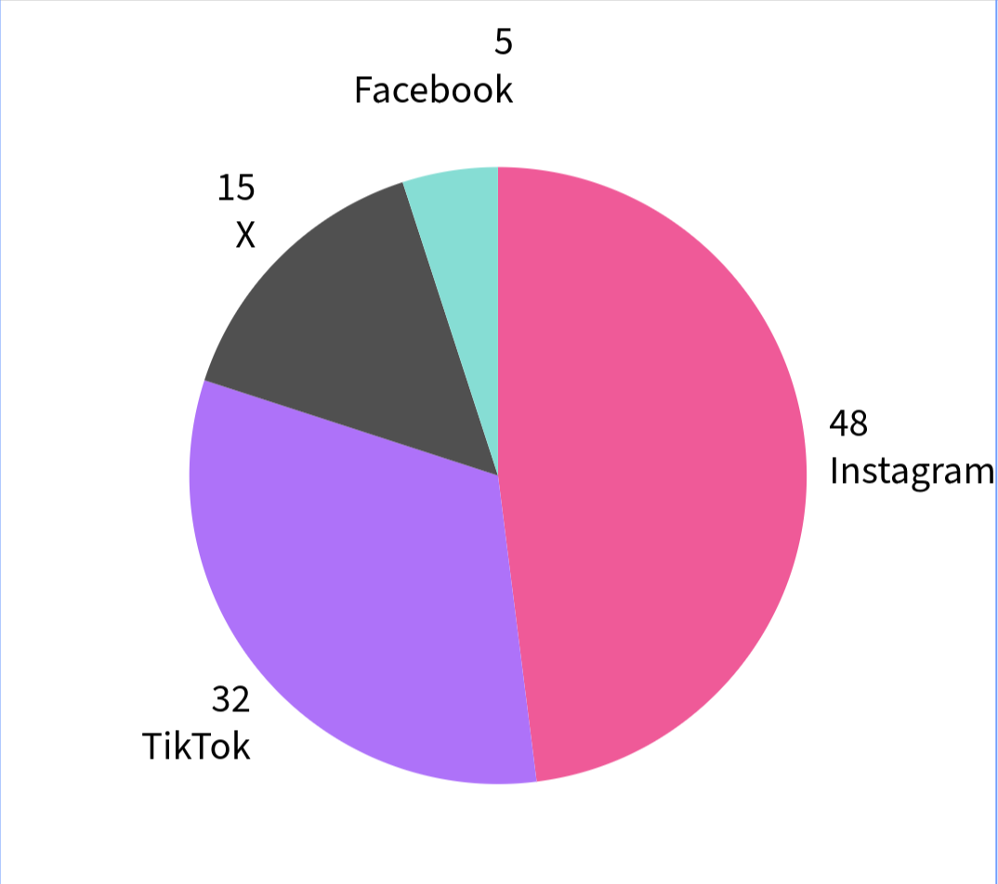

Participants showed a preference for:
- short-form video content
- behind-the-scenes footage
- match highlights
- player interviews
- supporter interaction
- entertaining content

The findings suggested that supporters responded more positively towards authentic and personality-driven communication rather than formal club messaging. Many participants believed this type of content strengthened connection and improved supporter engagement.
However respondents also suggested that Welsh football clubs were generally less effective in their marketing strategies compared to larger football organisations. 61% Of participants believed Welsh clubs lacked consistency in posting content while 57% stated that domestic football content appeared less visible online than content produced by elite football clubs.
Several respondents referenced Wrexham A.F.C. As an example of digital branding and storytelling within Welsh football. Participants highlighted documentary storytelling, community-focused content and strong branding as contributors towards the club’s increased visibility and supporter engagement.

Overall the findings demonstrated that digital media represents an opportunity for Welsh football clubs although financial and staffing limitations continue to restrict the effectiveness of many clubs’ online strategies.

National Team Versus Domestic Football

One of the significant findings from the survey involved the relationship between support for the Wales national team and engagement with domestic Welsh football clubs.
82% of respondents reported strong emotional attachment towards the Wales national football team particularly following recent international tournament success such as UEFA Euro 2016 and qualification for the 2022 FIFA World Cup.
Participants frequently associated the team with:

- national pride
- Welsh identity
- unity
- emotional connection

However this emotional attachment did not consistently translate into regular engagement with domestic league football. 38% Of respondents stated that they regularly followed Welsh domestic football clubs while 52% reported that they primarily consumed football content relating to English football leagues.

Several participants suggested that Welsh domestic football lacks visibility and mainstream exposure compared to football competitions. As a result supporters often engage heavily with football through televised leagues and digital media coverage rather than local domestic clubs.
The findings highlighted a disconnect between national football identity and domestic football engagement within Wales.

Interview Findings
The qualitative interviews provided insight into supporter perceptions, emotional attachment and attitudes towards Welsh football. Through analysis three major themes emerged consistently throughout the interviews.

Theme One – Lack of Visibility

One of the most consistent themes identified throughout the interviews was the lack of visibility surrounding Welsh domestic football. Several interviewees believed domestic Welsh football receives limited media coverage and insufficient digital promotion compared to larger football leagues. Interview participants included supporters of clubs operating within both the English and Welsh football pyramid systems, including followers of domestic Welsh football and clubs such as Cardiff City F.C. and unfortunately Swansea City, Taffs Well and Penybont as well as local grassroots football volunteers. This provided a broader understanding of how Welsh football is perceived across different supporter groups and football environments.

A Cymru Premier supporter explained:
“Welsh clubs need to do more to market themselves locally because many people simply aren’t aware of matches taking place.”

Similarly, a Cardiff City supporter suggested:
“You have to actively search for Welsh football content. It isn’t promoted towards supporters in the same way as larger leagues.”

These responses suggested that limited visibility and weaker marketing strategies continue to affect supporter engagement within Welsh football.

Theme Two – Community Identity

Community identity emerged as one of the strongest positive themes throughout the interviews. Participants frequently highlighted the sense of local pride, accessibility, and personal connection associated with Welsh football clubs.
Interviewees regularly discussed:
- grassroots atmosphere
- volunteer culture
- supporter accessibility
- personal relationships
- local identity

One supporter involved in grassroots Welsh football explained:
“The community side of Welsh football is one of its biggest strengths.”
Similarly, a Taffs Well supporter stated:
“At Welsh clubs you feel far more connected to the people around you than you would at larger football clubs.”
The findings suggested that community identity represents a significant strength within Welsh football and may contribute towards long-term supporter loyalty and emotional attachment.

Theme Three – Social Media Limitations

Another recurring theme involved the digital limitations experienced by Welsh football clubs. Participants regularly identified financial constraints, limited staffing, and inconsistent content production as barriers affecting supporter engagement online.

One interviewee involved with local Welsh football media stated:
“Most Welsh clubs simply don’t have the resources to maintain full-time media operations.”
Similarly, a supporter who regularly follows Welsh domestic football explained:
“Social media is extremely important now, especially for younger supporters, but many clubs struggle to post consistently.”

Despite these challenges, participants generally believed digital media represented one of the biggest opportunities for Welsh football clubs to improve visibility and supporter interaction.
Overall, the interview findings demonstrated that Welsh football possesses strong community foundations but continues to face significant visibility and resource-related challenges within modern football media environments.

Summary of Findings

Overall the findings demonstrated important patterns relating to supporter engagement within Welsh football. Survey findings indicated emotional attachment towards the Wales national team although this did not consistently translate into regular engagement with domestic Welsh football clubs.
The findings also highlighted the growing importance of media and digital engagement particularly among younger supporters. However participants regularly identified visibility issues, financial limitations and inconsistent digital marketing strategies as barriers affecting supporter engagement within Welsh football.

Qualitative interview findings further emphasised the importance of community identity, local pride and grassroots culture within Welsh football. Despite challenges relating to visibility and resources participants consistently viewed community engagement as one of the sport’s strongest qualities.
The following part will discuss these findings in relation to existing literature and the wider research objectives surrounding supporter engagement, digital marketing and community identity, within Welsh football.

Discussion

This part talks about what we found out in part Four and how it fits with what people know about Welsh football culture, digital marketing, community identity (Smith and Porter, 2004) and supporter engagement. (Bauer et al., 2005) We want to understand what the findings mean and how they relate to the goals of our research and what other experts have said.
We looked at the points that came up during the research like supporter engagement, community identity, digital media, national identity and the money problems that Welsh football clubs face. We also thought about how these findings might affect the future of Welsh football. We connected our findings to what other people have said and written to get an understanding of how marketing and supporter engagement work in Welsh football.

Supporter Engagement and Community Identity

One big thing we found out was how important community identity is to Welsh football. When we asked people about it they said that they love the sense of belonging (Tajfel and Turner, 1979) that comes with supporting a Welsh football club. They think of these clubs as being part of their community easy to get to and connected to culture.

This makes sense when you think about Social Identity Theory, which says that people get a sense of who they're from the groups they belong to. For football fans their team is a part of who they are and it represents their community and shared experiences. (Funk and James, 2001) Our findings suggest that Welsh football clubs are good at making people feel emotionally attached to them because of their identity and community relationships (Smith and Porter, 2004).

We also found out that people tend to be loyal to their team because they feel an emotional connection. When we talked to people they said that they love the atmosphere and how easy it is to get to know the players and other fans at Welsh football clubs. This is different from what you might find at more commercial football clubs.

It's also important to note that Welsh football clubs don't have a lot of money so building relationships with fans is crucial. Morgan and Hunts Commitment-Trust Theory says that trust and emotional connection are key to a companys long-term success. (Morgan and Hunt, 1994) Since Welsh football clubs rely much on local fans and volunteers making emotional connections with them is really important.

However even though community identity is a strength for Welsh football we found that many clubs struggle to get people to come to games and to grow their fan base. This means that while community identity is a thing clubs need to find better ways to engage with fans and make them want to support the team.

Social Media and Digital Engagement

We found out that social media is really important (Pegoraro, 2010) for getting fans engaged with Welsh football, younger fans. When we looked at the data we saw that Instagram and TikTok are the popular platforms for fans. We also found that fans love personality-driven content.

This makes sense when you think about what other researchers have said. Pegoraro found that social media has changed the way teams communicate with fans making it more direct and personal. (Vale and Fernandes, 2018) that digital engagement helps fans feel more connected to their team.

We also found that fans prefer content that's real and entertaining rather than formal or boring. They love videos interacting with players and getting a behind-the-scenes look at the team. This shows that emotional storytelling and digital branding (Anagnostopoulos et al., 2018) are really important in football marketing.

However even though social media is important we found that many Welsh football clubs struggle to use it. Fans said that clubs don't post enough don't make content and aren't visible enough online. This is similar to what other researchers have found that smaller football clubs often struggle to compete with clubs when it comes to digital marketing.

One example of a club that is doing media well is Wrexham A.F.C. Fans said that the clubs strong narrative marketing and consistent online branding (Keller, 2013) have helped it become more visible. This shows that storytelling and emotional branding can be really effective for Welsh football clubs.

Overall our findings suggest that digital media is an area for growth in Welsh football. If clubs can use media effectively they can increase their visibility strengthen their relationships with fans and attract younger fans.

National Identity and Domestic Football

We also found that there is a connection between supporting the Wales national football team and supporting domestic Welsh football clubs. However we found that fans are emotionally attached to the national team than to domestic clubs. Fans said that they feel a sense of national pride and cultural identity (Smith and Porter, 2004) when supporting the national team.

This makes sense when you think about Social Identity Theory, which says that people get a sense of who they're from the groups they belong to (Tajfel and Turner, 1979). For Welsh football fans the national team represents their country and their culture.

The success of the team in recent years has helped to increase emotional engagement among fans. Campaigns like " Stronger" have created a strong sense of unity and national pride (FAW, 2021). However despite this increased engagement we found that it hasn't translated into support for domestic Welsh football clubs.

Fans said that one reason for this is that domestic clubs don't get much visibility or media coverage as the national team. They also said that the popularity of football leagues in Wales makes it harder for domestic clubs to attract fans.

Our findings suggest that Welsh football clubs need to find ways to tap into the identity and pride that fans feel when supporting the national team. If they can do this they may be able to increase their visibility and attract fans.

Visibility and Commercial Challenges

We found that Welsh football clubs face a number of visibility-related challenges. Fans said that limited media exposure, financial constraints and reduced marketing resources are barriers to growth.
This is similar to what other researchers have found that smaller football clubs often struggle to compete with clubs when it comes to marketing and visibility. Welsh football clubs operate in a competitive environment with bigger clubs like those in the Premier League dominating the media and fans attention.

We also found that limited visibility affects fans awareness and attendance behavior. Many fans said that they don't know much about football or whats going on with their local club. This suggests that improving communication and increasing visibility are important priorities for Welsh football clubs.
Our findings also suggest that supporter engagement strategies may be more effective for Welsh football clubs than marketing campaigns. Because of limitations clubs may be better off focusing on community-based marketing (Morgan and Hunt, 1994), relationship building and digital storytelling rather than expensive advertising campaigns.

However despite these challenges we found that Welsh football clubs have some strengths. Fans said that they love the authenticity, accessibility and community atmosphere of football. These qualities can help clubs differentiate themselves from more commercial clubs and attract fans who are looking for a more personal and emotional connection, with their team (Funk and James, 2001).

Overall our findings suggest that Welsh football clubs face challenges but they also have opportunities to strengthen their relationships with fans and improve their long-term sustainability. By focusing on community identity, digital engagement and emotional branding clubs can increase their visibility. Attract more fans.

Recommendations and Conclusion

This study looked at how Welsh football clubs can get more people to support them and be part of their community. The study found that Welsh football clubs have a sense of community and people feel emotional about them but they are still struggling to get noticed and to get people to engage with them online. The study also found that people who support the Wales football team do not always support their local Welsh football club. This is a problem because Welsh football clubs could be getting support from people who love Welsh football.

The study found some things about Welsh football too. People like that Welsh football clubs are part of their community. That they are not just about making money. Many people think that Welsh football clubs are more genuine and care about their community more than football clubs. The study also found that digital media, like Instagram and TikTok are very important for getting younger people excited about football. People like to watch videos and see what is going on behind the scenes.

The study also found that many Welsh football clubs are struggling to use digital media well because they do not have enough money or staff. Overall the study suggests that Welsh football clubs can grow and get support if they use marketing and community engagement in a smart way. They need to make people feel emotional about their club and to be part of their community.

Recommendations

Based on what the study found here are some ideas for how Welsh football clubs can get support and be more successful.

Recommendation One Make a Strong Welsh Football Identity

Welsh football clubs should work together to make a Welsh football brand that people can get behind. The Wales national football team has done a job of making people feel proud to be Welsh and to support their team. Welsh football clubs can learn from this. Make their own brand stronger by working together and sharing ideas.

Recommendation Two Improve Social Media

The study found that digital media is very important for younger people. Welsh football clubs should make sure they are using media well and posting interesting content that people will want to watch and share. They should use platforms like Instagram and TikTok to connect with their fans and to show them what is going on behind the scenes.

Recommendation Three Work with the Community

The study found that community is very important for Welsh football. Clubs should work with schools, universities and community groups to get more people involved and to make their club more a part of the community. They can do things like visit schools and run football programs for kids.

Recommendation Four Make Matchdays Fun

Some people said that they do not go to matches because they are not very exciting or because they are too expensive. Welsh football clubs can make matchdays more fun by having activities and events after the match. They can also make tickets more affordable so that more people can come.

Recommendation Five Tell Stories

The study found that people like to watch videos and stories about football. Welsh football clubs can make videos that show what their club is about and what makes them special. They can tell stories about their players and their community.

Recommendation Six Make Tickets More Affordable

The study found that some people cannot afford to go to matches because tickets are too expensive. Welsh football clubs can make tickets more affordable by offering discounts to students and families. This can help get more people to come to matches and to support their club.

Overall the study suggests that Welsh football clubs should focus on their community and on making people feel emotional about their club. They should use media and marketing in a smart way to get more people to support them.

Final Reflection and Future Research

This study helped us understand more about how Welsh football clubs can get support and be more successful. The study found some challenges. It also found some good things about Welsh football. One of the limitations of the study is that it only looked at a group of people. Future studies could look at people and see if the findings are the same.

Future studies could also look at how digital media's changing the way people engage with football. They could look at how Welsh football clubs can use media to get more people to support them and to make their club more a part of the community. More research could also be done on what makes people support their football club and how clubs can make people feel more emotional, about their team.

Reference List

Andrews, D.L. and Jackson, S.J. (2001) Sport Stars: The Cultural Politics of Sporting Celebrity. London: Routledge.
Anagnostopoulos, C., Byers, T. and Shilbury, D. (2018) ‘Corporate social responsibility in professional team sport organisations: Towards a theory of decision-making’, European Sport Management Quarterly, 18(1), pp. 1–18.
Bauer, H.H., Sauer, N.E. and Schmitt, P. (2005) ‘Customer-based brand equity in the team sport industry’, European Journal of Marketing, 39(5/6), pp. 496–513.
Braun, V. and Clarke, V. (2006) ‘Using thematic analysis in psychology’, Qualitative Research in Psychology, 3(2), pp. 77–101.
Bryman, A. (2016) Social Research Methods. 5th edn. Oxford: Oxford University Press.
Creswell, J.W. (2014) Research Design: Qualitative, Quantitative and Mixed Methods Approaches. 4th edn. London: SAGE.
FAW (2021) Together Stronger Strategy Report. Cardiff: Football Association of Wales.
Funk, D.C. and James, J. (2001) ‘The Psychological Continuum Model: A conceptual framework for understanding an individual’s psychological connection to sport’, Sport Management Review, 4(2), pp. 119–150.
Giulianotti, R. (1999) Football: A Sociology of the Global Game. Cambridge: Polity Press.
Giulianotti, R. and Robertson, R. (2009) Globalization and Football. London: SAGE.
Keller, K.L. (1993) ‘Conceptualizing, measuring, and managing customer-based brand equity’, Journal of Marketing, 57(1), pp. 1–22.
Morgan, R.M. and Hunt, S.D. (1994) ‘The commitment-trust theory of relationship marketing’, Journal of Marketing, 58(3), pp. 20–38.
Pegoraro, A. (2010) ‘Look who’s talking—Athletes on Twitter: A case study’, International Journal of Sport Communication, 3(4), pp. 501–514.
Saunders, M., Lewis, P. and Thornhill, A. (2019) Research Methods for Business Students. 8th edn. Harlow: Pearson.
Smith, D. and Porter, D. (2004) Sport and National Identity in the Post-War World. London: Routledge.
Tajfel, H. and Turner, J.C. (1979) ‘An integrative theory of intergroup conflict’, in Austin, W.G. and Worchel, S. (eds.) The Social Psychology of Intergroup Relations. Monterey, CA: Brooks/Cole, pp. 33–47.
UEFA (2016) UEFA Euro 2016 Tournament Report. Nyon: Union of European Football Associations.
Vale, L. and Fernandes, T. (2018) ‘Social media and sports: Driving fan engagement with football clubs on Facebook’, Journal of Strategic Marketing, 26(1), pp. 37–55.
Wrexham A.F.C. (2023) Welcome to Wrexham and Digital Brand Growth. Wrexham: Wrexham Association Football Club.

