2023506
David Cornelius
Networking Operating Systems and Services

BSC-PT Computing (Computer Networks & Cybersecurity)

9th April 2023

Abstract
The following documentation presents a practical demonstration and theoretical understanding of the technology utilised when deploying a virtual network.
The demonstration portion consists of building, configuring, and deploying a virtual network utilising Virtual Box, Windows Server, and Active Directory to establish a working domain. This has been demonstrated using annotated screenshots to provide an overview of the critical configuration processes.
The demonstration concludes with succesful authentication on the domain.
Following the practical demonstration, research has been presented to show an understanding of the underlying technologies utilised to achieve the goals set out the in practical scenario. Topics discussed include Hypervisors and their uses, DHCP and Active directory.
The Research aims to clearly demonstrate an understanding of the need for these technologies, how they are applied to different scenarios and any considerations required when utilising them.

Table of Contents
Contents
1. Task 1 4
1.1 Introduction 4
1.2 Mandatory Team Submission Details 4
1.3 Building of a virtual Network (Screenshots) 5
VM Creation and Operating Systems 5
Virtual Network Configurations 5
1.4 Install Critical Network Services (Screenshots) 9
Pre-Requisite 9
Deploying Active Directory as a role or feature based installation. 10
Creating user account objects using Active Directory Users and Computers snap-in console 10
Object Attributes of Interest 10
Adjoining the Domains and Testing user logins 10
2.1. Question i 11
2.2 Question ii 11
2.3 Question iii 11
2.4 Question iv 11
2.5 Question v 11
3. References 12

Table of Figures
Figure 1 – DHCP DORA Flow

Task 1

Introduction
The Purpose of this Task is to work as a team on the practical aspect of building, configuring, managing, and deploying a virtual network. This involves downloading VM Box and creating and configuring servers and clients using specific Type 2 Hypervisor management software. This forms the building blocks of configuring the network, then allowing suitable services and features to be utilised.

Mandatory Team Submission Details
Name of the Team: DMTJ
Team Members:
Student Name | Student ID
Dave Cornelius | 2023506
David Corner | 1809784
Dylan Thomas | 2014801
Morgan Combstock | 2014028
Team Evaluation (Self Evaluate your Team)
 | Student 1 | Student 2 |  | Student 3 |  | Student 4 |  | Student 5
Student 1 | X |  | 5 |  | 5 |  | 5 |  | X
Student 2 | 5 |  | X |  | 5 |  | 5 |  | X
Student 3 | 5 |  | 5 |  | X |  | 5 |  | X
Student 4 | 5 |  | 5 |  | 5 |  | X |  | X
Rate your Teams Contribution with a scale of 1 to 5 (1 No Contribution and 5 Excellent Contribution)
Add your comments on Team Evaluation: (Justify your evaluation)
Student 4: Morgan was keen to get stuck into the technical aspects of the project. Worked on setting up hypervisor. Worked out of Uni hours when required. Always positive and keen to drive the project forward. Easy to work with. Good communication. Overall excellent contribution.
Student 3: Dylan kept everyone collaborating and making sure the project stuck to a deadline. Annotated the screenshots and built out the collaborative section of the document. Positive attitude towards getting the work done and always available. Easy to work with overall excellent contribution.
Student 2: Excellent contribution, very keen to be involved in all aspects. Helped annotate screenshots and generally drive forward the project. Positive attitude and great communication.
Student 1: N/A

Building of a virtual Network (Screenshots)

VM Creation and Operating Systems
Figure – Initial Client and Server creation within VM Box
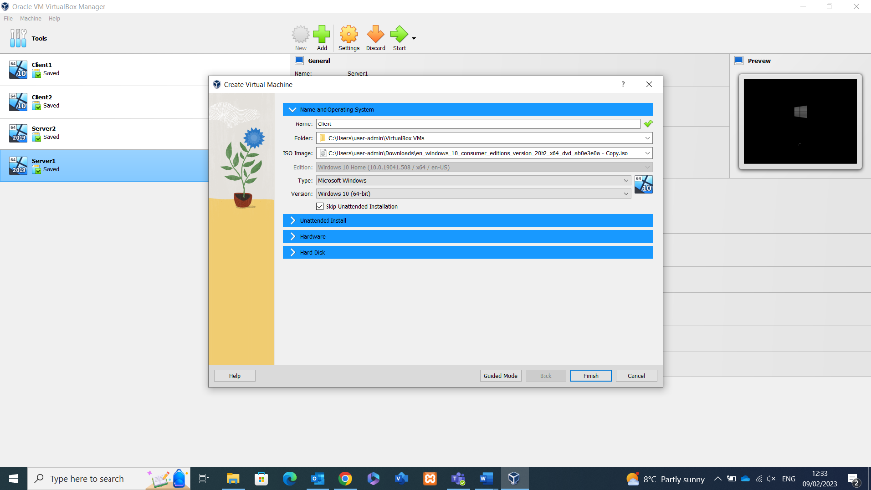
Having downloaded and Installed VM box, and the associated files provided for the VM examples, VM Box can now be loaded up. It is now possible to create the two clients and two servers as required. The above screenshot shows the VM box Manager screen, when selecting the Add button, selecting the relevant File and ISO Image allows the creation of clients and servers [1]. Once this is done, select finish and repeat to reach the point above with the required clients and servers.

Virtual Network Configurations
Once the VM’s are created and Windows 10 Operating System is installed, the configuration of the virtual network can begin.
Figure – Network configuration of Server
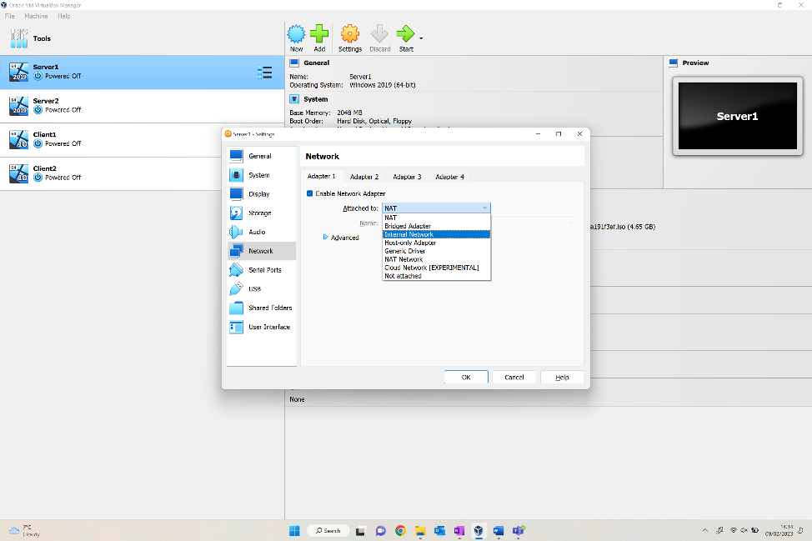
The above shows the selection of the first server, navigating to Networks tab it allows the end user to select the enable network adapter, thus allowing selection of what network it’s attached to (Internal) in this case. This creates a switch for the network.
Figure – Accessing Control Panel of VM
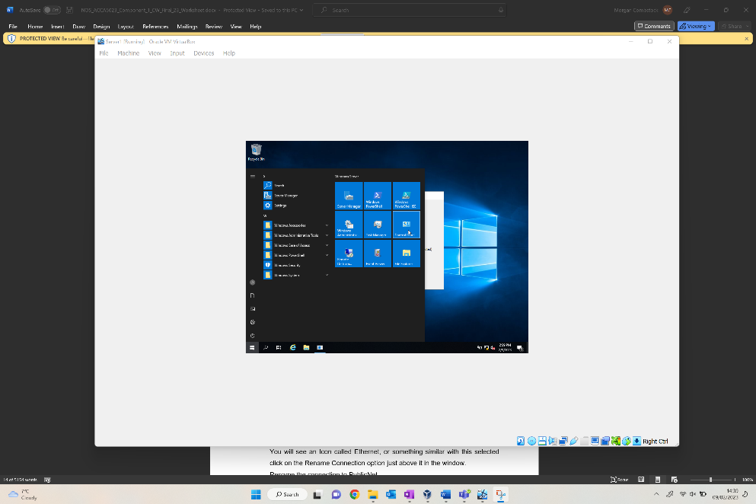
Following the network amendments, booting up Server1 allows the user to select the Windows Start section, then the control panel as seen above to access the Network Status and Tasks section. By doing this, you will be able to amend the change adapter settings.
Figure – Amending Adaptor Settings within Network Status
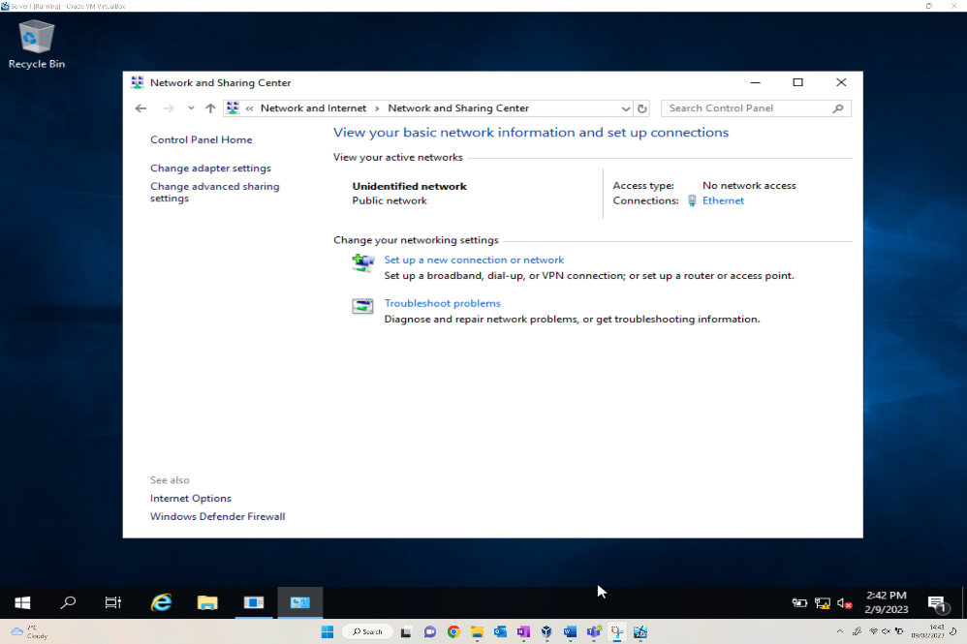
The above shows the options provided for the Network and sharing centre after navigating via the Network and Internet section of the control panel. The Ethernet hyperlink found to the right of the screen allows amendments to be made to the ethernet adaptor properties, along with changing the IPv4 specification.

Figure – Amending IPv4 within ethernet adaptor properties.
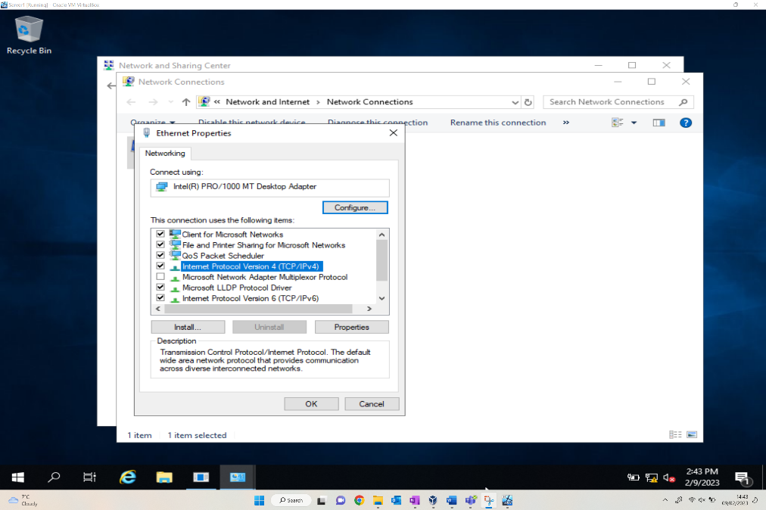
The connection has been renamed PublicNet as requested, which could be seen behind the Ethernet Properties window. The above shows the ethernet properties screen, where the Internet Protocol Version 4 option should be selected and amended.

Figure – Assigning manual IPv4 address and auto assigning Subnet mask within PublicNet.
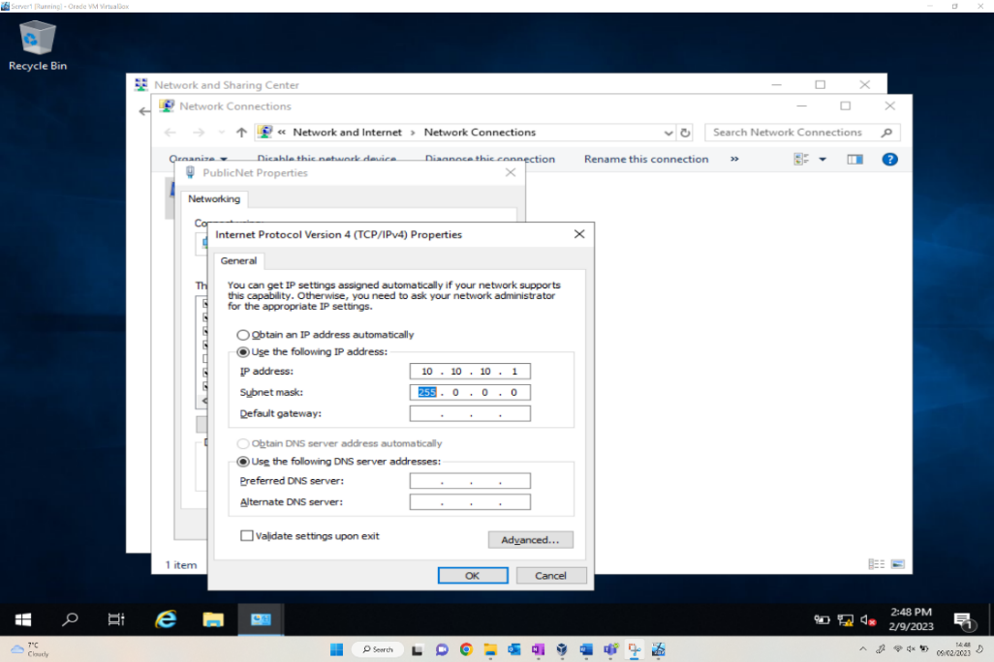
After accessing the Internet Protocol Version 4 window, the user can manually amend the IP address as required, this has been changed to 10.10.10.1 which is the address specified in the Trial Network Config diagram. The subnet mask has been auto assigned.

This process is then repeated to create the second connection for PrivateNet1. This involves the similar steps documented above, beginning by selecting Server1 and the Adapter 2 tab, this then creates the second connection which is now visible, seen in the next figure.
This connection has been named PrivateNet1 as required in the network specification document. Once the network connection has been renamed, like the first network connection the IPv4 address can be assigned, along with an auto populated subnet. The subnet should be a different one to the other adaptor.
Figure – Client1 connection to PrivateNet1
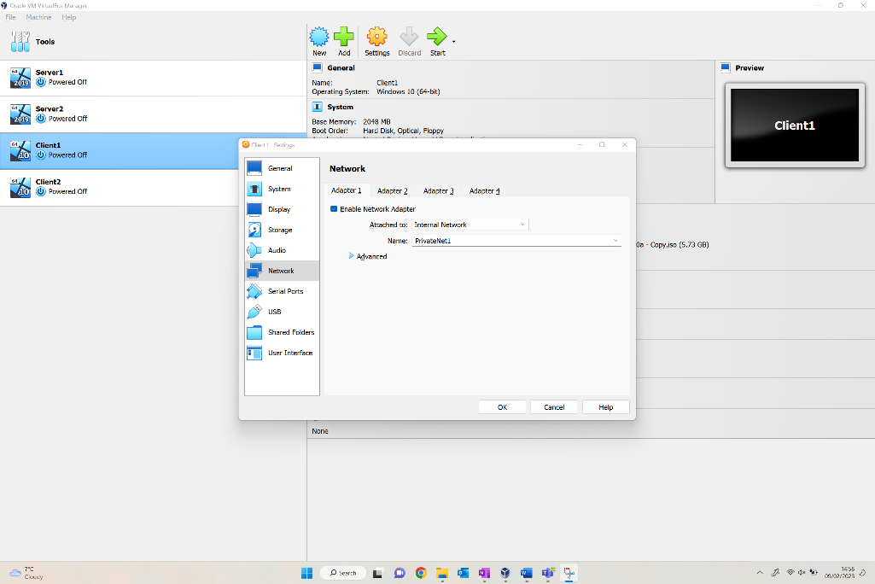
Now that both Public and PrivateNet1 connections have been configured, the Clients can now be connected to the relevant Networks. The above figure shows the Network options for Client1, the Adapter attachment has been amended to Internal Network, and the network selection is PrivateNet1.
Figure – Client2 PrivateNet2 IP Address
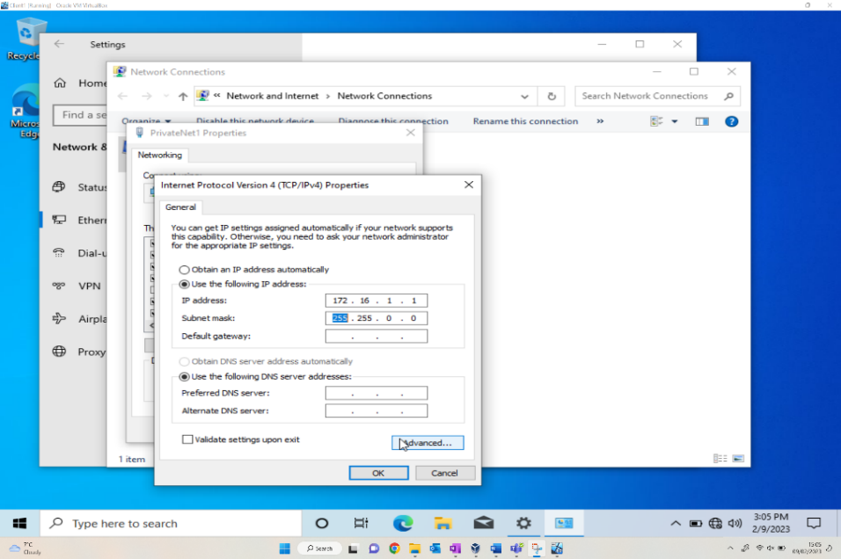
Like the previous processes for the servers, the Ethernet within Client 1 is renamed, then the client is manually assigned with the IPv4 address of PrivateNet1 172.16.1.1 as per the Trial Network Config diagram, subnet mask again automatically allocated.

Install Critical Network Services (Screenshots)

Pre-Requisite
Figure – Server 1 Firewall Turned Off
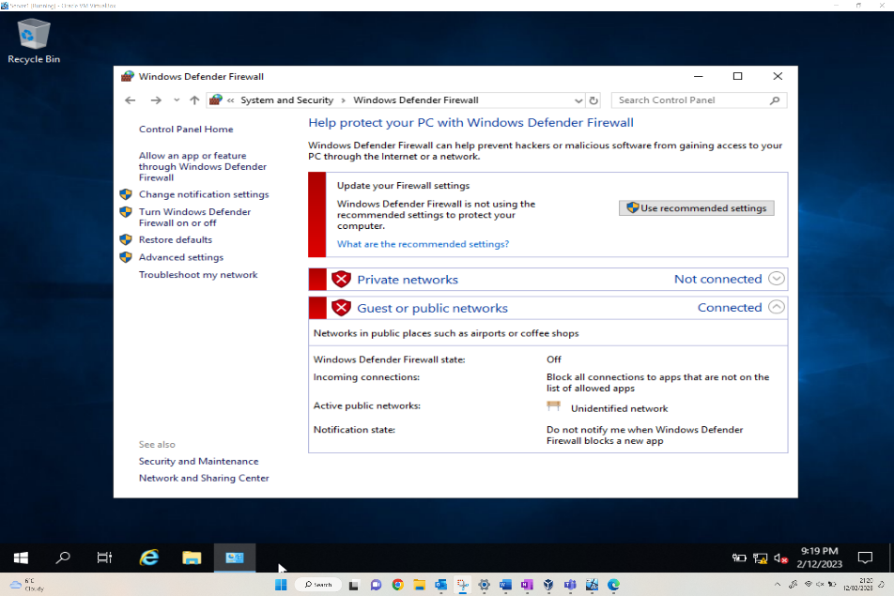
As a pre-requisite to the next task, there needs to be verification that there’s no DNS setup, and that the Firewall is turned off. The above screen allows the user to customize the settings of each network, both the private and public network firewall settings.
This screenshot confirms that the Server1 Firewalls have now been turned off, showing as Not connected in the private networks section specifically.
Figure – Confirmation of Rename
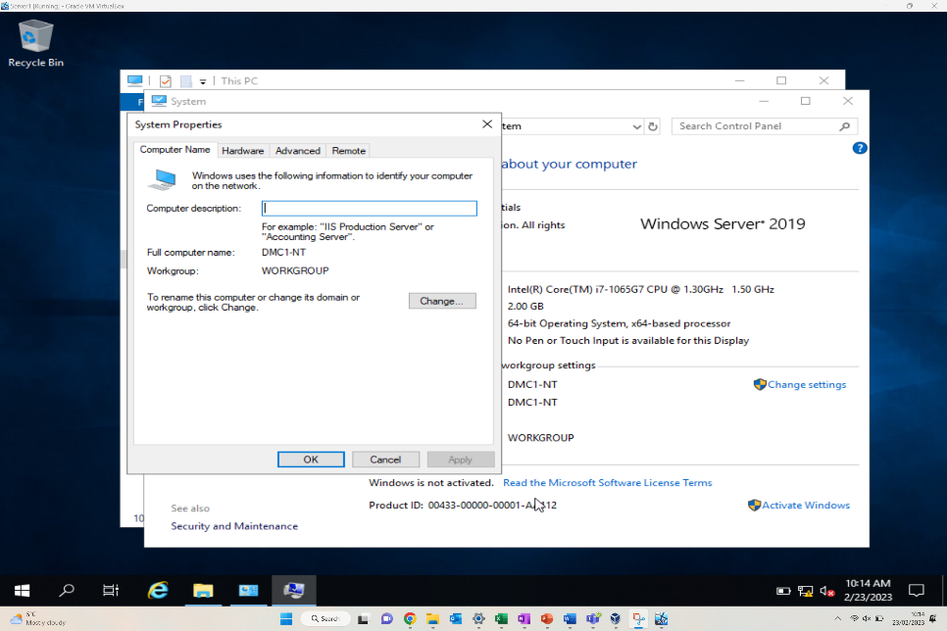
The above screenshot evidences the renaming of server 1, following the instructions provided via the worksheet the computer name has been amended to DMC1-NT. Following this action, a system restart was required.

Deploying Active Directory as a role or feature based installation.

For the roles to be installed on the required server, this is all handled within the ‘Server manager’ application on the server OS. To launch Server Manager the user will need to search for it within the start menu and search for it within there. Once Server Manager is open select ‘Manage > Add Roles and Features’, where the following window will be displayed, when the user is at this point, it is required to select ‘next’ to proceed through the Add role wizard.
Figure – Server Management Dashboard to add Features.
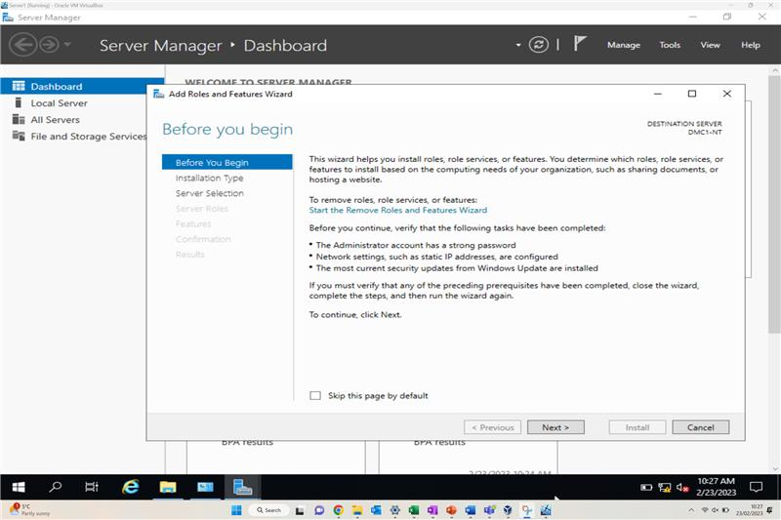
The next window that will appear is to select the destination server, this allows the user to select a different server to install the roles, in this example the destination will be set to the local server the add roles and features wizard is currently running on, so just click ‘next’ to proceed.
Figure – Selection of Renamed Server
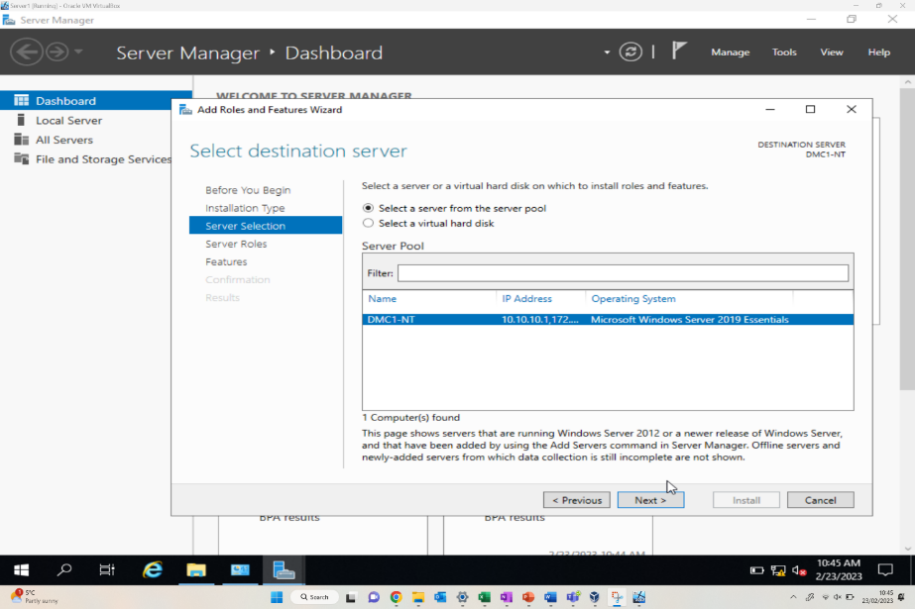
The next window that is presented is to ‘select server roles’, within here it gives the user the ability to install any ‘out the box’ features which are disabled by default as part of the Windows Server OS. As part of this example Active Directory requires installing on the server host so selecting the checkbox next to ‘Active Directory Domain Services’ then clicking ‘next’ will allow the installation to commence [2].
Figure – Adding Active Directory Domain Services
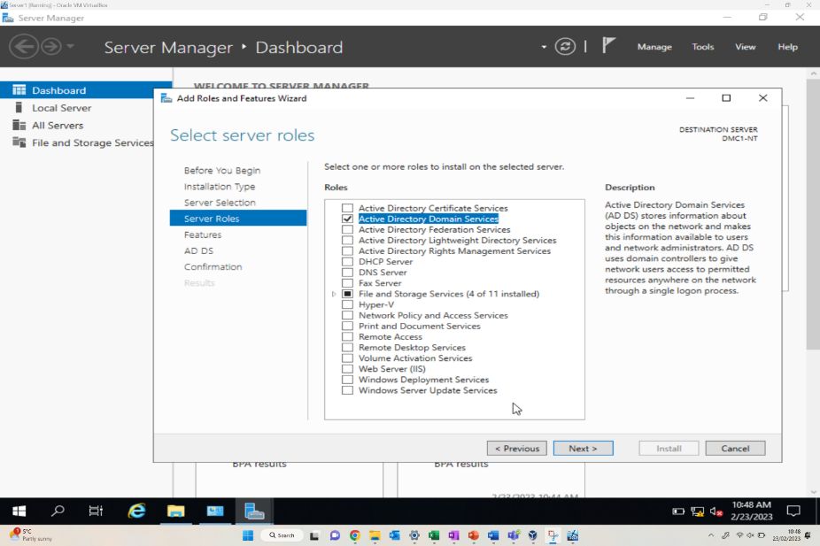
Role installation progression can be monitored through the status ‘flag’ within server manager.
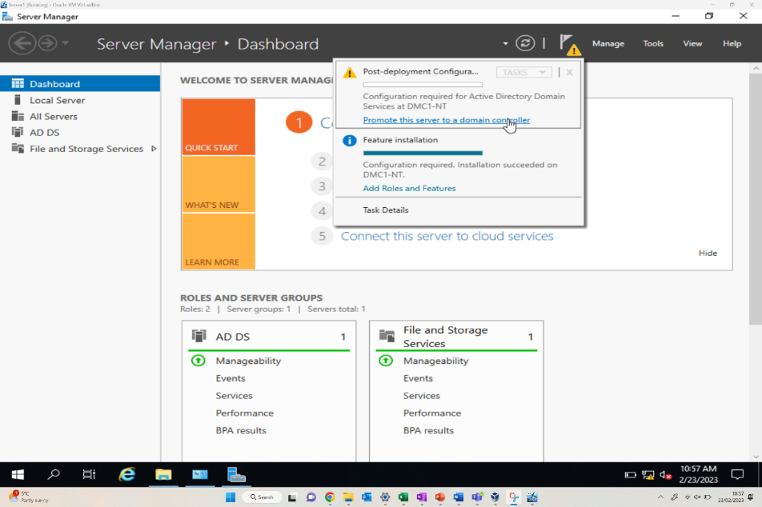

Creating user account objects using Active Directory Users and Computers snap-in console
Search for ‘Active directory users and computers’ in the start menu of the server, this will then open the MMC snap-in console with the AD configurations within there, like the following:
Figure – Verification of DMC1-NT Server
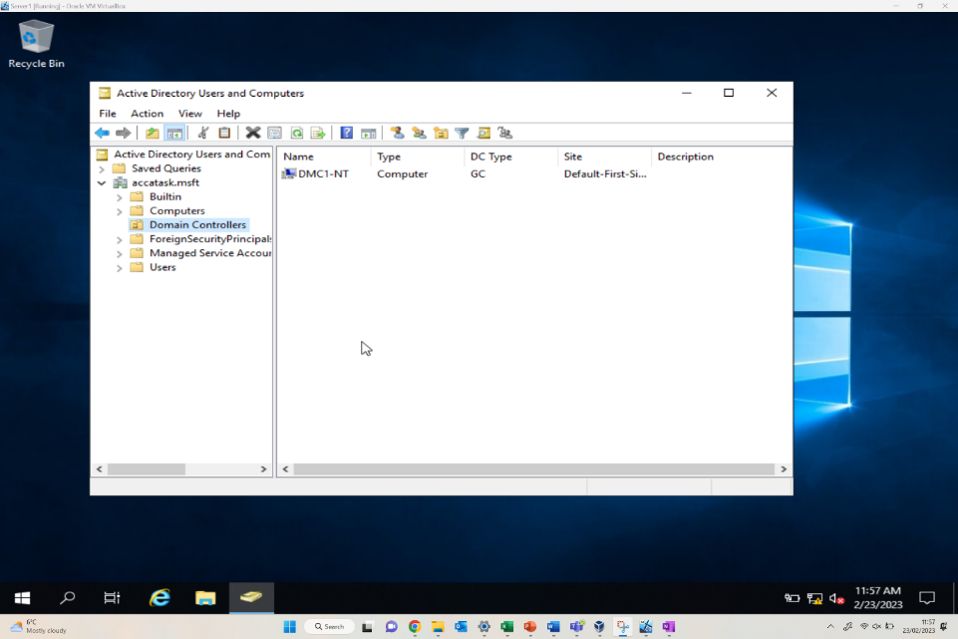
To create a new user object right-click on the ‘users’ container within the left-hand pane and select ‘New > User’, here the new user account creation window will appear, here the user's information such as first and last name, logon names all require entering to create the domain account.

Figure – Creation of user “Morgan Combstock”
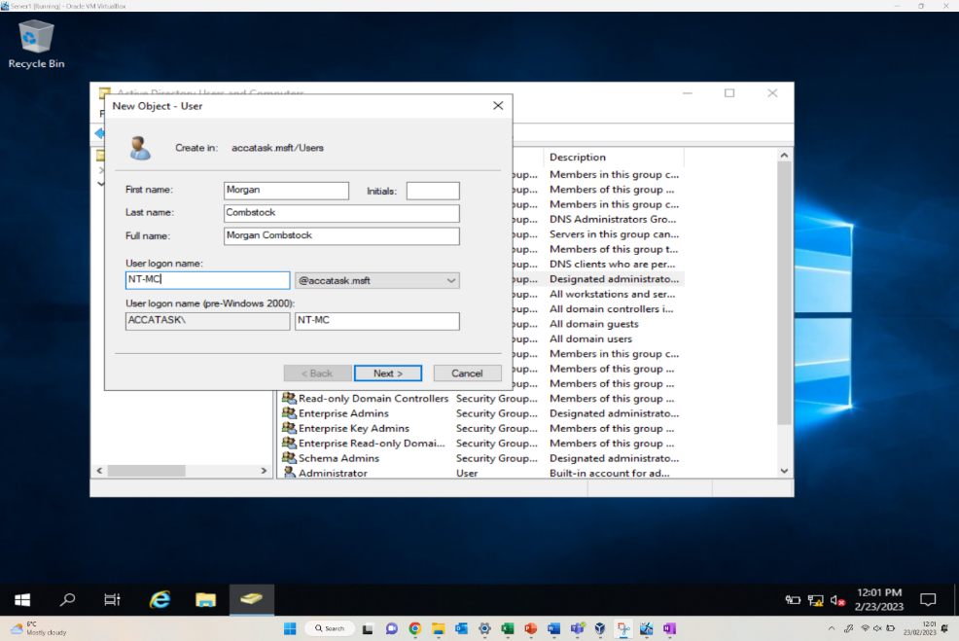
Once the user details have been inputted, simply select ‘next’ to create a password for the account and to select any additional functions on the account, i.e., set password to never expire, user must change password at next logon etc.
Figure – Adding Password for user Accessibility
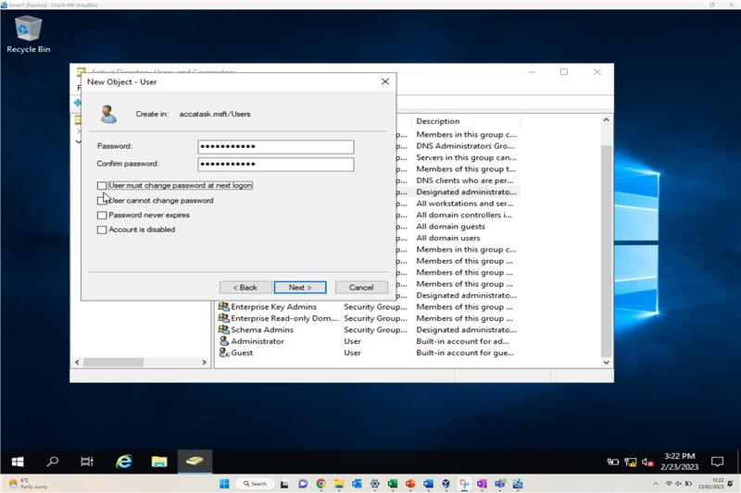
Once the user has been created and password assigned, the user then needs to be added to a domain admin group, whether this is with admin accessibility rights or just general user with lesser network accessibility.

Object Attributes of Interest

Once the Active Directory users and account objects have been created, further object attributes of interest can be created. Various attributes can be implemented to optimise the Active Directory management capability. This includes imposing limitations on restricted user groups, or enforcement of user activities upon the network.
Figure – New user in user membership domain
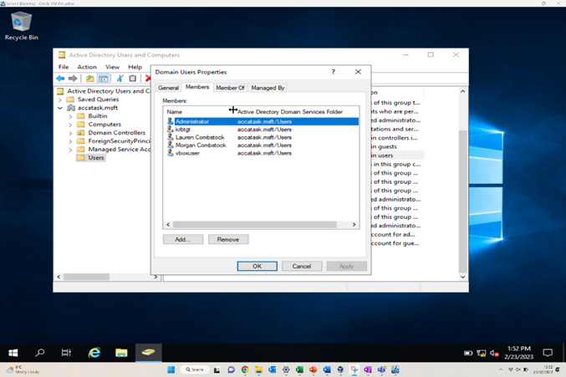
The above figure shows the addition of new users into the user membership. Various users can then be added, including an administrator user, or even group to separate those who need/should have higher levels of access and influence on the network compared to those who should only have restricted access.
Figure – Restriction of Login hours for specified User
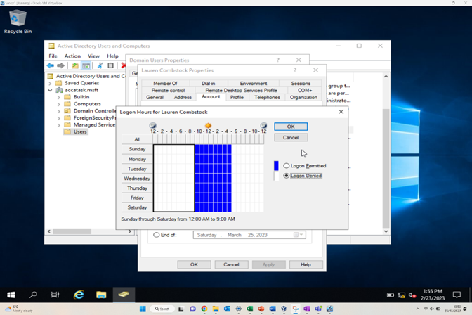
Other restrictions can be imposed, the above is an example of restricting the access hours of a generic user of the network. The user ‘Lauren Combstock’ has had the hours of permitted access to 9am – 5pm, meaning the user will be unable to log in to the network in times outside the permitted access.

Adjoining the Domains and Testing user logins

Figure – WC1-NT successful Domain connection
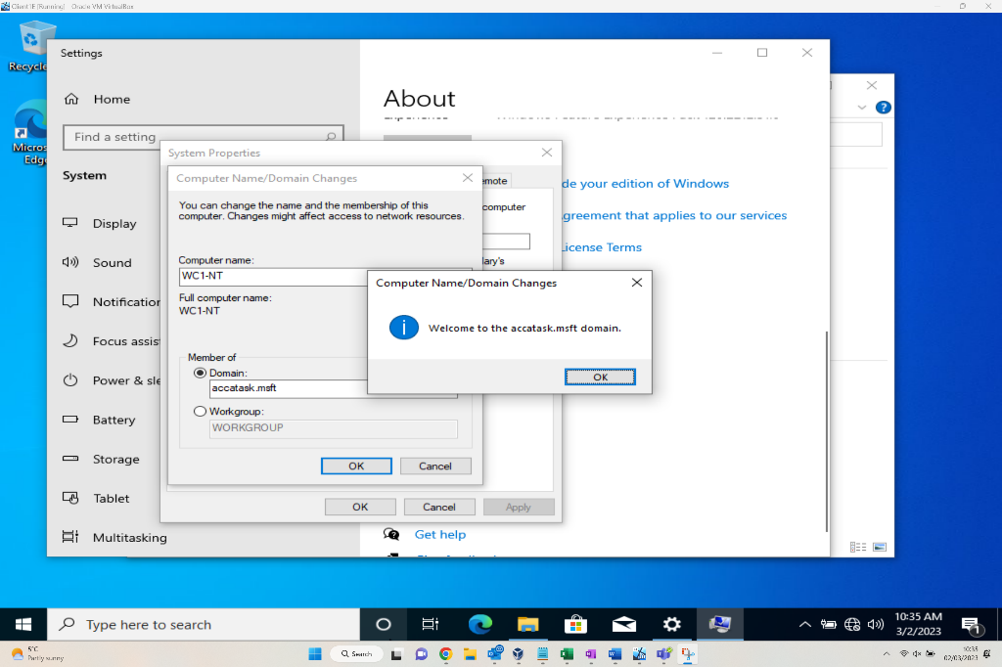
The above figure demonstrates the computer WC1-NT being connected to accatask.msft domain successfully. This is accessed via the system properties window within the control panel [3].
Figure – Morgan Combstock home screen prior to Log out.
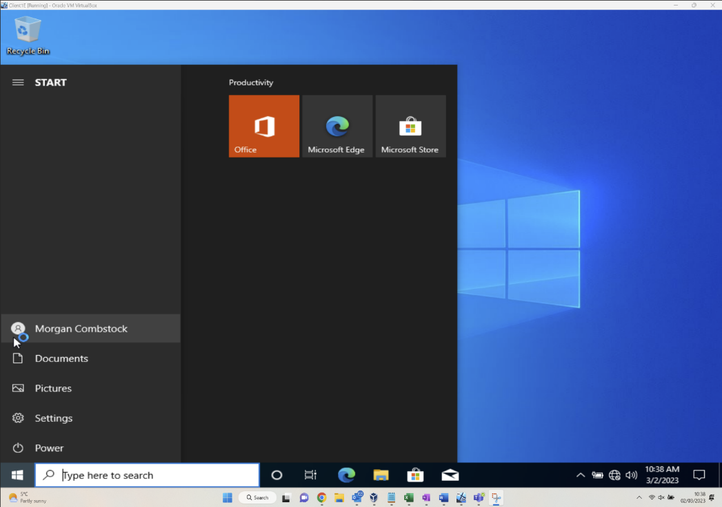
This above figure shows a completed login by the user “Morgan Combstock” after successful authentication of domain credentials. The user is now successfully connected following the completion of all the previous steps in setting up the network.
Figure – Access denied for user without domain access.
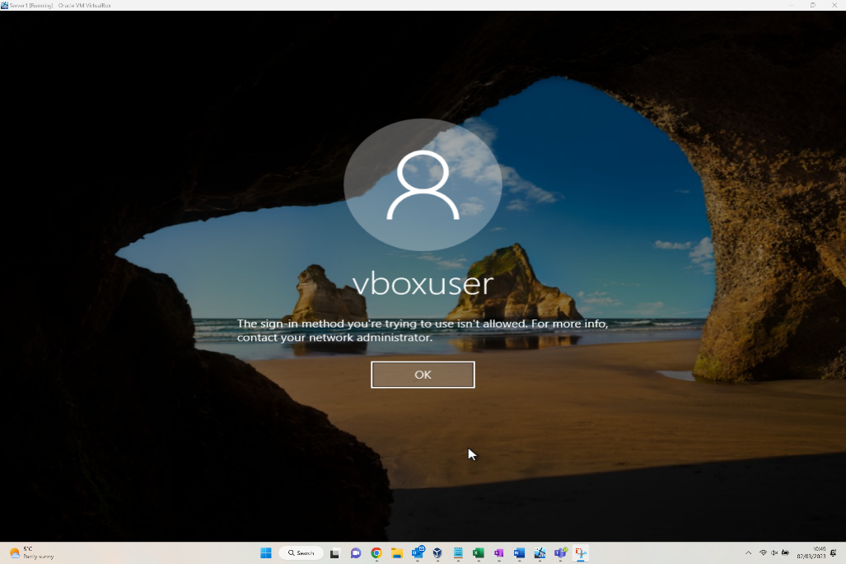
Having showcased a successful login in the previous figure, the above examples a user who now attempts to login using non-domain credentials. This shows that when a user attempts to do this, they are denied access to the domain as intended.

Task 2

2.1. Question i
Type 2 Hypervisors are better suited for an individual user to who wants to run multiple operating systems at once in a desktop environment such as an office, classroom, or home lab [4].
Generally considered easier to install and deploy than Type 1 and requiring less hardware [5], Type 2 Hypervisors provide the user with an opportunity to leverage the host machines operating system and resources to deploy a multi-client environment specific to the requirments of any scenario.
The presented scenario being in a desktop PC environment and requiring a client server model with multiple machines and operating systems. The utilisation of a Type 2 hypervisor is the most practical choice.
Type 1 in this scenario would be inpractical and unnecessary. Type 1 Hypervisors require direct access to hardware [6]. This requires the removal of the base operating system rendering the host machine useless for general day to day tasks.

Furthermore, the requirments of the task are not based around performance [5] or scalability [5] which are the Type 1 hypervisors key benefits.
Type 1 Hypervisors, however, are generally employed in data centres, server farms and enterprise environments with many servers, a good example being AWS [7]. These environments do have requirments such as high performance, resource management, optimization, security, and scalability making them ideal environments to deploy Type 1.

As demonstrated above the Type of hypervisor deployed depends on the requirments of your scenario and environment. Some of the common benefits and drawbacks to both types are:
Type 1:
Pros: | Cons:
- Better performance [5] | - Requires direct access to hardware.
- Scalable [5] | - Not suitable for all environments
- Excellent resource allocation and optimization [4] | - Setup requires more knowledge
- Higher level of security (No OS vulnerability) [5]

Type 2:
Pros: | Cons:
- Easy deployment [5] | - Affects performance of the host machine [4]
- Compatible with wide range of hardware [5] | - More points of failure. If you need to reboot host OS - VM also must reboot. [5]
- Suitable for Desktop PC environment [5] | - Not suitable for environments where performance is critical [4].
 | - Less secure (OS vulnerability)

2.2 Question ii
Dynamic Host Configuration Protocol commonly referred to as DHCP is a network management protocol [8] responsible for the automatic assigning of network parameters to connected hosts on a TCP/IP Network [8]. Parameters assigned by DHCP include Ip address, subnet mask, default gateway and domain name.

DHCP works in conjunction with a DHCP server utilising a client / server architecture [9].

First, A DHCP Server is pre-configured to allocate a set pool of IP Address which can be served out to hosts as they request them [10].

When a host joins the network and is configured to automatically obtain a network configuration the DHCP client software will send out a DISCOVER request utilising the broadcast function [10]. This will be sent to all hosts on the network including the DHCP server.
The DHCP Server on receiving the request will accept the discover request and respond with an OFFER. This offer will include the critical network configuration parameters [10].

The client on receiving the offer, will indicate to the server that the Ip address is suitable for use and that it REQUESTs the use of the Ip address.

Finally, the DHCP server will Acknowledge the client which completes the process. This is referred to as DORA [10].

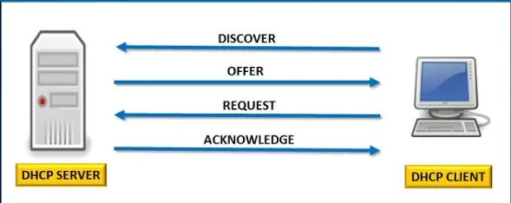
figure 1 – DHCP DORA Flow
DHCP when implemented on a network can remove the need for an administrator to perform any manual configuration [10] of hosts by allowing the DHCP server to automatically allocate and manage the network parameters.

Although not critical on smaller networks [11]. When scaling to larger network the use of DHCP is essential. Utilsing DHCP effectively allows for rapid deployment of network resources with minimal errors [9]. This is critical when designing and implementing a network and is why DHCP is generally deployed as an industry standard.

2.3 Question iii
Active directory’s main purpose is to provide a centralized platform that allows administrators to manage permissions and control access to network resources [12].
By utilising objects that are stored in a hierarchical and structured format Active Directory firstly provides a network with a level of logical structure [12].
Logical structure is critical when managing access and resources due to its ability to be scaled.
The logical structure can be defined as follows:
Forest:
Collection of trees which don’t share a namespace [13].
Trees:
Collection of domains that share a namespace [13].
Domains:
Collection of computers that share a common directory database [13].
Organizational Unit (OU):
Container object used to organize objects in domain [13]. An OU contains other objects such as user accounts, computers, or file shares. Each of these objects also attributes [13]. Attributes describe objects for example a user object may have a name attribute.
Utilising objects and attributes provide you with a consistent approach [14] to administration and this consistency makes it viable to scale almost infinitely.
Further to providing logical structure objects provide you with the ability to manipulate and control resources on mass. This is critical when managing large groups of users, network resources, permissions levels, files etc.
An example of this manipulation that is common is group policy. If you have a department or group of users with specific security complexity requirments. You can force these requirments on them by applying the desired policy to their pre-defined group which as we illustrated above would simply be an object.
Ultimately, Active Directories approach aims to provide an efficient, logical and all-encompassing platform to manage a network.

2.4 Question iv

Ping
Ping command is utilised via the command line to verify layer 3 connectivity to a host within a network by leveraging the ICMP echo request message. A message is sent, and replies are displayed with corresponding round-trip times [15]. Ping is the first and most used command line function utilised when troubleshooting connectivity [15]. Ping is employed on nearly every OS however some differences exist. Linux for example uses a continous ping [16] whereas windows only use 4 messages by default.

Server Manager / Server Management
Server manager is a UI management console for windows server which allows the user to deploy local and remote windows servers [17]. It provides logical prompts starting with basic server configuration such as installation type and server selection before moving onto adding specific features such as active directory, DNS etc [2].
Whereas windows use windows server and server manager Linux uses open-source server distributions such ubuntu server.
There are pros and cons to each. Windows is generally seen as more user friendly [18] due to its server manager and UI as described above. However, Linux is generally considered more secure [18], however lacking in being UI friendly with users interacting primarily with the CLI [18].

Virtual Box
Virtual box is a type 2 hypervisor tool leveraged for virtualising computing architecture allowing users to deploy hosts, servers with an extensive variety of operating systems and configurations [19].
Virtual box is used by all types of tech professionals such as IT admins, developers, testers, and cybersecurity for a wide array of purposes [20]. One such example could be the use of a virtual environment as a sandbox to test infected apps or files [21]. Alternatively, as demonstrated in the practical demonstration to configure a virtual network.

Virtual box is an open-source multi-platform tool lending to why it’s one of the most recognizable and widely used virtualization platforms [22].
Other virtualization platforms are also used such as VMWare [23], however they are not open-source and require licensing to use. Most platforms generally function the same providing access to the virtualization of architecture based on your desired configuration.

Conclusion
The following documentation provides a clear overview of the use of a type 2 hypervisor to achieve the goal of configuring a virtual network.
The practical demonstration clearly outlines the applicability of utilising VBox, windows server, and active directory to configure the scenario requirments. While also providing key insight to some of the necessary configuration steps required.
Demonstrating a clear understanding of how the technology is used and the practical capability to deploy it.
Furthermore, the additional research provides additional clarity to the technological aspects and terminology engaged with in the practical demonstration showing how necessary they are to achieve a succesful configuration and how they may be utilised depending on the scenario requirements.
To conclude, the applicability of the technology discussed is broad. All the technology can be employed individually or in conjunction with each other to achieve any number of given scenarios. As suggested by the research the main challenge is how and when to deploy the technology and understanding fully the constraints or benefits of it use.

Reflection on collaborative work
I thought the task was not very effective at encouraging a group approach. Ultimately, the use of step-by-step instructions was way too linear to induce any sort of necessary troubleshooting. The main topics of discussion were related to documentation as apposed to being technical in nature which although useful seems to miss the underlying learning objectives of the module.
I would of preferred a less structured scenario which would of allowed for creative input from each member of the team allowing them to draw on their specific knowledge to contribute.
This would have encouraged deeper engagement and established a necessity to work to everyone’s strengths.
I think ultimately this would have led to higher knowledge gained and satisfaction felt.

3. References
[1] VirtualBox – Manual - Available: https://www.virtualbox.org/manual/ch01.html [Accessed Feb 9, 2023].
[2] Microsoft. – Installing AD - Using Server Manager - Available: https://learn.microsoft.com/en-us/windows-server/identity/ad-ds/deploy/install-active-directory-domain-services--level-100 [Accessed Feb 9, 2023].
[3] Microsoft. – Joining a domain - - Available: https://learn.microsoft.com/en-us/windows-server/identity/ad-fs/deployment/join-a-computer-to-a-domain [Accessed Feb 9, 2023].
[4] IBM. – Hypervisors - Available: https://www.ibm.com/topics/hypervisors [Accessed March 9, 2023].
[5] Matthew Portnoy – Virtualization Essentials - [Accessed March 9, 2023].
[6] Wikipedia. – Hypervisors - Available: Hypervisor - Wikipedia [Accessed March 9, 2023].
[7] VMWare. – What is cloud Hypervisor – Available - What is a Cloud Hypervisor? | VMware Glossary [Accessed March 9, 2023].
[8] Butterfield, & Ngondi, G. E. (2016). A dictionary of computer science (A. (Andrew) Butterfield & G. E. Ngondi, Eds.; Seventh edition.). Oxford – [Accessed March 9, 2023].
[9] Microsoft. – DHCP - Available: https://learn.microsoft.com/en-us/windows-server/networking/technologies/dhcp/dhcp-top [Accessed March 9, 2023].
[10] Huawei Technologies Co. (n.d.). Data Communications and Network Technologies (1st ed. 2023.). Springer Nature. Available: https://doi.org/10.1007/978-981-19-3029-4 – [Accessed March 9, 2023].
[11] Wikipedia. – DHCP - Available: https://en.wikipedia.org/wiki/Dynamic_Host_Configuration_Protocol [Accessed March 9, 2023].
[12] Microsoft – Active Directory Overview – Available: https://learn.microsoft.com/en-us/windows-server/identity/ad-ds/get-started/virtual-dc/active-directory-domain-services-overview - [Accessed March 9, 2023].
[13] Microsoft – Active Directory Logical Model – Available: https://learn.microsoft.com/en-us/windows-server/identity/ad-ds/plan/understanding-the-active-directory-logical-model [Accessed March 9, 2023].
[14] UTWSD – Lecture 3 Directory Services – Available – https://moodle.uwtsd.ac.uk/mod/resource/view.php?id=486658 [Accessed March 9, 2023].
[15] Microsoft. – Ping - Available: ping | Microsoft Learn [Accessed March 9, 2023].
[16] Linux. – Ping - Available: ping (8) - Linux man page (die.net) [Accessed March 9, 2023].
[17] Microsoft. – Server Manager - Available: https://learn.microsoft.com/en-us/windows-server/administration/server-manager/server-manager [Accessed March 9, 2023].
[18] Phoenix Nap. – Linux vs Microsoft - Available: https://phoenixnap.com/blog/linux-vs-microsoft-windows-server [Accessed March 9, 2023].
[19] VirtualBox – VB Overview – Available: https://www.oracle.com/assets/oracle-vm-virtualbox-overview-2981353.pdf [Accessed March 9, 2023].
[20] SpiceWorks – What is Virtual Box – Available: https://www.spiceworks.com/tech/cloud/articles/what-is-virtualbox/ - [Accessed March 9, 2023].
[21] GeeksforGeeks – VB for Malware Analysis - Available - https://www.geeksforgeeks.org/virtual-machine-for-malware-analysis/ - [Accessed March 9, 2023].
[22] Wikipedia – VirtualBox – Available - https://en.wikipedia.org/wiki/VirtualBox - [Accessed March 9, 2023].
[23] VMWare – VMware Player – Available - https://www.vmware.com/uk/products/workstation-player.html - [Accessed March 9, 2023].

3. Figure References
Fig 1 - IPwithease – Understanding DORA – Available - https://ipwithease.com/understanding-dora-process-in-dhcp/ - [Accessed March 9, 2023].

