problem Solving and Decision making
BMSW4004
Sheanne Ojea-Simpson (2133151)
Lecturer: Aparna Venkatesan.
University of Wales Saint Trinity David.
Contents

1. Introduction.
2. The problem (Scope and Impact).
3. The Decision-Making Process.
3.1 Fishbone Analysis.
4. Plan for Solution
4.1 PESTLE Analysis and Implementing Solution.
4.2 Communication plan to stakeholders.
5. Conclusion.
6. Reference.
1. Introduction

Common complex work problems occur often in all types of workplace industry’s and there’s a growing number of problems that hinder the development of an organisation. A common workplace problem can be in the form of discrimination, lack of training, performance issues or bullying and harassment.

My report will be highlighting a common complex work-based situation and its components and how it impacts individuals in the workplace. The problem I’ll be applying is work based discrimination and/or harassment that causes work related issues , I’ll be discussing the negative impact discrimination can cause and identify why it’s a problem using the fishbone analysis and begin to propose solutions using a PESTLE analysis decision making technique to identify an appropriate resolution to the issue, with the assistance of all components my conclusion will identify a plan that can be presented to the stakeholders of the organisation to ensure the situation doesn’t occur in the future.

2. The Problem (Scope and Impact)

Miss S, a temporary African Caribbean female employee is employed by a large luxurious retail department store to work a part time Christmas season contract on a concessions table, she is employed straight away as she fits the job description criteria and states she has open flexibility on her job application. She is contracted to work 40 hours per week at £9.50 per hour. She starts her first shift with another new staff who is a male Caucasian and are both given a brief training day and sent to work on the shop floor. During her first week, she works extremely hard, hitting targets and assisting customers with their shopping experience. Unfortunately, due to the COVID19 pandemic all stores are ordered to shut down to stop the risk and spread of the virus. The female employee is informed by her store manager she would unfortunately have to be made redundant, as the store can no longer afford to keep temporary staff, she agrees and finishes her shift early. A month goes by, and the female employee realises she has only been paid for 1 week of her shift and that the male staff member was kept on working shifts as contracted for the remainder of the fixed term.

She tries for several weeks to contact the store manager to discuss her concerns as she believes she was made redundant on unfair basis and a form of non-verbal discrimination against her gender and race was at play, the store manager continues to ignore her request for a conversation until the employer raises her concern to HR and the CEO in a formal email, a formal meeting was arranged to discuss the situation and a resolution.

The impact of this situation not only would cause the employee in question to feel she was used but also ranging in feelings of her feeling in shock, worthlessness and decrease her confidence (Redundancy factsheet - the Provincial Grand Lodge of Hampshire & isle, 2018) in applying for jobs in similar role. The main cause for concern and impact was the unlawful discrimination that was placed against her. Discrimination is the treating someone different from another person based on status or skills (Introduction to discrimination, 2021). On the case of Miss S, she was discriminated on the bases of her Sex, Colour and Race as the Caucasian male employer was not made redundant and still was allowed to remain an employer of the store, it is clear there was no clear objective criteria as to why she was the selected employee for redundancy. The Race Relations Act 1976 (as amended) banned discrimination against race or any causable action pertaining to that notion of treatment being involved in making decisions on how to treat individuals for example employing staff or in this case reasons for making staff members redundant.

3. The Decision-Making Process.
As mentioned above the main cause of impact is the act of unlawful discrimination, which is against the law, the only form of decision process to be brought forward to resolve the situation is Miss S bring forward a claim on the basis on unfair dismissal and discrimination, which would require a tribunal occurring which would be an example of rational decision-making process being implemented as it favours objectivity from both sides based on facts and evidence. The employers could argue there was a genuine need for redundancy on the bases of work was undertaken because the need of Miss S was no longer needed due to being business being shut and the work could be completed by the other employee. The rational decision-making process works as it’s been established and used on many occasions however it may cause possible disadvantages due to lack of resources available to every employee that has been given an unfair judgement.

A proposal that may work in the case of Miss S and Employer is a Creative Decision making in which could occur in the form of a meeting between Miss S, The Concessions Store Manager, The HR manager, and the CEO. Creative decision making enables a less structured formal approach and allows ideas and opinions to create an alternative solution to the problem which allows innovation to be used.

During the meeting all four individuals will allow attributed listening to occur, the manager can explain why the need for redundancy was exceptional and not on the basis of unfair judgement against Miss S and Miss S can explain why she felt her dismissal was based on discrimination against the factors that she was a black female against the other employee who had the complete opposite characteristics that was able to keep their job. Once all parties have listened, the senior staff (CEO and HR Manager) can assist both parties in brainstorming ideas to find a solution to the idea. This allows everyone to build on each other’s ideas, combine and improve on existing ideas. The brainstorming process aims to explore the challenge using objective finding, fact finding and problem finding.

Exploring the Challenge:

The aim of the exploring the challenge during the meeting is to evaluate a range of solutions to our redundancy case and the most appropriate option to a solution. In this situation a goal or wish must be stated by Miss S to be able to find a Cause and Effect, before doing this data must be gathered and assessed for example asking questions Who, What, When and Why? These questions will enable everyone to understand and clarify the problem at hand.

In the meeting a decision-making technique that could effectively evaluate exploring the challenge is a Fishbone analysis.

3.1 Fishbone Analysis
According to Kaoru Ishikawa a fishbone analysis also known as Ishikawa diagram was used to highlight the cause-and-effect sources of a problem (kabanize, 2023). The tool has become one of the best in quality management processing as individuals are able to identify problems and analyse problem, which will assist in finding agreed solutions.

The analysis tool enables the brainstorming process to generate ideas which the second part of the creative problem-solving process, the team can then find a solution that everyone can agree on therefore a fishbone analysis is only affective if there is a defined cause and affect (goal) established. In the case of Miss S, her cause was unfair grounds for redundancy and the effect (goal) is financial compensation for dismissal and emotional damages caused. A fishbone analysis doesn’t only address the cause and affect but also enables parties to accept the findings and realise who may have been responsible for the issue occurring in the first place and what can be done to prevent the situation arising in the future e.g., better resources and policies.

The fishbone diagram has highlighted several factors that resulted to the redundancy occurring, we can see that there wasn’t just one plausible cause but several causes that contributed. I’ll be discussing two cause and effects from the fishbone analysis. We will begin with people; the lack of customers coming into the store would have resulted in the reduction for a retail assistance being present and a reduction in customer purchases result in sales which would mean keeping Miss S would lead to a reduction in her pay as the company would not have any money to pay for her shifts. This would have caused another issue that she may have complained about because a lack of pay is illegal which was why redundancy would be the best cause of action in this case. The second factor will discuss is Process; we can see from the fishbone analysis there was two factors that contributed to Miss S’s redundancy, the first one being a lack of a fair selection process being made aware to her, we can see from looking at this factor alone another factor would have had to contribute to this issue, for example the environment (The covid 19 pandemic) made it impossible for the managers to take the time to implement a justified and fair selection process as the decision was very last minute and short notice. The second factor was the quick decision on the redundancy choices, in this case why was Miss S made redundant but not the other employee that was recruited the same time as her? This itself would need another brainstorming tool to find justified factors as to why for example Miss S’s Gender or her lack of experience etc.

The brainstorming tool enables the questions of Who, what, When Why and Where which are the five W’s. English rhetorician Thomas Wilson (1524-1581) established the question method to discuss the seven circumstances of rhetorical questioning (Nordquist, 2020), with asking these questions were able to create a plan for a solution to the cause-and-effect discussions that have occurred.

4. Plan for Solution.

Planning a solution is the next step after the brainstorming process is completed, it will involve understanding the three types of control and implementing one to manage and solve the problem. The first is the input stage, which solves problems before they occur, the second is the conversation stage which is manging problems as they occur and the last is the output stage which manages a problem are they have risen. In the case of Miss S, the managers during the meeting will use feedback control (the output stage) to plan for a solution and ensure the solution is agreed by both parties.

The output stage will involve the organisational change process. An organisational change is the actions a business approaches to adjust or implement components to the organisation it can either be adaptive or transformational changes. Adaptive change are small changes to an organisation for example in the dismissal of Miss S leaving the concession store which is the type of change that will occur for Miss S and Transformational changes are larger changes to the organisation for example in Miss S Case changing the whole management team of the store and implementing new policies. To implement a solution, we will be using the four elements of effective plans for change, which are:

1. Agree on strategic goals (or solution in this case).
2. Key Performance indicators to measure the solution is working or has worked.
3. Project the solution to the stakeholders and team.
4. Project scope (what are the detailed and outlined steps).

Following these four steps will ensure the management team implement the best cause of action and monitoring the results and progress effectively. Using the fishbone analysis, we can produce a PESTLE analysis to ensure Miss S and the senior staff of the store to decide on the best action to problem and if its viable. A PESTLE analysis is a strategy tool that can analyse a business’s political, economic, social, technological, legal, and environmental elements to make the best decision (optimus, 2023).

4.1 PESTLE Analysis and Implementing Solution.

The pestle analysis below will be highlighting the factors that will affect the decision to offer Miss S full months’ pay of compensation for her complaint to an unfair redundancy and immediate dismissal due to the Covid 19 pandemic situation, with using this analysis tool we will be able to identify if the team will be able to offer this solution and monitor if it will the best cause of action.

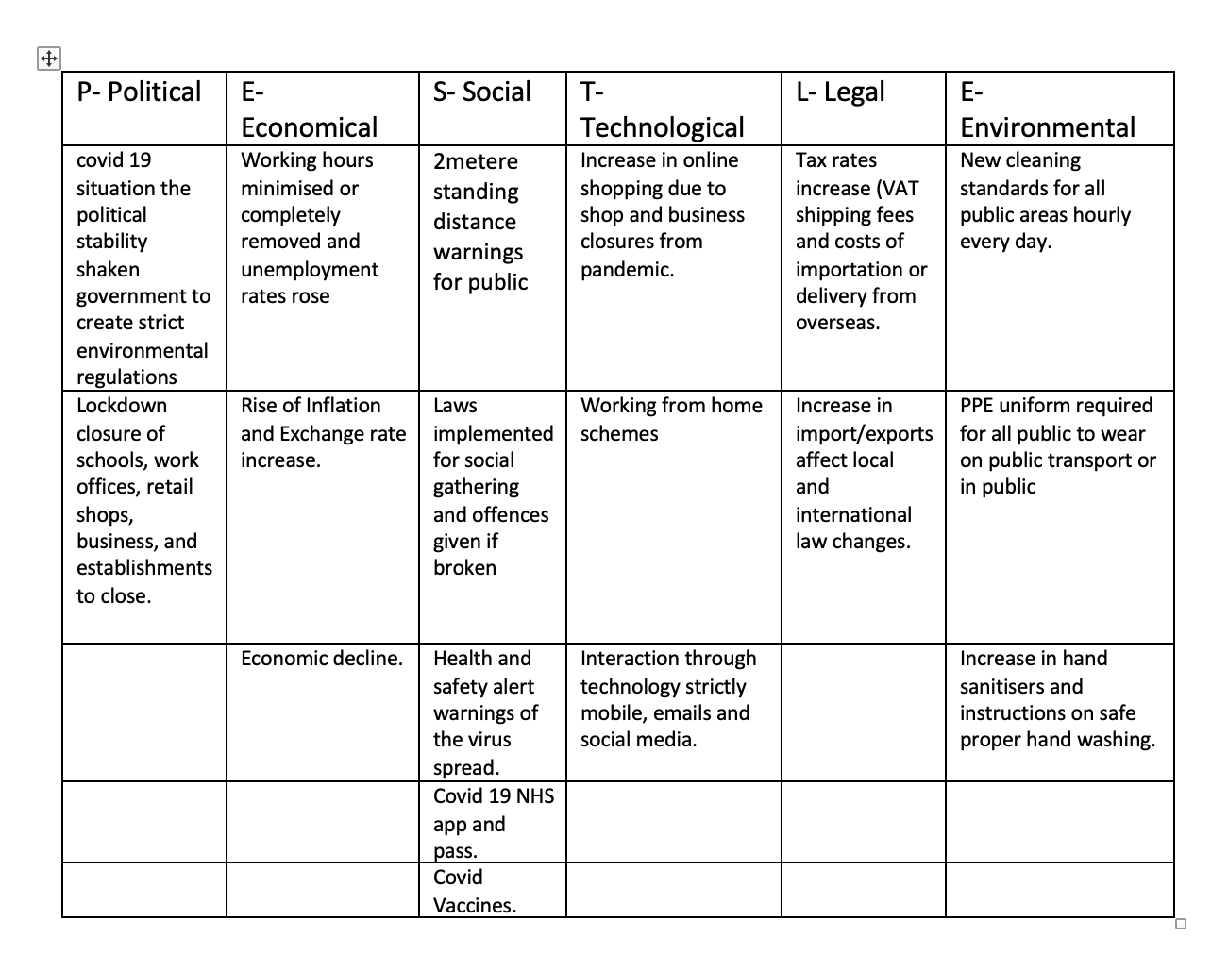
With the PESTLE analysis conducted the team can conclude with the solution as mentioned above and analyse whether it’s the best cause of action to offer Miss S. They agreed to offer her a month’s worth of pay for the immediate dismissal and redundancy. Implementing the plan will be based solely on the findings from the SWOT analysis and the methods on how it will occur. The team will aim to pay Miss S the compensation fee by the end of the financial calendar month.

Implementing Solution.

Once the solution has been established the team needs to apply the solution to their situation and find a tool to measure whether the solution has been effective in resolving the issue that was at hand. The team must ensure that the ex-employer is satisfied with the resolution without their being a risk for another complaint being brought forward with a monitoring technique.

The monitoring technique that will be the most effective in implementing the solution and monitoring the outcome is a Gantt chart. The Gantt chart is a popular project management tool used to show a task against a timeframe. The first Gantt chart was created by Karol Adamiecki in the mid 1980’s to track project schedules. The team will be able to keep track of the solution and how far the solution has progressed (Duke, 2023).

The information in the Gantt Chart is a perfect way to communicate the problem, cause and effect and solution from beginning to end to everyone in the team including the stakeholders. The chart will also be able to spot delays and issues that may arise during the project so they can be addressed in advance.

4.2 Communicate plan to stakeholders.

Communicating the plan to stakeholders will involve bringing all techniques mentioned above to draw a continuous plan for the company to ensure they have a strategic policy for effective problem solving in the business. The communication process can be produced in the form of a presentation, with transcripts and documentations to hand in the form of an appraisal, with the opportunity for conversations, questions, and ideas to discussed about implementing the problem and solution to the business organisational change process.

Stakeholders are individuals or a group of individuals that are impacted by the outcome of a business project, they have an interest in the success of the business project and can sometimes be outside the organisational structure (Landau, P. 2023). In many cases, stakeholders invest finances into the business.

5. Conclusion

To conclude, problem solving is a key tool and skill all businesses should be aware of when and how to utilise the components, as common workplaces issues are inevitable and occur daily, if businesses and managers are aware of how to solve problems before they arise and while they are occurring, we can be reassured we are creating pleasant work place environments for the future.

6. References

1. Redundancy factsheet - the Provincial Grand Lodge of Hampshire & isle ... (2018) Redundancy Factsheet. Masonic Charitable Foundation. Available at: https://www.hiowmasons.org/wp-content/uploads/2021/05/Redundancy-factsheet.pdf (Accessed: March 29, 2023).
2. Introduction to discrimination (2021) nidirect. Available at: https://www.nidirect.gov.uk/articles/introduction-discrimination (Accessed: March 29, 2023).
3. Race relations act 1965 - UK parliament (n.d.). Available at: https://www.parliament.uk/about/living-heritage/transformingsociety/private-lives/relationships/collections1/race-relations-act-1965/race-relations-act-1965/ (Accessed: March 29, 2023).
4. Team, E. (2021) What are fair reasons for redundancy? Davidson Morris. Available at: https://www.davidsonmorris.com/reasons-for-redundancy/ (Accessed: March 29, 2023).
5. Fishbone diagram (n.d.) ASQ. Available at: https://asq.org/quality-resources/fishbone (Accessed: March 29, 2023).
6. What is a fishbone diagram (2023) Kanban software for Agile Project Management? Available at: https://kanbanize.com/lean-management/lean-manufacturing/root-cause-analysis/fishbone-diagram (Accessed: April 16,2023)
7. Nordquist, R. (2020) The journalists' questions: 5 WS and an H, ThoughtCo. ThoughtCo. Available at: https://www.thoughtco.com/journalists-questions-5-ws-and-h-1691205 (Accessed: April 16, 2023).
8. Optimus, R. (2023) Using SWOT and pestle analysis together for crafting strategy, Research Optimus Blog RSS. Available at: https://www.researchoptimus.com/blog/using-swot-and-pestle-analysis-together-for-crafting-strategy/ (Accessed: April 17, 2023).
9. Kelsey, K. (2020) 5 critical steps in the Change Management Process: HBS Online, Business Insights Blog. Harvard Business School Online. Available at: https://online.hbs.edu/blog/post/change-management-process (Accessed: April 17, 2023).
10. Strategic Planning for Business Growth (no date) PESTLE analysis example. Available at: https://www.nibusinessinfo.co.uk/content/pestle-analysis-example (Accessed: April 17, 2023).
11. Millard, V. (2020) Using pestle analysis to develop new products in the manufacturing industry, Elite Centre for Manufacturing Skills (ECMS). Available at: https://www.theecms.co.uk/using-pestle-analysis-to-develop-new-products-in-the-manufacturing-industry/ (Accessed: April 23, 2023).
12. Duke, R. (2023) what is a Gantt chart? Gantt chart software, information, and History., Gantt.com. Available at: https://www.gantt.com/ (Accessed: April 24, 2023).
13. What is a Gantt chart? A step-by-step guide (no date) TeamGantt. Available at: https://www.teamgantt.com/what-is-a-gantt-chart (Accessed: April 24, 2023).
14. Landau, P. (2023) What is a stakeholder? definitions, types & examples, ProjectManager. ProjectManager. Available at: https://www.projectmanager.com/blog/what-is-a-stakeholder (Accessed: April 24, 2023).

