Learning in the Digital Era
Student Name: Cosmin Lautaru
ID:2021592

Date of submission: 10.03.2023

- PREPARING FOR HIGHER EDUCATION
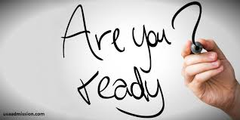
Higher education is one of the most significant education levels since it equips one with the knowledge and skills required to sharpen careers. Therefore, preparation for higher education is crucial in realizing one’s career goals. (Prepared for higher education? Staff and student perceptions of academic literacy dimensions across disciplines). Preparing for higher education involves having enough knowledge when selecting the college and course of choice. It is a state of mind since it is an attained education level.
The best preparation for higher education begins with discovering the importance and need for higher education. This knowledge steers focus and hard work. Positive educational reviews on the school and course of choice equip one with determination for excellence (Dalton et al., 2018, p.156). Discovering what is achievable via higher education can be done by viewing the success stories of a tertiary institution, their academic developments and inventions, and the impactful career persons that have been nurtured and modeled by one’s choice course.

One of the most important preparations is mindset shaping. Developing a college and university-oriented mindset begins with visualization. One must see themselves on campus, attending lecture rooms, creating study plans, and associating with students who pursue excellence (Giersch and Jason, 2018, p.120). These self-affirming pictures help in shaping one's goals. Another way to develop an academic-oriented mindset is to seek advice and counsel from teachers and career persons (Gaertner et al., 2014, p.154). It helps one identify role models and mentors who play a significant role in ensuring we maintain our focus.


Finally, time and financial management are also very crucial preparation needed. A strong focus shapes how we spend our time and money. Time and money management practices can start before joining campus (Edmunds et al., 2017, p.120). One can begin developing this discipline in their daily routines and activities. Financial preparation does not only involve paying school fees on time but also involves spending every coin constructively.
- MIND MAP
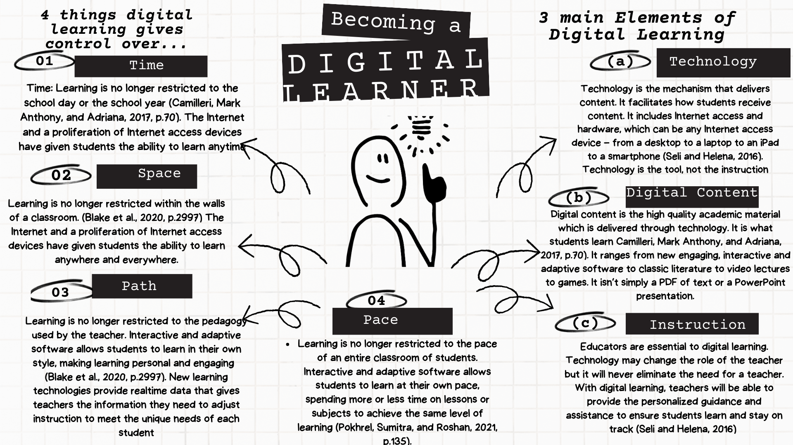

- PRESENTATION IS ATTACHED ON THE APPENDIX
- REFLECTIVE WRITING
WHAT?
I have always wanted to attend university and do my career course. My experience was so exciting and fulfilling. One of the most memorable moments was the introduction to the e-learning experience; this was my first time interacting with the virtual learning environment. After the introduction, we were given our first online assignment was to be uploaded through the e-learning portal. At first, it was challenging since the portal only accepted pdf files, while mine was a word document. Thanks to my online instructor, who came to my rescue. One exciting thing was getting the assessed assignment within two hours.
SO WHAT?
The online learning environment made me feel in control of my studies. I could set my own pace and plan my timetable. I accessed more learning materials in the comfort of my room. Since then, learning has been so enjoyable. Having interacted more with my career through the virtual space, I feel more responsible for my studies (Martin, Florence, and Doris, 2018, p.215). I appreciate my teachers and instructors so much for the time-to-time counseling, especially on punctuality, since, at times, I would submit my assignments past the deadline. I am passionate about my career; I am self-managed and self-managed. I have developed a desire for research through online space. Learning in general and specifically virtual learning requires self-driven determination and discipline.

NOW WHAT?
Therefore, online learning is the best learning environment for a successful student. My classmates and I today have learned to utilize virtual learning for group discussions and project development (Raspopovic et al., 2017). This reflection has also opened my eyes to more opportunities I can get through online learning. This reflection made me realize I need to engage my teachers and instructors more. I have also seen the need to submit my research in my e-portal library for assessment by my instructors. One of the areas I still need to improve is my research skills. I get overwhelmed with so much online information that I don't know what to pick and what to leave. With consultation from my teachers, I propose to improve on this.

References
Blake, H., Bermingham, F., Johnson, G. and Tabner, A., 2020. Mitigating the psychological impact of COVID-19 on healthcare workers: a digital learning package. International journal of environmental research and public health, 17(9), p.2997.
Camilleri, M.A. and Camilleri, A.C., 2017. Digital learning resources and ubiquitous technologies in education. Technology, Knowledge and Learning, 22, pp.65-82.
Černevičiūtė, J. and Strazdas, R., 2018. Teamwork management in Creative industries: factors influencing productivity. Entrepreneurship and sustainability issues, 6(2), pp.503-516.
Corbacho, A.M., Minini, L., Pereyra, M., González-Fernández, A.E., Echániz, R., Repetto, L., Cruz, P., Fernández-Damonte, V., Lorieto, A. and Basile, M., 2021. Interdisciplinary higher education with a focus on academic motivation and teamwork diversity. International Journal of Educational Research Open, 2, p.100062.
Dalton, L.C., Hajrasouliha, A.H. and Riggs, W.W., 2018. State of the art in planning for college and university campuses: site planning and beyond. Journal of the American Planning Association, 84(2), pp.145-161.
Designed for higher education? Staff and student perceptions of academic literacy dimensions across disciplines (no date). Available at: https://www.tandfonline.com/doi/full/10.1080/13538322.2021.1830534.
Edmunds, J.A., Arshavsky, N., Lewis, K., Thrift, B., Unlu, F. and Furey, J., 2017. Preparing students for college: Lessons learned from the early college. NASSP Bulletin, 101(2), pp.117-141.
Gaertner, M.N., Kim, J., DesJardins, S.L. and McClarty, K.L., 2014. Preparing students for college and careers: The causal role of algebra II. Research in Higher Education, 55, pp.143-165.
Giersch, J., 2018. Academic tracking, high-stakes tests, and preparing students for college: How inequality persists within schools. Educational Policy, 32(7), pp.907-935.
Loughry, M.L., Ohland, M.W. and Woehr, D.J., 2014. Assessing teamwork skills for assurance of learning using CATME team tools. Journal of Marketing Education, 36(1), pp.5-19.
Martin, F. and Bolliger, D.U., 2018. Engagement matters: Student perceptions on the importance of engagement strategies in the online learning environment. Online learning, 22(1), pp.205-222.
Pokhrel, S. and Chhetri, R., 2021. A literature review on impact of COVID-19 pandemic on teaching and learning. Higher education for the future, 8(1), pp.133-141.
Raspopovic, M., Cvetanovic, S., Medan, I. and Ljubojevic, D., 2017. The effects of integrating social learning environment with online learning. The International Review of Research in Open and Distributed Learning, 18(1).
Seli, H., 2016. Motivation and learning strategies for college success: A focus on self-regulated learning. Routledge.

TASK 2
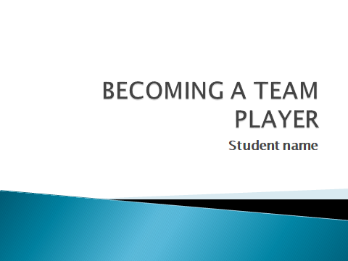
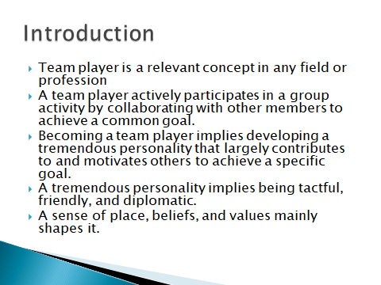

Team player is a relevant concept in any field or profession. A team player actively participates in a group activity by collaborating with other members to achieve a common goal. Becoming a team player implies developing a tremendous personality that largely contributes to and motivates others to achieve a specific goal. A tremendous personality implies being tactful, friendly, and diplomatic. A sense of place, beliefs, and values mainly shapes it.
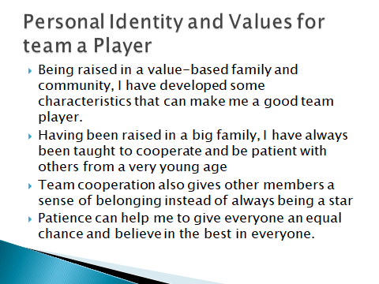
Being raised in a value-based family and community, I have developed some characteristics that can make me a good team player. I have learned and developed values such as patience and teamwork. Having been raised in a big family, I have always been taught to cooperate and be patient with others from a very young age. These qualities make one want to see the best in everyone. Team cooperation also gives other members a sense of belonging instead of always being a star (Loughry et al., 2014, p.13). Patience can help me to give everyone an equal chance and believe in the best in everyone.
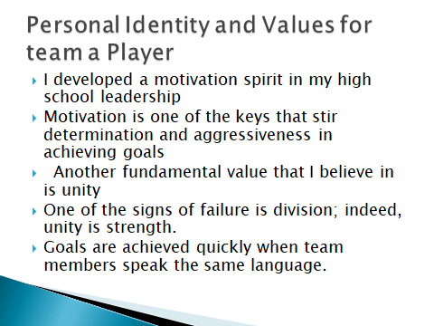
I developed a motivation spirit in my high school leadership; this is very crucial to becoming a good team leader. Motivation is one of the keys that stir determination and aggressiveness in achieving goals (Corbacho, 2021). Another fundamental value that I believe in is unity. Every team player knows that the success of any team is highly dependent on the unity of members. One of the signs of failure is division; indeed, unity is strength. Goals are achieved quickly when team members speak the same language.
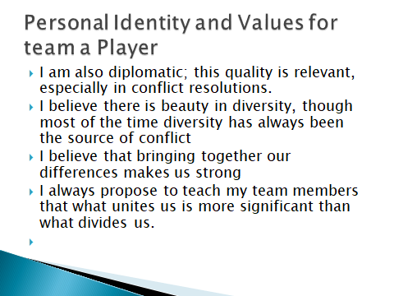

I am also diplomatic; this quality is relevant, especially in conflict resolutions. I believe there is beauty in diversity, though most of the time diversity has always been the source of conflict (Černevičiūtė, Jūratė, and Rolandas, 2018, p.512). I believe that bringing together our differences makes us strong; therefore, I always propose to teach my team members that what unites us is more significant than what divides us.


