Student name: Iulian Vasile Purice
Sudent id number: 1919243
Lecturer: Dr Olusoyi Richard Ashaye

Programme: BA Business Management
Module: Managing People
Module code: LCBB5004
Assessment 1
Individual presentation

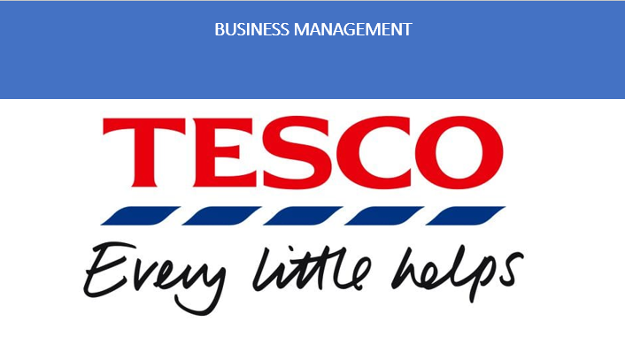

Table of Contents

1.Introduction……………………………………………………………………………2
2.Overview of the company……………………………………………………………3
3.Organizational objectives regarding planning for resource………………………5
4.Evolution of planning process based on HR activities in Tesco…………………6
5.Organizational objectives regarding recruitment for resource…………………...10
6.Evolution of recruitment process based on HR activities in Tesco……………...11
7.Organizational objectives regarding selection for resource………………………15
8.Evolution of selection process based on HR activities in Tesco………………...16
9.Conclusion…………………………………………………………………………….18
10.Reference list………………………………………………………………………..19

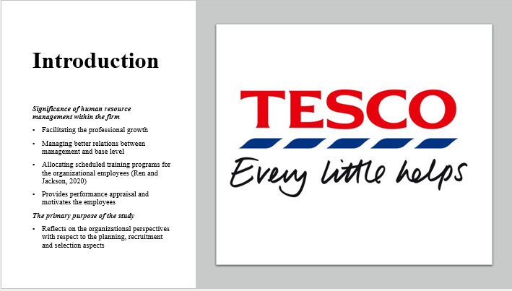

Significance of human resource management within the firm
- Facilitating the professional growth
- Managing better relations between management and base level
- Allocating scheduled training programs for the organizational employees (Ren and Jackson, 2020)
- Provides performance appraisal and motivates the employees
The primary purpose of the study
Reflects on the organizational perspectives with respect to the planning, recruitment and selection aspects
Human resource activities are responsible for playing a significant role within the organizational context. In addition, they are processing various organizational functions including resourcing, recruitment, training, selection, implementation of strategies, employee performance management and so on.

Overview of the company

- British grocery and general merchandise retailer
- Most valuable brand in the UK
- Having 25% of the market share (Statista, 2021)
- brand value of around 7.68 billion GBP
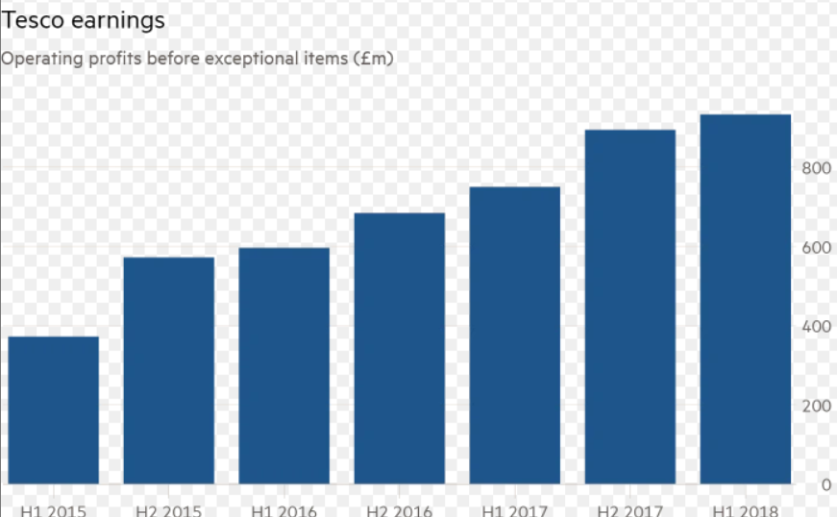
Figure: Tesco’s growth over the years
Source: (Statista, 2021)
In the year 2020-2021, the annual revenue of Tesco is 53 billion British pounds respectively. In the UK, Tesco is one of the leading grocery retailers by having over 25% of the market share. Besides this, it has been noteworthy that the chosen company is one of the UK’s big four giants, counted with other big retailers including Sainsbury, ASDA, Morrison’s.

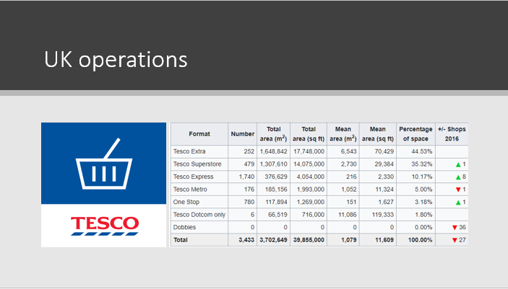

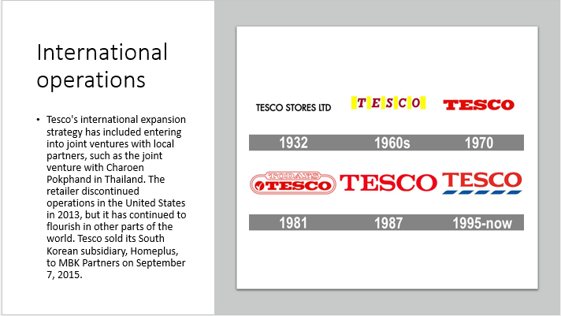

Tesco has extended its business outside of the United Kingdom to include 11 more nations across the globe. Although the firm discontinued operations in the United States in 2013, it has continued to flourish in other parts of the world as of 2018. To meet the requirement of being sensitive to local expectations in other countries, Tesco's international expansion strategy has included entering into joint ventures with local partners, such as the joint venture with Charoen Pokphand in Thailand to form Tesco Lotus, as well as hiring a significant number of people from the local community to hold senior management positions. Additionally, as part of its overall strategy, it undertakes modest purchases. For example, during the 2005/2006 fiscal year, it made acquisitions in South Korea, one in Dubai, United Arab Emirates, one in Poland, and one in Japan. Tesco sold its South Korean subsidiary, Homeplus, to MBK Partners on September 7, 2015, in a transaction in which the retailer collaborated with a Canadian pension fund and Singapore-based Temasek Holdings.

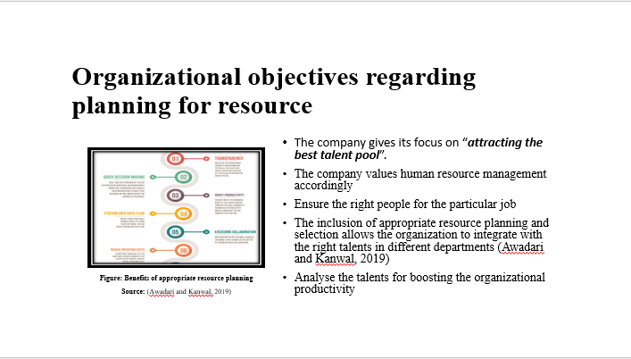
The company gives its focus on “attracting the best talent pool”
- The company values human resource management accordingly
- Ensure the right people for the particular job
- The inclusion of appropriate resource planning and selection allows the organization to integrate with the right talents in different departments (Awadari and Kanwal, 2019)
- Analyse the talents for boosting the organizational productivity
It has been noted that the inclusion of the right talent within the organizational context of Tesco is responsible for increasing productivity. Hence, the human resource management of Tesco has given a core focus on the implementation of the right talents through resource planning, recruitment and selection respectively (Awadari and Kanwal, 2019). It helps them to achieve the business objectives accordingly.
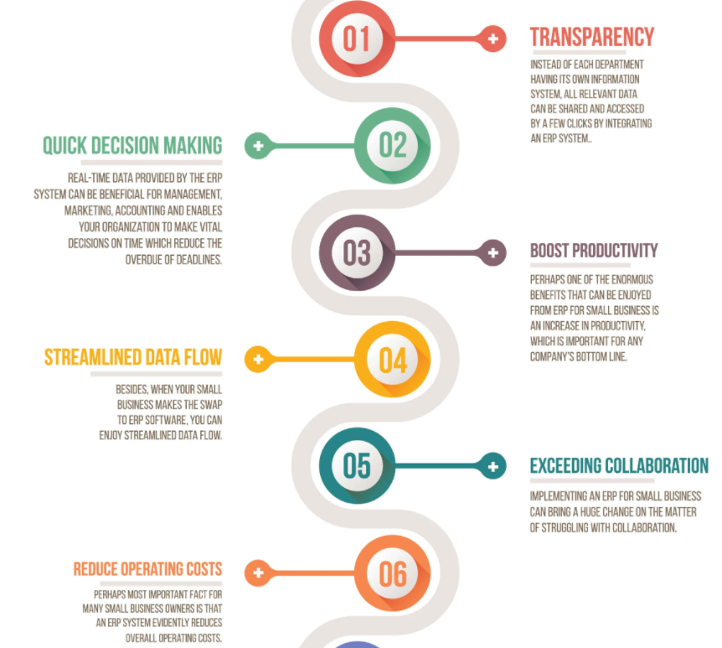
Figure: Benefits of appropriate resource planning
Source: (Awadari and Kanwal, 2019)

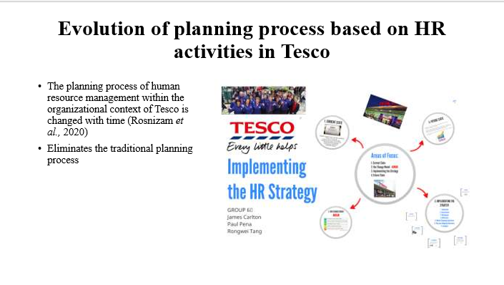
- The planning process of human resource management within the organizational context of Tesco is changed with time (Rosnizam et al., 2020)
- Eliminates the traditional planning process
It should be noteworthy that the current workforce planning regarding the HR process is responsible for replacing the traditional planning accordingly. This is considered as one of the effective aspects as it allows the chosen organization to analyse the current performance and /or state across the overall workplace.
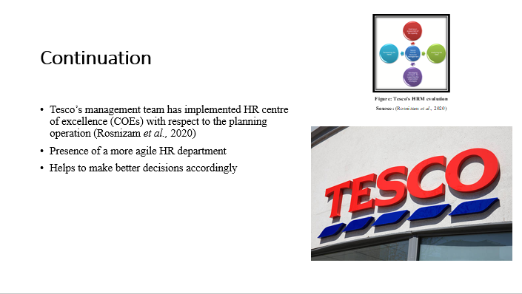
- Tesco’s management team has implemented HR centre of excellence (COEs) with respect to the planning operation (Rosnizam et al., 2020)
- Presence of a more agile HR department
- Helps to make better decisions accordingly
It should be noteworthy that Tesco Plc has implemented the HR centre of excellence (COEs) within its organizational context. This help the company with the inclusion of innovation and collaboration between departments. Moreover, this type of approach helps the organization to boost knowledge development, especially for the HRM practices accordingly.
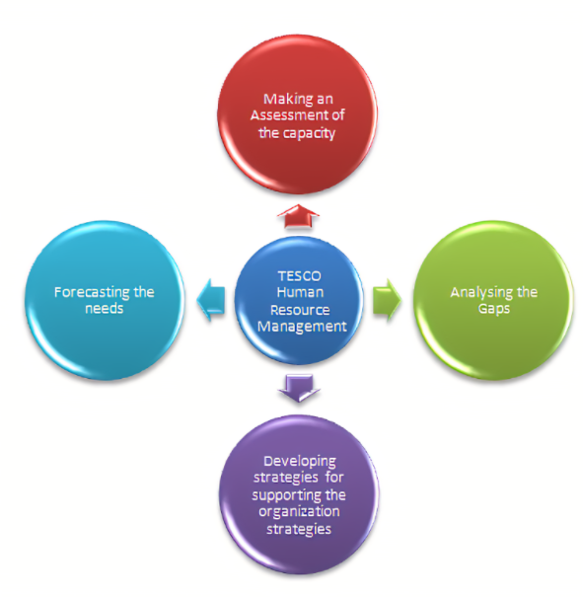
Figure: Tesco's HRM evolution
Source: (Rosnizam et al., 2020)

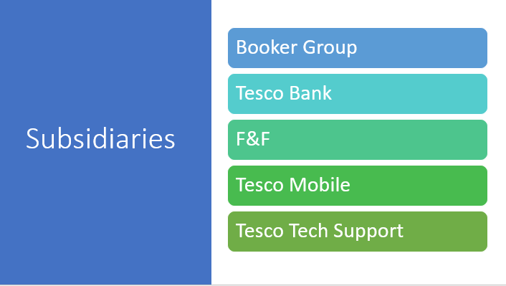
The Booker Group is a private equity firm that invests in startups and established businesses.The Booker Group is the main article.During the month of March 2018, Tesco finalized its purchase of food wholesaler Booker. The Budgens, Londis, Euro Shopper, and Premier Stores brands, all of which are operated under franchise agreements, are also owned by Booker.

Tesco Bank is a British multinational corporation that operates as a financial services provider.Tesco Bank is the main article.Tesco Bank, which was formerly a 50:50 joint venture with The Royal Bank of Scotland, provides financial services in the United Kingdom. Credit cards, loans, mortgages, savings accounts, and a variety of insurance products, including auto, home, life, and travel insurance, are among the options available. Tesco's leaflets are distributed in its stores, and the company's website promotes them. The group generated profits of £130 million for the 52 weeks ending February 24, 2007, with Tesco accounting for £66 million of the total. In addition to providing potential for expansion outside of the retail sector, this shift towards the financial industry broadened the Tesco brand's appeal and provided diversification. Tesco stated on July 28th, 2008, that it will purchase the Royal Bank of Scotland's 50% share in the firm for a total of £950 million (£950 million).F&FFlorence & Fred first appeared in Tesco's UK and Ireland shops in 2001 under the name Florence & Fred. In 2010, the brand began to develop standalone locations, with its first location opening in London the following year. When it first opened its doors in shops and online in the early to mid-2010s, it was a small operation.In the United Kingdom, F&F maintained its own website until 2016, when it was absorbed into Tesco Direct, which itself was dissolved in August 2018. Following this, F&F did not have an internet presence in the United Kingdom until it collaborated with Next PLC a year later. Tesco debuted a scaled-down F&F on Tesco.com shortly after completing its acquisition of Next.

Tesco Mobile is a mobile application developed by Tesco. More information is available at Tesco Mobile.Throughout the United Kingdom, Ireland, Slovakia, Hungary and the Czech Republic, Tesco has a mobile phone company. It first launched in the United Kingdom in 2003 as a joint venture with O2 and now operates as a mobile virtual network operator (MVNO) on the O2 network, with the exception of Hungary, where the network of Vodafone Hungary is used, and Ireland, where the network of Three Ireland is used. It was founded in 2003 as a joint venture with O2 and first launched in the UK in 2003 as a joint venture with O2.
Tesco Mobile operates as a virtual operator, which means that it does not own or maintain its own network infrastructure. Tesco reported in January 2011 that it has more than 2.5 million mobile users in the United Kingdom. Aside from that, Tesco had a residential telephone and broadband company as well. Its broadband offering, which is an ADSL-based service supplied over BT phone lines, was introduced in August 2004 to supplement the company's existing internet service provider business, which was already profitable at the time. Tesco sold its home telephone and internet businesses, as well as Blinkbox, to TalkTalk for around £5 million in January 2015. By 2016, all of its clients had been moved.

Tesco Technical Assistance
Following the acquisition of The PC Guys, a small information technology support firm, in 2007, Tesco was able to launch Tesco Tech Support in December 2008.

Organizational objectives regarding recruitment for resource
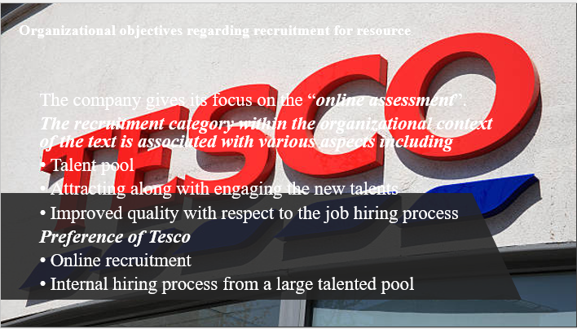
The company gives its focus on the “online assessment”.
The recruitment category within the organizational context of the text is associated with various aspects including
- Talent pool
- Attracting along with engaging the new talents
- Improved quality with respect to the job hiring process
Preference of Tesco
- Online recruitment
- Internal hiring process from a large talented pool
In accordance with the pandemic period, the management team of the chosen organization such as Tesco has given its focus on the online recruitment policy and the internal hiring process accordingly. It helps the overall workforce integrity amidst the Covid-19 situation.

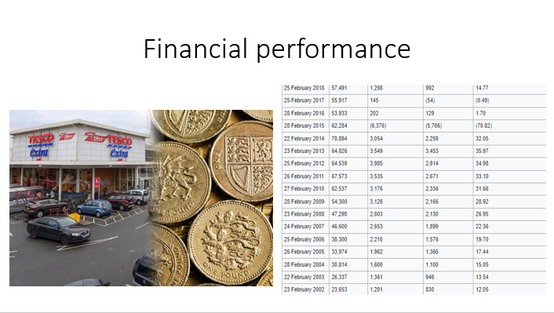

Evolution of recruitment process based on HR activities in Tesco

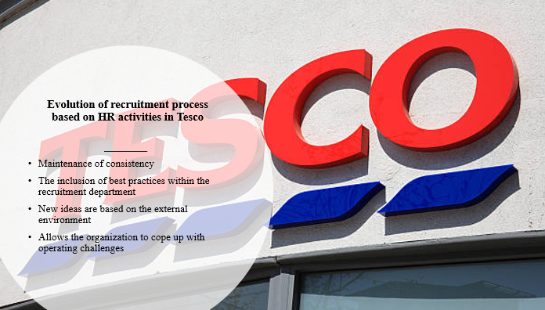
- Maintenance of consistency
- The inclusion of best practices within the recruitment department
- New ideas are based on the external environment
- Allows the organization to cope up with operating challenges
It should be noteworthy that the current recruitment department of Tesco Plc is worked through engaged and motivated employees. This mentioned aspect help the company to get better productivity followed by increased profit margin respectively (Krypa, 2017). In recent times, the current scope regarding the recruitment strategy of the chosen organization deals with the equipping specialists. In addition, this mentioned aspect allows the company to achieve its business objectives through the international markets.

- The inclusion of experienced professionals
- Able to work in different areas or departments of the organizational context of Tesco
It should be noteworthy that the chosen organization such as Tesco Plc operations regarding the recruitment policies are dealing with the aspect of the Reward and Recruitment department accordingly. In order to evolve the recruitment process, Tesco Plc has changed its aspects with the passing of time (Krypa, 2017). The management team in recent times involves professionals based on external along with internal advertisements respectively.
- 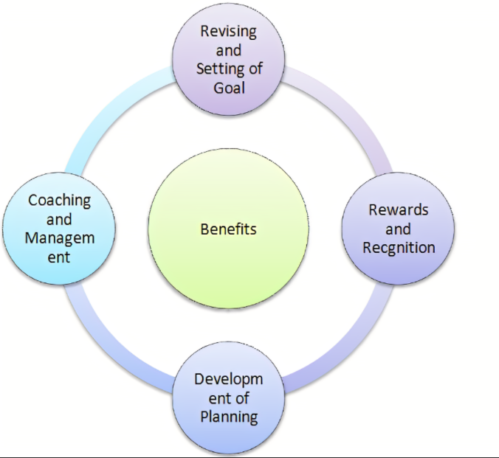
- Figure: Benefits of Tesco’s recruitment strategy
- Source: (Krypa, 2017)

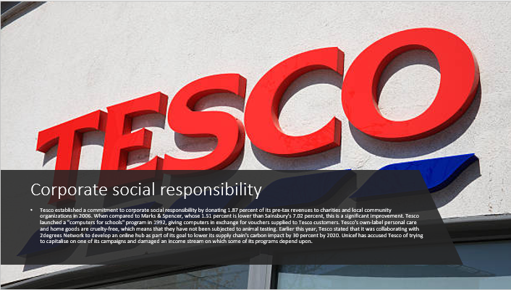

Tesco established a commitment to corporate social responsibility by donating 1.87 percent of its pre-tax revenues to charities and local community organizations in 2006, demonstrating its dedication to the cause. When compared to Marks & Spencer, whose 1.51 percent is lower than Sainsbury's 7.02 percent, this is a significant improvement. Although this sum, £42 million, is smaller than the amount of money stated to have been saved from tax in 2007, it is still significant (see below). Will Hutton, then the chief executive of The Work Foundation, complimented Tesco for being at the forefront of the discussion on corporate social responsibility in 2007 in his capacity as chief executive. Although Intelligent Donating has praised the firm for its "staff giving," the corporation has been criticized for diverting all donations to the company's Charity of the Year.Tesco in Evesham is a supermarket chain.Tesco launched a "computers for schools" program in 1992, giving computers in exchange for vouchers supplied to Tesco customers, which were then donated to schools and hospitals by the consumers themselves. They received equipment worth £92 million from the government up to 2004. In addition to the United States, Poland adopted the program.The phrase "Change for Good" was used in advertising by Tesco in 2009, which was a violation of Unicef's trade mark policy, which prohibits the use of the phrase for commercial or retail purposes. Unicef stated that it was "the first time in Unicef's history that a commercial entity has purposely set out to capitalise on one of our campaigns and subsequently damaged an income stream on which several of our programs for children are dependent." It went on to urge members of the public "...who are concerned about the wellbeing of children, to think carefully about who they support when making purchasing decisions."It is asserted that Tesco's own-label personal care and home goods are cruelty-free, which means that they have not been subjected to animal testing.Earlier this year, Tesco stated that it was collaborating with 2degrees Network to develop an online hub as part of its goal to lower its supply chain's carbon impact by 30 percent by 2020 by partnering with 2degrees Network.According to a Greenpeace investigation published in September 2011, Tesco shops in China were selling vegetables that contained pesticides at levels that exceeded the legal limit or that were otherwise prohibited. The presence of methamidophos and monocrotophos in a green vegetable sample from Tesco was confirmed, despite the fact that their usage has been outlawed in China since the beginning of 2007.

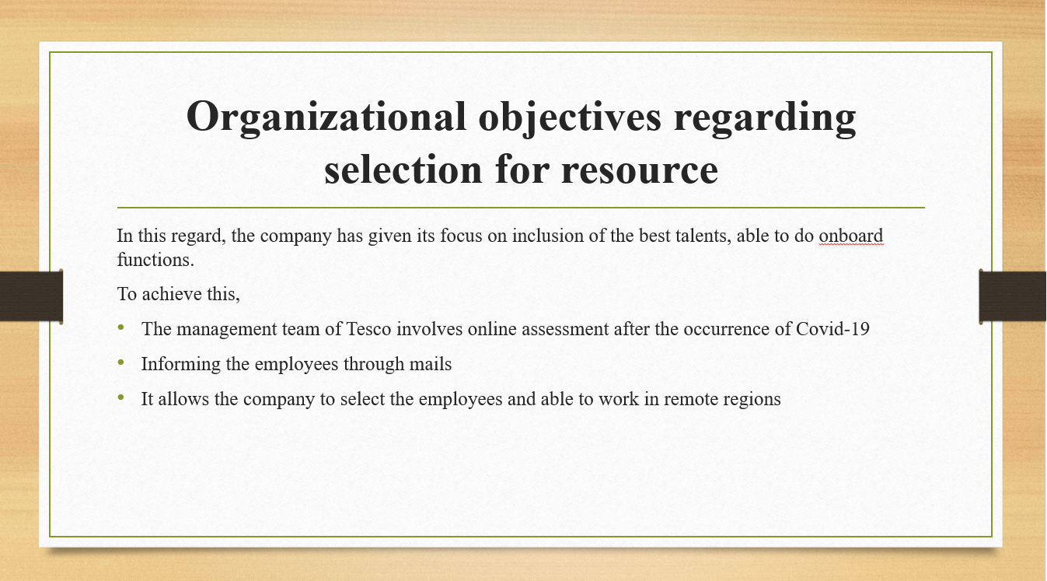
In this regard, the company has given its focus on inclusion of the best talents, able to do onboard functions.
- The management team of Tesco involves online assessment after the occurrence of Covid-19
- Informing the employees through mails
- It allows the company to select the employees and able to work in remote regions
It should be noteworthy that the selection process is considered as one of the important aspects within the organizational overall recruitment processes as it helps the respective business to hire talented employees. In addition, the selection process is quite responsible for allowing the HR professionals to equip the best ways for recognizing the appropriate talents, able to perform onboard functions of the organization. In this regard, the company involve online assessment, especially after the occurrence of Covid-19. After the online assessment, the HR professionals of Tesco Plc is able to select the successful candidates followed by providing employment contract including job details, salary details, and many more.

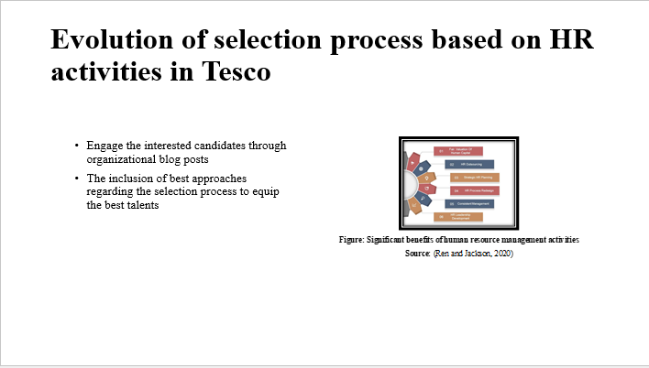
- Engage the interested candidates through organizational blog posts
- The inclusion of best approaches regarding the selection process to equip the best talents
It should be noted that the selection process within the organizational context of Tesco Plc is considered an integral part of the overall recruitment operation. With the passing of time, the steps of selecting the talents are changed accordingly. The company tries to post different types of blogs on its official websites. It helps the aspirant candidates to make a follow up in this regard. In addition, it has been noted that the HR professionals of Tesco Plc have been involved effective selection process so that the best talents are recruited without bias.
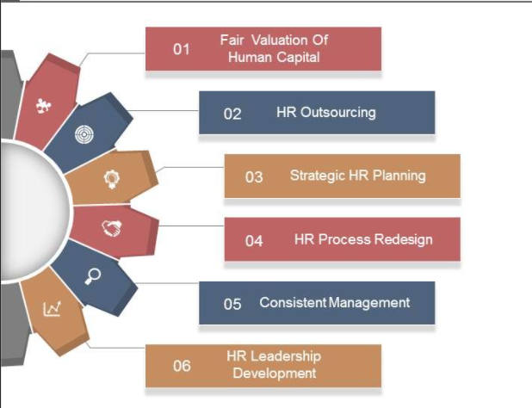
Figure: Significant benefits of human resource management activities
Source: (Ren and Jackson, 2020)

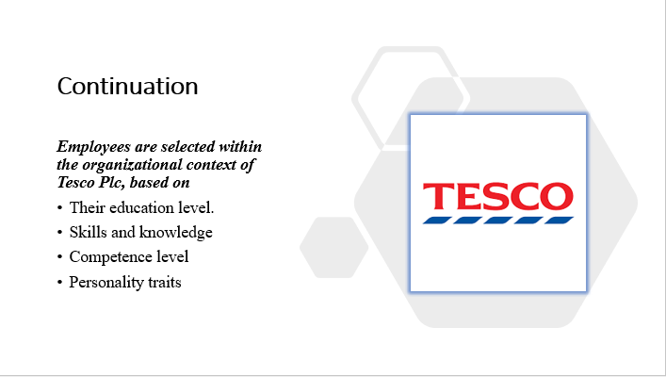

Employees are selected within the organizational context of Tesco Plc, based on
- Their education level.
- Skills and knowledge
- Competence level
- Personality traits
It should be noteworthy that the occurrence of the pandemic or covid-19 situation has changed the selection procedure accordingly. This is because the management team of the chosen company is given more focus on the online recruitment process. However, it should be noteworthy that the HR professionals of Tesco Plc are responsible for selecting the best talents based on the various aspects including, their education, competence, skills and knowledge and so on. The HR professionals are responsible for targeting the best talents as they ensure the business with more productivity followed by increased profit margin and revenues.

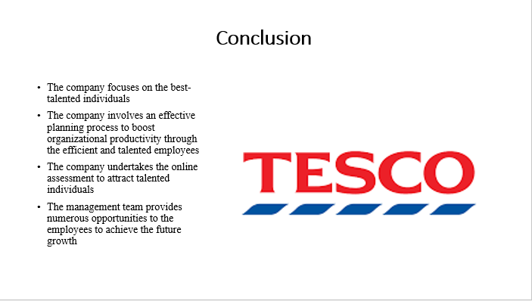
- The company focuses on the best-talented individuals
- The company involves an effective planning process to boost organizational productivity through the efficient and talented employees
- The company undertakes the online assessment to attract talented individuals
- The management team provides numerous opportunities to the employees to achieve the future growth

This selected study provides a transparent image about the concerns of the chosen company such as Tesco’s planning, recruitment and selecting perspectives.

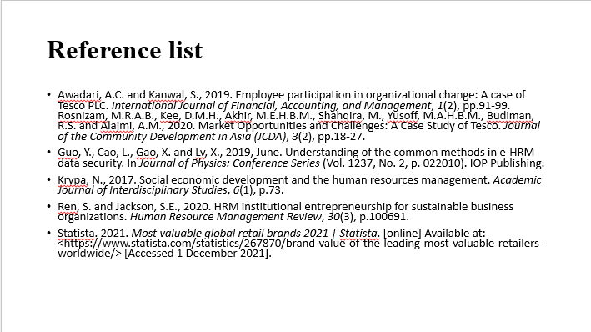
Awadari, A.C. and Kanwal, S., 2019. Employee participation in organizational change: A case of Tesco PLC. International Journal of Financial, Accounting, and Management, 1(2), pp.91-99. Rosnizam, M.R.A.B., Kee, D.M.H., Akhir, M.E.H.B.M., Shahqira, M., Yusoff, M.A.H.B.M., Budiman, R.S. and Alajmi, A.M., 2020. Market Opportunities and Challenges: A Case Study of Tesco. Journal of the Community Development in Asia (JCDA), 3(2), pp.18-27.
Guo, Y., Cao, L., Gao, X. and Lv, X., 2019, June. Understanding of the common methods in e-HRM data security. In Journal of Physics: Conference Series (Vol. 1237, No. 2, p. 022010). IOP Publishing.
Krypa, N., 2017. Social economic development and the human resources management. Academic Journal of Interdisciplinary Studies, 6(1), p.73.
Ren, S. and Jackson, S.E., 2020. HRM institutional entrepreneurship for sustainable business organizations. Human Resource Management Review, 30(3), p.100691.
Statista. 2021. Most valuable global retail brands 2021 | Statista. [online] Available at: <https://www.statista.com/statistics/267870/brand-value-of-the-leading-most-valuable-retailers-worldwide/> [Accessed 1 December 2021].


