INTRODUCTION TO PHYSIOLOGY, BSC IN HEALTH AND SOCIAL CARE (BMHP5003)

POSTER: Part 1, Assignment
STUDENT NAME: MONICA DORMER, ID 1907095
LURTURE: Dr, MUMTAZ GOOLAM


This Photo by Unknown Author is licensed under CC BY Bing picture

1) The Immune system responsibility is to protect an unborn child from outside attack form viruses, fungi, all toxins that’s (chemicals gives by microbes) It made with different cells, organs also proteins that work has a term. | 1) Build-up of main areas of the immune system, are the white blood cells and that of antibodies, with complement system and lymphatic system, that of thymus, spleen, and that of bone marrow. Refer: Hopkins, J. (2012)
INTRODUCTION Of, Autonomy: IMMUNE SYSTEM
And - Immune system protects us every 24 hours per day, many ways you can help with caring of the immune system. Getting more rest going outdoors, often, getting more exercise and eat well.
Immune system belongs to one of the main 10 groups of the body system. All connect to support each other Your immune system has high influence in the human body.
3) In, secondary repones is of that repones that acres when act of exposure to pathogen take place after the initial immune response. Memory B and of T cells that connect to rapidly get rid of this pathogen to help prevent reinfection. Refer: https://www.sciencedirect..
3) Diagram above show of antibody, bacteria first exposure and of the primary response of the immune system.
Looking at the secondary part of the diagram show that the longer you leave it the wiser it gets, taking longer to recover, time is of the séance. Refer: Aryl, S. (29 – 04 – 2021)
Form Einstein to Edison, many great thinkers account that sleep can help with better innovations, for sleep is vital for studying problems and finding solutions, also for memorising too.
Sleep addressing an important part for mental health however, quoted getting out of bed on the wrong side of the bed is a real thing.
No matter what, not getting the right amount of sleep will not help with emotions and your mental health will suffer.
A study done with 153 of health adult, who took part the ones that got a longer sleep, over eight hours had a batter immune system.
Then those who had less sleep under seven hours, now we know that a good night rest give your immune system a better response. Refer: Immune System, (Aug 17, 2021)
1)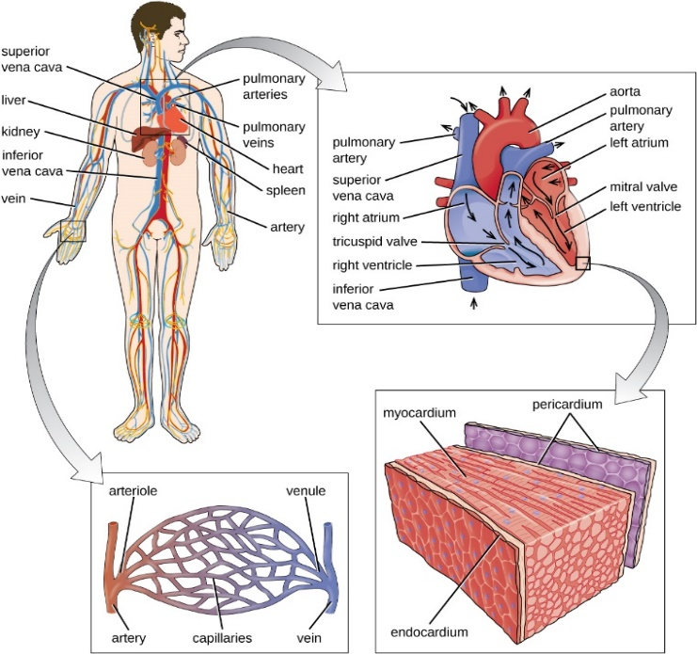 2)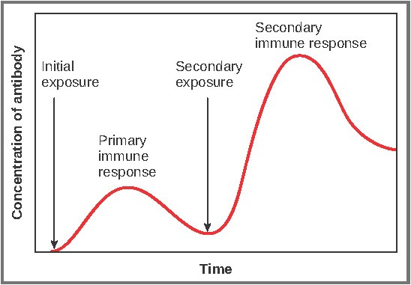
This Photo by Unknown Author is licensed under CC BY-SA-NC, Bing
This Photo by Unknown Author is licensed under CC BY.SA-NC

3) Not like the immune activate/ report, where it is of a specific against these certain Inflammatory of the response to uniform – specific broadly generalize.
Some cause of the inflammation of the respiratory system is always at risk from very small particles, such has pollution. Refer: Parker. S.
A, overview form the worlds organisation contamination of that of indoors or outdoors, show that any chemical, that of physical or of biological which part that modifies the order of natural atmosphere.
Household chemical driven cars, all carbon footprint facilities and like large fires, all air pollution which we inhale.

Report estimation, on several million people world-wide that intakes of 99% of recommended limit.
The high levels of air pollution are found in countries with low / middle income, who will help those countries?
Refer: World Health Organization, (18 Aug: 2011) , Cit: (11/ 2021)
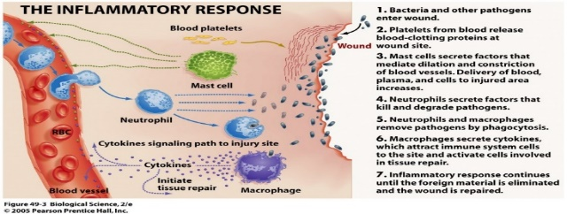
This Photo by Unknown Author is licensed under CC BY Bing

hand in hand to keep us alive. Refer: Revere Health Aug – 22 – 2016
4) Our human system contains trillions of cells, they are 78, different organs and over 60,000 distance of blood vessels if lad out from end to end. Therefore, cells blood vessels and of organs works

4) Microbiome, which is tailored supplement, plan based on results of the human microbiota which lives on or inter bodies tissue and that of biofluids amongst the corresponding anatomical sites, to where they place in the skin.

4) Microbiome is for a plant – based diet that help to promotes the beneficial of having this tip of diet, reducing the risk of having diseases, as well as probiotics helping support other conditions like IBS, eczema. Refer, Dr, Kell man, R. (15 – 06 – 2020)

All body system plays in conjunction with other system of the body.
Circulatory system is an example of the interact of each other.
A heart carries blood around the body though a workforce of blood vessels. Where your blood circulates through to your digestive system takes up nutrients then your body absorbed it from your last meal. Refer: Revere Health (Aug 22, 2016), cited (09/ 2021).

A balance diet is essential to help men tine a health immune system, helping to provide all the micronutrients which is needed to support the natural functioning of immune system.
These nutrients are recognised to have played specific part of immune system

2)
The most common are known has a swollen glands which could mean several things like a viral infection, depend on where it is this, however, increase glands can be (Tonsillitis) or cancers. immune, cell system as detected something wrong. Refer: https://www.menual... 17/12/2017) (1Cited:(15/10/2021)

2) This diagram shows that there is an information of the body, these signs are one that the (LYMPH NODE) it indicated a problem, body temperature change further investigation will, be of what kind? Of infection is within the body. Refer: https://www.merckmanual...
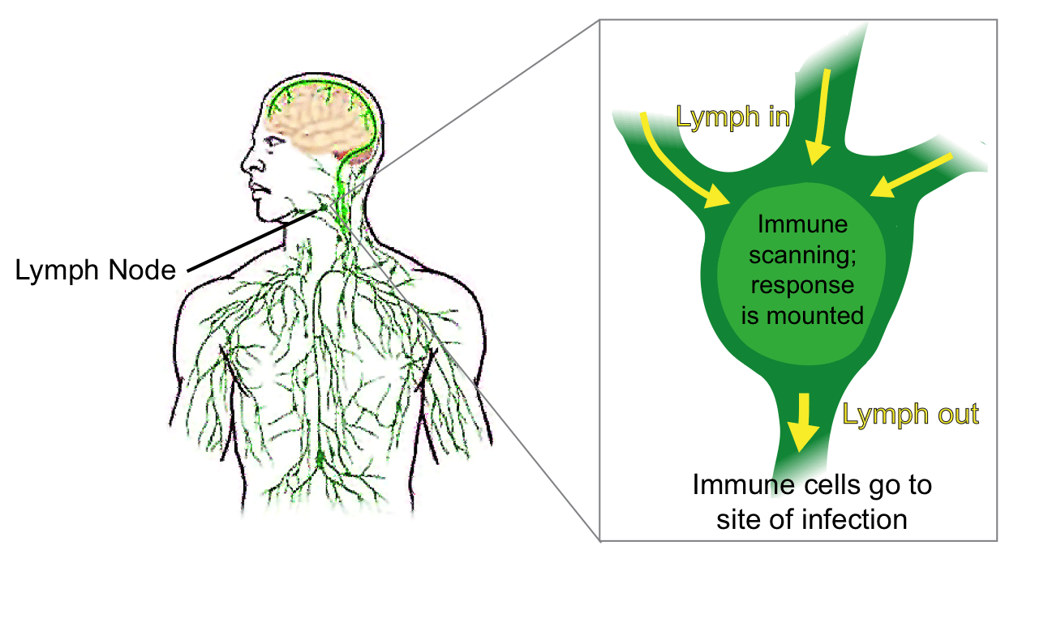
This Photo by Unknown Author is licensed under CC BY-SA-NC

REFERANCE LIST:
- Arial, S. (April – 29- 2021) 12 Differences between Primary, and Secondary Immune Response
- Air Pollution – WHO I World Health Organization, (2011) https://www.who.int>health
- Dr, Kalman, R, et - al (June – 15 – 2020), What is The Microbiome Diet, cited: (Oct/ 2021)https://www.medicalnewstoday.org.uk, Cited (Oct – 2021)
- Hopkins, J, (2012) et – al. Copyright (2021), The Johns Hopkins University, The Immune System: https://www.insmedicine.org.uk Cited: (11/ 2021)
- How to support your Immune System, (Aug – 17 – 2021), Cited: (10- 2021), https://wwwactimel.cosystem/what-food-are-good-for-your-immune-system
- By, Revere Health, (22 – 08 – 2016), https://wwwreverhealth.com, Cited: 09 – 2021
- Neck Lump- Ear, Nose, and Throat Disorders – Merck Manual https://www.merckmanual.org.uk Cited:11/ 2021)
- Secondary Immune Response an Overview, Science direct Topic, Date https://www.sciencedirect.org.uk
- The Main Part of The Immune System, (17/Dec/2017 https://www.betterhealth.vic.gov.uk
- This Photo by Unknown Author is licensed under CC BY-SA-NC the Immune System online Microsoft
- This Photo by Unknown Author is licensed under CC BY-SA-NC , Lymph Nodes online, Microsoft, Bing picture
- This Photo by Unknown Author is licensed under CC BY-SA-NC Primary and Secondary Response Bing picture

