Title: Case Study: The Seaview Resort

Name: Viktoria Benko

Student Number: 2130343

Module Name: Financial Management for the Hotel Industry BMIH5007

Lecture: Tristan Hawkins

Word Count: 2186

Executive Summary:

After assessing Sea View Resorts financial performance and sustainability over three years for example income statements, balance sheet analysis, cash flow analysis, findings seems to suggest that there was a decline in revenue, net profit dropped from 15% 2020, 8% 2021 and 4% 2022, occupancy rates and customer satisfaction. Some of the reasons behind the decline include highly competitive market, shift in customer preferences and amenities. A comprehensive turnaround strategy from 2023 to 2026 which includes partnership funding, Bowman's Strategy Clock for market position and a model on growth strategy, such as Ansoff matrix ,deep market Analysis, Market segmentation and options enhancing customer experience, prioritize cleanliness and hygiene, monitor online reputation, empress sustainability, offer personalised experiences, train staff even collaborating with other businesses was drafted to revitalise the resort’s financial health and restore their reputation as premier vacation destination with viable financial outcomes. Sea View resorts’ financial performance improved after restructuring and utilising resources more effectively.

Contents
Executive Summary: 3
Introduction 3
Scope and Objectives: 3
Sea View Resort Financial Analysis: Income Statement Analysis (2020-2022): 4
Balance Sheet Analysis. 4
Cash Flow Analysis: 4
Financial Ratios: 5
Additional Financial Information: 5
Factors contributing to decline in revenue, occupancy rates and customer satisfaction. 5
Sea View Resort Swot analysis: 6
Market Analysis: 7
Market Trends in the Hotel Industry 7
Turnaround Strategy: (2023-2026) 10
Financial Projections (2023-2026): 10
Sea View Resort Financial Analysis: 10
Income Statement Analysis (2023-2026): 10
Balance Sheet Analysis (End of 2023-2026) 11
Cash Flow Analysis (2023-2026): 11
Financial Ratios (2023-2026): 11
Additional Financial Information (2023-2026): 11
Sea View Resort Financial Risk Assessment: 12
Conclusion 13
Recommendations: 13
References 15

Introduction

The Sea View Resort, located in picturesque coastline, once thriving destination for vacationers seeking relaxation and luxury. After assessing their financial performance and sustainability over three years for example income statements, balance sheet analysis, cash flow analysis, findings seems to suggest that there is a decline in revenue, occupancy rates and customer satisfaction. Some of the reasons behind the decline include highly competitive market, shift in customer preferences and amenities. A comprehensive turnaround strategy has been drafted to revitalise the resort’s financial health and restore their reputation as premier vacation destination with viable financial outcomes. The strategy includes deep market analysis and options enhancing customer experience, prioritize cleanliness and hygiene, monitor online reputation, empress sustainability, offer personalised experiences, train staff even collaborating with other businesses.

Scope and Objectives:
The Seaview Resort was once a thriving destination for vacationers seeking relaxation and luxury. However, in recent years, the resort has experienced a decline in revenue, occupancy rates, and customer satisfaction due to a lot a factors. The main of this assessment is to address the concern about the future viability of the business. Also to assess if the business can be salvaged through a turnaround strategy.

Sea View Resort Financial Analysis: Income Statement Analysis (2020-2022):
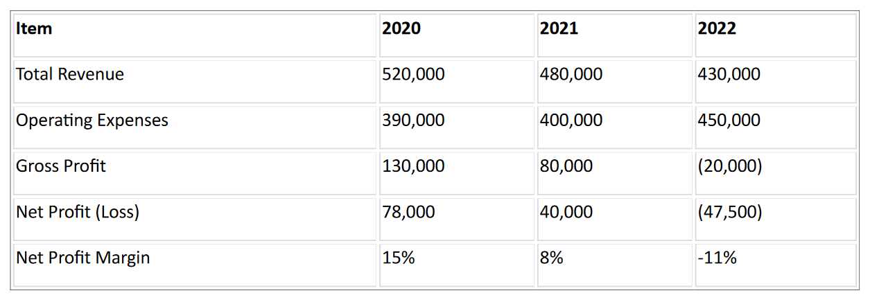

Balance Sheet Analysis.
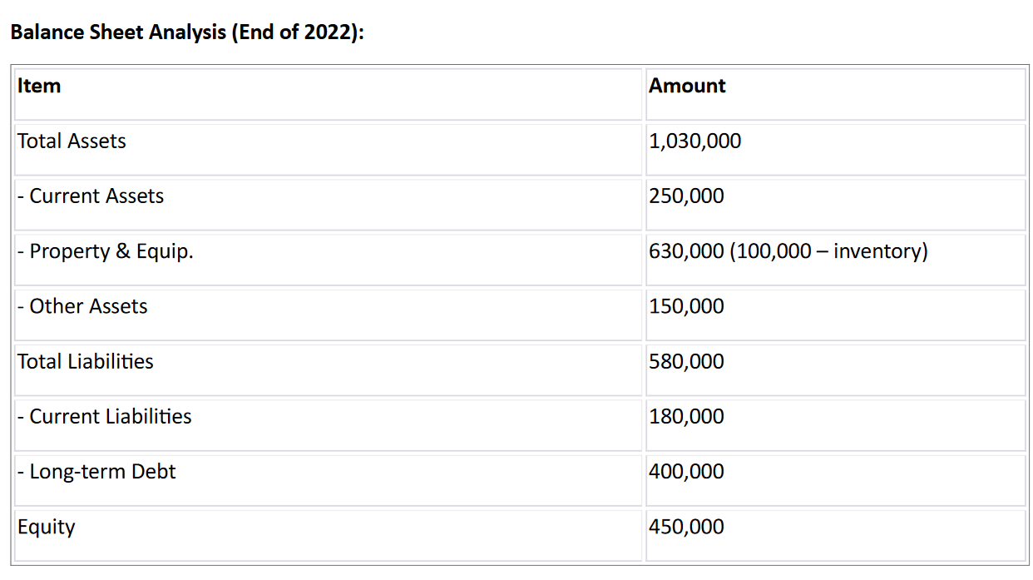

Cash Flow Analysis: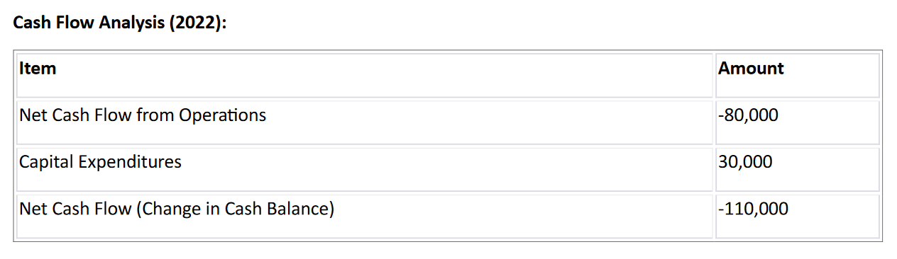

Financial Ratios:
Current Ratio: 1.4
Quick Ratio: 0.6
Debt-to-Equity Ratio: 1.3
Return on Assets (ROA): 0.0
Return on Equity (ROE): -0.11

Additional Financial Information:
Average Room Rate (ARR):
2020: 250
2021: 230
2022: 210
Occupancy Rate:
2020: 70%
2021: 65%
2022: 60%

Factors contributing to decline in revenue, occupancy rates and customer satisfaction.
Some factors that contributed to the latter are:
- Increased competition: the presence of a new hotels brings more competitors in the market, added more competition for guests.
- Price wars: Some guests tend to go for accommodation that they can afford so many hotels had to lower room prices.
- Differentiation strategies: hotels with better strategies turn to keep comparing with hotels with better budget for improvement.
- Service quality: The Seaview Resort's customer reviews indicate declining service quality and outdated amenities.
- Market segmentation: The need for a clear strategy outlining target market.
- Market Research. Lack of investment.

Sea View Resort Swot Analysis:
Strengths:  - Established Brand: The hotel has recognized brand name which helps help them attract guests building a good customer base.  - Strategic Location: Hotel is located near the central of the city which helps them attract customers looking for convenience and accessibility. | Weaknesses:  - Financial Constraints: Limited financial resources is hindering the hotel's ability to invest in necessary upgrades, marketing campaigns, or staff training.  - Outdated Facilities: It seems aging facilities and outdated decor is a deterrent for potential customers looking for modern amenities and aesthetics.  - Negative Reputation: Hotel has experienced negative reviews or customer complaints damaging its reputation and making it harder to attract guests.

Opportunities:  - Marketing and Promotions: Targeted marketing campaigns and promotions can be utilized to attract more customers, especially during specific seasons or events.  - Collaborations: The hotel has opportunity to explore partnerships with local businesses or event organizers to provide special packages or attract a different customer segment.  - Cost Reduction: Identifying areas to reduce costs, such as energy consumption, supplies, or staffing, can help improve the financial situation. | Threats:  - Competitor Landscape: Other hotels, including bigger chains or boutique accommodations are a threat, especially those with more resources or better offerings.  - Changing Consumer Behaviour: Customers are shifting towards alternative accommodation options or the hotel's target market is decreasing, it can impact occupancy rates.  - Economic Factors: Economic downturns, changes in tourism patterns, or unforeseen events may impact travel demand and negatively affect the hotel's revenue.

Market Analysis:

Market Trends in the Hotel Industry

UK hotel industry needs to :
- Embrace technology: Embrace hotel management software, online booking systems, improve guest satisfaction and stay competitive. While embracing digitalization that is further focused on by Covid-19 pandemic. Companies research outcome is achieved through a strong and well-crafted Data Science Strategy as an outstanding constituent of Enterprise Digital Strategy. (Reddy, et al., 2022-03)
- Leverage online presence: To stand out in a crowded market, establish a strong online presence. Optimize your website, use social media platforms, and encourage guest reviews to build credibility and attract potential customers.
- Adapt to customer preferences: Stay updated on evolving guest preferences and adapt your offerings accordingly. Consider incorporating sustainable practices, providing flexible cancellation policies, or offering personalized experiences based on guest preferences.
- Strengthen relationships: Cultivate strong relationships with existing customers by offering loyalty programs, personalized communication, and special perks. Happy guests can become brand ambassadors and attract more business through word-of-mouth.
- Increased competition: Sea View Hotel need to explore more marketing strategies and offering to stay in the business, and generating useful customer responses.
- Price wars: The hotel need to offer services at competitive rates for room price based on customer requirements, cutting down or give discount loyal customers.
- Differentiation strategies: hotels may need to be transform themselves offering the new entrants unique features, amenities or service. This can help them to stand out and attract customers, who are looking for a great experiences.
- Improved services and facilities: To keep their competitive edge, to invest in upgrading their services and facilities to make sure they have goods and services to attract customers. This includes room quality, dining options, spa services to improve their customer services.
- Market segmentation: To reevaluate target market segments to find sectors where they can focus and excel. Good market segmentation also enables businesses to learn more about customers and improve the performance of the campaigns targeting right customers with right messaging at the right time. (Vives, et al., 2018-09)
- Monitor the market: create systemic swap in the business logic of corporations when they guide innovative products and results to the market. Companies should be quick to respond to their business environment and capable to modify their BMs in an agile way. (Bouwman, et al., 2018-05)
- Enhance guest experience: continuously strive to provide exceptional experiences to the hotel guests. Offer a range of attribute-based services that recognize customer wish and gladly used by guests while staying at the hotel, which mean that is hotels at recognized the attributes of importance to their guest. Focus on delivering excellent service ,maintaining cleanliness, offering a comfortable and relaxing stay with additional modern amenities. (Ristova Maglovska, 2020)
- Tailor marketing strategies: Create targeted marketing campaigns to engage with your target audience. Highlight your unique offerings, advertise special promotions or packages, and collaborate with local businesses or influencers to attract attention.
- Conduct an environmental audit and develop an eco-friendly policy: Asses the current impact of hotel on the environment and identify areas for improvement. Internal control is expected to have a beneficial effect on Environmental, Social, Governance ratings, which is a measure of corporate sustainability. (Koo & Ki, 2020), Be transparent about your efforts and involve your guests and staff in the journey towards sustainability for example using solar power. (Wang, 2022-08) (Taecharungroj & Prasertsakul, 2023).
- Educate your staff: Train your employees on eco-friendly practices, such as proper waste management, energy conservation, and water-saving techniques. Encourage them to actively participate in implementing sustainable measures.
- Upgrade Infrastructure: Invest in energy-efficient appliances and lighting systems, install smart thermostats, and consider incorporating renewable energy sources like solar panels.
- Implement water-saving measures: Install low-flow faucets, showerheads, and toilets to minimize water consumption. Encourage guests to participate in towel and linen reuse programs.
- Reduce waste production: Provide recycling bins in all areas of your hotel, including guest rooms, and promote the importance of recycling to both staff and guests. Look for opportunities to minimize single-use plastics and packaging.

Turnaround Strategy: (2023-2026)
In order to revitalise the resort’s financial health and reputation as premier vacation destination or viable financial outcomes, The Sea View resort Management had to go into partnership with a business that is going to invest £400 000.

Financial Projections (2023-2026):

Sea View Resort Financial Analysis:

Income Statement Analysis (2023-2026):
Item | 2023 | 2024 | 2025 | 2026
Total Revenue | 500,000 | 600,000 | 700,000 | 800,000
Cost of goods | 100,000 | 125,000 | 150,000 | 175,000
Gross Income | 400,000 | 475,000 | 550,000 | 625,000
Total Expenses | 100,000 | 125,000 | 150,000 | 175,000
Earnings before Tax | 300,000 | 350,000 | 400,000 | 450,000
Tax | 75,000 | 87,500 | 100,000 | 112,500
Net Income | 225,000 | 262,500 | 300,000 | 337,500

Balance Sheet Analysis (End of 2023-2026)
Item | Amount 2023 | 2024 | 2025 | 2026
Total Assets | 1,000,000 | 1,100,000 | 1,200,000 | 1,300,000
-Current Assets | 350,000 | 400,000 | 450,000 | 500,000
-Property and Equipment | 500,000  (100000-Inventory) | 500,000  (100000-Inv) | 500,000  (100000-Inv) | 500,000  (100000-Inv)
-Other Assets | 150,000 | 200,000 | 250,000 | 300,000
Total Liabilities | 500,000 | 500,000 | 500,000 | 500,000
-Current Liabilities | 100,000 | 100,000 | 100,000 | 100,000
-Long-term Debt | 400,000 | 400,000 | 400,000 | 400,000
Equity | 450,000 | 450,000 | 450,000 | 450,000

Cash Flow Analysis (2023-2026):
Item | Amount 2023 | 2024 | 2025 | 2026
Net Cash Flow from Operations | 100,000 | 100,000 | 100,000 | 100,000
Capital Expenditures | 550,000 | 550,000 | 550,000 | 550,000
Net Cash Flow (Change In Cash Balance) | 125,000 | 125,000 | 125,000 | 125,000

Financial Ratios (2023-2026):
Current Ratio: | (2023) 3.5 | (2024) 2.0 | (2025) 2.0 | (2026) 2.0
Quick Ratio: | 1.5 | 3.0 | 3.0 | 3.0
Debt to Equity Ratio: | 1.4 | 1.3 | 1.2 | 1.1
Return on Assets: | 0.2 | 0.2 | 0.0 | 0.0
Returns of Equity: | 0.5 | 0.5 | 0.5 | 0.5

Additional Financial Information (2023-2026):
• Average Room Rate (ARR):
2023: 220
2024: 230
2025: 240
2026: 250
• Occupancy Rate:
2023: 75%
2024: 80%
2025: 85%
2026: 90%

Sea View Resort Financial Risk Assessment:
It is important to conduct a comprehensive financial risk assessment regularly and adapt the strategies accordingly and consider seeking assistance from financial experts or consultants with experience in the hotel industry to enhance the accuracy of the assessment. (Chung & Choi, 2018-10)
Some of financial risks are:
- Market Risk: Market conditions may change ultimately affecting revenue and occupancy rates.
- Credit Risk: Creditworthiness of clients and partners to minimize the risk of non-payment or defaults. This involves analysing customer profiles, credit histories, and implementing effective credit management practices.
- Liquidity Risk: Hotel's ability to meet short-term financial obligations such as payroll, operating expenses, and debt service payments. Analysing the property of the portfolios specify higher ranked managers hold stocks with higher information asymmetry, especially the growth companies that are younger, smaller, and with lower liquidity. (Chen, et al., 2018-01)
- Operational Risk: Potential risks arising from day-to-day operations, such as staffing issues, technology failures, security breaches, and regulatory compliance
- Capital Investment Risk: Feasibility and profitability of capital investments, such as renovations, expansions, purchases of new properties, or major upgrades.
- Foreign Exchange Risk: Exposure to currency fluctuations, especially if it operates in international markets or deals with multiple currencies.
- Impact of exchange rate movements on financial statements.
- Insurance and Liability Risk: insurance coverage, including property insurance, liability insurance, and business interruption insurance. Identify potential areas of risk and ensure adequate coverage is in place to protect the hotel's financial interests. (Flansburg, 2021-10).
It is vital to continue assessing some of these risks from time to time to minimize disruptions if one of them occur. Hotel has insurance and investor or partner who is willing to invest more to cover the costs.

Conclusion

Although The Sea View Resort had a difficult three years from 2019 to 2022 due high competitive market, shift in customer preferences and amenities etc, even their income statements, balance sheet analysis, cash flow analysis, clearly showing decline in revenue, occupancy rates and customer satisfaction. After implementing a comprehensive turnaround strategy that included Bowman's Strategy Clock for market position and a model on growth strategy, such as Ansoff matrix market analysis, marketing mix, enhanced customer experience, prioritized cleanliness and hygiene, monitor online reputation, empress sustainability, offer personalised experiences, train staff even collaborating with other businesses Sea View Resort’s financial health and their reputation as premier vacation destination with viable financial outcomes seems to have been was restored as the their income statements, balance sheet analysis, cash flow analysis from 2023 to 2026 clearly shows a steady rise in revenue.

Recommendations:

Sea View Resort’s management should continue to follow guidelines focusing on key areas such as service quality, facility upgrades, staff training, and implementing innovative marketing strategies, the hotel can effectively address its shortcomings and provide a memorable guest experience. Utilize customer feedback and leverage social media platforms which also serve as powerful tool to both improve guest satisfaction and rebuild the hotel's reputation. While the road to recovery may present challenges, the dedication and commitment of the hotel's management and staff, coupled with a comprehensive turnaround plan, can pave the way for a successful reputation resurrection. With perseverance, adaptability, and a sincere commitment to guest satisfaction, this hotel has the potential to become a shining example of reputational transformation in the hospitality industry.

Références:
Bouwman, H. et al., 2018-05. Achieving agility using business model stress testing. Electronic markets, Vol.28(2), pp. p.149-162.
Chen, F., Qian, M., Sun, P.-W. & Yu, B., 2018-01. In search for managerial skills beyond common performance measures. Journal of banking & finance, Volume Vol.86, pp. p.224-239.
Chung, J. & Choi, J. G., 2018-10. Conceptualizing Global Investment Evaluation Model by Understanding the Environmental Key Risk Variables and their Impacts on the Market Size of the Hotel Industry. Global business and finance review, 2018-10, Vol.23 (3), p.68-80, Vol.23(3), pp. p.68-80.
Flansburg, C., 2021-10. Tips for obtaining appropriate business insurance coverage. Rochester Business Journal, Vol.37(20), pp. p.00-12.
Koo, J. E. & Ki, E. S., 2020. Internal Control Personnel’s Experience, Internal Control Weaknesses, and ESG Rating. Sustainability (Basel, Switzerland), 2020-10, Vol.12 (20), p.8645, Vol.12(20), p. p.8645.
Reddy, R. C., Bhattacharjee, B., Mishra, D. & Mandal, A., 2022-03. A systematic literature review towards a conceptual framework for enablers and barriers of an enterprise data science strategy. Information systems and e-business management, Vol.20(1), pp. p.223-255.
Ristova Maglovska, C., 2020. What do hotel guests really want? An analysis of online reviews using text mining. Menadžment u hotelijerstvu i turizmu, 2020-01, Vol.8 (1), p.37-48, Vol.8 (1), pp. p.37-48.
Taecharungroj, V. & Prasertsakul, D., 2023. Placeful Business: Reimagining a Small Business Concept That Embraces and Enriches Places. Sustainability , Vol.15 (12), p. p.9370.
Vives, A., Jacob, M. & Payeras, M., 2018-09. Revenue management and price optimization techniques in the hotel sector: A critical literature review. Tourism Economics, Vol.24(6), pp. p.720-752.
Wang, X., 2022-08. Design and development of an integrated environmental waste management system with a sustainable solution. Water science & technology. Water supply, 2022-08, Vol.22 (8), p.6516-6531, Vol.22(8), pp. p.6516-6531.
https://www.british-assessment.co.uk/insights/what-is-the-scope-of-my-business/
https://www.proquest.com/docview/2363513696?accountid=130472&parentSessionId=9wc%2BjCNR4IWTpG63r1ZmOfmZE8gUSRmCfmyImKWgQSQ%3D&pq-origsite=primo
ttps://www.proquest.com/docview/2725935040/885165184274947PQ/14?accountid=130472

