
reflective report
Professional Development

February 21, 2020
UNIVERSITY OF WALES TRINITY SAINT DAVID

COSMINA-ELENA GADICEANU
1914674

Table of Contents

INTRODUCTION 2
Findings 3
Conclusion 11
References 12
Appendices 13

INTRODUCTION

Professional career development is very important because helps me to be more competent into my career, to improve my skills and to raise the standards of care in my workplace.
Self-awareness is the ability to understand correctly how others perceive me, to be aware of my emotions, behaviour and actions. “Self-awareness enables us to stand apart and examine even the way we “see” ourselves – our self-paradigm, the most fundamental paradigm of effectiveness. It affects not only our own attitude and behaviours, but also how we see other people. It becomes our map of the basic nature of mankind.” Stephen Covey, 1999, P.66 -67
Self-assessment is a judgement or an official purpose that I make about my4 abilities, qualities or actions. (Cambridge Advanced Learner's Dictionary & Thesaurus)
This report shows the reflection of my work, strategies that I’m using to reach my development, obstacles that I face in my work-place, my weakness and threats that help me to transform all this process in to my strengths and objectives to accomplish my goals.

Findings

In this reflective report I am demonstrating my understanding off the skills and knowledge which contribute toward working effectively, to work efficient I need skills.
A skill is something that I learn to do over a period as: communication, playing an instrument, sport, drawing. As a nurse I need also different skills as the employer expect: teamworking, problem solving, efficient learning, IT, good expertise, flexibility, strong work ethic, knowledge and initiative.
Communication is essential when working in healthcare, in Western Journal Research, July 2018, Vol.40(7), pp.1012-1031 it is saying that using person centred communication we are able to recognise the individuals as persons and will respond to their needs according to their feelings and emotions. This skill is very important because helps us to maintain accurate and clear information about our patients, written or electronical recorded, also helps us to identify ways to identify a good communication with relatives, colleagues and other professionals. Lucy Webb, (2011) Nursing: Communication Skills in Practice pp6.
Working as a team is making a noticeable difference on a shift and our patients will notice as well. We set up goals, share tasks, listen to each other, communicate better with everyone around us and receive openly any feedback. “Effective feedback can enhance performance and improve the outcomes for the team.” Peter Ellis and Sherley Bach (Eds) (2015) Leadership, Management and Team Working in Nursing. 2nd Edition. London: Sage Publications Inc
All employers seek in their employees the problem-solving skills in order to survive in this global crisis. For me, problem solving skills means to know how to work smart, to find the problem, to fix it, how to avoid it next time, strategies in place to make the job easier with less costs.
In some of the companies the computers are taking over the staff who been hired to do a certain job, in my work-place this computers are actually a problem-solving because all the information are stocked in the memory, if we need to search we will access the archive and we can find very easy all the info that we need with data protection, in less time, without wasting paper, we reduced the cost and it is safe. In other for everyone to know to use the computer and understand this program I had to attend a course to be able to train my colleagues, to explain and help them to learn how to use it in our domain.

Kolb’s Learning Style
David Kolb’s says that learning may be a process where knowledge is made through the transformation of experience. Kolb’s experiential theory may be a process by which knowledging experience are gathering transformed in to learning that leads to changing of behaviour and action. He describes six characteristics of experimental learning: learning may be a process, all learning is relearning, learning requires the resolution of conflict or tensions which drives to learning process, learning may be a holistic process, learning results how we interact with our surroundings, learning is that the process of making knowledge.
As a nurse i'm using this process each day in work, before taking a serious decision i'm brooding about my concrete experience, what are my feelings, I observe and reflect over the case and just after I take any action per the code of practice. Taking a call , an action will send me back to Kolb’s experimental learning because this can be a never ending cycle where anything I do become an element of my experience where I reflect to work out if I done good, if I could do better, what I can improve next time.
EXPERINCE

TEST REFLECTION

CONCEPTUALIZE

Honey and Mumpherd (1992) diagnosed that human beings have extraordinary innate getting to know possibilities closely associated with Kolb's thinking/ reflective cycle.
Research conducted through Honey and Mumpherd Suggest that some people are higher at learning experience (activist) other learn higher by way of reflection (Reflectors), others with the aid of developing own ideas preferring theoretical input (theorist) and others like take records and plan for the future and asks ‘what ifs’ (Pragmatists).
In my point of view, I see myself as an activist-pragmatism, because I prefer to deal with new problems, to be hand’s on, I am an enthusiastic person and I love challenges, new experiences

Johari’s Window
Definition: This diagram wants to illustrate people's level of self-awareness and the way to boost their game. Note: Not very often we will find the four quadrants of equal size.
We're humans with brains, feelings, tempers, and also the ability to reason. that the quadrants morph and shift along the way.
Mahoney, Dawn J, CPLP. Training; Minneapolis Vol. 56, Iss. 5, (Sep/Oct 2019): 52.
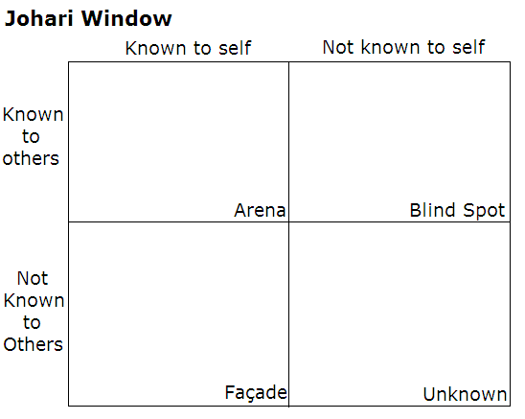
Intelligent
Relaxed
Warm
Wise
cc

Accepting, clever, self-concious
Not being able to know how I will be in the next 5 years, or what will happen in the next day, or if I will reach my goals
Sensible
Shy
Silly
Trustworthy
Calm
Logical
Organised
Reflective
This Photo by Unknown Author is licensed under CC BY-SA

The rules to succeed in the business are constantly changing, to stay oneself on a par with others, it’s a must to strengthen the technical competence and knowledge as they're the key drivers of career growth and success. However, with globalization, the importance of soppy skills has grown tremendously.
For self-assessment, it's important to own the essential skills. Skills will be categorized as hard skills and soft skills.
Hard skills, among other things, include computer skills, technical expertise, analytical skills, lab techniques.
Soft skills include the talents which are acquired without conscious efforts over a period of time, like inter-personal skills, communication skills, time management, etiquette and manners. Sharma, Sangeeta; Sharma, Sakshi. IUP Journal of Soft Skills; Hyderabad Vol. 13, Iss. 2, (Jun 2019): 49-54.
Maslow’s Theory of needs

H. Maslow (1943)developed a theory of about human motivation following research worn out us. His theory called hierarchy of needs gives variety of hierarchical levels to elucidate motivation.
Firstly they're physiological needs. Maslow said we are only motivated to fulfil all our safety needs after we have fulfilled our physiological ones. Thirdly there's sense of belonging wit others and fourthly we've got esteem needs. the notion of self actualisation – state on top of his hierarchy of needs where someone is engaged in an activity that they lose the track of time. Progression through his hierarchy was supported the notion that after a requirement was satisfied it had been no loner acted as a motivator.
Self actualisation was exception to the current rule- once you've got experienced it you wish it more. It refers to the will for self-fulfillment, namely, to the tendency for him to become actualized in what he's potentially. This tendency could be phrased because the desire to become more and more what one is, to become everything that one is capable of becoming.
Classifications of motivations must be based upon goals instead of upon instigating drives or motivated behaviour. Taking time to appear exhaustive at what motivates you and forms the essential foundations of change.
Motivation theory should be human-centred instead of animal-centred, although Maslow suggests that the majority people have basic needs he makes it clear that there's no fixed order For example for a few creative people the drive for creativity and self-actualisation may arise despite satisfying basic needs.
Professional Career Development, Week 2 – Swot and Conversion’s Strategies https://moodle.uwtsd.ac.uk/course/view.php?id=7845
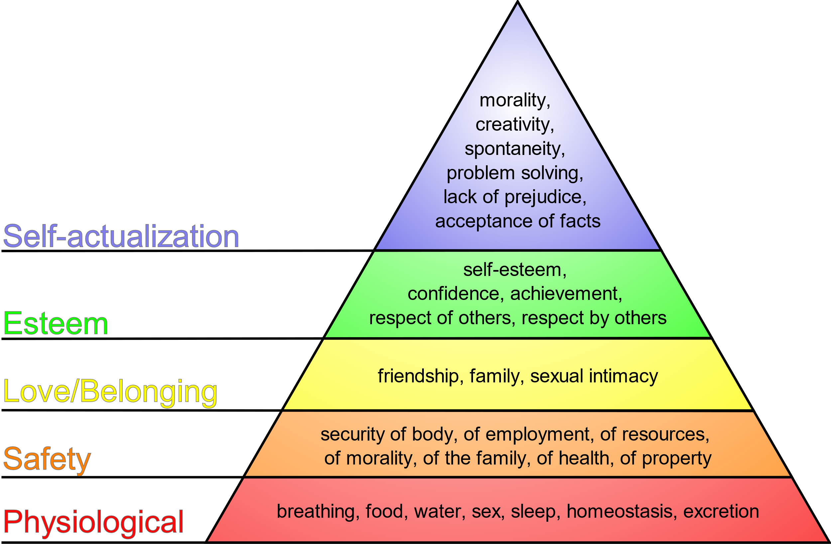
This Photo by Unknown Author is licensed under CC BY-NC

Smart Goals

Most businesses today will assert that they implement SMART goals, but they have an inclination to skip some aspects of constructing the goals Specific, Measurable, Attainable, Relevant and Time-bound.
If the goal you've set is simply pie-in-the-sky, it's unrealistic and not fair to impose on your team as you're effectively setting them up for failure rather than agreeing: "We want more profit", you will need to mention "We want to extend overall revenue by 10% within the next quarter." That's specific and measurable (not just trackable), (hopefully) attainable, quite relevant and time-bound, making it more likely to be stuck to and met.
The next step is to seek out the vital behaviours to leverage the results you are looking for and canopy the six sources mentioned above from a strategic point of view. It will be an interactive, practical session and quite emotional too, and we will found ourselves unpacking what we actually care about, what frustrates us most among the myriad influencer problems we face daily and therefore the basics of a way to influence the specified change to urge things on the right track. Andrews, Leigh. Bizcommunity.com; Cape Town: SyndiGate Media Inc. (Nov 23, 2016).
To be able to reach these objectives we need to use the Swot Conversion.
Conversion strategies

WEAKNESS  | STRENGHT
POOR MANAGERIAL SKILLS | EFFECTIVE STRATEGIES
POOR TIME MANAGEMENT | ORGANISED
LACK OF SKILLS | VERY WELL-TRAINED STAFF

THREATS | OPPORTUNITIES
MANY COMPLAINTS | Explore new solutions to problems
NOT ENOUGH NURSES | MENTORSHIP PROGRAM FOR TRAINEE NURSES TO DO THEIR PLACEMENT HERE, POSSIBLE FUTURE NURSES IN OUR WORKPLACE
POOR WOUNDS MANAGEMENT | CHAMPION IN WOUND CARE

Using this tool, helped me to review my goals, to see my smart objectives, to understand my weakness, strengths and to see my threats and opportunities, also helped me to learn how to convert them.
My Smart Goal is to change the care services in my workplace, my goal is specific because is defined, is clear, I know very well that with hard work people will change the bad habits and our care services will improve. Because for the next 6 months everyone’s work will be monitored and supervised, we will apply new strategies, regular meetings, appraisals, improve our communication with our clients and their families, this goal is measurable and achievable.
As a Clinical Lead, with my experience and my mentorship skills I will be able to motivate, inspire and gain the trust not just from my staff, from my clients also and because of this I can consider that my objective is realistic.
All staff and myself will have six months as a time limit to reach our goal, there is plenty of time to change bad habit, implement a new “face” for the care services that we provide in our workplace.

Personal Development Plan
A Personal Development Plan is a written account of self-mirrored image and improvement, which doubles up as a detailed movement plan used to fulfil academic, personal, or career based totally goals.
Personal development plan is visible as a method of implementing strategic initiatives and managing the self-improvement to gain and maintain competitive advantage. Greenan, Peter. Journal of Workplace Learning; Bradford Vol. 28, Iss. 5, (2016): 322-334. DOI:10.1108/JWL-09-2015-0068

Personal Development Plan

Development objective | Specific actions | Blockers and how they will be removed | Support required | How I will know when I have achieved the objective
1.To finish all three years of university, to graduate | To attend all my classes  To do all my assignments  To pass all my modules | My blockers are: over working, time-management.  I will be able to remove by being more responsible, more organised (to finish assignments in time), to work just my contract hours | I need support from the manager to set up flexible shifts to be able to attend and pass all my modules, family support and I have to set up a plan to get myself organised.  To improve my communication in relation with my lecturers and to request help when needed. | I will know that I have achieved my objective when I will graduate and I will have a degree in BA Honours Leadership and Management skills in the work place
2.To be a Health  Care Inspector | To finish the university  To pass the QCF Level 9 in health and social care | Time-management  Not passing the exams  In order to remove my blockers I have to make sure that I will graduate, I will have to set up Smart Goals to be able to monitor my achievements as passing my exams for QCF Level 9 | Family support  Financial Support  Get more organised to be able to support my own goals  Trainings and professional support | Having the degree and the certificates that I need to be able to be qualified as a healthcare inspector, working as a inspector in health and social care.
3.To lose half of my weight | Changing my lifestyle  Joining a gym | Over working, time-management, not being focused into my goal, not being realistic are some of the blockers but I will be able to remove them by being focused, setting a smart objective every week, monitor my weight weekly, working just my contract hours | Support that I will need will be from my GP, professional from the gym instructor, from my manager to be able to have breaks and have healthy meals, be more organised and realistic to support my own goal. | Losing half of my weight and being healthy will be the result to show that I have reached my objective.

A personal improvement plan (PDP) will guide all the nurses in their career, no matter what grade they're at and whether they work in an acute or community setting. PDPs help nurses and doctors turn out to be extra self-aware, permitting them to understand a way to enhance performance and expand new skills. They must engage in this process, as it is far now a key component of value determinations and revalidation.
Setting specific, measurable, achievable, relevant, and time bound (SMART) objectives is crucial to PDP as it is miles notion that low fulfilment of goals may relate to poor first-rate PDP planning. A PDP facilitates plan and show the success of persevering with expert development. Planning and comparing learning need to be a continual process as circumstances change and plans may need to be modified. The final step is to mirror on how powerful the PDP has been and whether there are areas that have no longer been tackled or have not worked. Reflection need to pressure learning, and a completed PDP need to be a building block for future PDPs. Tasker, Fiona. BMJ : British Medical Journal (Online); London Vol. 351, (Oct 28, 2015). DOI:10.1136/bmj.h4603

Conclusion
In conclusion, this report is a mirror of my research and study in order to reach my first step in my professional development. Using Kolb’s is learned how to reflect over my action, because of Johari’s window I discovered myself and through others peoples eyes, because of Maslow’s pyramid I understand my needs better and I know how to work at my personal development plan using smart goal and conversion strategies. Using this skills in my work place will improve qualities as a manager, to improve the services for my clients, to manage better my staff and to improve our relation in work, to use our resources, to reduce the cost and to implement new plan of action.
Offering support to my staff with good trainings for their own personal and professional development, using supervisions, appraisals and meetings to improve our communication, to build a better manager-employees connexion, to reduce the risks and for better problems solving.
References
- https://dictionary.cambridge.org/dictionary/english/self-assessment 15.02.20/16:40
- Stephen Covey, 1999, P.66 -67
- Williams, Kristine N, Yelena Perkhounkova, Ying-Ling Jao, Ann Bossen, Maria Hein, Sophia Chung, Anne Starykowicz, and Margaret Turk. "Person-Centred Communication for Nursing Home Residents with Dementia: Four Communication Analysis Methods." Western Journal of Nursing Research 40.7 (2018): 1012-031. Web.
- Lucy Webb, (2011) Nursing: Communication Skills in Practice pp6.
- Peter Ellis and Sherley Bach (Eds) (2015) Leadership, Management and Team Working in Nursing. 2nd Edition. London: Sage Publications Inc
- Mahoney, Dawn J, CPLP. Training; Minneapolis Vol. 56, Iss. 5, (Sep/Oct 2019): 52.
- Sharma, Sangeeta; Sharma, Sakshi. IUP Journal of Soft Skills; Hyderabad Vol. 13, Iss. 2, (Jun 2019): 49-54.
- Andrews, Leigh. Bizcommunity.com; Cape Town Cape Town: SyndiGate Media Inc. (Nov 23, 2016)
- Professional Career Development, Week 2 – Swot and Conversion’s Strategies https://moodle.uwtsd.ac.uk/course/view.php?id=7845
- Greenan, Peter. Journal of Workplace Learning; Bradford Vol. 28, Iss. 5, (2016): 322-334. DOI:10.1108/JWL-09-2015-0068
- Tasker, Fiona. BMJ : British Medical Journal (Online); London Vol. 351, (Oct 28, 2015). DOI:10.1136/bmj.h4603

Appendices

EXPERINCE

TEST REFLECTION

CONCEPTUALIZE

Development objective | Specific actions | Blockers and how they will be removed | Support required | How I will know when I have achieved the objective
1.
2.
3.

Personal Development Plan

