University of Wales Trinity Saint David
Wales Institute of Science and Art


Electronical Circuit Testing & Applications

Electrical Control Systems/ ACHA4010

Nicholas Davey
2104746
31/03/2023
Contents
Task 1, Circuit Question Sheet 1
1 A 1
1.1 B 1
1.2 c (i) 1
1.3 c (ii) 1
1.4 c (iii) 1
1.5 c (iv) 1
1.6 d 1
1.7 e 2
1.8 f 2
1.9 g 2
2 Task 2 3
2.1 Scope Time Division Calculations 3
2.2 Function Generator output sine wave 3
2.3 Unsmoothed Rectifier Wave 3
2.4 Smoothed Rectifier Wave 4
2.5 Drop in Voltage Question 4
2.6 Rectifiers use in Automotive applications Question. 5
2.7 Probing Question 5
3 Task 3 6
3.1 Scope Time Division Calculations 6
3.2 Function Generator output sine wave 6
3.3 Capacitor charge and discharge wave marked at correct points. 7
3.4 Basic Capacitor Calculations 7
3.5 Capacitor discharge table 8
3.6 Gradient Plot and calculations 8
3.7 Inaccuracies Question 9
4 References 10

Task 1, Circuit Question Sheet

1 A
Voltage = Current x Resistance ( V=IR)
Resistance = Voltage / Current (R=V/I)
12 / 0.5 =
24
24 / 4 =
6 Ohms
Resistance of E = 6 Ohms

B
IB + IC = 0.3A
0.3 / 2 = 0.15A
Direct Current passing through B = 0.15A
Direct Current passing through C = 0.15A

c (i)
P = IV
= i^2R
R = P / I^2
= 0.9Js / (0.3A) ^2
= 10Ohms
Therefore, Resistance of A = 10Ohms

c (ii)
The resistance of B and C =

c (iii)
To work out the potential difference between A, B and C we need to use the equation V = I x R
Therefore the Potential Difference across A, B and C will be 4.5V

c (iv)
As the diagram shows, the resistors across A, B and C are all in parallel with each other. As previously calculated, The resistance of D would be 5V

d

e

f

g

Task 2

2.1 Scope Time Division Calculations
In order to work out 1 full time period of a 10Hz sine wave, we had to do the following equation:
Time period = 1/Frequency
10Hz = 1/10
= 0.1s
Therefore, 1 full period for a 10Hz sine wave would be 0.1s

2.2 Function Generator output sine wave
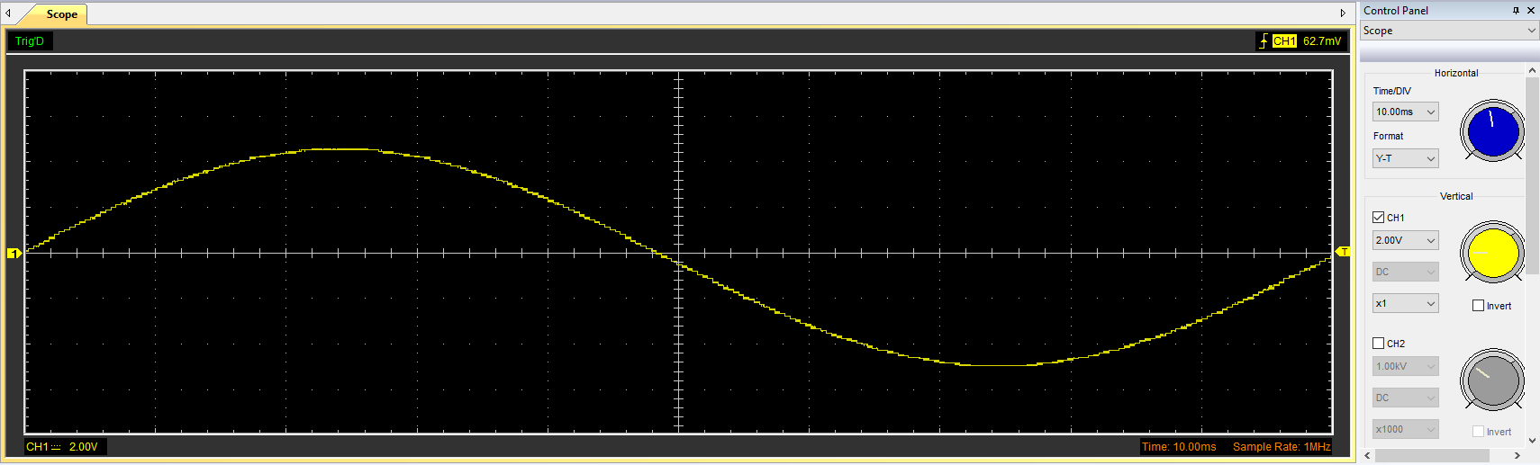
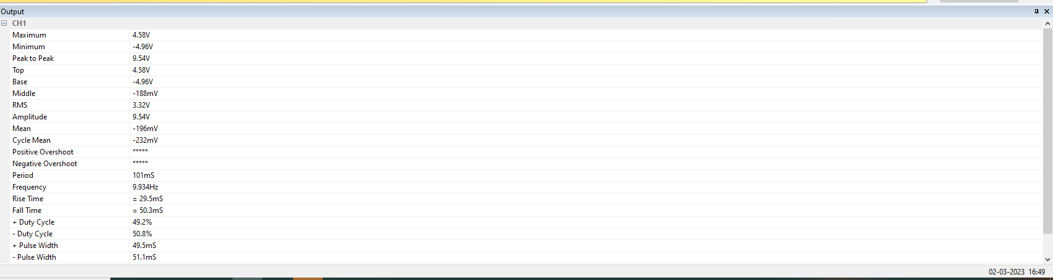

2.3 Unsmoothed Rectifier Wave
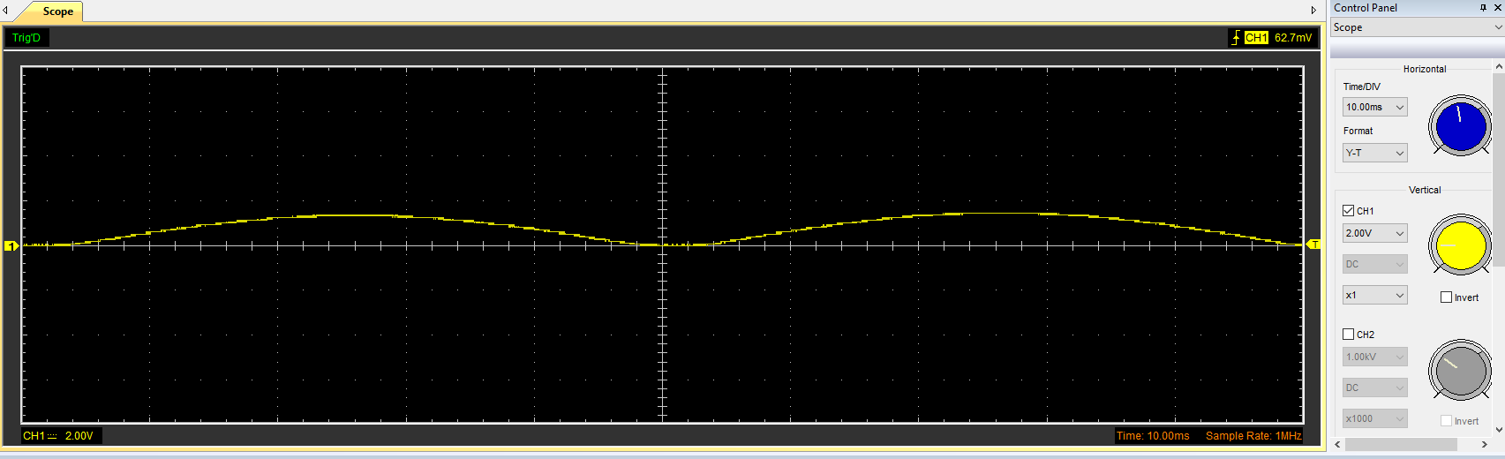
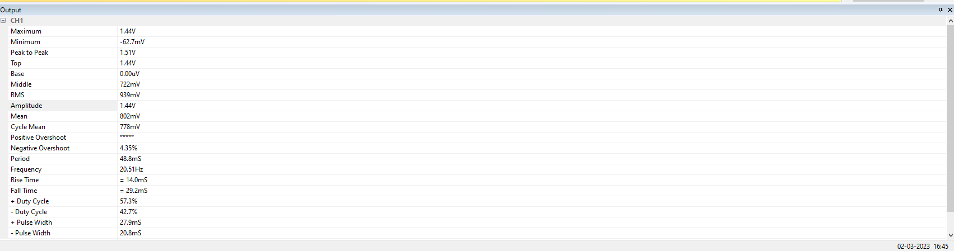

2.4 Smoothed Rectifier Wave
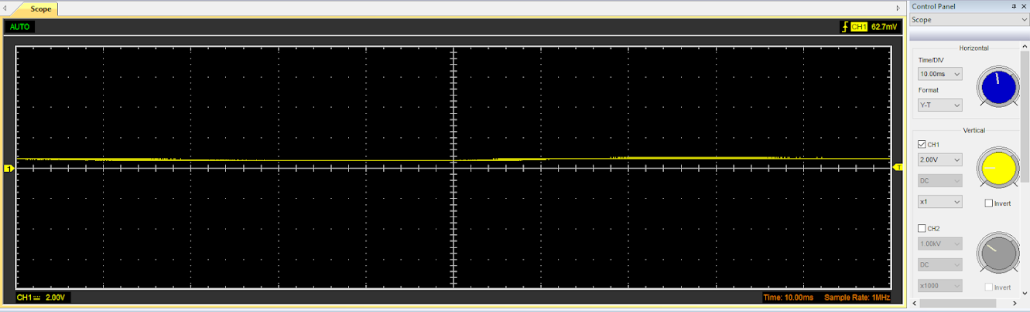
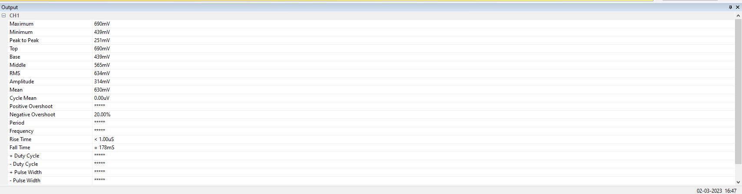

2.5 Drop in Voltage Question
There can be different factors that cause this drop in voltage. For example, this may be caused by a Voltage drop across diodes or the load resistance. Diodes are used to help covert the AC voltage to DC voltage. During the rectification process, there is a voltage drop across the diodes. This drop across the diodes can in turn cause a loss in the DC output voltage. Furthermore, when a load is attached to the rectifier, the rectified DC voltage powers the load. The load resistance affects how much electricity the load draws. Ohm's Law states that the load current is directly proportional to the voltage decrease across the load resistance. As a result, the DC output voltage decreases as the load current rises and the voltage drop across the load resistance increases.

2.6 Rectifiers use in Automotive applications Question.
Rectifiers are technological tools that change alternating current (AC) to direct current. (DC).
In automobiles, rectifiers are usually used in the alternator. As the alternator spins, it produces AC voltage, which is then rectified by the diodes to create DC voltage. The DC voltage is then what can be used to charge the car's battery and power its electrical systems. Without this rectification, the AC voltage produced by the alternator would be unusable in powering the electrical systems and charging the battery.
Another example where rectifiers are used in automotive application would be in an ECU. An ECU requires a stable and reliable power source to function correctly. Like this, many other electrical systems in a car require this stable cand constant power output which again why rectifiers are used in automotive application.
‘In systems powered by internal combustion engines, alternator provides power to the automotive electrical system by charging the battery during normal runtime of the vehicle. Rectified alternator output voltage can contain AC voltage ripple superimposed on the battery voltage during entire life time of the vehicle depending on the operating conditions.’ ( Texas Instruments, Sep 2021)

2.7 Probing Question
Simultaneous Probing is the process of measuring multiple signals at the same time using either probes or sensors. It is commonly used within engineering in order to measure the various outputs from complex systems where lots of signals are involved.
Simultaneous Probing is important in terms of automotive application for many reasons. For example, Simultaneous probing can be used to perform diagnostic checks on a car. Using Simultaneous probing, an engineer can diagnose problems within a cars electrical or mechanical function. When measuring multiple signals at once, an engineer can identify issues such as component failure and voltage drops that may be affecting the performance of the vehicle.
Furthermore, simultaneous probing can also be used for optimization purposes. When measuring multiple signals at once, an engineer can seek out areas where adjustments can be made in order to improve/benefit the performance, efficiency and reliability of the car. In addition to this, Simultaneous probing can help to test various components and electrical systems of an engine. An engineer can measure the performance of an engine under specific conditions. This allows for optimization for these specific conditions to get the desired performance from the engine.
In class, the function generator and rectifier circuit could have been connected to the same ground. The Ground is a reference point for signals, so when connecting multiple probes to the same ground, we have essentially created a ‘Ground Loop’. A ground loop is a situation where there are numerous ways for current to flow through a circuit between two or more points, which can lead to interference and affect the precision of the measurements. Another factor which could have affected the outcome could have been the equipment used in class. This is because the equipment used was of fairly low quality. This low quality means that the efficiency and accuracy of the device could have been affected. This may be less of a concern when using equipment that is to a higher quality standard.

Task 3

3.1 Scope Time Division Calculations
10Hz is a Frequency
Period = 0.1s x 1/10Hz = 100mS
10Hz is the Frequency (1/0.1s)
Marked on Cap = 106
10Ohms is the Resistance
0.00001F is equal to 10 microfarads of capacitance (Farads)
T = (R*C) = 10 x 0.00001 = 0.0001s which equals 0.1 mS
20T = 20 x 0.0001 = 0.002 mS
12T = 12 x 0.0001 = 0.0012 mS

3.2 Function Generator output sine wave
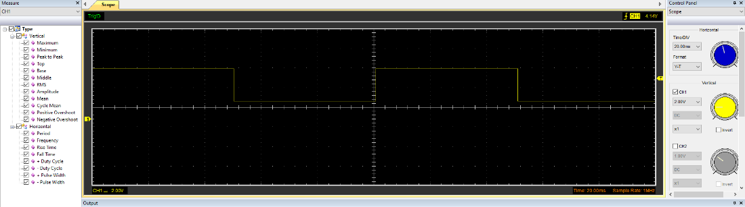
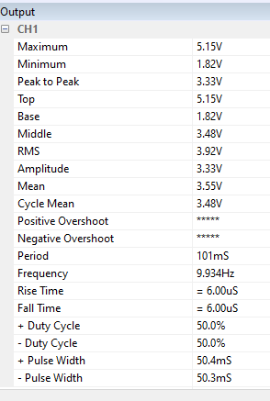

3.3 Capacitor charge and discharge wave marked at correct points.
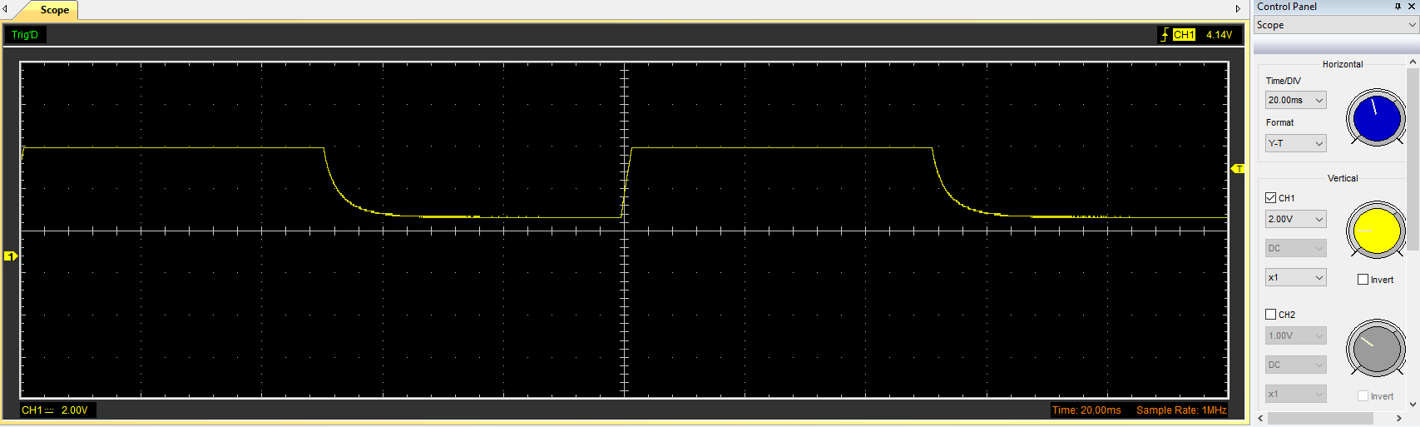
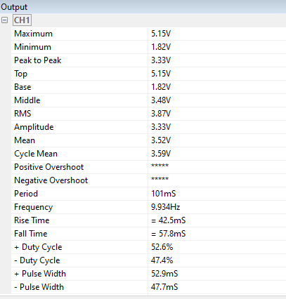
Discharge
Charge

3.4 Basic Capacitor Calculations
T = RC
RC = 0.0001s
R = 10Ohms
C = T/R
= 0.0001s / 10 Ohms
= 0.00001
= 10µF

3.5 Capacitor discharge table
A = lnV0
=1.6380
B = -(1/RC)
= -10,000
t(s) | 0 | 0.02 | 0.04 | 0.06 | 0.08 | 0.1 | 0.12 | 0.14 | 0.16
Voltage (V) | 5.1451 | 4.7686 | 4.3294 | 3.8902 | 3.3882 | 2.9490 | 2.4471 | 2.0078 | 1.8196
lnV | 1.638 | 201.638 | 401.638 | 601.638 | 801.638 | 1001.638 | 1201.638 | 1401.638 | 1601.638

3.6 Gradient Plot and calculations
t(s) | 0 | 0.02 | 0.04 | 0.06 | 0.08 | 0.1 | 0.12 | 0.14 | 0.16
Voltage (V) | 5.1451 | 4.7686 | 4.3294 | 3.8902 | 3.3882 | 2.9490 | 2.4471 | 2.0078 | 1.8196
lnV | 1.638 | 201.638 | 401.638 | 601.638 | 801.638 | 1001.638 | 1201.638 | 1401.638 | 1601.638
Log V | 0.71139 | 200.6783 | 400.6364 | 600.5899 | 800.5299 | 1000.469 | 1200.389 | 1400.303 | 1600.260
Delta | 0.92661 | 0.9597 | 1.0016 | 1.0481 | 1.109 | 1.169 | 1.249 | 1.335 | 1.378
% Difference | 43.43% | 99.524% | 99.7506% | 99.8258% | 99.862% | 99.883% | 99.8961% | 99.905% | 99.914%

3.7 Inaccuracies Question
There are many factors that need to be considered when talking about why the measurement can be different to the specified value. Some of these factors could be Huma Error, Signal Interference, low quality equipment or the amount of times which a test is conducted.
Human error refers to mistakes or deviations made in the testing process which can potentially cause an unexpected outcome. This is due to cognitive, physical, organizational and environmental factors. For example, fatigue, stress and situation awareness can all play a part in taking an accurate final result, or during the test.
Signal interference takes place when unwanted signals ( referred to as ‘noise’) disrupt or distort the intended signal. This can lead to poor quality or a total loss of the signal. The interference can come down to things such as physical obstacles, natural events (such as lightning) and electromagnetic interference from other devices or signals. To prevent this from happening, multiple methods have been put in place to reduce the interference like frequency hopping, error correction algorithems and more such as filtering and shielding techniques.
Low quality equipment can also play a part in taking our final result. The lower quality equipment led to our results being less accurate due to a reduced efficiency. This can also lead to having a worse signal quality which can lead to unclear recordings.

References
chrome-extension://efaidnbmnnnibpcajpcglclefindmkaj/https://www.ti.com/lit/an/slvaf88/slvaf88.pdf?ts=1680450527707&ref_url=https%253A%252F%252Fwww.google.com%252F
Torchinsky, J. (2018) This is why cars use ac-producing alternators when they run on DC power, Jalopnik. Jalopnik. Available at: https://jalopnik.com/this-is-why-cars-use-ac-producing-alternators-when-they-1826966427 (Accessed: April 2, 2023).

