Managing Projects in the Workplace

Course Code : BMSW5104
Course Title:MANAGING PROJECTS IN THE ORGANISATION
Student Name: STEFANIA ENOAICA
Student ID :2124107
Name of Tutor – Aderemi Ojebode (Dr)
Table of Contents
1. Introduction 3
2. Project description 3
3. Scope 4
4. Work breakdown structure 6
5. Quad Chart 7
6. Gantt Chart 9
7. Stakeholders' Involvement 10
8. Allocation of resources 11
9. Risk Analysis 11
10. Conclusion 12
Reference List and bibliography 13

Task 2: Project Management Plan

1. Introduction
The purpose of this project management plan is to demonstrate the plan for launching a new product. Minus-Sugar is the name for the anticipated product. Minus-Sugar is a sugar-free cold drink that uses alternatives to sugar, such as stevia leaves to sweeten the beverage. Stevia is a natural sweetener; however, it does not contain calories which makes it the perfect alternative to sugar. The report is going to demonstrate the overall product idea, and the steps involved in launching the product. Stakeholders and their involvement in the project will be demonstrated. Allocation of resources will be included in the discussion followed by a thorough analysis of the risk potentially associated with the project.

2. Project description
This project relates to the launching of a new sugar-free cold drink, MINUS SUGAR ! There are several sugar-free cold drinks available in the market, however, the anticipated sugar-free drink, called Minus-Sugar is different as it is going to uses stevia leaves as an alternative to sugar in the drink, whereas the regularly available sugar-free drinks, for example, Coca-Cola Zero Sugar, contain chemical sweeteners, such as Aspartame. Such sweetening agents, such as Aspartame have been found to lead to certain side effects on health, including certain types of cancer, tumours in the urinary tract, preterm delivery, toxic liver diseases and so on. Therefore, to eliminate the health hazards associated with the common alternatives to sugar, Minus-Sugar is going to launch a sugar-free drink with the goodness of Stevia leaves. A purified form of Stevia called stevioside is approved by the FDA which indicates its consumption safety.
The product launch project has a range of steps. The first and foremost step is to gather market knowledge before the product can be launched. For instance, information related to the demand for cold drinks and the hazards produced by the regular consumption of cold drinks can be considered before the product is designed and launched.
The next step is to find the target market for the newly launched product. In this case, the market will be segmented based on demographic characteristics. Especially, age will be taken into account while segregating customers into distinctive groups. There will be four age groups, such as 11-18 years old, 19-26 years, 27-34 years, and 34+ years. Among these, the 11-18-year-old age group will be mainly targeted by Minus-Sugar. According to Collins et al. (2016), individuals belonging to the age group 11-18 years in the UK consume the highest volumes of sugar-sweetened beverages. Therefore, this age group is more prone to develop health complications related to excess consumption of sweetened beverages. Although Minus-Sugar will also target other age groups, this particular age group will be the main target of the marketing initiatives undertaken by the company.
Determining the marketing mix is the next most important step in launching the product (Marušić, 2018). The product offered by Minus-Sugar is a range of sweet beverages with some of the most preferred flavours, including lime, orange, cola-caramel, and apple. The beverages will be made available in different sizes and at different price points. A penetrative pricing strategy will be used by the company. Under the penetrative pricing strategy, low initial pricing is used by companies to garner the attention of customers. In this case, penetrative pricing would help the company in setting a foothold in the beverage industry of the UK. Minus-Sugar would be mainly sold through dealers and distributors. In addition, eCommerce websites would also be used for selling the beverage. Both online and offline channels would be used to distribute the products to the end-users. The use of an omnichannel distribution would ensure that the beverage reaches as many consumers as possible. Social media marketing will be mainly incorporated to promote the products. The company will use different social media channels, such as Facebook, Instagram, and YouTube to propagate the product to the customers. On the other hand, Freebie marketing will also be used under which free samples of the product will be distributed to consumers to raise general awareness about the product. Once customers become acquainted with the product, it would be easier to sell the product.

3. Scope
The scope of the project is a method of setting boundaries for the project. In other words, project scope is a part of planning for the project which encompasses the determination and documentation of project goals, deliverables, tasks, costs, and deadlines. The scope of the current project will be discussed in the form of project objectives, deliverables, the key tasks involved in the project, the cost of accomplishing each task, and the determination of the deadlines for executing the tasks.
The objectives of the project are stated below.
- To develop a successful plan to launch a new product in the market.
- To set a firm foothold in the food and beverage market and gain a fair market share in the beverage market of the UK.
- To develop a new customer base through the launch of a new product Minus Sugar.
- To develop a viable marketing plan for the new product called Minus Sugar.
Deliverables
The project deliverables are tangible or intangible outcomes that must be handed over to the owners of the project after the completion of the project. The deliverables of the project are as follows.
- The first deliverable is a business plan. The business plan would have a detailed discussion regarding the idea of the product. In addition, a descriptive marketing plan would be included in the business plan.
- The second deliverable is a financially viable product that would help generate economic profit through sales.
- The third deliverable is an idea of the target market for the new product.
- The fourth deliverable is a viable marketing plan for the new product.
- The fifth deliverable is a budget plan for the launch and subsequent operations of the newly launched product.

Budget for the project
The following table depicts the planned budget for the new product Minus-Sugar.

Particulars | Estimated cost (£)
Marketing research | 1000
Inbound and outbound transportation | 3000
Raw materials and resources | 4000
Unit of production | 7000
Workers’ wages | 5000
Training and development | 3000
Marketing and promotion of the product | 2500
Legal formalities | 1500
Miscellaneous | 4000
Total | 31000
Table 1: Budget for the project
(Source: Created by the learner)

The tasks related to the accomplishment of the project are outlined below.
- The first task is to conduct extensive marketing research to identify the appropriate target market. The identification of the target market is necessary to frame an appropriate marketing plan for the launch of the new product.
- The next task is to determine the marketing mix for the product. The marketing plan is a comprehensive plan of initiatives that a company must undertake to sell a product successfully.
- The third task is to create a pitch for the product to convince the investors. This is an important step to secure adequate financial resources for executing the anticipated project. In the absence of adequate financial resources, the project cannot be successfully executed.
- The fourth and final task is to start the production of the product and monitor the performance of the product against the stated marketing objectives.

4. Work breakdown structure
A work breakdown structure refers to a management plan to accomplish a complex multi-step project. Using the work breakdown structure, a complex project is broken down into multiple smaller steps to ease the process of accomplishing each of the steps (Tereso et al., 2019). In other words, a work breakdown structure helps in breaking down a complex multistep project into manageable tasks. The following table represents the work breakdown structure for the project at hand. The WBS not only showcases the subtasks of the project but also determines the start date, duration, and end date of each subtask.
Activities | Start date | Duration | End date
Determining the objectives of the project | 13/10/2023 | 2 | 11/13/2023
Conducting extensive marketing research | 11/13/2023 | 20 | 12/3/2023
Determining the project deliverables | 12/3/2023 | 10 | 12/13/2023
Meeting with stakeholders to state the project goals | 12/13/2023 | 5 | 12/18/2023
Determining the required resources for the project | 12/18/2023 | 7 | 12/25/2023
Selecting the target market | 12/25/2023 | 10 | 1/4/2024
Creating a marketing plan | 1/4/2024 | 12 | 1/16/2024
Making settlements with the suppliers | 1/16/2024 | 15 | 1/31/2024
Procuring raw materials | 1/31/2024 | 14 | 2/14/2024
Project execution | 2/14/2024 | 21 | 3/6/2024
Monitoring the success of the product | 3/6/2024 | 10 | 3/16/2024
Table 2: Work breakdown structure
(Source: Created by the learner)

5. Quad Chart
A quad chart is defined as technical documentation that briefly demonstrates an innovation through writing and illustration (Frost, 2012). The reason behind naming the document as a “quad chart” is the presence of the four quadrants with a landscape layout. The components of a quad chart include “purpose, capabilities, customers, and success/connection”. The following quad chart demonstrates the purpose, capabilities, customers, and success of Minus-Sugar.

Description
Quadrant 1: Product
The first quadrant signifies the product of Minus Sugar. The product is a sugar-free soft beverage that would be sweetened using stevia leaves instead of using another chemical sweetening agent. The specifications of the product are as follows.
- Carbonated soft drink sweetened with stevia extract named stevioside.
- Several size alternatives will be available for consumption.
- Primarily, the soft drink would be sold in recycled metal cans. The larger volume of drinks will be sold in recycled plastic bottles.
- The price of the product will be quite affordable as the target market of the product contains individuals aged between 11 and 18 years. Therefore, affordable pricing is important to attract customers of that age.
The second quadrant of the quad chart represents capabilities and differentiation. The capabilities of the newly launched product are outlined below.
- Soft beverage but with zero calories.
- Replaces sugar with stevioside and exerts little to no harmful impact on the human body.
- Minus-Sugar has production capabilities that will help the company manufacture and distribute the new products.
- The company has a group of well-trained staff which will help achieve the business objectives.
- The company has transportation capabilities which would help the company develop a well-established supply chain for the procurement of raw materials and distribution of end-products to consumers.
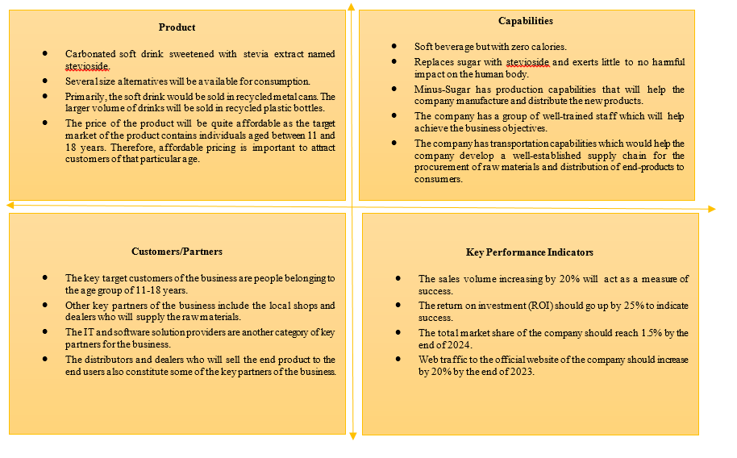
Figure 1: Quad Chart
(Source: Created by the learner)

The third quadrant represents key customers and partners associated with the business.
- The key target customers of the business are people belonging to the age group of 11-18 years.
- Other key partners of the business include the local shops and dealers who will supply the raw materials.
- The IT and software solution providers are another category of key partners for the business.
- The distributors and dealers who will sell the end product to the end users also constitute some of the key partners of the business.
The fourth quadrant of the chart represents key performance indicators that would be used to measure the performance of the newly launched products.
- The sales volume increasing by 20% will act as a measure of success.
- The return on investment (ROI) should go up by 25% to indicate success.
- The total market share of the company should reach 1.5% by the end of 2024.
- Web traffic to the official website of the company should increase by 20% by the end of 2023.

6. Gantt Chart
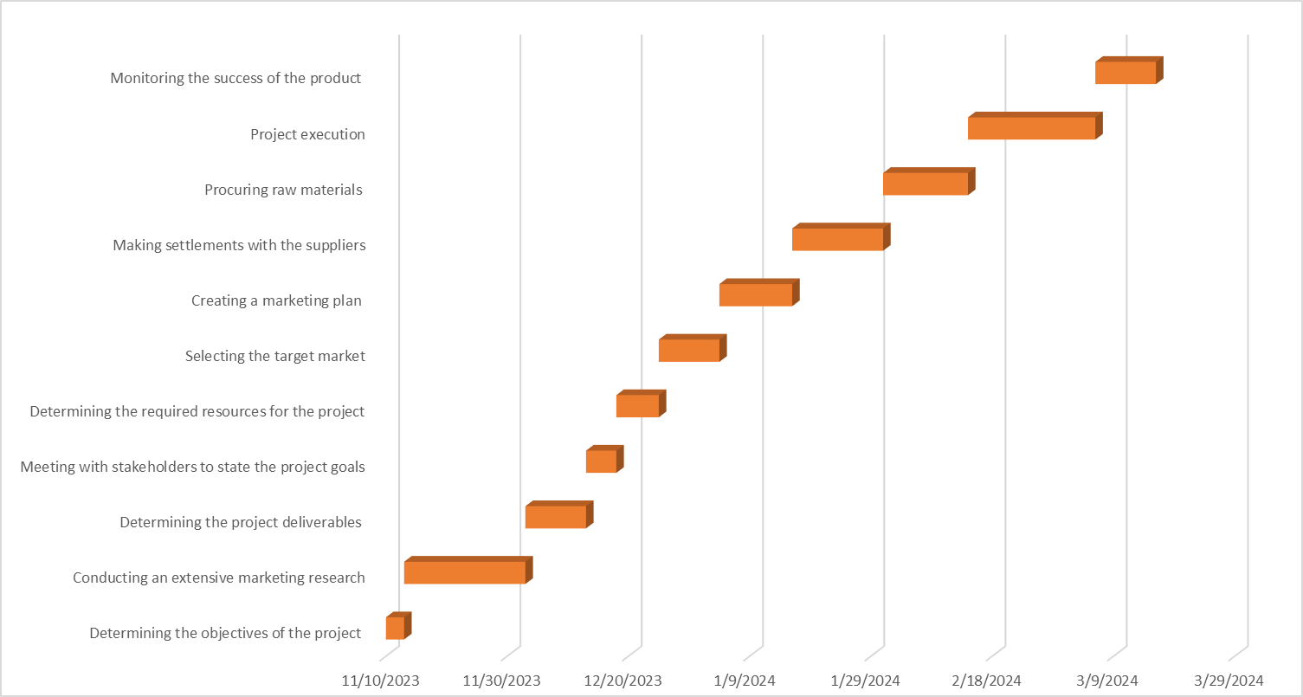
Figure 2: Gantt Chart
(Source: Created by the learner)

7. Stakeholders' Involvement
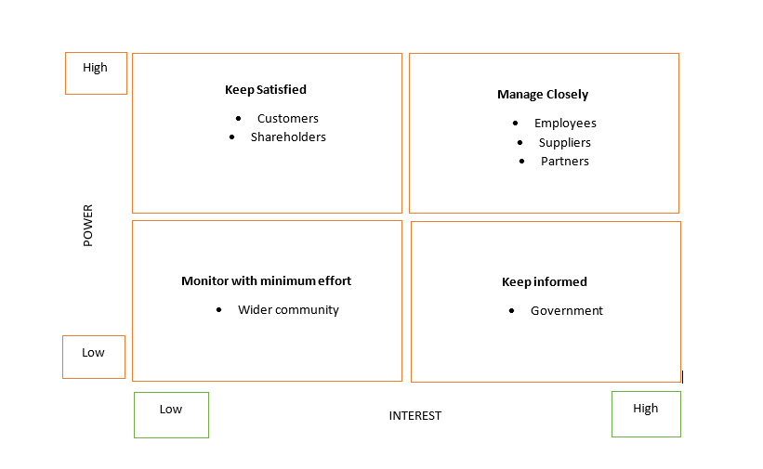
Figure 3: Stakeholder matrix
(Source: Created by the learner)
Figure 2 presents the stakeholder matrix, otherwise known as the power/interest matrix. The stakeholders of the company have been categorised based on their respective power and interest in the company’s operations (Nguyen and Mohamed, 2018). As can be perceived from the picture, the highest power is held by the customers and shareholders of the company. Therefore, these stakeholders need to be satisfied with the operations of the company. Customers can be kept satisfied by tailoring the products to their specific requirements. Shareholders can be kept satisfied by generating adequate financial profit from the business operations of the company. The next category of stakeholders who hold high power and high interest are the employees, suppliers, and business partners of the company. These stakeholders must be managed closely to strike a balance between different operations of the business. For instance, employees can be managed closely by subjecting them to performance management systems. On the other hand, suppliers can be subject to regular audits to make sure that they comply with the company standards and set procedures. The government has been categorised as a stakeholder who has a high interest but can not directly influence the company’s decisions. Therefore, the government should be kept informed about the activities of the company. Finally, the wider community has the lowest power and the lowest interest in the function of the company. Therefore, the wider community should only be monitored with minimum effort spent on them.

8. Allocation of resources
Resource allocation is the part of project management whereby the tangible and intangible resources are divided among different tasks of the project management (Selaru, 2012). To successfully allocate resources, first a plan for the resource allocation should be developed. As such, the resources will be allocated in a way to maximise the efficiency of the project management team and accomplish the tasks within the stipulated time.

9. Risk Analysis
Risk | Intensity of the risk | Likelihood of the risk | Mitigation strategy
Financial risk | High | High | Financial risk can be mitigated by conducting extensive market research. Through primary and secondary market research, a product that meets the needs and demands of customers will be developed to minimise the risk of product failure.
Risk of injury | High | Low | Employees might get injured while working at the production facility. To mitigate such risks, employees will be provided with adequate personal protective gear. In addition to that, every piece of equipment used in the production facility will be scrutinised to ensure safety.
Operational risk | Moderate | Low | To avoid operational failure, regular audits and risk analyses will be performed so that external risks can be identified as soon as they emerge.
Table 3: Risk analysis table
(Source: Created by the learner)

10. Conclusion
The report has delivered a project management plan for the new product. The new product is called Sugar-Minus which is a zero calorie carbonated beverage. The main idea is to let customers enjoy a sweet beverage without having to worry about the development of side effects of sugar or other chemical alternatives to sugar. The report has presented the key project deliverables. A Gantt chart has been developed to indicate the time frame of the subtasks. In addition, a risk analysis has been conducted.

Reference List and bibliography
Akhwaba, J.K., 2020. The Moderating Influence of Project Scope on Leadership Skills, Stakeholder Management, and Execution of Fibre Optic Infrastructure. Advances in Civil Engineering, 2020.
Bond-Barnard, T.J., Fletcher, L. and Steyn, H., 2018. Linking trust and collaboration in project teams to project management success. International Journal of Managing Projects in Business, 11(2), pp.432-457.
Chen, C. and Tang, L., 2019. BIM-based integrated management workflow design for schedule and cost planning of building fabric maintenance. Automation in construction, 107, p.102944.
Collins, B., Capewell, S., O’Flaherty, M., Timpson, H., Razzaq, A., Cheater, S., Ireland, R. and Bromley, H., 2015. Modelling the health impact of an english sugary drinks duty at national and local levels. PLoS One, 10(6), p.e0130770.
Dwivedi, Y.K., Ismagilova, E., Hughes, D.L., Carlson, J., Filieri, R., Jacobson, J., Jain, V., Karjaluoto, H., Kefi, H., Krishen, A.S. and Kumar, V., 2021. Setting the future of digital and social media marketing research: Perspectives and research propositions. International Journal of Information Management, 59, p.102168.
Fda. 2023. GRAS NOTICE FOR STEVIA LEAF EXTRACTS . [Online] Available at: <https://www.fda.gov/media/119340/download> [Accessed On 13th October 2023]
Fleck, A. 2023. The Biggest Soft Drinks Markets In The World. [Online] Available at: <https://www.statista.com/chart/30385/estimated-sales-of-soft-drinks/> [Accessed On 13th October 2023]
Frost, E., 2012. So What’sa Quad Chart, Exactly?: Exercises in Genre. GRASSROOTS WRITING RESEARCH JOURNAL, p.113.
Good, A. and Omisade, O., 2019. Linking activity theory with user centred design: a human computer interaction framework for the design and evaluation of. Applied Interdisciplinary Theory in Health Informatics: A Knowledge Base for Practitioners, 263, p.49.
Heagney, J., 2016. Fundamentals of project management. Amacom.
Huo, Y., Xu, Z., Moon, H., Bao, S., Assad, A., Moyo, T.K., Savona, M.R., Abramson, R.G. and Landman, B.A., 2018. Synseg-net: Synthetic segmentation without target modality ground truth. IEEE transactions on medical imaging, 38(4), pp.1016-1025.
Jenkins, E.L., Legrand, S., Brennan, L., Molenaar, A., Reid, M. and McCaffrey, T.A., 2021. Psycho-behavioural segmentation in food and nutrition: A systematic scoping review of the literature. Nutrients, 13(6), p.1795.
Kerzner, H., 2022. Project management metrics, KPIs, and dashboards: a guide to measuring and monitoring project performance. John Wiley & Sons.
Kotler, P., 2012. Kotler on marketing. Simon and Schuster.
Leisch, F., Dolnicar, S. and Grün, B., 2018. Market segmentation analysis: Understanding it, doing it, and making it useful.
Lock, D., 2020. Project management. Routledge.
Marušić, T., 2019. Importance of marketing mix in successful positioning of products and services on the market. Ekonomska misao I praksa, 28(1), pp.431-446.
Nguyen, T.S. and Mohamed, S., 2018. Stakeholder management in complex projects.
Organ, C and Bottorf, C. 2023. Work Breakdown Structure (WBS) In Project Management. [Online] Available at: <https://www.forbes.com/advisor/in/business/what-is-work-breakdown-structure/> [Accessed On 13th October 2023]
Park, J. and Kim, D., 2022. A case study of medicalized wellness clinic design process and result in the context of an emerging wellness service market.
Ridder, M. 2023. Soft drinks: carbonates by regular, mid and no calorie in the United Kingdom 2021. [Online] Available at: <https://www.statista.com/statistics/283926/soft-drinks-carbonates-by-regular-or-no-added-sugar-in-the-united-kingdom-uk/> [Accessed On 13th October 2023]
Selaru, C., 2012. Resource allocation in project management. International Journal of Economic Practices and Theories, 2(4), pp.274-282.
Sreenivasan, A., Suresh, M. and Nedungadi, P., 2023. Mapping analytical hierarchy process research to sustainable development goals: Bibliometric and social network analysis. Heliyon, 9(8).
Statista, 2023. Soft Drinks - United Kingdom. [online]. Available at:<https://www.statista.com/outlook/cmo/non-alcoholic-drinks/soft-drinks/united-kingdom> [Accessed on: 13th October 2023].
Tereso, A., Ribeiro, P., Fernandes, G., Loureiro, I. and Ferreira, M., 2019. Project management practices in private organizations. Project Management Journal, 50(1), pp.6-22.
Thabit, T. and Raewf, M., 2018. The evaluation of marketing mix elements: A case study. International Journal of Social Sciences & Educational Studies, 4(4).
Who. 2023. Aspartame hazard and risk assessment results released. [Online] Available at: <https://www.who.int/news/item/14-07-2023-aspartame-hazard-and-risk-assessment-results-released> [Accessed On 13th October 2023]
Zarrella, D., 2009. The social media marketing book. " O'Reilly Media, Inc.".

