
Computational Methods ACMA6001
Arnaud Marotin

January 26, 2024
University of Wales Trinity Saint David

Adam Evans 2005959

Table of Contents
Adam Evans 2005959 0
Tabel of Figure 2
1.0 Introduction 4
1.1 Problem Statement 4
1.2 Aims and Objectives 4
1.3 report structure 5
2.0 The Constitutive equation 5
3.0 Explicit finite difference form of the constitutive equation 5
3.1 Tayor Series 6
3.2 Difference Approximations 8
3.3 Explicit Finite Difference Scheme 9
3.3.1 Stability Criteria 9
3.4 Fourier’s Law 10
4.0 The initial and boundary conditions implemented 10
4.1 Initial conditions 10
4.2 Boundary conditions 11
Dirichlet Boundary Condition 11
4.3 Analytical solution 12
5.0 Code details and explanations 12
6.0 Validation of the Model 15
7.0 Sensitive analysis of the code 20
7.1 Grid Spacing h 20
7.2 Time Step 21
7.3 Tolerance change 22
8.0 Limitations 23
9.0 Suggestion for improvement 24
10 Conclusion 25
Bibliography 27
11. Appendix – Script 28

Tabel of Figure
Figure 1 - Aluminium Plate properties 4
Figure 2 - Objectives 4
Figure 3 - Heat equation no heat source 5
Figure 4 - second-degree heat equation for 2D steady state heat generation 6
Figure 5 - non heat source 6
Figure 6 - Taylors series 7
Figure 7- compressed format 7
Figure 8 - Graph 1 8
Figure 9- Forward Difference 8
Figure 10 - Backwards Difference 8
Figure 11 - Central Difference 9
Figure 12 - heat transfer grid 9
Figure 13 - Spatial discretisation 9
Figure 14 - stable time step 10
Figure 15 - Fourier’s equation 10
Figure 16 - Initial Boundary conditions 11
Figure 17 - Peter Gustav Lejeune Dirichlet 11
Figure 18 - Analytical solution 12
Figure 19 - MATLAB 1 12
Figure 20 - MATLAB 2 12
Figure 21 - MATLAB 3 13
Figure 22 - MATLAB 4 13
Figure 23 - MATLAB 5 13
Figure 24 - MATLAB 6 13
Figure 25 - MATLAB 7 14
Figure 26 - MATLAB 8 14
Figure 27 - MATLAB 9 14
Figure 28 - MATLAB 10 14
Figure 29 -MATLAB 11 15
Figure 30 - MATLAB 12 15
Figure 31 - MATLAB 13 15
Figure 32 - MATLAB 14 16
Figure 33 - Analytical equation 16
Figure 34 - MATLAB 15 17
Figure 35 - MATLAB 16 17
Figure 36 - MATLAB 17 17
Figure 37 - MATLAB 18 18
Figure 38 - h = 1 time step 3600 18
Figure 39 - h = 0.5 time step = 750 19
Figure 40 - 0.8 difference. 19
Figure 41 - MATLAB 19 20
Figure 42 - MATLAB 20 20
Figure 43 - Grid spacing h 20
Figure 44 - graph for Grid spacing h 21
Figure 45 - Change in Time step 21
Figure 46 - Time step Graph 22
Figure 47 -Tolerance Value changed 22
Figure 48 - Tolerance Graph 23
Figure 49 - Old version 24
Figure 50 - New version 24
Figure 51- Different approaches 25

1.0 Introduction

1.1 Problem Statement

The assignment brief requires the study of heat being transferred through a plate of aluminium against a given time against the aluminium plate properties. Figure 1 - Aluminium Plate properties
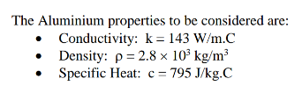
Figure 1 - Aluminium Plate properties

1.2 Aims and Objectives

The aim of the assignment is simulating the heat transfer through the aluminium plate until the aluminium plate reaches the state of thermal equilibrium.
To be able to do this a program will need to be written using the computer software MATLAB
The reason for using MATLAB is that it allows the user to write in a high-performance technical language. Integrating computation, visualization and programming in an easy to use, structured environment. Which allows problems and solutions to be expressed in a familiar mathematical notation. (cimss.ssec.wisc.edu, 2024)
The objectives that must be followed are shown in Figure 2 - Objectives
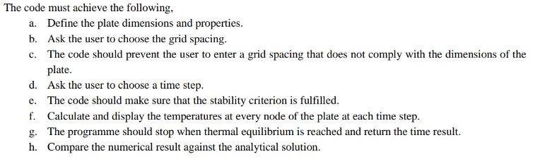
Figure 2 - Objectives

Using the methodology used in the Explicit Finite Difference Method or EFDM in short hand.
Finite difference methods use discrete approximations to the space derivatives. This results in a set of ordinary differential equations that can be solved numerically
The program which will be written will also be interactive, allowing the end user to in put their own desired grid reference although restricted against a pre-set of rules, and also allowing the user to input a desired time to which they would like to study the heat transfer.
The boundary conditions which will be applied and will remain constant will be the heat which will be applied to a defined set location, however as the ambient temperature has not been defined in the brief this will remain at 0°C along the South, East and West axis, the temperature which will remain a constant is 50°C and this will be applied to the North Axis.
The Explicit Finite Difference Method will be looked and researched to prove this is the correct equation which should be used within this study.

1.3 report structure

This report will be using extracts taken from the MATLAB coding software showing both the coding and the generated results. The MATLAB code will be written to generate both an analytical solution and a numerical solution which can be used to compare against each other.

2.0 The Constitutive equation
The heat equation in two dimensions (2D) with no heat source can be written as shown in
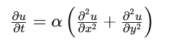
Figure 3 - Heat equation no heat source
Defining the terms with this equation
U = The temperature at point x,y at time t.
α = The thermal diffusivity of the material, a constant that depends on the properties of the material
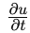 = The partial derivative of u with respect to time t, representing the rate of change of temperature.
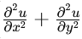 = are the second partial derivatives of u with respect to the spatial coordinates xxx and y, respectively, representing the spatial distribution of temperature

3.0 Explicit finite difference form of the constitutive equation

What is finite difference? The finite difference method or abbreviated to (FDM) replaces derivatives in the governing field equations by difference quotients, which involve values of the solution at discrete mesh points in the domain under study. Repeated applications of this representation set up algebraic systems of equations in terms of unknown mesh point values (Sadd, 2014)
The finite difference method is one way to solve the governing partial differential equations into numerical solutions in a heat transfer system. This is done through approximation, which replaces the partial derivatives with finite differences. This provides the value at each grid point in the domain. (Cadence CFD, 2024)

When using the finite difference method, it will require the aluminium plate to be split in to grid where at each intersection of the grid a temperature reading will be calculated, the finer the grid the more accurate the approximated answer which will be provided. As the aluminium plate has been split into a grid the second- degree heat equation for 2D steady-state heat generation can be applied which is shown below in Figure 3 - second-degree heat equation for 2D steady state heat generation.

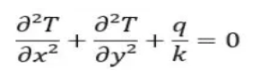
Figure 4 - second-degree heat equation for 2D steady state heat generation

When applying this equation to an object with no heat source the equation looks like Figure 4 - non heat source
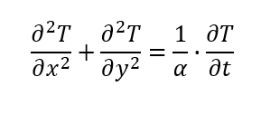
Figure 5 - non heat source

The reason why we use Explicit Finite Difference Method is that is a numerical problem-solving methodology which systematically uses equations like the ones shown above to approximate values of the unknowns, so in this case the heat being transferred through the aluminium plate. (Harish, 2023)

3.1 Tayor Series

Taylor series is widely used in the following fields
- numerical analysis,
- approximation theory,
- Engineering and physics
To approximate complex functions with simpler polynomial expressions, this is used especially for solving differential equations which is what is going to be used to calculate the heat transfer through the aluminium plate.
So with this in mind the Tayor Series will be used to understand how to generate different approximations from the first to the second derivatives.
A key word in the above information is approximations as the answer which is provided is only an approximation to what the correct answer will be, but how the Taylor Series works is the more terms you add to the equation the more accurate the approximation will become.
In mathematics, the Taylor series of a function is an infinite sum of terms that are expressed in terms of the function’s derivatives at a single point. For most common functions, the function and the sum of its Taylor series are equal near this point. Taylor’s series are named after Brook Taylor who introduced them in 1715. (yasin capar, 2020)
When looking at the first and second derivatives
While a Taylor series of the first or second order is usually sufficient for a wide range of combustion responses, there exist situations in which the response is of higher order within the model parameter space. (Bayen, 2021)
The equation for Taylors series looks like Figure 5 - Taylors series
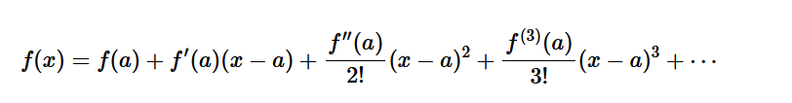
Figure 6 - Taylors series
And this can be written into a compress format show below Figure 6- compressed format
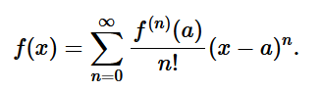
Figure 7- compressed format

where:
- is the n-th derivative of (x) evaluated at the point a,
- n! (n factorial) is the product of all positive integers up to n (with 0! =1),
- 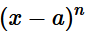 is the n-th power of the difference between x and a.

3.2 Difference Approximations

Looking at the direction derivatives as in forward, backwards, and central this is best explained firstly by plotting a graph (Figure 7 - Graph 1) with a straight line on it, the slope on the line is the approximation generated by the Tayor series equation.
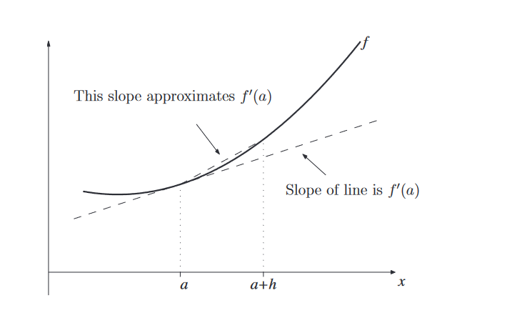
Figure 8 - Graph 1

Selecting a point on the line will give you what is called one sided difference or better known as the forward difference this equation is show below. Figure 8- Forward Difference
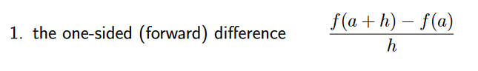
Figure 9- Forward Difference
Working backward from this point would be the backwards difference shown below Figure 9 - Backwards Difference
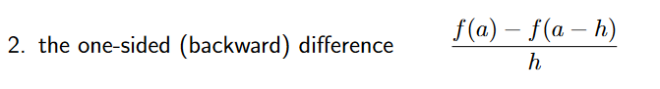
Figure 10 - Backwards Difference
And focusing on that point would be the central difference which is the most accurate. Figure 10 - Central Difference
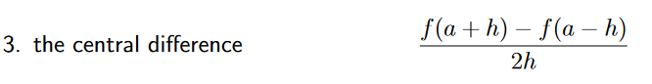
Figure 11 - Central Difference

When applying these in relation to a grid which will be generated you can work out the direction of travel using the forward, back and central equations. But the as the direction will be looking at rows and columns its easy to refer to these as North and South instead of forwards and backs columns and east to west for the rows.

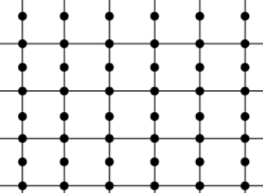
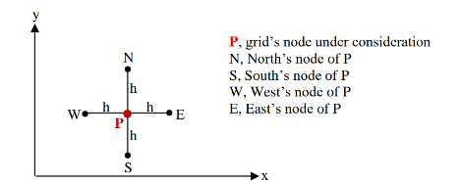
Figure 12 - heat transfer grid
Figure 13 - Spatial discretisation

This will be applied to generate the grid when calculating the heat transfer as shown in Figure 11 - heat transfer grid.

3.3 Explicit Finite Difference Scheme

In physics and mathematics, heat equation is a special case of diffusion equation and is a partial differential equation (PDE). A very popular numerical method known as finite difference methods (explicit and implicit schemes) is applied extensively for solving heat equations successfully. Examples of Explicit schemes are Forward Time and Centre Space (FTCS), Dufort and Frankel methods, whereas examples of implicit schemes are Laasonen and Crank-Nicolson methods
(Roomi, 2024)
By using the explicit method you can work out the an unknown value of a certain point in the a grid depending on the known values of its neighbouring grid points.

3.3.1 Stability Criteria

To ensure that the explicit finite difference scheme is stable the time step Δt must satisfy the following criteria Figure 14 - stable time step.
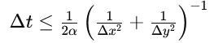
Figure 14 - stable time step

3.4 Fourier’s Law

What is Fourier's Law?
Fourier’s law states that the negative gradient of temperature and the time rate of heat transfer is proportional to the area at right angles of that gradient through which the heat flows. Fourier’s law is the other name of the law of heat conduction. This can be applied to the heat transfer grid as is one molecule is of higher heat is transferring heat to a lower temperature molecule. (byjus.com, 2024)
As the heat equation uses Fourier’s number which needs to be calculated through the equation shown below Figure 11 - Fourier’s equation
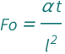
Figure 15 - Fourier’s equation
The answer to this is equation is represented by Fo, this number is the dimensionless number that characterizes transient heat conduction. Which will provide the ratio to which the heat diffuses through the matter or thermal energy. (resources.wolframcloud.com, 2024)

When all the equations and working out are complete the subject which the heat is being applied to will at some point reach a state of Stability criterion, this is reached when the subjected no longer exchanges heat due to reaching a state of equilibrium resulting in a uniformed temperature.

4.0 The initial and boundary conditions implemented

4.1 Initial conditions

The temperature will be applied only to one face of the aluminium plate at a set point and the other three faces will remain at 0 degrees along the South, East and West axis, the temperature which will remain a constant is 50°C and this will be applied to the North Axis.

4.2 Boundary conditions

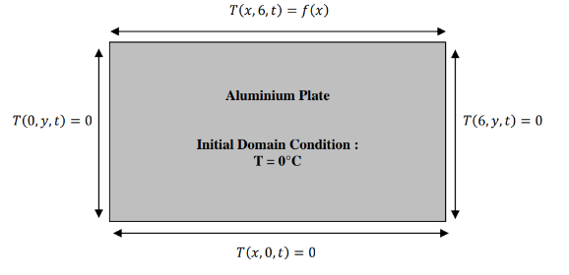
Figure 16 - Initial Boundary conditions
Boundary conditions are constraints necessary for the solution of a boundary value problem. A boundary value problem is a differential equation (or system of differential equations) to be solved in a domain on whose boundary a set of conditions is known. It is opposed to the “initial value problem”, in which only the conditions on one extreme of the interval are known. (simscale.com, 2023)

Dirichlet Boundary Condition

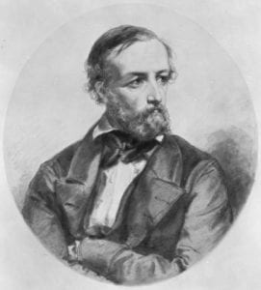
Figure 17 - Peter Gustav Lejeune Dirichlet

This condition specifies the value that the unknown function needs to take on along the boundary of the domain. Given, for example, the Laplace equation, the boundary value problem with the Dirichlet b.c. is written as:
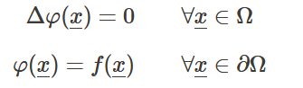
As there is only one known temperature of 50 degrees the other axis are all an unknown so the unknown functions will need to take on the boundary temperature, as it passed through the nodes which have been set on the grid.

4.3 Analytical solution

To provide confirmation that the program works within the assignment brief the analytical solution of the temperature at thermal equilibrium Figure 18 - Analytical solution has been provided, this will be written within the program to provide the comparison proving the method is correct.
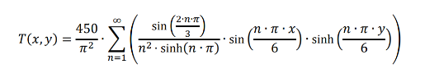
Figure 18 - Analytical solution

5.0 Code details and explanations

When writing a code, a MATLAB it is always good practice to open the code with the following Figure 13 - MATLAB 1

Figure 19 - MATLAB 1
This will clear all the windows which will prevent confusion as they could contain information from previous run codes.
The next part to enter is what we already know from the assignment brief which has been handed to us. Figure 14 - MATLAB 2
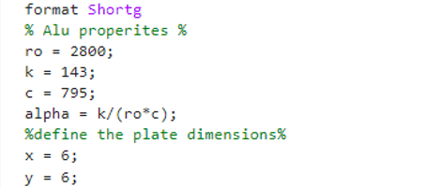
Figure 20 - MATLAB 2
On row 5 I have used the code “format shortg” this will reduce the decimal place which number are shown, so that the program is easier to read and decipher.
As the code will require user inputs to determine the grid spacing and a time step these need to be written into the program.
Figure 21 - MATLAB 3
In the above image the user is asked to enter a grid spacing Figure 15 - MATLAB 3, however the number which is being entered must be larger than 0 and also disable by 6. If an incorrect number is entered this will be displayed on the screen and the user must renter a number. The program will not continue until the correct number is entered. This code is shown in Figure 16 - MATLAB 4
Figure 22 - MATLAB 4
To allow this function to happen a while loop is used which will not allow the program to progress unless the set parameters are met and until these are met it will keep asking the user the same question repeatedly. (mathworks.com, 2024)
The input function allows the program to interact with the user by asking the question written within the (), this then can allow program to continue if it meets the while loop parameters.
The next user input is the time step in seconds and again this need to be within a set limit which is determined by Fourier’s number, but as the user won’t know what this number is the prompt if the number is entered in incorrect the first time will display the maximum number which can be entered. This is shown in Figure 17 - MATLAB 5
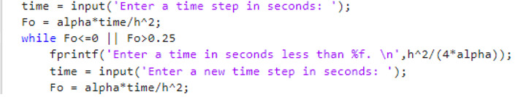
Figure 23 - MATLAB 5
With all the user inputs, inputted correctly the program will utilise these and start the calculation process.
Firstly, the matrix with the initial temperature will be made.
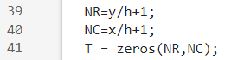
Figure 24 - MATLAB 6
The reason for the added 1 to the h value is that the grid spacing will start on 0 shown in Figure 18 - MATLAB 6
Now the boundary condition needs to be set shown in Figure 19 - MATLAB 7
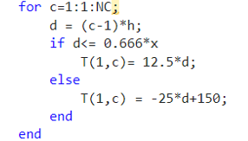
Figure 25 - MATLAB 7
Now a matrix needs to be generated for the updated temperature what are passing through the aluminium block. These will continue to calculate until thermal equilibrium is reached.
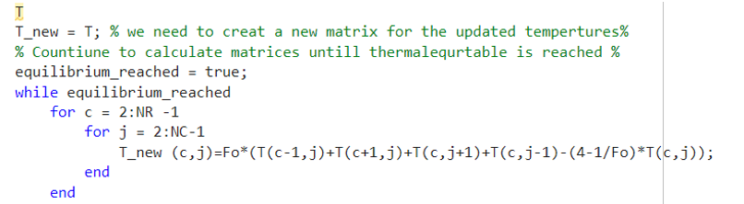
Figure 26 - MATLAB 8
Within this you can see that each direction is being considered North, South, East and West when calculating each nod. This done using the analytical equation which can be used to compare against the numerical equation.
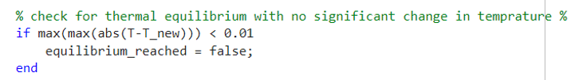
Figure 27 - MATLAB 9
The While loop will check every calculation and keep running with an increased value until equilibrium is reached.
With this the original temperature will be replaced with the new temperature
Figure 28 - MATLAB 10
This can now be plotted into a graph to show what is happening pictorially, this will allow the user to see what is happening visually, and to understand it more clearly a colormap can be selected to represent heat diffusion. Turbo has been selected as a high number is represented with a red colour and a low number is represented with a blue.
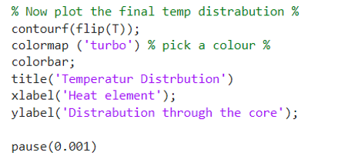
Figure 29 -MATLAB 11
The pause is added so that when the user is running the program, they can see the heat transferring through the core step by step.
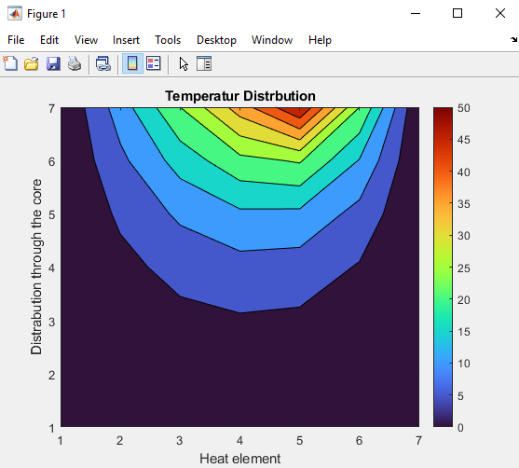
Figure 30 - MATLAB 12

A calculation and a loop counter will tell us how long it has taken this will be referred to further in the program.
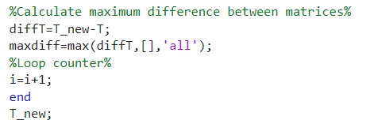
Figure 31 - MATLAB 13

6.0 Validation of the Model

To see if the program has worked using a numerical calculation, an analytical equation can be written into the program to generate a separate graph, this can then be interrogated to see how much difference there is between two temperature graphs being generated.

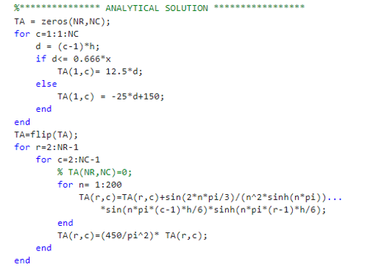
Figure 32 - MATLAB 14

This Analytical equation is provided in the assignment brief.
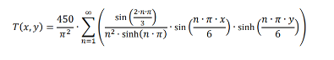
Figure 33 - Analytical equation
However instead of using an infinite number this has been replaced with 200.

Again, the result of this is put into a graph and to ensure it is displayed it is called figure(2) within the code .
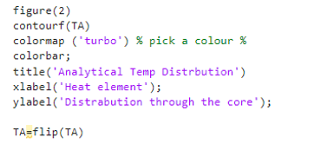
Figure 34 - MATLAB 15
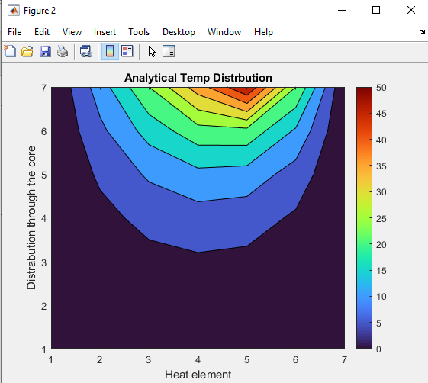
Figure 35 - MATLAB 16
To compare the graphs against each other another code was write and again this was plotted.
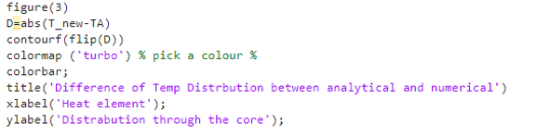
Figure 36 - MATLAB 17
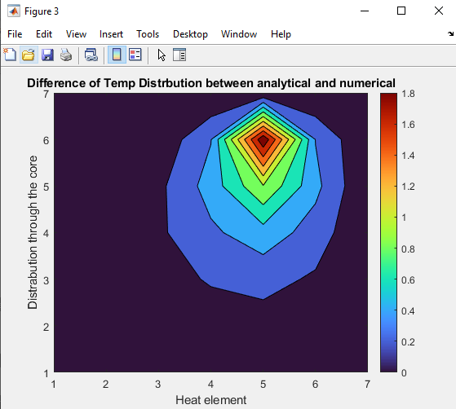
Figure 37 - MATLAB 18

From this the graphs are pretty much identical with a max difference of about 2 degrees, this shows that the numerical and analytical methods produce a result which is comparable and either result could be used.
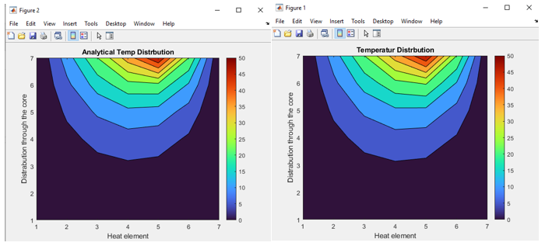
Figure 38 - h = 1 time step 3600
This program was run with the user inputs being h = 1 and time step being 3600

If the user inputs are more refined with h = 0.5 and the time step being 750 the graphs look a lot smoother.
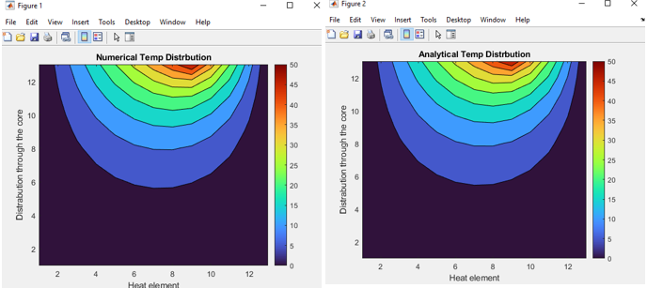
Figure 39 - h = 0.5 time step = 750

The difference between the numerical and the analytical is only 0.8 degrees, by doing this it has provided a more accurate result compared to the Figure 33 - h = 1 time step 3600, this shows that the value h which is the grid spacing the tighter the grid is the more accurate result will be provided.
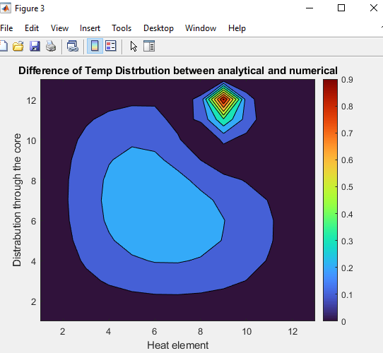
Figure 40 - 0.8 difference.

Knowing that the program which has been written is correct the final stage is establish how long thermal equilibrium takes.
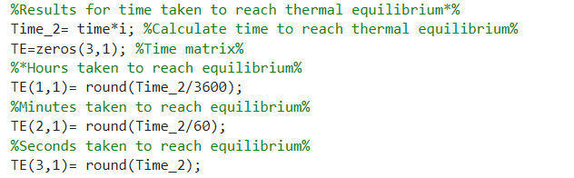
Figure 41 - MATLAB 19
With this worked out it needs to be displayed for the user to see.
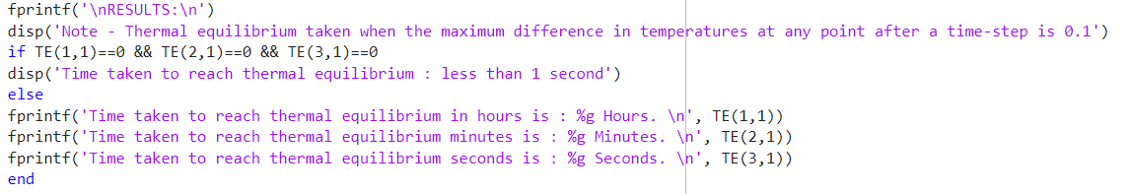
Figure 42 - MATLAB 20

7.0 Sensitive analysis of the code

In this section of the report altering different values of the program will be looked at to see how these effects the time taken to reach thermal equilibrium. The values which will be altered are.
- Grid Spacing h
- Time step
- Tolerance
Only one area will be altered leaving the other values the same during each exercise.

7.1 Grid Spacing h

For this the grip spacing will be the value which is altered leaving the time step fixed at 150 and the tolerance fixed at 0.001, this is shown in Figure 37 - Grid spacing h
Figure 43 - Grid spacing h
When these number are plotted onto a graph it can be seen that the tighter the grid spacing is the more consistent the values are and the last four grid spacing results are similar with the last two being the same.( Figure 38 - graph for Grid spacing h)

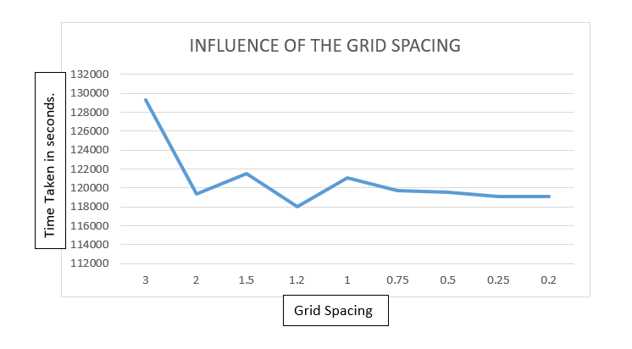
Figure 44 - graph for Grid spacing h

7.2 Time Step

Again, the same method is going to be applied where only the time step changes with the other two factors staying the same. Figure 39 - Change in Time step

Figure 45 - Change in Time step

When plotting these values, the smaller the time step the more the line changes where with the larger time step the graph increase isn’t as dramatic. Figure 40 - Time step Graph
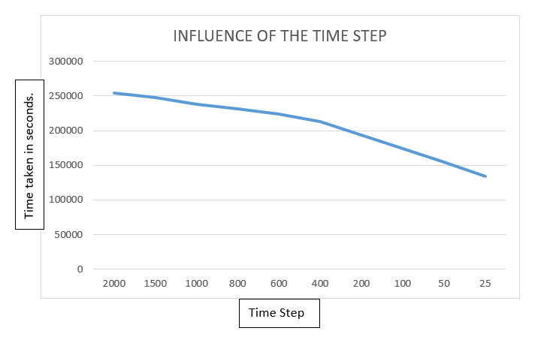
Figure 46 - Time step Graph

7.3 Tolerance change

The same method was applied when looking at the effect of the tolerance change, with only the tolerance value being altered. Figure 41 -Tolerance Value changed

Figure 47 -Tolerance Value changed

When these values are plotted the line which is given off is straight, which means the tighter tolerance will take much longer reach the thermal equilibrium time. Figure 42 - Tolerance Graph
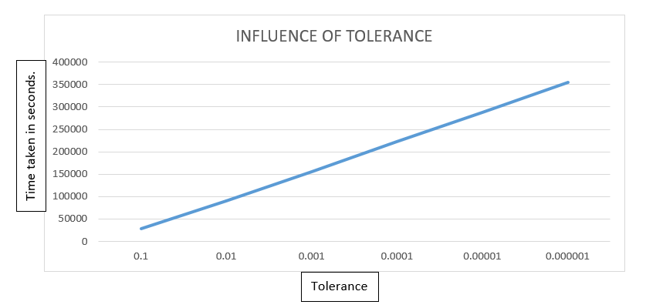
Figure 48 - Tolerance Graph

8.0 Limitations

When looking at the limitations both numerical method and the coding method have them.
numerical method can provide round off errors as computers represent numbers in binary form, which means numbers can be represented infinite binary form fractions, example 1/3 is 0.010101010101010……. therefore, any normal computer which sees a finite number of bits in each storage location will not represent the number exactly. (Smith, 2021)
A truncation error can be given, this means that there is an difference between an actual and a truncated, of a cut off value. The truncated quantity is represented by a number with a number of allowed digits with an excess digits chopped off. (Awati, 2024)
Example of truncation error
e^{x} = 1 + (x / 1!) + (x² / 2!) + (x³ / 3!) + ⋯ + (x^{n} / n!) + ⋯ ∞
e^{x} = 1 + x + (x² / 2) + (x³ / 6) + ⋯ + (x^{n} / n!) + ⋯ ∞
Thus, e^{x} has an infinitely long series that can be expressed in a truncated (approximated) format:
e^{x} = p₂x +∑∞ (x^{n} / n!)
n = 3
(Awati, 2024)

9.0 Suggestion for improvement

When writing this about the program I have realised that the use of the letter c to represent rows and the letter j to represent columns was a confusing situation, so in the program which I have submitted I have corrected these. This is shown below in Figure 43 - Old version and Figure 44 - New version. Going forward I will use letters which represent the item which I am referring too and not just a random letter.

Figure 49 - Old version

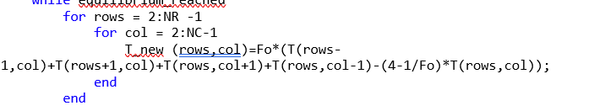
Figure 50 - New version

The use of comments as I am writing the program, will benefit me so when I need to come back to the program after a long period of time I can understand more clearly when I am coding.
Apart from looking at ways to improve the current program there are also methods which could be looked at for heat equation the Crank-Nicholas method could be used or the Implicit Scheme.
With this assignment Taylors theory has been used but alternatively Eulers method could be used although when comparing Taylors and Euler’s method the following needs to be considered.
Euler’s method is a simple and intuitive numerical technique suitable for basic problems, while Taylor’s method offers higher accuracy but may be more computationally demanding. The choice between these methods depends on the specific requirements of the problem at hand, including the desired level of accuracy, computational resources available, and the nature of the differential equation being solved. (easynotesstore.com, 2024)
The below Figure 45- Different approaches displays different methods which could be used to calculate and understand Finite Differences.
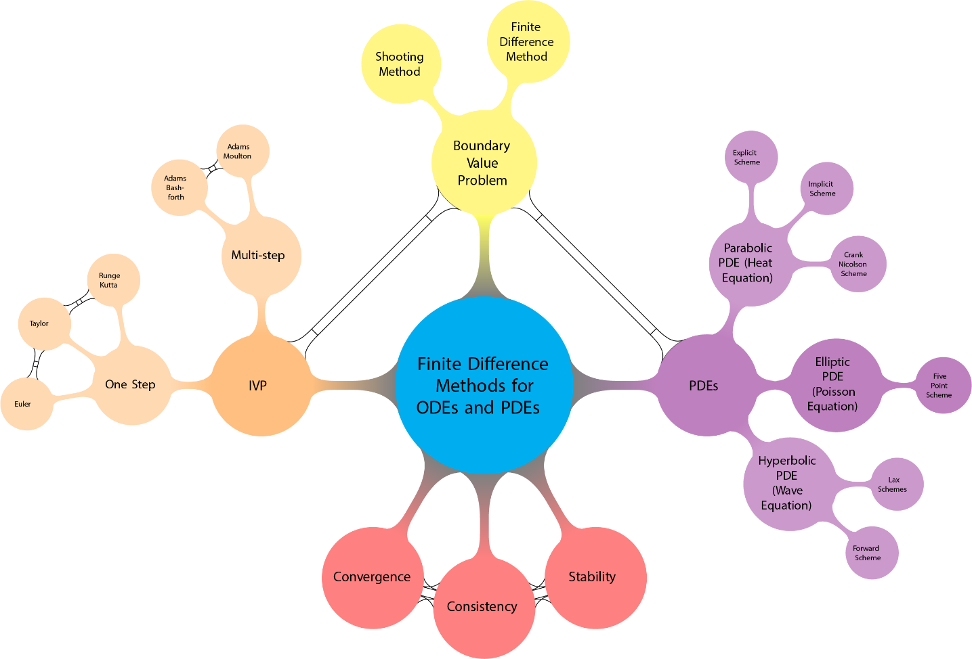
Figure 51- Different approaches
Understanding how the heat is being applied to the aluminium plate can also lead us to use other methods for example if the heat was being applied though radiation the problem would be represented in a nonlinear format and the Stefan-Boltzmann constant could be applied
Where the the PDE describing the temperature in this thin plate is
ρCptz∂T∂t−ktz∇2T+2Qc+2Qr=0
(uk.mathworks.com, 2024)

10 Conclusion

The code which has been written gives off a theoretical value and this must always be taken into consideration when applying the results to a real word situation, in this incident there was an analytical equation which we could compare the results to showing that they were very similar. However, having an analytical solution is not always the case as this is one of the only few which are written. But what this code does is provide the end user with data which can be used and which will give the best possible idea to how something is going to react under the situation it has been subjected too.
What is made clear is that the tolerances, time and grid spacing which you apply will change the level of accuracy which is generated and this need to be considered when taking your result of thermal equilibrium, this has been shown in Figure 39 - graph for Grid spacing h, Figure 40 - Change in Time step, Figure 41 - Time step Graph. To prove this comparing the answers giving in Figure 33 - h = 1 time step 3600Figure 34 - h = 0.5 time step = 750. Where h was changed only by 0.5 give a more accurate answer.
The code which has been generated relies on the boundary conditions not changing over time, in a real-world situation this would not be the case as air temperature would need to be considered also the object itself wouldn’t be at an even set temperature.

Bibliography
Awati, R., 2024. https://www.techtarget.com/. [Online]
Available at: https://www.techtarget.com/whatis/definition/truncation-error
[Accessed 20 january 2024].
Bayen, A. M., 2021. https://www.sciencedirect.com. [Online]
Available at: https://www.sciencedirect.com/topics/engineering/taylor-series
[Accessed 20 january 2024].
byjus.com, 2024. byjus.com. [Online]
Available at: https://byjus.com/physics/fouriers-law/#what-is-fouriers-law
[Accessed 21 6 2024].
Cadence CFD, 2024. resources.system-analysis.cadence.com. [Online]
Available at: https://resources.system-analysis.cadence.com/blog/msa2022-explaining-the-finite-difference-method-and-heat-transfer
[Accessed 2 January 2024].
cimss.ssec.wisc.edu, 2024. cimss.ssec.wisc.edu. [Online]
Available at: https://cimss.ssec.wisc.edu/wxwise/class/aos340/spr00/whatismatlab.htm
[Accessed 1 6 2024].
easynotesstore.com, 2024. easynotesstore.com. [Online]
Available at: https://easynotesstore.com/eulers-method-taylors-method/
[Accessed 1 6 2024].
Harish, A., 2023. https://www.simscale.com. [Online]
Available at: https://www.simscale.com/blog/implicit-vs-explicit-fem/
[Accessed 2 january 2024].
jpeterson, 2024. CrankNicolson, Florida: people.sc.fsu.edu.
mathworks.com, 2024. www.mathworks.com. [Online]
Available at: https://www.mathworks.com/help/matlab/ref/while.html
[Accessed 22 6 2024].
resources.wolframcloud.com, 2024. https://resources.wolframcloud.com. [Online]
Available at: https://resources.wolframcloud.com/FormulaRepository/resources/Fourier-Number-Using-Thermal-Diffusivity
[Accessed 20 January 2024].
Roomi, D. T. O., 2024. https://www.uomustansiriyah.edu.iq. [Online]
Available at: https://www.uomustansiriyah.edu.iq/media/lectures/6/6_2021_11_16!12_16_20_PM.pdf
[Accessed 21 6 2024].
Sadd, M. H., 2014. www.sciencedirect.com. [Online]
Available at: https://www.sciencedirect.com/topics/engineering/finite-difference-method
[Accessed 21 6 2024].
simscale.com, 2023. https://www.simscale.com. [Online]
Available at: https://www.simscale.com/docs/simwiki/numerics-background/what-are-boundary-conditions/
[Accessed 21 6 2024].
Smith, I., 2021. https://www.quora.com. [Online]
Available at: https://www.quora.com/What-is-a-round-off-error-in-numerical-analysis
[Accessed 20 January 2024].
uk.mathworks.com, 2024. uk.mathworks.com. [Online]
Available at: https://uk.mathworks.com/help/pde/ug/nonlinear-heat-transfer-in-a-thin-plate.html
[Accessed 22 6 2024].
yasin capar, 2020. yasincapar.com. [Online]
Available at: https://yasincapar.com/taylor-expansion/
[Accessed 20 January 2024].

11. Appendix – Script
% first clear the workspace and command window%
clc
clear all
close all
format Shortg
% Alu properites %
ro = 2800;
k = 143;
rows = 795;
alpha = k/(ro*rows);
%define the plate dimensions%
x = 6;
y = 6;
% asking the user to define the grid referance %
h = input('Enter the grid perameters for h: ');

% Check if the entered value is greater than 0 and entirely
% divisible by 6

while rem(6,h)~=0 || h>=6 || h<=0
fprintf('The entered value must be greaterthan 0 and also entirely divisible by 6.\n');
h = input('Enter the grid perameters for h: ');
end
% now that we have the grip spacing we need them to enter a time %
time = input('Enter a time step in seconds: ');
Fo = alpha*time/h^2;
while Fo<=0 || Fo>0.25
fprintf('Enter a time in seconds less than %f. \n',h^2/(4*alpha));
time = input('Enter a new time step in seconds: ');
Fo = alpha*time/h^2;
end
%start to generate the matrix with intial temps when h=1 %
NR=y/h+1;
NC=x/h+1;
T = zeros(NR,NC);
for rows=1:1:NC
d = (rows-1)*h;
if d<= (2/3)*x
T(1,rows)= 12.5*d;
else
T(1,rows) = -25*d+150;
end
end
T;
T_new = T; % we need to creat a new matrix for the updated tempertures%
% Countiune to calculate matrices untill thermalequrtable is reached %
i=0; %Set Loop Counter%
equilibrium_reached = true;
while equilibrium_reached
for rows = 2:NR -1
for col = 2:NC-1
T_new (rows,col)=Fo*(T(rows-1,col)+T(rows+1,col)+T(rows,col+1)+T(rows,col-1)-(4-1/Fo)*T(rows,col));
end
end

% check for thermal equilibrium with no significant change in temprature %
if max(max(abs(T-T_new))) < 0.01
equilibrium_reached = false;
end

% Now i need to update the matrix with the new temperatures%
T = T_new;

% Now plot the final temp distrabution %
contourf(flip(T));
colormap ('turbo') % pick a colour %
colorbar;
title('Numerical Temp Distrbution')
xlabel('Heat element');
ylabel('Distrabution through the core');

pause(0.001)
i=i+1; %Loop counter%
end
T_new;

%*************** ANALYTICAL SOLUTION *****************
TA = zeros(NR,NC);
for rows=1:1:NC
d = (rows-1)*h;
if d<= 0.666*x
TA(1,rows)= 12.5*d;
else
TA(1,rows) = -25*d+150;
end
end
TA=flip(TA);
for r=2:NR-1
for rows=2:NC-1
% TA(NR,NC)=0;
for n= 1:200
TA(r,rows)=TA(r,rows)+sin(2*n*pi/3)/(n^2*sinh(n*pi))...
*sin(n*pi*(rows-1)*h/6)*sinh(n*pi*(r-1)*h/6);
end
TA(r,rows)=(450/pi^2)* TA(r,rows);
end
end
figure(2)
contourf(TA)
colormap ('turbo') % pick a colour %
colorbar;
title('Analytical Temp Distrbution')
xlabel('Heat element');
ylabel('Distrabution through the core');

TA=flip(TA)

figure(3)
D=abs(T_new-TA)
contourf(flip(D))
colormap ('turbo') % pick a colour %
colorbar;
title('Difference of Temp Distrbution between analytical and numerical')
xlabel('Heat element');
ylabel('Distrabution through the core');

% Results for time taken to reach thermal equilibrium%
%Calculate time to reach thermal equilibrium%
Time_2= time*i;
%Time matrix%
TE=zeros(3,1);
TE(1,1)= round(Time_2/3600); %Hours taken to reach equilibrium%
TE(2,1)= round(Time_2/60); %Minutes taken to reach equilibrium%
TE(3,1)= round(Time_2); %Seconds taken to reach equilibrium%
%Displaying results%
fprintf('\nRESULTS:\n')
disp('Note - Thermal equilibrium taken when the maximum difference in temperatures at any point after a time-step is 0.1')
if TE(1,1)==0 && TE(2,1)==0 && TE(3,1)==0
disp('Time taken to reach thermal equilibrium : less than 1 second')
else
fprintf('Time taken to reach thermal equilibrium in hours is : %g Hours. \n', TE(1,1))
fprintf('Time taken to reach thermal equilibrium in minutes is : %g Minutes. \n', TE(2,1))
fprintf('Time taken to reach thermal equilibrium in seconds is : %g Seconds. \n', TE(3,1))
end

