  Component One: Student Journal (learning log) | Student  No: 2234842
Module
Title: Hotel Administration and Front Office
Module
Code: BMIH4004
 | Lecturer: Natalie Brailsford,Muhammad Cassamo

Component One: Student Journal (learning log)

Gibbs Reflective Cycle
Gibbs’ reflective cycle was primarily developed by Graham Gibbs in 1988. This particular reflective framework is associated with six integral stages that help in indulging in the concept of learning from experience (Adeani et al., 2020). This particular reflection is focused on identifying the skills that are required for working in the front desk of a Hospitality organisation and aligning my skills concerning my personal and professional experience.

Description
The description is the first stage of this specific learning model, which is associated with the overall narration of the experience initiated by an individual (Williams et al., 2020). I am currently working as a front desk associate at Holiday Inn in Sunderland, City Centre, SR1 3DS. In my workplace, I am in charge of doing various responsibilities that include coming to the visitors, ensuring and making a reservation on behalf of the visitors, keeping account of check-in and check-out, scheduling guest activities and administrative and clerical tasks such as data entry. In my professional role, I have developed several skills and still learning about many things that could enhance my overall work capacity.

Feelings
Feeling refers to the internal thoughts, emotions and ideal of the individual that is prevalent previously during and after the overall learning session (Markkanen et al., 2020). As this particular job role is associated with work-based learning, I was quite excited yet nervous at the same time. However, with the help of effective training, I was able to deal with my lower self-esteem and improve my skills regarding effective communication, maintaining polite interpersonal behaviour, active listening to the guests and timely completing all my duties. Now, I am quite confident about my overall skills and knowledge regarding my professionalism as a front desk associate at the Holiday Inn.

Evaluation
Evaluation refers to the process of making sense of the overall situation by comprehending both the positive and negative aspects of the experience (Matsuo and Nagata, 2020). The things that work well in this particular work-based learning is that I was able to develop a range of skills that include effective customer service, communication and interaction, interpersonal behaviour, organisation and time management and effective computer ecoefficiency. Attention to detail is an important aspect of maintaining accuracy in the aspect of Hospitality Management including recording overall information of the consumers along with payment handling and assigning rooms to the guests (Bardi, 2011). These are the major aspect that was completely unknown to me previous to the job experience and I have developed this knowledge. However, the thing that does not go well in this situation is that, my lack of problem-solving and adaptability skills.

Analysis
Analysis refers to the process of assessing the overall sense of the experience. In my opinion, the initial aspect of utilising the Transferable competencies worked well as I was previously accustomed to concepts like communication and interpersonal behaviour along with effective time management. For example, the Guest Cycle theory would be apprehended in this particular contact that focuses on the overall understanding of the operation management through the stages like pre-arrival, arrival, Occupancy and post-departure of the guests of the hotel (Tesone, 2012). Similarly, in my opinion, the aspect that does not go well in this experience is simply associated with my lack of understanding and confidence. Night audit management in this aspect could be a helpful process that helps ensure the accuracy of the activities associated with the specific day (Tewan, 2009).

Conclusion
The conclusion is the next stage of Gibb's reflective cycle and it describes the overall learnings from a situation. I feel the learning process helps in the development of the situational experiences in the front office and provides the area of improving skills The essence of positive and negative impacts of a situation can be obtained better from the knowledge of the conclusion stage. It provides an arena for improving the skills that are required in the tasks for the front office and executing the upscaling of the performance (Chalupa and Chadt, 2021) I observed that there are various ways of solving any issues of incident that can be addressed.

Action Plan
The action plan is the final stage of Gibb’s reflective cycle and it provides the knowledge of planning. I feel that every situation can be repeated in the hotel industry. Therefore, the stages of the action plan provide the knowledge for developing the plan to face any kind of similar situation in future and to overcome it with the necessary skills. I feel the action of acting in a situation can be improved in a better way. The duty of the front office manager has a high range of interaction with the guests and requires skills in communication (Sayin and Karaman, 2019). Therefore, the reaction to the situation can be improved with a more developed action plan evaluation.

References
Adeani, I.S., Febriani, R.B. and Syafryadin, S., 2020. Using GIBBS’reflective cycle in making reflections of literary analysis. Indonesian EFL Journal, 6(2), pp.139-148.
Bardi, J. 2011. Hotel Front Office Management, Wiley, London.
Markkanen, P., Välimäki, M., Anttila, M. and Kuuskorpi, M., 2020. A reflective cycle: Understanding challenging situations in a school setting. Educational Research, 62(1), pp.46-62.
Matsuo, M. and Nagata, M., 2020. A revised model of experiential learning with a debriefing checklist. International Journal of Training and Development, 24(2), pp.144-153.
Sayin, O.G.K. and Karaman, A., 2019. Communication and productivity with guests at front office; A qualitative study on hotels. Journal of International Management and Social Researches, 6(11), pp.186-196.
Tesone, D., 2012. Principles of management for the hospitality industry. Routledge.
Tewan, J.R., 2009. Hotel front office: operations and management. Oxford University Press.
Williams, K., Woolliams, M. and Spiro, J., 2020. Reflective writing. Bloomsbury Publishing.

Component Two

Trip Advisor Review Response

Dear customer,
Thank you, for the time to provide us with this valuable feedback. We are very happy to know that you have chosen our hotel for your stay and you have been quite satisfied with our services. Your feedback is extremely valuable to us this review has been a great motivation for our entire Holiday Inn family to continue to provide excellent services that will meet all the needs and Expectations of our guests. The mission of our organisation is to make a difference to all the people we come in contact with every day and your review has been identified as a small step towards our commitment. We look forward to the opportunity to welcome you again to our hotel shortly. If you have any kind of recommendations for us to provide you with extra care that will meet your expectations and make the overall stay at our hotel more special, please feel free to contact us again or leave a review for us.
Warm regards,
Hotel Holiday Inn.

Referenced Screen Shot:
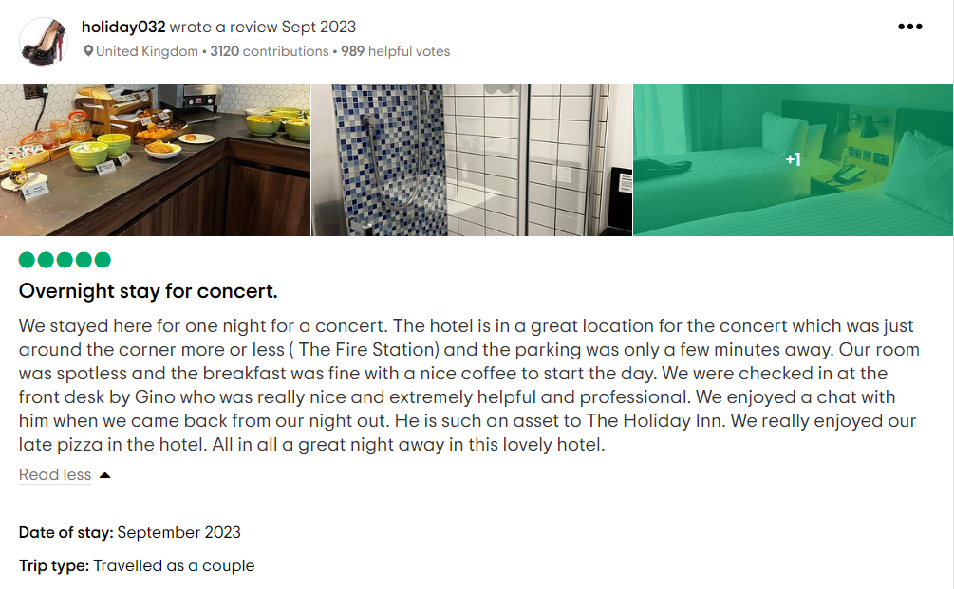
Figure 1: Positive Review of the Hotel Holiday Inn
(Source: Trip Advisor, 2023)

Letter of complaint response

To
Mr. Ronald Frederick.
17 Trinity Court,
Swansea
SA1 2AR

Subject: Response to the formal complaint
Dear Mr. Friedric,
Hope this letter finds you well. We appreciate your precious time to provide us with the complaint and bring the overall issue to my attention. I am deeply disheartened to know that your recent stay at our Hotel is not as per your expectations. I want to start by expressing my sincere apologies for this below-the-mark experience that you have encountered in our hotel.
I understand that you have faced several issues related to your stay such as the lack of taste and appeal of the food followed by disturbing your night sleep and an unhygienic restroom. However, I want to assure you that this is not our standard of providing convenience and service to our guests. You can find it from the positive reviews on our online platform as well as other websites like Google Reviews and Trip Advisor. In our hotel, we always maintain a high standard of customer service that will help in providing comfort and satisfaction to all our guests which is the main concern of your complaint.
With your complaint, we have taken some immediate steps regarding the problems or issues that you have mentioned in your letter. First with the Complaints regarding the quality of the food, we have already revisited our kitchen protocols and revised some of them and it would not be for any guests in our hotel. Regarding the cleanliness of your room, I have already personally talked with our staff who were previously in charge of cleaning your room and sent them for proper disciplinary action. We are also considering with our staff to provide them with complete and additional training to improve the overall quality of the services like food and hygiene which will provide the best experience for our consumers. We also understand the importance of a good night's sleep and we are incorporating the sound insulation and noise control system in all our rooms.
Lastly, I would really like to express my heartfelt apologies for the inconvenience that we have caused you and could not accommodate you with proper services. I know that our relationship has started on the wrong foot and we are really embarrassed for the incapacity to serve you properly. To express our sincerity in the process of serving you, I would like to invite you and your family members for a complimentary one-night stay at our hotel. This complimentary one-night stay would include complimentary breakfast and we would really like to welcome you on your next visit. We want to assure in that our family really care about the well-being of our guest and I can ensure that this experience will really meet your expectations in every way. If you have further recommendations for your preferences, you can contact us anytime. We will eagerly look forward to hearing back from you.
Thanking You.
Yours Sincerely,
CRM Head.
The Hotel Authority.

References
TripAdvisor. 2023. Holiday Inn Sunderland, an IGH Hotel. [online]. Available at: https://www.tripadvisor.in/Hotel_Review-g227059-d25070859-Reviews-Holiday_Inn_Sunderland_an_IHG_Hotel-Sunderland_Tyne_and_Wear_England.html [Accessed 02 November 2023].

Component Three

Element 1 – Pre-Arrival
The tourism and hotel business has a higher rate of dependency on the satisfaction rate of the guests. It helps to create the market value of the brand along with the building of reputation. There are multiple stages will be discussed in the study to provide a brief evaluation. The stages and their evaluation have a detailed share of knowledge that helps improve the satisfaction rate of the guests. The guest cycle provides descriptive stages to execute the process of guest interaction for the hotel. It is a vital duty for the managers and other staff of the front office to apply the guest cycle properly. Pre-arrival is the first stage of the guest cycle and there are various types of elements related to it. The stage of pre-arrival deals with the process of the choice and accommodation of the guest regarding the reservation of the hotel (Özdemir et al., 2019). Holiday Inn is a popular hotel in the UK and it is a common expectation of the guest to get a high level of satisfaction with their visit. Therefore, the level of efficiency of the front office staff is tested in the stage of pre-arrival of the guest cycle. The role of the front office manager is crucial in the sector of hotel management (Bardi,2011). In the stage of the pre-arrival, the front office staff performs the role of collecting the information of the guests along with attaining them by phone. Therefore, the skills of communication and efficiency are crucial to make the pre-arrival stage successful for the hotel Holiday Inn.

Element 2 – Arrival
The arrival stage is the second stage of the guest cycle for the management of guests. The stage of arrival involves the guest's arrival and social interaction in the hotel (Lukanova and Ilieva, 2019). The formal process of the room assessment and the role of staff management come into the segment. It is one of the crucial stages of the guest cycle as it is the stage of social interaction among the guests and the staff of the hotel. Therefore, to attract the attention of the guest, staff need to offer the best service to the guest. Holiday Inn is one of the leading hotels in the UK and offers premium service to the guests (Jones and Comfort, 2021). The offering of premium class rooms and services are common expectation of the guests from the staff and managers of the hotel. The role of the front office staff is to complete the registration process of the guest and to resolve any kinds of queries of the guest. The primary feedback of the guests is based upon the enhancement and experiences they get from the arrival stage. The staff needs to provide a great sense of behaviour towards the guests. The front office staff performs the legal activities related to the registration of the guests. The status of the check-in process and passport verification are the legal tasks in the duty of the front office staff. It exhibits the entry process of guest and guide them to the rooms that are booked by them.

Element 3 – Duration of stay
Stay is termed as the third stage of the “guest cycle” in hospitality management and it deals with the main representation of the hotel service to the guest. Coordination is one of the crucial factors involved in the industry of hotel management (Corgel et al., 2011). Therefore, the focus of the staff is to provide the best possible services to the attentive guests. A form of intelligent service design has a great impact on the hotel of the Holiday Inn (Giousmpasoglou and Hua, 2020). The execution of the technology helps to improve the services of the hotel and to maintain the quality. The stage of stay is termed the stage of occupancy in the guest cycle. Therefore, the stage has a great form of involvement in the experiences that guest gets from the staff of the hotel. A pattern of correct behaviour needs to be executed properly by the staff in the hotel (Latchem-Hastings, 2021). The behaviour of the staff helps to build the reputation of the hotel in front of the guests. The process of the interaction can be enhanced more with appropriate and professional behaviour. The demands of the guest can be identified in the stage of stay. Guest satisfaction is a crucial part that is related to the hotel management sector (Solomon, 2018). Therefore, the demand of the guest needs to be fulfilled by the staff of the hotel up to their possible limit to get positive feedback. A positive level of feedback helps in boosting the confidence of staff to perform better.

Element 4 – Departure
Departure is the last stage of the “hotel guest cycle” and it deals with the perspectives of guest accounting. It is the stage that guest use to leave the hotel and gets reported to the front office. The core feedback is obtained by the hotel from the guest in this stage. Holiday Inn is one of the reputed brands in the hotel industry of the UK (Aroul et al.,m 2023). Therefore, the values of the feedback are essential for the hotel to maintain stability and sustainability in the competitive industry. The front office staff in the departure stage performs the role of check-out formalities to support the guest. The method of transportation is essential in this stage. The staff must provide the facilities of transport to the guests in completing the role of services. A complete level of guest service is essential for improving the knowledge of hospitality management (Tesone, 2010). It is the stage of improvising the overall experiences of the guests in the hotel. Collecting feedback is a crucial task that needs to be performed by the front office staff (Tewan, 2009). The feedback helps to improve the issue that the guest has faced in the hotel. It helps to set the plan for improving the guest cycle more efficiently for future guests who will be visiting the hotel.

References
Aroul, R.R., Hodari, D., Bianchi, G. and Martignoni, G., 2023. The impact of brand affiliation on asset values: the case of UK hotels. Journal of property research, 40(2), pp.157-187.
Chalupa, S. and Chadt, K., 2021. The Perception of Soft Skills and Their Training at Hotel Front–Office in Connection to CoVid-19 Pandemics. TEM journal, 10(2), p.517.
Corgel, JB, Sturman, MC & Verma, R. 2011 The Cornell School of Hotel Adm inistration on Hospitality: Cutting Edge Thinking and Practice,John Wiley & Sons, Incorporated, Hoboken.
Giousmpasoglou, C. and Hua, T.T., 2020. The use of self-service technologies in budget hotels: the case of Bournemouth. European Journal of Tourism, Hospitality and Recreation, 10(3), pp.251-261.
Hammer,J. 2016 Revenue superstar! Thesimple rules of hotel revenue management. Great Britain: Amazon.
Jones, P. and Comfort, D., 2021. Modern slavery statements and leading UK hotel companies. Athens Journal of Tourism, 8(3), pp.147-162.
Latchem-Hastings, J., 2021. Caring relations at the margins of neurological care home life: the role of'hotel service'staff in brain injury rehabilitation. Journal of Long-Term Care, pp.12-23.
Lukanova, G. and Ilieva, G., 2019. Robots, artificial intelligence, and service automation in hotels. In Robots, artificial intelligence, and service automation in travel, tourism and hospitality (pp. 157-183). Emerald Publishing Limited
Özdemir, A.İ., Çolak, A. and Shmilli, J., 2019. Business process management in hotels: with a focus on delivering quality guest service. Quality & Quantity, 53(5), pp.2305-2322.
Solomon, M. 2018 The Heart of Hospitality. New York: SelectBooks, Inc.

