Game Review

Alexander Jenkins (2103347)

Computing (Games Development)

Game Design and History

Introduction
Door Kickers: Action Squad is an action game published 17 November 2017, it’s a 2D side scroller game where you go through missions taking out enemies that are in your path. The aim of the game is to go through all the missions and episodes by completing the mission objective, whether that be clearing all hostiles, or as well defusing a bomb or making an arrest.

Genre
Door Kickers: Action Squad could be defined by many genres, a good one being a mix of a Beat ‘em up and a shoot ‘em up style of video game, but can easily be defined as an action game, as beat ‘em up and Shoot ‘em ups are just sub-genres to the action genre. Door Kickers: Action Squad fits well into the action genre as clearing a level involves killing all the enemies in that level, as well as the run and gun style the game can have, as you can run into a room, clearing all the enemies then move onto the next.

Interface
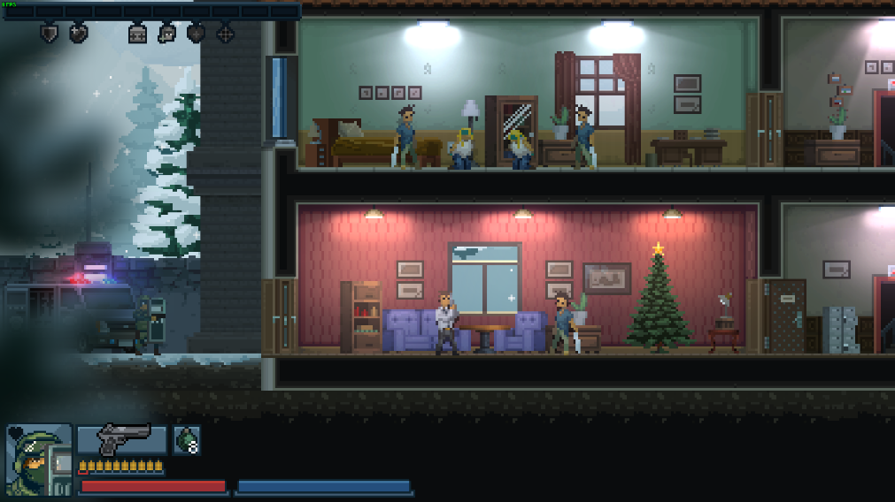
Door Kickers: Action Squad uses a simple interface, as everything is easy to follow, this makes it intuitive for the player to navigate the menu and easy to find what you are looking for, as each button in the main menu is well labelled. The in-game interface is very well designed as well. When it comes to designing the in-game interface (called the HUD, meaning head-up display), it is vital that it is as simple as possible, while showing what is needed to be seen by the player. For example, your character has a certain amount of health, so it would be important that that is displayed in the HUD for the player to always see how much health their character has (this can also affect the players play style, as the lower the health the more cautious they might play). But when adding all the information for the player to see on the HUD, it is very important it’s done right, as a messy, big HUD can clutter the screen and could distract the player from the core gameplay, or/and make it hard for the player to read the HUD. Most games, and Door Kickers: Action Squad does this, make their HUD in the corners of the screen, so it doesn’t distract you while you are focusing on the gameplay. Door Kickers: Action Squad utilises the top and bottom left corners of the screen to display the HUD elements, so the entirety of the middle of the screen is empty for the gameplay. The one thing (which would only affect beginners) is the fact that there are no button prompts on the interface, so to find out the controls you need to test every key or view the key bindings in the option. This is for the better still as this goes with not having a cluttered HUD, and the controls are minimal and easy to learn.
Image showing the in-game HUD of Door Kickers: Acton Squad
We can look at an online website that investigates HUD design and compare what they say to the HUD of Door Kickers: Action Squad. One quote of G. Staff is “Bad HUD design, sticks out. We remember when we can’t find the minimap or our health bars are too small, or too big, or entirely nonexistent, or when the screen is cluttered with useless information, blocking our view of the game itself.” [2] Door Kickers: Action Squad follows all this very well, as all the information on the HUD is useful, so it is non cluttered and shows all the vital information, while sticking to the corners of the screen to keep the middle of the screen uncovered for the gameplay. Another useful quote to look at from G. Staff are “A good HUD's primary objective is to provide the user with information quickly, efficiently, and with minimal effort on the part of the player. Our eyes should be drawn to the crucial information without having to search for it”. [2] This is relevant to having a good HUD as in mid combat, you want to know how many bullets/health points you have left, so being able to quickly glance and get the information as quickly as possible is key. Door Kickers: Action Squad accomplishes this as all the information is easy to always spot, everything you need to see is on the basic HUD. A final quote from G. Staff is “One of the most effective methods of drawing the player's eye is color—that's part of the reason that health and stamina bars are usually bright colors—but developers can easily go overboard with drawing the eye.” [2] This is important to note, as you want the HUD elements to stand out from the gameplay, so all the information can be quickly spotted. But you don’t want to go to far as then the HUD can distract you from the core gameplay. Door Kickers: Action Squad gets the perfect amount of eye catching as the colours stand out from the core gameplay and can easily be seen, but due to the small size and the HUD sticking to the corners, it affects the gameplay vision in no way.

Game Structure
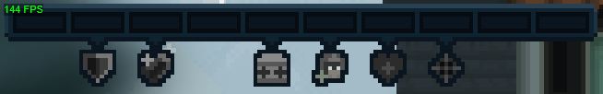
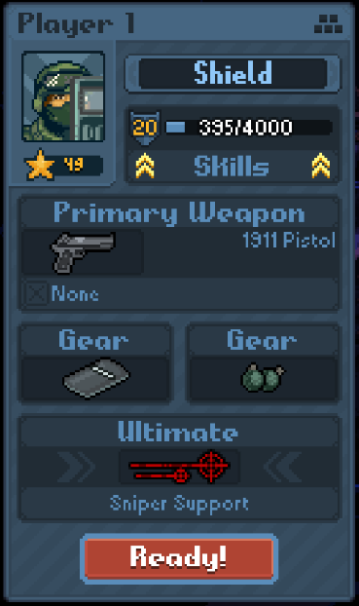
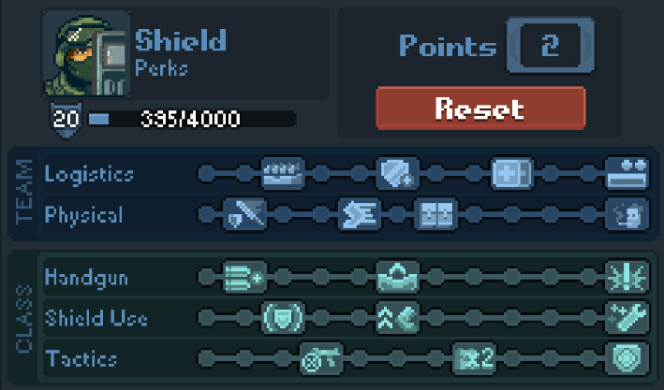
The structuring for Door Kickers: Action Squad is a simple one, when you go to play the game, there are a choice of 3 modes, “Infinity Tower”, “Classic Mode” and “Zombie Invasion Mode”. The focus will be on the classic mode for now. The classic mode uses a structure of what they call “Episodes”, which are different areas, that all contain 12 missions (which are levels) each. There are 8 episodes in total, including 1 which you need to purchase as DLC. Every mission follows the same one completion rule, being that you need to kill all the enemies to pass the level, but most missions will also have another/more completion rules, that you need to do before you would have completed the level. The most common one you’ll see is “Hostage Rescue” where you need to rescue the hostages (you don’t need to rescue all the hostages you only need to rescue one at a minimum for the mission to pass, it doesn’t matter if the rest die when it comes to completing the level that will only affect your after mission score), as well as kill all the enemies. Another level type is “Arrest Warrant” Where you need to find the special target and arrest them, if the target dies, the mission fails. The final mission type is “Bomb Defusal” Where there will be a bomb in the mission that you need to defuse in a time frame (such as 5 minutes), the time is displayed at the top of the screen, if you fail to defuse the bomb in time, you fail the mission. These missions can also contain hostages, but unlike hostage rescue missions, saving at least one hostage isn’t required to complete the mission. The variety in mission types is a good way to keep the player engaged, as if all the missions were hostage rescue missions, it could get stale for the player after some time. But throwing in a bomb defusal mission and clear hostile mission (allowing the playing to run and gun the mission not having to worry about accidentally shooting a hostage) can slightly mix things up and keep the player engaged in the gameplay. After completing each mission, you will get an overall grade of either 1 star, 2 stars or 3 stars. These are to reflect your performance in that mission. Time has no effect on your mission scoring, only hostages rescued and the number of times you die seem to influence how many stars you get. Having this star mission score system is a great way of adding some replay value to the game, as completionists will want to get 3 stars on each mission. This gives the player something to work towards, as after they have completed all mission, they can go back and get 3 stars on the mission they failed to on the first completion. When in a level, you have “Strategic Abilities” which are various pieces of equipment you can purchase in the level with your accumulated points (such as a “medikit” to heal, or your character’s ultimate ability). Each ability costs a certain number of points, and your points reset on death. Using the strategic ability tool is also how you can get an extra life, you can get as many of these as you want, if you have the points to do so. You gain points to for your strategic abilities by mainly killing enemies and rescuing hostages but defusing a bomb and making a VIP Arrest fill it by a great amount. Undoubtedly, strategic abilities do make the game easier, but they add another unique game mechanic to the game, as if you are low on health and close to getting a medikit, that may influence which room you want to go in next, as you may opt to go into a safer room with easier/smaller number of enemies until you have enough points, or may go for one with hostages in to get more points fast, strategic abilities do add another layer of strategy when it comes to earning points. One final game structure Door Kickers: Action Squad has to offer is customizability options before loading into the level. This is where you can choose your character, weapon, gear, and ultimate ability. Each character has their own base stats, as well as all having their own unique roster of weapons and ultimate abilities, and some have unique pieces of gear. All these different variables make for each character having completely unique playstyles, making them all feel different to each other when played. This can be a breath of thresh air for the player, adding more variety to the game, and so adding more replay value to the game. Each character also has its own skill tree, with 3 different columns, each one improving the character in some way with different upgrades. This is a good way to keep the player engaged with a character as this gives them a reason to play a character over again to fully upgrade their skill tree, adding replay value.
Image of the Strategic Abilities bar
Images of the skill tree for the Shield character
Images of the skill tree for the Shield character

Visual Style
The visual style Door Kickers: Action Squad inhabits is a 2D pixel art style. Pixel art has always been a popular visual style adopted by video games for decades, with the earliest video games all being pixel art. There may be many reasons they went for this art style, one leading factor could be that pixel art visual styles are timeless, their quality never ages, so the game won’t age badly and look worse in a few years, whereas if they did go with a realistic look, it might not age as well, also considering pixel art is far easier to make than realistic graphics.

Intended Demographic
The audience Door Kickers: Action Squad tries to appeal to people aged 13 and above, probably not any younger due to the gaming having violence in it such as blood splatter when shooting enemies. Due to the simple nature of the game, anyone can pick it up and play it, as the objective is simple, and the controls are easy to pick up. Their main audience would be people that enjoy action games, as this is what this game is at the core. As this game is a player versus enemy game with next to nothing to learn about the game before playing, this makes it an extremely casual game to play and very easy to pick up and play whenever. Casual games often reach a larger audience, due to the simplicity, will cater to more people as the more complex a game is the harder it can be in general for a person to learn and play.

Replay Value
When it comes to replay value, Door kickers: Action Squad offers a lot for the player to come back and do, even after completing a first play through. The first being is achievements, there are a total of 51 steam achievements for the player to obtain. A lot may be obtained just by playing the game during your first run (maybe half), but a lot you will have to seek out to complete, which gives purpose to playing the game again, even after you’ve completed all the missions. Something else for completionists to look out for are the mission star ratings. At the end of each mission, you are graded from 1-3 stars, trying to get 3 stars on every mission can be something you may want to achieve, as getting 3 stars on each mission on the first completion is highly unlikely. Even after you have completed all that, there is an endless amount of content to be had with this game being with the steam workshop, which allows players to create and download their own missions for Door kickers: Action Squad. There are still custom missions being made for this game today, 3 years after the game’s release, the latest mission being made 7 days ago as of writing this. Door kickers: Action Squad has multiplayer support, allowing you to play with a friend, local or online. This will typically make the game more enjoyable for players if they have a friend to play with and makes it more replayable as the more fun the player has with the game, the more they’re going to play it.

Use of Audio and Visual Feedback
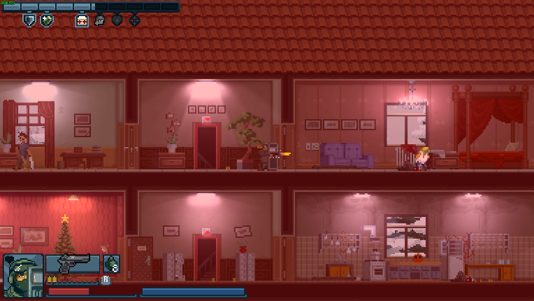


Door Kickers: Action Squad uses audio and visuals to give feedback to the player on something that is happening, such as one being that once you have fired your gun you will hear the bullet sound effect. Another use of audio feedback is if you shoot a hostage, the hostage will make a sound of pain, this is so the player knows they are shooting a hostage, as you can still hit enemies/hostages even if they are off screen. There are also many instances of visual feedback such as, you know if you have hit an enemy with a bullet as there will be a blood splatter that comes from the enemy and goes on the wall. As well as getting audio feedback when shooting a hostage, your screen will also flash red, which also gives good visual feedback, especially if you have your game volume muted. One final good use of visual feedback are enemy expressions, when an enemy sees you, but then you go back out of line of sight, a question mark (?) will appear above them, this also happens if they hear you kick a door. This means they are looking for you. When an enemy sees you, an exclamation mark (!) will appear above them, this lets the player know they have been seen by the enemy and will engage in combat.
Image showing the red screen flash when shooting a hostage
Images showing enemies when they are looking for you, then when they see you

Conclusion
In conclusion, Door Kickers: Action Squad is a great simple action game to engage yourself with, being very easy to pick up and play, the variety this game has to offer makes it refreshing to come back to and to complete missions at your own pace. This is also a great game for completionists, with each mission having an overall star rating, and the game having 51 achievements for you to unlock, the audience it can appeal to is vast. With Door Kickers: Action Squad, you are never restricted to approaching a mission in one set way, you always have a great wide of choices that you can choose before and during the mission. When loading into the mission, you can fully customise your entire load-out from your character and gear and weapon, allowing you to try tackle the mission with completely different character setups. When in the mission, there is no one set route to take, there are typically multiple different ways to go, such as you can either take the stairs to the second floor or climb up outside and enter through the window to the second story. This makes Door Kickers: Action Squad feel very fresh compared to other some games, where you may be more restricted to how you can approach a mission, where you’re forced with a specific set of loadouts, and can only take a single path.

References
[1] Door Kickers: Action Squad. [Software], Romania: KillHouse Games, 2017.
[2] G. Staff, “HUD Design: A Good HUD Is Hard To Find”, Game Rant, Jun 23, 2015. [Online]. Available: https://gamerant.com/good-hud-design-229/. [Accessed Nov 05, 2021].

