University of Wales Trinity Saint David
Wales Institute of Science and Art


BEng (Hons) Motorsport Engineering
Engineering Academic Discipline: Motorsport Engineering
Electronic Circuit testing and Applications
Vehicle Electronics ACHA4019

Frankie Brown
2500730
19/04/26
Word Count:1252

Full Scope Trace of the Function Generator Output
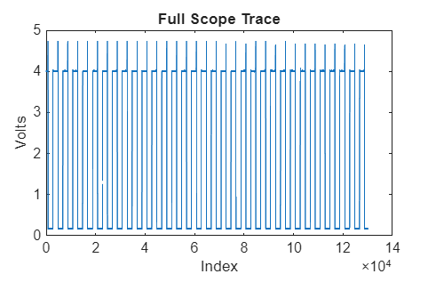
Figure 1: Full Scope Trace showing a function generator output (Square Wave)
Figure 1 shows the full scope trace of the voltage signals that were measured throughout the sampling period. A pulsed pattern is visible throughout the whole waveform, this occurs as it’s constantly altering between a high and low value (4 V and 0 V). This switching behavior is commonly seen in a PWM signal.
It can be seen that every pulse is evenly spaced, this suggests that there is a constant frequency of switching occurring, this occurs while the consistent amplitude indicates a stable operation while the measurement period occurs.

Graph Showing Voltage of Capacitor Discharge Vs Time

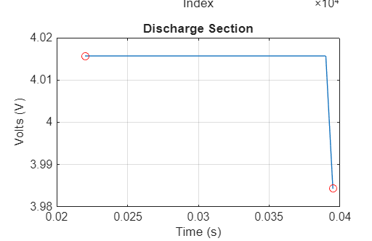
Figure 2: Zoomed in Section of the discharge of the voltage of a Capacitor, indicating a voltage drop from 4.0l V to 3.98 V in a small amount of time.

Figure 2 shows a zoomed-in view of the discharge area of the signal. For the majority of the intervals, the voltage remains at a value of 4.01 V, this indicates that the charging is stable. The discharge phase of the system can be seen via the rapid decline in voltage at 0.04 seconds. The rapid decline in voltage will suggest that the discharge process is fairly quick, this correctly follows the characteristics of a capacitor with its behavior of switching.
The capacitor's discharge should theoretically be exponential, but as this discharge process has been zoomed in, it looks to be more linear than exponential. This occurred due to the intervals which are short, leading to making the graph appear to be more linear than exponential.

Logarithmic Plot showing Capacitor Discharge Log (V) Vs Time)
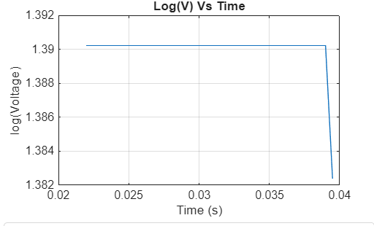
Figure 3: Logarithmic plot of capacitor voltage against time
A logarithmic plot, voltage against time was also created to dive deeper into the analysis of the behavior of the discharge process. As seen in figure 3, it can be seen that there is a linear relationship, indicating that an exponential trend is followed and aligns with the expected theoretical values.
As the voltage variation is limited over this chosen time period displayed on the graph, the level of clarity with the linear trend is lowered.
The gradient of the log(Voltage) vs time graph is seen as –0.0707. This represents the exponential decay rate of the discharge of the capacitor and is related to the RC time constant of the electrical circuit.

In order to determine the time constant of the electrical circuit, two data points were chosen that are located on the logarithmic plot of the graph.
Point 1:
t1 = 0.0008 s, LN(V1) = 1.3895

Point 2:
t2= 0,004 s, LN(V2) = 1.3824

To calculate the gradient of the graph, the following equation was used:
Gradient = (LN(V2) -(LN(V1)/(t2-t1)
Therefore, Gradient = (1.3824-1.3895)/(0.004-0.0008)
Gradient = -0.0071/ 0.0032
Final Gradient = -2.22
Time constant (T) is given by:
T = -1/gradient
T = -1/ (-2.22)
T = 0.45 s

The time constant that was calculated (T = 0.45 S), seems to be a much higher value after comparing the data to T value to the data range that was collected before these calculations. This issue is clearly due to a small level of voltage difference between the interval that was selected.

Common uses of Capacitors
. Timing Circuits- The capacitor can control time delays via charging and discharging
. Signal filtering- This removes any noise that isn't wanted from the electrical signals
. Smoothing power supply process- The capacitor reduces the rippling of voltage inside the DC outputs
. Ignition systems- Capacitors are used to quicken the process of releasing energy to generate a spark in an engine
. Audio devices- Capacitors are used in speaker crossovers to separate the different frequencies
. Starting motors- Creates an extra boost of energy to aid the starting process of the motor
. Coupling circuits- They allow AC signals to move between the different parts of the circuit while they also block the DC components in the circuit
. Decoupling- Helps stabilize the circuit’s voltages while also reducing component interferences.
. Pulse circuits- Help produce fast pulses of energy, this can be seen in flashing cameras.
. Backing up energy systems- If little interruptions occur in a sensitive circuit, capacitors can provide a quick but short level of power which ensures that operations continue.

Measurement Inaccuracies
It is common for the capacitor discharge experiment to differ from theoretical values, this can happen for multiple reasons.
The first form of inaccuracy will likely be from human error when experimenting. This likely occurs due to the person selecting points on the graph and finding it difficult to correctly read precise values for the voltage and time, therefore affecting the calculations made later.
Another form of inaccuracy will likely occur due to oscilloscope inaccuracies. Each oscilloscope has performance limits for sampling rates, this means there could be a variety in voltage capture performance for different oscilloscopes. This often causes fluctuations in readings, creating inaccuracies. (Stallings, 2017).
One other form of inaccuracies will likely come from different tolerances for the components. Both resistors and capacitors are both fitted with different tolerances, this means that their labelled values could likely vary from their actual values, causing an effected time constant and therefore leading to differences compared to the results theorized.

CANBUS Systems, Cybersecurity (ISO/SAE 21434)
In modern automotive vehicles, the CANBUS system is used to allow different ECUs to communicate with one another. The CANBUS system was not designed to be highly efficient with security, this makes it highly vulnerable to cyberattacks. One key issue is that Cyber attackers can send spoof messages to control certain areas of the vehicle, which can cause the vehicle to suddenly start braking or create further issues inside the engine system.
Multiple mechanics can be selected to help lower the risk of attacks, while complying with ISO/SAE 2134. One key mechanic is message authentication, this is when the electrical system begins to check and authorise the messenger and confirm them as a trusted source for messaging. This system ensures that no cyber hacker can send data that is unwanted to the computer network.
Another way to prevent attackers from getting into the system is by using an Intrusion Detection System. This system takes on the role of looking for any activity that is suspicious inside the system. The suspicious activity would likely include uncommon message patterns that haven't been seen before. If this mechanism begins to develop a fear of someone trying to get into the system, it will notify the system that a potential attack is happening.
Even though encryption isn't originally supported by the standard CANBUS package, extra security can be added to the system to ensure every message is protected when being sent to the system, causing larger difficulty for the messages to be changed and read by the potential attacker.
Another beneficial mechanism is network segmentation. This is where steering or braking systems are separated to a different area from the less crucial electricals systems, such as the lighting system or the seat adjustment system which doesn't really endanger harm when driving.
To conclude, the CANBUS system has a crucial role in modern vehicles, but it does have a shortage of security, leading to far higher risks of cyberattacks caused by an unknown hacker. By adding different mechanisms to the CANBUS system, such as message authentication or an intrusion Detection system, the risk is far lower, and a cyberattack is far less likely to occur on the system.

References
ISO/SAE (2021) ISO/SAE 21434: Road vehicles- Cybersecurity engineering.
Stallings, W. (2017) Cryptography and Network Security: Principles and Practice. 7th edn. Pearson.

