

Memory for Assessment Feedback in Higher Education: Does self-reported student motivation influence this process?

Ella Morris-fuge

MSc Applied Psychology

University of Wales Trinity Saint David School of Psychology

2021

Declaration
This work has not previously been accepted in substance for any degrees and is not being concurrently submitted in candidature for any degrees.
Signed: Ella Morris-fuge
Date: 17.07.2021
This dissertation is being submitted in partial fulfilment of the requirements for the degree of MSc Applied Psychology
Signed: Ella Morris-fuge
Date: 17.07.2021
This dissertation is the result of my own independent work/investigation, except where otherwise stated. Other sources are acknowledged by giving explicit references. A reference list is appended.
Signed: Ella Morris-fuge
Date: 17.07.2021
I hereby give consent for my dissertation, if accepted, to be available for photocopying and for inter-library loan, and for the title and summary to be made available to outside organisations.
Signed: Ella Morris-fuge
Date: 17.07.2021
Acknowledgements
Thank you to Dr. Kate Williams for her outstanding feedback and communications throughout my dissertation and previous modules in my MSc. Your attention to detail and enthusiasm for teaching psychology to all students is inspiring.
Thank you to Dr. Ceri Phelps for being there for me throughout my higher education journey from undergraduate to MSc level. Your passion and love for your job is inspiring.

Thank you to Dr. Paul Hutchings for also being there throughout my higher education journey and for challenging me with Qualtrics.

Thank you to all of the participants who took park in my study, especially under the constraints of Covid-19.

Thank you to my friends and family for supporting me throughout the process. Especially to my nan for helping out with childcare so that I could attend my MSc lectures, and my boyfriend Morgan for encouraging me that I can do it.

Table of contents
Declaration i
Acknowledgements ii
Table of contents iii
List of tables v
List of figures vi

Chapter one: Executive Summary 1
1.1 Research context 1
1.2 Applied Experimental research 1
1.3 Key findings from research 2
Chapter two: Systematic Literature Review 3
2.1 Abstract 3
2.2 Paragraph of context 4
2.2.1 Objectives 6
2. 3 Method 7
2.3.1 Literature search 7
2.3.2 Study inclusion and exclusion criteria 8
2.3.3 Included studies 8
2.3.4 Quality assessment of studies 9
2.4 Results 10
2.4.1 Overview of studies 10
2.4.2 Memory 11
2.4.3 Feedback type 13
2.4.4 Amount of feedback 14
2.4.5 Motivation 16
2.5 Discussion 17
2.6 Limitations 20
2.7 Conclusions 20
Chapter three: Research Paper 22
3.1 Introduction 23
3.3 Current study 25
3.4 Methods 25
3.4.1 Participants 26
3.4.2 Design 26
3.4.3 Materials 27
3.4.4 Procedure 28
3.5 Results 31
3.6 Discussion 36
Chapter four: Reflective Chapter 40
Reference List 49
Appendices 57

List of tables
Table 2.1: Components and search terms used for the database searches 9
Table 3.1 42
Table 3.2 43

List of figures
Figure 1. Flow chart showing study selection process 16

Chapter one: Executive Summary
1.1 Research context
The revised UK Quality Code for Higher Education (QAA, 2018), states that students should have the opportunity to experience high-quality education to attain a qualification of high standards through their degree. Feedback can support this principle since it can enhance students learning potential if they engage with it effectively (Cutumisu & Schwartz, 2018). Students present differing levels of engagement with feedback, while some do not utilise feedback at all (Ali et al., 2017). If the feedback is not acted upon then students are unlikely to reach their full potential. Therefore, it is essential to understand which feedback is best remembered by students in HE to increase the likelihood of them remembering and consequently using the feedback to fulfil their learning potential.
1.2 Applied Experimental research
- A systematic literature review exploring whether type of feedback, amount of feedback and self-reported levels of motivation influence student’s memory for feedback in higher education was carried out. In the past, research to improve feedback in HE focused mainly on feedback content, such as the most effective length and type of feedback. Presently research is becoming more concerned with the student’s role as a recipient of the feedback. This adds another level to the interaction between educator and student, which requires further research to understand how students process their feedback and which is most effective for students to remember and utilise to improve their learning. The review indicated contradicting findings with regards to the most effective feedback alongside many theories in support of these contrasting results. Students’ individual differences appear to influence their processing of feedback. Limitations, implications for future research and conclusions were presented following the review.
- Succeeding the review, a 2 x 4 cross-sectional mixed-subjects experimental quantitative design study was conducted. The study examined the effects of phrasing (positive/negative) and amount of feedback (limited/extended), as well as self-reported levels of motivation on memory for feedback comments provided on a hypothetical piece of work.
1.3 Key findings from research
A mixed between-within subjects Analysis of Variance (ANOVA) was conducted to examine students’ memory recall performance for feedback comments that differed in phrasing and amount, based on differences in self-reported motivation. The three research hypotheses were that 1. Students will remember significantly more negative feedback than positive feedback comment, this was not true in this research, 2. Memory of feedback comments will be significantly better when there are fewer comments, this hypothesis was accepted. Finally, 3. Students who report higher levels of motivation will remember more feedback than those who report lower levels of motivation, regardless of the type of feedback; this was true as the high motivation group had better memory recall for feedback comments than the low motivation group. The study findings and limitations are discussed, and suggestions for educators are given. Implications for future research include focusing on student comprehension of feedback, and the use of an eye tracker to measure student attention to feedback.

Chapter two: Systematic Literature Review
A systematic literature review exploring whether type of feedback, amount of feedback and self-reported levels of motivation influence student’s memory for feedback in higher education

2.1 Abstract

Feedback has been highlighted as an important aspect in student learning (Ali et al., 2017; Cutumisu & Schwartz, 2018; Hattie & Timperley, 2007). However, there is conflict concerning the most effective type of feedback to provide to students in higher education (Adarkwah, 2021; Lim et al., (2020); Wang et al., (2019). The review objectives are (1) explore studies relating to memory recall and how this is examined, (2) evaluate the effects of type of feedback (positive and negative) on student engagement with feedback, (3) evaluate the effects of amount of feedback (limited and extended) on student engagement with feedback (4) consider whether motivation plays a role in student engagement with feedback, (5) review and assess the quality of the studies presented in this review in the context of higher education where applicable. This systematic literature review included qualitative and quantitative studies, reviews and a case study published between 2017 and 2021 with additional papers from reference lists, extending to 2006, relating to findings on memory recall, type and amount of feedback, and motivation. The majority of papers focused on a higher education context. Forty-eight studies were included in this review. The reviewed literature indicates that motivated students are more likely to engage with their feedback than those who are less motivated. Limited research was found in relation to the influence type and amount of feedback, and motivation all together have on memory for feedback. Further research should be carried out to consider feedback content and students processing of feedback with the consideration of individual motivational differences. This will add to the ever-evolving research area of ensuring students are given effective feedback.

Key words: assessment feedback, memory recall, motivation, feedback type, feedback amount and higher education.

2.2 Paragraph of context

Higher education (HE) providers in the UK must adhere to the principles in the revised UK Quality Code for Higher Education (QAA, 2018). The code states that assessment must be “reliable, fair and transparent”, additionally, HE providers must “support all students to achieve successful academic and professional outcomes” (QAA, 2018., p. 3). Advance HE share similar expectations, emphasising that assessment should facilitate learning (Advance HE, 2020). As outlined in the QAA’s (2018) code, students should have the opportunity to experience high-quality education to attain a high standard of qualification through their degree. The role of feedback in assessment can assist in achieving that.

From a cognitive perspective, feedback can be defined as information that is required for improvement (Wisniewski et al., 2020). Feedback has the potential to improve a student’s attainment by closing gaps in learning (Cutumisu & Schwartz, 2018). Some students lack engagement with feedback and do not use feedback to facilitate their learning (Ali et al., 2017). This is an issue as feedback is only beneficial to students if they utilise it, if it is not utilised then the feedback loop will stay open, resulting in limited learning opportunities (Boud & Molloy, 2013). Furthermore, the 2020 National Student Survey reported lower positive responses relating to assessment than the majority of aspects of the learning experience (Office for Students, 2021). Thus, more research is needed surrounding feedback in HE. The more knowledge educators acquire, the more likely HE providers will deliver high quality educational experiences. Consequently, increasing student engagement and their potential to reach their desired outcomes. This review aims to examine feedback content (in terms of type and length), students processing of feedback, and the influence motivation has on student’s engagement with feedback.

With regards to feedback type, this review will evaluate the effects of positive and negative feedback. In this review, positive feedback praises, encourages and motivates students (Lizzio & Wilson, 2008). Negative feedback is critical and has the tendency to be received more negatively (Ackerman et al., 2016). Positive and negative feedback have been selected as they are contrasting types of feedback yet both have the potential to facilitate and hinder learning (Hattie & Timperly, 2007; Van der Kleij & Lipnevich, 2020).

Student engagement with feedback can also be influenced by the length of feedback (Ackerman and Gross, 2010; Ackerman et al., 2016). Some students may engage more with detailed feedback, whereas some may find extended feedback overwhelming and prefer concise feedback. These factors influence student’s memory for feedback as attention to feedback may diminish if the information presented is too much, or too complex, according to cognitive load theory (Sweller, 1988). Conversely, more feedback comments of a similar nature or with a detailed explanation may enhance a student’s memory for feedback due to repetition and increased meaning respectively. It must be acknowledged that one of the main barriers to students not using their feedback to improve their work is incomprehension of the comments given, therefore even if students remember feedback, they may not understand how to use it (O’Donovan et al., 2019; Weaver, 2006). Student motivation may impact this as Spitzer (1996) emphasises that motivation is key to successful learning, and, it has been shown to influence students processing of feedback (DePasque and Tricomi, 2015). Hence, a motivated student may seek to understand their feedback to improve their learning and attain their goals, in congruence with goal orientation theory (Vandewalle, 1997).

To evaluate student engagement with feedback, memory for feedback will be explored. Memory is an important process involved in learning. Kahneman (2011) highlights that our memories inform our future decisions, therefore, if a student remembers feedback, the likelihood of them using it to enhance future learning and attainment increases. Memories can be strengthened by the way information is presented, its meaningfulness, and feelings of the individual at the time of the memory being created as proposed by Craik and Lockhart (1972), who recognised the difference between surface and deep levels of processing.

Due to students’ differing in levels of engagement and satisfaction, depending on the type of feedback they receive, it is essential to know which type (positive or negative), and amount (limited or extended) of feedback is most memorable for student’s when they process feedback, and whether motivation plays a role. The purpose of this review is to provide an overview of existing studies that explore type of feedback (positive and negative), amount of feedback (limited and extended), the influence student motivation has on engagement with feedback, memory recall and how this is measured, with consideration of the HE context.

2.2.1 Objectives
This review focuses on five objectives:
1. Explore studies relating to memory recall and how this is examined.
2. Evaluate the effects of type of feedback (positive and negative) on student engagement with feedback.
3. Evaluate the effects of amount of feedback (limited and extended) on student engagement with feedback.
4. Consider whether motivation plays a role in student engagement with feedback.
5. Review studies presented in this review in the context of HE where applicable.

Following the review of current literature based on the review objectives, a discussion will be presented, in addition to implications for future research, limitations of current research and conclusions.

2. 3 Method

2.3.1 Literature search
A systematic process was followed to gather literature about memory recall and how this is examined; type of feedback (positive and negative); amount of feedback; and the influence student motivation has on engagement with feedback and learning in HE. The electronic databases used to search for relevant literature were: Academic Search Premier, Proquest Central, PsycArticles, Science Direct, British Education Index, Education Source, EBSCO Host, Taylor & Francis Journals, and the Springer database. The reference lists of all included papers were also manually reviewed to establish any further relevant literature.

Each database was searched using a combination of search terms (See table 2.1). To narrow the search, only papers that had been published between 2017-2021, gave full text access, had been peer-reviewed and were written in the English language were included in the literature review.

Table 2.1

Components and search terms used for the database searches

Components | Search terms
Assignment feedback | Assignment feedback, Assessment feedback
Feedback type | Feedback type, Feedback amount, Feedback comments
Memory | Memory recall
Motivation | Motivation, Student engagement
Higher education | Higher education, Undergraduate
Note: All search terms were combined with ‘AND’ and ‘OR’.

2.3.2 Study inclusion and exclusion criteria
Studies were included in the review if they met one of the following inclusion criteria:
1. Studies relating to memory recall and how this is examined
2. Studies that consider type of feedback (positive and negative)
3. Studies that consider amount of feedback
3. Studies that consider student motivation in relation to feedback
4. Studies that consider student motivation in relation to feedback and learning in HE
Studies that did not meet one of these criteria were excluded from the review.

2.3.3 Included studies
In adherence to the inclusion criteria, 48 studies were included in this review. The study selection process carried out to select appropriate studies for review is displayed in figure 1.

Figure 1. Flow chart showing study selection process

References identified through electronic database searches: n = 3604 results

References excluded based on abstracts or titles:
n = 3562

Main reasons for exclusion:
- Did not adhere to the inclusion criteria
- Duplicate publications

Articles meeting inclusion criteria: n = 42

Articles identified through the reference lists:
n = 6

Total number of studies meeting inclusion criteria:
n = 48

2.3.4 Quality assessment of studies
The quality assessment of the included studies was completed using the Mixed Methods Appraisal Tool (MMAT) (Hong et al., 2018) for the qualitative, quantitative, mixed methods and a case study. The Critical Appraisal Skills Programme Criteria (CASP) (2018) for reviews was used to evaluate the reviews included in this review. This facilitated a range of methodologies to be assessed. The critical appraisal of all included studies is displayed in Appendix A.
2.4 Results

2.4.1 Overview of studies
An overview of the study characteristics and outcomes of included studies is presented in Appendix A and B respectively. The studies included in this review were published between 2006-2021, with the majority of studies being published between 2017-2021 (n=42) due to the search terms used for this review. Six studies fell outside of this range as they were identified through the reference lists of papers found in the database search. The majority of studies were carried out in the UK (n=16), with the remaining studies being conducted in 13 different countries (See Appendix B). Most of the studies included in this review were quantitative (n=24). Fourteen studies were qualitative, seven reviews, two mixed methods, and one case study were also included. ANOVA’s appeared most frequently when reviewing the data analysis used in the quantitative studies and thematic analysis was the most frequently used analysis for the qualitative studies. Number of participants across all included studies ranged from 5 – 2445. Most studies included a student population, with more females than males.

Following selection, the studies were grouped into four areas of interest in line with the review objectives: (1) memory (n= 19); (2) feedback type (n= 20); (3) amount of feedback (n= 16); (4) motivation (n= 11). Some studies were reviewed in multiple groups (see appendix D). For each area of interest, where applicable, the context of HE will be reviewed.

2.4.2 Memory
How a student processes their feedback and subsequently remembers their feedback can be influenced by their perception of the feedback (Van der Kleij & Lipnevich, 2020). Hattie and Timperly (2007) suggest that a student may not accept feedback that contradicts their view of self. Suppressing feedback could lead to it not being readily available to support future learning, as suggested by De Vito and Fenske’s (2017) findings that show reduced memory for suppressed words. Similarly, critical feedback can negatively influence memory for feedback if students do not wish to receive critical feedback (Cutumisu & Schwartz, 2018). The limitations of negative feedback could be attributed to the negative affect associated with the critique of work. Pekrun et al. (2011) support this view in line with control-value theory (Pekrun, 2006), which proposes that emotions can orient an individuals’ psychological processes, for example, their memory. To support this, Lipnevich et al. (2021), found that emotionally unstable students are less likely to engage with feedback which may hinder their memory for feedback. Nonetheless, when students choose critical feedback it can improve memory for feedback (Cutumisu & Schwartz, 2018). These students may be more emotionally stable and able to use the feedback effectively without emotions interfering with their perception of their feedback.

Amount of feedback can influence memory for feedback, İli̇c and Akbulut (2019) found that too much information can overload a student and result in less engagement. Similarly, Taylor et al. (2020) explored students’ attention to online information, when the results are applied to feedback it is implied that students attend to more simplified information. This could be ascribed to simple information requiring less effort to process. Thus, students may feel that their goals will be attained more easily by focusing on information that is easy to process. These notions suggest that depending on a students’ perceptions and goals in relation to their learning, they may attend to more detailed or simpler feedback accordingly. However, both Wang et al. (2019) and İli̇c and Akbulut (2019) found that more information can result in more effort invested by the student, which may lead to increased memory of feedback.

Other factors may also influence memory for feedback. Carmona et al. (2019) found that a positive outcome from using feedback previously, may lead to increased engagement with feedback. Vermunt and Donche (2017) reported that gender, year of study, motivation, and discipline studied can influence students’ ability to process information on a deeper level. This could influence memory for feedback and how memories are used in the future as surface level memories may be forgotten more easily (Craik & Lockhart, 1972). In line with the gender differences found, Wu and Cheng (2019) found that males had more attention issues than females when learning online. Furthermore, Cutumisu and Lou (2020) found that students with a growth mindset, who believe that they can improve, focus on feedback more than those with a fixed mindset, who believe they cannot improve.

The majority of studies included in this review used a recall task to measure participants memory (Brown et al., 2019; Cutumisu & Schwartz, 2018; De Vito & Fenske, 2017; Li & Tsai, 2017; Taylor et al., 2020). Boyle et al. (2020) used the Revised Study Process Questionnaire; Carmona et al. (2019) presented stimulus sequence pictures and asked participants to report any changes; Wang et al. (2019) measured cognitive load with a subjective task difficulty scale and mental effort scale; and İli̇c and Akbulut (2019) used a paper based visual working memory test response sheet. Some of the studies included in this review used eye trackers to accompany measurements of memory (Berndt et al. 2017; Damiano & Walther, 2018; Ramey et al., 2019).

2.4.3 Feedback type
Feedback type has been shown to impact how students engage with feedback (Van der Kleij & Lipnevich, 2020; Winstone et al., 2017). Adarkwah (2021) indicates that negative feedback can inhibit learning outcomes. This may be due to emotions (Hill et al., 2021; Pitt & Norton, 2017). Lim et al. (2020) showed that critical feedback can enhance learning as it may increase student’s effort to engage with feedback due to the negative emotions it evokes. This suggests some students require critical feedback, as without the potent message delivered via negative feedback, it may not be utilised. Year of study has been shown to influence student reaction to different types of feedback, Hill et al. (2021) suggested that students in earlier stages of their education find it harder to process and use negative feedback. This suggests that students who lack academic maturity, and have low levels of feedback literacy, perceive themselves as failures when they receive negative feedback. This inhibits them from being able to benefit from critical feedback. These findings highlight the need to give encouraging feedback to students in earlier years of study. Xu and Carless (2017) indicate that acceptance of critical feedback can be developed by improving feedback literacy, by building trust between the educator and student and by improving attitudes towards critical feedback. Likewise, Noble et al. (2019) suggest that reframing feedback via training will develop student’s engagement with feedback. Deeley et al. (2019) suggest that feedback literacy be embedded into course content, Adarkwah (2021) supports the necessity of feedback literacy due to the complex nature of feedback.

Positive feedback can facilitate positive emotions in students, Trigonaki (2019) found that all participating students were content with positive feedback. This study is limited due to the small number of participants and does not consider whether the positive affect results in effective use of the feedback. Effective use of positive feedback has been suggested by Hattie and Timperly (2007), as feedback that satisfies the students view of self is engaged with more and Vaughan-Johnston and Jacobson (2020) suggest that positive feedback is preferred when the self is concerned. To support this, Lowe and Shaw (2019) found that many students viewed sensitive and motivational feedback as the most effective feedback. Similarly, Dawson et al. (2018) found that students believe positive, considerate feedback to be most effective. Bohndick et al. (2019) and Sharp et al. (2018) reported that positive feedback positively correlated with motivation which may enhance engagement with feedback. Furthermore, Shafi et al. (2017) adapted their assessment feedback based on their findings, to include a positive comment, followed by an encouraging recommendation. Opposingly, positive feedback can be overlooked and ignored (Winstone et al., 2017). This may be determined by the student’s disposition (Cutumisu & Lou, 2020) suggesting that students could benefit from personalised feedback as proposed by Wang and Lehman (2021). Ackerman et al. (2016) found that students are more open to critical feedback when they have the opportunity to improve their work, therefore the feedback structure on the course should be considered when choosing the most appropriate feedback.

2.4.4 Amount of feedback
Amount of feedback has been shown to influence student’s perception of feedback (Van der Kleij & Lipnevich, 2020). Gjerde et al. (2018) show that irrespective of the type of feedback given, it is advantageous to receive more feedback for enhanced learning performance. Moreover, Dawson et al. (2018) found that detailed feedback is viewed as most effective for many students. Furthermore, Noble et al. (2019) found that participants sought to increase the amount of feedback they received through feedback conversations, suggesting that they require extended feedback. Attali and Van der Kleij (2017) found that when students receive elaborate feedback, they are less likely to review the feedback again, showing that the feedback satisfied their needs. This could be due to the added detail and meaning that makes the feedback easier to process and remember to use effectively in the future. Berndt et al. (2017) underlines students’ preference for elaborated feedback, although, signifies not to overload the recipient with feedback so that their cognitive processing is inhibited. Wang et al. (2019) showed similar findings as detailed feedback increased learners’ perception of their feedback, motivation and germane cognitive load; the cognitive process of moving the feedback to long term memory, which aids learning. Lowe and Shaw (2019) reported similar findings, that more students preferred detailed than concise feedback.

Some students prefer concise feedback. Nicol’s (2010) recommendations state that feedback should be selective, focusing on two or three improvements. In agreement, Lim et al. (2020) found that students expressed negative affect towards lengthy feedback, and they did not attend to all of it. This may be due to the type of feedback given. Ackerman et al. (2016) reported that a high amount of critical feedback is not beneficial. Contrastingly, Sparrow et al. (2020) expressed that elaborate feedback is beneficial, though it must be clear. Deeley et al. (2019) and Glover and Brown (2006) support the notion that the quality of the feedback is more important than the amount of feedback. For example, if there are lots of comments on grammar and spelling, this may be unbeneficial as other feedback may be overlooked due to extraneous cognitive load. However, amount of feedback may differ across courses, Fernández -Toro and Furnborough (2018) denote how language courses may provide more feedback to support the student using a corrective approach. Moreover, Ackerman and Gross (2010) highlight that the amount of feedback given should be appropriate for the task, for example, if students have the opportunity to improve their work then more feedback is reasonable, if resubmission is not an option, then concise feedback may be more advantageous.

2.4.5 Motivation
Students have varying levels of motivation, which can be supported by feedback that is helpful for them (Wang & Lehman, 2021). Gravett and Winstone (2018) highlighted how students who lack motivation struggle to implement feedback. This signifies how motivation can impact engagement with feedback. This can be explained by Rogaten and Moneta’s (2017) findings, that motivated students can be better equipped when faced with academic challenges. Zeidner and Stoeger (2019) found links between goal orientation, motivation, engagement and higher achievement. Furthermore, Taylor at al. (2020) reported that goal orientation influences information processing. These findings suggest that students whose goals are to improve their learning will be more motivated to attend to feedback. As supported by Zeidner and Stoeger (2019) who found that motivated students are more likely to invest effort and persist with their learning by rehearsing learning materials. Moreover, Lynam and Cachia (2018) found that students with high academic motivation are highly engaged with assessments as they understand the benefits. Moreover, Li and Tsai (2017) found that students who are more motivated access and engage with their learning materials more frequently, these students also displayed high goal orientations which is in line with the previous literature presented in this review. The research suggests a cycle of higher motivation resulting in higher engagement, thus higher performance and sustained motivation. To support this, Boyle et al. (2020) showed that students with higher motivation performed better.

Vermunt and Donche (2017) recognise the importance of exploring motivation in relation to students processing of information. This area was explored by Forsythe and Johnson (2017) in the context of students’ mindset. Students with a growth mindset were more inclined to welcome critical feedback as an opportunity to learn compared to students with a fixed mindset. Students with a fixed mindset have a tendency to exhibit splitting when faced with critical feedback (Forsythe & Johnson, 2017). This means that they view the feedback as solely bad, and that it adds no value to their learning, preventing them from viewing the feedback accurately, and from being able to productively engage with it. This type of defence mechanism may lead to distorted memories of the feedback. In contrast, students who have a growth mindset may be motivated to change their behaviour based on feedback regardless of the feedback given due to their openness to change and develop.

Sharp et al. (2018) reported that students who were less motivated invested less effort into their learning which resulted in worse performance. This supports previous literature showing the contrasting effect of more effort being invested in learning when high motivation is present. Zeidner and Stoeger (2019) found that students have the ability to improve their motivation as their competence to self-regulate their learning grows. Lynam and Cachia (2018) also advocate the implementation of training that develops students’ motivation to improve student engagement.

2.5 Discussion

This systematic literature review considered 48 articles exploring memory recall and how this is measured, type and amount of feedback, and the influence motivation has on learning and engagement with feedback with consideration of HE (See Appendix B and C for full study details). The majority of papers focused on a HE context. A number of results were identified.

Students’ perception of feedback can be influenced by the type and amount of feedback given, subsequently their perception of feedback shapes their memory for feedback (Van der Kleij & Lipnevich, 2020). Critical feedback was shown to be more memorable than positive feedback when students choose to receive it, otherwise it is unfavourable (Cutumisu & Schwartz, 2018), possibly due to the negative emotional impact (Lipnevich et al., 2021; Pekrun et al., 2011), or due to it contradicting the students view of self (Hattie & Timperly, 2007). This corresponds with De Vito and Fenske’s (2017) findings concerning the suppression of memories of words. The amount of feedback can also influence memory. Too much feedback may be detrimental to memory (Berndt et al., 2017; İli̇c & Akbulut, 2019), while less feedback allows for easier processing and goals to be reached more efficiently (Taylor et al., 2020). Conversely, extensive feedback can instigate increased effort by the student to engage with feedback (İli̇c & Akbulut, 2019; Wang et al., 2019). Individual differences can account for variations in memory for feedback (Carmona et al., 2019; Cutumisu & Lou, 2020; Vermunt & Donche, 2017; Wu & Cheng, 2019). Memory was mainly measured via recall tasks (Brown et al., 2019; Cutumisu & Schwartz, 2018; De Vito & Fenske, 2017; Li & Tsai, 2017; Taylor et al., 2020), with several studies using eye trackers to enhance findings (Berndt et al., 2017; Damiano & Walther, 2018; Ramey et al., 2019).

In relation to type and amount of feedback, emotions are instrumental (Hill et al., 2021; Pitt & Norton, 2017). Positive feedback can induce positive feelings and motivate students (Bohndick et al., 2019; Sharp et al., 2018; Trigonaki, 2019), enhance engagement with feedback (Hattie and Timperly, 2007; Shafi et al., 2017), and be viewed as effective by students (Dawson et al., 2018; Lowe and Shaw, 2019). Nonetheless, positive feedback can be disregarded by some students (Winstone et al., 2017). Critical feedback can both inhibit (Adarkwah 2021; Hill et al., 2021) and enhance engagement with feedback depending on the student’s disposition, the opportunity to revise work and their year of study (Ackerman et al., 2016; Cutumisu & Lou, 2020; Hill et al., 2021; Lim et al., 2020; Winstone et al., 2017). The use of critical feedback can also be developed (Deeley et al., 2019; Noble et al., 2019; Xu & Carless, 2017). The majority of studies show that more feedback, compared to less, is effective for student engagement with feedback (Attali & Van der Kleij, 2017; Berndt et al., 2017; Dawson et al., 2018; Gjerde et al., 2018; Lowe & Shaw, 2019; Noble et al., 2019; Wang et al., 2019). However, it is crucial not to overburden students (Berndt et al., 2017) as suggested by cognitive load theory. To support this, concise feedback is more effective for some students (Lim et al., 2020; Lowe & Shaw, 2019; Nicol, 2010). Articles expressed that quality (Deeley et al., 2019; Glover & Brown, 2006), type (Ackerman et al., 2016), clarity (Sparrow et al., 2020) and timing (Ackerman & Gross, 2010) of feedback, as well as the subject studied (Fernández-Toro & Furnborough, 2018) are important factors to consider when choosing the appropriate amount of feedback to give.

The influence motivation has on student engagement with feedback are apparent in the review (Hill et al., 2021; Li & Tsai, 2017; Rogaten & Moneta, 2017). Students with high motivation are more likely to engage with their feedback due to goal orientation, increased effort and understanding of the advantage engagement provides (Li and Tsai, 2017; Lynam & Cachia, 2018; Taylor at al., 2020; Zeidner & Stoeger, 2019), which then enhances performance (Boyle et al., 2020). As opposed to students with low motivation (Hill et al., 2021; Gravett & Winstone, 2018; Sharp et al., 2018). Similar to the view that acceptance of critical feedback can be developed, motivation has the potential to increase with development training (Lynam & Cachia, 2018; Sharp et al., 2018; Zeidner & Stoeger, 2019).

2.6 Limitations
The review objectives were achieved, nonetheless, limitations of this review are present. No studies spanning across motivation and memory for feedback were found to review. Limited studies focused on memory for feedback whilst accounting for type and amount of feedback. Additionally, many of the study participants were female which gives a bias reflection of the findings as gender has been shown to influence attention and memory (Wu & Cheng, 2019; Vermunt & Donche, 2017). Many of the studies included used self-reported surveys and questionnaires which may lead to social desirability responding (Paulhus, 2017), and present inauthentic results. However, social desirability bias in the HE population has been shown to be minimal (Miller, 2011). Some of the studies presented a small sample size which does not allow for results to be generalised to the wider population. Only English language papers were included which limited the scope of literature to review. Given that the review extends across both education and psychology, there may be literature in specialised publications which may be relevant but not accessed. Additionally, aspects related to education may be published through other mediums than papers (e.g., educational documents) which may not have been located through the database search.

2.7 Conclusions
The studies presented in this review emphasise contradicting findings surrounding the most effective feedback for students to process in HE. The reviewed literature indicates that motivated students are more likely to engage with feedback than those who are less motivated. Limited research was found in relation to the influence type and amount of feedback, and motivation have on memory for feedback. Further research should be carried out to consider feedback content and students processing of feedback with the consideration of individual differences.

The specific gap in the literature that the following project aims to fill will measure memory for both positive and negative feedback, as well as extended and limited feedback with a recall task, whilst also accounting for students self-reported motivation differences.

Chapter three: Research Paper
This manuscript has been written for submission to Studies in Higher Education
following that journal’s Instructions to Authors.
Memory for Assessment Feedback in Higher Education: Does self-reported student motivation influence this process?
Ella Morris-fuge
Discipline of Psychology and Counselling, University of Wales Trinity Saint David, Swansea, Wales
Emorris-fuge.128653@student.uwtsd.ac.uk
Word count:4950

Memory for Assessment Feedback in Higher Education: Does self-reported student motivation influence this process?
This research paper explores whether the type of feedback (in terms of amount and phrasing), and self-reported levels of motivation influence memory for feedback in a higher education setting. A 2 x 4 cross-sectional mixed-subjects experimental quantitative design was used to examine the effects of phrasing (positive/negative) and amount of feedback (limited/extended), as well as self-reported levels of motivation on memory for feedback comments provided on a hypothetical piece of work. A mixed between-within subjects Analysis of Variance (ANOVA) was conducted to examine students’ memory recall performance for feedback comments that differed in phrasing and amount, based on differences in self-reported motivation. Results show that limited feedback was better remembered than extended feedback and the high motivation group remembered more feedback comments than the low motivation group. There were no differences in memory recall performance between negative and positive feedback when comparing limited positive and limited negative and extended positive and extended negative. The study findings and limitations are discussed, suggestions for educators are given. Implications for future research include focusing on student’s comprehension of feedback and the use of an eye tracker to measure student attention to feedback.
Keywords: assessment feedback; memory recall; motivation; feedback type; feedback amount, higher education

3.1 Introduction
The Quality Assurance Agency (QAA), ensure that students in higher education (HE) in the UK receive quality education. QAA’s (2018) principles suggest that assessment should be consistent, inclusive and purposeful. An expectation of the QAA is that students receive feedback, to develop their learning, which should adhere to the assessment principles. It is beneficial for students in HE to process and act on feedback as it can help them to recognise what they have done well, any gaps in their learning, and how to improve (Ali et al. 2017; Cutumisu and Schwartz 2018; Hattie and Timperley 2007).

Existing research shows that motivated students, have high levels of goal orientation and increased engagement with their feedback (Li and Tsai 2017; Lynam and Cachia 2018; Taylor at al. 2020; Zeidner and Stoeger 2019). This can result in increased memory of the information presented (Damiano and Walther 2018), resulting in better performance (Boyle et al. 2020) in line with achievement goal theory (AGT; Nicholls 1984). AGT suggests that cognitions align to enable an individual to reach their goals. Contrastingly, a lack of motivation may result in limited learning (Gravett and Winstone 2018), which can be attributed to the expectancy-value theory (Vroom 1964) as they may not value the task or feedback.

Positive feedback provides positive affect for students by motivating and encouraging them through praise (Bohndick et al. 2019; Lizzio and Wilson 2008; Sharp et al. 2018; Trigonaki 2019). However, some students will overlook praise (Winstone et al. 2017) and seek critique of their work (Cutumisu and Lou 2020). Negative feedback is often perceived as critical and associated with negative affect (Ackerman et al. 2016; Hill et al. 2021) which can influence memory for feedback, in line with control-value theory (Pekrun 2006). Nonetheless, receipt of critical feedback can promote increased effort for some students, as this is their reaction to the associated negative emotions (Lim et al. 2020). Equally it could be explained by the hypercorrection effect (Butterfield and Metcalfe 2006) when confident students are given critical feedback.

Both type and length of feedback can interact to form a student’s perception of the feedback. Ackerman et al. (2016) found that extended critical feedback is not beneficial for student’s engagement. Nevertheless, extended feedback can be advantageous for students as increased detail may lead to increased understanding (Wang et al. 2019). In contrast, memory for feedback decreases when too much feedback is given (Berndt et al. 2017; İli̇c and Akbulut 2019), in line with cognitive load theory, if there is overload then performance is likely to deteriorate (Atkinson and Shiffrin 1968).

It appears that student perspective of their feedback can determine how they engage with it (Van der Kleij & Lipnevich, 2020), and it is suggested that students’ perspectives are shaped by the content of the feedback presented (Wisniewski et al., 2020). Furthermore, Wisniewski et al. (2020) found that memory for feedback can be influenced by the feedback. It would be advantageous for educators to be aware of the most memorable type of feedback to provide to students to enable efficient processing and use of feedback in future work. With this awareness they could tailor feedback to be well remembered, subsequently promoting learning as intended. Additionally, an understanding of whether motivation influences student’s engagement with feedback would be valuable. If students’ motivation influences their engagement with feedback, then attention could be given to students’ motivation and how to maintain or enhance this through suitable training (Lynam and Cachia 2018).
Vermunt and Donche (2017) indicate that student motivation should be considered when measuring students processing of feedback. Boyle et al. (2020) acknowledged limitations of self-reported measures of cognitive processing, highlighting the need for a behavioural measurement such as a recall task. To eliminate effects of competence a hypothetical situation could be used as suggested by Berndt et al. (2017).

3.3 Current study
The aim of the study is to examine the effects of phrasing (positive/negative) and amount of feedback (limited/extended), as well as self-reported levels of motivation on memory for feedback comments provided on a hypothetical piece of work. The research questions this study will explore include whether students will remember negative feedback more than positive feedback and whether memory will be worse for extended feedback comments compared to limited feedback comments. and whether students who report higher levels of motivation remember more feedback comments than those who report lower levels of motivation, regardless of the type of feedback presented. As a result of this study, educators could gain insight into the most effective feedback comments to provide to improve engagement, memory for feedback and learning performance. This study will consider the following three hypotheses: (1) Students will remember significantly more negative feedback than positive feedback comments, (2) Memory of feedback comments will be significantly better when there are fewer comments, (3) Students who report higher levels of motivation will remember more feedback than those who report lower levels of motivation, regardless of the type of feedback.

3.4 Methods
3.4.1 Participants

To ensure a sample from the target population of students studying at HE was captured, the study made use of the Psychology department’s Experiment Management System (EMS) to recruit participants from any of the Psychology related undergraduate and postgraduate degree programmes at the University of Wales Trinity Saint David. An opportunity sample was obtained, and in total, 48 participants voluntarily signed-up to the study in exchange for participation credits. Of those who signed-up, 45 completed the full consent procedure, which included 33 females, 11 males, and one non-binary/third gender. Forty-five provided information on their age, which ranged from 19-71 (M = 30.84, SD = 12.30). Forty-one provided information on their specific degree programme. For those at undergraduate level, 21 were in the first year, 15 in the second year, and five in the third year. There were four postgraduates. All participants were required to have normal or corrected-to-normal vision and be capable of reading and responding to questions on the computer.

3.4.2 Design
The study involved a 2 x 4 cross-sectional mixed-subjects experimental quantitative design. The within-subjects factor, feedback type, consisted of four conditions, extended positive (EP), limited positive (LP), extended negative (EN), limited negative (LN). The between-subjects factor was the participants’ self-report motivation levels, using a total of the intrinsic and extrinsic goal orientation, task value, control of learning beliefs and self-efficacy for learning and performance subscales from the motivation section of the Motivated Strategies for Learning Questionnaire (MSLQ; Pintrich et al. 1991). The motivation variable had two levels, either high or low based on the sample mean. The dependant variable was memory for the feedback comments captured through the total number of feedback comments correctly recalled. Memory performance will then be analysed in a 2x4 mixed Analysis of Variance (ANOVA) to establish any significant main and interaction effects. Any significant main effect for the feedback condition variable will be further explored with pairwise comparisons, and any significant interaction effect will be further explored with post-hoc analyses.

3.4.3 Materials
An adapted version of the motivation section of the Motivated Strategies for Learning Questionnaire (MSLQ;Pintrich et al. 1991) was used to capture the students’ self-reported levels of motivation. The motivation section of the questionnaire contains six subscales (intrinsic goal orientation, extrinsic goal orientation, task value, control of learning beliefs, self-efficacy for learning and performance and test anxiety). Pintrich et al. (1991) states that the subscales can be used individually or together to accommodate the researchers needs. The test anxiety subscale was not used to compute a total motivation score in this study as a high test anxiety score is negative and does not reflect a motivated student as the other subscales do. The MSLQ was adapted by changing the wording, for example, by removing the phrase, ‘In a class like this’ from the question ‘In a class like this, I prefer course material that really challenges me so I can learn new things’. This adaptation was completed to ensure the questions were relevant to the participants. The motivation section of this questionnaire contains 31 items that aim to assess student’s self-reported motivational orientations, including statements such as ‘If I try hard enough, then I will understand the course material’. Participants respond to each statement on a seven-point Likert scale from 1, not at all true of me to 7, very true of me (See Appendix E). The total possible score ranges from 26-182, the higher the score the higher the self-reported motivation level. The reliability ranges from 0.52-0.93 according to Pintrich et al. (1991).

In order to display feedback comments to the participants, the researcher constructed a hypothetical piece of work in the form of a brief essay. This contained a number of deliberate errors, such as inaccuracies in citation and referencing format, spelling and grammatical errors, etc. The researcher then created four different feedback conditions to accompany the hypothetical essay: positive-limited, positive-extended, negative-limited, and negative-extended (See appendix F). The feedback was designed to correct the errors within the hypothetical essay and was presented within a box next to the errors being corrected with a number linking the feedback comment to the particular error to avoid ambiguity. The manner in which the feedback was written was based on examples from previous literature. The positive feedback was based on Brooks et al. (2019) Matrix of Feedback for Learning. This is a model of feedback for learning based on Hattie and Timperley’s (2007) model of feedback which includes prompts and strategies to support the student. Negative feedback was based on examples as to what constitutes negative feedback wording (for example, from the work of Biggs 1999; Lizzio and Wilson 2008), in terms of what has been done wrong in a blunt tone. The two extended feedback conditions included 16 feedback comments and the two limited feedback conditions included eight feedback comments. Participants were also asked to rate each feedback form for effectiveness after viewing each form on a scale of 1 (not effective) - 5 (very effective) to assess their perceptions of the feedback given.

3.4.4 Procedure
Ethical approval to run the study was received from the faculty ethics committee (Appendix G). Before the study was made available to participants for the study, checking for face-validity and piloting of the study was carried out. The study was then available to participants on EMS. After participants signed up to the study, they were required to click a link taking them into the study, which was available online through the Qualtrics platform. A standardised procedure and standardised instructions were given to all participants. Confidentiality and anonymity was maintained throughout the study, as students signed-up to the study via their unique EMS ID code, and the collected data was then assigned a separate unique ID code in Qualtrics. The anonymised data could only be accessed by the researcher and supervisor via a password protected Qualtrics account. To begin, participants were required to read an information sheet (see appendix H), which detailed the intentions of the study and what the participants would be required to do and aspects relating to ethics were explained. If happy to continue, they were asked to complete a series of participation criteria checks, and tick whether they understood the information provided. If they did not meet the necessary requirements or ticked that they did not understand what was required, then the study automatically skipped to the end where an explanation of why they could not complete the study was provided and they were thanked for their time. If they met the relevant study criteria, they were required to read and complete the online consent form (see appendix I). This contained details of the study intentions, tasks involved, and ethical aspects. In line with British Psychological Society (BPS) ethical guidance for Internet Mediated research, participant names were not collected, instead participants were asked to tick a box to denote whether they agreed to the statements and consented into taking part in the study. If they did not consent, again the study would automatically skip to the end. If they did consent, then they were asked to provide demographic information on their age, gender, degree programme, and level of study. A skip logic was entered into Qualtrics to prevent them from taking part if they entered any age below 18. Participants were then required to complete the MSLQ. This was presented on Qualtrics, the instructions were given at the beginning of the questionnaire followed by each question and all seven available response options were labelled and given for each question (see Appendix E). The participants had to tick a box to indicate their answer on the 1-7 Likert scale, ten questions were displayed on each page before instructing participants to click the arrow at the bottom of the page to move on to the next page.

After completing the MSLQ, participants were provided with instructions on how to complete the feedback memory task (See appendix J) Participants then viewed the first out of the four feedback forms (see appendix F). This was presented as a single document on the screen, where participants could scroll down the page to view the whole essay and read all feedback comments. The presentation order of the feedback conditions was counterbalanced to deal with order-effects. Participants had five minutes to view each form. After this, the screen would automatically move on and they were asked to complete a maze puzzle for one minute as a distractor task, each condition had a different maze puzzle to keep the participants interested. Participants were asked to find the route from one end of the maze to the other visually or by using the mouse cursor (see appendix K). They were then asked to recall as many of the feedback comments as they could by typing them in on the computer. They had up to five minutes to complete the recall task. Following the recall task, participants rated the feedback they had viewed on a scale of 1(not effective) -5 (effective) (see Appendix L). They then continued with the puzzle for another minute before moving onto the next feedback form. The same procedure as above applied to all remaining conditions. Once all conditions had been completed, that was the end of the study. Participants were instructed that if they were happy to have their data included in the study they should click the confirmation button provided. Finally, participants were shown the debrief form (See appendix M) on the screen which outlined what their participation has added to the study, how the results will be used, thanks for completing the study and the researchers/supervisors contact details.
3.5 Results
Prior to running the analyses, a data completion checking procedure was conducted for the 45 participants who consented to take part in the study. As a consequence, the data from nine participants was removed (four due to incomplete data, two due to the data including randomly typed letters; one due to recalling the essay instead of the feedback comments; one due to stating “the same as before” when recalling the feedback comments, and one for not including any feedback comments. Inspection of the histogram, stem and leaf plot, Q-Q plots, and boxplot prior to the primary analysis, found that three participants had extended positive, limited negative and limited positive scores that were highlighted as outliers. The data for these participants were removed from the dataset. Following data screening and cleaning, each participant’s total score from the 31-item motivation section of the MSLQ was calculated. the remaining 33 participants were then grouped into either the high or low motivation groups based on the sample mean. Participants scored between 110 and 178 (M=141.09, SD=17.21). The sample mean was calculated as 141.09. Therefore, any participant who scored 141.09. and above was grouped into the high motivation group (N=15) and any participant who scored below this value was grouped into the low motivation group (N=18). Reliability analysis suggested a very good internal consistency reliability for the combined subscales in this sample as Cronbach’s Alpha was .901. Both groups completed the memory task for all feedback types (extended positive, extended negative, limited positive, limited negative), which provided a total memory recall score for each condition. Due to differences in the number of feedback comments in the four study conditions (eight in the limited and 16 in the extended), total memory scores for all participants in each of the conditions was converted into percentages.

Concerning students’ ratings of each feedback type for effectiveness on a scale of 1 (not effective) -5 (very effective), two participants did not rate the feedback conditions, so their ratings were not included. Ratings ranged from 1-5, with the extended positive condition having the highest overall rating (M = 4.44, SD = .62); followed by limited positive (M = 3.91, SD = .84); extended negative (M = 2.78, SD = 1.41); and finally limited negative (M = 2.44 SD = 1.44). The feedback ratings for each condition separated by motivation group are displayed in table 3.1.

Table 3.1
Means and Standard Deviations for Feedback Ratings for Feedback Condition by Group
Group | EP |  | EN |  | LP |  | LN
 | M | SD | M | SD | M | SD | M | SD
Low motivation  N = 17 | 4.41 | .51 | 2.53 | 1.28 | 3.65 | .79 | 2.29 | 1.21
High motivation  N= 14 | 4.43 | .76 | 3.00 | 1.57 | 4.21 | .80 | 2.43 | 1.60
Total  N = 31 | 4.42 | .62 | 2.74 | 1.41 | 3.90 | .83 | 2.35 | 1.38
Note. EP = extended positive, EN = extended negative, LP = limited positive, LN = limited negative.

The pattern of the data suggests that participants perceive extended feedback as more effective than limited feedback. When comparing extended and limited feedback, students appear to view positive feedback as more effective than negative feedback. The high motivation group seem to perceive all feedback conditions as more effective compared to the low motivation groups perception of feedback effectiveness. The standard deviations for the negative feedback are slightly larger than those of the positive feedback, suggesting more discrepancy in feedback effectiveness ratings for the negative feedback, and little inconsistencies between the positive feedback.

The mean percent memory scores and standard deviations for the different feedback conditions, separated by self-reported motivation groups are presented in Table 3.2. All scores are a percentage of memory accuracy based on the amount of feedback presented in each condition.

Table 3.2
Means and Standard Deviations for Memory for Feedback Condition by Group.
Group | EP |  | EN |  | LP |  | LN
 | M | SD | M | SD | M | SD | M | SD
Low motivation  N = 18 | 37.5% | .15 | 43.75% | .18 | 59.72% | .17 | 59.03% | .21
High motivation  N= 15 | 45.42% | .10 | 45.42% | .12 | 71.67% | .19 | 75% | .16
Total  N = 33 | 41.1% | .13 | 44.51% | .15 | 65.15% | .19 | 66.29% | .20
Note. EP = extended positive, EN = extended negative, LP = limited positive, LN = limited negative.

The pattern of the data suggests that limited feedback is better remembered than extended feedback. When comparing extended and limited feedback, negative feedback appears to be remembered better than positive feedback. The high motivation group seem to be able to recall more feedback than the low motivation group in all conditions. The standard deviation values look quite small, suggesting little discrepancy in memory performance within groups and conditions.

A mixed between-within subjects Analysis of Variance (ANOVA) was conducted to examine students’ memory recall performance for feedback comments that differed in phrasing and amount, based on differences in self-reported motivation. No assumptions of the data were violated. There was also no significant interaction between self-reported motivation groups and feedback type F (3, 29) = 2.29; p = .10, partial η² = .19, indicating that there was no significant difference in memory for feedback between the low motivation group and the high motivation group across the different feedback conditions. There was a significant main effect for feedback type, F (3,29) = 31.13; p <0.001, with a very large effect size - partial η² = 0.763 according to Cohen’s (1988) guidelines, illustrating a significant difference in memory for feedback across feedback types for both groups. The main effect of self-reported motivation group was significant F (1,31) = 4.51; p <.05, with a moderately large effect size - partial η² = .13 according to Cohen (1988), showing that statistically significant differences were found in in memory recall performance between the high and low motivation groups.

To explore the main effect of feedback type further a series of post-hoc pairwise comparisons were conducted to investigate the significance in greater depth, since there were four different feedback type conditions. With the application of the Bonferroni post-hoc test, it was found that memory for feedback collapsed across both motivation groups was significantly higher for limited negative feedback (M = .66; SD = .20) and limited positive feedback (M = .65; SD = .19), compared to extended negative feedback (M = .45; SD = .15 (p < 0.001) and extended positive feedback (M = .41; SD = .13) (p < 0.001). No significant difference was found in memory recall performance between limited negative feedback (M = .66; SD = .20) and limited positive feedback (M = .65; SD = .19) (p = 1) or extended negative feedback (M = .45; SD = .15) and extended positive feedback (M = .41; SD = .13) (p = 1).

The results show that the high motivation group remembered more feedback comments than the low motivation group. Concerning feedback amount, limited feedback was better remembered than extended feedback. No differences were found in memory recall performance between negative and positive feedback when comparing limited negative and limited positive and extended negative and extended positive.

3.6 Discussion
The present study examined the effects of phrasing (positive/negative) and length of feedback (limited/extended), as well as self-reported levels of motivation on memory for feedback comments provided on a hypothetical piece of work. Based on previous literature, it was hypothesised that students would remember negative feedback more than positive feedback. However, from the current findings, this hypothesis was not supported. This finding contradicts current literature (Bohndick et al. 2019; Dawson et al. 2018; Lim et al., 2020; Lowe and Shaw 2019;) that suggests positive and negative feedback can influence a student’s processing of the feedback. Nevertheless, the existing research argues that both types can improve engagement with feedback which may give reason for the results in this study showing no statistical difference between positive and negative feedback. This may be since the study was based on hypothetical feedback so no true meaning was present for participants, therefore emotions may not have influenced their memory feedback as suggested by control-value theory (Pekrun 2006), which suggests that emotions can influence memory. It was also hypothesised that student’s memory would be worse for extended feedback comments than limited comments. This hypothesis was supported in line with current literature indicating that concise, limited feedback is more effective for students processing of feedback (Lim et al. 2020; Lowe and Shaw 2019; Nicol 2010). This is in line with studies that show students engage with concise feedback more, in this study it could be explained by cognitive load theory (Atkinson and Shiffrin 1968), and participants not being able to remember extended amounts of feedback. This opposes current literature that promotes the effectiveness of extended feedback (Lowe and Shaw 2019; Wang et al. 2019), again this may be due to the meaning and detail that evokes effort to engage and remember feedback not being present since the study is hypothetical. Finally, it was hypothesised that students who report higher levels of motivation would remember more feedback than those who report lower levels of motivation, regardless of the type of feedback. The results revealed that memory for feedback was influenced by self-reported motivation as hypothesised, which is in line with the current literature (Li and Tsai 2017; Lynam and Cachia 2018; Taylor at al. 2020; Zeidner and Stoeger 2019), showing that students who are more motivated are more likely to engage and remember feedback as suggested by achievement goal theory (AGT; Nicholls 1984).

Overall, a theme emerged showing that limited feedback was shown to be more memorable than extended feedback and students with higher self-reported motivation levels were more likely to remember feedback regardless of type. No statistical difference between memory for positive and negative feedback presented itself. Though the descriptive data associated with student’s perception of feedback effectiveness indicated that students perceived extended positive feedback as the most effective feedback. This was not the focus of this study, however, it shows that the descriptive data relating to students’ perceptions did not equate to the most memorable feedback. This indication supports the notion that although participants may prefer positive feedback, they may not remember it better. This opposes Van der Kleij and Lipnevich’s (2020) review which suggested that student’s perception of feedback shapes their memory for feedback. Future research could explore this further.

There are also limitations to this study that must be discussed. Firstly, the use of a hypothetical feedback scenario may have hindered the authenticity of the results, as participants may have not been emotionally invested or influenced during the task. Additionally, when reviewing the participants memory for feedback comments, some participants grouped similar feedback comments into one memory of feedback. These cases were reviewed carefully; however, it may mean that participants remembered more feedback than they recalled in the study. To extend upon this, the conversion of feedback comments into memory scores is a potential limitation, as although the researcher followed a criterion to complete this, there was still room for human error. Future studies could involve multiple researchers to check the data input, alternatively, participants could engage in a yes/no recognition task to provide a more reliable means of capturing a specific memory score. Another limitation is the potential that participants did not complete the self-reported motivation scale honestly due to social desirability responding (Paulhus, 2017). However, Miller (2012) has found limited support for social desirability bias in HE students, nonetheless, first year students have been found to demonstrate the halo effect whereby they wish to give a positive impression of themselves. Given that the majority of students in this sample were first year students, this may have influenced the authenticity of the results obtained. Another factor to consider is that that the students’ understanding of the feedback was not measured. Therefore, although feedback was remembered, there was no way of measuring whether it would be used effectively. Future research could carry out a similar study with the additional aspect of student’s comprehension of the feedback. Finally, another issue this study faced was having to be completed entirely online due to Covid-19. This was an experimental study and would have benefited from being conducted in the lab with researcher control and standardisation. Many extraneous variables may have been present in this current study, which could have influenced results (e.g., type of device to display the experimental task, distractions in the participants home/lack of focus or concentration, etc.). The use of an eye tracker would also be a beneficial element to be added to this type of study if conducted in a lab as it could capture data on student attention to feedback to understand which type of feedback (positive or negative) they attend to the most. Furthermore, it would allow the researcher to see, when presented with varying amounts of feedback, how the student engages with this. On the other hand, the study was successfully transferred online and shows that future research needing to be conducted online is possible.

Suggestions for HE educators when giving feedback based on the findings of this study include giving limited feedback, and to assess student’s motivation levels. Following this assessment, any students lacking motivation could be supported to develop their motivation to engage so that they are more likely to utilise the feedback that they are given and achieve their desired outcomes.

To conclude, this study revealed that less feedback is more effective when student’s memory for feedback is concerned and students with higher self-reported motivation levels are more likely to remember feedback. Further research should be carried out to establish whether positive or negative feedback is more memorable. Overall, this study has provided real-world implications that have the potential to develop feedback practices in HE to maximise student learning and development.

Chapter four: Reflective Chapter
To reflect upon my MSc dissertation project, I will use Gibbs (1988) reflective six stage cycle. I will evaluate my professional development as a researcher, in line with the Vitae Researcher Development Framework (RDF) (CRAC, 2011). Following the first stage of Gibbs (1988) reflective framework, I will describe the event. At the final stage of my Applied Psychology MSc programme, I was tasked with the challenge of carrying out a systematic literature review, conducting my own research study, and subsequently reporting my findings conforming to the standards of a relevant academic journal. Originally, my study was going to be conducted in the university laboratory, due to COVID-19 constraints it had to be carried out remotely. I completed the entire project from home and participants completed the study online. I was the main researcher, and my dissertation supervisor overlooked the project, encouraging and supporting me throughout. My main aim of the project was to create a successful study that would produce meaningful data to make an impact within applied psychology and education. My dissertation supervisor had a study idea involving cognitive psychology and education that she was happy for me to explore. Specifically, I explored which type and amount of feedback is most memorable for HE students, whilst also considering the influence students self-reported motivation had on their memory for different types of feedback.

Considering the RDF (CRAC, 2011), initially I had core subject knowledge of effective feedback from a primary school teachers’ perspective. However, I only had knowledge of higher education (HE) feedback from a student’s perspective. This may have led to initial bias, though I appreciated that my own engagement with feedback, and what I constituted to be effective for me, was unlikely to be the same for all students. This awareness led to a curiosity into the current research surrounding feedback in HE. With regards to cognitive psychology, in particular memory, my knowledge was limited. I understood that I would have to engage with a multitude of studies to be able to integrate all included elements into my study design successfully. My cognitive abilities continuously developed throughout my MSc programme and this process allowed me to use them independently for an individualised focus of completing my dissertation. I will consider the impact this project has had on my professional development in line with elements of the RDF (CRAC, 2011) towards the end of this reflection.

The second stage of Gibbs (1988) reflective cycle contemplates my thoughts and feelings. Initially, I felt excited to combine my interest in education with psychology, to be able to conduct actual research involving two disciplines that I am very passionate about was incredibly appealing to me. I felt privileged to be supervised by my dissertation supervisor as she had inspired and supported me to complete the highest quality work in previous modules on the MSc programme. The original study design involved the use of eye-tracking equipment which I found interesting as this would have been a new challenge for me to overcome. I felt disappointed when this aspect of the study had to change due to COVID-19, I also had to make changes to the ethics form which was disheartening as I had invested effort in the form of research into the original study design. Nonetheless, I had gained new knowledge about how eye tracking can be used in experimental studies and I was still able to go ahead with my study via Qualtrics. The prospect of using Qualtrics was encouraging as I had enjoyed using this software previously. I was familiar with Qualtrics and felt that I could present the study effectively. I work best when I am inspired and challenged, yet, when I feel comfortable with the task at hand. The use of Qualtrics provided that environment. Despite the prospect of setting up my study, and analysing the data to observe the findings, I first had to invest my time in reviewing current literature and presenting my research proposal. These aspects were the most challenging for me. Comparatively, after completing my dissertation project it was clear to me that conducting my own study would not have been as fulfilling and inspiring had I not engaged with previous literature fully.

Since the study idea was already established, my first decision as the main researcher was to decide on an individual factor to explore alongside memory for feedback. Initially I was interested in the influence student’s growth mindset may have on memory for feedback. After a discussion with my supervisor, I explored other possible variables to consider in my study. Intriguingly, during my systematic literature review I found recent research exploring the effects of student’s growth mindset on their memory for feedback (Cutumisu & Lou, 2020). Finding this research gave me confidence that my idea had not been unfounded, as the lead researcher involved in the research conducted a study (Cutumisu and Schwartz, 2018), which had incited the idea for my study. My dissertation supervisor had suggested I consider emotions, though I chose to explore the influence self-reported motivation has on memory for feedback. In hindsight, after engaging with previous literature more intently and finding no significant results concerning the variable motivation in my study, it may have been more advantageous to explore whether student’s emotions influence memory for feedback as the influence of emotions appeared frequently.

The next hurdle was completing the research proposal and ethics form. I felt confident in this process due to having previous experience of completing both of these forms to an approved standard. I was also familiar with the guidelines for Internet Mediated Research (BPS, 2017), which aided my understanding of setting up an online study. My study was approved which was a positive movement in the process as I could now start creating my study. I had to complete a systematic review of the literature, based on previous experience I felt apprehensive as I had received fairly low marks on a previous systematic literature review submission. Ironically, from memory, I remembered my feedback expressing how my writing was the downfall of the assignment. To my surprise, after contacting the head of the psychology department for a copy of my previous review and accompanying feedback, I could instantly see that this was not the case. Showing that memory for feedback is not always accurate. This may have been due to me supressing the feedback comments which inhibits memory (De Vito & Fenske, 2017) due to the feedback not corresponding to my view of self (Hattie & Timperly, 2007) or due to the low grade attained (Lancaster et al., 2020). In reality, I had not received high marks for my previous review, since I had only included three articles, and I had removed all quantitative studies from the review without clear reasoning. I would not make this same mistake; I systematically reviewed all literature in line with the examples given and steps presented in Boland et al. (2017). This was a time-consuming task due to the popular topics I was exploring but worthwhile to result in an informative review to inform my study.

Whilst completing my dissertation project, COVID-19 was affecting my job and childcare due to schools being closed. Consequently, I felt like I did not have enough time to complete my dissertation to a good standard. I discussed my concerns with my supervisor, and she reassured me that I had done the hard bit of setting up the study, and I just had to write about it. This encouraged me to work efficiently to complete my dissertation in time. I felt time-constraints were my biggest challenge, nevertheless I was motivated to succeed as I had accomplished so much. Fortunately, the thought of analysing data from an experimental study that I had created filled me with excitement and was a driving force to motivate my completion of the project. The final stage of the process was to report my findings in line with an academic journal. This was an opportunity I had not yet experienced, thus I was hesitant of how to do it well, yet I was comforted by the structure that accompanied this style of writing. After reviewing the journal guidelines, it became apparent that it was not that different from previous study write ups I had completed so I felt relieved and enthusiastic about this element of my research.

Moving onto the third stage of Gibbs (1988) reflective cycle, evaluating the process. Overall, my self- doubt about my writing ability always resulted in time consuming edits as I wanted each section to include all necessary information and to be presented in the most effective way. In addition to this, the extra pressures from COVID-19 limiting my time to complete the study, and the change of study design were overall negative aspects of the process. Nonetheless, positive elements of the project in its entirety include observing significant results from my study and the realisation that my study went as planned. The review went as planned due to the systematic process I applied, and the support given via books, examples and discussions with university staff I had organised. Setting up the study on Qualtrics also went well, though I did have to take a more considerate approach with the presentation of the study on Qualtrics as I would not be coming into contact with any of the participants as previously expected. The participants would need to understand and complete the study based only on the information provided via Qualtrics, thus, I had to ensure I specified each component and accompanying instructions clearly. In hindsight the use of a self-reported questionnaire to measure student’s motivation may have been the wrong decision as many participants gave answers which showed that they were highly motivated. My study showed that self-reported motivation did not influence memory for feedback, nonetheless, limited feedback was found to be the most memorable feedback type for the student population in UWTSD. These results reflect previous research (Lowe & Shaw, 2019; Lim et al., 2020; Nicol, 2010), thus this represented a promising aspect of the process. These findings could impact the feedback that educators give on the psychology related courses at my university, as well as, adding to the research surrounding effective feedback in HE. The impact my research could have is a positive element of the process.

The fourth stage of Gibbs (1988) reflective cycle involves analysing the process.
To consider my self-doubt in my writing ability in line with theory, it may have had a positive impact, as Lim et al. (2020) indicates that negative feedback results in increased effort. I cannot determine whether this feeling was due to negative feedback, but the notion stands as I invested a lot of effort into the writing aspect of my study due to my negative feelings about this aspect of my work. My self-doubt improved over the course of the project; this may have been a consequence of encouraging discussions with my dissertation supervisor, who I admire, which stimulated my determination to succeed, in line with the Elaboration likelihood model (Petty & Cacioppo, 1986). Equally, my confidence may have improved the more autonomy over my project and competence in my work I felt, in congruence with self-determination theory (Ryan & Deci, 2000). Furthermore, I was more open to improve my work based on feedback given during this process as I was able to make changes to my work as suggested by Ackerman et al. (2016). The unexpected changes and increased time-constraints due to COVID-19 were undesirable, nevertheless, the whole world was experiencing changes due to COVID-19 which evoked a sense of positive groupthink (Janis, 1972) which was a helpful consideration when faced with these issues. The considerate approach I took when setting up the study on Qualtrics went well as only one participant misunderstood the task given. The majority of participants completed the study correctly showing that the instructions given on Qualtrics were clear. Several participants entered no feedback comments when asked to remember feedback, though, this may have been due to them not remembering any feedback. The corresponding low memory scores were dealt with, as the data was treated appropriately, and any outlying data was removed from the dataset. With regards to the self-reported motivation scores, they may have been higher overall due to social desirability responding (Paulhus, 2017). This may have been an inauthentic representation; however, many studies show that HE students who complete self-reported questionnaires do report honest answers (Miller, 2012).

To present the fifth stage of Gibbs (1988) reflective cycle, conclusions, I will discuss what I have learned and need to develop in line with the RDF (CRAC, 2011). My experience as a researcher in applied psychology has improved. After completing my dissertation, I have extensive knowledge of the current literature surrounding the influence feedback has on memory for feedback. I am also able to compare previous literature with my own research and how this can be applied to the real world. I have made a contribution to the research which shows my progression in subject knowledge. The completion of my project enabled me to appreciate the range of data collection techniques available for the research question I was addressing, such as the use of memory recall and eye tracking, and I would now be able to support future students completing a similar study. Searching for literature in this project has increased my confidence to use a range of data bases to find relevant information. Additionally, I have more trust in myself to evaluate the research presented and decide if it is appropriate to include. This process further developed my cognitive abilities as I made connections between existing literature to equate to my study design and using problem-solving to find solutions to problems throughout. I had to critically think about all aspects of my study and evaluate my own findings to produce a successful dissertation. My personal qualities of enthusiasm and perseverance are evident as I remained resilient throughout the process. I still have many skills to develop as I believe that continuous development is the key to an effective researcher, as a priority I must improve my time-management. I could do this by adhering to the Gantt charts that I prepare in the future. Additionally, I would like to improve my continuing professional development, perhaps by submitting my journal article to be published to gain that unique experience.

The final stage of Gibbs (1988) reflective cycle comprises of an action plan, I will deliver this as a message to students carrying out research for their MSc dissertation in the future. Assess your competence as a researcher using the RDF (CRAC, 2011) before starting your project. This should give you confidence in all of the skills and knowledge you have gained throughout your MSc programme so far, enabling you to feel capable of carrying out your own research. Make yourself a Gantt chart, giving yourself extra time as each step takes longer than you first expect. When it comes to reviewing previous literature, engage with examples and informative books that will inform you of how to approach your review in the best way. My mistake was being taken aback by the vast amount of literature provided by the database searches and putting off the evaluation and extraction of data. Try not to be phased, you have the experience to deal with this. Ensure you maintain good communication with your dissertation supervisor as they are there to support you on your journey. Be kind to yourself throughout the process, it may not go as planned and that’s OK, just be sure to make notes along the way to reflect on it in your reflective chapter. Finally, make sure you allow yourself time to submit each chapter, receive feedback and then review it before your final submission. Since using feedback effectively is fundamental to your success.

Overall, I am content with the process of my dissertation as I was able to achieve my aim of creating a successful study that has produced meaningful data, which has the potential to make an impact within applied psychology and education. I managed to meet my deadline and overcome all obstacles presented during the process. It was an enlightening experience to set up a novel experimental paradigm and gain results from participants in the real world, showing a significant result that reflects existing literature.

Reference List
Abrahamson, D., & Mann, J. (2018). For whom is the feedback intended? A student-focused critical analysis of turnitin software as a tool for learning. Journal Of Pedagogical Research, 2(3), 145-166. Retrieved 7 April 2021, from.
Adarkwah, M. (2021). The power of assessment feedback in teaching and learning: a narrative review and synthesis of the literature. SN Social Sciences, 1(3). https://doi.org/10.1007/s43545-021-00086-w
Ackerman, D., & Gross, B. (2010). Instructor Feedback: How Much Do Students Really Want?. Journal Of Marketing Education, 32(2), 172-181. https://doi.org/10.1177/0273475309360159
Ackerman, D., Dommeyer, C., & Gross, B. (2016). The Effects of Source, Revision Possibility, and Amount of Feedback on Marketing Students’ Impressions of Feedback on an Assignment. Journal Of Marketing Education, 39(1), 17-29. https://doi.org/10.1177/0273475316628293
Adachi, C., Tai, J., & Dawson, P. (2017). Academics’ perceptions of the benefits and challenges of self and peer assessment in higher education. Assessment & Evaluation In Higher Education, 43(2), 294-306. https://doi.org/10.1080/02602938.2017.1339775
Advance HE. (2020). Transforming assessment in higher education | Advance HE. Advance-he.ac.uk. Retrieved 17 July 2021, from https://www.advance-he.ac.uk/guidance/teaching-and-learning/transforming-assessment.
Advance HE. (2021). Student Partnerships in Assessment | Advance HE. Advance-he.ac.uk. Retrieved 17 July 2021, from https://www.advance-he.ac.uk/membership/advance-he-membership-benefits/student-partnerships-assessment.
Agricola, B., Prins, F., & Sluijsmans, D. (2019). Impact of feedback request forms and verbal feedback on higher education students’ feedback perception, self-efficacy, and motivation. Assessment In Education: Principles, Policy & Practice, 27(1), 6-25. https://doi.org/10.1080/0969594x.2019.1688764
Ali, N., Ahmed, L., & Rose, S. (2017). Identifying predictors of students’ perception of and engagement with assessment feedback. Active Learning In Higher Education, 19(3), 239-251. https://doi.org/10.1177/1469787417735609
Atkinson, R., & Shiffrin, R. (1968). Human Memory: A Proposed System and its Control Processes. Psychology Of Learning And Motivation, 2, 89-195. https://doi.org/https://doi.org/10.1016/S0079-7421(08)60422-3
Attali, Y., & van der Kleij, F. (2017). Effects of feedback elaboration and feedback timing during computer-based practice in mathematics problem solving. Computers & Education, 110, 154-169. https://doi.org/10.1016/j.compedu.2017.03.012
Berndt, M., Strijbos, J., & Fischer, F. (2017). Effects of written peer-feedback content and sender’s competence on perceptions, performance, and mindful cognitive processing. European Journal Of Psychology Of Education, 33(1), 31-49. https://doi.org/10.1007/s10212-017-0343-z
Biggs, J. (1999) What the Student Does: teaching for enhanced learning, Higher Education Research & Development, 18:1, 57-75, DOI: 10.1080/0729436990180105
Bohndick, C., Menne, C., Kohlmeyer, S., & Buhl, H. (2019). Feedback in internet-based self-assessments and its effects on acceptance and motivation. Journal Of Further And Higher Education, 44(6), 717-728. https://doi.org/10.1080/0309877x.2019.1596233
Boland, A., Cherry, G., & Dickson, R. (2017). Doing a Systematic Review: A Student's Guide Paperback (2nd ed.). SAGE Publications Ltd.
Boud, D., & Molloy, E. (2013). Rethinking models of feedback for learning: the challenge of design. Assessment & Evaluation In Higher Education, 38(6), 698-712. https://doi.org/10.1080/02602938.2012.691462
Boyle, G., Wongsri, N., Bahr, M., Macayan, J., & Bentler, P. (2020). Cross-cultural differences in personality, motivation and cognition in Asian vs. Western societies. Personality And Individual Differences, 159, 109834. https://doi.org/10.1016/j.paid.2020.109834
British Psychological Society (BPS). (2017). Ethics Guidelines for Internet-mediated Research. INF206/04.2017. Leicester: Author. www.bps.org.uk/publications/policy-and-guidelines/ research-guidelines-policy-documents/research- guidelines
Brooks, C., Carroll, A., Gillies, R. M., & Hattie, J. (2019). A Matrix of Feedback for Learning. Australian Journal of Teacher Education, 44(4). Retrieved from https://ro.ecu.edu.au/ajte/vol44/iss4/2
Brown, S., Tenbrink, A., & LaMarre, G. (2019). Performance while distracted: The effect of cognitive styles and working memory. Personality And Individual Differences, 138, 380-384. https://doi.org/10.1016/j.paid.2018.10.025
Butterfield, B., & Metcalfe, J. (2006). The correction of errors committed with high confidence. Metacognition And Learning, 1(1), 69-84. https://doi.org/10.1007/s11409-006-6894-z
Careers Research and Advisory Centre (CRAC). (2011). Researcher Development Framework[Ebook] (2nd ed.). Retrieved 1 April 2021, from.
Carmona, I., Marí-Beffa, P., & Estévez, A. (2019). Does the implicit outcomes expectancies shape learning and memory processes?. Cognition, 189, 181-187. https://doi.org/10.1016/j.cognition.2019.04.007
Carless, D., Salter, D., Yang, M., & Lam, J. (2010). Developing sustainable feedback practices. Studies In Higher Education, 36(4), 395-407. https://doi.org/10.1080/03075071003642449
Chase, J., & Houmanfar, R. (2009). The Differential Effects of Elaborate Feedback and Basic Feedback on Student Performance in a Modified, Personalized System of Instruction Course. Journal Of Behavioral Education, 18(3), 245-265. https://doi.org/10.1007/s10864-009-9089-2
Craik, F., & Lockhart, R. (1972). Levels of processing: A framework for memory research. Journal Of Verbal Learning And Verbal Behavior, 11(6), 671-684. https://doi.org/10.1016/s0022-5371(72)80001-x
Critical Appraisal Skills Programme (2018). CASP (Review) Checklist. [online] Available at: URL. Accessed: Date Accessed.
Cutumisu, M., & Schwartz, D. (2018). The impact of critical feedback choice on students' revision, performance, learning, and memory. Computers In Human Behavior, 78, 351-367. https://doi.org/10.1016/j.chb.2017.06.029
Cutumisu, M., & Lou, N. (2020). The moderating effect of mindset on the relationship between university students’ critical feedback-seeking and learning. Computers In Human Behavior, 112, 106445. https://doi.org/10.1016/j.chb.2020.106445
Damiano, C., & Walther, D. (2018). Distinct roles of eye movements during memory encoding and retrieval. Journal Of Vision, 16(12), 350. https://doi.org/10.1167/16.12.350
Dawson, P., Henderson, M., Mahoney, P., Phillips, M., Ryan, T., Boud, D., & Molloy, E. (2018). What makes for effective feedback: staff and student perspectives. Assessment & Evaluation In Higher Education, 44(1), 25-36. https://doi.org/10.1080/02602938.2018.1467877
Deeley, S., Fischbacher-Smith, M., Karadzhov, D., & Koristashevskaya, E. (2019). Exploring the ‘wicked’ problem of student dissatisfaction with assessment and feedback in higher education. Higher Education Pedagogies, 4(1), 385-405. https://doi.org/10.1080/23752696.2019.1644659
DePasque, S., & Tricomi, E. (2015). Effects of intrinsic motivation on feedback processing during learning. Neuroimage, 119, 175-186. https://doi.org/10.1016/j.neuroimage.2015.06.046
De Vito, D., & Fenske, M. (2017). Suppressing memories of words and familiar objects results in their affective devaluation: Evidence from Think/No-think tasks. Cognition, 162, 1-11. https://doi.org/10.1016/j.cognition.2017.01.020
Dirkx, J. (2001). The Power of Feelings: Emotion, Imagination, and the Construction of Meaning in Adult Learning. New Directions For Adult And Continuing Education, 2001(89), 63. https://doi.org/10.1002/ace.9
Fernández-Toro, M., & Furnborough, C. (2018). Evaluating alignment of student and tutor perspectives on feedback on language learning assignments. Distance Education, 39(4), 548-567. https://doi.org/10.1080/01587919.2018.1520043
Forsythe, A., & Johnson, S. (2017). Thanks, but no-thanks for the feedback. Assessment & Evaluation In Higher Education, 42(6), 850-859. https://doi.org/10.1080/02602938.2016.1202190
Gibbs, G. (1988). Learning by Doing: A Guide to Teaching and Learning Methods. Further Education Unit.
Gjerde, K., Skinner, D., & Padgett, M. (2018). Feedback Effectiveness: Is It What You Say or How Much You Say It?. Journal Of Higher Education Theory And Practice, 18(3), 26-43. https://doi.org/10.33423/jhetp.v18i3.556
Glover, C., & Brown, E. (2006). Written Feedback for Students: too much, too detailed or too incomprehensible to be effective?. Bioscience Education, 7(1), 1-16. https://doi.org/10.3108/beej.2006.07000004
Gravett, K., & Winstone, N. (2018). ‘Feedback interpreters’: the role of learning development professionals in facilitating university students’ engagement with feedback. Teaching In Higher Education, 24(6), 723-738. https://doi.org/10.1080/13562517.2018.1498076
Hattie, J., & Timperley, H. (2007). The Power of Feedback. Review Of Educational Research, 77(1), 81-112. https://doi.org/10.3102/003465430298487
Higgins, E. T. (1997). Beyond pleasure and pain. American Psychologist, 52(12), 1280–1300. https://doi.org/10.1037/0003-066X.52.12.1280
Hill, J., Berlin, K., Choate, J., Cravens-Brown, L., McKendrick-Calder, L., & Smith, S. (2021). Exploring the Emotional Responses of Undergraduate Students to Assessment Feedback: Implications for Instructors. Teaching & Learning Inquiry, 9(1), 294-316. https://doi.org/10.20343/9.1.20
Hong QN, Pluye P, Fàbregues S, Bartlett G, Boardman F, Cargo M, Dagenais P, Gagnon M-P, Griffiths F, Nicolau B, O’Cathain A, Rousseau M-C, Vedel I. (2018) Mixed Methods Appraisal Tool (MMAT), version 2018. Registration of Copyright (#1148552), Canadian Intellectual Property Office, Industry Canada.
İli̇c, U., & Akbulut, Y. (2019). Effect of disfluency on learning outcomes, metacognitive judgments and cognitive load in computer assisted learning environments. Computers In Human Behavior, 99, 310-321. https://doi.org/10.1016/j.chb.2019.06.001
Janis, I. L. (1972). Victims of groupthink: A psychological study of foreign-policy decisions and fiascoes. Houghton Mifflin.
Kahneman, D., & Egan, P. (2011). Thinking, fast and slow. Random House Audio.
Kluger, A. N., & DeNisi, A. (1996). The effects of feedback interventions on performance: A historical review, a meta-analysis, and a preliminary feedback intervention theory. Psychological Bulletin, 119(2), 254–284. https://doi.org/10.1037/0033-2909.119.2.254
Lancaster, G., Bayless, S., & Punia, R. (2020). Examining how the presence, absence and numerical value of a grade affects students’ perceptions of assessment feedback. Psychology Teaching Review, 26(2), 26-35. Retrieved 18 April 2021, from.
Li, L., & Tsai, C. (2017). Accessing online learning material: Quantitative behavior patterns and their effects on motivation and learning performance. Computers & Education, 114, 286-297. https://doi.org/10.1016/j.compedu.2017.07.007
Lim, L., Dawson, S., Gašević, D., Joksimović, S., Pardo, A., Fudge, A., & Gentili, S. (2020). Students’ perceptions of, and emotional responses to, personalised learning analytics-based feedback: an exploratory study of four courses. Assessment & Evaluation In Higher Education, 1-21. https://doi.org/10.1080/02602938.2020.1782831
Lipnevich, A., Gjicali, K., Asil, M., & Smith, J. (2021). Development of a measure of receptivity to instructional feedback and examination of its links to personality. Personality And Individual Differences, 169, 110086. https://doi.org/10.1016/j.paid.2020.110086
Lizzio, A., & Wilson, K. (2008). Feedback on assessment: students’ perceptions of quality and effectiveness. Assessment & Evaluation In Higher Education, 33(3), 263-275. https://doi.org/10.1080/02602930701292548
Lowe, T., & Shaw, C. (2019). Student Perceptions of the ‘Best’ Feedback Practices: An Evaluation of Student-Led Teaching Award Nominations at a Higher Education Institution. Teaching & Learning Inquiry, 7(2), 121-135. https://doi.org/10.20343/teachlearninqu.7.2.8
Lynam, S., & Cachia, M. (2018). Students’ perceptions of the role of assessments at higher education. Assessment & Evaluation In Higher Education, 43(2), 223-234. https://doi.org/10.1080/02602938.2017.1329928
MacKay, J., Hughes, K., Marzetti, H., Lent, N., & Rhind, S. (2019). Using National Student Survey (NSS) qualitative data and social identity theory to explore students’ experiences of assessment and feedback. Higher Education Pedagogies, 4(1), 315-330. https://doi.org/10.1080/23752696.2019.1601500
Miller, A. (2012). Investigating Social Desirability Bias in Student Self-Report Surveys. Educational Research Quarterly, 36(1), 30-47. Retrieved 18 April 2021, from.
Morris, C., & Chikwa, G. (2016). Audio versus written feedback: Exploring learners’ preference and the impact of feedback format on students’ academic performance. Active Learning In Higher Education, 17(2), 125-137. https://doi.org/10.1177/1469787416637482
Mulliner, E., & Tucker, M. (2015). Feedback on feedback practice: perceptions of students and academics. Assessment & Evaluation In Higher Education, 42(2), 266-288. https://doi.org/10.1080/02602938.2015.1103365
Murre, J., & Dros, J. (2015). Replication and Analysis of Ebbinghaus’ Forgetting Curve. PLOS ONE, 10(7), e0120644. https://doi.org/10.1371/journal.pone.0120644
Nicholls, J. G. (1984). Achievement motivation: Conceptions of ability, subjective experience, task choice, and performance. Psychological Review, 91, 328-346.
Nicol, D. (2010). From monologue to dialogue: improving written feedback processes in mass higher education. Assessment & Evaluation In Higher Education, 35(5), 501-517. https://doi.org/10.1080/02602931003786559
Noble, C., Billett, S., Armit, L., Collier, L., Hilder, J., Sly, C., & Molloy, E. (2019). “It’s yours to take”: generating learner feedback literacy in the workplace. Advances In Health Sciences Education, 25(1), 55-74. https://doi.org/10.1007/s10459-019-09905-5
O’Donovan, B., den Outer, B., Price, M., & Lloyd, A. (2019). What makes good feedback good?. Studies In Higher Education, 46(2), 318-329. https://doi.org/10.1080/03075079.2019.1630812
Office for Students. (2021). National Student Survey - NSS - Office for Students. Officeforstudents.org.uk. Retrieved 1 April 2021, from https://www.officeforstudents.org.uk/advice-and-guidance/student-information-and-data/national-student-survey-nss/.
Paulhus, D. (2017). Socially Desirable Responding on Self-Reports. Encyclopedia Of Personality And Individual Differences, 1-5. Retrieved 18 April 2021, from.
Pekrun, R. (2006). The Control-Value Theory of Achievement Emotions: Assumptions, Corollaries, and Implications for Educational Research and Practice. Educational Psychology Review, 18(4), 315-341. https://doi.org/10.1007/s10648-006-9029-9
Pekrun, R., Goetz, T., Frenzel, A., Barchfeld, P., & Perry, R. (2011). Measuring emotions in students’ learning and performance: The Achievement Emotions Questionnaire (AEQ). Contemporary Educational Psychology, 36(1), 36-48. https://doi.org/10.1016/j.cedpsych.2010.10.002
Petty, R., & Cacioppo, J. (1986). The Elaboration Likelihood Model of Persuasion. Advances In Experimental Social Psychology, 19, 123-205. Retrieved 7 April 2021, from.
Pintrich, P., Smith, D., García, T., & McKeachie, W. (1991). A manual for the use of the motivated strategies for learning questionnaire (MSLQ). Ann Arbor, MI: University of Michigan.
Pitt, E., & Norton, L. (2017). ‘Now that’s the feedback I want!’ Students’ reactions to feedback on graded work and what they do with it. Assessment & Evaluation In Higher Education, 42(4), 499-516. https://doi.org/10.1080/02602938.2016.1142500
QAA. (2018). UK QUALITY CODE, ADVICE AND GUIDANCE: ASSESSMENT [Ebook]. Retrieved 17 July 2021, from.
QAA. (2018). The revised UK Quality Code for Higher Education [Ebook]. Retrieved 17 July 2021, from https://www.qaa.ac.uk/docs/qaa/quality-code/revised-uk-quality-code-for-higher-education.pdf?sfvrsn=4c19f781_8.
Ramey, M., Yonelinas, A., & Henderson, J. (2019). Conscious and unconscious memory differentially impact attention: Eye movements, visual search, and recognition processes. Cognition, 185, 71-82. https://doi.org/10.1016/j.cognition.2019.01.007
Rogaten, J., & Moneta, G. (2017). Positive and Negative Structures and Processes Underlying Academic Performance: A Chained Mediation Model. Journal Of Happiness Studies, 18(4), 1095-1119. https://doi.org/10.1007/s10902-016-9765-6
Ryan, R., & Deci, E. (2000). Self-determination theory and the facilitation of intrinsic motivation, social development, and well-being. American Psychologist, 55(1), 68-78. https://doi.org/10.1037/0003-066x.55.1.68
Ryan, T., Henderson, M., & Phillips, M. (2019). Feedback modes matter: Comparing student perceptions of digital and non‐digital feedback modes in higher education. British Journal Of Educational Technology, 50(3), 1507-1523. https://doi.org/10.1111/bjet.12749
Shafi, A., Hatley, J., Middleton, T., Millican, R., & Templeton, S. (2017). The role of assessment feedback in developing academic buoyancy. Assessment & Evaluation In Higher Education, 43(3), 415-427. https://doi.org/10.1080/02602938.2017.1356265
Sharp, J., Sharp, J., & Young, E. (2018). Academic boredom, engagement and the achievement of undergraduate students at university: a review and synthesis of relevant literature. Research Papers In Education, 35(2), 144-184. https://doi.org/10.1080/02671522.2018.1536891
Sparrow, A., Smith, S., Petronzi, D., Wilson, H., & Roeschlaub, S. (2020). Student autonomy of feedback format in higher education and perceived functional behaviours for academic development. Journal Of Pedagogical Research, 4(2), 98-111. https://doi.org/10.33902/jpr.2020060191
Spataro, P., Mulligan, N. W., & Rossi-Arnaud, C. (2013). Divided attention can enhance memory encoding: The attentional boost effect in implicit memory. Journal of Experimental Psychology: Learning, Memory, and Cognition, 39(4), 1223–1231. https://doi.org/10.1037/a0030907
Spitzer, D. (1996). Ensuring successful performance improvement interventions. Performance + Instruction, 35(9), 26-27. https://doi.org/10.1002/pfi.4170350909
Sweller, J. (1988). Cognitive Load During Problem Solving: Effects on Learning. Cognitive Science, 12(2), 257-285. https://doi.org/10.1207/s15516709cog1202_4
Taylor, S., Graff, M., & Taylor, R. (2020). How can you persuade me online? The impact of goal-driven motivations on attention to online information. Computers In Human Behavior, 105, 106210. https://doi.org/10.1016/j.chb.2019.106210
Trigonaki, E. (2019). Students' perceptions regarding the strengths and weaknesses of written feedback in distance learning: The case of the TESOL M.Ed. of the HOU. Research Papers In Language Teaching And Learning, 10(1), 170-187. Retrieved 7 April 2021, from.
Tulving, E. (1974). Cue-dependent forgetting. American Scientist, 62, 74-82. Retrieved 7 April 2021, from.
Vandewalle, D. (1997). Development and Validation of a Work Domain Goal Orientation Instrument. Educational And Psychological Measurement, 57(6), 995-1015. https://doi.org/10.1177/0013164497057006009
Van der Kleij, F., & Lipnevich, A. (2020). Student perceptions of assessment feedback: a critical scoping review and call for research. Educational Assessment, Evaluation And Accountability, 33(2), 345-373. https://doi.org/10.1007/s11092-020-09331-x
Van Ginkel, S., Gulikers, J., Biemans, H., & Mulder, M. (2016). Fostering oral presentation performance: does the quality of feedback differ when provided by the teacher, peers or peers guided by tutor?. Assessment & Evaluation In Higher Education, 42(6), 953-966. https://doi.org/10.1080/02602938.2016.1212984
Värlander, S. (2008). The role of students’ emotions in formal feedback situations. Teaching In Higher Education, 13(2), 145-156. https://doi.org/10.1080/13562510801923195
Vaughan-Johnston, T., & Jacobson, J. (2020). “Need” personality constructs and preferences for different types of self-relevant feedback. Personality And Individual Differences, 154, 109671. https://doi.org/10.1016/j.paid.2019.109671
Vermunt, J., & Donche, V. (2017). A Learning Patterns Perspective on Student Learning in Higher Education: State of the Art and Moving Forward. Educational Psychology Review, 29(2), 269-299. https://doi.org/10.1007/s10648-017-9414-6
Wang, H., & Lehman, J. (2021). Using achievement goal-based personalized motivational feedback to enhance online learning. Educational Technology Research And Development, 69(2), 553-581. https://doi.org/10.1007/s11423-021-09940-3
Wang, Z., Gong, S., Xu, S., & Hu, X. (2019). Elaborated feedback and learning: Examining cognitive and motivational influences. Computers & Education, 136, 130-140. https://doi.org/10.1016/j.compedu.2019.04.003
Weaver, M. (2006). Do students value feedback? Student perceptions of tutors’ written responses. Assessment & Evaluation In Higher Education, 31(3), 379-394. https://doi.org/10.1080/02602930500353061
Winstone, N., Nash, R., Rowntree, J., & Parker, M. (2017). ‘It'd be useful, but I wouldn't use it’: barriers to university students’ feedback seeking and recipience. Studies In Higher Education, 42(11), 2026-2041. https://doi.org/10.1080/03075079.2015.1130032
Wisniewski, B., Zierer, K., & Hattie, J. (2020). The Power of Feedback Revisited: A Meta-Analysis of Educational Feedback Research. Frontiers In Psychology, 10. https://doi.org/10.3389/fpsyg.2019.03087
Wu, J., & Cheng, T. (2019). Who is better adapted in learning online within the personal learning environment? Relating gender differences in cognitive attention networks to digital distraction. Computers & Education, 128, 312-329. https://doi.org/10.1016/j.compedu.2018.08.016
Xu, Y., & Carless, D. (2017). ‘Only true friends could be cruelly honest’: cognitive scaffolding and social-affective support in teacher feedback literacy. Assessment & Evaluation In Higher Education, 42(7), 1082-1094. https://doi.org/10.1080/02602938.2016.1226759
Zeidner, M., & Stoeger, H. (2019). Self-Regulated Learning (SRL): A guide for the perplexed. High Ability Studies, 30(1-2), 9-51. https://doi.org/10.1080/13598139.2019.1589369

Appendices
Appendix A
Quality assessment of qualitative, quantitative, mixed methods and a case study included in the literature review using the Mixed Methods Appraisal Tool (MMAT)

Qualitative

Study | Clear research questions? | Does the data address the research questions? | Appropriate approach? | Adequate data collection methods? | Findings adequately derived from data? | Interpretation of results sufficiently substantiated by data? | Coherence throughout?
Hill et al. (2021) | Y | Y | Y | Y | Y | Y | Y
Gravett & Winstone (2018) | Y | Y | Y | Y | Y | Y | Y
Lowe & Shaw (2019) | Y | Y | Y | Y | Y | Y | Y
Dawson et al. (2019) | Y | Y | Y | Y | Y | Y | Y
Winstone et al. (2017) | Y | Y | Y | Y | Y | Y | Y
Trigonaki (2019) | Y | Y | Y | N | Y | Y | Y
Sparrow et al. (2020) | Y | Y | Y | Y | Y | Y | Y
Xu & Carless (2017) | Y | Y | Y | Y | Y | Y | Y
Noble et al. (2019) | Y | Y | Y | Y | Y | Y | Y
Deeley et al. (2018) | Y | Y | Y | Y | Y | Y | Y
Lynam & Cachia (2018) | Y | Y | Y | Y | Y | Y | Y
Lim et al. (2020) | Y | Y | Y | Y | Y | Y | Y
Glover & Brown (2006) | Y | Y | Y | CT | Y | Y | Y
Pitt & Norton (2017) | Y | Y | Y | Y | Y | Y | Y
Note. Y = yes, N = no, CT = can’t tell.

Quantitative randomized controlled trials

Study | Clear research questions? | Does the data address the research questions? | Is the randomization appropriate? | Are the groups comparable at baseline? | Complete outcome data? | Outcome assessors blinded to the intervention? | Did participants adhere to assigned intervention?
Bohndick et al. (2019) | Y | Y | Y | Y | Y | Y | Y
Gjerde et al. (2018) | Y | Y | Y | Y | Y | Y | Y
Damiani & Walther (2018) | Y | Y | Y | Y | Y | Y | Y
Carmona et al. (2019) | Y | Y | Y | Y | Y | Y | Y
Llic & Akbulut (2019) | Y | Y | Y | Y | Y | Y | Y
Attali & Van der Kleij (2017) | Y | Y | Y | Y | Y | Y | Y
Berndt et al. (2017) | Y | Y | Y | Y | Y | Y | Y
Wang et al. (2019) | Y | Y | Y | Y | Y | Y | Y
Taylor et al. (2020) | Y | Y | Y | Y | Y | Y | Y
Cutumisu & Schwartz (2018) | Y | Y | Y | Y | Y | Y | Y
Note. Y = yes, N = no, CT = can’t tell.

Quantitative non-randomized

Study | Clear research questions? | Does the data address the research questions? | Are participants representative of the target population? | Appropriate measurements? | Complete outcome data? | Confounders accounted for? | Is intervention administered as intended?
Li |& Tsai (2017) | Y | Y | Y | Y | Y | Y | Y
Boyle et al. (2020) | Y | Y | Y | Y | Y | Y | Y
De Vito & Fenske (2017) | Y | Y | Y | Y | Y | Y | Y
Brown et al. (2019) | Y | Y | Y | Y | Y | Y | Y
Pekrun et al. (2011) | Y | Y | Y | Y | Y | Y | Y
Wu & Cheng (2019) | Y | Y | Y | Y | Y | Y | Y
Cutumisu & Lou (2020) | Y | Y | Y | Y | Y | Y | Y
Ackerman & Gross (2010) | Y | Y | Y | Y | Y | Y | Y
Ackerman & Gross (2016) | Y | Y | Y | Y | Y | Y | Y
Note. Y = yes, N = no, CT = can’t tell.

Quantitative descriptive

Study | Clear research questions? | Does the data address the research questions? | Relevant sampling strategy? | Representative sample? | Appropriate measurements? | Low risk of nonresponse bias? | Appropriate statistical analysis?
Forsythe & Johnson (2017) | Y | Y | Y | Y | Y | Y | Y
Vaughan-Johnston & Jacobson (2020) | Y | Y | Y | Y | Y | Y | Y
Ramey et al. (2019) | Y | Y | Y | N | Y | Y | Y
Lipnevich et al. (2021) | Y | Y | Y | Y | Y | Y | Y
Rogaten & Moneta (2017) | Y | Y | Y | Y | Y | Y | Y
Note. Y = yes, N = no, CT = can’t tell.

Mixed methods

Study | Clear research questions? | Does the data address the research questions? | Adequate rationale? | Different components integrated effectively? | Divergences and inconsistencies addressed? | Adhere to quality criteria?
Shafi et al. (2017) | Y | Y | Y | Y | Y | Y
Fernández -Toro & Furnborough (2018) | Y | Y | Y | Y | Y | Y
Wang & Lehman (2021) | Y | Y | Y | Y | Y | Y
Note. Y = yes, N = no, CT = can’t tell.
Quality assessment of reviews included in the literature review using the Critical Appraisal Skills Programme Criteria (CASP)
Study | Clear  focus | Did the authors look for the right type of papers? | Relevant studies included | Assess quality of included studies? | Reasonably combined results | Overall useful results | How precise are the results? | Applied to local population? | Outcomes considered? | Benefits worth the harms and costs?
Vermunt & Donche (2017) | Y | Y | Y | Y | Y | Y | Y | Y | Y | Y
Hattie & Timperley (2007) | Y | Y | Y | Y | Y | Y | Y | Y | Y | Y
Nicol (2010) | Y | Y | Y | Y | Y | Y | Y | Y | Y | Y
Sharp et al. (2018) | Y | Y | Y | Y | Y | Y | Y | Y | Y | Y
Zeidner & Stroeger (2019) | Y | Y | Y | Y | Y | Y | Y | Y | Y | Y
Adarkwah (2021) | Y | Y | Y | Y | Y | Y | Y | Y | Y | Y
Van der Kleij & Lipnevich (2020) | Y | Y | Y | Y | Y | Y | Y | Y | Y | Y
Note. Y = yes, N = no, CT = can’t tell.

Appendix B
Study characteristics
ID | Study name | Author(s) | Date | Country | Study focus | Study design
1 | Exploring the emotional responses of undergraduate students to assessment feedback: implications for instructors | Hill et al. | 2021 | UK | Emotions experienced by undergraduate students in relation to assessment feedback. | Qualitative: small group interviews and diaries
2 | ‘Feedback interpreters’: the role of learning development professionals in facilitating university students’ engagement with feedback | Gravett & Winstone | 2018 | UK | Exploring insights into the barriers students confront when engaging with feedback, and into the role of learning developers within the feedback landscape. | Qualitative, semi-structured interviews
3 | Student Perceptions of the "Best" Feedback Practices: An Evaluation of Student-Led Teaching Award Nominations at a Higher Education Institution | Lowe & Shaw | 2019 | UK | To investigate student perceptions of feedback. | Examines the qualitative data from three years of Student-Led Teaching Awards
4 | What makes for effective feedback: staff and student perspectives. | Dawson et al. | 2019 | Australia | Investigation of what educators and students think the purpose of feedback is, and what they think makes feedback effective, | Qualitative: survey
5 | The role of assessment feedback in developing academic buoyancy | Shafi et al. | 2017 | UK | (i) what students find most and least useful in their assessment feedback; (ii) how students use feedback to approach future assessments; and (iii) how students respond to feedback in terms of what they think, feel and do. | Qualitative: survey
6 | Evaluating alignment of student and tutor perspective on feedback language | Fernández- Toro & Furnborough | 2018 | UK | Identify areas of potential misalignment by bringing together self-reported data and feedback analysis. | Mixed methods, survey, FACT analysis of actual tutor feedback
7 | Feedback in internet-based self-assessments and its effects on acceptance and motivation | Bohndick et al. | 2019 | Germany | Literature on feedback in general has suggested relationships between acceptance of feedback and motivation, feedback sign (positive versus negative) and regulatory focus (promotion focus versus prevention focus), influence acceptance and the motivation to develop. To investigate if these findings are transferable to the context of ISAs, | Experimental, questionnaires
8 | It'd be useful, but I wouldn't use it’: barriers to university students’ feedback seeking and recipience | Winstone et al. | 2017 | UK | To explore barriers to students use of feedback. | Qualitative, focus groups, semi-structured interview. Activity-orientated focus groups
9 | Thanks, but no-thanks for the feedback | Forsythe & Johnson | 2017 | UK | The extent to which students' perceptions of feedback and their personal dispositions can be used to predict whether they appreciate, engage with and act on the feedback that they receive, | Quantitative self-report Questionnaires
10 | A Learning Patterns Perspective on Student Learning in Higher Education: State of the Art and Moving Forward | Vermunt & Donche | 2017 | USA | review the state of the art of research and theory development on student learning patterns in higher education and beyond. | Review
11 | Students’ perceptions regarding the strengths and weaknesses of written feedback in distance learning: The case of the TESOL M.Ed. of the HOU | Trigonaki | 2019 | Greece | investigating the perceptions of the students enrolled in the TESOL M.Ed. of the Hellenic Open University (HOU) as regards the written feedback they receive on their assignments. | Qualitative: interviews
12 | Student autonomy of feedback format in higher education  and perceived functional behaviours for academic  development | Sparrow et al. | 2020 | UK | the perceived influence of student autonomy over feedback format and whether this promotes engagement and academic development. | Qualitative: focus groups
13 | Feedback Effectiveness: Is It What You Say or How Much You Say It? | Gjerde et al. | 2018 | USA | examine the effect of feedback amount and type on classroom performance. | Quantitative
14 | ‘Only true friends could be cruelly honest’: cognitive scaffolding and social-affective support in teacher feedback literacy | Xu & Carless | 2017 | China | This case study addresses both processes and products of a Chinese university English teacher’s feedback enabling practice by involving students in peer feedback on oral presentations. | Case study, classroom observations, teacher interviews
15 | “It’s yours to take”: generating learner feedback literacy in the workplace | Noble et al | 2019 | Australia | problematise student feedback literacy in the healthcare setting, from the learner’s perspective. | Qualitative: semi-structured interviews
16 | “Need” personality constructs and preferences for different types of self- relevant feedback | Vaughan-Johnston & Jacobson | 2020 | Canada | the relationship between three “need” personality constructs and preferences for assessment, consistency, and/or enhancement feedback. | Quantitative
17 | The power of feedback | Hattie & Timperley | 2007 | USA | Conceptual analysis of feedback and reviews the evidence related to its impact on learning and achievement. | Review
18 | Accessing online learning material: Quantitative behavior patterns and their effects on motivation and learning performance | Li |& Tsai | 2017 | Taiwan | analyzed system logs recorded by a Learning Management System in which 59 computer science students participated in a blended learning course to learn mobile phone programming. | Quantitative (uses MSLQ)
19 | Conscious and unconscious memory differentially impact attention: Eye movements, visual search, and recognition processes | Ramey et al | 2019 | USA | we measured eye movements while participants searched repeated real-world scenes for embedded targets, and we assessed memory for each scene using confidence-based methods to isolate different states of subjective memory awareness. | Experimental, eye movements tracked and memory
20 | Cross-cultural differences in personality, motivation and cognition in Asian vs. Western societies | Boyle et al | 2020 | Australia, Thailand | investigate cross-cultural differences in personality, motivation, learning styles and academic achievement | Between groups design
21 | Development of a measure of receptivity to instructional feedback and examination of its links to personality | Lipnevich et al | 2021 | USA, New Zealand | report on the construction of an instrument to measure receptivity to instructional feedback (RIF) and provide initial validity evidence for its use. We also explored the degree to which students' receptivity of instructional feedback was associated with their the Big Five personality traits of Conscientiousness, Agreeableness, Neuroticism, Openness, and Extraversion. | Quantitative, self-report questionnaire
22 | Distinct roles of eye movements during memory encoding and retrieval | Damiani & Walther | 2018 | Netherlands | whether the positive influence of eye movements on memory is primarily a result of overt visual exploration during the encoding or the recognition phase. | 1: experimental, eye movements and memory  2: recognition memory task,
23 | Does the implicit outcomes expectancies shape learning and memory processes? | Carmona & Mari-Beffa | 2019 | Spain | aim to extend these findings by exploring the impact of the DOP under conditions of non-conscious processing. | experimental
24 | Effect of disfluency on learning outcomes, metacognitive judgments and cognitive load in computer assisted learning environments | Llic & Akbulut | 2019 | Turkey | The effect of fluency modifications on learning outcomes, metacognitive judgments and cognitive load is investigated. | Quantitative
25 | Effects of feedback elaboration and feedback timing during computer-based practice in mathematics problem solving | Attali & Van der Kleij | 2017 | USA, Australia | investigated the effects of feedback on performance with pairs of isomorphic items that were embedded within consecutive mathematics web-based practice tests | Experimental, Quantitative
26 | Effects of written peer-feedback content and sender’s  competence on perceptions, performance, and mindful  cognitive processing | Berndt et al | 2017 | Germany, USA | peer-feedback content (concise general feedback [CGF] vs. elaborated specific feedback [ESF]) and competence of the sender (high vs. low) were varied.  , and a text revision, distraction, and peer-feedback recall task. Eye tracking was applied | Quantitative
27 | Elaborated feedback and learning: Examining cognitive and motivational influences | Wang et al. | 2019 | China | investigated the complexity of elaborated feedback (additional instructional information of the correct answer) and item format as influences on learning in a computer-based formative assessment. | Quantitative
28 | Exploring the ‘wicked’ problem of student dissatisfaction with assessment and feedback in higher education | Deeley et al | 2018 | UK | This paper explores the meaning, challenges and potential opportunities for enhancement in assessment and feedback within the authors' own institution as illustrative of approaches that can be taken elsewhere. | Qualitative, Individual reviews, focus groups
29 | From monologue to dialogue: improving written feedback processes in mass | Nicol | 2010 | UK | This paper takes a different perspective. It argues that the many diverse expressions of dissatisfaction with written feedback, both from students and teachers, are all symptoms of impoverished dialogue. | Review
30 | Academic boredom, engagement and the  achievement of undergraduate students at  university: a review and synthesis of  relevant literature | Sharp et al | 2018 | UK | This review and synthesis of relevant literature considers the nature of boredom and boredom proneness in general terms before focusing on how the academic boredom experienced by undergraduates at university is sufficiently different from other known types to warrant a unique and important field of study. | Review
31 | Self-Regulated Learning (SRL): A guide for  the perplexed | Zeidner & Stroeger | 2019 | Israel, Germany | This introductory paper to the special issue of High Ability Studies aims to provide a "guide for the perplexed" relating to self-regulated learning (SRL) theory, research, and applications. | Review
32 | Students’ perceptions of the role of  assessments at higher education | Lynam & Cachia | 2018 | UK | assess students’ experience of assessments. The evidence for what factors within assessments actually contribute to student engagement is not fully understood and more research is required, | Qualitative, Three focus groups
33 | Students’ perceptions of, and emotional responses to, personalised learning analytics-based feedback: an exploratory  study of four courses | Lim et al | 2020 | Australia | understand students’ sensemaking of personalised, learning analytics-based feedback. | Qualitative, Focus groups
34 | How can you persuade me online? The impact of goal-driven motivations on attention to online information | Taylor et al | 2020 | UK (Wales) | examining individuals’ attention to, and motivations to process, online information. Information recall paradigm was adopted.  Uses MSLQ | Quantitative
35 | Measuring emotions in students’ learning and performance: The Achievement Emotions Questionnaire (AEQ) | Pekrun et al | 2011 | Germany | This article reports on the construction, reliability, internal validity, and external validity of the Achievement Emotions Questionnaire (AEQ) which is designed to assess various achievement emotions experienced by students in academic settings. | Quantitative
36 | Performance while distracted: The effect of cognitive styles and working memory | Brown et al | 2019 | USA | effects of cognitive styles (i.e., creating and planning) and working memory on task accuracy, in a distracting context. | Quantitative
37 | Suppressing memories of words and familiar objects results in their affective devaluation: Evidence from Think/No- think tasks | De Vito & Fenske | 2017 | Canada | Growing evidence suggests that the impact of inhibition is not limited to reduced neurocognitive processing, but also includes negative affective consequences for any associated stimuli. The link between inhibition and aversive response has primarily been studied using tasks involving attentional- or response-related inhibition of external sensory stimuli. Here we show that affective devaluation also occurs when inhibition is applied to fully-encoded stimulus representations in memory. | Quantitative
38 | The impact of critical feedback choice on students' revision, performance, learning, and memory | Cutumisu & Schwartz | 2018 | Canada | examines empirically the impact of students' critical feedback choices on their memory for feedback. | Experimental
39 | The moderating effect of mindset on the relationship between university students’ critical feedback-seeking and learning | Cutumisu & Lou | 2020 | Canada | This study examines the relationships between mindset, critical feedback-seeking, and learning. | Quantitative
40 | Who is better adapted in learning online within the personal learning environment? Relating gender differences in cognitive attention networks to digital distraction | Wu & Cheng | 2019 | Taiwan | In response to increasing concerns about digital distraction, we bridged people's cognitive attention to digital distraction within the personal learning environment (PLE). Gender differences were investigated in college students' media-related perceived attention problems (PAP) and their attention self-regulatory strategies (SRS). Also examined were the gender moderating effects on the correlations of attention problems and regulatory strategies with six dimensions of social media usage and four cognitive- and adjustment-related criteria: online search strategies, media-multitasking self-efficacy (MMSE), positive/negative self-esteems, and academic achievement. | Questionnaires
41 | Instructor Feedback: How Much Do Students Really Want? | Ackerman & Gross | 2010 | USA | How much feedback? | Experimental
42 | The Effects of Source, Revision Possibility, and Amount of Feedback on Marketing Students’ Impressions of Feedback on an Assignment | Ackerman & Gross | 2016 | USA | This study examines how three factors affect students’ reactions to critical feedback on an assignment—amount of feedback (none vs. low amount vs. high amount), source of feedback (instructor-provided feedback vs. peer-provided feedback), and the situational context of the feedback (revision of paper is or is not possible). | Experimental
43 | Written Feedback for Students: too much, too detailed or too incomprehensible to be effective? | Glover & Brown | 2006 | UK | this paper focuses on the effectiveness of written feedback at both universities. The paper presents a more detailed analysis specifically of the perceptions of the levels and relative effectiveness of written feedback. | Qualitative
44 | ‘Now that’s the feedback I want!’ Students’ reactions to feedback on graded work and what they do with it. | Pitt & Norton | 2017 | UK | This paper reports on an students reflecting on their perceptions of feedback written on marked assignments, by selecting examples of what they considered to be ‘good’ and ‘bad’ work. | Semi-structured interviews
45 | Student perceptions of assessment feedback: a critical scoping review and call for research | Van der Kleij & Lipnevich | 2020 | Australia | This paper presents a critical scoping review of the feedback perceptions literature. | Review of 164 studies between 1987-2018.
46 | Using achievement goal-based personalized motivational feedback to enhance online learning | Wang & Lehman | 2021 | China, USA | Implementation of principles for designing personalized motivational feedback based on students’ achievement goals. | A sequential explanatory mixed-methods design
47 | The power of assessment feedback in teaching and learning: a narrative review and synthesis of the literature | Adarkwah | 2021 | China | The focus of the narrative synthesis is to examine these different dimensions of assessment feedback and its powerful role in teaching and learning. | A narrative evidence involving 82 studies was presented in thematic themes identified in literature.
48 | Positive and Negative Structures and Processes Underlying Academic Performance: A Chained Mediation Model | Rogaten & Moneta | 2017 | UK | Questionnaires measuring their approaches to studying, positive and negative affect, evaluation anxiety, use of creative cognition, motivational orientations, and adaptive and maladaptive metacognitions. | Questionnaires given to students

Appendix C
Study outcomes
ID | Study name | Author(s) | Date | Country | Number of P and other participant information | Analyses | Study outcomes
1 | Exploring the emotional responses of undergraduate students to assessment feedback: implications for instructors | Hill et al. | 2021 | UK | 24, ?, ¾ female, ?, undergraduate | Thematic data analysis | receiving feedback was inherently emotional for students, permeating their wider learning experience positively and negatively.  Many students struggled to receive and act upon negative feedback, especially in early years, when it was often taken personally and linked to a sense of failure.  Negative emotional responses tended to reduce students’ motivation, self-confidence, and self-esteem. Some students, especially in later years of study, demonstrated resilience and engagement in response to negative feedback.  By contrast, positive feedback evoked intense but fleeting emotions. Positive feedback made students feel cared about, validating their self- worth and increasing their confidence, but it was not always motivational.  The paper concludes with recommendations for instructors, highlighting a need to communicate feedback carefully and to develop student and staff feedback literacies.
2 | ‘Feedback interpreters’: the role of learning development professionals in facilitating university students’ engagement with feedback | Gravett & Winstone | 2018 | UK | 9, 3 males, 6 females, learning developers in a university | Thematic analysis | This study suggests that, while many challenges exist for staff and students in the context of assessment feedback, learning development professionals are able to provide a meaningful source of guidance, in partnership with academic staff, and are able to promote students’ development through dialogic interactions. Hitherto these interactions have not been fully explored, yet they provide powerful insight into the hidden processes of feedback recipience.
3 | Student Perceptions of the “Best” Feedback Practices: An Evaluation of Student-Led Teaching Award Nominations at a Higher Education Institution | Lowe & Shaw | 2019 | UK | three years of student-led teaching awards nominations at the University of Winchester for the category “Best Lecturer for Constructive and Efficient Feedback.” | Thematic analysis | students focus on the quality of the linguistic elements of feedback rather than the mode of delivery.  The study also finds that students are often perceiving feedback in a literal sense, with many staff nominated based on their informal email responses rather than the formal assignment feedback often attributed to this question in the National Student Survey.  In order to tease out the repetitive emerging themes for which practices students are perceiving to be “good” feedback, this article outlines the findings of this study, including the methodology and nomination process of the student-led teaching awards at the University of Winchester.
4 | what makes for effective feedback: staff and student perspectives. | Dawson et al. | 2019 | Australia | 323 staff with assessment responsibilities and 400 students | Thematic analysis | Staff and students largely thought the purpose of feedback was improvement. With respect to what makes feedback effective, staff mostly discussed feedback design matters like timing, modalities and connected tasks. In contrast, students mostly wrote that high-quality feedback comments make feedback effective – especially comments that are usable, detailed, considerate of affect and personalised to the student’s own work. This study may assist researchers, educators and academic developers in refocusing their efforts in improving feedback.
5 | the role of assessment feedback in developing academic buoyancy | Shafi et al. | 2017 | UK | 91 undergraduate students | Thematic analysis | students use their feedback more than anticipated and look for specific information to help their future performance. In addition, five indicators of academically buoyant behaviour were identified: an internal locus of control, understanding the grade, being forward looking, being improvement focused and being action orientated. These indicators suggested a distinction between students who were academically buoyant because they were constructive in their response to feedback, and those who appeared less so because they were not action orientated, but more focused on their emotional response. These findings have implications for the provision of assessment feedback in higher education and offer insight into opportunities for the development of academic buoyancy.
6 | evaluating alignment of student and tutor perspective on feedback language | Fernández-Toro & Furnborough | 2018 | UK | analysis of 216 marked assignments | feedback analysis categorisation tool (FACT) according to the orientation (focus on a weakness or a strength) and depth (layers of scaffolding) of feedback omment | Misalignment was most apparent in relation to feedback on strengths and mutual assumptions regarding feedback ownership. The findings support the need for a more dialogic approach to feedback and confirm the value of feedback analysis as a means of evaluating feedback alignment for sustainable assessment.
7 | Feedback in internet-based self-assessments and its effects on acceptance and motivation | Bohndick et al. | 2019 | Germany | N = 249 German university students (73% female; M = 22.84 years of age (SD = 3.73 | Regression | Regression analyses indicate a positive effect of positive feedback sign, but no differences regarding regulatory focus.
8 | It’d be useful, but I wouldn’t use it’: barriers to university students’ feedback seeking and recipience | Winstone et al. | 2017 | UK | 31 undergraduate, most were female (n=28) | Thematic analysis | Thematic analysis identified four underlying psychological processes:awareness, cognisance, agency,andvolition.We argue that these processes should be considered when designing interventions to encourage students’ engagement with feedback. Whereas the barriers identified could all in principle be removed, we propose that doing so would typically require – or would at least benefit from – a sharing of responsibility between teacher and student. The data highlight the importance of training students to be proactive receivers of feedback.
9 | Thanks, but no-thanks for the feedback | Forsythe & Johnson | 2017 | UK | 151 (113 females and 38 males), undergraduate. | Regression analysis | Results suggest that, in this university population, growth mindset students were in the minority. Generally, students are fostering selfdefensive behaviours that fail to nurture remediation following feedback. Recommendations explore the implications for students who engage in self-deception, and the ways in which psychologists and academics may intercede to help students progress academically by increasing their selfawareness.
10 | A Learning Patterns Perspective on Student Learning in Higher Education: State of the Art and Moving Forward | Vermunt & Donche | 2017 | USA | Systematic literature review | Systematic literature review | Four themes are covered here: the dimensionality and the internal relationships of learning patterns and relationships of learning patterns with personal, contextual, and outcome variables. In the second section, new directions in learning patterns research are examined. These include studies on learning patterns in new international contexts and populations, longitudinal development of learning patterns over time, methodological advances in learning patterns research, and studies on fostering the quality of students’ learning patterns. Next, relationships with adjacent theories on student learning are discussed, the learning patterns perspective is critically examined, and pathways are derived to move the model forward.  ? – expand
11 | Students’ perceptions regarding the strengths and weaknesses of written feedback in distance learning: The case of the TESOL M.Ed. of the HOU | Trigonaki | 2019 | Greece | 5 senior female students | Thematic analysis | The student responses on the first three research questions are quite enlightening and, in most cases, consistent with related research on the issue, while their proposals for amendments may serve as an insightful basis for the improvement of the written feedback provided in the programme and, perhaps, in distance learning programmes generally.
12 | Student autonomy of feedback format in higher education  and perceived functional behaviours for academic  development | Sparrow et al. | 2020 | UK | 15 undergraduate students, 14 females, 1 male | TA, inductive approach | The findings revealed three core themes: [1] Personalisation – (a) sense of autonomy/involvement, (b) engagement and (c) motivation, [2] Clarity – (d) depth and detail, and [3] Areas for development. Overall, these findings suggest that feedback type – and the inherent option to choose – has a functional impact on academic engagement and development. We discuss these findings in relation to a sense of being valued that was associated with autonomy of choice, a divergence in how and when students engage with feedback, as well as the requirement for academic clarity and provision of formats that support academic development.
13 | Feedback Effectiveness: Is It What You Say or How Much You Say It? | Gjerde et al. | 2018 | USA | 134 students, unknown level of study | Regression | we find improved performance across multiple measures for students who received more feedback compared to those who received less. The effects of process feedback are more complex and depend on both the specific measure or assessment instrument used and the ability/motivation of the student.
14 | ‘Only true friends could be cruelly honest’: cognitive scaffolding and social-affective support in teacher feedback literacy | Xu & Carless | 2017 | China | 57 first-year undergraduates who learn English as a Foreign language (Efl). | Nvivo 9.0 ? | Our analysis revolves around generic and contextually grounded strategies in cognitive scaffolding and social-affective support,
15 | “It’s yours to take”: generating learner feedback literacy in the workplace | Noble et al | 2019 | Australia | 27 students | Qualitative analysis | Findings suggest that student engagement with feedback can be augmented with focussed retraining. However, further research examining the structural and cultural influences on students’ capacity to be active in workplace feedback is warranted.
16 | “Need” personality constructs and preferences for different types of self- relevant feedback | Vaughan-Johnston & Jacobson | 2020 | Canada | 215 undergraduate students, The final sample (M_{age} = 18.1 years, SD = 1.0) consisted of 182 women, 27 men, 1 non-binary, and 5 preferred not to say; 362 undergraduate students, The sample (M_{age} =18.1 years, SD_{age} =1.0) consisted of 251 women, 43 men, and 68 preferred not to say. | Factor analysis | need for cognition was positively related to preferences for assessment feedback, need for closure with consistency feedback, and need for self-esteem with enhancement feedback.
17 | The power of feedback | Hattie & Timperley | 2007 | USA | Review | Review | This evidence shows that although feedback is among the major influences, the type of feedback and the way it is given can be differentially effective.
18 | Accessing online learning material: Quantitative behavior patterns and their effects on motivation and learning performance | Li |& Tsai | 2017 | Taiwan | 59 computer science undergraduate students (44 males and 15 females) | ANOVA | These different behavior patterns were also associated with their motivation and learning performance.
19 | Conscious and unconscious memory differentially impact attention: Eye movements, visual search, and recognition processes | Ramey et al | 2019 | USA | 26 undergraduate students | Linear mixed effects models | memory-informed eye movements during visual search were predicted both by conscious recollection, which led to a highly precise first eye movement toward the remembered location, and by unconscious memory, which increased search efficiency by gradually directing the eyes toward the target throughout the search trial. In contrast, these eye movement measures were not influenced by familiarity-based memory (i.e., changes in subjective reports of memory strength). The results indicate that conscious recollection and unconscious memory can each play distinct and complementary roles in guiding attention to facilitate efficient extraction of visual information.
20 | Cross-cultural differences in personality, motivation and cognition in Asian vs. Western societies | Boyle et al | 2020 | Australia, Thailand | 395 Thai, and 313 Australian undergraduate students | Between-group MANCOVA | Nevertheless, our findings provide some evidence that Asian and Western learning style stereotypes may be breaking down in the modern digitally connected world.
21 | Development of a measure of receptivity to instructional feedback and examination of its links to personality | Lipnevich et al | 2021 | USA, New Zealand | N = 319 undergraduate students from the United States (n = 147) and New Zealand (n = 172) enrolled in public universities. Among the United States participants, 81.6% (n = 120) were female and 18.4% (n = 27) were male. The gender composition of New Zealand participants was very similar with 82.6% (n = 142) females and 16.9% (n = 29) males. Students’ age ranged from 19 to 46 and 18 to 49 with modes 20 and 18 for the U.S. and N.Z. samples, respectively. | Structural equation modelling (SEM) using Mplus | experiential attitudes, instrumental attitudes, cognitive engagement with feedback, and behavioural engagement with feedback componets had good model fit. Out of the five personality dimensions, Conscientiousness and Openness were the strongest predictors of the receptivity components, especially of students’ behavioural engagement with feedback. This study presents initial validity evidence of the utility of the RIF scale.
22 | Distinct roles of eye movements during memory encoding and retrieval | Damiani & Walther | 2018 | Netherlands | 1: 77 undergraduates  2: 40 undergraduates | 1: Analysis of eye movements  2: same as above | these results reveal a dissociation of the role of eye movements during the encoding and recognition of scenes. Eye movements during study are instrumental in forming memories, and eye movements during recognition support the judgment of memory veracity.
23 | Does the implicit outcomes expectancies shape learning and memory processes? | Carmona & Mari-Beffa | 2019 | Spain | Forty-four participants (ranging in age from 18 to 38years, M = 20.9, SD = 4.9) and forty-six participants (ranging in age from 18 to 36 years, M = 20.8, SD = 3.2) volunteered in experiments 1A and 1B, respectively. | Mixed ANOVA | Results from both experiments showed a better visual recognition memory when participants were trained with the DOP regardless the awareness of the outcomes or even of the stimuli used for training. To our knowledge, this is the first demonstration that the DOP can be effective under unconscious conditions. This finding is discussed in the light of the two-memory systems model developed by Savage and colleagues to explain the beneficial effects observed on learning and memory when differential outcomes are applied.
24 | Effect of disfluency on learning outcomes, metacognitive judgments and cognitive load in computer assisted learning environments | Llic & Akbulut | 2019 | Turkey | 292 undergraduate students, 292; 181 females [62%]; Mean age = 20.06 years; SD | ANCOVA, MANCOVA | Significant differences were observed with regard to the extraneous cognitive load, while there was no variation in the learning outcomes and metacognitive judgments in the experimental groups. Moreover, significant relationships were observed between cognitive load, the number of animations watched by the students and the learning outcomes. The results were interpreted in accordance with the approach in contemporary studies into the Disfluency Effect, and theoretical and practical implications are discussed.
25 | Effects of feedback elaboration and feedback timing during computer-based practice in mathematics problem solving | Attali & Van der Kleij | 2017 | USA, Australia | 2445 participants | ANOVA | With respect to feedback type, EF resulted in higher performance than KCR following incorrect first responses (suggesting initial lack of knowledge and understanding), but not following correct first responses.
26 | Effects of written peer-feedback content and sender’s  competence on perceptions, performance, and mindful  cognitive processing | Berndt et al | 2017 | Germany, USA | 45 native speaker psychology students (10 males, 35 female) 18-50 m age 25.13 | MANOVA | Feedback by a high competent peer was perceived as more adequate. Compared to CGF, participants who received ESF scored higher on positive affect towards the peer feedback. No effects were found for peer-feedback content and/or sender’s competence level on performance. Glance durations were negatively correlated to text-revision performance regardless of condition, although peer-feedback recall showed that a basic amount of mindful cognitive processing occurred in all conditions. Descriptive findings also hint that this processing might be dependent on an interaction between peer-feedback content and sender’s competence, signifying a clear direction for future research.
27 | Elaborated feedback and learning: Examining cognitive and motivational influences | Wang et al. | 2019 | China | 107 undergraduate students | ANCOVAs | item format moderated the effect of feedback complexity on learning: Detailed explanation promoted learners’ feedback perception (learners’ response to the quality and use of feedback) and transfer performance in the constructed-response item condition. Detailed explanation resulted in lower extraneous cognitive load but higher germane cognitive load and learning motivation than cue; constructed-response items resulted in lower intrinsic and extraneous cognitive load but higher germane cognitive load than multiple-choice items. Furthermore, the assumed indirect effects were verified: Feedback perception fully mediated the moderating effect of item format on feedback complexity and transfer performance; feedback complexity had an indirect effect on transfer performance via germane cognitive load. The results have implications for matching item type and feedback type to maximize learning.
28 | Exploring the ‘wicked’ problem of student dissatisfaction with assessment and feedback in higher education | Deeley et al | 2018 | UK | 44 students | Content analysis | The findings highlighted variations in assessment and feedback practice across the College with dissatisfaction typically being due to misunderstanding or miscommunication between staff and students. Drawing on the review, we assert in this paper that students’ dissatisfaction with assessment and feedback is not a ‘tame’ problem for which a straightforward solution exists. Instead, it is a ‘wicked’ problem that requires a complex approach with multiple interventions.
29 | From monologue to dialogue: improving written feedback processes in mass | Nicol | 2010 | UK | Review | Review | The paper suggests ways in which the nature and quality of feedback dialogue can be enhanced when student numbers are large without necessarily increasing demands on academic staff. It concludes with a conceptual discussion of the merits of taking a dialogical approach when designing feedback.
30 | Academic boredom, engagement and the  achievement of undergraduate students at  university: a review and synthesis of  relevant literature | Sharp et al | 2018 | UK | Review | Review | Rooted largely within Control-Value Theory, the implications associated with academic boredom are far from trivial, particularly with respect to understanding sites and triggers, how students respond and cope and how the overall quality of the student experience might be improved. Limitations in the work undertaken to date draw attention to opportunities for further educational and interdisciplinary research.
31 | Self-Regulated Learning (SRL): A guide for  the perplexed | Zeidner & Stroeger | 2019 | Israel, Germany | Review | Review | We begin by defining SRL and its key cyclical stages and criterial attributes. We move on to discuss a number of motivational and meta-motivational constructs supporting SRL. We then briefly present a number of issues related to teaching and promoting SRL. Finally, we review research shedding light on SRL in gifted, high ability, and high achieving students.
32 | Students’ perceptions of the role of  assessments at higher education | Lynam & Cachia | 2018 | UK | 23 undergraduate psychology students (4 male, 19 female) | Experimental, inductive, thematic analysis | two themes were identified as effecting student learning. The first was teaching factors which included two subthemes: timeliness and type of assessment. The second theme was student factors which included two subthemes: academic maturity and emotions. These themes were found to be mediated by the relationship between tutors and students. The outcome relates to previous research while also providing a better understanding into the role personal qualities and emotional factors have on learner engagement. Strategies to promote academic maturity and reduce stress and fear in students could foster a more constructive approach to learning.
33 | Students’ perceptions of, and emotional responses to, personalised learning analytics-based feedback: an exploratory  study of four courses | Lim et al | 2020 | Australia | 86 students, 66 females, 20 males from different courses | Deductive analysis and epistemic network analysis | students mostly held positive perceptions of their feedback – especially in regard to quality, task-focus and instructor care. While emotions to feedback were often negative, students also noted this increased their motivation to invest more effort in the learning tasks. The results of the study provide further evidence of the interpersonal communication variables influencing students’ proactive recipience of feedback. Importantly, the findings show that students were mostly actively engaged with their personalised feedback, and that the instructor-mediated approach to feedback based on learning analytics is aligned to the principles of effective feedback.
34 | How can you persuade me online? The impact of goal-driven motivations on attention to online information | Taylor et al | 2020 | UK (Wales) | 91 undergraduate student | ANOVA | Results identified that peripheral (e.g. contextual) cues activated goal-driven motivations significantly increasing attention to message content (i.e. central information) when personal benefits were implied. Conversely, when personal costs were implied these effects were reversed and information processing significantly attenuated. These results serve to reinforce the notion that online information processing is motivated by goal-driven behaviour and are the first to identify how goals impact on information processing. The findings have implications for both organisations and individuals who use the internet for persuasive purposes (e.g. political campaigning) and are discussed in relation to the dominant theories of persuasion and how they can explain online persuasion.
35 | Measuring emotions in students’ learning and performance: The Achievement Emotions Questionnaire (AEQ) | Pekrun et al | 2011 | Germany | 89 students (234 female; age: M = 20.63 years; SD = 3.48) in several undergraduate psychology courses at a large, Midwestern Canadian university | Factor analysis, correlational analysis etc. | Findings indicate that the scales are reliable, internally valid as demonstrated by confirmatory factor analysis, and externally valid in terms of relationships with students’ control-value appraisals, learning, and academic performance. The results provide further support for the control-value theory and help to elucidate the structure and role of emotions in educational settings. Directions for future research and implications for educational practice are discussed.
36 | Performance while distracted: The effect of cognitive styles and working memory | Brown et al | 2019 | USA | 166 psychology undergraduates | Regression | Controlling for general mental ability (GMA), we found a direct effect of creating on task accuracy. However, we observed no significant moderating effects of working memory on the effects of creating and planning on task accuracy. Our results highlight the value of further research on cognitive styles, within the context of distracting work
37 | Suppressing memories of words and familiar objects results in their affective devaluation: Evidence from Think/No- think tasks | De Vito & Fenske | 2017 | Canada | 1: 48 participants (mean age 18.4 years, SD = 0.8, 42 females, 45 right-handed).  2: 60 participants (mean age 18.8 years, SD = 1.0, 50 females, 54 right-handed).  3: 48 participants (mean age 18.6 years, SD = 0.9, 43 females, 43 right-handed). | ANOVA | Given the critical role of memory for guiding thoughts and actions, these results suggest that the affective consequences of inhibition may occur across a far broader range of situations than previously understood.
38 | The impact of critical feedback choice on students’ revision, performance, learning, and memory | Cutumisu & Schwartz | 2018 | Canada | 1: 89 middle school students, 50 females aged 13-14  2: 98 students from a college (55 F) | Paired samples t-test | Results show that, when they have a choice between critical and confirmatory feedback, students tend to remember critical feedback better than confirmatory feedback. Second, a yoked experiment was designed to compare the performance and learning of college students who chose and were assigned the same amount and order of critical feedback, respectively.  Results show that 1) critical feedback and revision are positively associated with performance when students choose their feedback, while critical feedback is negatively associated with learning when students receive their feedback; 2) students who engaged with higher levels of critical feedback significantly outperformed the rest of the participants only if they had a choice over their feedback; and 3) students enjoy designing posters significantly more when they choose rather than receive their feedback. Ramifications for student learning are discussed. Future work will examine whether there are any differences in memory for feedback between students who choose and those who are assigned the same amount and order of critical feedback.
39 | The moderating effect of mindset on the relationship between university students’ critical feedback-seeking and learning | Cutumisu & Lou | 2020 | Canada | Participants were 155 undergraduate students (119 females and 36 males; M_{age} = 21.57, SD_{age} = 5.05) | Descriptive, correlation, path analyses | Findings show that the more the students seek critical feedback, the more they revise their posters and the better they perform across the game. Theoretical implications resulting from mediation analyses indicate that revision fully explains the link between critical feedback-seeking and performance. Moreover, moderation analyses of mindset revealed differential results on the relationship between critical feedback-seeking and learning, depending on the conceptualization of the mindset construct. Implications of these results with regards to the conceptualization of mindset are discussed.
40 | Who is better adapted in learning online within the personal learning environment? Relating gender differences in cognitive attention networks to digital distraction | Wu & Cheng | 2019 | Taiwan | 771 (245 males, 31.8%; 575 undergraduates, 74.7%) returned the questionnaire with complete responses (return valid rate = 99.  Undergraduate and graduate students from 10 universities in Taiwan. | Quantitative analysis? | Gender measurement invariance was established in the research instrument. Males exhibited higher PAP than females. Females demonstrated more versatile strategy use to regulate their attention with increased social media use, while males applied more behavioral strategies over social media use as disorientation increased during online searches. Higher MMSE was associated with higher executive and orienting problems for females, and higher alerting problems for males. Higher orienting problems was associated with more negative self-esteem for males. Females with higher PAP reported poorer academic achievement. Implications for practical intervention of PAPs are discussed for each gender group to promote college students’ psychological well-being with regard to social media use and learning performance.
41 | Instructor Feedback: How Much Do Students Really Want? | Ackerman & Gross | 2010 | USA | 109 marketing students | Between subject’s experimental design | The results of this study suggest that when an instructor provides a lot of feedback, as opposed to a small amount of feedback on an assignment, students receive it negatively. The results also suggest that students respond no more positively than when offered no feedback comments at all. Results suggest that if an instructor wants students to be receptive to the feedback provided because they believe it is fair, because they like the instructor, or because they feel the instructor has a positive impression of them, the instructor should provide only a modest amount of feedback or a moderate number of clear and specific feedback comments. Alternatively, an instructor who wants to offer students a greater amount of feedback needs to allow them to revise and resubmit their assignments.
42 | The Effects of Source, Revision Possibility, and Amount of Feedback on Marketing Students’ Impressions of Feedback on an Assignment | Ackerman & Gross | 2016 | USA | 266 students | An incomplete 3 × 2 × 2 between-subjects experimental design was used to expose students enrolled in a basic marketing course to hypothetical feedback scenarios that varied the aforementioned factors. N-way analyses of variance and analyses of covariance revealed main and interaction effects. | Students generally responded more negatively to higher versus lower amounts of critical feedback provided by the instructor. By contrast, when peers provided the feedback, students in most cases responded similarly to low and high levels of feedback, and they indicated that a high level of peer feedback was more helpful than a low level of peer feedback. Allowing students the opportunity to revise their work had two interesting effects. The revision opportunity made them feel more dissatisfied with their current grade, and it also made them more receptive to the critical feedback. The results suggest much promise for increased use of peer-provided feedback as well as judicious use of instructor-provided critical feedback.
43 | Written Feedback for Students: too much, too detailed or too incomprehensible to be effective? | Glover & Brown | 2006 | UK | Does not specify | Coded Analysis designed for study | Some key qualities of this feedback, and some examples of inappropriate use are identified, providing insights into possible changes in the nature of, and approach to written feedback to students.
44 | ‘Now that’s the feedback I want!’ Students’ reactions to feedback on graded work and what they do with it. | Pitt & Norton | 2017 | UK | 14 final year undergraduates | Thematic | Findings suggested that emotional reactions play a significant part in determining how students will act on the feedback they receive, and the concept of ‘emotional backwash’ is introduced.
45 | Student perceptions of assessment feedback: a critical scoping review and call for research | Van der Kleij & Lipnevich | 2020 | Australia | 164 studies published between 1987-2018 | Configurative in nature | Lacking theoretical frameworks, repetitiveness (not replicability) of studies, and methodological problems observed among the reviewed have resulted in somewhat disappointing conclusions. Based on the findings, we present a framework for future investigations into student perceptions of feedback and suggest several avenues for the future of the field.
46 | Using achievement goal-based personalized motivational feedback to enhance online learning | Wang & Lehman | 2021 | China, USA | Two sections with a total of 28 students were randomly chosen as the test group (T). Another three sections with a total of 40 students were chosen as the control group (C). | ANCOVA, thematic. | The results indicated students who received personalised feedback demonstrated significantly higher levels of motivation and satisfaction. However, their performance scores were not significantly higher than students in the control group. Post-interviews showed this personalized feedback helped students regulate their learning goals and behaviors and thus improved their learning. The evidence suggests this personalized feedback may benefit learning by improving motivation. While its effect on performance outcomes was not significant, we speculate that more complex factors may have obscured any performance effect.
47 | The power of assessment feedback in teaching and learning: a narrative review and synthesis of the literature | Adarkwah | 2021 | China | 82 studies | Thematic themes | The article presents assessment feedback as a valuable factor for educators and students seeking to ensure continuous school improvement. It was found that a blended form of formative and summative feedback can improve teaching and learning. Feedback in any form should be specific, timely, frequent, supportive, and constructive. Negative feedback can distort learning, affective states of the recipient of feedback, and the job performance of employees.
48 | Positive and Negative Structures and Processes Underlying Academic Performance: A Chained Mediation Model | Rogaten & Moneta | 2017 | UK | 373 university students | Chi square test, sensitivity , mediation, | A structural equation model explained 90 % of the variance in students’ future academic performance, supported all but one hypothesized intermediate paths, and revealed that only positive affect in studying and prior academic performance predict directly future academic performance. The theoretical and practical implications of these findings are outlined.

Appendix D
Studies grouped by area of interest for the systematic literature review
Memory
Study author(s)
Cutumisu & Schwartz (2018)
(Wang et al, 2019),
İli̇c and Akbulut (2019)
Berndt et al (2017)
Taylor et al. (2020)
Carmona et al (2019)
Cutumisu & Lou (2020)
Boyle et al (2020)
Vermunt & Donche (2017)
Pekrun et al (2011)
Lipnevich et al. (2021)
De Vito & Fenske (2017)
(Hattie & Timperly, 2007),
Brown et al (2019)
Wu & Cheng (2019).
Damiano & Walther’s (2018)
(Li and Tsai, 2017).
Ramey et al (2019)
Van der Kleij & Lipnevich (2020)
Feedback type
Study author(s)
Sharp et al. (2018)
Lowe & Shaw (2019)
Dawson et al. (2018)
Shafi et al. (2017)
Trigonaki (2019)
Winstone et al. (2017)
Ackerman et al. (2016)
(Cutumisu & Lou, 2020)
Bohndick et al. (2019)
Hattie and Timperly (2007)
Lim et al. (2020)
Vaughan-Johnston & Jacobson (2020)
Pitt & Norton (2017)
Hill et al. (2021)
Xu & Carless (2017)
Noble et al. (2019)
Deeley et al. (2019)
Wang & Lehman (2021)
Van der Kleij & Lipnevich (2020)
Adarkwah (2021)

Feedback amount

Study author(s)
Dawson et al. (2018)
Lowe & Shaw’s (2019)
Sparrow et al. (2020)
Gjerde et al. (2018)
Deeley et al. (2019)
Glover & Brown (2006)
Noble et al. (2019)
Nicol (2010)
Attali & Van der Kleij (2017)
Berndt et al. (2017)
Wang et al. (2019)
Lim et al. (2020)
Ackerman & Gross (2010)
Ackerman et al. (2016)
Fernández -Toro & Furnborough (2018)
Van der Kleij & Lepnevich (2021)
Motivation
Study author(s)
Gravett & Winstone
Forsythe & Johnson
Vermunt & Donche
(Li and Tsai, 2017).
Boyle et al (2020)
Sharp et al (2018)
Zeidner & Stroeger
Lynam & Cachia
Taylor et al. (2020)
Wang & Lehman (2021)
Rogaten & Moneta (2017)

Appendix E
Adapted MSLQ used in this study
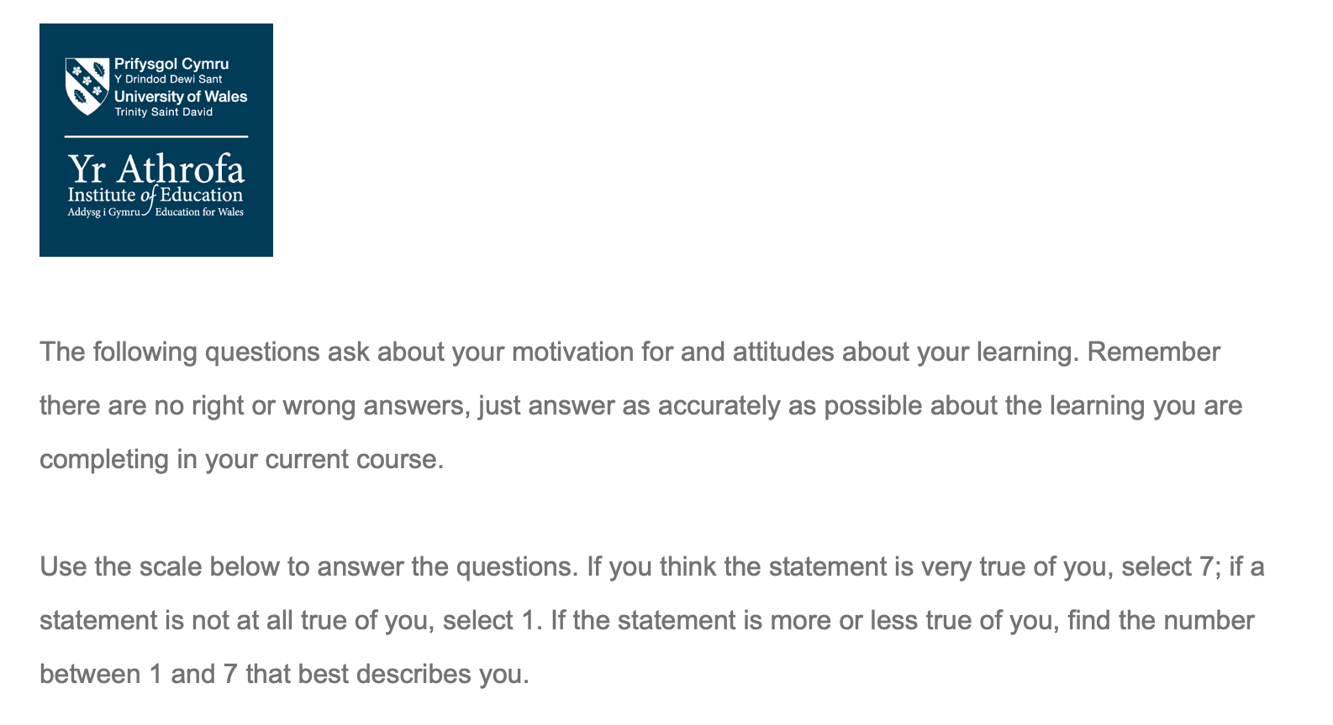
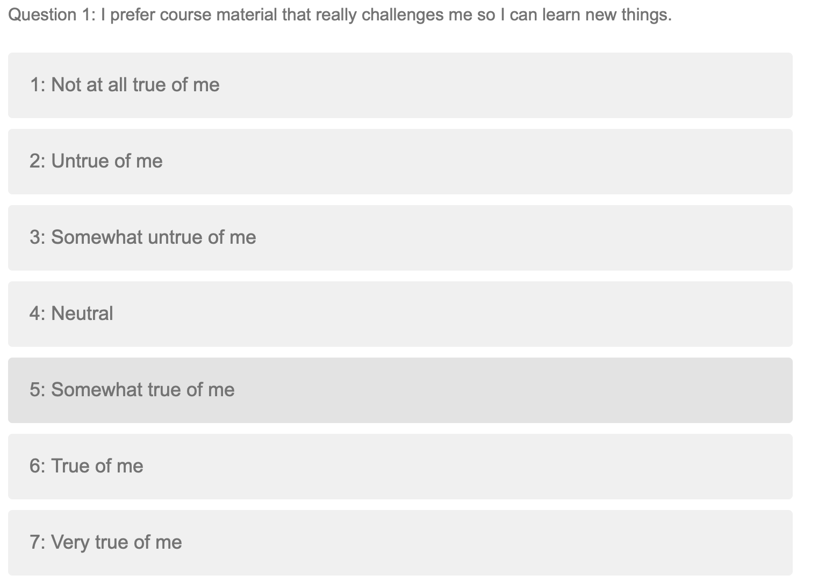
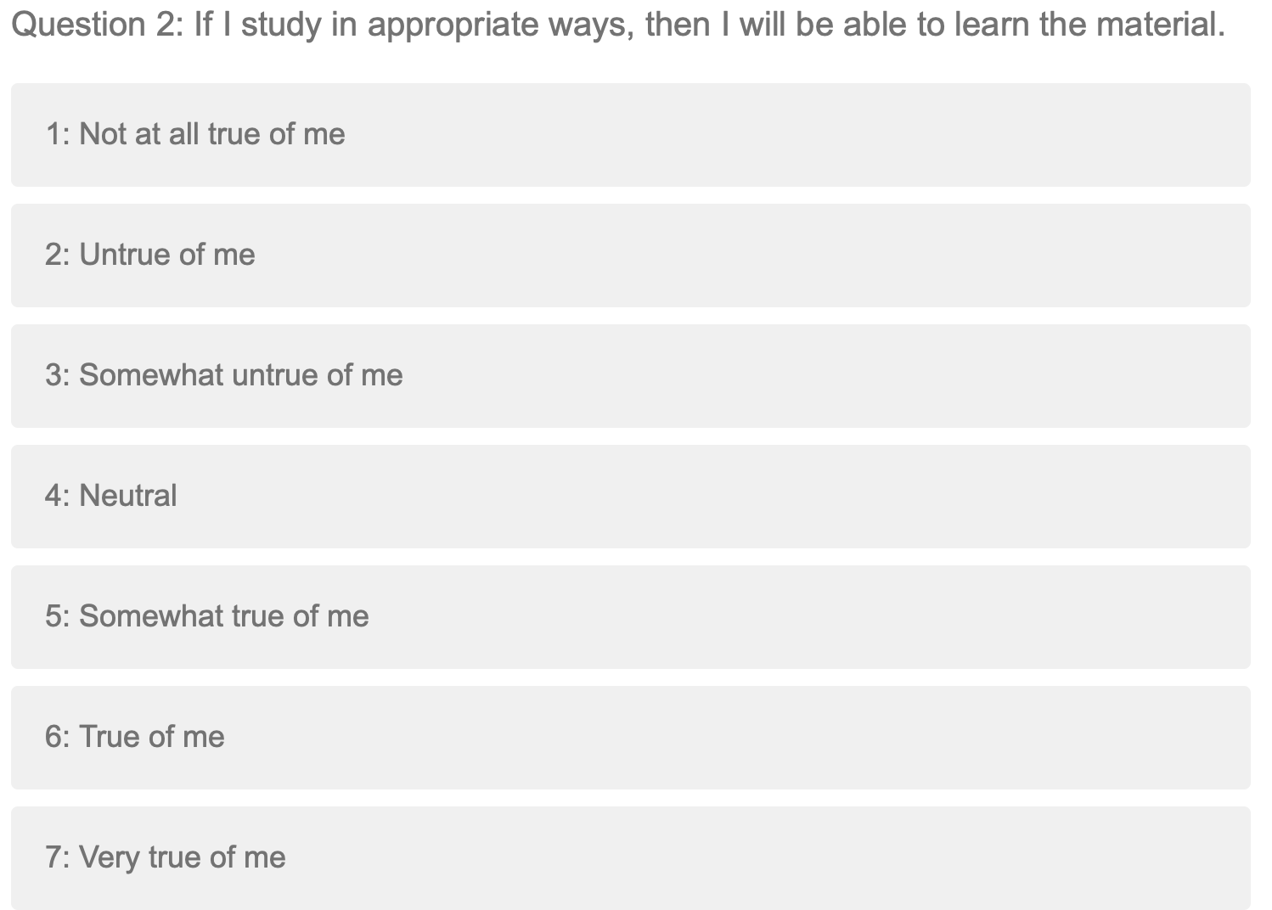
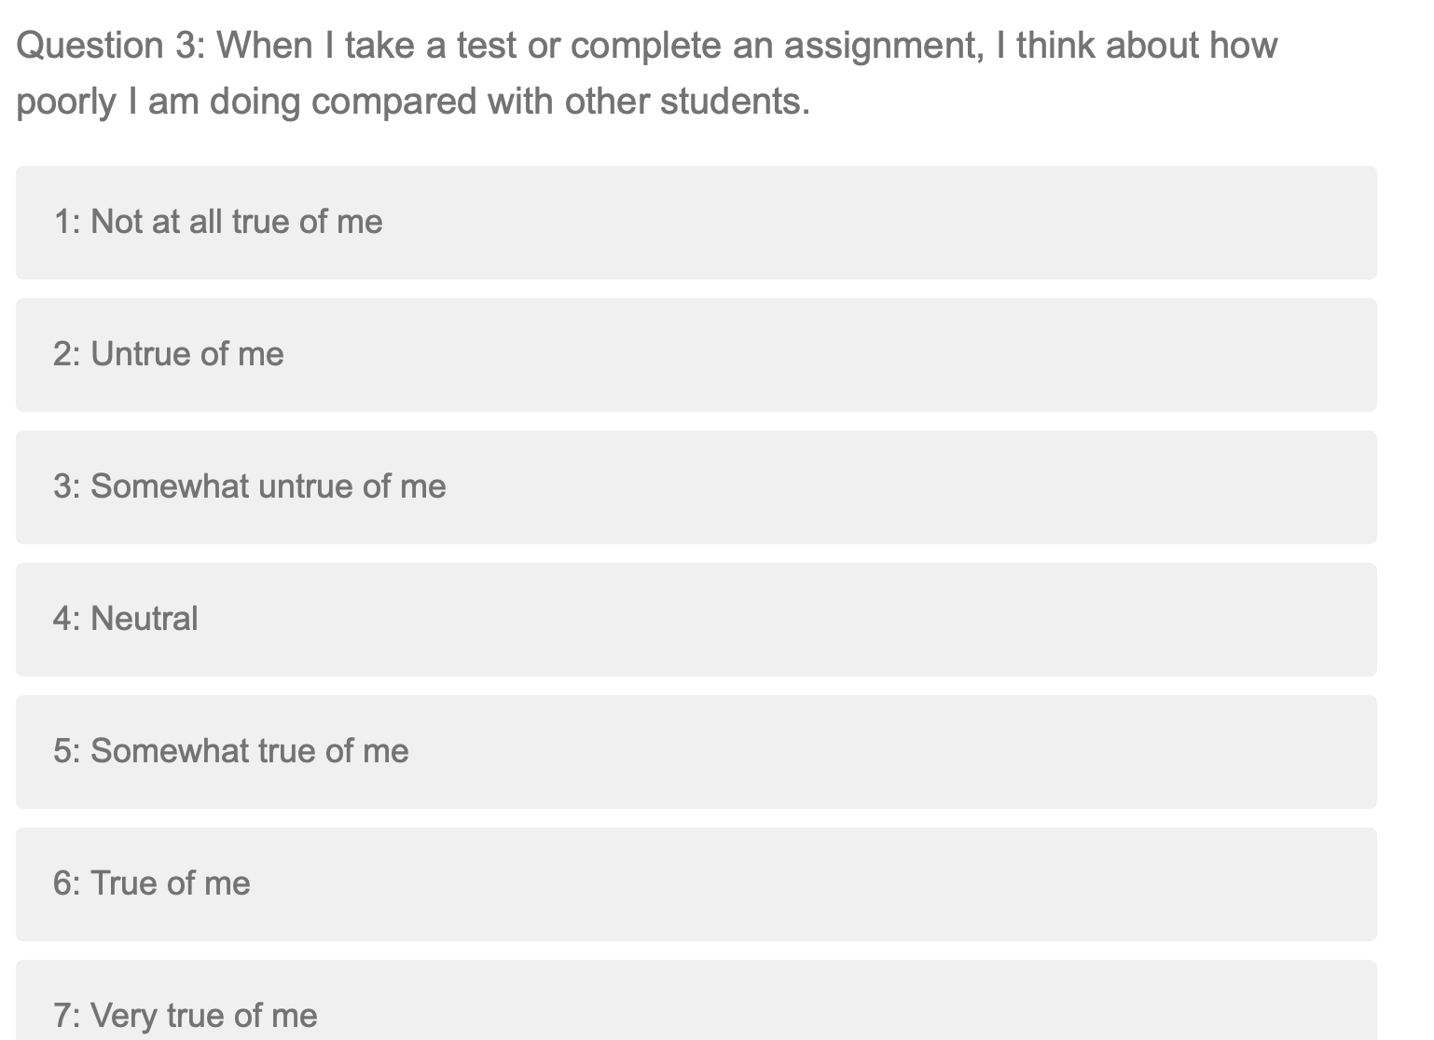
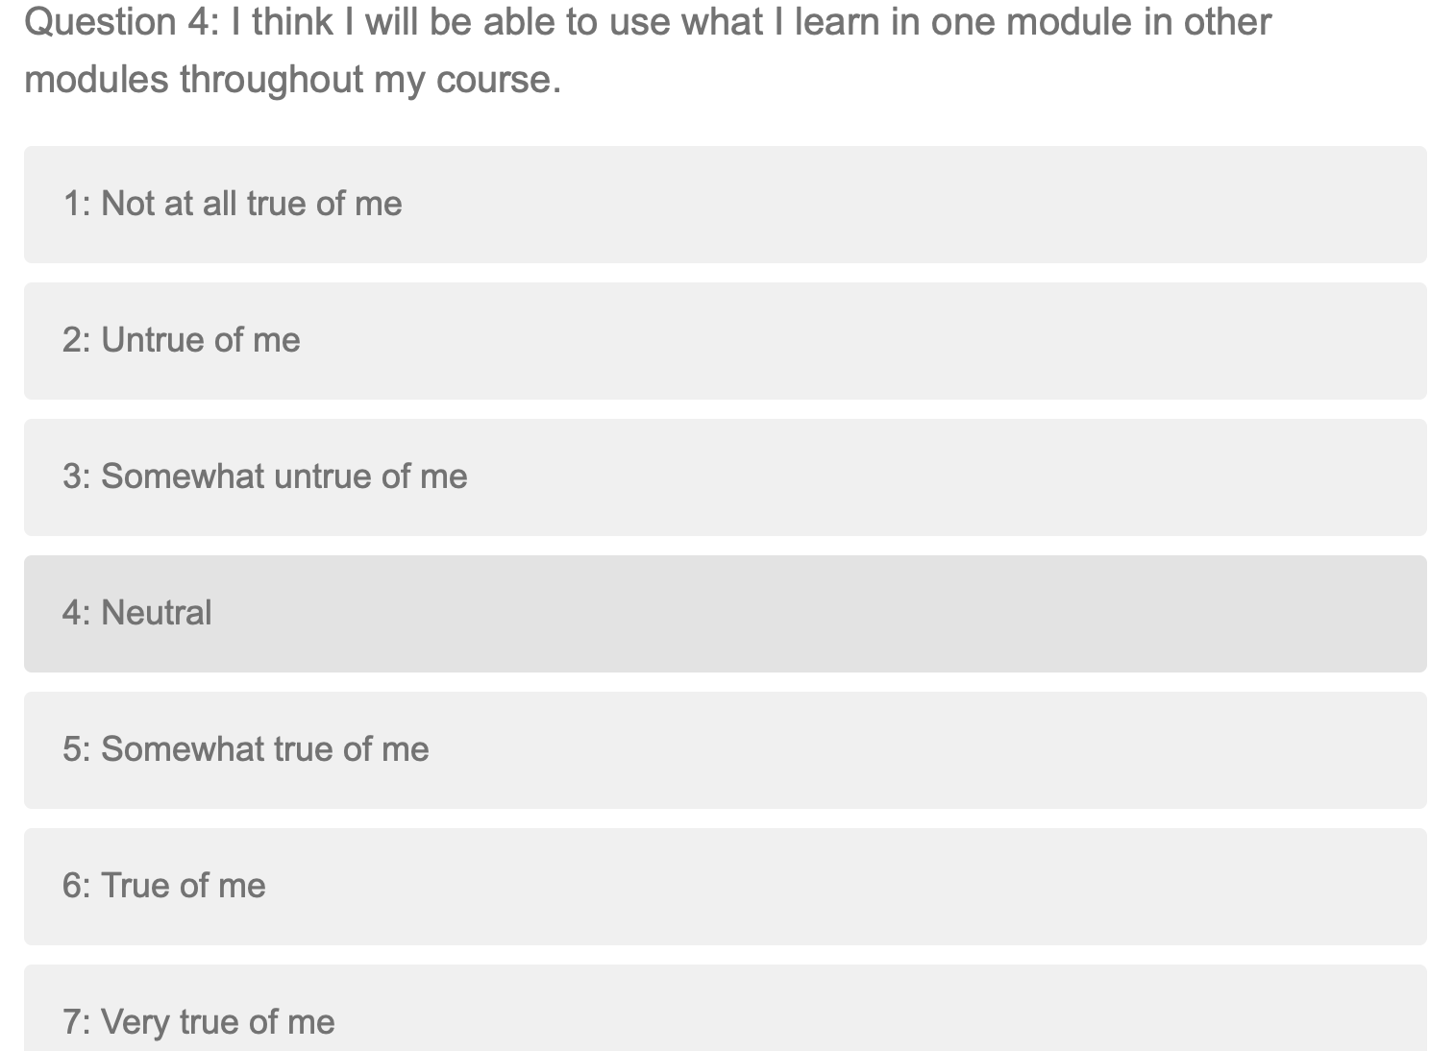
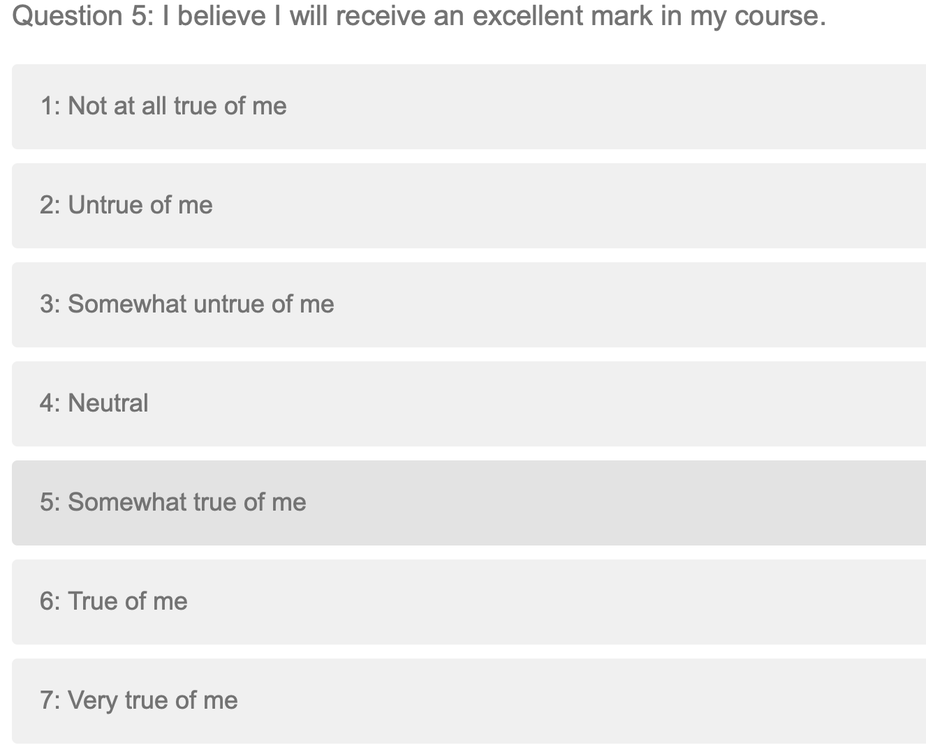
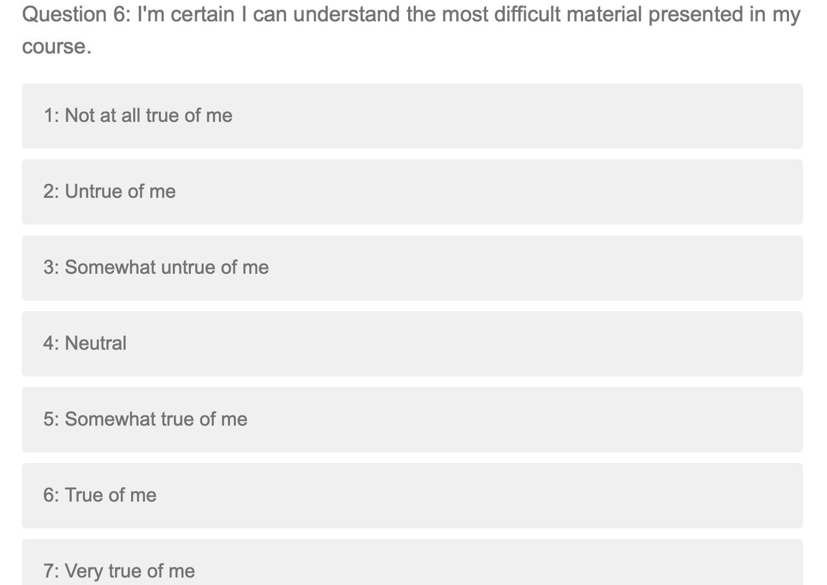
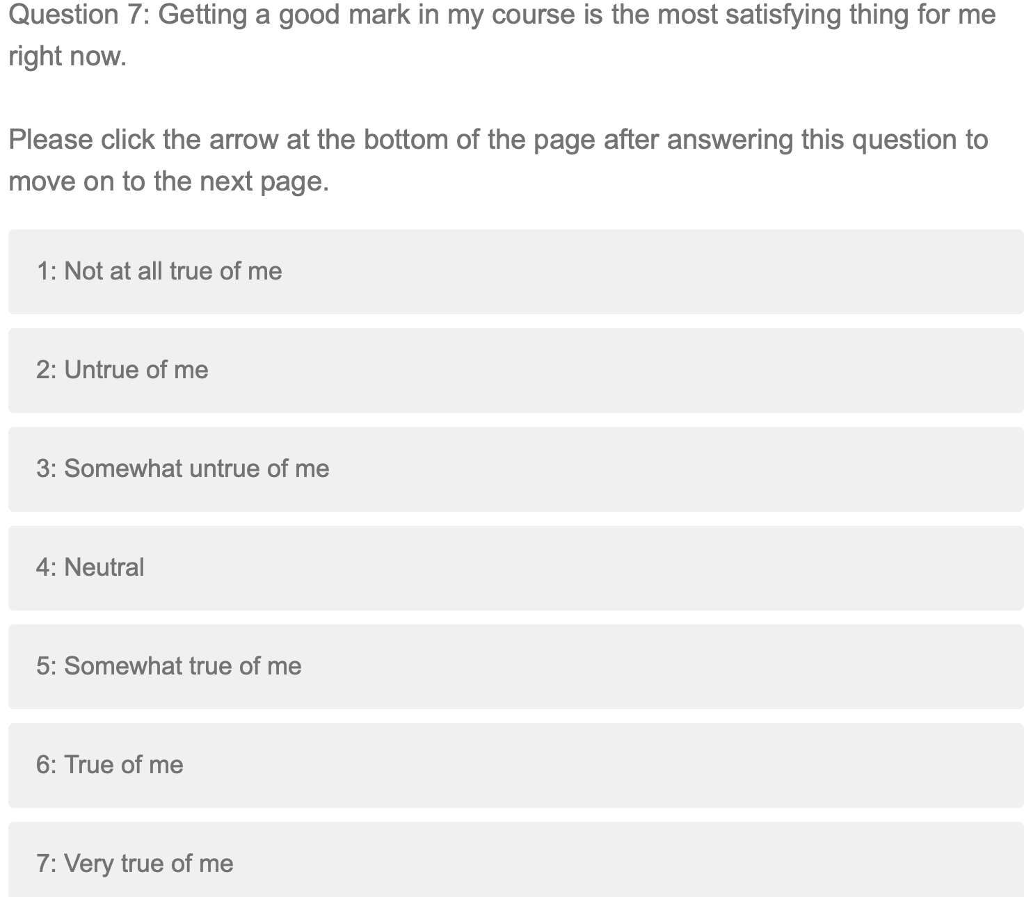
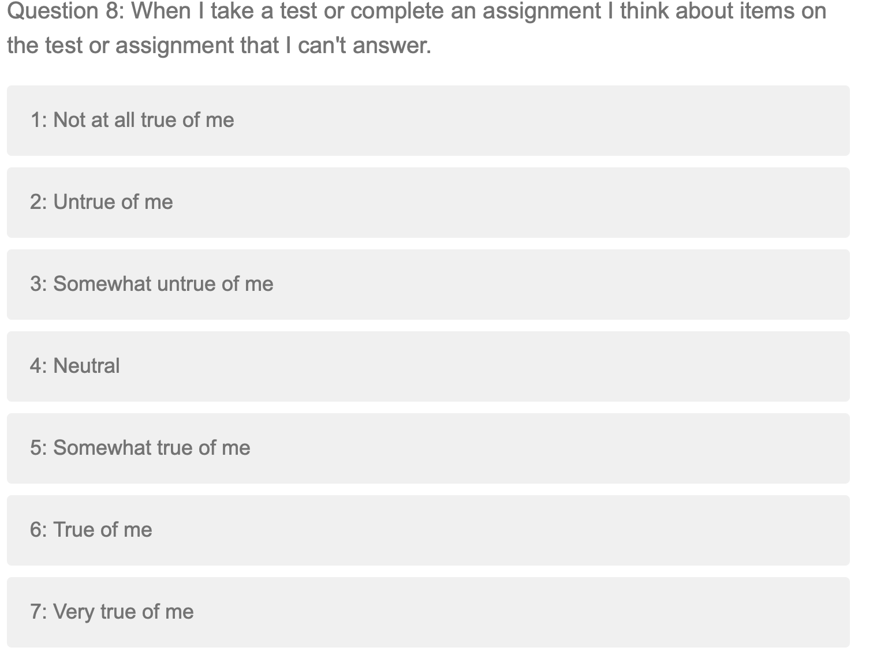A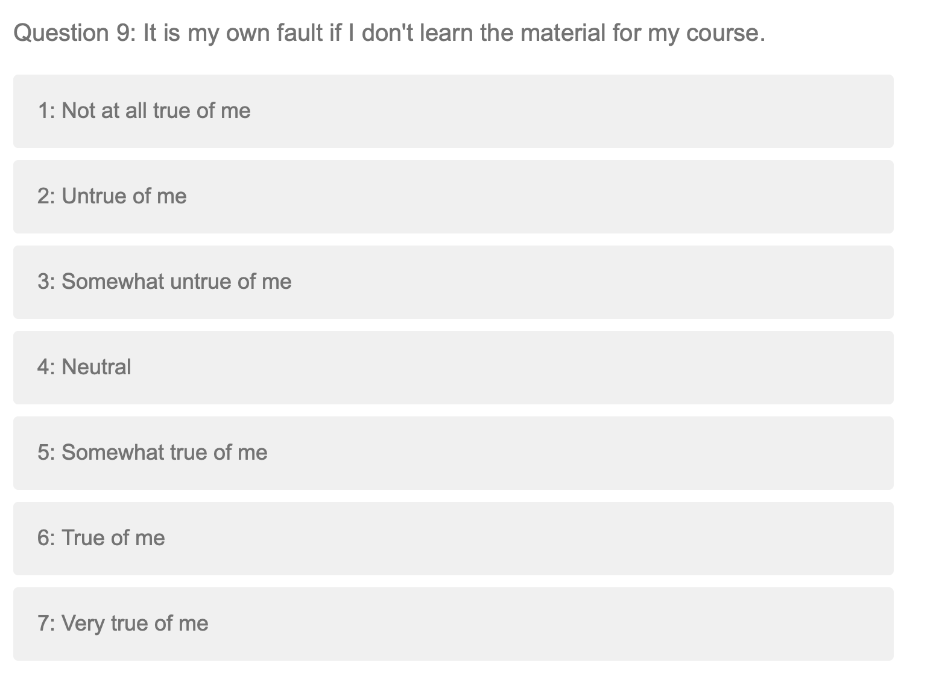
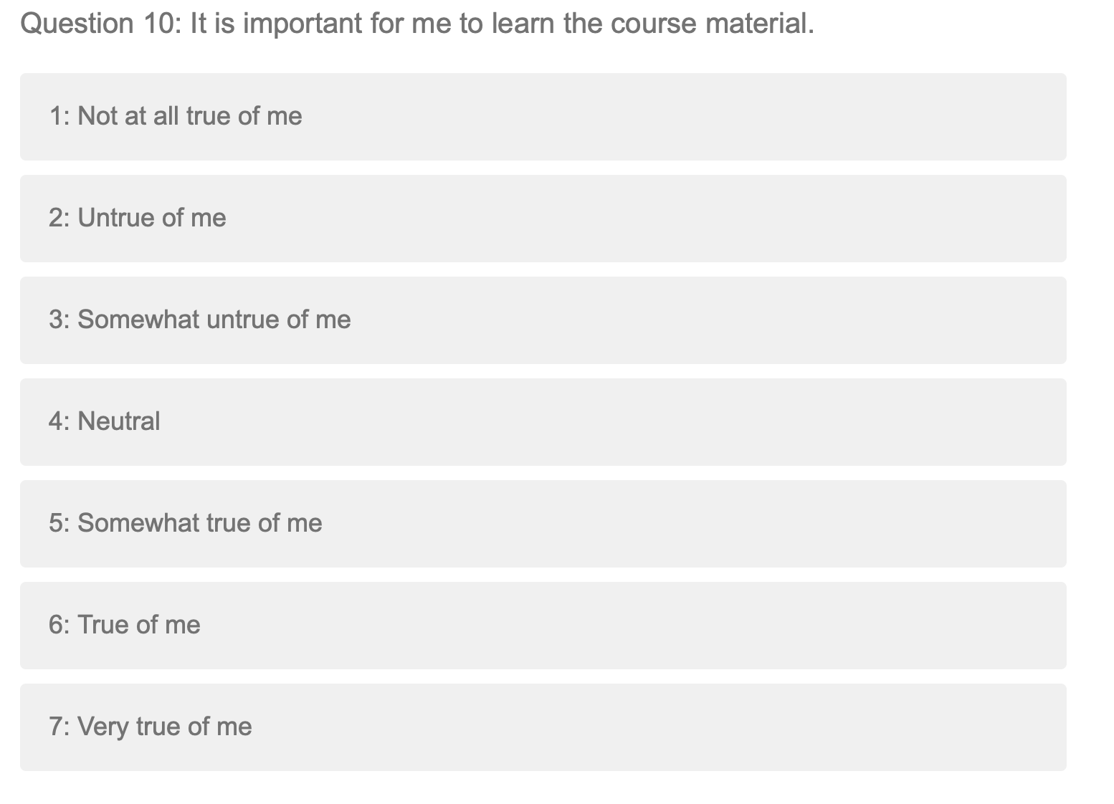
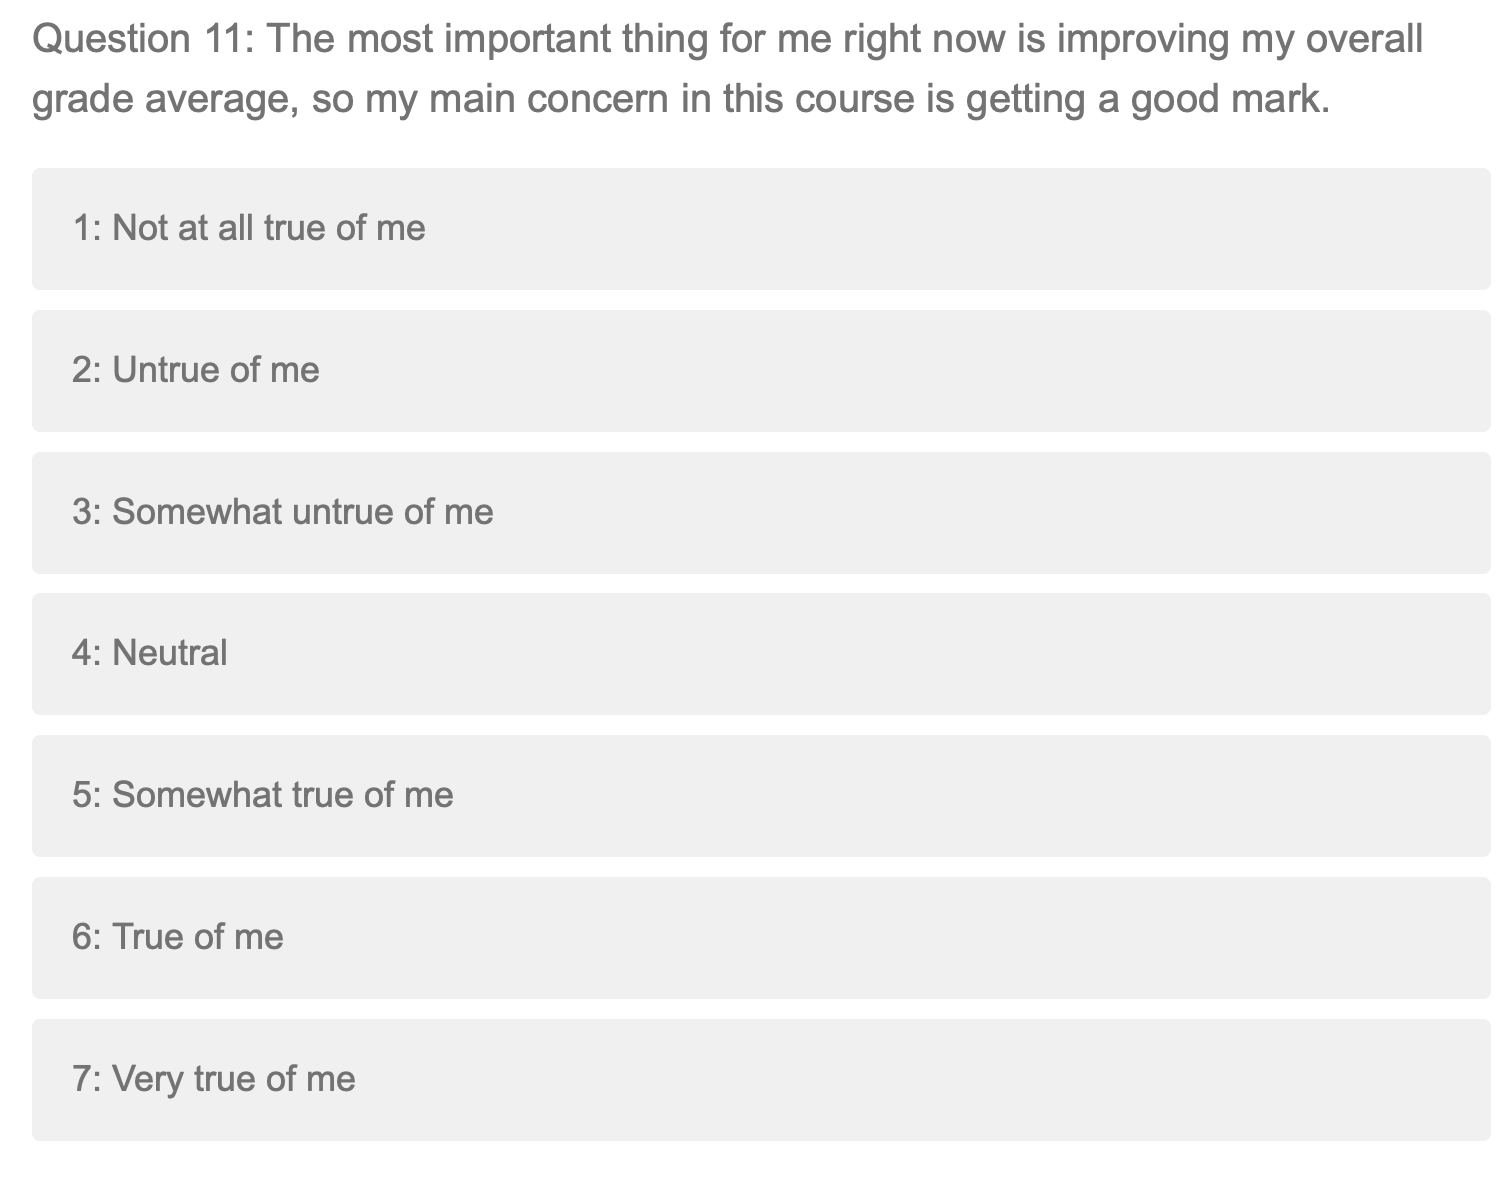
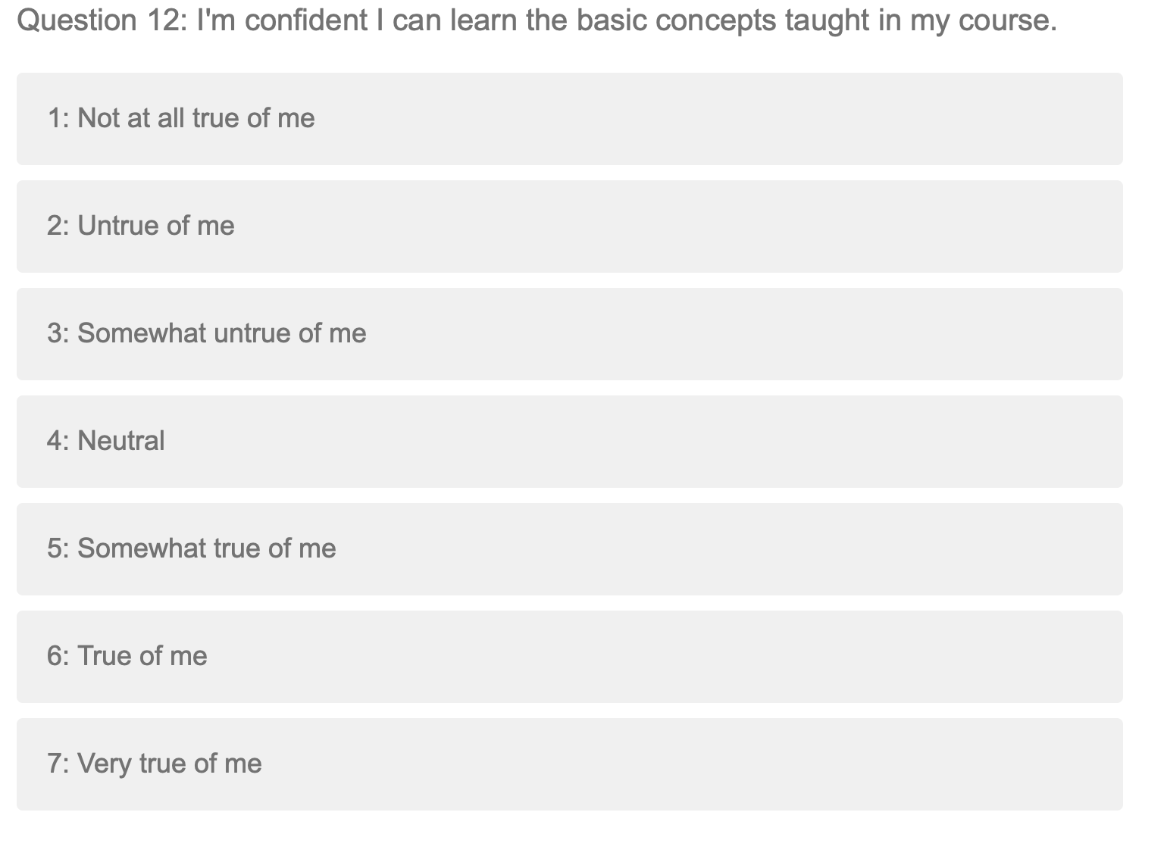
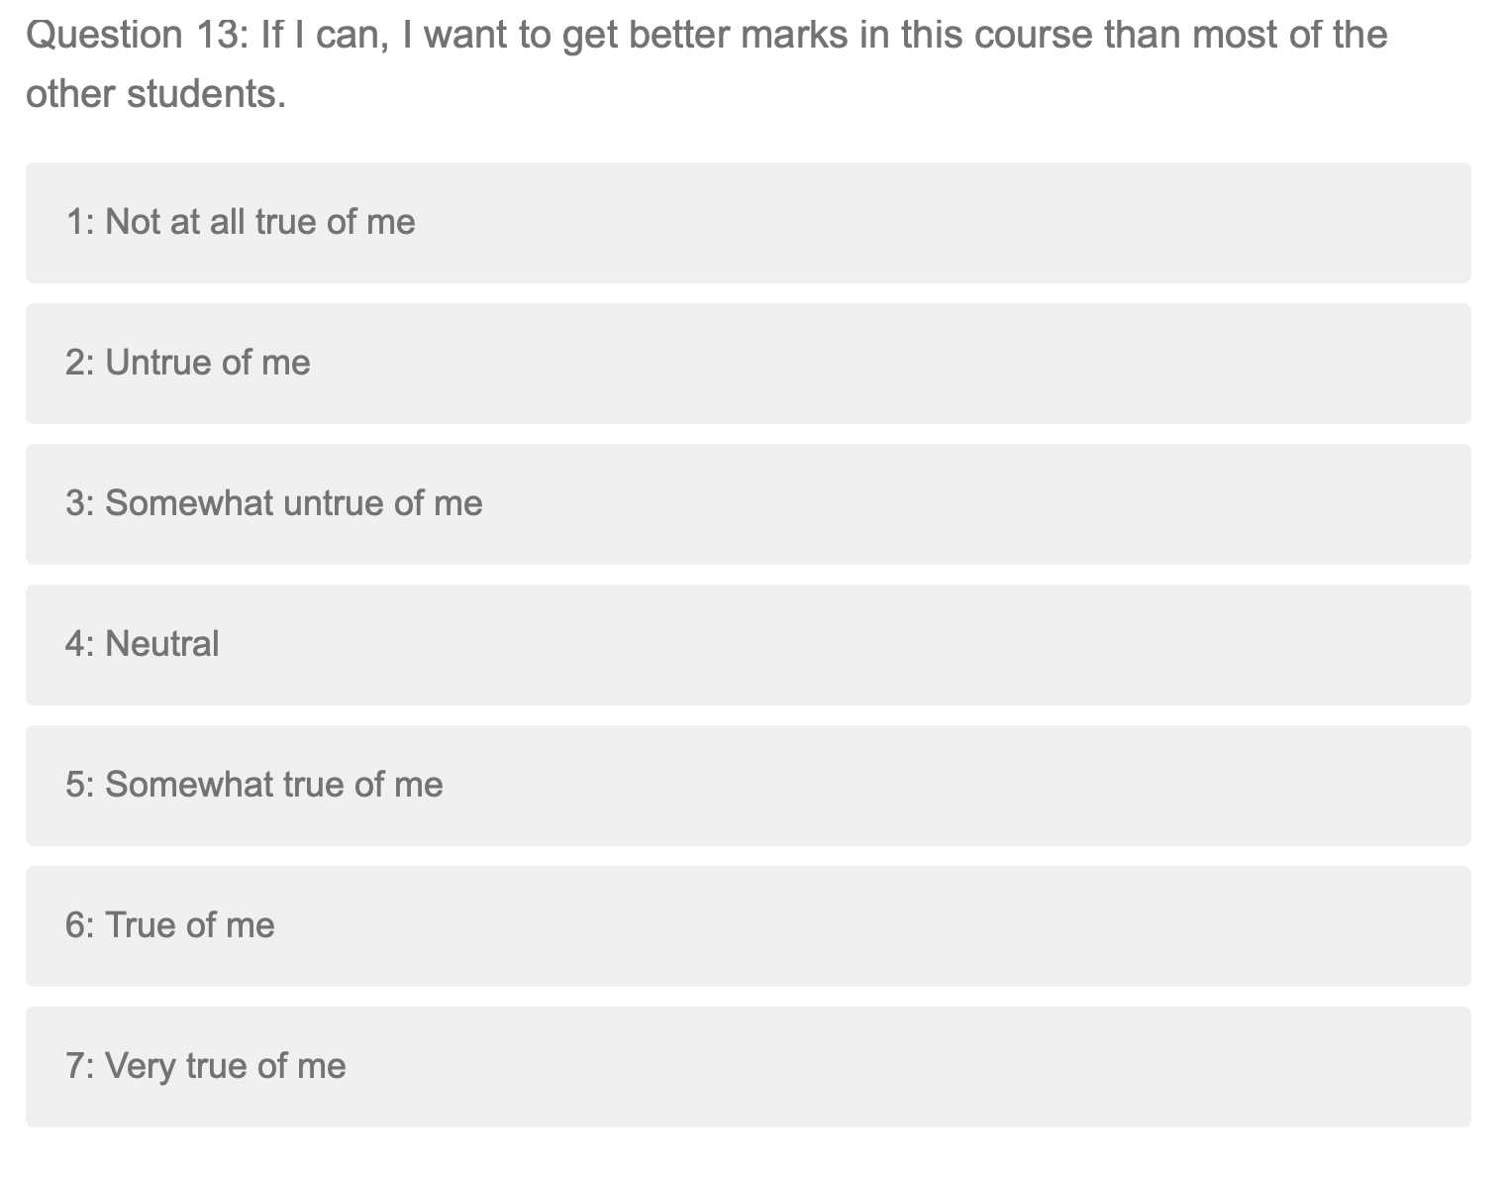
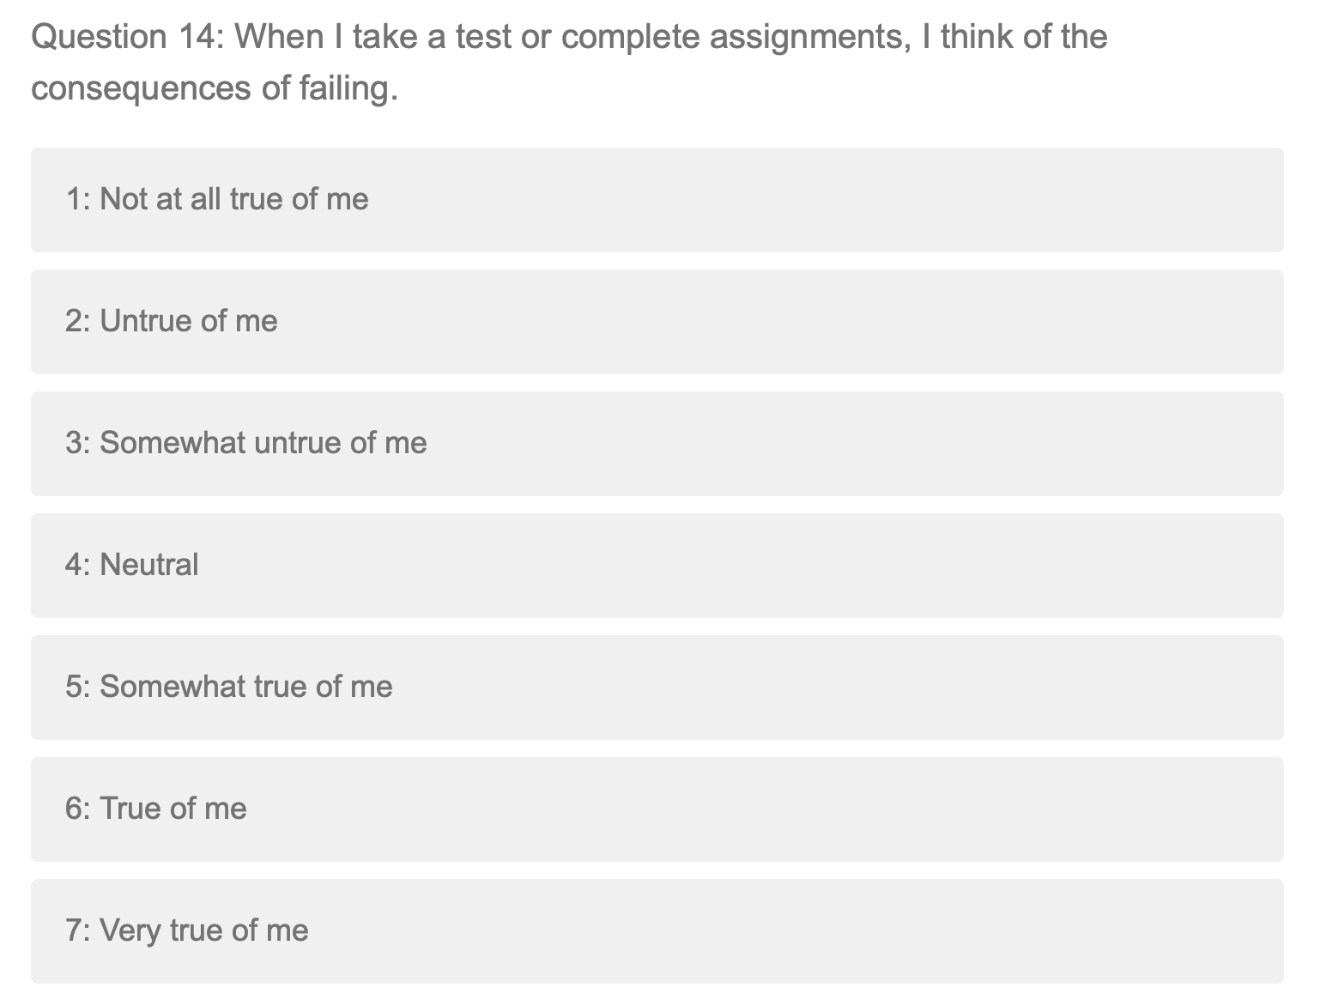
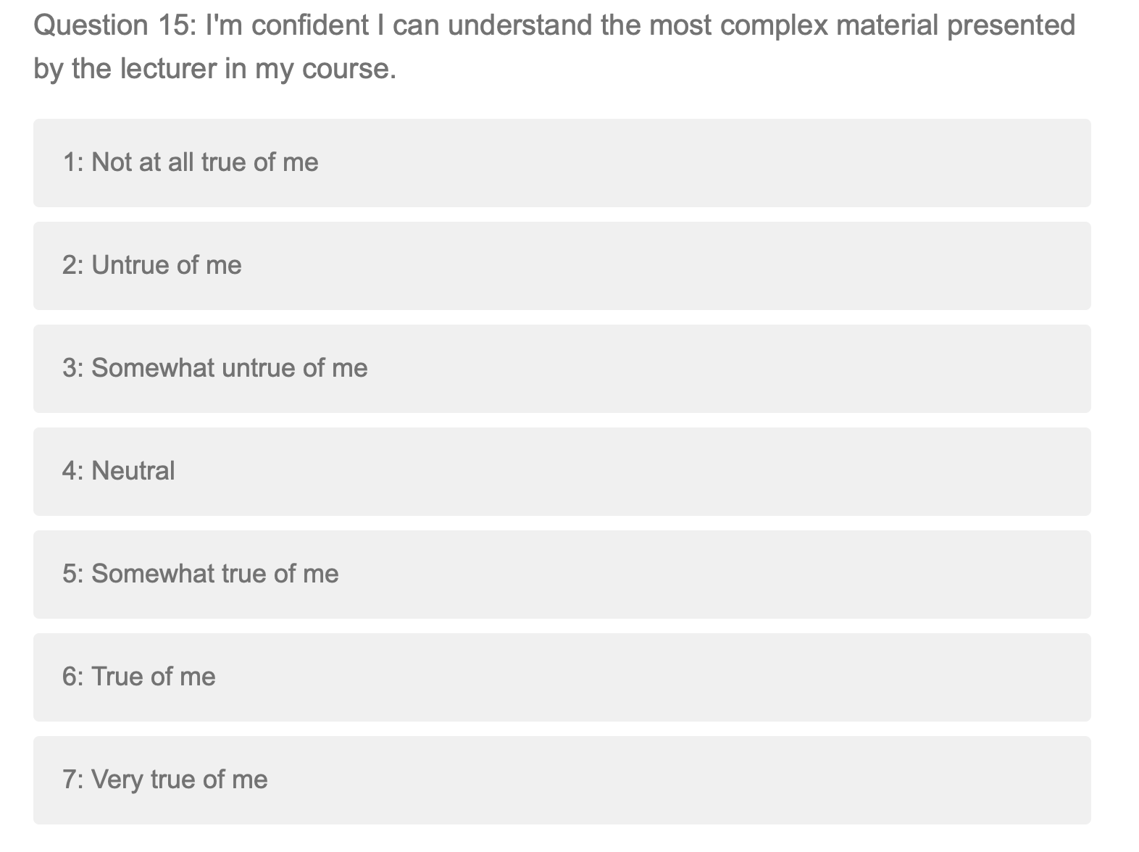
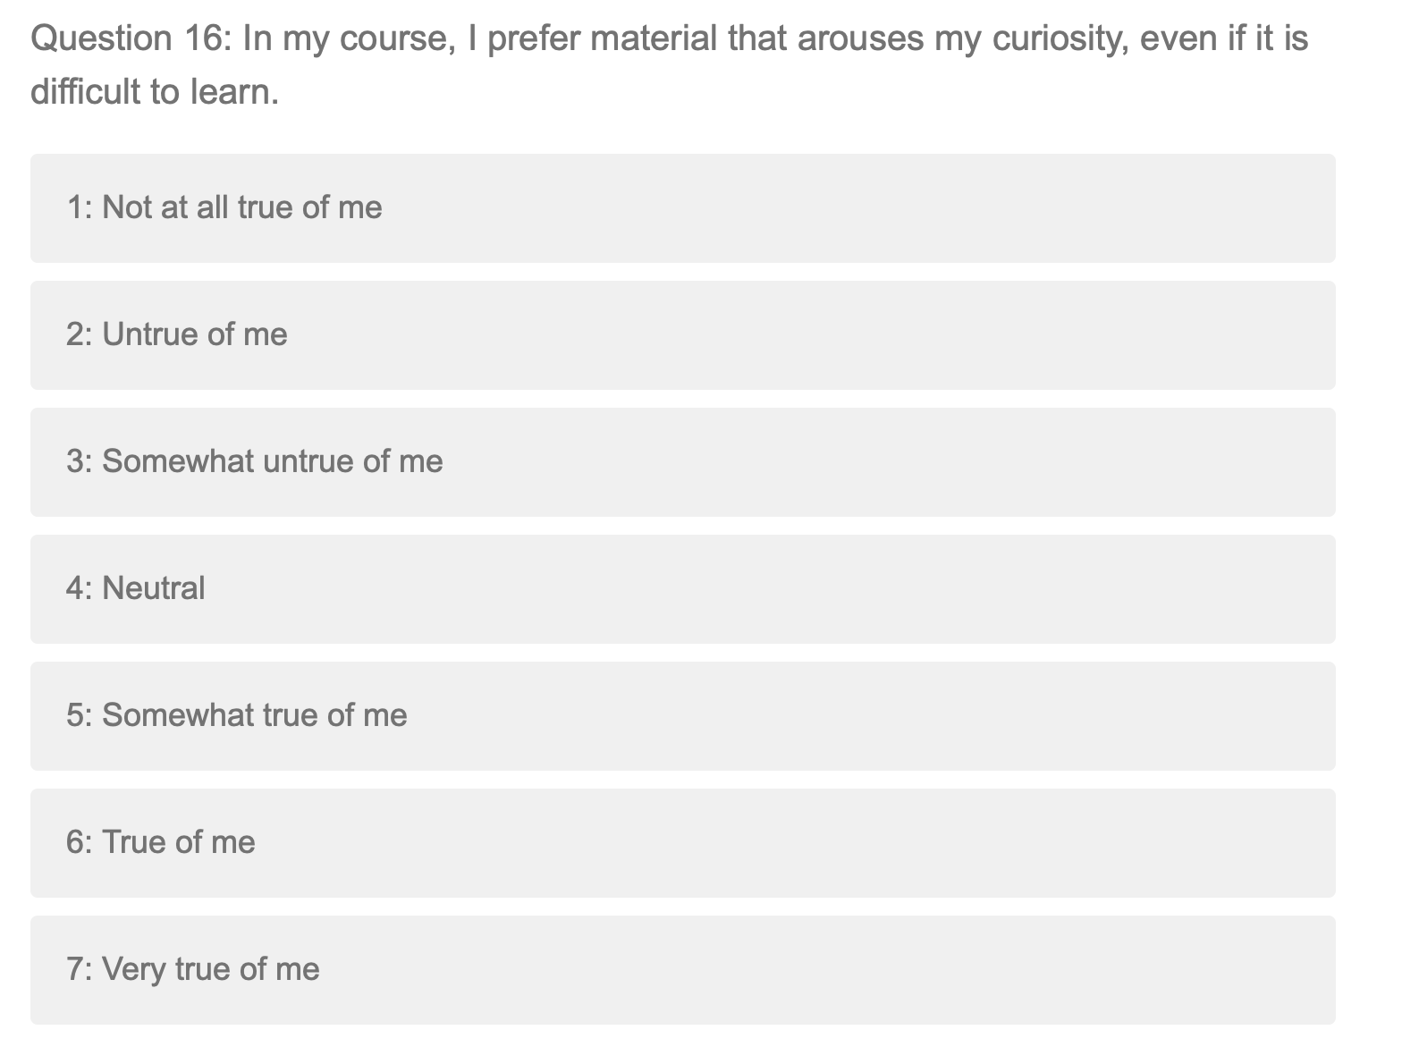
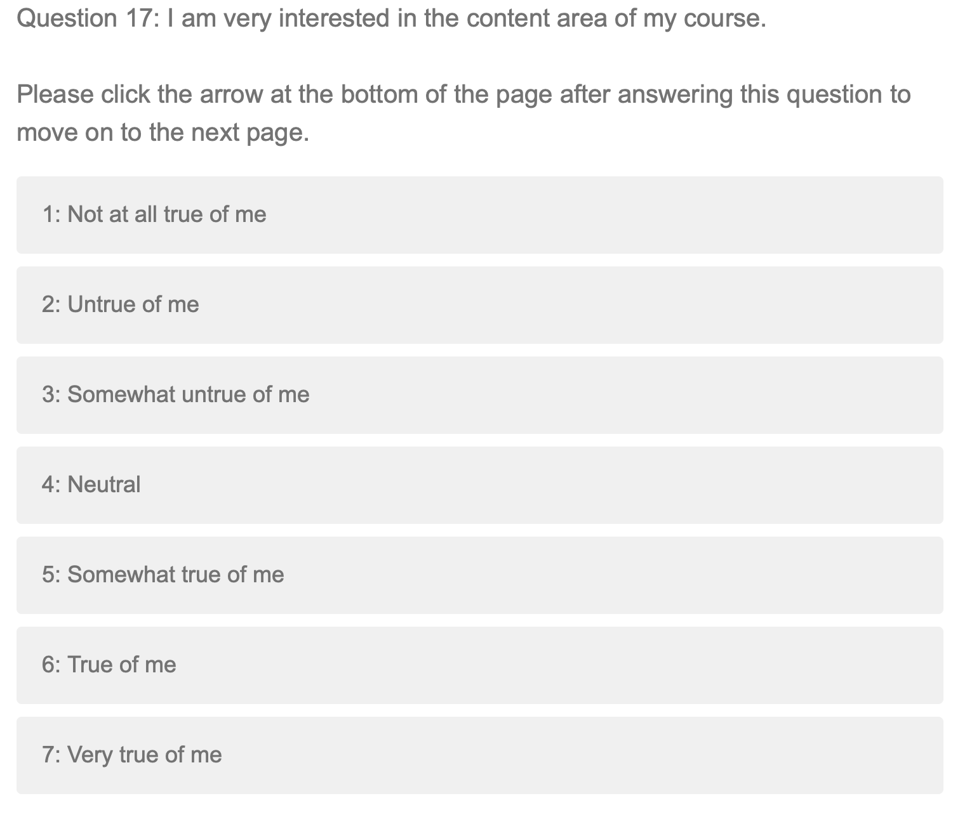
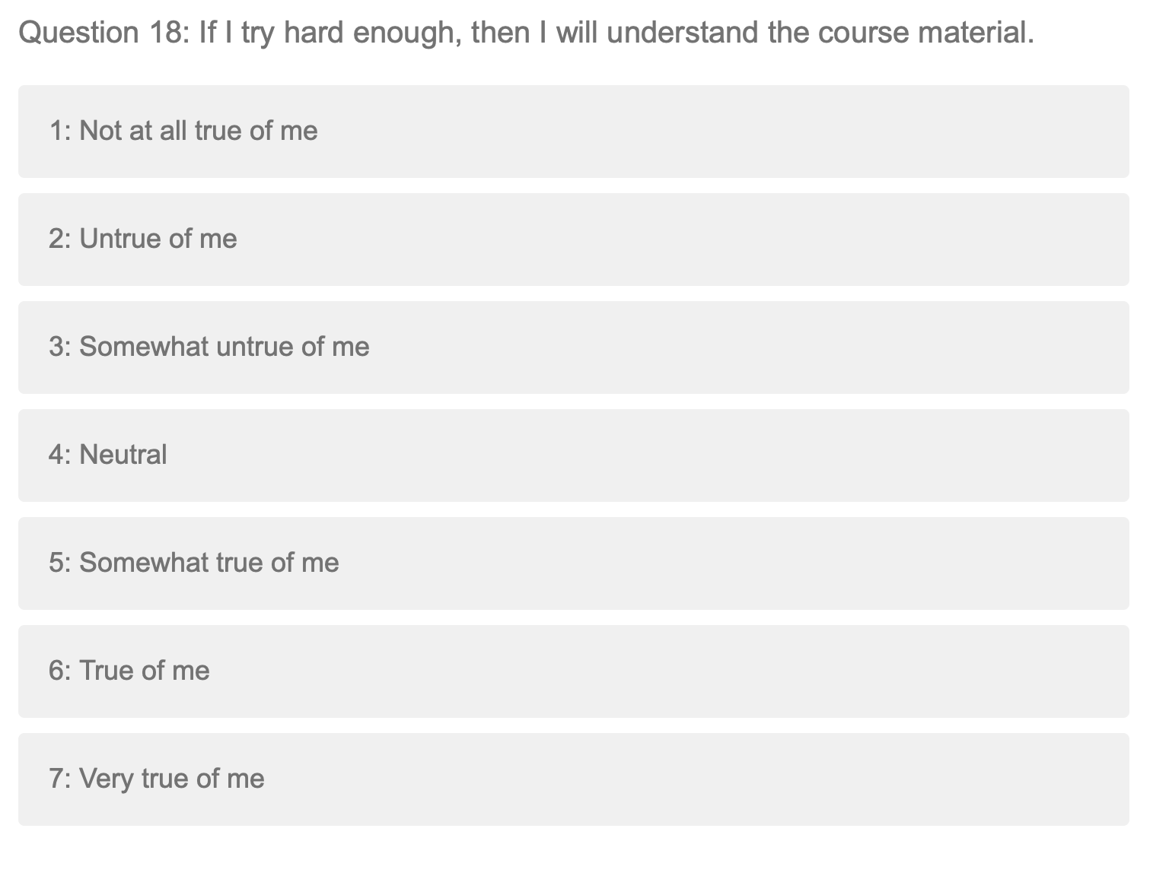
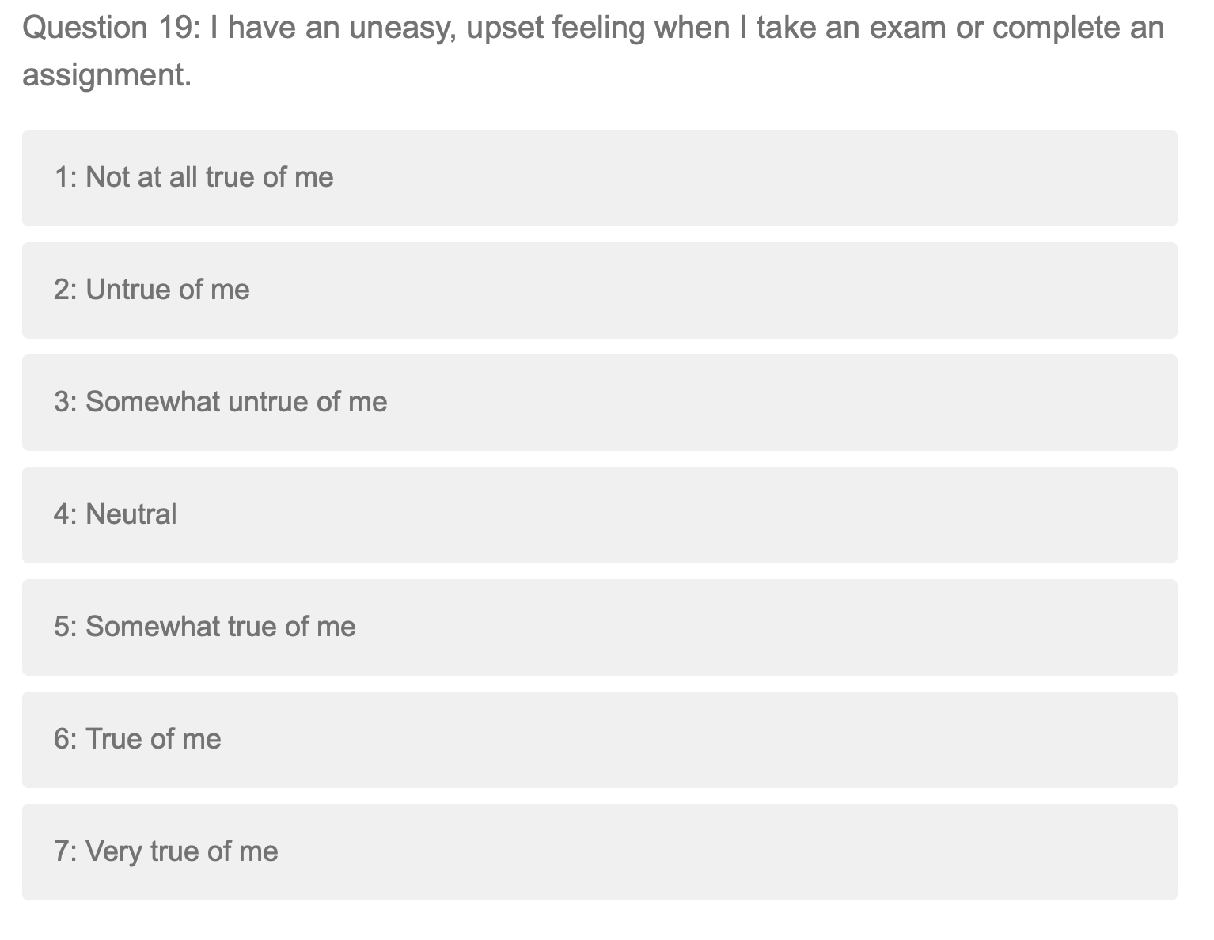
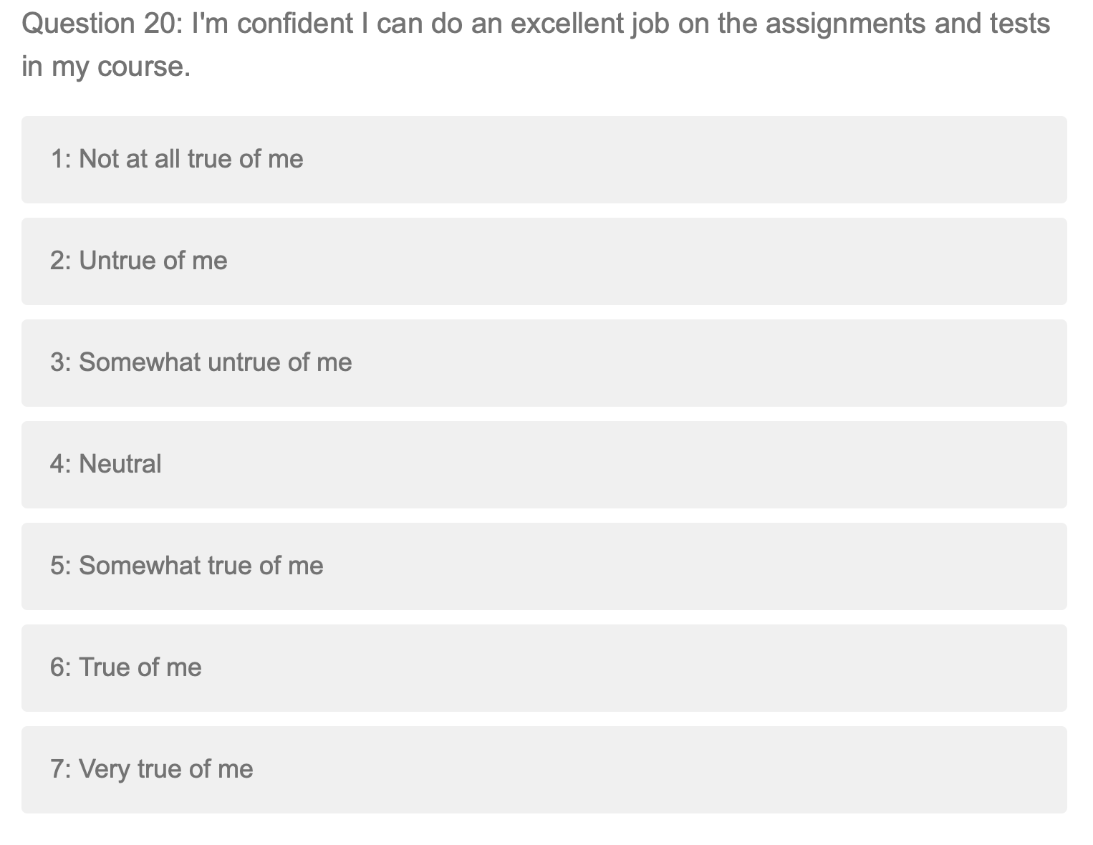
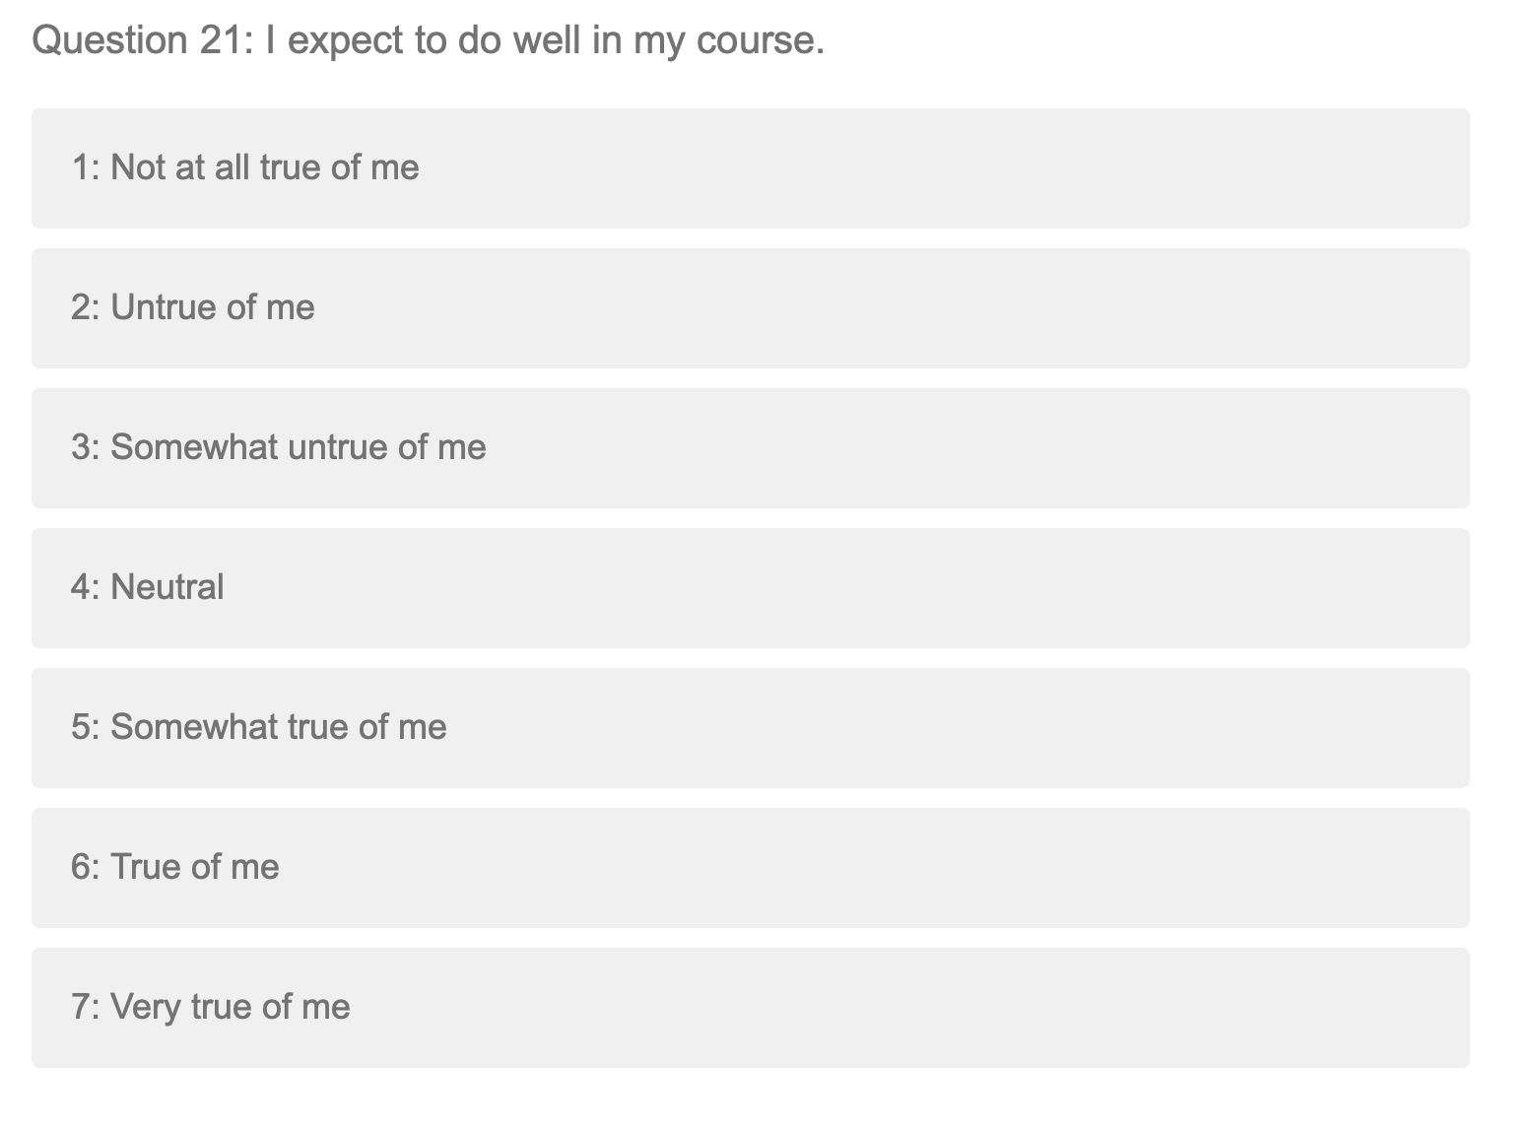
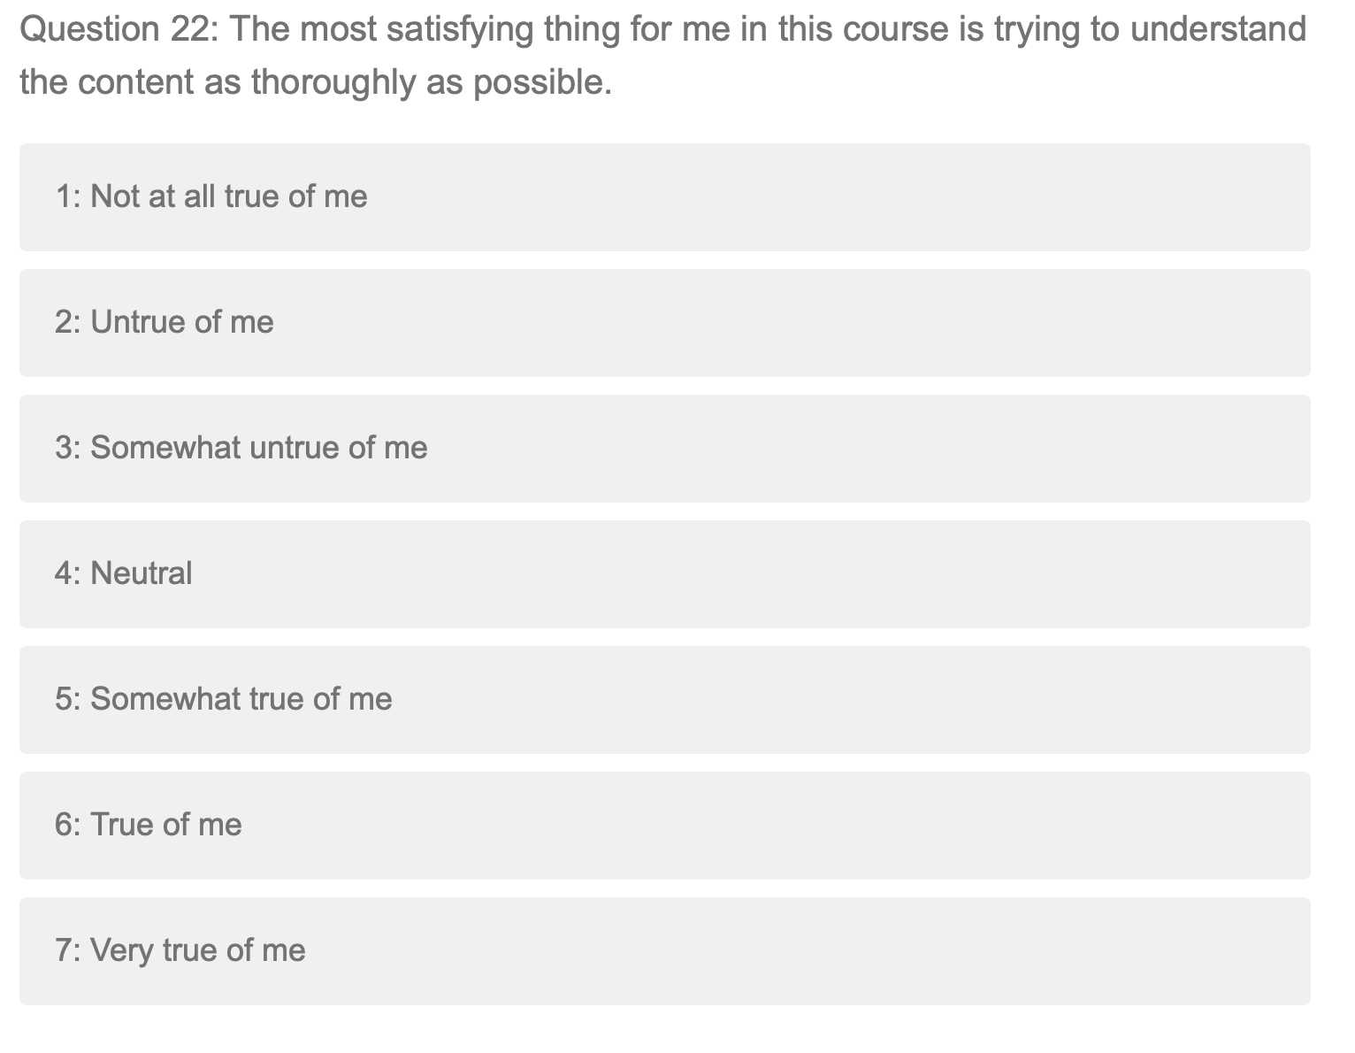
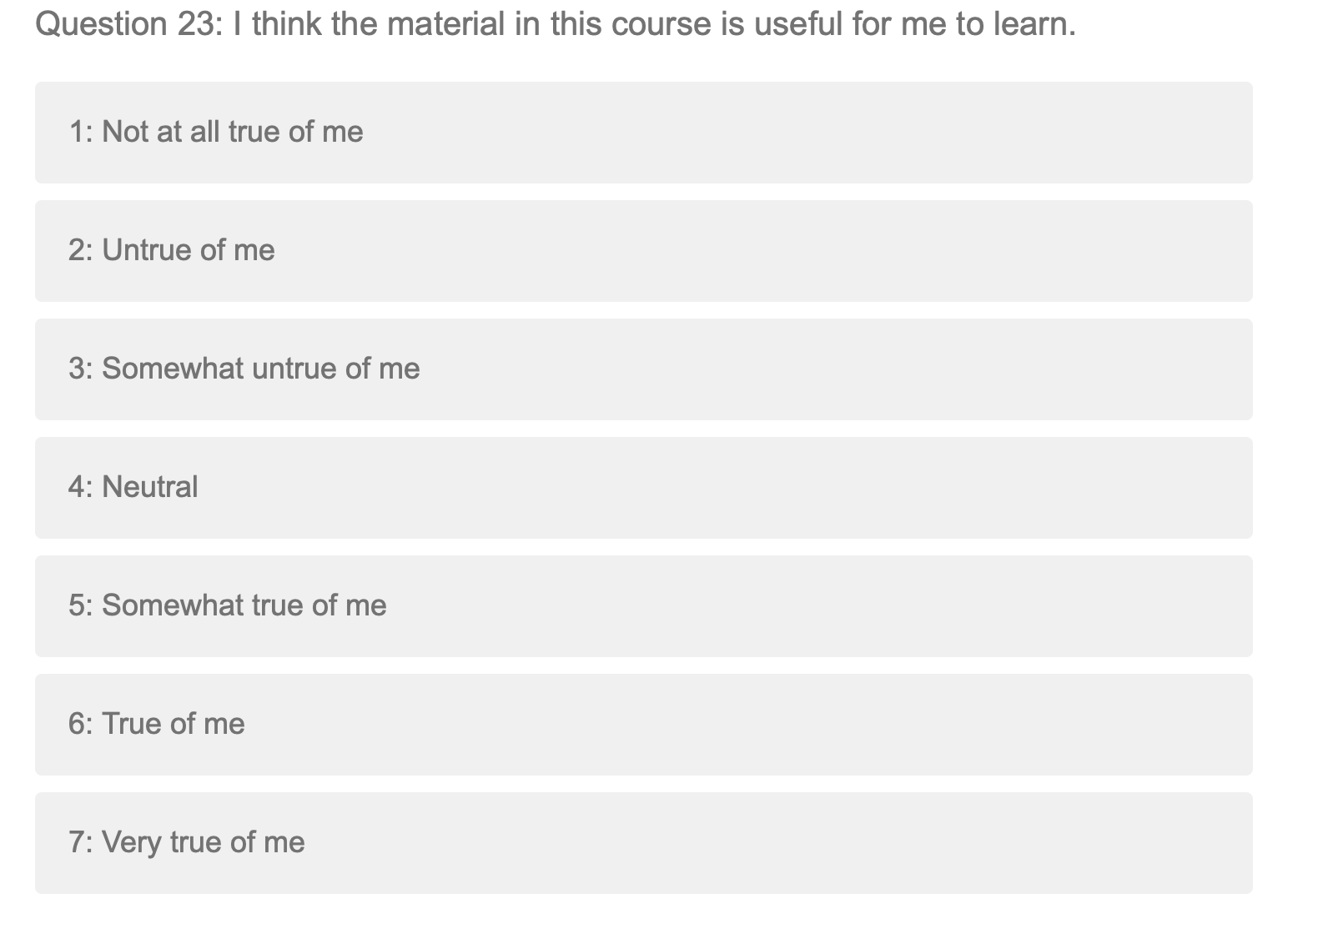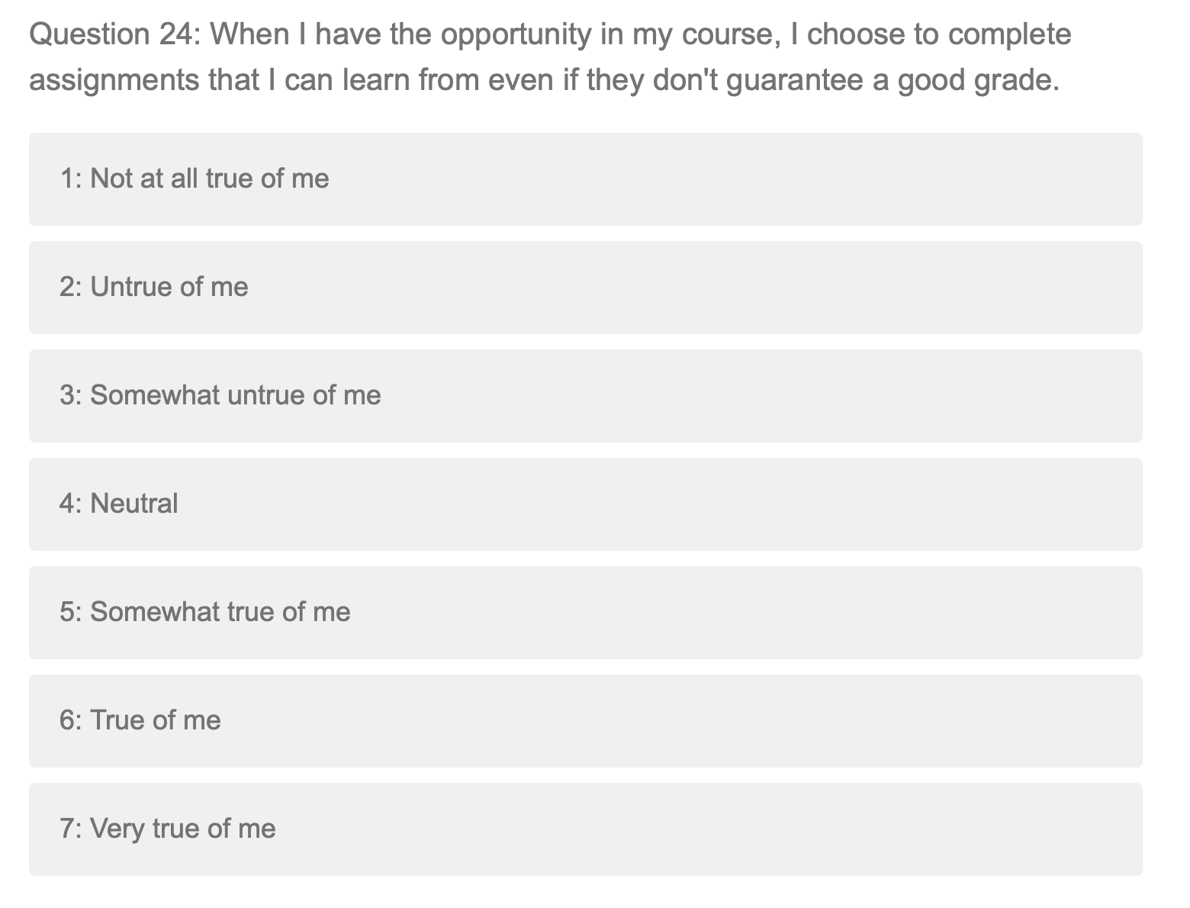
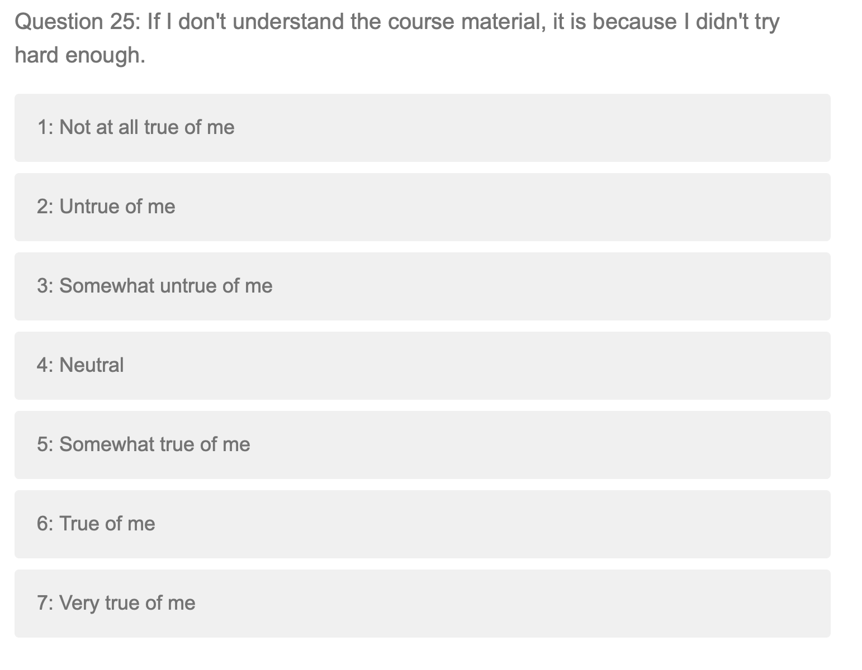
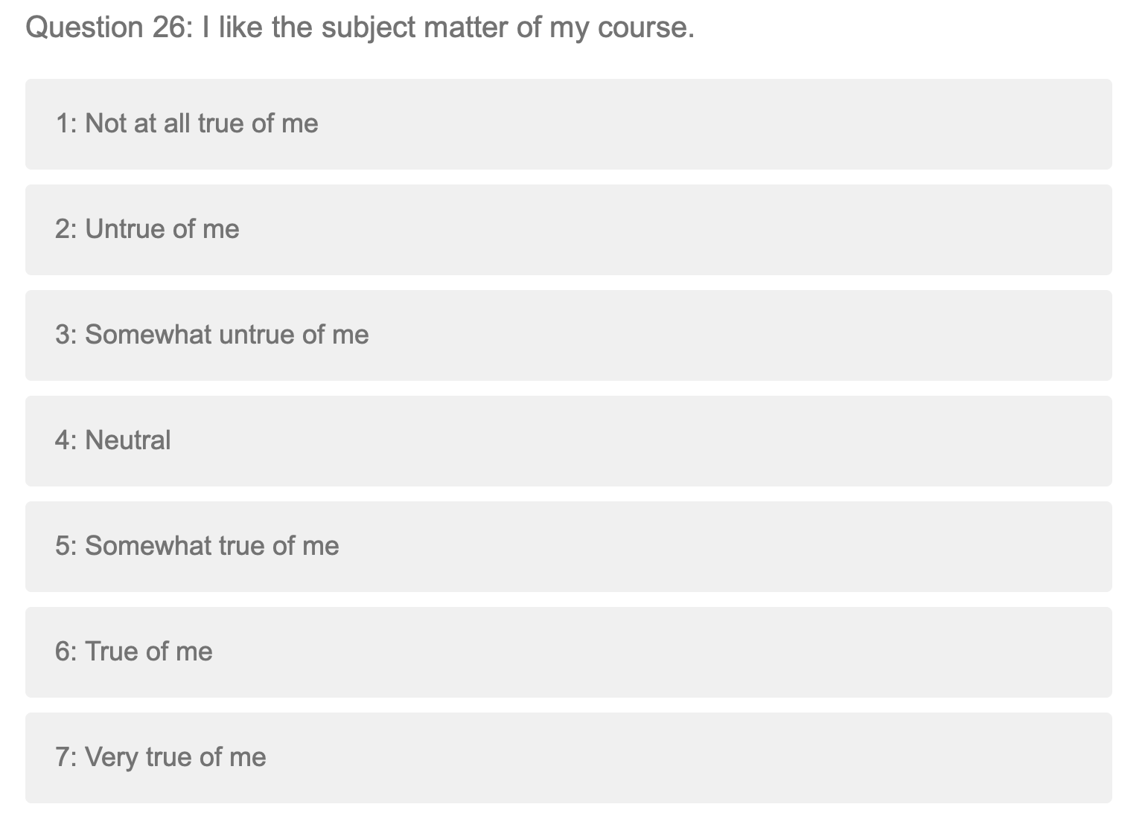
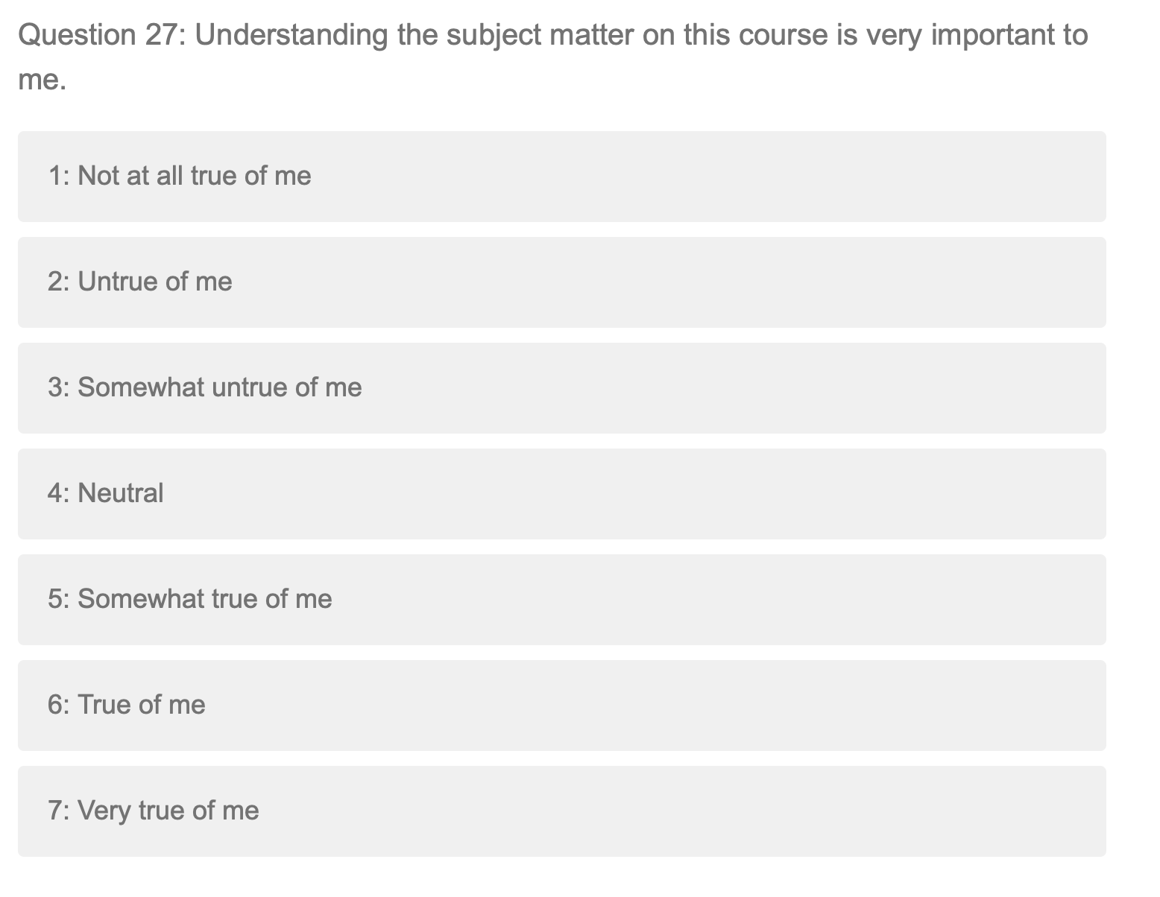
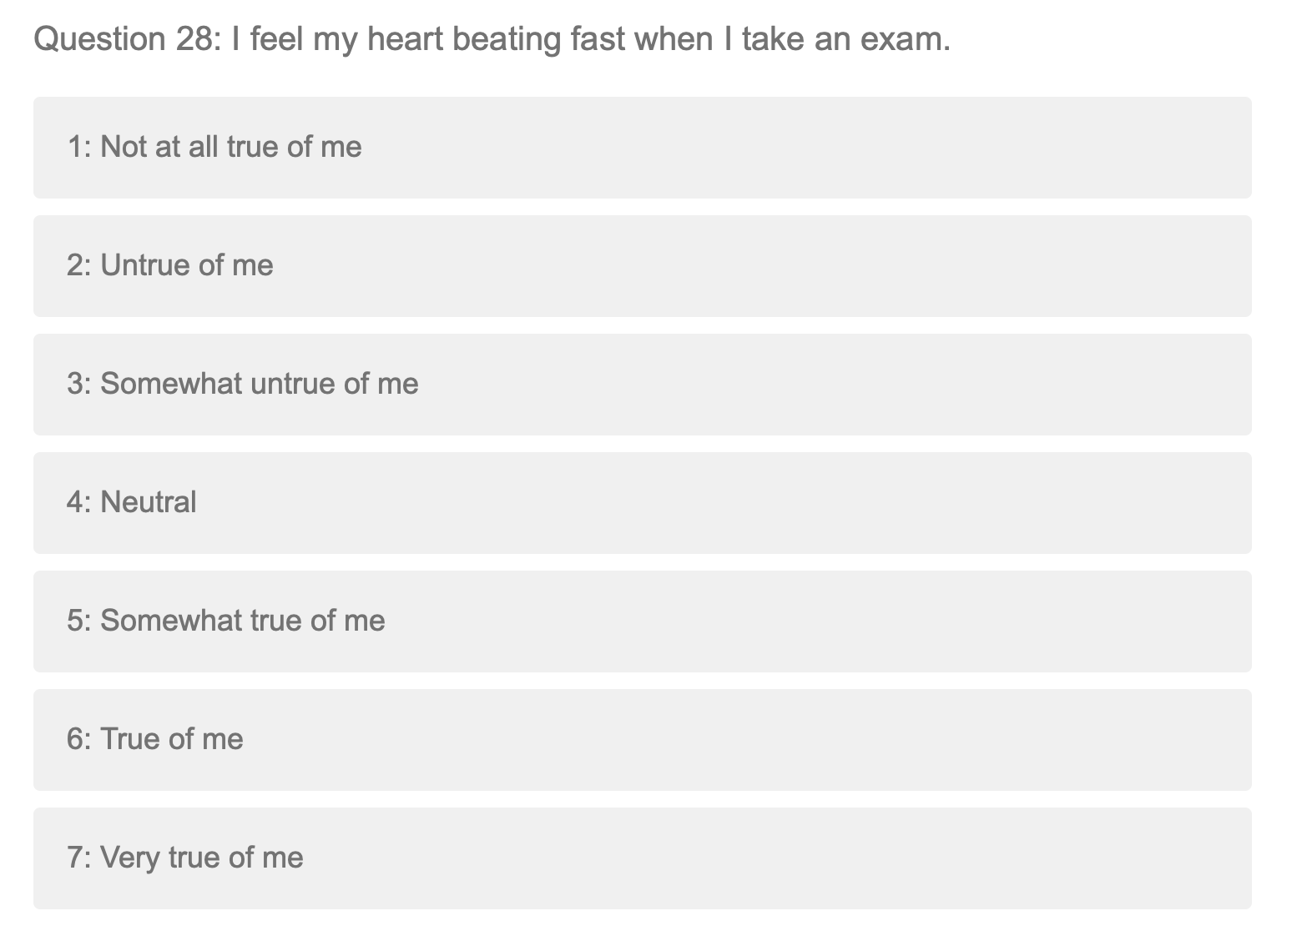
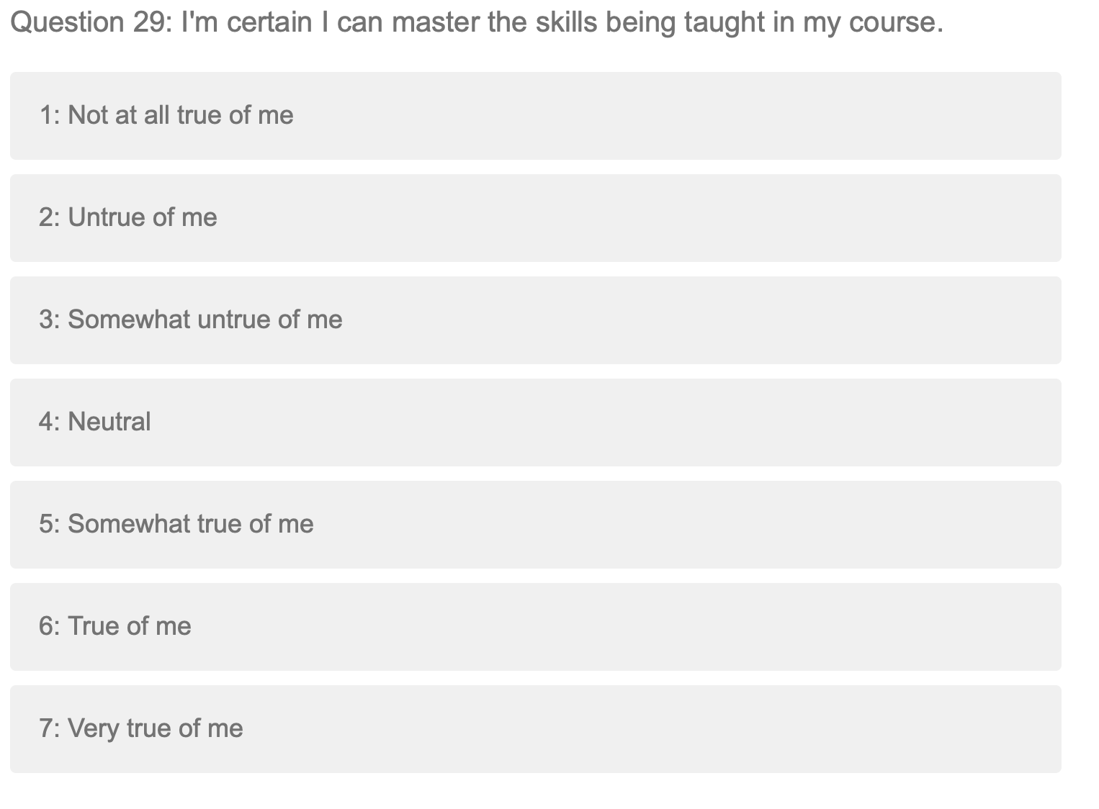
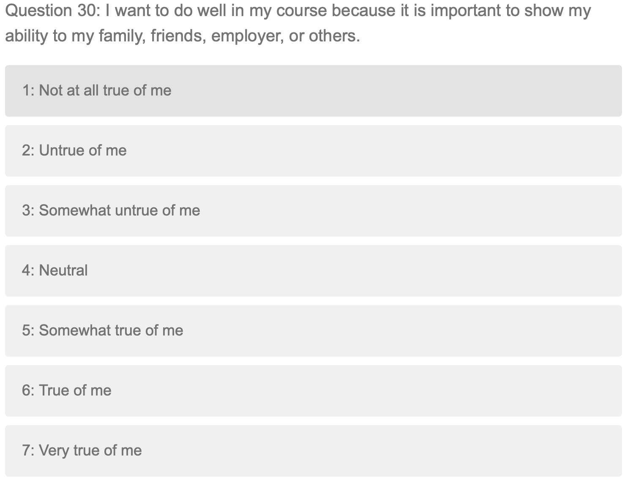
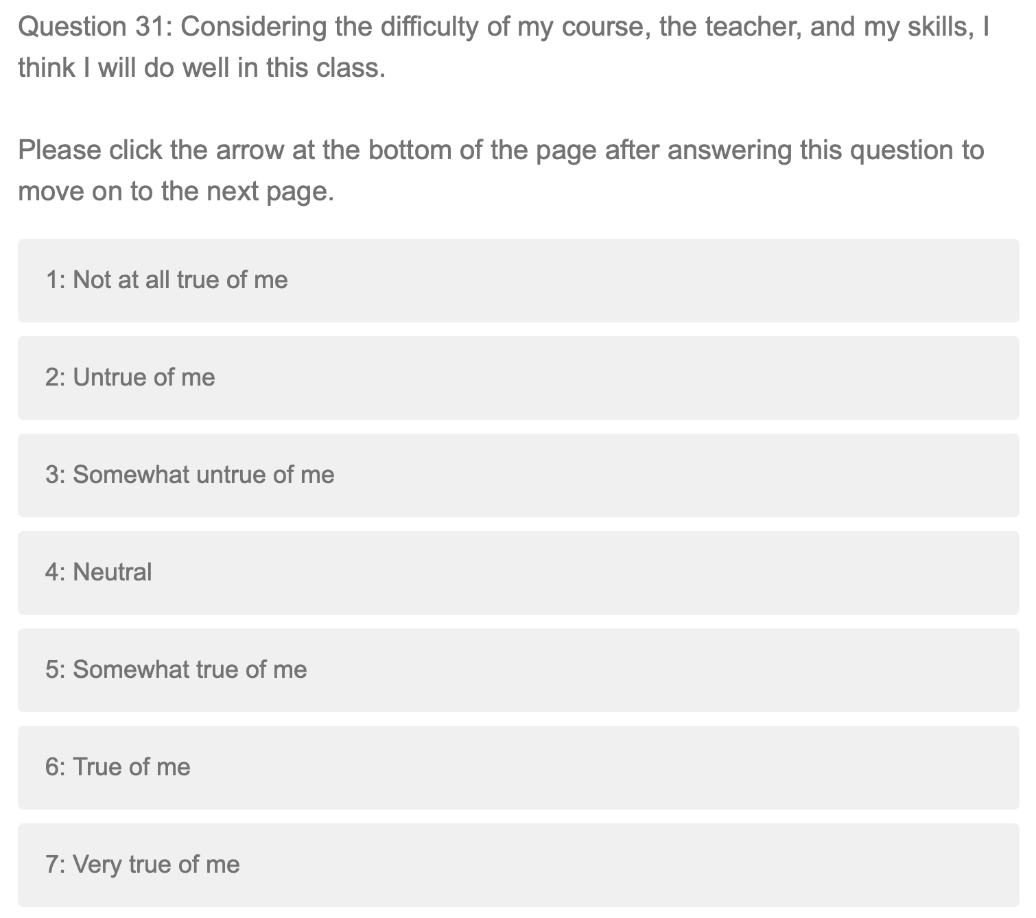
Appendix F
Feedback conditions
Extended negative
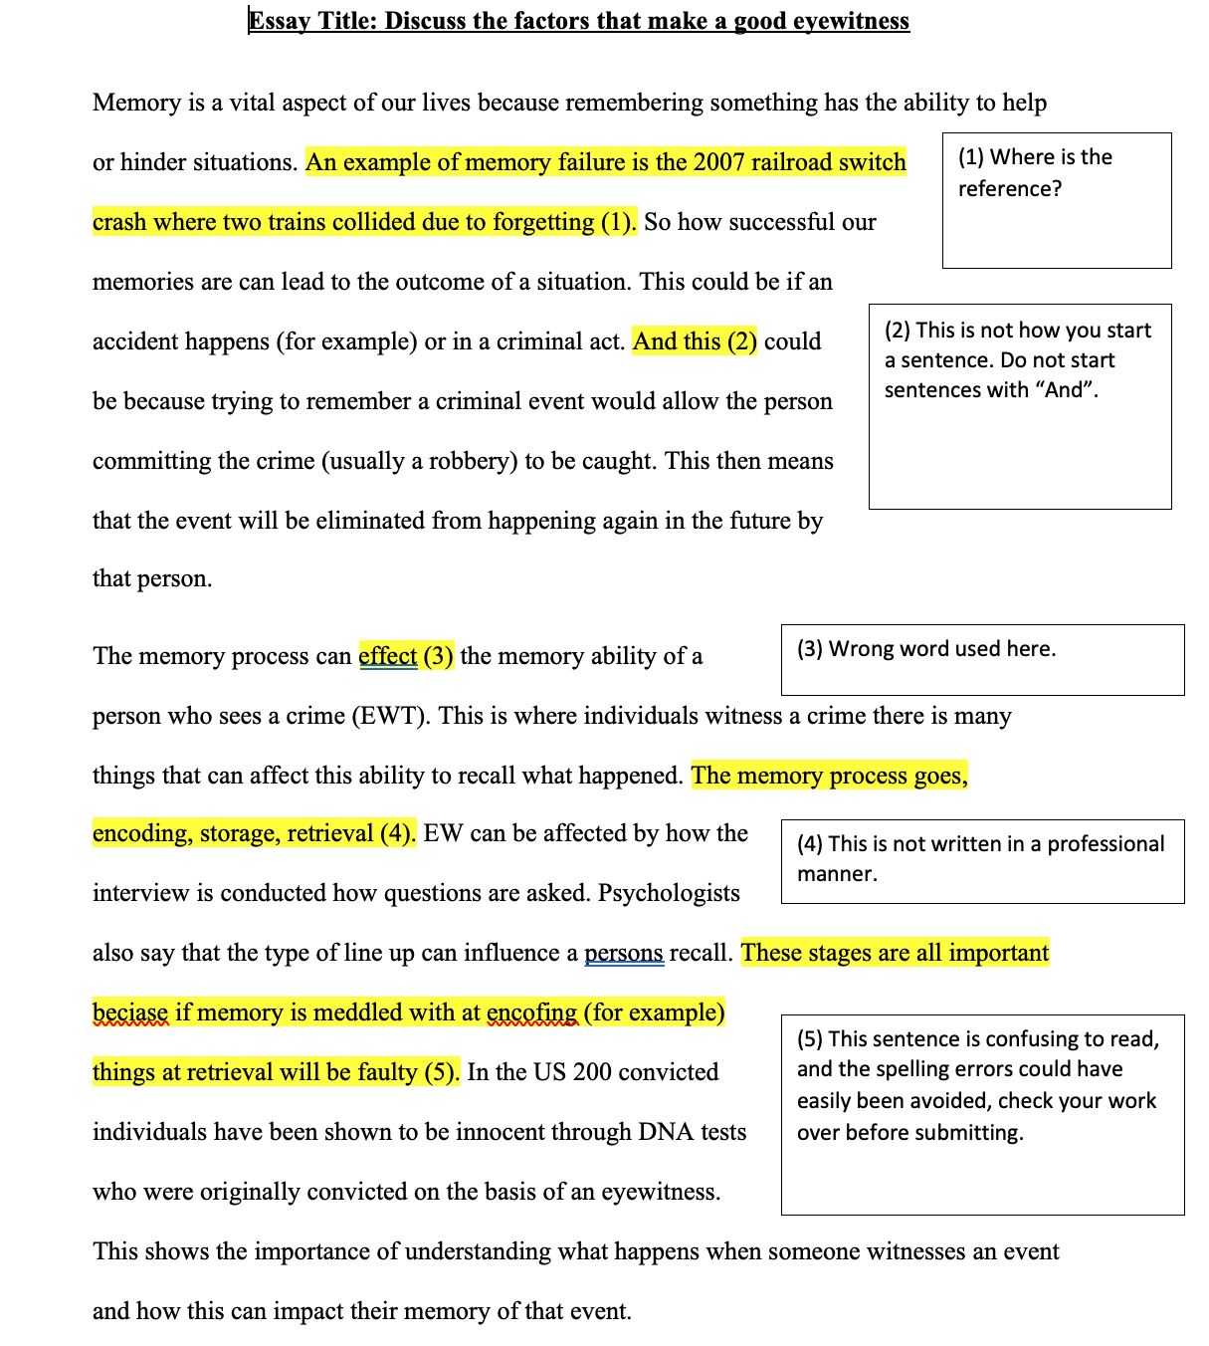

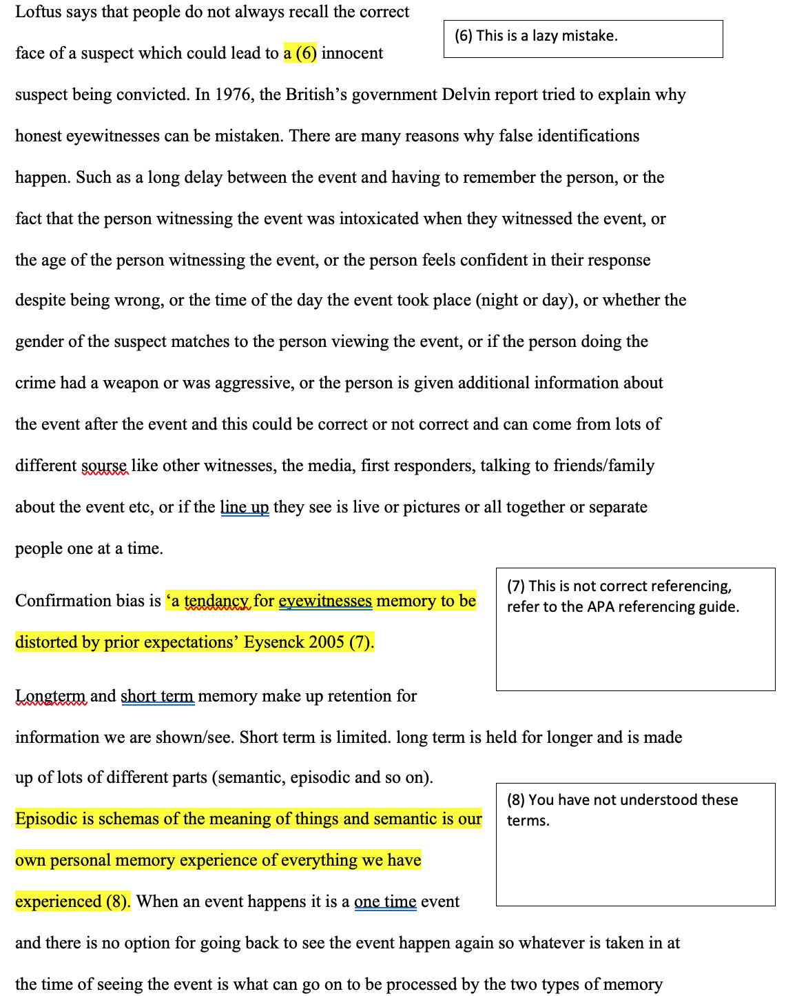
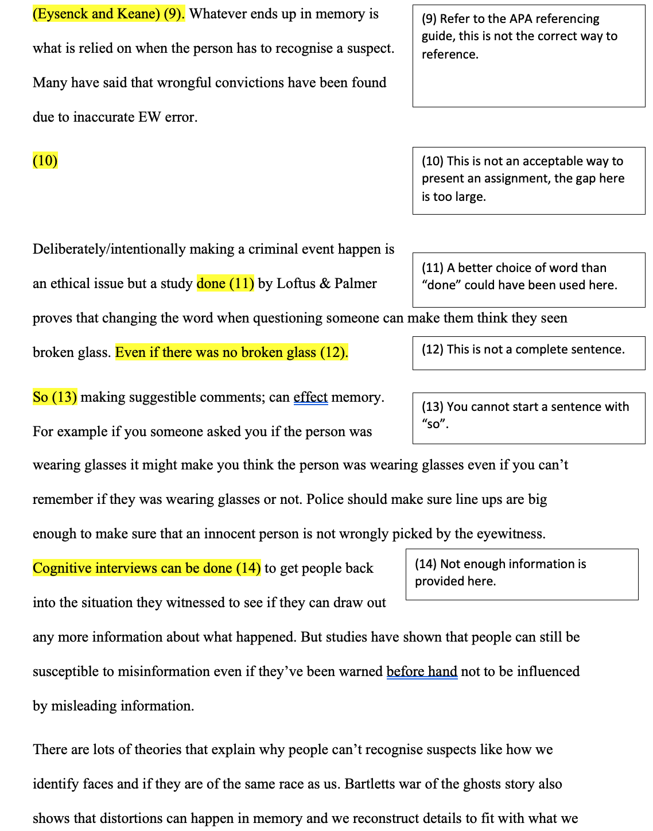
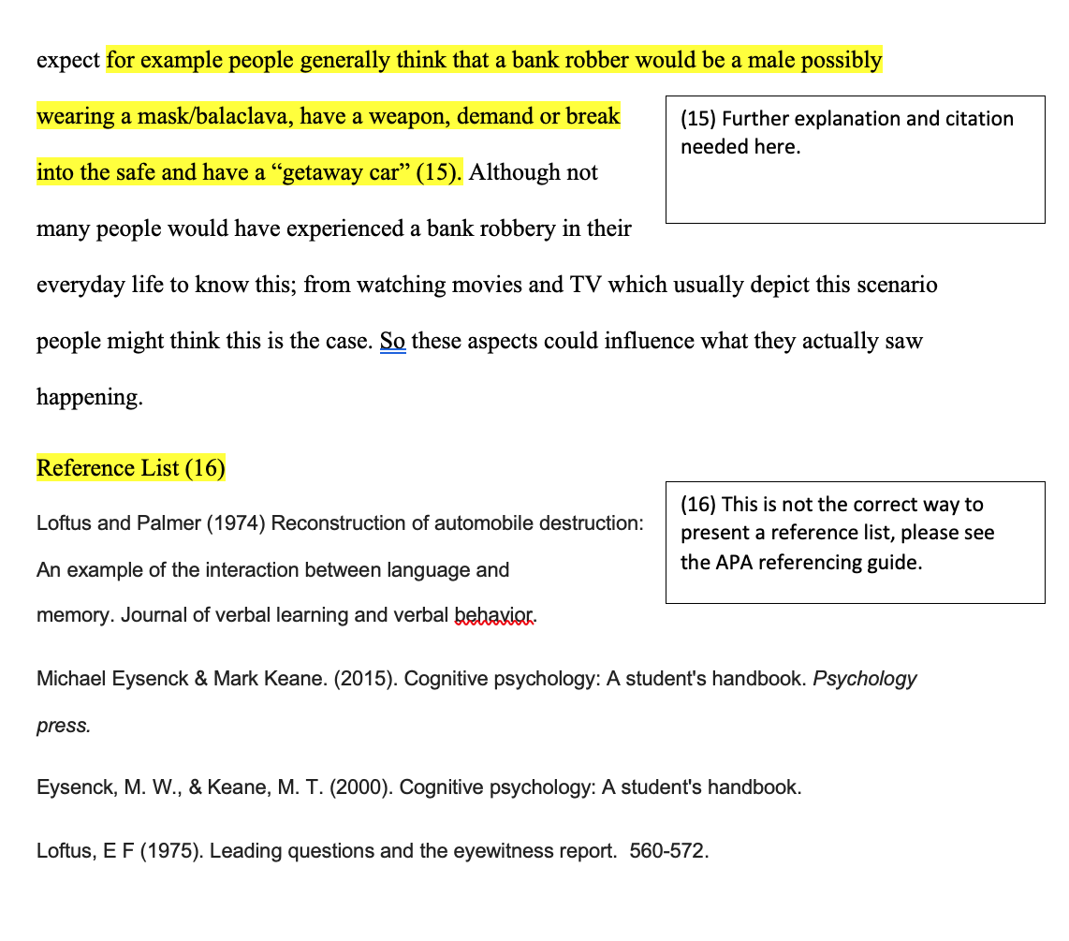
Extended positive
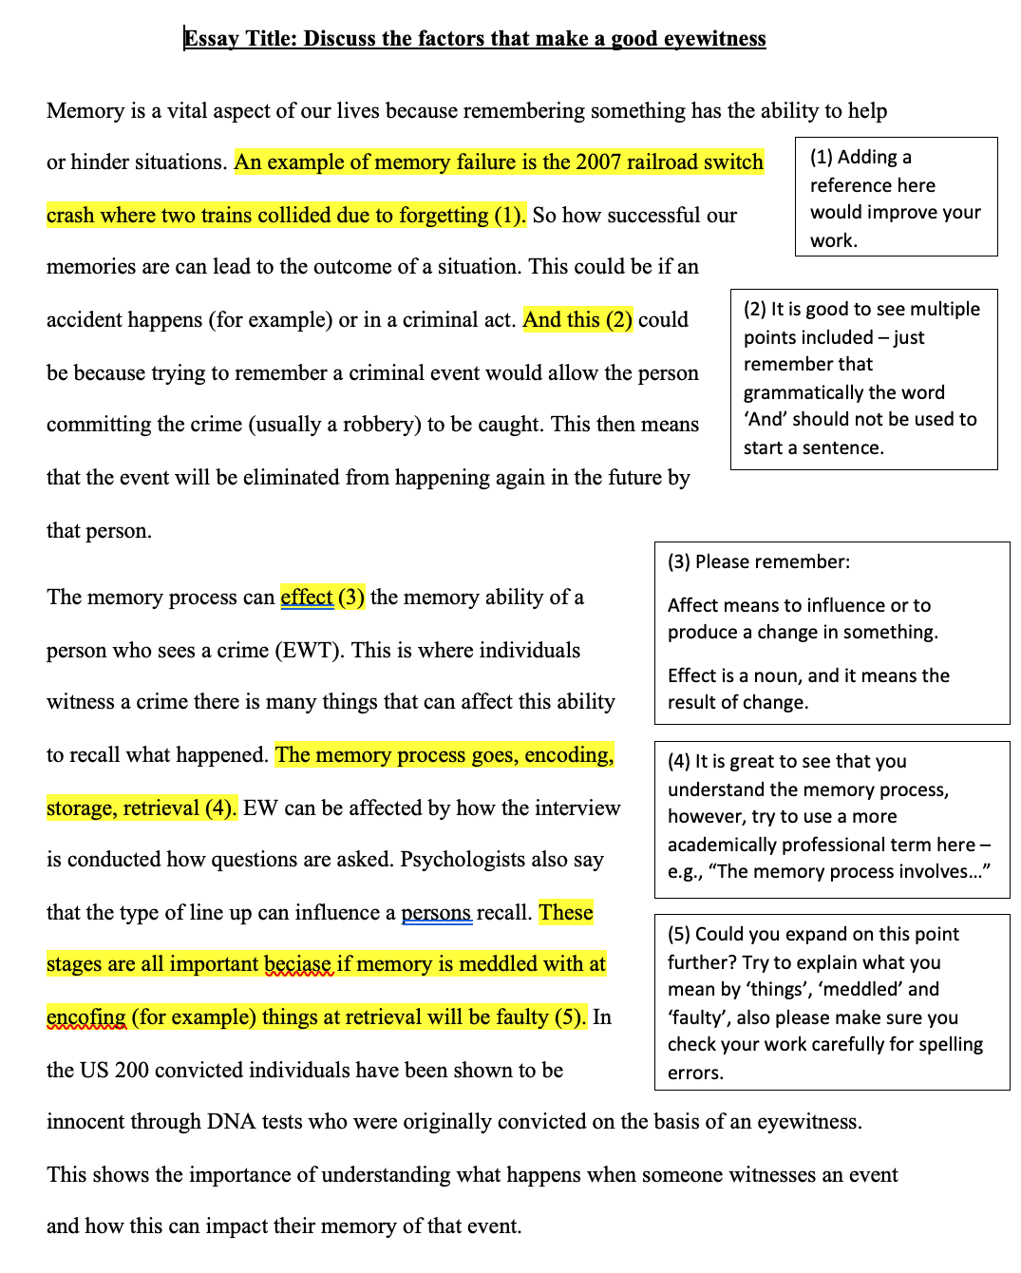
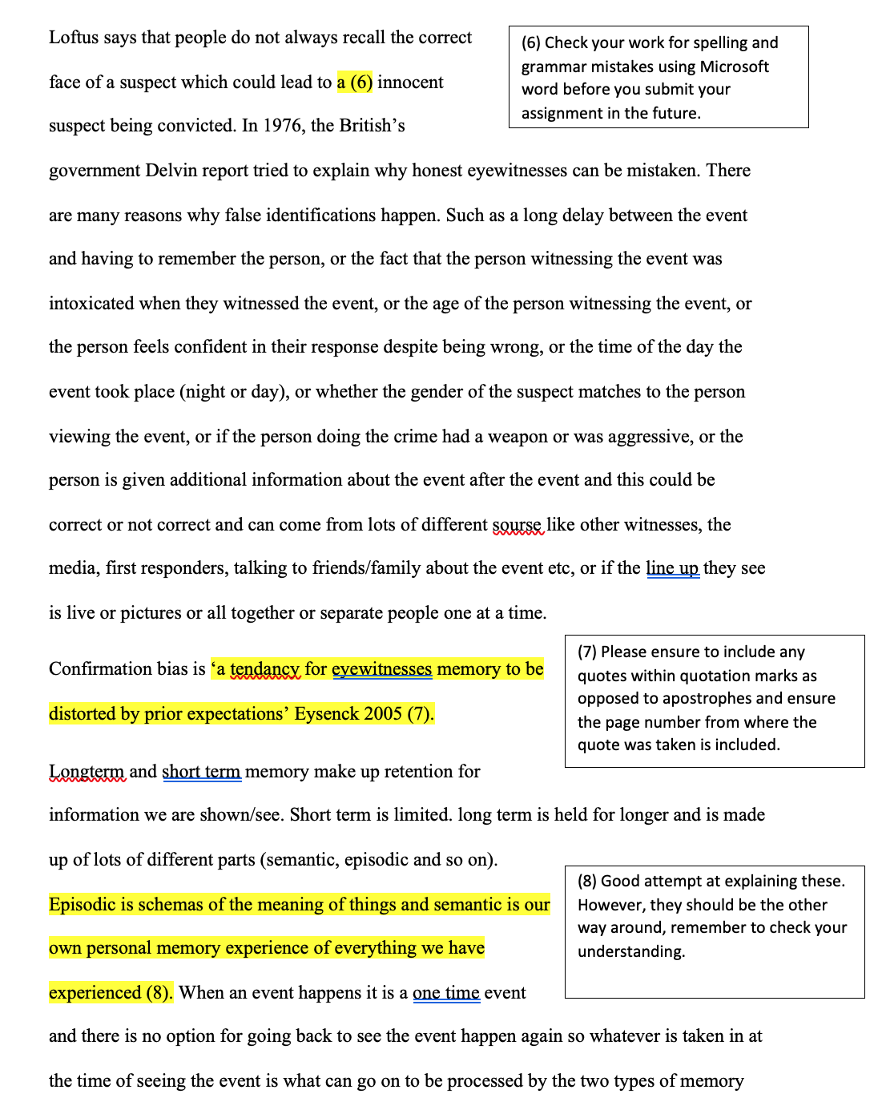
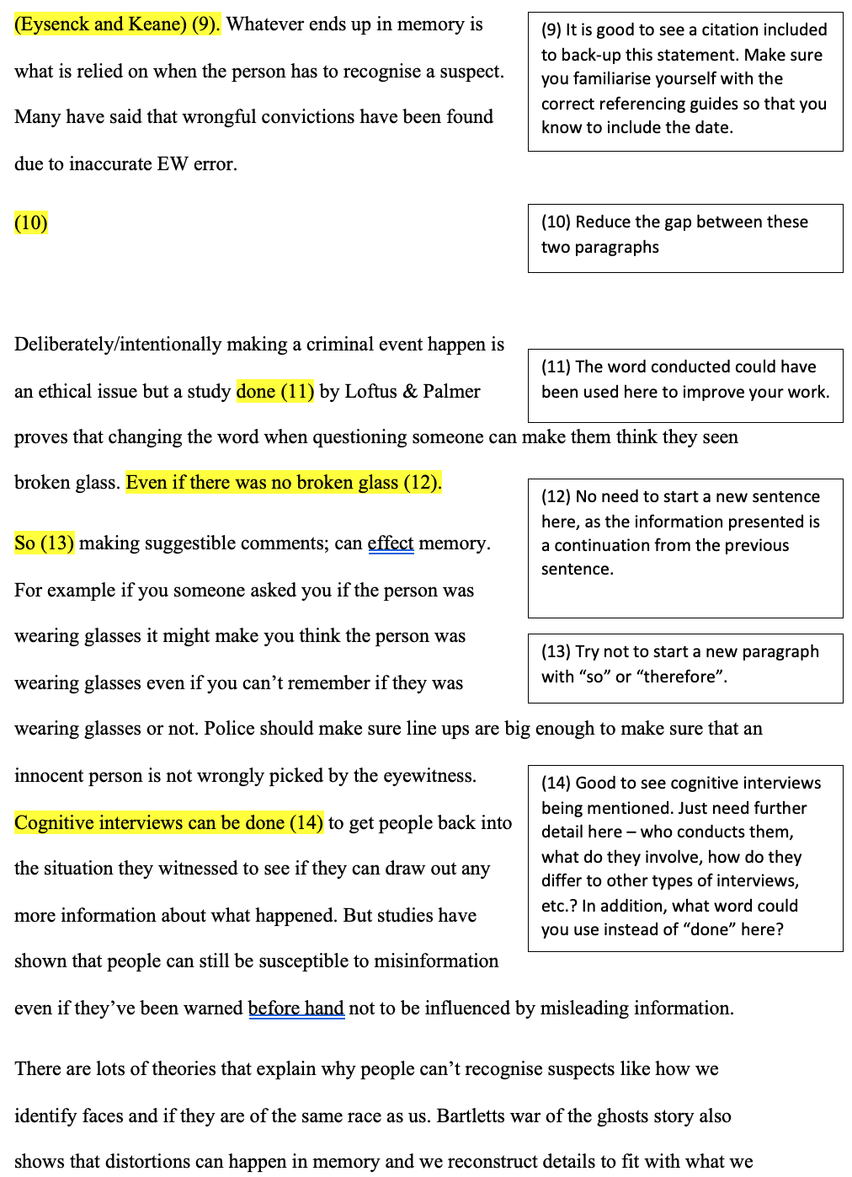
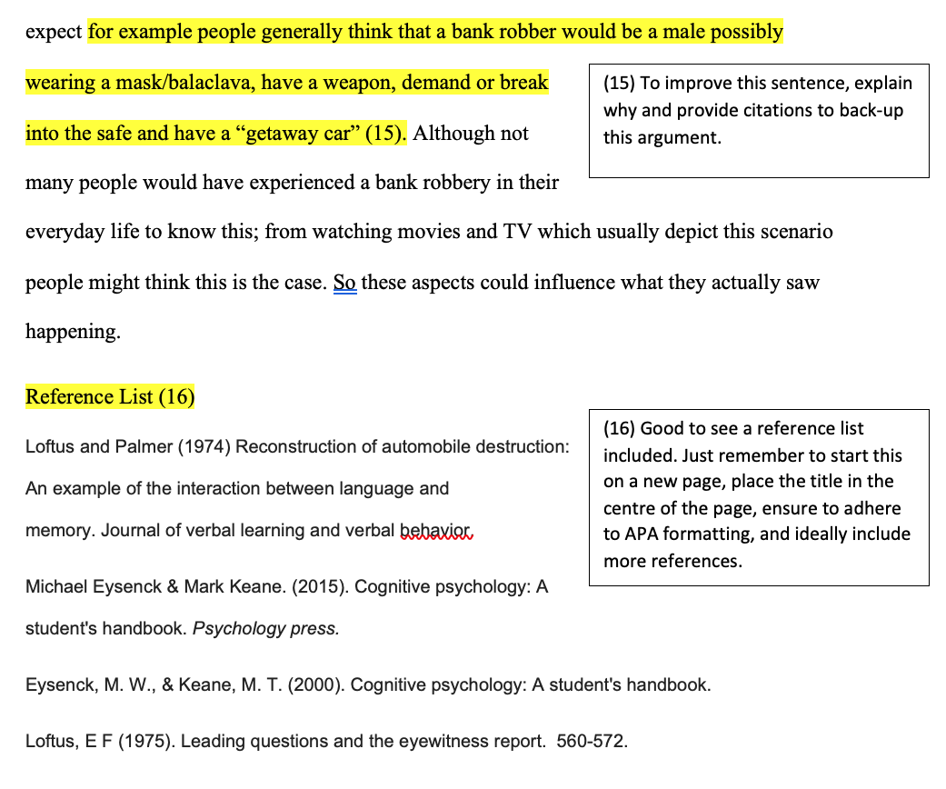

Limited negative
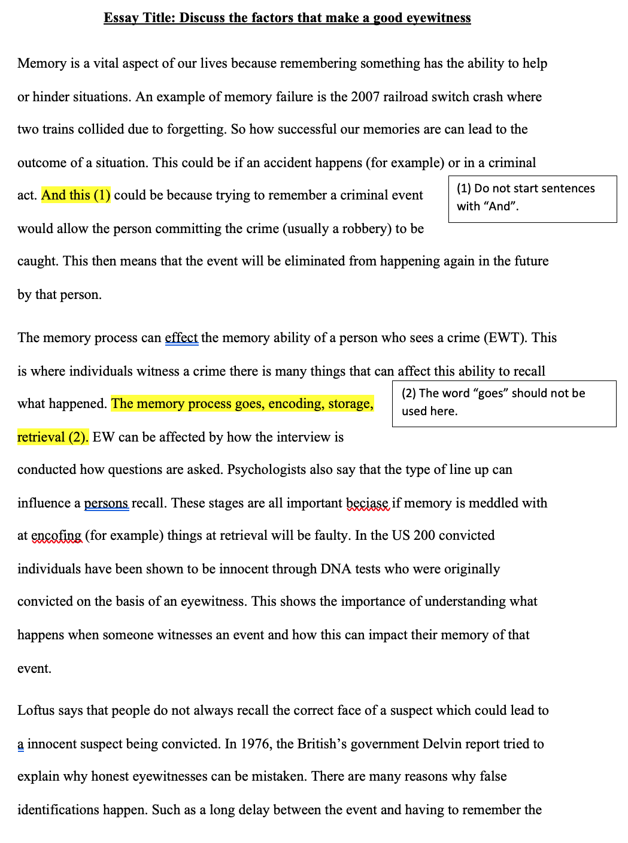
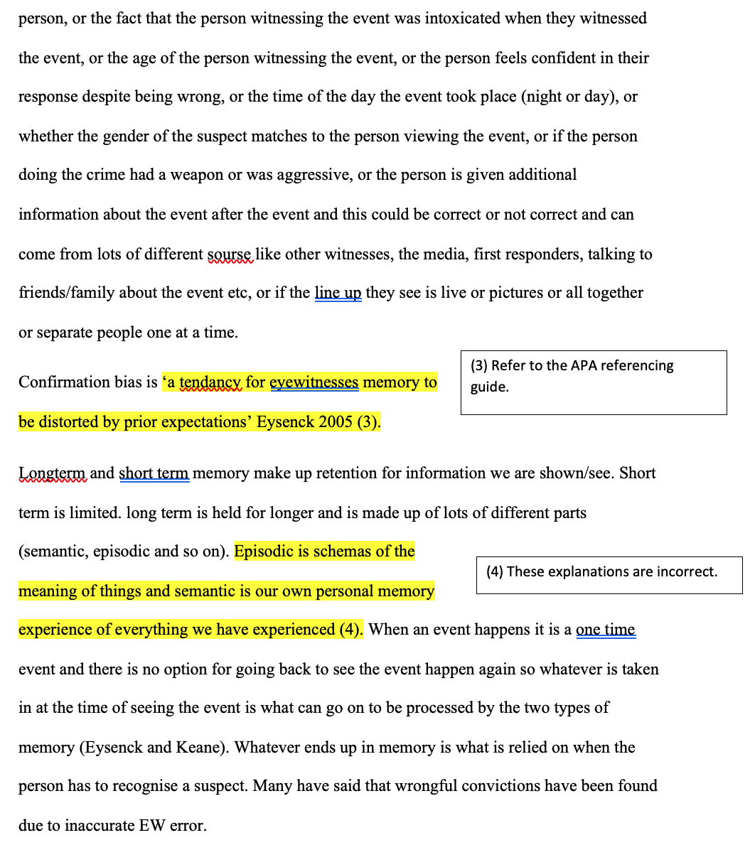
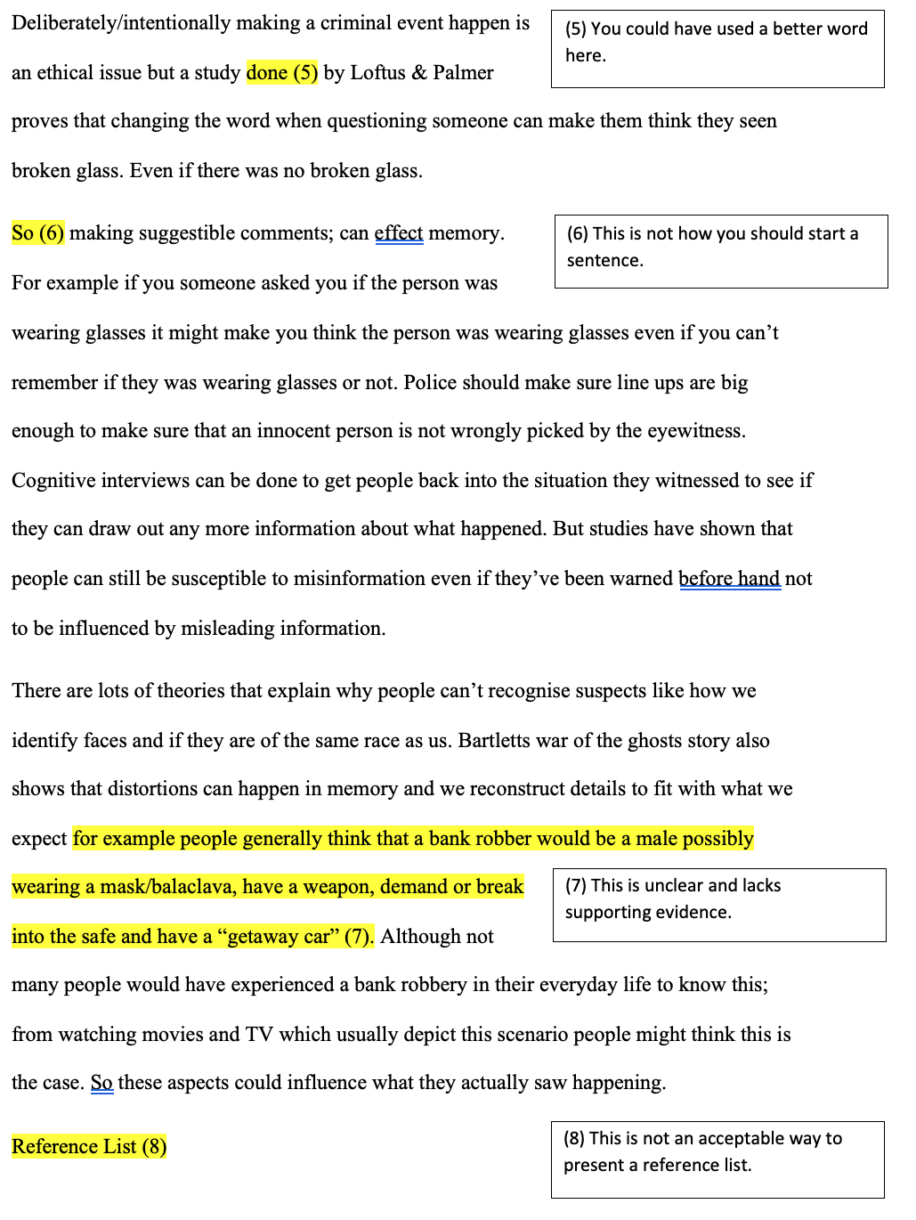
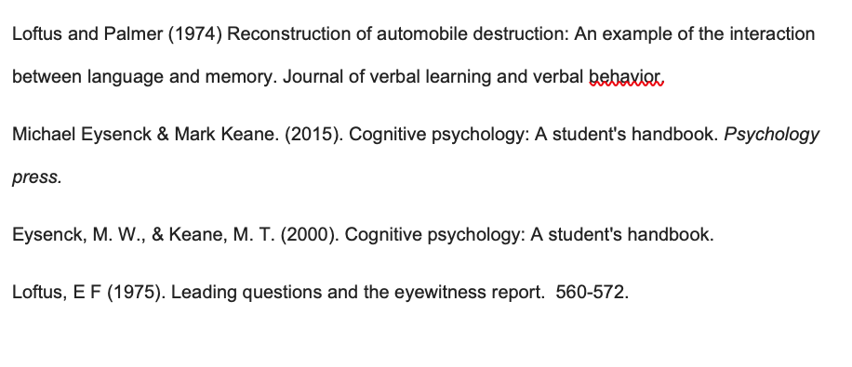

Limited positive
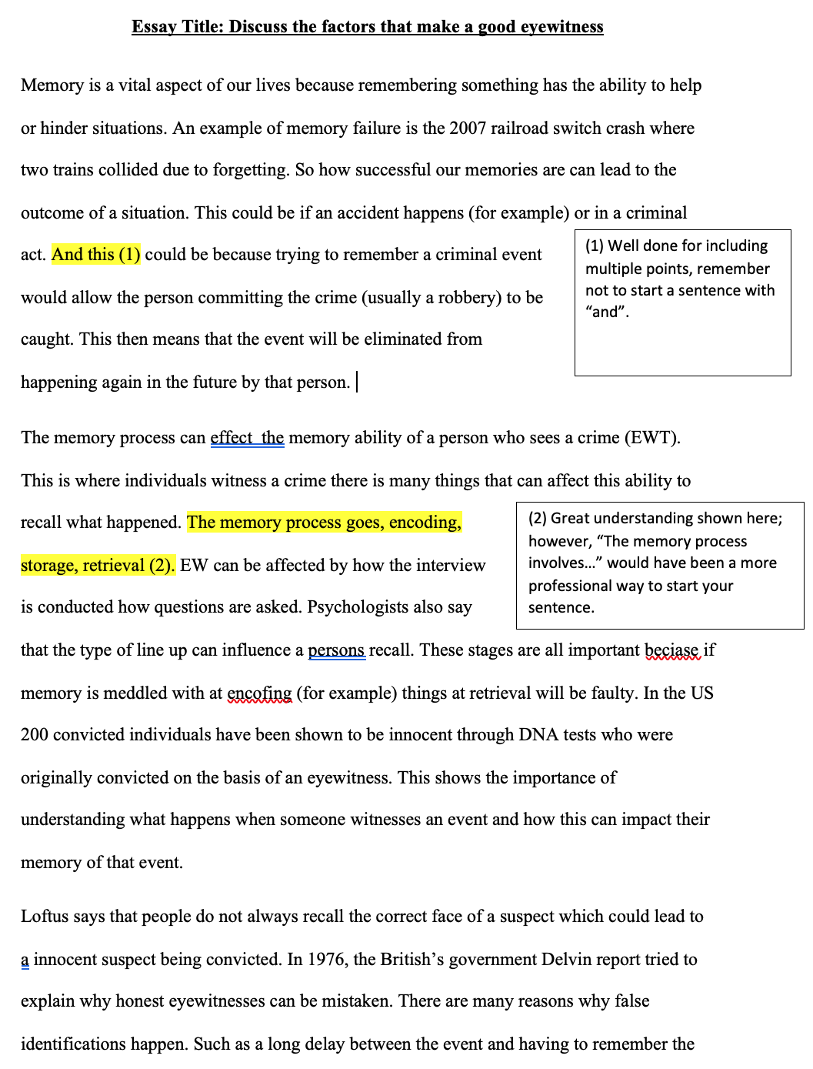
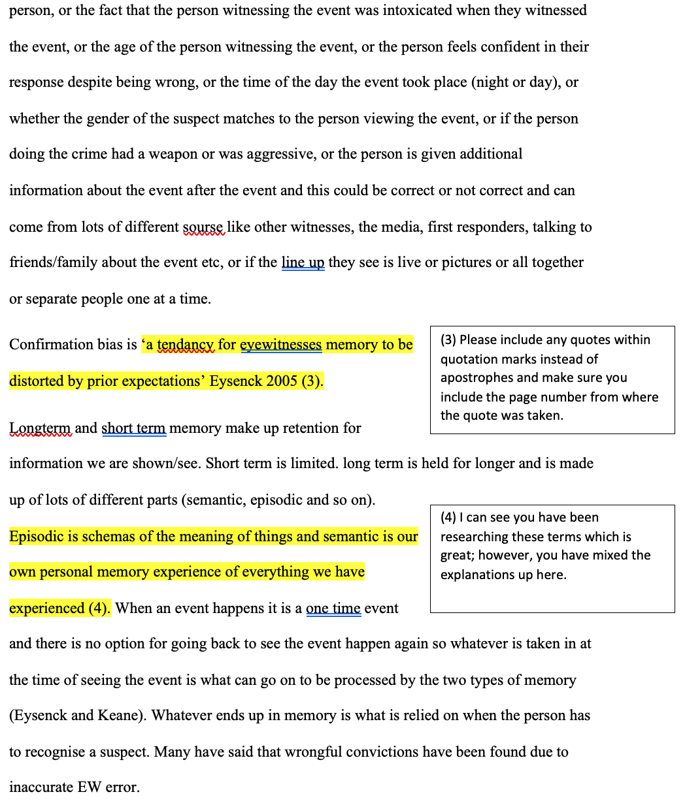
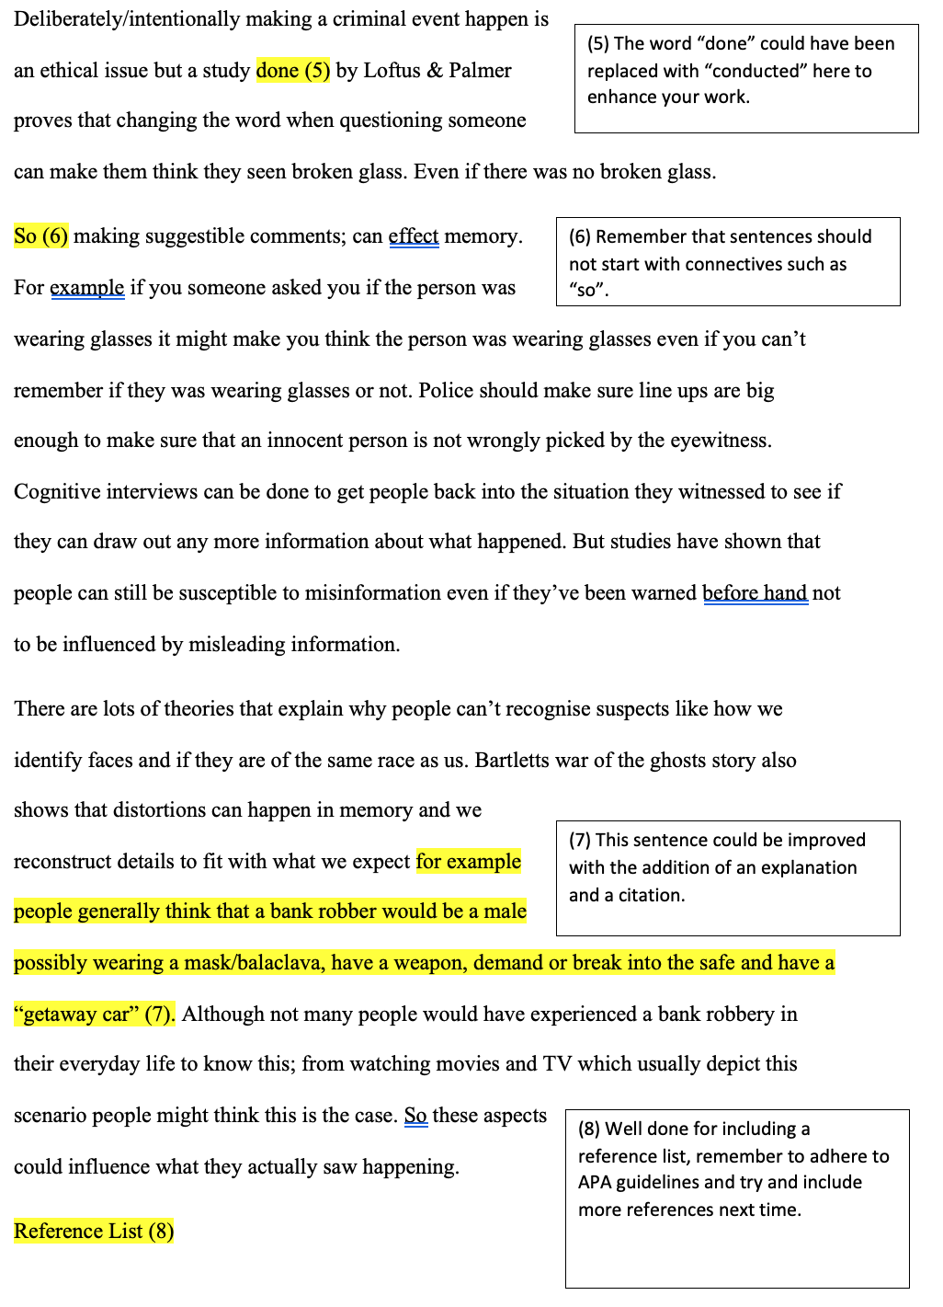
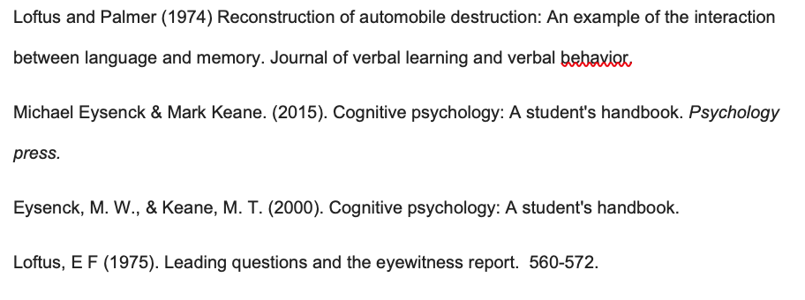

Appendix G
Ethical approval
MSc Applied Social and Health Psychology | Ella Morris-Fuge | Kate Williams | Conditional approval/ tutor to confirm following changes are made:  Should it say yes to obtaining written consent? And how will the WG announcement about delayed student return affect her ability to conduct the study?
Following this conditional approval, the points were addressed and reviewed by the ethics panel and final confirmation was given.

Appendix H
Information sheet
Thank you for being interested in participating in this study!
This study is being carried out by an MSc student who is currently completing their dissertation project in Applied Psychology at UWTSD. The intention of this project is to measure student’s memory for different types of feedback, to understand whether the type of feedback given in terms of phrasing (positive/critical) and length of feedback affects student’s memory for the feedback. Additionally, student motivation will be measured to see if this impacts memory for feedback.
The results from the study could be used to direct future feedback comments provided on student work to enhance learning, as it hopes to point out the most effective, memorable way to give feedback. The results will be published in the MSc student’s dissertation and potentially in a future academic journal.
The study involves a reading element, and the entire study will take place online, it is advised that you complete the study in a quiet area with no distractions. You should not sign up to participate if you will not be able to complete this or are unable to view and type responses on the computer.
If you are happy to continue after reading this information sheet you will need to complete the online consent form on the computer. If you choose to consent and participate in this study you will then be asked to provide demographic information on your age, gender, course, and level of study. You will then be presented with the Motivated Strategies for Learning Questionnaire (MSLQ) (Pintrich et al., 1991). This questionnaire contains 31 items that aim to assess your self-reported motivational orientations. This element of the study should take no longer than 10 minutes to complete. Further instructions on how to complete this questionnaire will also be provided at the top of the questionnaire when it is presented on the computer screen.
You will then move on to the memory section of the study. You will read a total of four assessment feedback forms based on a hypothetical piece of work, so you do not need to feel that your own academic work is under scrutiny. Each piece of work and accompanying feedback will be presented individually, one after the other. You will have five minutes to view each feedback form. Once that time is up, you will be asked to complete a maze puzzle with a regular pattern of lines on the computer for one minute as a distractor task before being asked to recall as many of the feedback comments as you can (by typing them in on the computer) to assess your memory for the feedback comments. You will have up to five minutes to complete this memory recall task. You will then be asked to rate the feedback for effectiveness before continuing with the puzzle for another minute before moving onto the next feedback form. The same procedure as above will apply to the remaining feedback forms. Once all feedback forms have been viewed, that will be the end of the study and you will have the option to submit or withdraw your final responses before being debriefed.
You will not have the option to omit answers on the motivation questionnaire. This is to ensure a full dataset can be obtained. You will have the option to omit answers on the memory section of the study if you cannot remember the feedback comments. The purpose of the research is not to assess your individual abilities, memory, or performance on the tasks, but to explore the cognitive processes involved in engagement with feedback. The study is not aiming to judge your levels of motivation in any way, it is being collected to understand whether motivation interacts with the type of feedback that is remembered.
Your participation in this study is completely voluntary and your responses are anonymous, there will be no way to identify you from your responses as your data will be assigned to a unique study ID code. You will have the option to withdraw your participation until you check the box at the end of the study to submit your final responses. You can stop at any point during the study without penalty. Your data will be held anonymously.
In order to take part in this study you must be over 18 and be a current student studying at any level at UWTSD. You must also be capable of reading and responding to questions on the computer.
Your participation in this study should take approximately one hour to complete.
If you need more information or have any concerns about the study, please use the following contact details:
Researcher: emorris-fuge.128653@student.uwtsd.ac.uk
Supervisor: kate.williams@uwtsd.ac.uk

Appendix I
Consent form
I understand that this research study is being carried out by an MSc student currently completing their dissertation project in Applied Psychology at UWTSD, and that taking part in this study will involve providing demographic information on my age, gender, course and level of study. I will then be required to complete a motivation questionnaire, and then read four hypothetical pieces of work and accompanying feedback where my memory for the feedback on the work will be tested in a free recall task. Before I complete the free recall task, I will complete a maze puzzle with a regular pattern of lines as a distractor task.
I understand that the intention of this project is to measure memory for different types of feedback, to understand whether the type of feedback given in terms of phrasing (positive/critical) and length of feedback affects memory for feedback. Additionally, my motivation levels will be measured to see if this impacts memory for feedback.
This study will take approximately 1 hour to complete.
I understand that participation in this study is voluntary and I am free to withdraw participation during or before the end of the study without giving a reason. I understand that once I complete the study, I will not be able to withdraw my data, as it will be anonymised. I am aware that if I have concerns about the study, I can contact the researcher at any time during or after the study on emorris-fuge.128653@student.uwtsd.ac.uk or the research supervisor Dr Kate Williams (kate.williams@uwtsd.ac.uk), should I have any concerns.
I understand that the information provided by me will be held confidentially, with a code assigned in place of my name. These data will be stored indefinitely in accordance with the Data Protection Act.
I also understand that at the end of the study I will be provided with a debrief form.
- I am age 18 or over
- I understand I can withdraw at any time without penalty by closing the browser
- I understand my data will be held confidentially and my identity will remain anonymous
- I understand all the above information
- I consent to taking part in this study
Do you agree with all five statements shown above?
Appendix J
Instructions on how to complete the feedback memory task

Thank you for completing the motivation section of the study. You will now complete the memory section of the study. You will read a total of four assessment feedback forms based on a hypothetical piece of work, so you do not need to feel that your own academic work is under scrutiny. Each piece of work and accompanying feedback will be presented individually, one after the other.
You will have five minutes to view each feedback form. Once that time is up, you will be asked to complete a maze puzzle on the computer for one minute as a distractor task before being asked to recall as many of the feedback comments as you can (by typing them in on the computer) to assess your memory for the feedback comments. You will have up to five minutes to complete this memory recall task. You will then be asked to rate the feedback for effectiveness before continuing with the puzzle for another minute before moving onto the next feedback form.
The same procedure as above will apply to the remaining feedback forms. Once all feedback forms have been viewed, that will be the end of the study and you will have the option to submit or withdraw your final responses before being debriefed.
Please click the arrow below to move on to the next page.

Appendix K
One of the maze puzzle distractor tasks with instructions used in this study

Please complete the following maze puzzle by visually finding the route from one end of the maze to the other, you can use your mouse cursor to follow your route if you wish to do so. You will have one minute to complete this task.

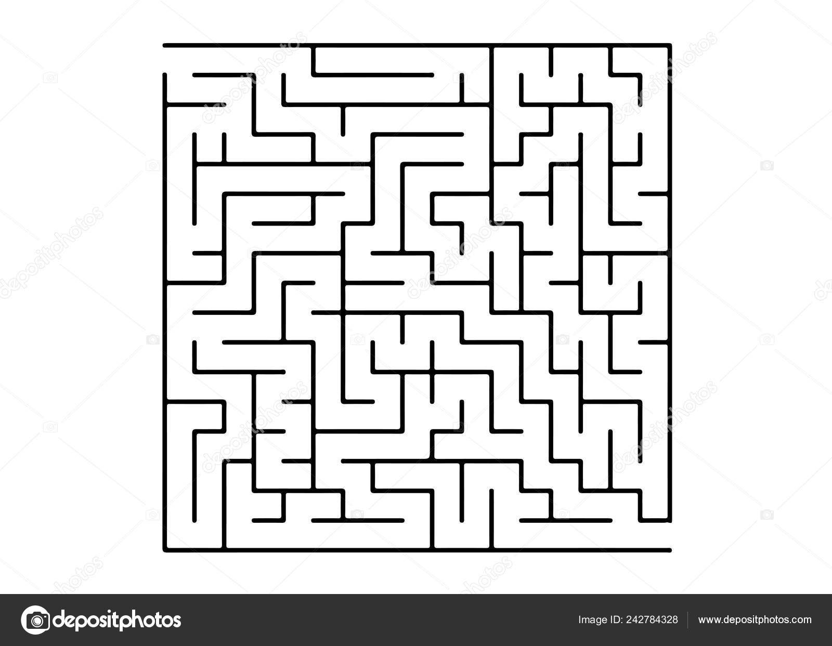

Appendix L
Feedback rating

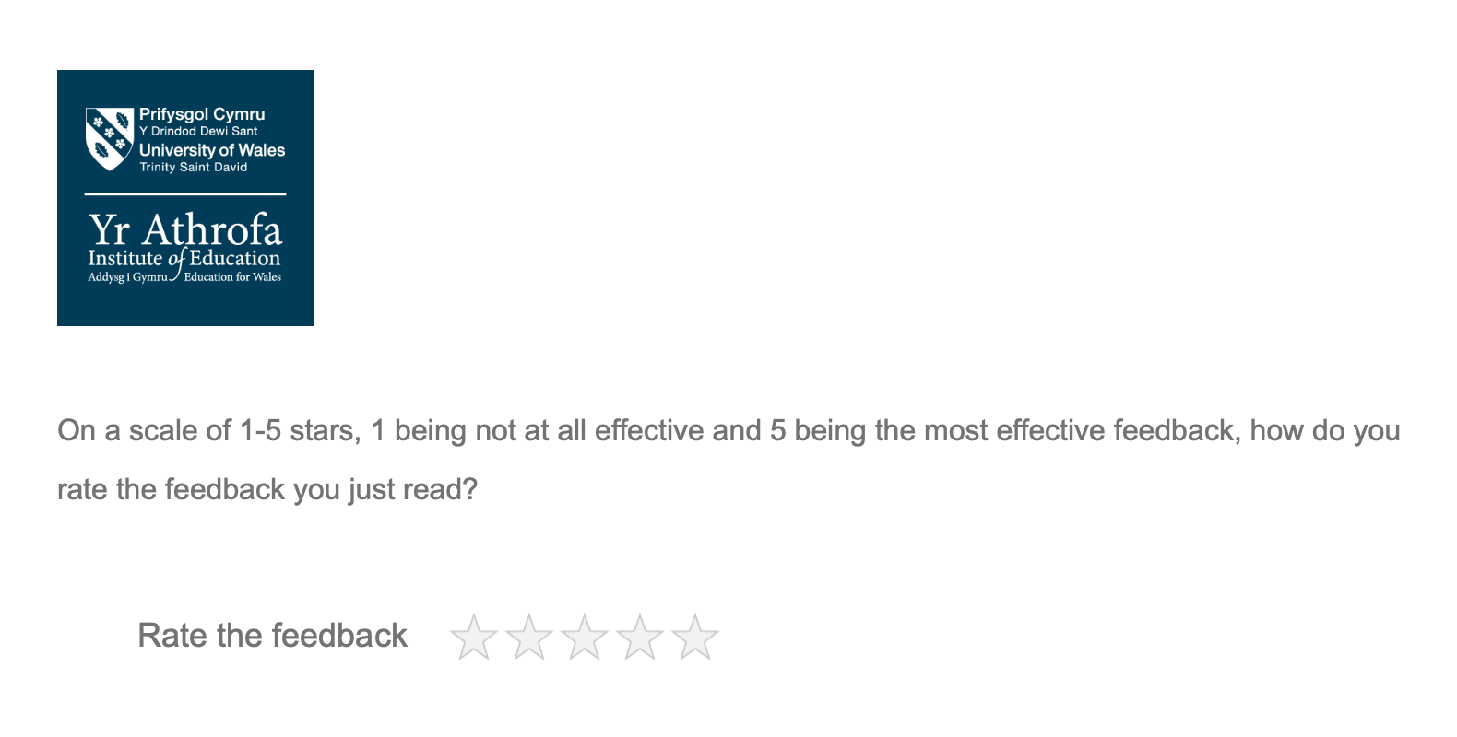

Appendix M
Debrief form
Debrief form
Thank you for completing the study. Your participation will provide information on memory for different types of feedback, to understand whether the type of feedback given affects memory for the feedback. Additionally, your level of self-reported motivation will help to see if motivation impacts memory for feedback. The results from the study could be used to direct future feedback comments provided on student work to enhance learning, as it hopes to point out the most effective, memorable way to give feedback. The results will be published in the MSc student’s dissertation and potentially in a future academic journal.
If you have any questions or queries regarding the study, please contact the MSc researcher or supervisor using the contact details below.
Thank you again for your participation.
Researcher:
emorris-fuge.128653@student.uwtsd.ac.uk
Supervisor:
Kate.williams@uwtsd.ac.uk

