Name:_Collette Owen____________________

Student Number: _2517697________________
__________________________________________________________

WORKSHEET 1 – TESTING (Using Variables)

- Original code:
[Copy and paste your original code from Moodle into this box. Do not change it.]

name = input("What is your surname?: ")
car_registration = input("What is your Car Registration?: ")
userAge = input("How old are you?:")
Hours_per_week = input("How many hours per week of lectures do you have?: ")
Summarise=(name, car_registration, userAge, Hours_per_week)
print("Surname:", name)
print("Car Registration:", car_registration)
print("Age:", userAge)
print("Hours per week:", Hours_per_week)

- Code Testing

For each test below, run your code and enter the values provided. Provide a screenshot of the programme running. Did the programme behave correctly or did it do something unexpected? Fill in a box for each test below. You should present 14 separate boxes, 1 for each test. (Note: the first box is provided as a template)

Surname:
- Enter JONES
- Leave blank
- Enter 123

Car registration:
- Enter BG56UDU
- Leave blank
- Enter BG56345DFE (ie too long for a UK car registration number)

Age
- Enter 34
- Enter 150
- Enter -4
- Enter a letter

Hours per week of lectures
- Enter 12
- Enter 15.5
- Enter -4
- Enter 150 (ie longer than the maximum possible hours that the University is open in a week)

Test:
Surname i. Enter JONES

Screenshot(s) of output:
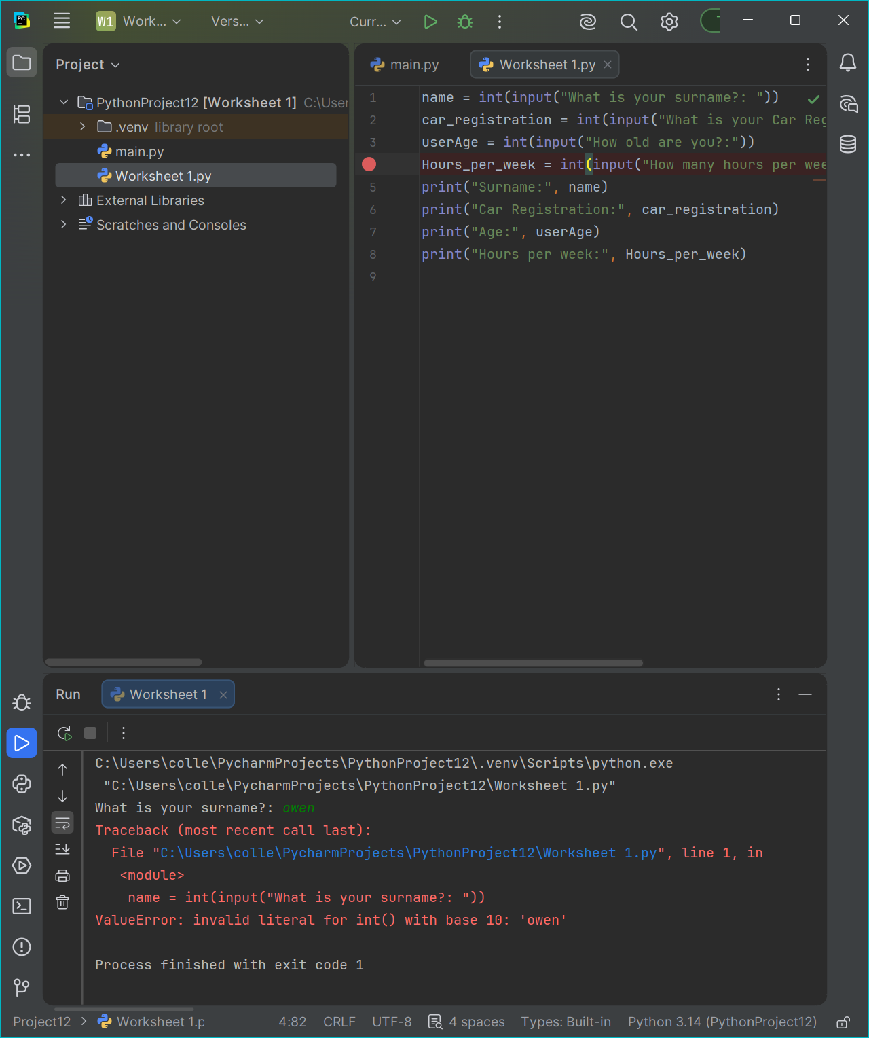
Result: Did the program behave as expected ie syntactically and logically correct?
No
If NO, what problems were encountered and why? Suggest how things could be improved.

(Copy and paste a box similar to the above for each of the rest of the tests)
- Consider the results of the above tests and revisit your original code in order to address the tests that failed. (Note: you may not be able to solve all of the problems that were originally encountered, but solve as many as you can.)

Paste your full revised code here :

[Copy and paste your full revised code here – note, do not use a screenshot]

name = input("What is your surname?: ")
car_registration = input("What is your Car Registration?: ")
userAge = input("How old are you?:")
Hours_per_week = input("How many hours per week of lectures do you have?: ")
print("Surname:", name)
print("Car Registration:", car_registration)
print("Age:", userAge)
print("Hours per week:", Hours_per_week)

