Databases and Application Development 
BOOK COLLECTION
SQL Injection Report
Lecturer: Dr Malik Uzair Mehmood
Ionut Ionel | 4/1/26 | Databases and Application Development

COMPONENT B -Part 2

SQL Injection
SQL Injection (SQLi) is a critical security vulnerability that affects database-driven web applications. It occurs when attackers manipulate input fields to inject malicious SQL commands into queries executed by the database. This vulnerability arises when user input is not properly validated or when developers directly embed user input into SQL queries. SQL injection attacks exploit the trust between the application and the database. Instead of being treated as simple data, user input is interpreted as part of the SQL command, allowing attackers to alter query logic. For example, authentication systems can be bypassed, sensitive data can be extracted, and databases can be modified or deleted.[1]
A classic vulnerable example is:
SELECT * FROM users WHERE username = '$username' AND password = '$password';
If an attacker inputs ' OR '1'='1, the condition becomes true, allowing unauthorized access. This demonstrates how weak input handling can completely undermine application security. Despite advances in secure development practices, SQL injection remains prevalent due to poor coding standards and lack of developer awareness [2].

2. SQL Injection Protection in the Book Collection Website
The Book Collection web application includes multiple features that interact with a database, such as login authentication, book search, and CRUD (Create, Read, Update, Delete) operations. These functionalities rely on user input, making them potential targets for SQL injection attacks if not properly secured.The Book Collection web application uses PHP PDO prepared statements. This ensures user input is treated as data, preventing SQL injection attacks.[2]
In this project, all database interactions are implemented using PHP Data Objects (PDO) with prepared statements. This ensures that user inputs are bound as parameters rather than directly embedded into SQL queries. For example: SELECT * FROM admins WHERE username = :username AND password = :password; This structure ensures that user input cannot modify the query logic. Testing was conducted by attempting common SQL injection techniques, such as entering ' OR '1'='1 in the login form. The system correctly rejected the login attempt, demonstrating that the application is protected. Additionally, input fields in forms such as add_book.php and search.php are handled securely, preventing manipulation. The use of PDO, parameter binding, and structured query design significantly reduces vulnerabilities.[3]

- Login.php
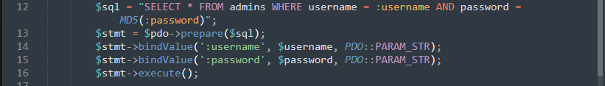
Figure 1 shows the implementation of prepared statements in the search functionality.
This screenshot shows the use of prepared statements in the login system, where user inputs are bound as parameters, preventing them from altering the SQL query structure.
- search.php
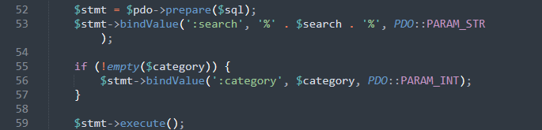
Figure 2 shows the implementation of prepared statements in the search functionality.
The search functionality uses parameter binding with wildcard values, ensuring that user input is safely handled and cannot inject malicious SQL code.

- add_book.php
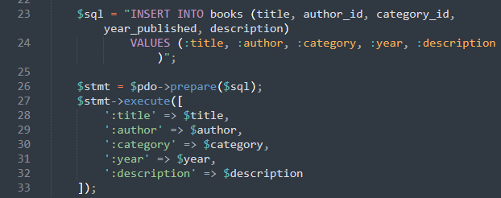
Figure 3 shows the use of parameterized SQL in CRUD operations to protect the database from malicious input.
This demonstrates secure insertion of data into the database using prepared statements, ensuring all input values are treated strictly as data.

Figure 4 shows an attempted SQL injection entered into the login form
An SQL injection attempt using ' OR '1'='1 is entered into the login form to test whether the system is vulnerable.

Figure 5: Figure 5 shows that the attempted SQL injection failed because the application treated the input as data rather than executable SQL
The application correctly rejects the malicious input, confirming that SQL injection protection is effectively implemented.
4. Security Evaluation and Testing
Security testing was conducted using typical SQL injection payloads. Attempts to bypass authentication failed, indicating that the application effectively neutralizes injection vectors. The consistent use of prepared statements across all database interactions significantly reduces the attack surface.This practical validation supports theoretical claims and demonstrates real-world resilience against SQL injection attacks [4].

5. Additional Security Measures
Beyond prepared statements, several additional security practices are important for protecting web applications:
- Input validation and sanitization
- Limiting database user privileges
- Error handling to avoid exposing system details
- Regular security testing and code review
These measures complement prepared statements and provide a layered security approach.[5]

6. Conclusion
SQL injections are a serious and persistent threat in web development. However, by using prepared statements, PDO, and secure coding practices, the Book Collection application successfully prevents such attacks. Testing confirms that the system is resilient against common SQL injection techniques.The system successfully prevents SQL injections using prepared statements and secure coding practices.

References
[1] W. Halfond, J. Viegas, and A. Orso, “A classification of SQL-injection attacks and countermeasures,” Proc. IEEE, 2006.
[2] OWASP Foundation, “SQL Injection Prevention Cheat Sheet,” 2023.
[3] S. Thomas, L. Williams, and T. Xie, “On automated prepared statement generation,” 2009.
[4] M. Howard and D. LeBlanc, Writing Secure Code, Microsoft Press, 2003.
[5] O. E. Taylor et al., “Preventing SQL injection using PDO,” 2019.

