Digital Business

Airbnb

Dr Roisin Mullins

Content page

1.1Introduction…………………………………………………………………………………………3

2.0 Main findings……………………………………………………………………………………………….
2.1 Business model…………………………………………………………………………………….4
2.2 Business model canvas (BMC)………………………………….………………………5,6
2.3 Strategic formulation framework………………………………………………………7,8
2.4 Tools/Systems…………………………………………………………………………………….9

3.0 Conclusion………………………………………………………………………………………………10

4.0 References…………………………………………………………………………………………11,12

1.0
1.1 Introduction
The original idea for Airbnb was born when housemates Brian Chesky and Joe Gebbia where struggling financially and came up with an inventive way to make money. Brian and Joe found that the local hotels in their area of San Francisco where always fully booked so decided to use three air mattresses in their home and rent them out to designers saying in the area for a small charge, adding in breakfast in the morning. After earning $80 per mattress per night the two housemates searched for help and advice from an old friend (a computer scientist graduate) who helped them make a reliable website. This idea soon grew resulting in them needing investors to help fund the rapid growth and financially prepare for the high demand. Airbnb has continued to expand and improve their services over the years and intend to continue in building their legacy. No longer a home sharing platform Airbnb offer hosts and guests the opportunity to fine or lease affordable spaces for just a small fee. Mostly used by individuals looking for a cheaper alternative to a hotel (Keyafe2019).

2.0
2.1 Business model
The business model has a range of different factors such as plans for making profit, what products or services they offer and their target market. The majority of Airbnb’s revenue comes from their booking fees and service charges to both parties (guests and hosts). Airbnb have found this method very effective from the start (Nath 2021). Airbnb also managed to raise $3.5 billion in initial public offerings in 2010. Airbnb are planning on continuing this method moving forward as it was proved to be most effective. Airbnb offers a two-sided online platform specifically designed for listing and renting homes by connecting hosts and travellers. Giving the hosts the ability to upload their property for free so that travellers can compare what properties are available for them to visit on their travels. Airbnb allows travellers to also use this service for free to compare the rental market.
Moving on to Airbnb target market. Their main target is aimed at any one individual seeking an affordable alternative option to a hotel. Originally companies focus on one market segmentation at a time where as Airbnb deal with both niche segmentation at the same time meaning dealing with hosts who are looking to list their free space and the guests who are looking for an affordable alternative to a hotel (Airbnb 2015). Below is a diagram relating to Airbnb’s business model

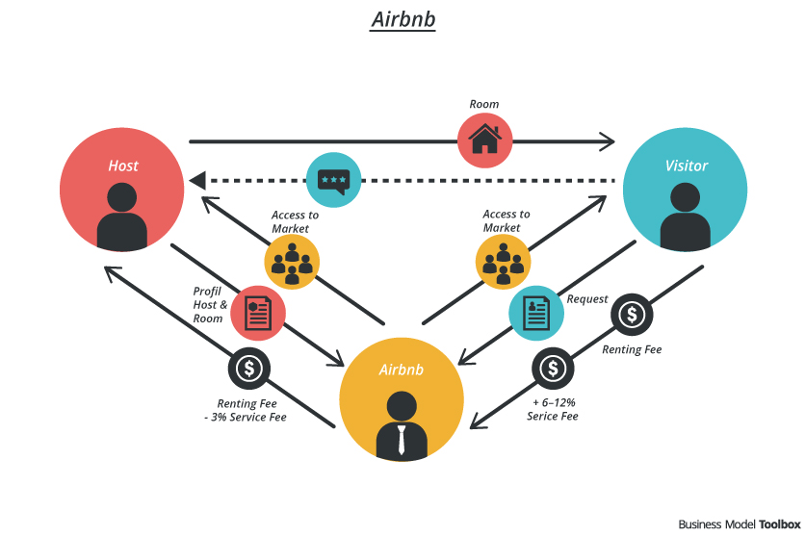
(November 2018)

2.2 Business model canvas
This is a business model canvas for Airbnb showing how they create value for themselves while delivering products or services for customers. This canvas is made up of 9 key components. Following the graph will be a description of each component in detail.

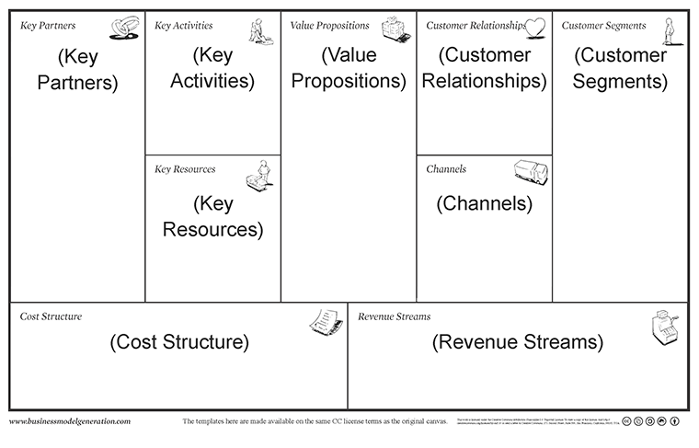
(Cowan 2014)
- Value propositions
- Make money renting idle rooms / properties or experiences in an easy and secure way
- Stay in unique places and live new experiences in a secure and convenient way

- Customer segments
- Hosts
- Guests

- Channels
- Airbnb website
- Airbnb app
- Customer relationships
- Self-service and personalized recommendations
- Customer support

- Revenue streams
- Hosts fees (Ranging from 3 to 5%)
- Travelers fees (Ranging from 0 to 20%)

- Key resources
- Airbnb platform
- Properties listed

- Key partners
- Professional photographers
- Insurance companies

- Key activities
- Platform development
- Customer support

- Cost structure
- Technology platform
- Marketing and customer support
- Employees

2.3 Strategic formulation framework
The grand strategy matrix is one of the tools that are involved in the strategic formulation framework. The grand matrix is a tool which charts the position of a product/company within a market to show its competitive position. The grand matrix is made up of four quadrants. Quadrant one – Companies can take advantage of external opportunities and can plan to take risks if necessary. Quadrant two – Companies need to re evaluate their methods in competing in the marketing competition as even though there is growth they are struggling to compete. Quadrant three – The company is at a disadvantage of slow industrial growth, such companies much start implementing new strategies. Quadrant four – The company initially started growing slow but is in a favourable competitive position (2021).

Airbnb
Quadrant 2 Quadrant 1
Weak strong
competitive competitive
position position

Quadrant 3 Quadrant 4

As shown on the diagram above Airbnb is situated in the first Quadrant which shows Airbnb has a strong competitive position in a rapid growth industry and Airbnb should continue using their strong competitive position to increase their growth rate (Ismail 2017).

2.4 Tools / Systems
Since Airbnb launched in 2008 they have been a reliable market place that makes it easy to rent or lease accommodations and has a good reputation when being safe and user friendly. Airbnb have a very interesting technology stack. All the main feature wouldn’t be achieved without advanced and reliability of technology. Following this is a list of nine tools and systems used throughout Airbnb.
- Cloud hosting
- Cloud database
- Cloud storage
- Web server
- Key-value
- Framework
- Java script framework
- Programming languages
- Big data tools
These tools and systems have helped Airbnb gain a competitive advantage against others who have tried to accomplish a similar company but have failed (Tokareva 2021).

3.0 Conclusion
The result of this report shows the business model of Airbnb followed in a little more detail going into the business model canvas stating the 9 key components before going through the strategic formulation framework and Airbnb’s position on the gran strategy matrix, Finally finishing with the tools and systems used by Airbnb to give them an advantage on their competitors.

4.0 References

Cowan, A. (2014). Business model plan made easy [Image]. Business Model Made Easy.
https://www.alexandercowan.com/business-model-canvas-templates/

Airbnb 2015 Review. (2015). Airbnb’s Target Audience. [online] Available at: https://airbnb2015review.wordpress.com/2015/07/07/airbnbs-target-audience/
Grand Strategy Matrix | EdrawMax Editable Templates. (2021, March 3). Edrawmax. Retrieved 15 January 2022, from https://www.edrawmax.com/templates/1002730/

Ismail, M. (2017, February 25). Airbnb, Inc. Strategic Plan 2017–2021 MBA - strategic Management Assignment (Harvard case study June 2017 ). Slideshare. Retrieved 15 January 2022, from https://www.slideshare.net/mohieismail9/airbnb-inc-strategic-plan-20172021-mba-strategic-management-assignment-harvard-case-study-june-2017

Nath, T. (2021, September 10). How Airbnb Makes Money. Investopedia. Retrieved 13
January 2022, from https://www.investopedia.com/articles/investing/112414/how-airbnb-makes-money.asp

Pereira, D. (2021, August 23). Airbnb Business Model Canvas. Business Model Analyst. Retrieved 15 January 2022, from https://businessmodelanalyst.com/airbnb-business-model/
Team, K. (2021, December 10). The History of Airbnb - Keycafe. Medium. Retrieved 15 January 2022, from https://medium.com/keycafe/the-history-of-airbnb-397c3d539f27

UKEssays. Image (November 2018). Airbnb Marketing Strategies. Retrieved from https://www.ukessays.com/assignments/airbnb-marketing-strategies-2021.php?vref=1

Tokareva, J. (2021, June 28). What Technology Stack Does Airbnb Use? Forbes. Retrieved 15 January 2022, from https://www.forbes.com/sites/quora/2018/02/20/what-technology-stack-does-airbnb-use/?sh=6429f12a4025

