IMPOSTERISM

Explore the private realm
Of overthinking creative females
Living in the shadows of their mothers
Carrying the burdens
Of broken systems.
A matriarchal display
Of exposed and imposed.
The Impostress.
A woman without child.

By Sophie Hancock

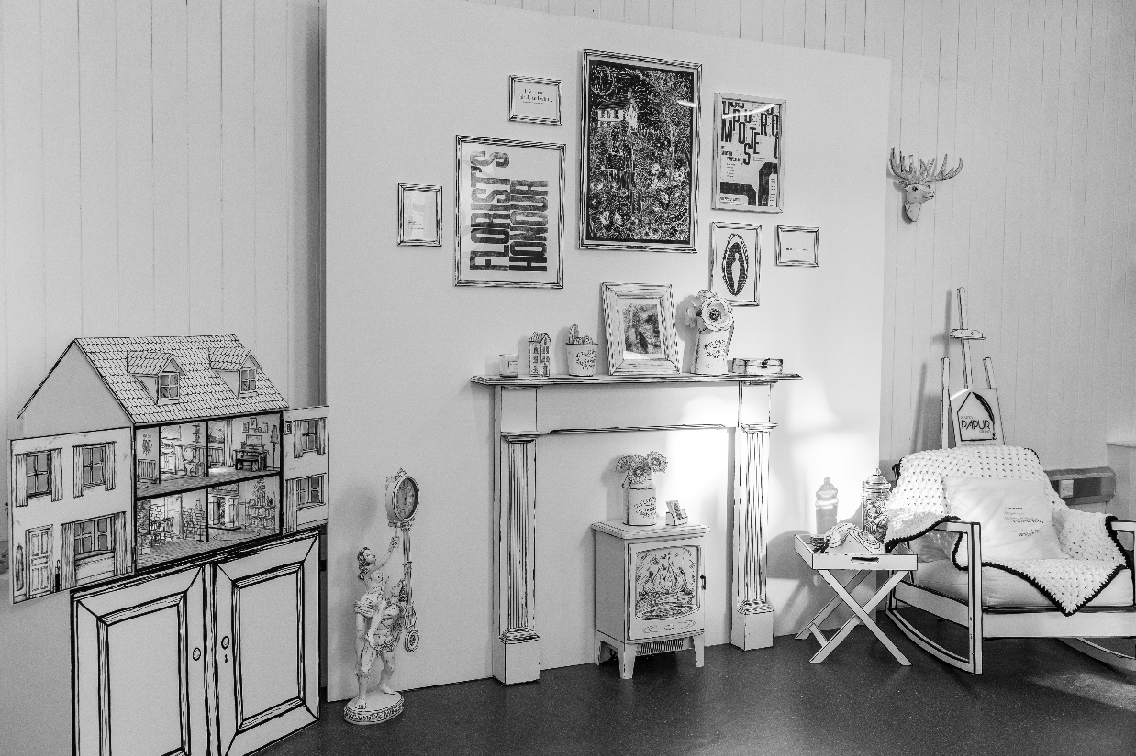
The “Imposterism” installation was created in response to a personal reflection on the multifaceted influences that create feelings of imposterism within myself as an artist and a creative professional. It asks the questions: What is imposter syndrome? Why are women so readily labelled with this pseudo-diagnosis? And is this an inherited phenomenon?
Figure 1: Imposterism Installation – MA Contemporary Dialogues Exhibition - Sophie Hancock
Inspired by self-narrative, the work builds connections between "imposter syndrome" and the social and gender constructs faced by the female. The black and white study explores how analysis of one’s nostalgia, memory and childhood associations of “motherhood”, “domesticity” and "home" are intrinsically linked with a hidden dialogue of privacy, separation and unspoken negative thoughts.
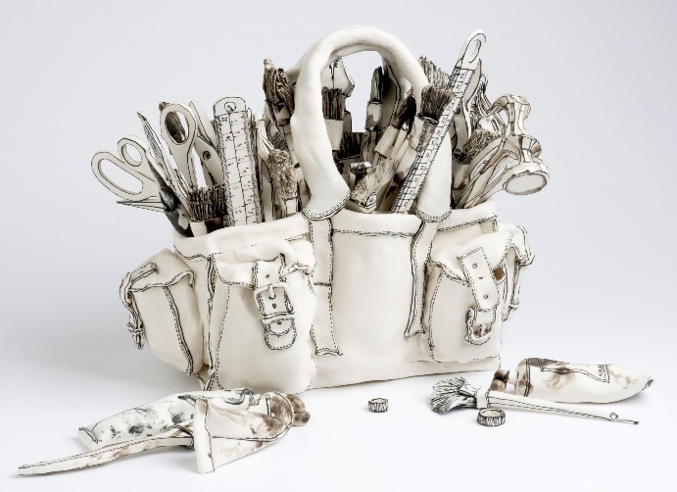
Utilising illustration, text and traditional forms of printmaking, the interlinking scene of images and works within this installation were influenced by the captivating ceramic work of Katharine Morling. Through deep reflection, my work was further developed and complimented by the writings of Rozsika Parker, the emotionally honest work of Louise Bourgeois, and other influential feminist critical works, such as Simone De Beauvoir’s The Second Sex.
Figure 2: Katharine Morling - "Toolbox" -
Porcelain and Black Stain
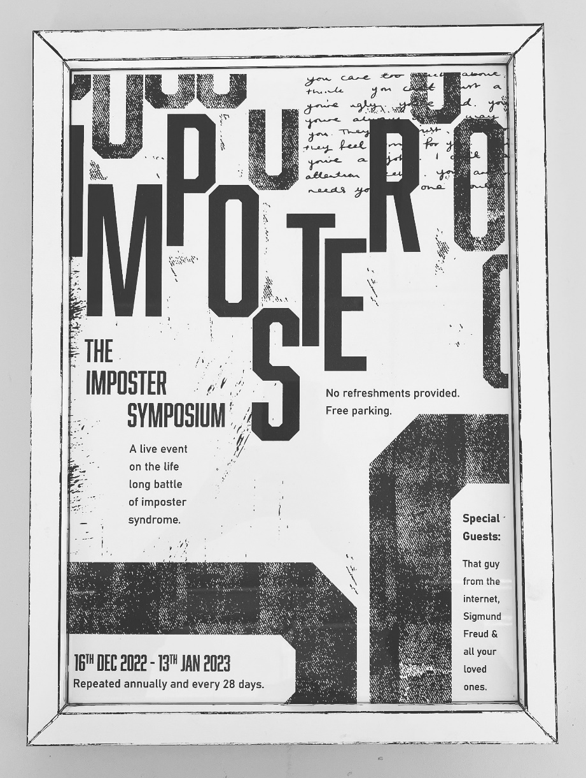
Duality and co-existence are important concepts when looking at and reading about this installation. Where there is a public performance, there is a hidden, private and unspoken element that the audience is invited to expose should they look closely enough to find it. Seen/unseen, inside/outside, real/imagined, positive/negative, work-life/home-life, mother/daughter all cohabit within the installation, just as the female artist must co-exist with the unconscious bias they face daily and, equally, how the house must accommodate many functions. Just as the home is inherited by the child, so too is our unconscious bias passed down from previous generations of privately discontented and domesticated women. As I touch upon in Imposterism, the exhibition statement shared at the forefront of this essay, it is only in collaboration with and consideration of the Impostress’s “private realm” that the artist within can be free to create without the “burden of broken systems”.
The ImPOSTER Symposium (Figure 3) neatly arranges my thoughts around my praxis into an imagined event. Set to the dates of the start of the installation exhibition and ending on the day of my final assessment, the event poster is styled to resemble the manually printed letterpress posters of Alan Kitching (Figure 4) and the visually playful shaping of Joseph Müller-Brockmann (Figure 5). The poster itself is an imposter, as it has been designed entirely digitally to resemble traditional manual printing. In my daily life as a designer, I repeatedly create rushed posters for events that require marketing, and creating in this fashion often leads one to become tired, stale and uninspired. When the work is no longer exciting, we begin to turn inwards and begin to feel our Imposter Syndrome. It is an uncomfortable place to be, as there are “no refreshments provided” and you can stay there as long as you let yourself be impacted by external influences on your psyche. Be that your mother or a “random guy from the internet”.
Figure 3: "The ImPOSTER Symposium" – RISO in black

Figure 4: Alan Kitching "Why Iraq?"
Figure 5: Joseph Müller-Brockmann – “Beethoven” Poster
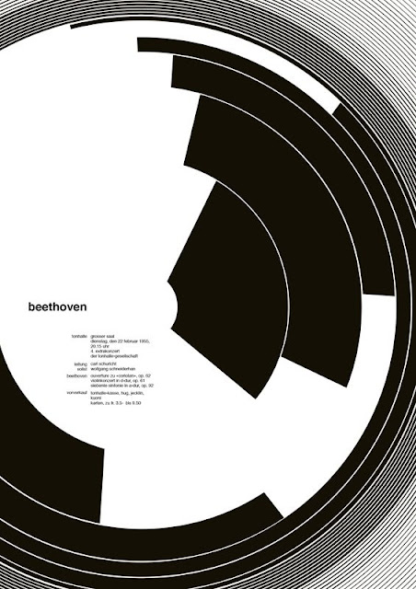
Identifying the Reality of the Creative Female
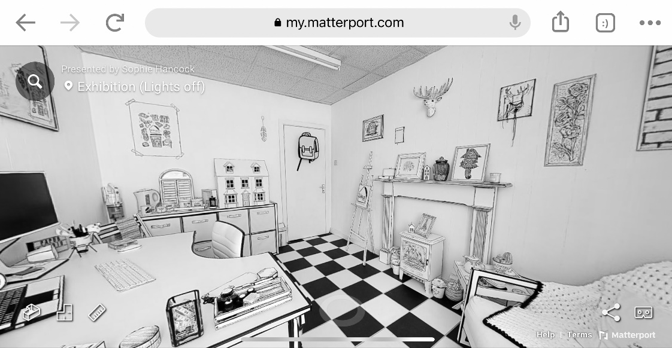
Knowing that I was about to leave the illustrated space I first created in response to my fascination with the monochromatic work of Katharine Morling (Figure 2) during my exploratory module, I wanted to preserve its image in some way. As such, I created a 360-degree virtual experience of the studio by scanning the space with a high-resolution lidar camera. Loading the image onto the Matterport platform and viewing it through Oculus Quest 2 VR goggles creates the illusion of being in the original room. However, I found that due to the height of the camera, you can only view the space within virtual reality at the similar eye-level of a child. It was through this digital capturing of that original space that the idea for my final body of work completely changed. Originally, my work had been rooted in the idea of creating the ideal work environment for a creative professional. A space between office and home. However, I had accidently already managed to achieve its creation as my ideal space and I had additionally captured it in a way that challenged me to a new line of thinking. Why did I feel that I needed a third space in the first place? And why was the iconography of the space so intrinsically linked to my childhood?
Figure 6: Virtual Reality View of Papur.Studio using Matterport Software
My reason for wanting to make this environment was anchored in the need to validate my decision to be a creative professional, and inadvertently I had created a unique style of performance piece that even the least creatively minded person can find intrigue in. I dressed in black and white and invited others into the space, observed how they interacted with it, and took pleasure in the different reactions and opinions the installation inspired in others. This need for “performance”, or “false confidence” as I have called it throughout my life, has been my protective barrier for my own unspoken anxiety and thus I decided that in my final module I wanted to peel back those layers to expose and challenge the inner, hidden thoughts that feed my “imposter syndrome”. For it is those feelings that are seemingly the fundamental flaws holding me back from being able to comfortably call myself an artist and allowing me to pursue it as a career.
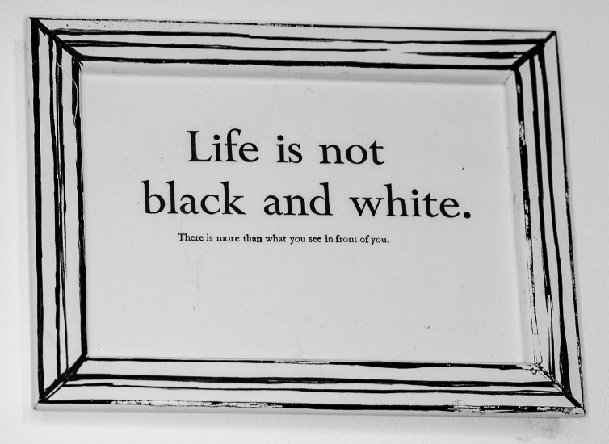
Utilising the wall that I felt most importantly captured the hidden narrative of my childhood (the fireplace, armchair and gallery wall seen in Figure 3), I designed a series of framed images to create the “Imposterism” installation. I found through my explorative praxis that the various forms of print and letter press I used to create the original framed pieces allowed me to bridge a gap between digital and traditional design. I decided that words would play a very important aspect in this final installation, as my own voice had been seemingly absent from the original studio space. Thus, during the process of designing, drawing and carving, I wrote poetry to help myself compartmentalise the thoughts that coexisted alongside each piece. As Juliet Miller writes: “Being able to connect with feelings, be it through thoughts or images, is central to an understanding of our internal emotional life. Young-Eisendrath proposes that this is the core of self-discovery” (Miller, 2008, p.102). This “self-discovery” is central to the essence of my work.
Figure 7: Letterpress in Oil. This piece challenges the viewer and the artist to look beyond the black and white images and see the hidden meaning beneath the installation
Through autobiographical poetry and a personal study of the meaning and symbolism of “home” observed within my work, I found myself writing an unspoken story shared between a mother and a child. The child, now an adult, is trapped within the “Motionless Childhood” that Gaston Bachelard describes in The Poetics of Space. Yet, it is not necessarily a “memory of protection” (Bachelard, 1964, p.28) envisaged in this particular fixation of the home. It is instead simultaneously a memory of comfort and a visceral reimagining of some more difficult moments. For as Louise Bourgeois similarly describes: "My childhood has never lost its magic, it has never lost its mystery, and it has never lost its drama" (Bourgeois, 1998, p.1). In explaining this complicated relationship, the mother in the story becomes exposed and her home, garden and private thoughts are opened up to an audience by her “disobedient” daughter. The mother faces her “maternal ambivalence” and must admit that “loving and hating feelings for their [child] exist side by side” (Parker, 1995, p.1) to release herself from the guilt she harbours for having those feelings. Additionally, the childless daughter must also reflect and learn from the process of exposing these emotions in order to grow and forgive her mother. While society dictates a “maternal ideal” of unobtainable “oneness” with one’s child (Parker, 1995, p.29), it is only through the “destructive” female act of “stepping out of accepted ways of being” (Miller, 2008, p.4) that the mother and child will be able break free from the chain of expectation placed upon them. As De Beauvoir writes:
To be feminine is to show oneself as weak, futile, passive, and docile. The girl is supposed not only to primp and dress herself up but also to repress her spontaneity and substitute for it the grace and charm she has been taught… Any self-assertion will take away from her femininity and her seductiveness. (De Beauvoir, 2011, p.537)
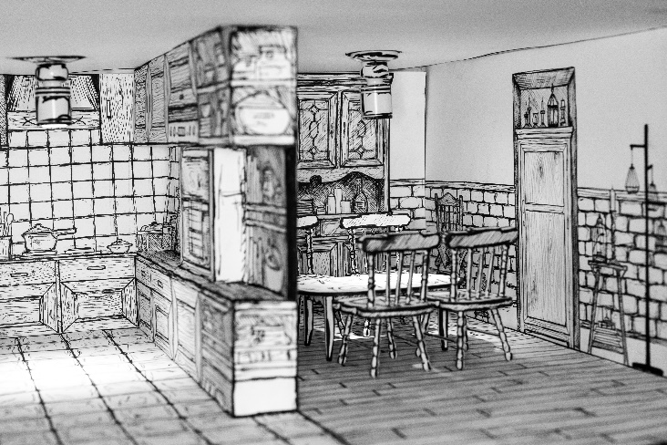
It is proposed through my work that much like a woman is expected to look a certain way to attract the admiration of others, this level of ideal has also become expectant of her home. If a woman can show herself as pristine, she becomes the ideal wife and it is then that “her physiological destiny” of motherhood is achieved (De Beauvoir, 2011, p.537). Thus, the wife, the mother and the domestic become entangled in the matrix of feminine expectations and imposed societal belief systems. As Gill Perry notes, “Images of home improvements or desirable “dream” homes fill the pages of magazines worldwide, and the subject derives a lucrative global publishing industry” (Perry, 2013, p.9). As such, the idea of maintaining a picturesque home is perpetuated by a woman’s surroundings; it was notably a prominent observation made of my mother throughout my childhood. Her home, as represented in the pieces within my installation, became a “gallery” of perfection for my mother, and this drive to improve and keep her home pristine continues today.
Figure 8: The Dollhouse. An illustrated interpretation of my mother’s pristine interior design. Her style is influenced by country home design.
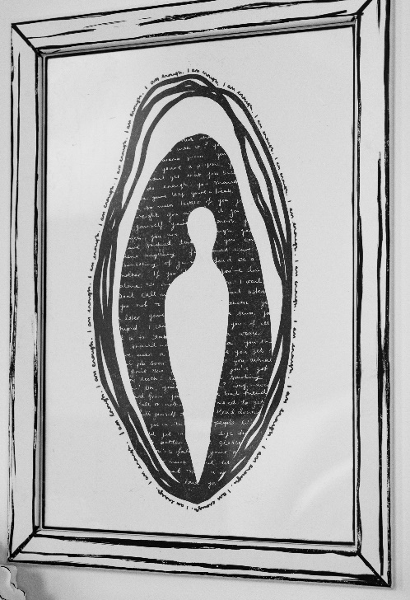
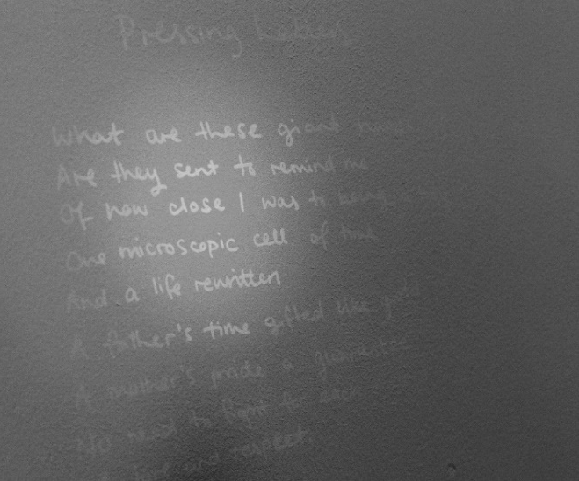
Since the early twentieth century, femininity has been “persistently identified… with the private, domestic sphere of the home, in contrast to the supposedly more public spheres of masculine, professional culture” (Perry, 2013, p.17). However, as Perry notes, the home has been revealed to be “a site both of feminine ‘homeliness’ and crisis” (Perry, 2013, p.17). It is, therefore, understandable to assume that when placed under a microscope, the pressures to deliver on societally-determined ideals becomes problematic for the continually observed female. The term Imposter Syndrome was first coined by Pauline Rose Clance and Suzanne Imes when they noticed the “phenomenon” within their study of high achieving professional and academic women in 1978. It has since become known as the “universal feeling of discomfort, second-guessing, and mild anxiety in the workplace” and noticeably it was pathologized “especially for women” (Tulshyan & Burey 2021). As Miller says, the “suppression of feminine is so much a part of our cultural, historical, and psychological histories that we are frequently blind to it” (Miller, 2008, p.10). Just as hysteria became the common diagnosis and “nonsological limbo of all un-named female maladies” (Schull, 2011 p.7), the term Imposter Syndrome has become a catch-all phrase for women suffering any anxieties of being seen as a failure. Yet, it could be suggested that all women are pre-disposed to have these negative emotions due to living in a society in which they are expected to achieve and maintain multiple roles. In fact, as Marjorie Hansen Shaevitz described, the pursuit of achieving perfection in all her female duties can inevitably lead to another pseudo-diagnosis: Superwoman Syndrome (Hansen Shaevitz, 1988). This is summarised as “the perception that one must be perfect in all things: perfect on the job, at home, in one’s body image, in one’s relationships, etc. and it is exacerbated by other social pressures” (Ofosu, 2017). Just as Young-Eisendrath suggested, female suppression “forms a benchmark that traps women and pathologizes their "unfeminine" emotions” (Miller, 2008, p.8) and this is certainly evident in the modern-day appropriation of the term “syndrome” for any undesirable female behaviours. Influenced by these feminist theories, I wanted my work to showcase the entrapment of female emotions and the guilt, shame and misdiagnosis that women face when discussing these private feelings. I wanted my work to display a frame of limitation, as well as represent a visual “breaking-out” from within that framing. Thus, the living room-style wall of the installation became a frame through which I endeavoured to portray this hidden narrative of guilt and shame. One key way that I achieved this expression of private thoughts was through the use of ultraviolet ink to handwrite poetry across the installation, as seen in Figure 10. Additionally, using this technique I was able to portray the hidden shame and guilt of the female that I call the “impostress”, a new term for the female imposter.
Figure 9: RISO printed “Russian Doll”. The female on the inside is covered by a layer of hidden negative thoughts and a further protective layer that tells the outside that “I am enough”. She is unable to reach this layer as a result of the hidden voices. The shape created in designing this is accidentally vaginal which made for an even more powerful message about “imposter syndrome”.
Figure 10: Poetry is handwritten on the walls of the installation in ultraviolet ink. Viewers must use UV torches available to be able to read the poetry.
Understanding Motherhood as the Childless Creative
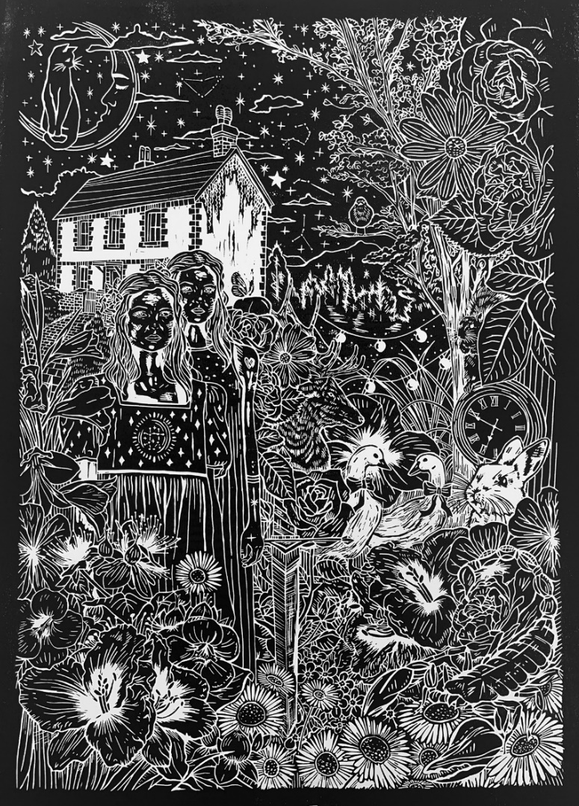
The work that went in to “papur.studio” brought out areas of my own personal journey linked to memory and childhood with a strong link to feminism and motherhood. The space was adorned with iconography that immediately felt like “home” to me, but also quite naturally brought in symbols of my own maternal figure. The flowers were representations of my mother, who worked as a florist when I was a child and who spends most of her free time gardening. The blanket was crocheted by my mother’s hands. The scene of the fireplace inspired was by memories of my childhood, and my hap-hazard stitching is a reminder that she is an accomplished seamstress and that talent was not passed down to me. I was bringing different parts of myself, my life and my mother’s life into those four walls, and I wanted to reflect, understand and compartmentalise these ideas of mother and home and their relationship to imposter syndrome in the final installation.
I began the process of condensing down the ideas shown in the original space by designing a large detailed illustration as an “homage” to my mother. Through its design, I found myself pulling in various symbolical moments of our history together and additionally wrote a seminal piece of autobiographical writing in my journal through the process:
Figure 11: An Homage to Motherhood
(Print in black oil based ink. 50 x 70 cm)
In many ways my mother has been alone in her garden, and because of this quiet solitude it has for her been a safe space. Over the years the garden has had many forms. She used to be more clinical. Clean lines and perfect lawn. Now, the garden is about exploration and rewilding. The grass has been replaced by bark chip and the borders are freely expanding as the shrubbery roots outwards. Walking through the large, long greenery takes me back to feelings of being a child even though when I was younger the garden was never as wild and magical. As an adult, it is a symbol for how far my mother has come on her journey by reimagining her life as this clinical, enclosed space to a free and fun place to play and explore.
In addition to this, I wrote Mother, one of three poems that can be seen hidden in ultraviolet ink on the walls alongside the final framed print of An Homage to Motherhood (Figure 11):
Mother is in the garden
Doing the unknown
The hard work no one cared for
But about when the work was done
The green flourished
Flowers peeled open to reveal
Splendour
Unimaginable
Wonderland.
Daughter sits at her drawing desk
Cracking crayons
Drawing rotund pictures of father
Concentrating on the tufts
That adorn the sides of his bald head.
A masterpiece.
It looks just like him.
I wonder when he will be home?
Without need for much explanation, this self-narrative poem summarises the magic and tragedy of my childhood, just as Louise Bourgeois “searches consistently for her own emotional truths through the making of structures and forms” (Miller, 2008, p.102). While my mother was alone in her garden retreating into her plants, I was alone in my bedroom retreating into my drawing. Neither my mother nor myself have ever truly acknowledged or realised this until I wrote this poem. This difficulty faced when previously attempting to be emotionally open in my creative practice echoes the sentiments of Juliet Miller:
If a woman is consciously aware of her struggle to express herself it can be hard for her to appreciate how self-destructive she may be in relation to her own creativity. For some women, their masochism (which I suggest is a result of the accepted theory of female inadequacy) is so deeply embedded in their way of being that they cannot identify this as a problem; it is part of their being. (Miller, 2008, p.10)
In Mother, I highlight that the “problem” Miller suggests (which I have struggled to identify) is that both my mother and I are being driven apart by the suffering we feel in the absence of my father. However, in my second poem, The Cut, which was written during the process of carving An Homage to Motherhood, I outline the further patriarchal influence on this disconnect between us:
A fresh sheet of linoleum
Placed at my fingers,
Graphite dusted,
Weighted heavy by thought
And worries
Of a misplaced line
From blade slipping
Through its buttery surface,
Warm and unforgiving.
Carving became garden shears
Trimming out the flowers
Revealing a hidden story
Of a mother and daughter
Trapped in the circle
Of loving their fathers
And resenting one another.
Offering up the reasoning
Of life’s moments
To the stars and planets.
Believing themselves
Incapable
Of being the ones
Holding the knife.
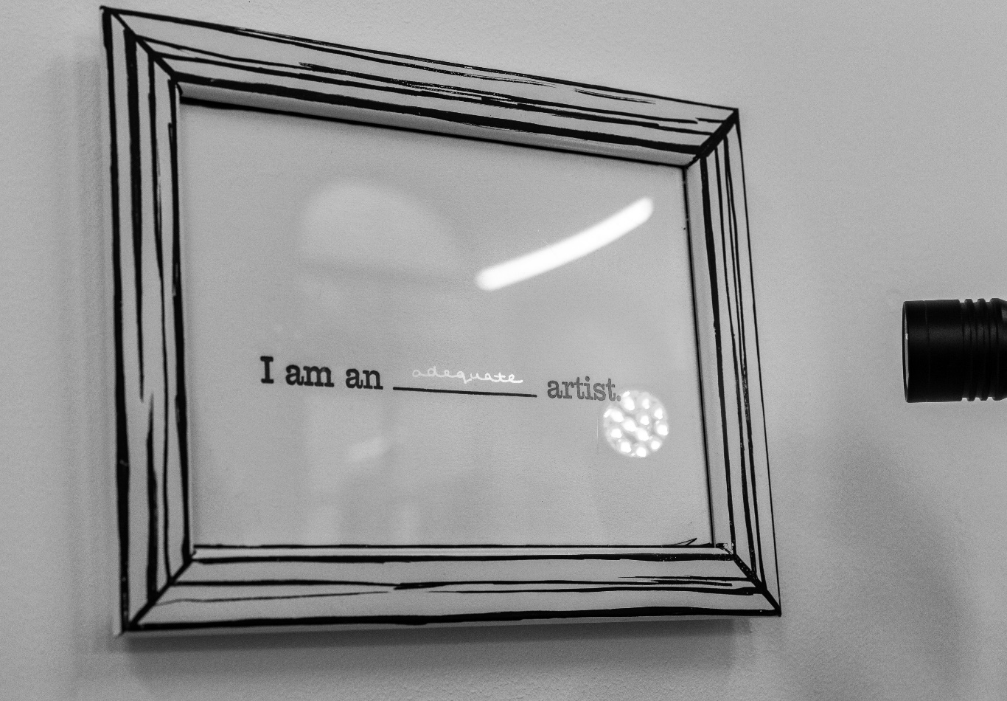
It is during the arduous movement of carving each flower from my mother’s garden onto the linoleum that I began to liken this process to what Rozsika Parker’s The Anxious Gardener calls the “licensed aggression” of pruning (Parker, 2006, p.62). Parker emphasises this comparison of motherhood and gardening by saying that her “son refused to allow her to cut his nails the minute he was old enough to hold the scissors” (Parker, 2006, p.62), proposing that her skills as a gardener are comparable to her maternal skills. These correlations are made throughout the text and perhaps most poignantly echoed by the ever-watching Maud-Next-Door, who likens the former’s lacklustre plant growth to her own children, saying, “I just knew that some mother somewhere was providing her children with precisely the right input while I stunted mine” (Parker, 2006, p.81). Similarly, as one might read the first lines of The Cut as an expression of “imposter syndrome” within the engraver, one might feel the sense of imposterism from the gardener who seeks perfection. As Parker suggests in Torn in Two, “the ever-changing, contradictory prescriptions for ‘perfect’ mother are a manifestation of an underlying awareness of the ‘imperfect’ impulses in all mothers provoked by the conflicts engendered by maternal ambivalence – magnified by persecutory ideals.” For as long as these women continue to prescribe to these preconceived and unattainable goals of perfection, they will continue to experience anxiety and creative discontent. As Miller says, women build a protective layer through their “complaints about not being good enough, or narcissistic desires for perfection” to defend themselves from the “a terror at being seen to be creative” (Miller, 2008, p.8).
Figure 12: Letterpress and UV Ink. "I am an ___ artist" represents the negative internal voice of the female artist and the examining gaze of the professional male artist who analyses and compares it to his own.

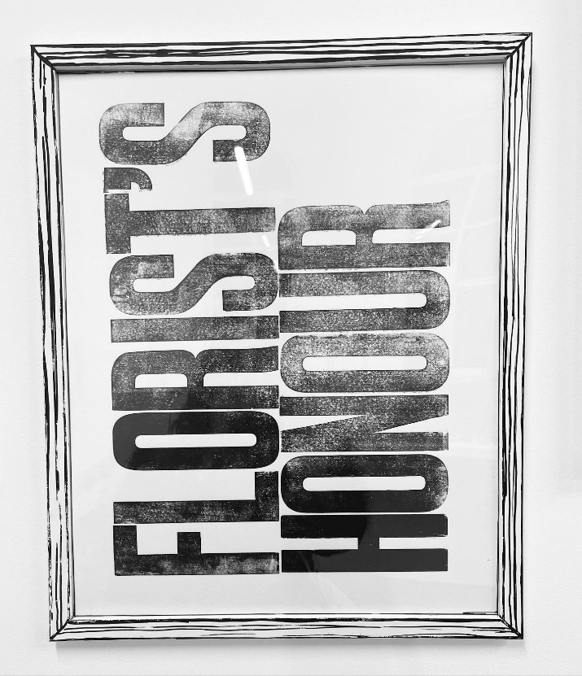
Until recently, many forms of traditional print were “inaccessible to women. This was a profession, and women did not become professionals… Ladies busied themselves with homely amusements” (Jaffe, 1988, p.10). As such, if a woman is to partake in a “male-dominated craft” (Jaffe, 1988, p.8) it is understandable that they may be fearful of mistakes, failure and judgement. It is not just the hands of one woman, but all women and their “amateur” abilities as “intruders” to the creative profession (Jaffe, 1988, p.10). I propose through The Cut that part of my need for perfection is indeed driven by this historical bias. My writing asks its female protagonists to break free from patriarchal oppressive systems and acknowledge how they have been affected by gender bias. My poem, Pressing Letters, further emphasises the gender bias in creative professions whilst also highlighting how systemic issues of male-preference within society have been inherited maternally throughout the generations:
What are these giant hands of mine?
Are they sent to remind me
Of how close I was to being a boy?
One microscopic cell of time
And a life rewritten.
A father’s time gifted like gold
A mother’s pride a guarantee.
No need to fight for each morsel
Of love and respect.
Instead
These long limbs
And broad shoulders
Would be admired
Not ridiculed.
My weight?
Irrelevant.
My intelligence?
Unnecessary.
My strength and masculinity
Would carry me through
To a career I’m sure would make a lot of money
And a wife I’m sure would carry the load
While I went out and won the bread.
Figure 13 : Florist's Honour. Letterpress Print in Black Oil Ink. These two words are a phrase used between myself and my mother that mean “you can trust me”. It felt instinctual to create this piece as a bold display as whilst I share these thoughts and emotions, I am incidentally breaking trust with my mother but asking her to trust in me that it is for a “greater good” that we face these internalised truths
As I fumble with metal letters
I think of all the women
Who never had the permission
To touch a printing press.
A man’s job.
A job for men.
Time consuming
Yet invigorating.
I hear the tap
And ding
Of typewriters
In a far off imagined room.
Laden with individual seats
At writing desks
Filled by working “girls”
In smart dresses
Typing out the words
Of men in suits.
I think of my grandmother
With chipped shoulder
Grumbling that she could have done that
Had she passed her eleven plus,
And mother grimacing
Saying she could have done anything
If her brother hadn’t been the golden child.
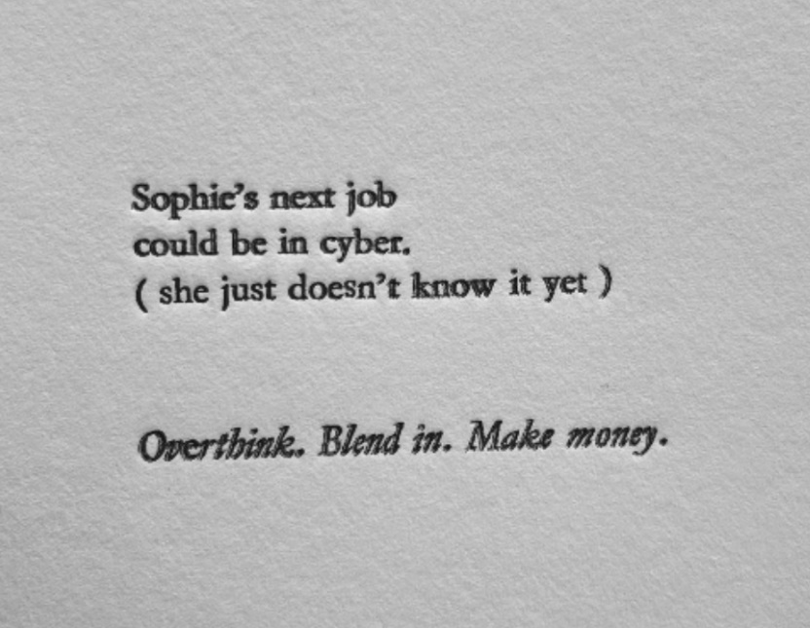

Echoing these patriarchal influences in women’s ability to be creative professionals, I utilised the letterpress technique to create Sophie’s Next Job Could be in Cyber (Figure 14). The piece is a satire of the controversial advert seen in Figure 15 that was released to the public during the pandemic of 2020. It was launched after public outrage following a since deleted “tweet by ITV News… the chancellor appeared to suggest that those in the creative industries who have been impacted by the ongoing coronavirus pandemic should simply retrain and find other jobs” (Dawson, 2020). This narrative led many British creative professionals to feel that Rishi Sunak was essentially telling them “Your career is no longer viable, find another” (Dawson, 2020) whilst they faced the extreme financial pressure of being unable to work during a global pandemic. Thus, in addition to a woman feeling they have to struggle to be seen in the “existing male-dominated field of art” (Parker & Pollock, 1981, p.169), they are now told that choosing a creative career at all is unwise financially. I chose to highlight this as a key element of the cultural and social drivers in my personal feelings of imposterism when being creative, because a significant memory from my own childhood was the push to choose a good career and avoid the arts at all cost. This voice echoes in my mind whenever I choose to embark on creative pursuits. As such, is an important homage to this lack of understanding or appreciation for the arts as a viable career path. As shown in Pressing Letters, the process of letterpress is complicated, slow and meticulous, but in the final design, an untrained or unknowing person might assume that it has been designed and typed on a computer. It is this lack of understanding that allows negative opinions of artistic careers, but it is important to emphasise that in particular a woman is judged for choosing such a career. As Parker & Pollock write:
Figure 14: “Sophie’s Next Job Could Be In Cyber”
Letterpress in Oil Based Ink.
Figure 15: Controversial Advert that told the unviable arts to retrain during the pandemic.
We have to reject the simple notions that women's art has been ignored, neglected or mistreated by art history… Women's practice in art has never been absolutely forbidden, discouraged or refused, but rather contained and limited to its function as the means by which masculinity gains and sustains its supremacy in the important sphere of cultural production. (Parker & Pollock, 1981, p.169-70)
For as long as women’s creative practice is seen as a “feminine hobby” (Jaffe, 1988, p.10), they will continue to be exiled from professional art spaces. In my praxis, this is portrayed as a hidden creative trapped within the walls of black and white domesticity.
The Secret Cosmos of Home
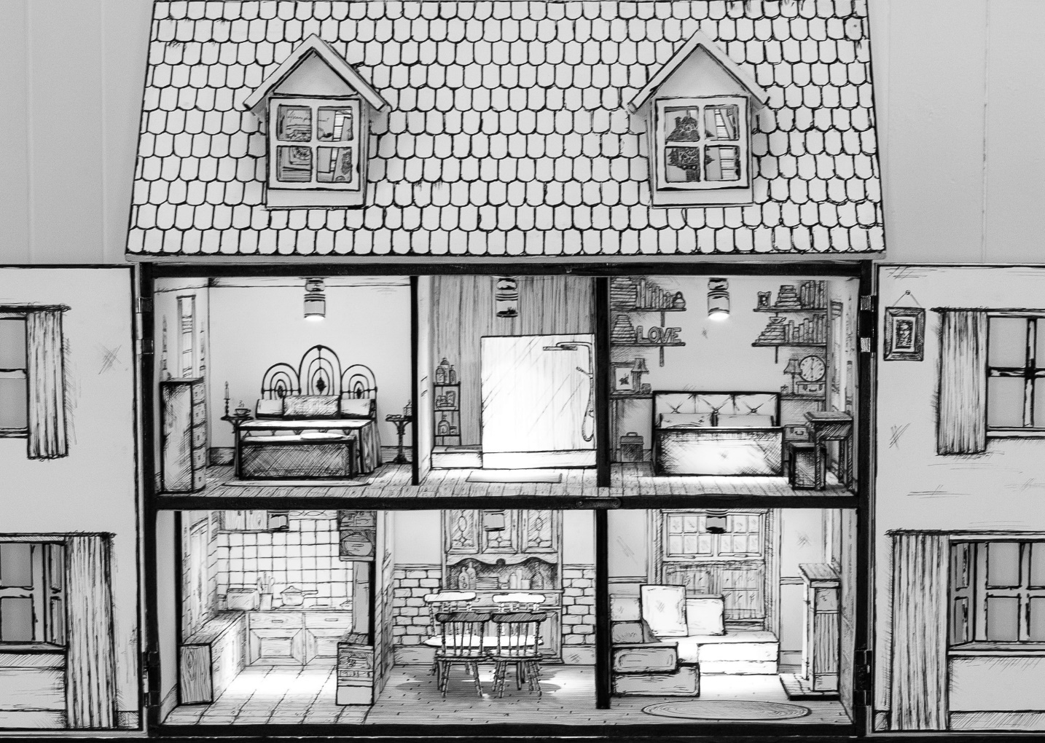
My work centres in what Griselda Pollock calls ‘the spaces of femininity’ and Frances Borzello refers to as the “hidden life” of home and domesticity (Perry, 2013, p.16). Gaston Bachelard calls the house “our first universe, a real cosmos in every sense of the word” (Bachelard, 1964, p.26), and that universe is what I tried to encapsulate in Anglesey House: A Female Cosmos.
Figure 16: Anglesey House: A Female Cosmos
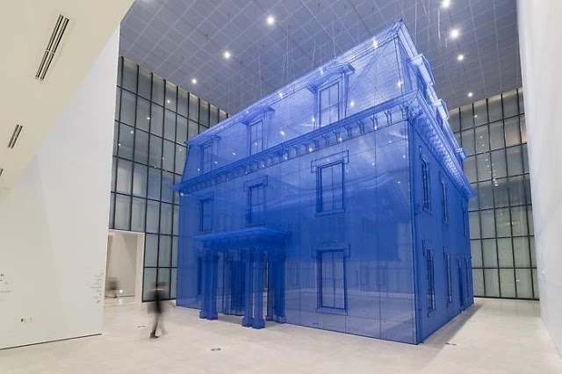
Reminiscent of the work of Do Ho Suh, I used the dollhouse as a “means to understand the path of my life and the time I’ve spent there… The walls behind the paper are starting to talk to me… I’m reliving 20 years of time’ (Turner, 2016). Each room seen in Anglesey House represents an actual room from my mother’s house of the same name. Its walls and furniture – constructed with paper and foam board – are illustrated in fountain pen with Onyx Black water-based ink. Within each room, hidden handwritten messages adorn the walls to represent the inner thoughts of its inhabitants. They are only visible with a UV torch, forcing the viewer to reach in and break the boundaries of the doors, which remain open. The attic space is nailed shut, so viewers must peer through the window to see the barely visible miniature artworks hang. These hanging posters are selected from my work throughout my master’s. The attic within my mother’s house was reserved for “crafts” and reflected my mother’s opinions that art was messy and should be hidden away. The house echoes the “primp” and pristine way that De Beauvoir says that all females should be.
Figure 17: “Home Within Home Within Home Within Home Within Home” by Do Ho Suh.
As Csikszentmihalyi & Rochberg-Halton state, ‘Few English words are filled with the emotional meaning of the word "home". It brings to mind one's childhood, the roots of one's being, the security of a private enclave where one can be free and in control of one's life” (Csikszentmihalyi & Rochberg-Halton, 1981, p.121). However, Luce Irigaray would argue “ that the ‘homeliness’ or domesticity of the house is dependent on a particular idea of the maternal feminine subject as ‘placed within the home, sheltered in the home’. Irigaray argues that same home places her in ‘internal exile’ (Perry, 2013, p.17). Alice T. Friedman further argues that:
“the creation of the country house helped to place domestic work and family life directly under women's control, it also opened up the possibility for an identification of women with the home and for the virtual exclusion of women from public life." One consequence of this exclusion, paradoxically, was the increased scrutiny upon women of all classes; more important than anything they did was the male perception of women's inactivity, silence, chastity, and obedience. (Abate, 2003, p.3)
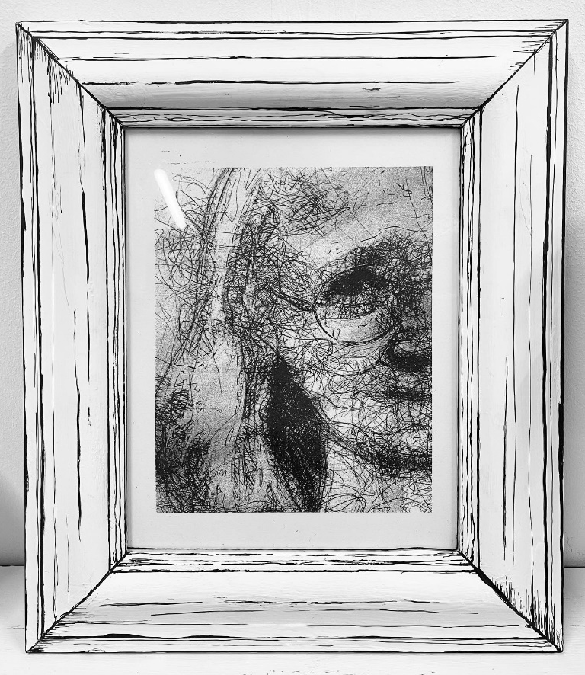
The home I created accentuates the silent and obedience feminine subject: The mother and her daughter. However, within their “private enclave” they are not in control of their lives and the “internal exile” is made public. In many ways, the home has become a prison for them in that they both live under a watchful eye. The mother observes the child while feeling herself watched from outside the windows. In Figure 18, this sketched mysterious RISO print symbolises this “ever-watching” gaze that the daughter faces from her mother, but also subverts the viewership of the installation. The audience is also being watched and observed, and this image serves as a reminder to that consistent reality for the female.
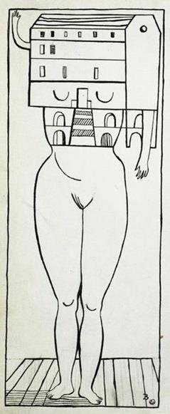
As previously mentioned, my work has been influenced by Louise Bourgeois, in particular her “Femme-Maisons” series of ink on linen, seen in Figure 19 . This series of the disembodied female combined with the image of the house depicts the “demands of family and domestic life” and embodies the “inner psychic state of the importace of the original family houses of her childhood and the dramas that have been enacted therein” (Miller, 2008, pp.105-6). Whilst my mother endeavoured to keep her private emotions hidden, they came out in various anxious behaviours and in her physical health. The the sexualised body of the woman without a face made me think about her own discontent being hidden within the walls. In the same way that Bourgeois “[harnesses] the power of the creative act” and “communicates feelings of vulnerability, pain, and anger that can be felt profoundly, both bodily and viscerally, by her audience” (Miller, 2008, p.105), I am also attempting to expose the shared vulnerability of myself and my mother. As with Bourgeois, “This capability to communicate powerfully conscious and unconscious enabled her to grow in strength as her career has progressed” (Miller, 2008, p.105), and I wish to do the same within my own praxis.
Figure 18: Femme-Maisons by Louise Bourgeois
Figure 19: “Cathryn” a digital sketch print of my mother
watching the installation viewer.
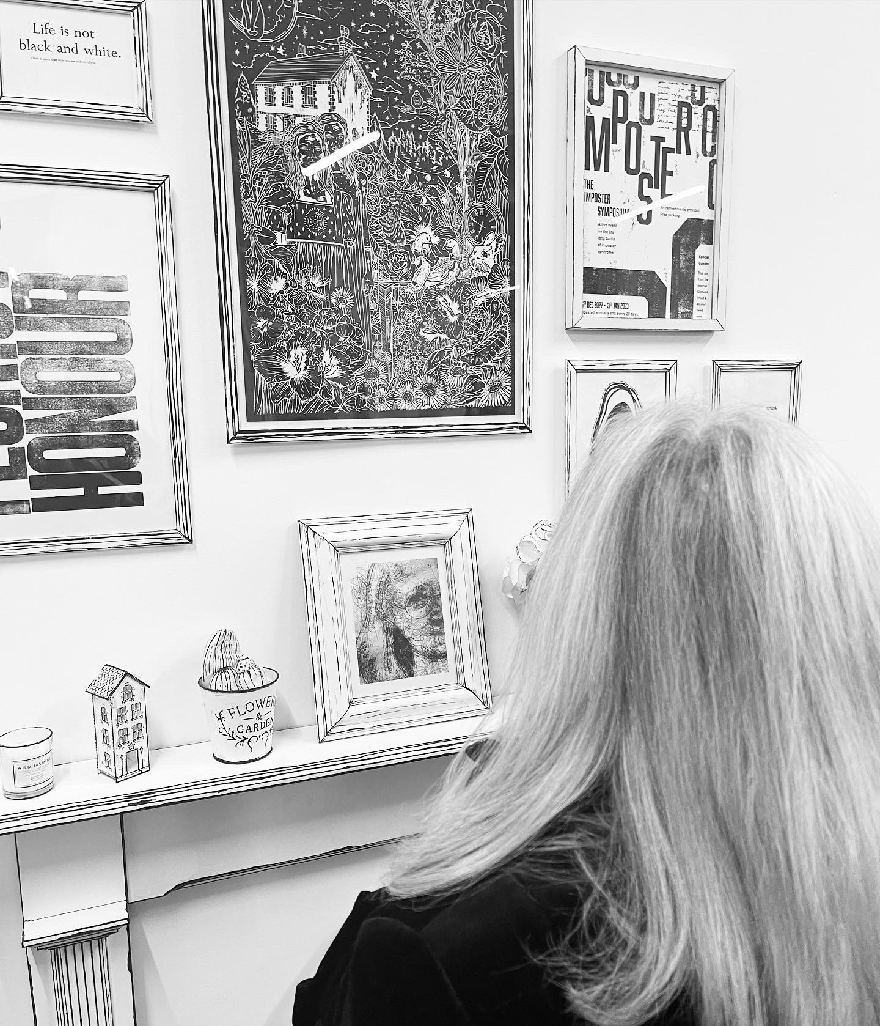
To conclude, I fully consider the final words of the Imposterism poem: “The Impostress. A woman without child.” In this line, I not only refer to myself as the childless woman, but also to my mother who is now without child, as that child has grown. Though affected by the anxieties that we similarly grew up with, we must now free ourselves from the “burdens” that have been put upon us by ourselves as much as society. By drawing on the walls of my exhibition, I create the antithesis of a stylised, perfect space and free myself from the emotional prison that the female instinctively and inadvertently creates for herself.
Figure 20: "An Inception" - My mother viewing herself at the installation
Word Count: 5236
Bibliography
Abate, C.S. (2003) Privacy, Domesticity, and Women in the Early Modern England, Ashgate: England.
Bachelard, G. (1964) The Poetics of Space, New York: Penguin Books.
Beech, D., Harrison, C., & Hill, W. (2009) Art and Text, Black Dog Publishing: London, UK.
Ettinger, B. (2006) The Matrixial Borderspace, University of Minnesota Press: Minnesota.
Gosling, L., Robinson, H., & Tobin, A. (2019) The Art of Feminism: Images that Shaped the Fight for Equality, Elephant Book Company: London.
Harding, A. (2022) Wild Light: A printmaker's Day and Night, Sphere: London.
Jaffe, P. (1988) Women Engravers, Virago: Suffolk.
Norman, D. (2004) Emotional Design: Why We Love (or Hate) Everyday Things, Basic Books: New York.
Miller, J. (2008) The Creative Feminine and Her Discontents: Psychotherapy, Art, and Destruction, Karnac: London.
Parker, R. (1995) Torn in Two: The Experience of Maternal Ambivalence, Virago: London.
Parker, R. (2006) The Anxious Gardener, Frances Lincoln: London.
Parker, R. & Pollock, G. (1981) Old Mistresses: Women, Art and Ideology, Rivers Oram Publishers: London.
Perry, G. (2013) Playing at Home: The House in Contemporary Art, Reaktion Books Ltd: London.
Schull, A. (2011) Hysteria: The Disturbing History, Oxford University Press: Oxford.
Walters, J. (2016) Alan Kitching: A Life in Letterpress, Laurence King Publishing: London.
Online References:
Dawson, B. (2020) A brief explainer on the government’s dystopian Fatima cyber ad. Available at: https://www.dazeddigital.com/politics/article/50747/1/a-brief-explainer-on-the-government-dystopian-fatima-cyber-ad. (Accessed: 07 January 2023).
Ofosu, H. (2019) The Superwoman Syndrome, Even Harder than it Looks. Available at: https://ioadvisory.com/superwoman-syndrome-harder/. (Accessed: 07 January 2023).
Lucarelli, F. (2016) Joseph Müller-Brockmann: Musica Viva Posters for the Zurich Tonhalle. Available at: https://socks-studio.com/2016/11/30/joseph-muller-brockmann-musica-viva-posters-for-the-zurich-tonhalle/. (Accessed: 07 January 2023).
Turner, C (2016) For Do Ho Suh There’s No Place Like Home, Apollo Magazine. Available at: https://www.apollo-magazine.com/ho-suh-theres-no-place-like-home/. (Accessed: 07 January 2023).
Images:
Figure 2: Morling, K. (2017) Toolbox. Available at: https://www.katharinemorling.com/. (Accessed: 07 January 2023).
Figure 4: Walters, J. (2016) Alan Kitching: A Life in Letterpress, Laurence King Publishing: London.
Figure 5: Whitehead, J. (2017) Beethoven poster by Josef Muller-Brockmann. Available at: https://medium.com/fgd1-the-archive/beethoven-poster-by-josef-muller-brockmann-ce06940edf74. (Accessed: 07 January 2023).
Figure 15: Dawson, B. (2020) A brief explainer on the government’s dystopian Fatima cyber ad. Available at: https://www.dazeddigital.com/politics/article/50747/1/a-brief-explainer-on-the-government-dystopian-fatima-cyber-ad. (Accessed: 07 January 2023).
Figure 17: Turner, C (2016) For Do Ho Suh There’s No Place Like Home, Apollo Magazine. Available at: https://www.apollo-magazine.com/ho-suh-theres-no-place-like-home/. (Accessed: 07 January 2023).
Figure 19: Miller, J. (2008) The Creative Feminine and Her Discontents: Psychotherapy, Art, and Destruction, Karnac: London.

This poem was written as a summary of my installation and presented in my statement at the Syzygy Collective MA Contemporary Dialogue exhibition in Dec 2022

