

Student name: FARZANA AKHTAR
Student ID: 2329139

Module name: Changemakers: Building your Personal Brand for Sustainable Employment
Module code: BMHP5015
Lecturer name: Caroline Salami

Contents Page

Introduction 3
Task 1 3
Task 2 6
Task 3 7
Task 4 8
Conclusion 11
References 12

Introduction
This portfolio provides a comprehensive reflection on my learning journey across the four units of the module Changemakers: Building Your Brand for Sustainable Employment. It examines how each unit has contributed to my personal and professional development within the health and social care sector.
Throughout the module, I explored keys topics including personal branding, globalisation, networking, opportunity recognition and wellbeing. These areas encouraged me to critically reflect on my strengths, values and career aspirations, while developing a deeper understanding of the evolving and interconnected nature of modern workplaces. These themes also helped me understand hoe external factors such as global labour markets, digitalisation and social networks influence career development
The module placed strong emphasis on resilience, reflective practice and wellbeing, which are essential in health and social care. These skills are increasingly important in managing complex service user needs and workplace pressures, which can be emotionally and physically demanding. Developing and understanding of how to manage stress, maintain professional boundaries and engage in reflective learning has been particularly valuable in preparing me for real-world practices.
Overall, this portfolio discusses each unit with a critical reflection, demonstrating how the knowledge and skills I have developed have strengthened my confidence, clarified my career direction and enhanced my readiness for future employment within the health and social care sector.

Task 1 Unit 1: Brand You
Unit 1 focused on personal branding and its importance within professional practice. It explored ambition, goal setting and boundaryless careers, encouraging reflection on how individuals present themselves and plan their future.
Personal branding is a process of influencing how others perceive you through behaviour, communication, and values (Shepard, 2005). In health and social care, this is particularly significant because service users, colleagues and employers rely on trust, consistency and professionalism. Through self-assessment, I identified strengths such as empathy and reliability, which are essential in providing quality care. I identified key strengths such as empathy, patience and reliability. These qualities are essential in delivering person-centred care and building effective therapeutic relationships.
In addition to these, I also recognised strong communication skills, active listening and adaptability as further strengths, Effective communication ensures that service users feel understood and respected, while active listening allows for accurate understanding of their needs and concerns. Adaptability is particularly important in health and social care settings, where situations can change quickly and require flexible and responsive approaches. I also identified teamwork as a key strength, as working collaboratively with other professionals is essential in delivering holistic and effective care.
However, I recognised that personal branding must remain authentic. Identity theory suggests that individuals may adapt their behaviour depending on context, which can sometimes lead to a constructed or inconsistent professional identity (Ibarra, 1999). This made me reflect on the importance of ensuring that my professional image aligns with my core values, both in physical and digital environments. To address this, I will engage in continuous reflective practice to maintain authenticity and self-awareness.
Figure 1: Personal Branding
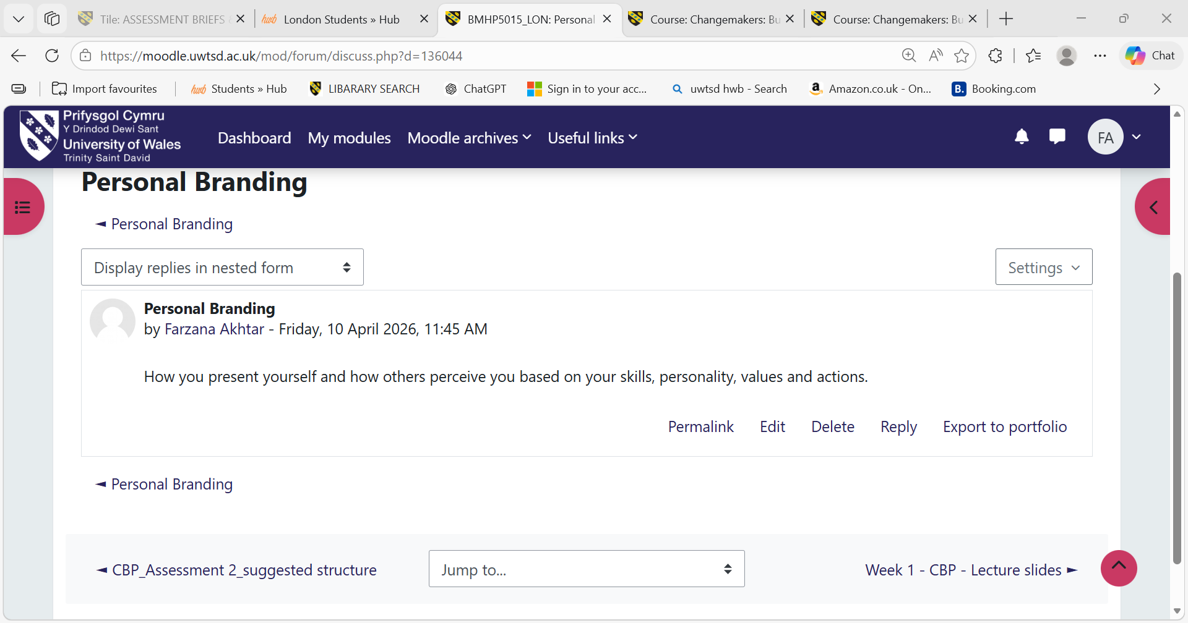
Goal setting was another important aspect of this unit. Research suggests that clearly defined and challenging goals significantly improve motivation and performance (Locke and Latham, 2002). Using SMART framework, I developed structured career objectives, including gaining additional qualifications and seeking leadership development opportunities with health and social care. This helped me break long-term ambitions into manageable steps. I also became aware of the potential risks associated with unrealistic ambition. In demanding sectors such as health and social care, excessive pressure can contribute to burnout and stress. Evidence shows that prolonged workplace stress can negatively affect wellbeing and performance (Maslach and Leiter, 2016). As a result, I now understand the importance of balancing ambition with wellbeing by incorporating regular self-checks and reflective pauses into my planning.

Figure 2: Career Goal

The concept of boundaryless careers expanded my understanding of modern employment. Boundaryless careers emphasise that career progression is no longer restricted to a single organisation and instead relies on transferrable skills and mobility across sectors (DeFillippi and Arther, 1994). Key competencies such as communication, teamwork, digital literacy and adaptability were identified as essential for employment. However, such careers can also create uncertainty and reduce organisational stability (Inkson, 2006). To manage this, I plan to maintain a structured CPD portfolio and actively engage in professional networking.
Figure 3: Boundaryless Careers
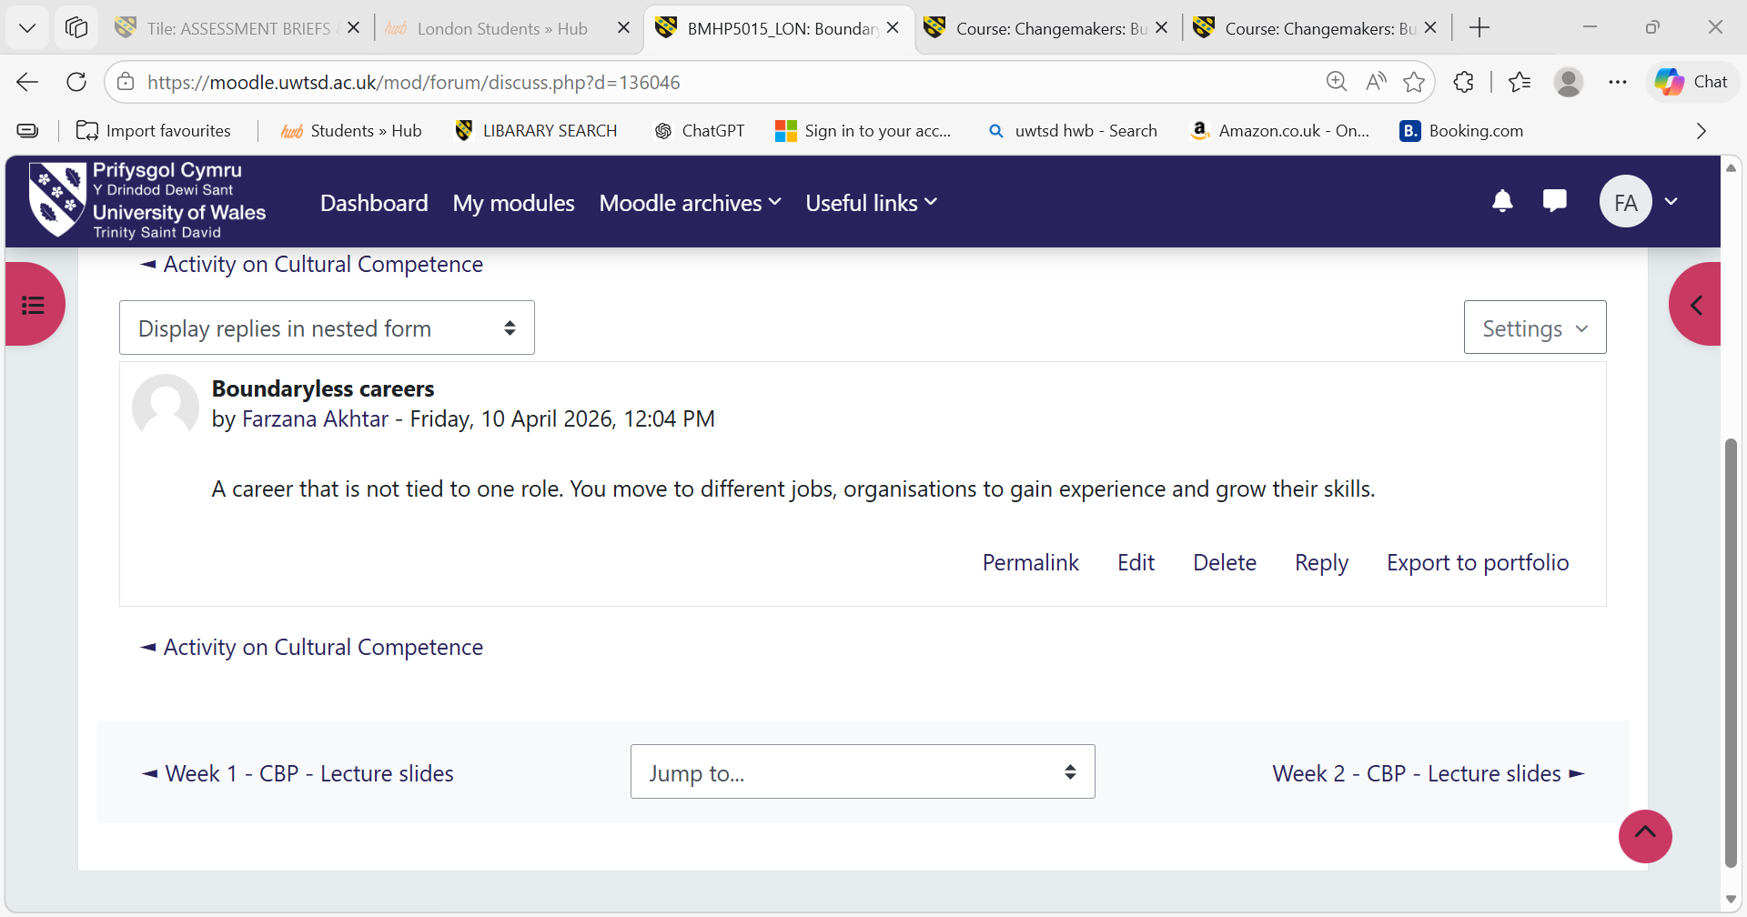
Overall, Unit 1 helped me develop a clearer understanding of my professional identity, strengthen my gaol-setting abilities, and highlighted the importance of authenticity and adaptability in career development.
Task 2 – Reflection on Unit 2: It’s a Small World
Unit 2 explored globalisation, cultural diversity, digital networks and professional relationship, emphasising how interconnected the health and social care sector has become.
Globalisation describes the growing interconnection between societies, economies and labour markets worldwide (Held et al., 1999). This helped me understand how global trends influence healthcare, including workforce migration, shared health challenges, and the global exchange of knowledge. It became clear that health and social care practice is no longer localised but shaped by international collaboration and policy developments.
Cultural diversity was another key theme. Cultural competence is essential in ensuring that care is respectful, inclusive and responsive to individual needs (Betancourt et al., 2005). Reflecting on this encouraged me to consider my own cultural assumptions and biases. I recognised the importance of adapting communication styles to meet the needs of individuals from diverse backgrounds. For example, being sensitive to cultural beliefs and preferences can significantly improve patient engagement, trust and outcomes in care settings.

Figure 4: Cultural Competence
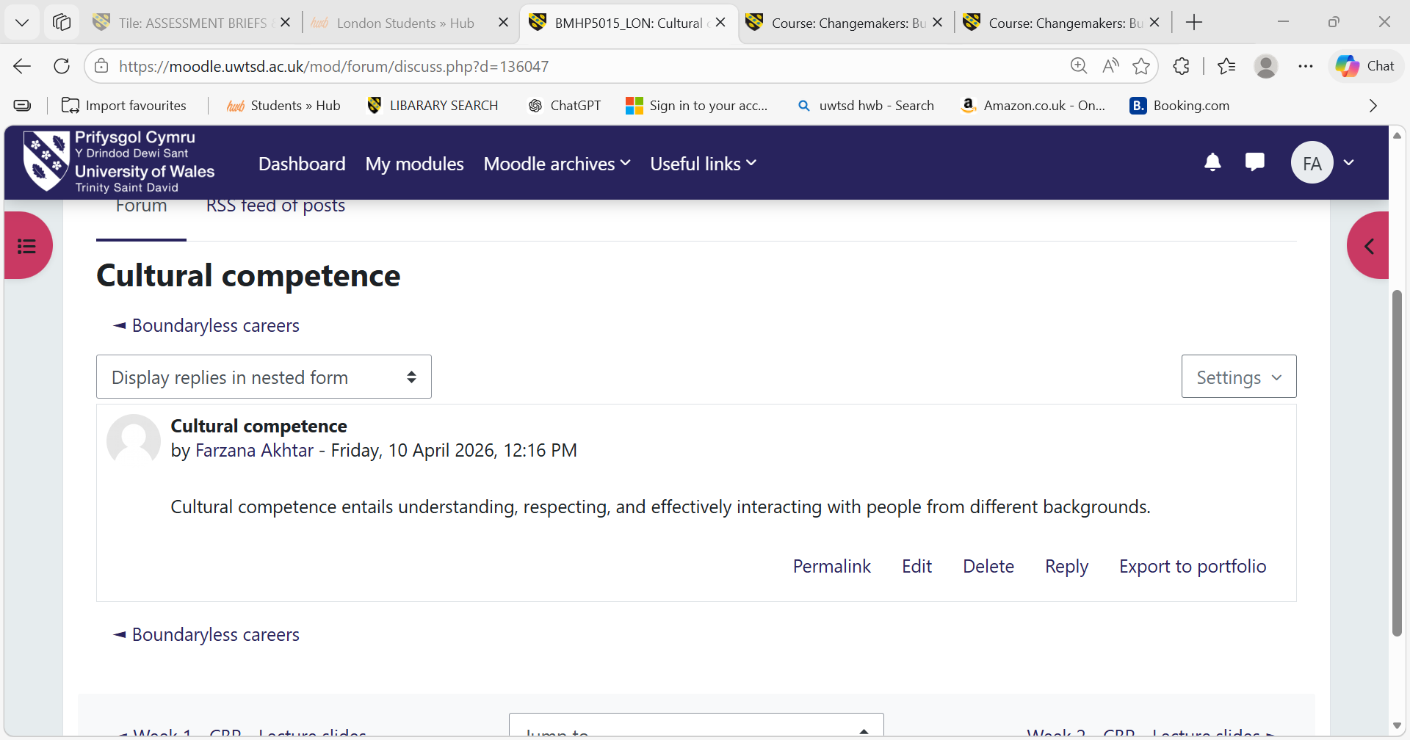
The concept of the network society highlighted the role of digital technologies in shaping modern professional life (Castells, 2010). Online platforms now influence learning, communication and career development. While this presents opportunities for collaboration and professional growth, it also introduces risks such as misinformation and blurred professional boundaries. As a result, I understand the importance of maintaining a professional and ethical digital presence that reflects my values and competence.
This has encouraged me to become more aware of how my online behaviour can impact my professional reputation, particularly in health and social care where confidentiality and professionalism are essential. I now recognise the importance of using digital platforms responsibly, ensuring that nay information shared aligns with professional standards and does not compromise service user privacy. Additionally, engaging withy credible sources online will support my ongoing learning and help me remain informed about current developments within the sector.
Networking and Social capital were also key themes. Social capital theory suggests that relationships and networks provide access to information, opportunities and career advancement (Lin, 2001). Although I currently have a supportive network, I recognise the need to expand it further. I plan to attend webinars, workshops and professional events to build confidence and strengthen my professional connections.
Overall, Unit 2 enhanced my understanding of global influences, cultural awareness and the importance of building meaningful professional relationships.
Task 3 – Reflection on Unit 3: Opportunity Knocks
Unit 3 focused on recognising, creating and acting on career opportunities, encouraging a proactive and self-directed approach to career development.
Research shows that proactive individuals are more likely to achieve career success due to their willingness to take initiative and seek opportunities (Seibert et al., 2001). This has encouraged me to explore potential career pathways such as volunteering in digital health projects and gaining exposure to emerging roles in integrated care. However, I also recognised the structural barriers within organisations such as the National Health Service (NHS) can limit opportunities. Therefore, I understand the need to balance proactive behaviour with realistic planning. will balance initiative with realistic planning.
The growth mindset theory suggests that abilities and intelligence can be developed through effort (Dweck, 2006). This perspective motivated me to embrace challenges and view setbacks as learning opportunities rather than failures. It reinforced my commitment to continuous personal and professional development.
Networking beyond immediate contacts was another important concept. Research indicates that weak ties often provide access to new and unexpected opportunities (Burt, 2004). This encouraged me to engage more actively in communities, online forums and webinars to broaden my exposure to the sector.

Figure 5: Networking
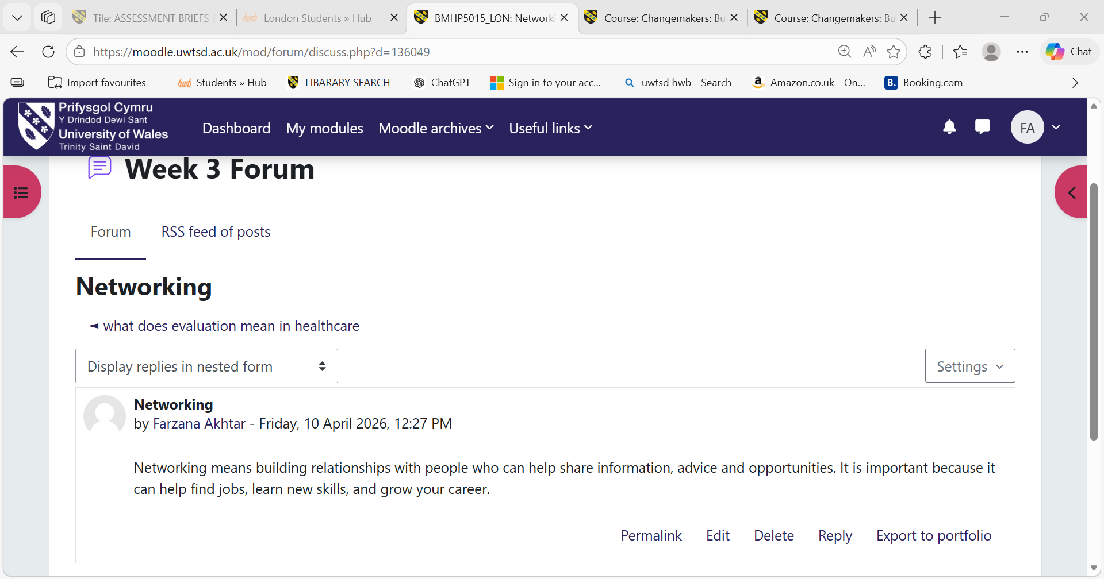
Career development theories also highlight the importance of adaptability and openness to chance events. Planned happenstance theory suggests that unplanned experiences can positively influence career paths when individuals remain flexible and proactive (Mitchell et al., 1999). In addition, self-efficacy plays a key role in determining whether individuals feel confident enough to act on opportunities (Bandura, 1997).
This understanding has encouraged me to adopt a more open mind ed approach towards my career, recognising that not all opportunities are planned and that being adaptable can lead to valuable experiences. It has also highlighted the importance of taking initiative rather than waiting for opportunities to arise, particularly in a competitive health and social care environment. Developing confidence in my abilities will enable me to take advantage of these opportunities more effectively.
I also reflected on my digital professional identity and recognised the importance of maintaining an up-to-date consistent online presence. I intend to improve my professional profile on LinkedIn to better reflect my skills, experiences and aspirations.
Overall, Unit 3 strengthened my confidence, adaptability and ability to recognise and act on opportunities within my career journey.
Task 4 – Reflection on Unit 4: The Pursuit of Happiness and Conclusion
Unit 4 focused on wellbeing, motivation, career planning and the influence of the role models in shaping professional development.
The ‘Future Me’ actively encouraged me to develop a long-term vision for my personal and professional development. The PERMA model identifies key components of wellbeing: positive emotions, engagement, relationships, meaning and achievement (Seligman, 2011). This framework helped me understand how wellbeing directly influences motivation, resilience and performance in the workplace.
Self-Determination Theory suggests that intrinsic motivation, autonomy and personal values are essential for long-term satisfaction and engagement (Ryan and Deci, 2000). Reflecting on this helped me recognise that my passion for helping others is a key strength. However, I also acknowledged the importance of maintaining emotional boundaries to prevent burnout and ensure sustainable practice in health and social care.
Figure 6: Positive Self-talk
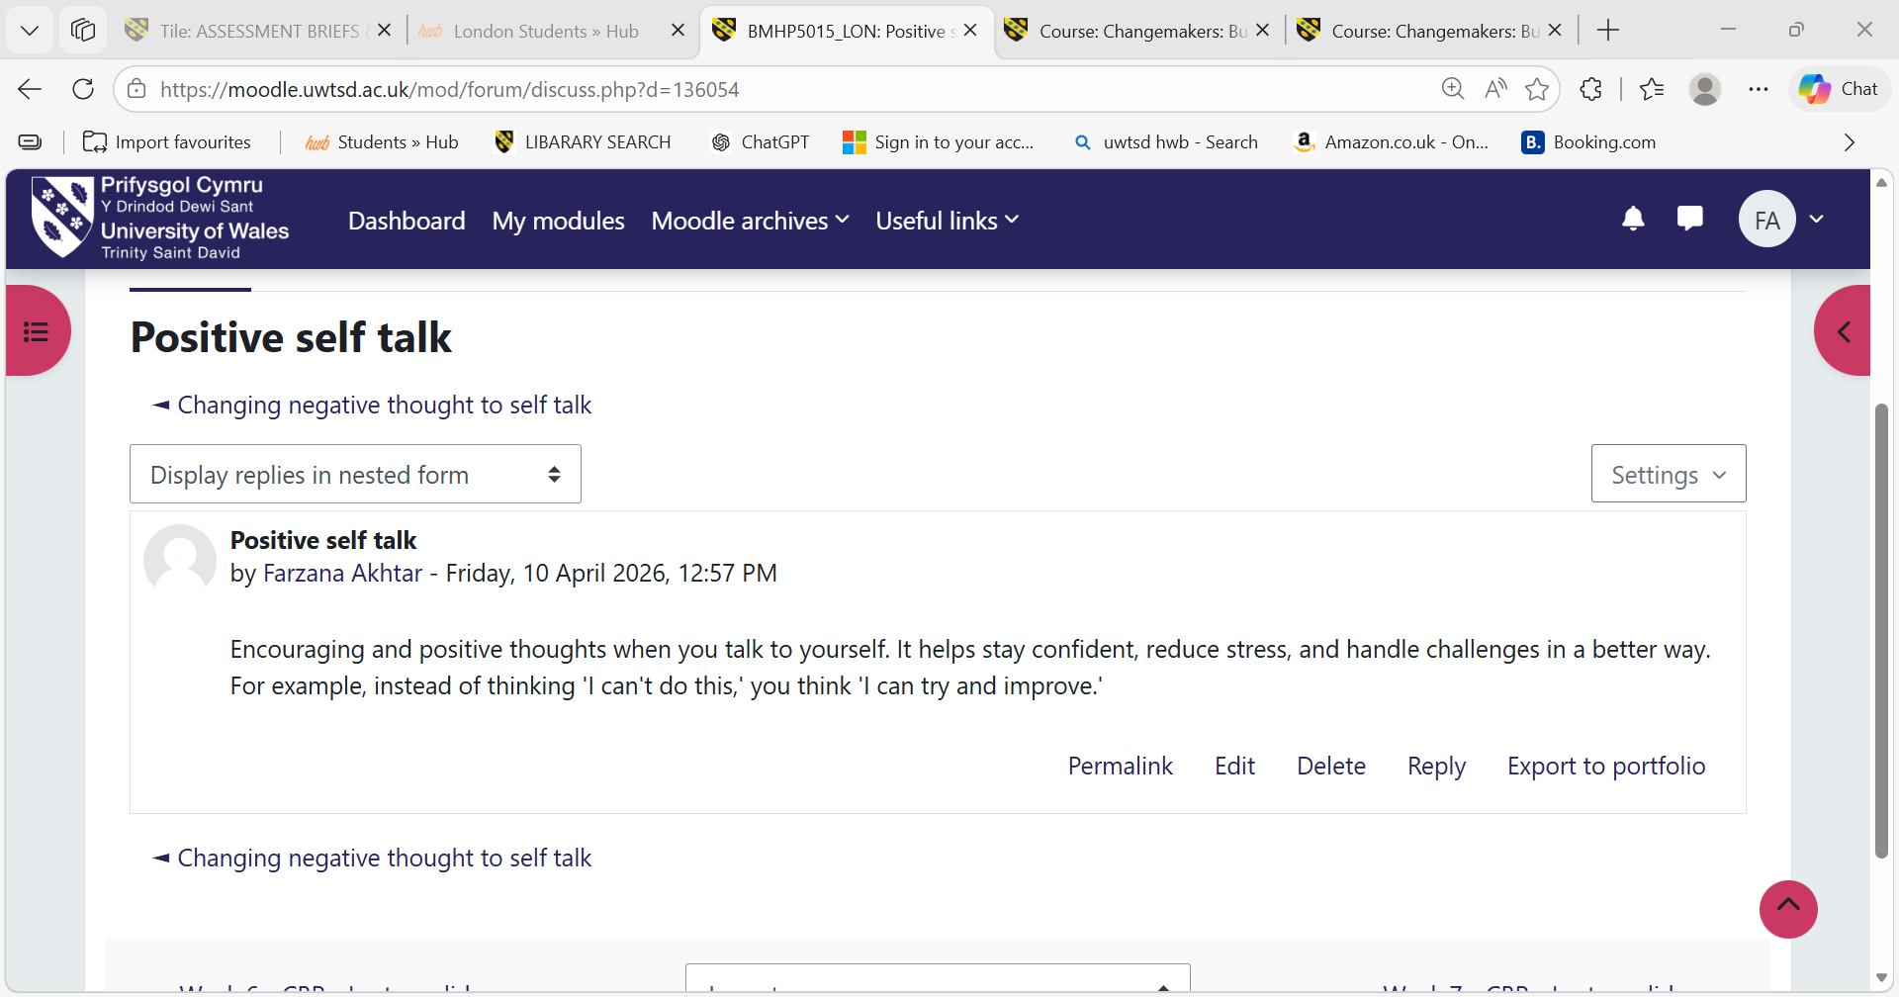
The Unit also introduced structured planning tools such as SMART goals, CPD planning and reflective practice frameworks. These tools support continuous development and help manage workload effectively while maintaining wellbeing.
Role models were also an important aspect of this unit. Reflective practice theory suggests that individuals learn effectively by observing and analysing the actions of experienced professionals (Schon, 1983). I now view role models not as standards for comparison but as sources of inspiration and guidance for professional growth.
In addition, I now recognise the importance of regular reviewing my goals and wellbeing to ensure they remain achievable and aligned with my values. This reflective approach will allow me to adapt to challenges within the workplace while maintaining a positive and sustainable mindset. I also understand that seeking support from colleagues, mentors and professional networks is an important part of maintaining wellbeing and continuing professional development.

Figure 7: Importance of mentoring
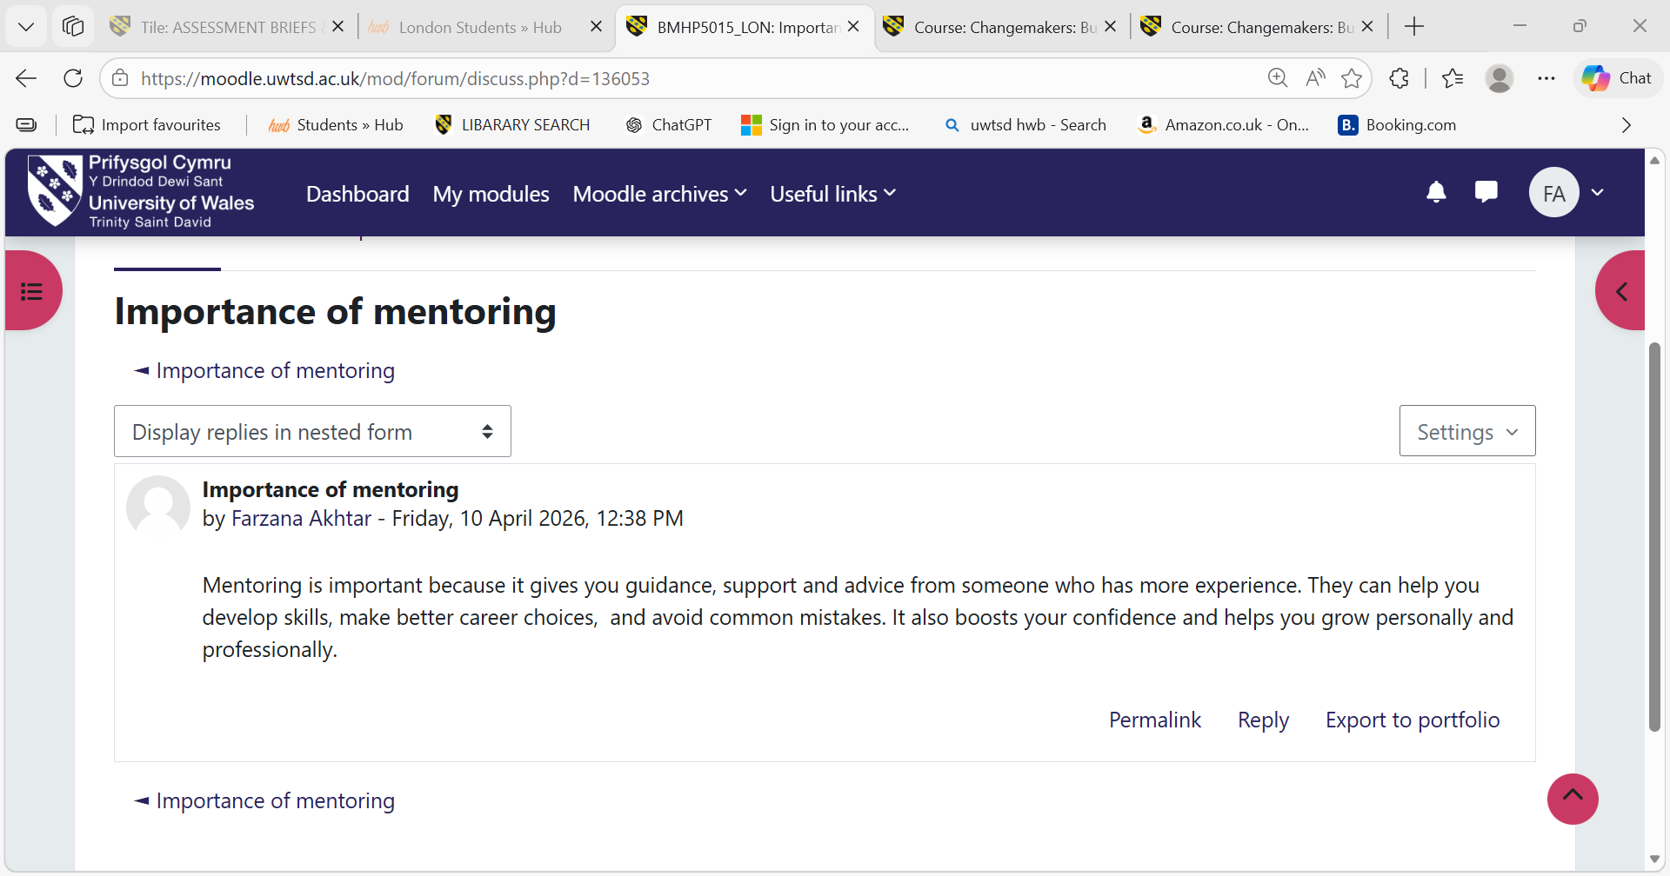
Overall, Unit 4 reinforced the importance of integrating wellbeing, motivation, structured planning and reflective learning to support sustainable career development. It highlighted that long-term success in health and social care is not only determined by skills and qualifications, but also by maintaining emotional resilience, clear goals, and a strong sense of personal purpose. This unit has strengthened my understanding that professional development must be balanced with self-care to prevent burnout and ensure consistent performance. Moving forward, I feel more confident in applying wellbeing strategies, setting realistic career goals and learning from role models in a constructive way that supports both my personal growth and future employability.

Conclusion –
This module has significantly developed my understanding of personal branding, global awareness, opportunity recognition and wellbeing within health and social care. Through engaging with each unit, I have developed a deeper awareness of how professional identity is shaped not only by individual skills and values, but also by wider social, cultural and organisational influences. The knowledge and skills gained throughout this module have strengthened by employability by improving my ability to reflect critically, set realistic goals and adapt to changing professional environments. I have developed greater confidence in managing my career progression, building meaningful relationships and recognising opportunities for growth within the sector. I now understand the importance of maintaining a proactive approach while also being mindful of personal wellbeing and resilience.
Furthermore, this module has highlighted the importance of continuous learning and self-development in achieving long-term career success. By applying theoretical concepts such as personal branding, networking and reflective practice, I am better equipped to navigate the complexities of the modern workplace.
Overall, this experience has prepared me to contribute effectively, ethically and responsibly to the health and social care sector. Moving forward, I feel confident in my ability to pursue a sustainable career that aligns with my values, supporting my wellbeing and allows me to make a meaningful impact on the individuals and communities I serve.

References –
Bandura, A., 1997. Self-efficacy: The exercise of control. New York: Freeman.
Betancourt, J.R., Green, A.R., Carrillo, J.E. and Park, E.R., 2005. Cultural competence and health care disparities. Health Affairs, 24(2), pp.499-505.
Burt, R.S., 2004. Structural holes and good ideas. American Journal of Sociology, 110(2), pp.349-399.
Castells, m., 2010. The rise of the network society. Oxford: Wiley-Blackwell.
DeFillippi, R.J. and Arthur. M.B., 1994. Boundaryless careers. Journal of organisational Behaviour, 15(4), pp.307-324.
Dweck, C.S., 2006. Mindset. The new psychology of success. New York: Random House.
Held, D., McGrew, A., Goldblatt, D. and Perraton, J., 1999. Global transformations: Cambridge: Polity.
Ibarra, H., 1999. Identity and adaption. Administrative Science Quarterly, 44(4). Pp.764-791.
Inkson, K., 2006. Boundaryless Careers. Journal of vocational behavior, 69(1), pp.48-63.
Lin, N., 2001. Social capital. Cambridge: Cambridge University Press.
Locke, E.A. and Latham, G.P., 2002. Goal setting Theory. American Psychologist, 57(9), pp.705-717.
Maslach, C. and Leiter, M.P., 2016. Burnout research. World Psychiatry, 15(2), pp.103-111.
Mitchell, K.E., Levin, A.S. and Krumboltz, J.D., 1999. Planned happenstance. Journal of Counselling & Development, 77(2), pp.115-124.
Ryan, R.M. and Deci, E.L., 2000. Intrinsic motivation. Contemporary Educational Psychology, 25(1), pp.54-67.
Schon, D.A., 1983. The reflective practitioner. New York: Basic Books.
Seibert, S.E., Kraimer, M.L. and Crant, J.M., 2001. Proactive personality. Personnel Psychology, 54(4), pp.845-874.
Seligman, M.E.P., 2011. Flourish. New York: Free Press.
Shepherd, I.D.H, 2005. Personal Branding. Journal of Marketing Management, 21(5-6), pp.589-606.

