

CertHE in Business Skills

Student Name: Wang Lui Chow
Student Number: 2514934
Course Name: Employability and Career Development (LCLM4005_LON)
Lecturer Name: Sukhpreet Grewal
Session: June 2026 Term

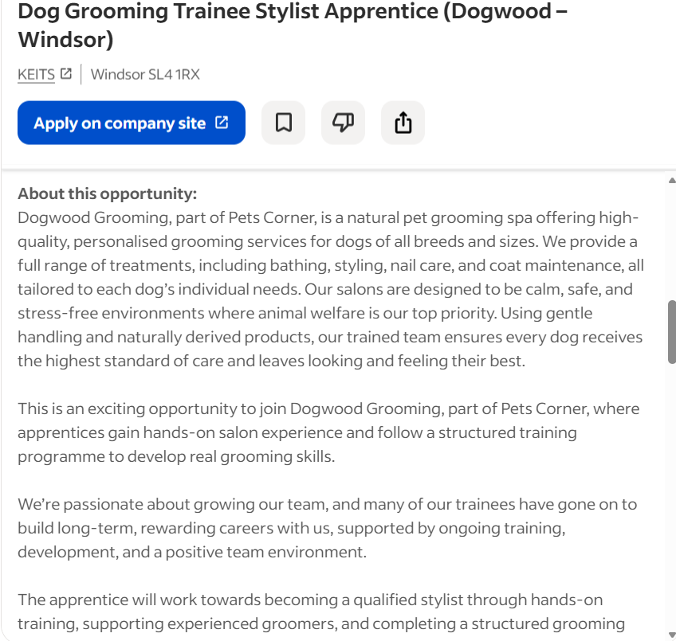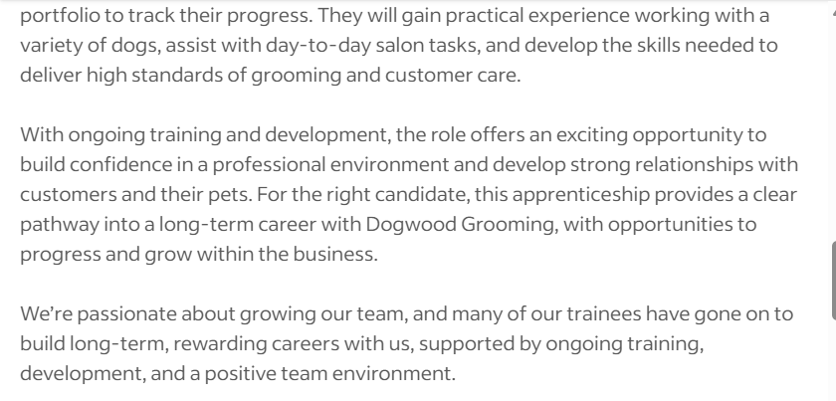

Task 1. Select Job Adverts and Identify Key Skills
To better understand the animal care sector, I compared two job advertisements: an Animal Carer at Mayhew and a Dog Grooming Trainee Stylist Apprentice at Dogwood Grooming. Comparing these two listings helps me see the common skills needed in pet care and how I can apply them as an Animal Carer.

- Key Skills and Knowledge Comparison
Skill / Knowledge Area | Mayhew (Animal Carer) | Dogwood Grooming (Apprentice)
Primary Focus | Daily care for cats and dogs, feeding, cleaning kennels, and checking health. | Bathing, styling dogs, nail care, coat maintenance, and keeping the salon clean.
Animal Handling | Safe and calm handling of rescued, nervous, or shy animals. | Gentle and confident handling during grooming sessions.
Customer Service | Talking to potential adopters and answering public questions about animal welfare. | Building good relationships with pet owners and providing friendly service.

2. Common Skills Across Both Adverts
Although the two roles have different daily duties, both job descriptions highlight three main important skills. First, safe animal handling is essential, as both positions require a calm and positive approach to keep animals relaxed and secure. Second, good communication and customer service skills are necessary to speak warmly with pet owners, adopters, and shelter visitors. Finally, both jobs place a strong emphasis on a willingness to learn, showing that carers must follow instructions, complete training, and continuously improve on the job.
3. Using a Key Skill in My Future Role
A key skill in both adverts is confident animal handling through watching their body language.
In my future role as an Animal Carer at Mayhew, I will use this skill every day during intake, health checks, and kennel rounds. Rescued animals are often stressed and scared in a new environment. By using gentle and quiet handling methods—similar to how groomers handle nervous dogs—I can help rescue animals feel safe. Reading small signs like ear position or tail movement helps me know how the animal feels so I can feed them, clean their space safely, and build trust before they meet adopters. Cottrell (2025) mentions success skills, such as communication or problem-solving abilities, which are crucial for surviving in a business environment.

Task 2, Reflective self-assessment
Section 1: Self-Assessment (SWOT Analysis)
Tarrant (2024) emphasizes the importance of reflection for professional development. Doing a SWOT analysis helps me look at my strengths and find areas I need to improve as I move into an Animal Carer role.
1. Strengths
- Practical Care Experience: I have practical experience feeding, cleaning, grooming, and walking cats and dogs. I understand their basic daily needs and routines.
- Patience and Empathy: My background in health counselling and elderly care taught me to be compassionate and patient. I stay calm and gentle, which helps comfort nervous people and anxious animals.
- Focus on Safety and Hygiene: Through my work with vulnerable people, I am used to following strict care plans, keeping spaces clean, and focusing on safety.
2. Weaknesses
- English Confidence: English is my second language, so I sometimes need extra time to express complex ideas clearly when I feel rushed or under pressure.
- Working Speed: Because I want to avoid mistakes and keep high safety standards, I sometimes work very carefully. I need to improve my speed during busy shelter hours.
3. Opportunities
- Learning and Training: Working in a shelter like Mayhew gives me the chance to learn more about animal welfare, shelter routines, and basic medical care.
- Community Work: My experience in volunteering and customer service allows me to help with adoption events, visitors, and working with other volunteers.
4. Threats
- Competitive Field: Many people want to work in animal care, so I need to show how my combination of human care and animal care skills makes me a strong candidate.
- Fast-Paced Work Environment: Unexpected rescues and busy feeding times require fast multi-tasking, which can be challenging without good time management.

Section 2: Evidence of Readiness for Employability and Personal Advancement
According to Morin (2021) self-awareness is the foundation of this process, it represents a person's ability to focus their attention on themselves. I have clear evidence from my past work, volunteering, and life experience that shows I am ready for employment and personal growth.
I have clear evidence from my past work, volunteering, and personal experience that proves I am ready for employment and future growth in animal care.

In terms of my work experience and transferable skills, my current role at the Camden Chinese Community Centre demonstrates my strong reliability and time management. I regularly deliver fresh meals on a strict two-hour schedule while managing essential safety checks, which proves I can handle strict feeding and cleaning routines in kennels. Furthermore, my previous roles as a Division Manager at MetLife and a health counsellor taught me how to handle emotional or stressful situations with care. I listen patiently and explain complicated ideas using clear, simple words—a key skill when talking warmly with pet adopters and visitors.
Through my recent university studies, I also developed valuable career management skills that directly prepare me for the workplace. By analyzing my personality through a SWOT assessment, I identified my strengths and areas for growth. I then created a Personal Development Plan (PDP) with clear short-term and long-term goals. My course also taught me the importance of reflective practice, which helps me evaluate my daily work and continually build professional habits. Furthermore, learning the STAR method allowed me to write a stronger CV and cover letter, while mock interview practice helped me build confidence in presenting my skills effectively to potential employers.
My leadership and volunteering background also shows my initiative, adaptability, and personal maturity. As a Volunteer Committee Member for Dream Possible, I host online wellness workshops where I support shy participants by giving gentle instructions and encouraging positive group dynamics. Additionally, moving to the UK required great adaptability; to overcome my language challenge, I proactively joined workplace training and took on public-facing volunteer roles to build my communication confidence.

Finally, my dedication to animal welfare comes from genuine passion and active preparation. My counselling background has trained me to pay close attention to non-verbal cues, allowing me to spot early signs of fear, pain, or illness in shelter cats and dogs. Coupled with my full driving license, strong physical fitness, and willingness to work outdoors in all weather conditions, I am fully prepared to take on the practical demands of an Animal Carer.

Task 3, Employment Goals and Personal Development Plan
Section 1. Set Employment Goals:
Short-Term Goal (0–12 Months)
My immediate goal is to work as a part-time or entry-level Animal Carer at Mayhew while continuing my current university degree. Over the next 3 to 6 months, I want to master daily cleaning, feeding, and care routines while learning essential animal care English vocabulary. This will help me balance my studies with practical shelter work and build confidence when talking with team members and prospective adopters.
Long-Term Goal (3–5 Years)
My long-term goal is to graduate from my wonderful University degree in two years and progress into a Senior Animal Carer or Team Leader role. Once I finish my degree, I plan to work full-time in the animal welfare sector, helping to train new staff, support animal behavior plans, and manage community adoption projects.
Alignment with Career Aspirations
Combining my university education with hands-on shelter work is very important to me. It allows me to apply academic learning and reflective skills directly to real-world animal care. Overcoming my language confidence and balancing my studies with shelter routines will prepare me for a successful, long-term career in animal welfare after graduation.
Section 2. Personal Development Plan (PDP):
To address my weaknesses in language confidence and task speed under pressure, I will execute the following action plan, it is a program designed to develop skills important for a career (Morgan, 2024).

 | Short-Term Time Frame What do I want to accomplish in the next three to six months? | Mid-Term Time Frame What do I want to accomplish in the next six months to two years? | Long-Term Time Frame What do I want to accomplish in the next two to three years?
Section 1 - My Goals  What are my overall goals that I want to accomplish in this period? | Work as an Animal Carer at Mayhew, learn all daily feeding and cleaning routines, and build workplace English confidence. | Work faster during busy hours while keeping high safety standards, and take on extra tasks like adoption tours. | Step into a Senior Animal Carer role, helping with shift leadership, volunteer training, and animal care plans.
Section 2 - Skills and Knowledge to be Learned  What specifically do I need to learn? What project do I need to work on? | Animal care vocabulary, shelter safety rules, and reading body language for stress or fear in cats and dogs. | Animal behaviour management, adoption assessment procedures, and fast time-management techniques during busy shifts | Team leadership skills, staff scheduling, problem-solving, and mentoring new volunteers.
Section 3 - Next Steps  How am I going to acquire the skills and knowledge? How am I going to do this project? | Make daily vocabulary cards for animal care terms, ask questions during shift handovers, and practice English in local community groups. | Watch and learn from senior carers during peak busy hours, help with health checks, and practice giving adoption briefings. | Join internal leadership training, help supervisors introduce new volunteers, and lead small daily shift tasks.
Adapted from: http://www.hr.ucdavis.edu/sdps/forms/IDP%20Final%2010.14.11.pdf
 | Short-Term Time Frame What do I want to accomplish in the next three to six months? | Mid-Term Time Frame What do I want to accomplish in the next six months to two years? | Long-Term Time Frame What do I want to accomplish in the next two to three years?
Section 4 – Resources  What resources do I need? | Mayhew care manuals, online veterinary word lists, and English practice groups. | Advice from Senior Animal Carers, task-tracking logs, and animal care workshops | Leadership workshops, team management advice, and shelter software tools.
Section 5 - Time Schedule What is my time schedule? | 3–6 Months | 6 Months–2 Years | 2–3 Years
When will I start? | Month 1 | Month 6 | Month 24
When do I expect to finish? | Month 6 | Month 24 | Month 36
Section 6 - Completion When have I completed each step | □__________  Date  □__________  Date | □__________  Date  □__________  Date | □__________  Date  □__________  Date
Adapted from: http://www.hr.ucdavis.edu/sdps/forms/IDP%20Final%2010.14.11.pdf

Summary
By executing this Personal Development Plan, I will systematically convert my current growth areas into professional strengths, ensuring I contribute effectively to animal welfare standards and achieve my long-term career aspirations.
Reference List
Cottrell, S. (2025) Skills for success: personal development and employability. London: Red Globe Press
Morin, A. (2021). Self‐Awareness Part 1: Definition, Measures, Effects, Functions, and Antecedents. Social and Personality Psychology Compass.
Morgan, P. (2024) The Business Student’s Guide To Study And Employability. London: Sage Publications
Tarrant, P. (2024) Reflective practice and professional development. California: Sage Publications

