

Student name: | Stefan Cristian Costache | Student ID number: | 2126833
Programme: | Master of Business Administration
Module: | International Marketing: Principles and Practices
Lecturer: | Taonga Kaonga Sobere-Snithers
Module code: | LCMB7026
Assignment Title: | International Marketing: Principles and Practices

Executive Summary
The study discusses external and internal environmental analysis of Starbucks in the UK and Japan, nurturing the adoption of the brand's marketing strategies along with the adoption of ethical issues within the marketing mix operations. The report also evaluated the company's perceptual positioning map to compete with its competitors and help towards its future competitiveness practices. The report implements PESTEL analysis. STP strategies have also been provided on these two places, along with analysing their marketing strategies by using the marketing mix of 7Ps. Further marketing strategies of Starbucks are executed in both the UK and Japan, along with analysing the ethical practices of the company in these two locations. Recommendations are on condition to improve their international marketing strategies in the report is included.
Table of Contents
Introduction 4
Brand overview and its operation in the UK and Japan 5
Comparison of the macro environment (PESTLE) of the UK and Japan 8
Comparison of Brand’s STP strategies in the UK and Japan 14
Segmentation and Targeting 14
Positioning 17
Comparison of Marketing Mix (7Ps) strategies in the UK and Japan. 20
Evaluation of the performance of marketing strategies 24
Evaluation of marketing ethics practice 26
Recommendation 28
Conclusion 29
Reference List 30

Introduction
International marketing is associated with company products and service promotion and sales into markets outside the home country. As stated by Kumar (2024, p. 1), international marketing requires the adaptation of diverse strategies in areas of political, economic and cultural environments for gaining sustainability and competitiveness in business. As argued by Gillespie and Swan(2021), the crucial activities for international marketing include market research, digital presence optimisation, product localisation, and local language, regulations and customer-oriented knowledge gain. The report is going to discuss external and internal environmental analysis of Starbucks in the UK and Japan, the brand's marketing strategies and ethical issues in marketing mix operations, hence recommending the best international marketing strategies to adopt.

Brand overview and its operation in the UK and Japan
Starbucks, a coffee bean wholesaler headquartered in Seattle and founded in 1971,is an American-based international chain of coffeehouses and roastery reserves with over 29,000 retail stores in 78 markets (Starbucks, 2025; Starbucks, 2023). The mission statement of Starbucks is to nurture unbounded human connection possibilities with every cup, conversation, and community (Starbucks, 2025). Starbucks' vision is to be committed to making their partners proud and invest in health, success and well-being, thereby creating a culture of belonging (Starbucks, 2025). Starbucks invested 60 million dollars as annual greener initiative costs, in 10,000 Greener stores and verified more than 9000 stores for sustainable practices (Starbucks, 2025).
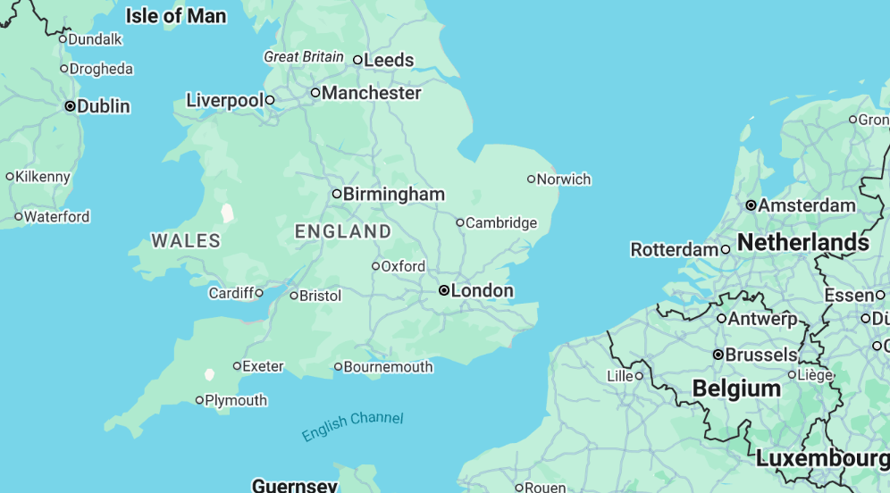
Figure 1: Starbucks in the UK
(Source: Starbucks, 2025)
UK Starbucks is in King's Road, London, with a chain of more than sixty coffee shops and 100 stores successfully (Simpson, 2023). Starbucks UK generated revenue in 2024 of £525.6 million, which is a 4% decline and reported a £35.2 million pre-tax loss due to macro-economic and consumer-oriented headwinds (Verdict Food Service, 2025). The downturn of Starbucks is conveyed by 4% annual deterioration in UK revenues and 9% reduction in gross profit to £525.6million and a total of 4000 employees (Verdict Food Service, 2025;Zoominfo, 2025).In this aspect, the UK coffee market showcases consumers' spending of about £3.25 billion per annum, with coffee drinking consumption of about 98 million cups of coffee per day (GOV.UK, 2025;CBI, 2022). However, in overall Europe, per capita coffee consumption is relatively lower, but the UK is associated with a strong coffee culture, which is mainly driven by speciality coffee, home consumption, sustainability, and the rise of online coffee sales.
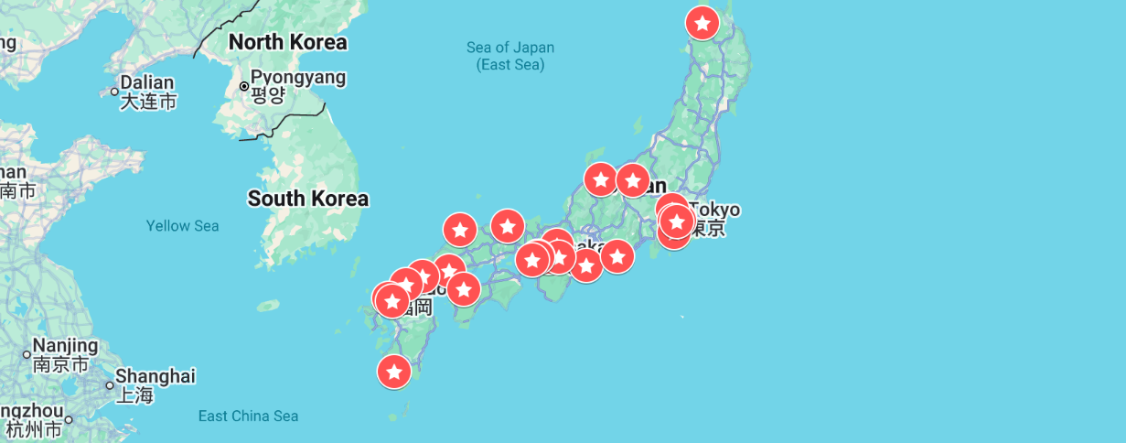
Figure 2: Starbucks in Japan
(Source: Milner, 2025)
Comparatively, in Japan, Starbucks' coffee market size is valued at 35.43 billion US dollars in 2024 and is expected to reach 49.47 billion US dollars by the end of 2032, a 4.26% CAGR (Stellar M R, 2025).
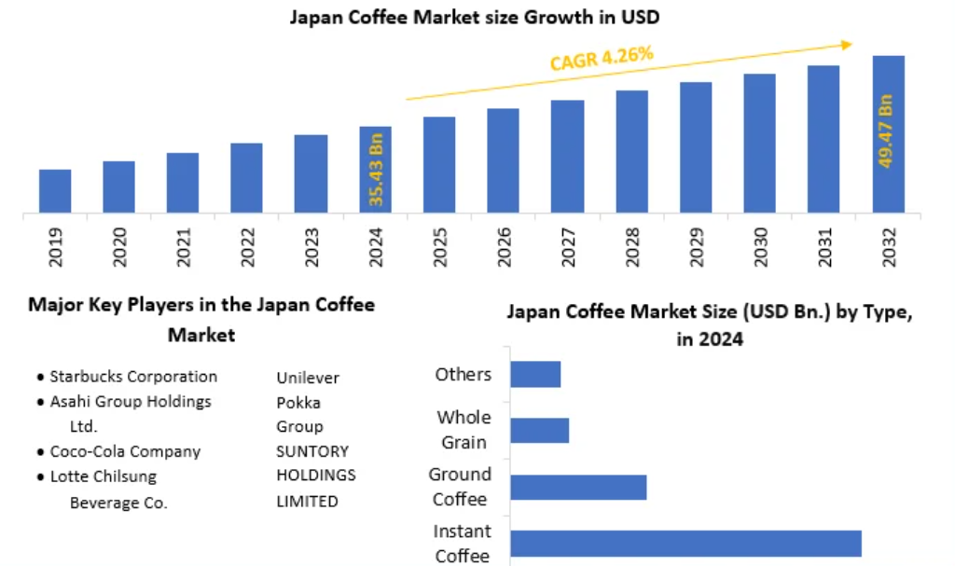
Figure 3: Japan coffee market size
(Source: Stellar M R, 2025)
In this context, the crucial coffee players in Japan are Starbucks Corporation, Asahi Group Holdings Ltd, Coca-Cola Company, Lotte Chilsung Beverage Co, Unilever, Pokka Group and Suntory Holdings Limited (Stellar M R, 2025). Starbucks, headquartered in Tokyo, Japan, founded in 1995, has generated revenues of 1.1 billion dollars with 5,500 total employees (Zoominfo, 2025).

Comparison of the macro environment (PESTLE) of the UK and Japan
Political
The UK's political stability score is observed at 0.51 points as in 2023, while for Japan it is 0.95 (Theglobaleconomy.com, 2025; Theglobaleconomy.com, 2025).
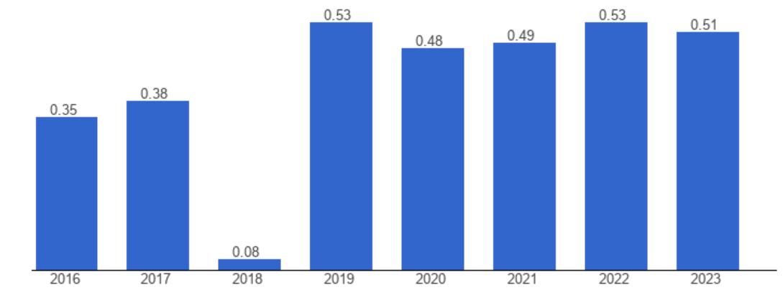
Figure 4: UK's political stability score
(Source: Theglobaleconomy.com, 2025)
From the political stability index score, it is evident that Starbucks is in a more politically stable condition in Japan than in the UK, with low violence, terrorism or other corruption issues. Moreover, the UK has a zero tax policy for coffee consumption; however, it only adds value-added tax (VAT) for lattés or milkshakes (Gregory, 2025).However, Japan’s consumption tax is levied at 8% reduced tax rate or a 10% standard tax rate for all goods that are manufactured or imported into Japan (Japan Customs, 2025). In this context, the UK is more favourable for coffee lovers to pay low tax than Japan.
Economic
The UK's annual inflation rate in August 2025 is 4%, which is down from 4.2% in July (ONS.GOV.UK, 2025).
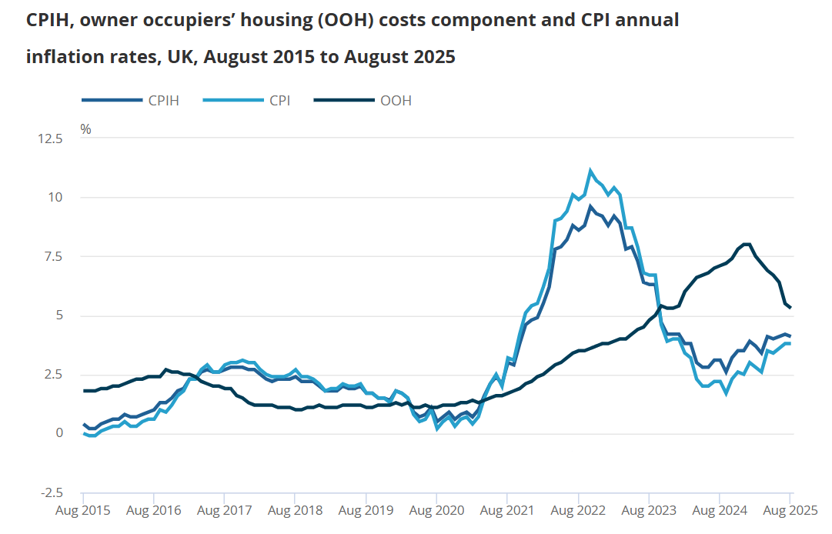
Figure 5: UK inflation rate
(Source: ONS.GOV.UK, 2025)
On the other hand, the annual inflation rate of Japan is 2.7% as of August 2025, from 3.1% in July (Trading Economics, 2025).
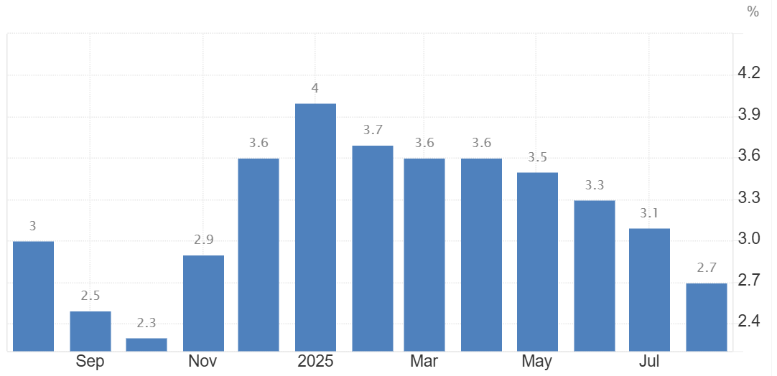
Figure 6: Japan inflation rate
(Source: Trading Economics, 2025)
From the inflation rate of both countries, it is evident that Japan has less inflation than the UK, which can be favourable for coffee sectors in terms of cost-effective operations in Japan than in the UK. In 2025, the UK's GDP growth is at 3.84 trillion US dollars with a projected growth rate of almost 1.2 to 1.3%, while that of Japan is at 4.31 trillion dollars (International Monetary Fund, 2025;The Yomiuri Shimbun, 2024). From GDP growth data, it is evident that Japan is in a better position economically compared to the UK for fruitful business operations like that of Starbucks.
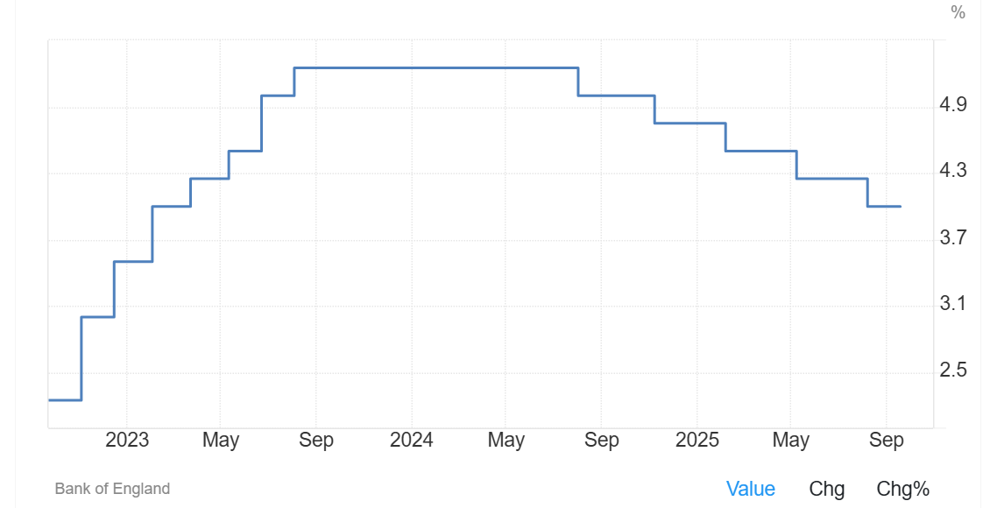
Figure 7: UK interest rate
(Source: Trading Economics, 2025)
Further, the UK interest rate is at 4% in 2025, while that of Japan is at 0.5% (Trading Economics, 2025; Trading Economics, 2025). Japan has a comparatively low interest rate compared to the UK, which displays increased business investment and consumer spending, and can potentially stimulate monetary growth.
Socio-cultural
Power distance dimension shows Japan (54) is a marginal hierarchical society in any social setting, with a meticulously slow decision-making process, a meritocratic society (The Culture Factor, 2025). Contradictorily, PDI of the UK (35) shows inequalities amongst individuals (The Culture Factor, 2025). Moreover, Japan scores 62 on the individualism dimension, showing individualistic societal characteristics, while with a 76 score, the UK is also an individualist society (The Culture Factor, 2025). Besides, a 95 score, Japan is the most decisive society accordingly to motivation towards success and achievement (The Culture Factor, 2025). However, in combination with minor collectivism, Japanese people are not too competitive and assertive in their individual behaviours. Conversely, the UK, with a 66 score, is also a decisive society (The Culture Factor, 2025).
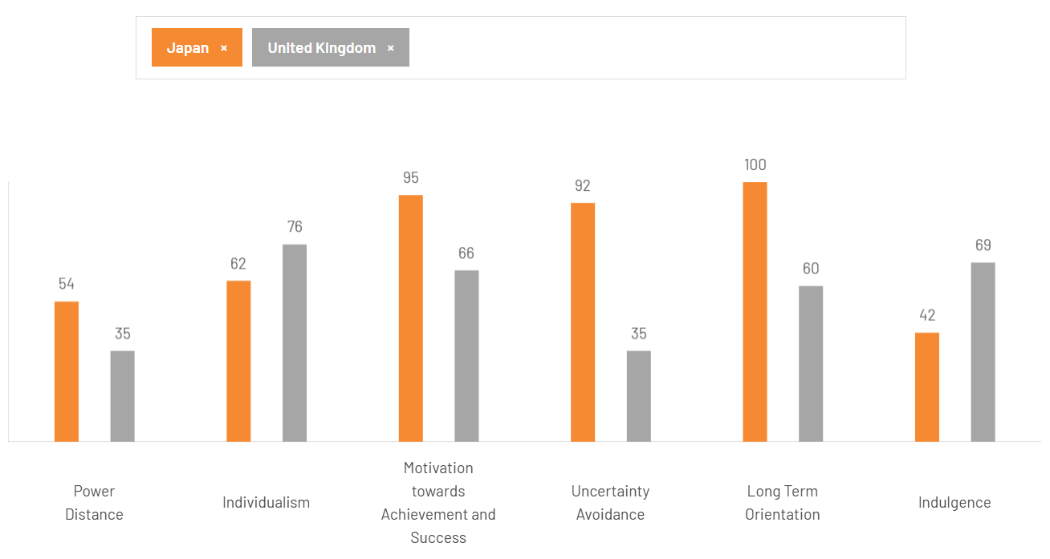
Figure 8: Hofstede cultural comparison of the UK and Japan
(Source: The Culture Factor, 2025)
Further, in case of uncertainty avoidance, Japan is at 92 as its geographical location demonstrates constant threats by natural disasters such as earthquakes, tsunamis, typhoons and volcanic eruptions (The Culture Factor, 2025). Consequently, Japanese businesses are aware of uncertain situations with emergency plans and precautionary measures. However, the UK has a low score of 35 with a strong necessity for innovation and a high level of creativity (The Culture Factor, 2025). UK individuals are drawn to heavy consumerism for new and innovative products, and so a highly creative industry thrives in advertising, financial and marketing engineering. Furthermore, for long-term orientation, Japan has score of 100 with high investment rates in research and development (R&D) (The Culture Factor, 2025). Contradictorily, the UK scores 60 as a pragmatic culture, being adaptable to diverse traditions and conditions, stinginess and persistence in attaining results (The Culture Factor, 2025). Furthermore, from the indulgence dimension, Japan scores 42, showing a restrained culture and a tendency to pessimism and cynicism with leisure and gratification desires (The Culture Factor, 2025). However, the UK scores 69 as being indulgent, and willingness to have fun and enjoyment, visualising life with a positive attitude and optimistic tendency (The Culture Factor, 2025).
Technological
The technological landscape in the UK is based on a transformational shift of diverse global tech giants and has pledged a significant investment of £29.3 billion towards data centre development and AI infrastructure (Malik, 2025). In Japan, the government and tech giant businesses have made a significant investment of around ¥10 trillion in the national economy for embracing an AI strategy, infrastructure and research and development (R&D) to stay competitive (Bloomberg, 2025). From the technological investment capabilities, it is evident that Japan is in a more economically viable position than the UK for economic sustainability and investment in areas of AI and R&D and a high level of innovation, tech awareness and automation.Technological changes within the UK coffee sector include increased online ordering through mobile apps and convenience, AI and automation for personalisation and quality in coffee products. However, in terms of innovation, Japan is in a better position with smart brewing technology utilising AI-controlled machines for quality control and roasting, and advanced RTD packaging using aseptic cartons and nitro infusions.
Legal
According to the UK Consumer Protection Act 1987, it is necessary for companies to provide their customers with proper quality and maintenance of quantity for no customer complaints and ensuring ethical and safety standards (GOV.UK, 2025). On the other hand, Japan's Consumer Act No. 78 of May 30, 1968, is associated with protection and consumer interest for ensuring consumption improvement and stabilisation in food products (Japanese Law Translation, 2025). From the legal infrastructure, it is evident that Starbucks must mandate consumer protection and safety in the consumption of its coffee products in both countries.
Environmental
UK environmental policies are enacted towards net-zero carbon emissions by 2050 as per the Environment Act 2021 and the Climate Change Act 2008, and circular economy efforts for water reduction and resource efficiency (CCE, 2025). On the other hand, Japan’s environmental laws are concerned with climate commitment by accelerating greenhouse gas GHG emission reduction by 46% by 2030 (OECD, 2025). Both countries are highly concerned about environmental regulations and climate safety measures, which showcase permitted safety laws and regulations to be followed by Starbucks.

Comparison of Brand’s STP strategies in the UK and Japan

Segmentation and Targeting
Demographic segmentation
UK's Starbucks primarily have targeted Gen Z, Gen X and millennials, mainly of the age range between 18 and 49 and with middle to high income families (Zhang and He, 2024, p. 23). Most Gen Z members between 18 and 24 years are more likely to choose the Starbucks brand. The premium positioning of the Starbucks brand is focused on creating both quality and comfort in a 3rdplaceenvironment to resonate with the young adults and college-educated people valuing relaxation, social interaction, contemporary, and trendy culture.
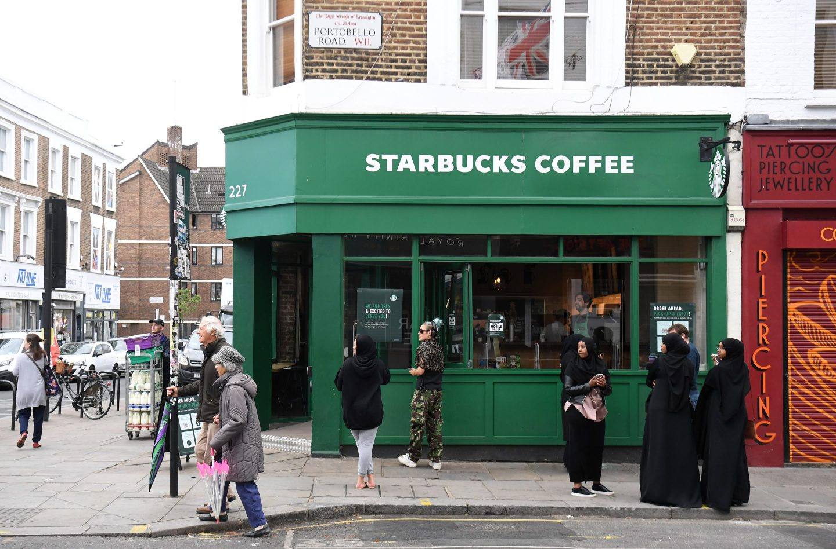
Figure 9: Starbucks in the UK
(Source: Kehnscherper, 2022)
Mostly, UK individuals prefer a social lifestyle, and urbanites who are tech-savvy and connected to a trendy culture. UK customer motivation for Starbucks is not just for coffee, but also atmosphere, ambience and experience, seeking a sophisticated and comfortable environment for relaxation and interaction. Additionally, most coffee consumers in the UK are baby boomers, with 98 million cups of coffee daily and a total coffee consumption of about 35,770 million cups (Bellis, 2025). Moreover, single-serve coffee pods and ground coffeehave been elevated mainly among the millennials of the age group 16 to 34 (Bellis, 2025).
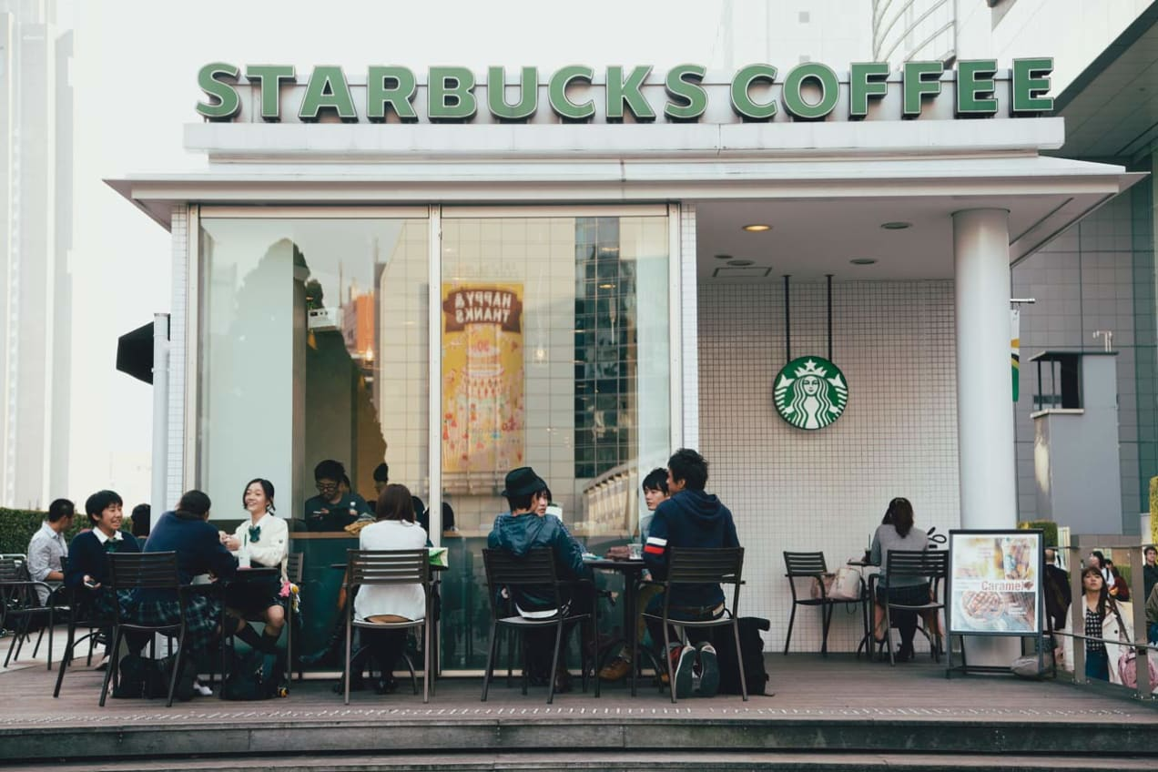
Figure 10: Starbucks in Japan
(Source: Mendini, 2025)
On the other hand, Starbucks in Japan has primarily targeted young, upwardly mobile students and women who emphasise premium coffee, no-smoking ambience, and Western lifestyle taste, symbolising progress and modernity (Li, 2023, p. 55). Compared to the UK, in Japan, Starbucks had targeted mainly to appeal to professionals aged between 25 and 44. However, compared to the UK, Japanese people are much more health-conscious, due to which Starbucks have integrated its product differentiation strategy by adapting to a smaller drink size, reduced or no-sugar, and localised products such as Sakura-themed and matcha items, aligning with Japanese culture, taste and preferences (Milner, 2025).Starbucks had a diverse crowd with business people with laptops, couples on dates, folks stopping for ten minutes, students buried in notes, and travellers checking maps, and remote workforces camped out for hours by seamlessly blending into their coffeehouse atmosphere.
Geographic segmentation
UKStarbucks is the largest market in Europe, Africa and the Middle East with 1000 stores in UK, 703 run by licensees, and 297 company-owned with a total revenue of Starbucks in UK is £328 million (Kehnscherper, 2022). On the other hand, Starbucks in Japan had made a remarkable revenue generation of more than ¥125 billion with over 600 stores (Milner, 2025). Starbucks in Japan adopted an internationalisation strategy of global bean sourcing for consistent quality, and regionally labelled brews from Verona, Guatemala, and Ethiopia (Milner, 2025).
Behavioural segmentation
In 2023, UK people have displayed coffee consumption of approximately 35,770 million cups and almost 98 million cups of coffee daily (Bellis, 2025).
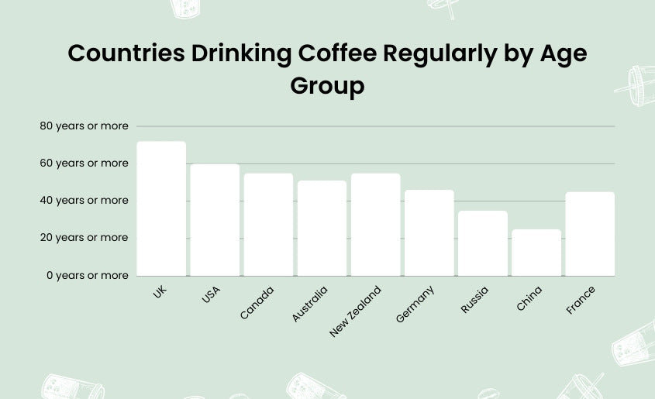
Figure 11: UK coffee consumption statistics
(Source: Bellis, 2025)
In this context, UK people prefer to visit coffee shops by about 80%, while for home coffee consumption, they prefer 73% of instant coffee (Bellis, 2025). From the empirical data, it is evident that UK people are highly driven to coffee consumption and are more coffee lovers than tea lovers. On a contradictory note, in Japan, coffee consumption is on trend towards health-conscious adoptions, with augmented demand for low-sugar, organic and functional options. There has been amounting interest in fair-trade beans, plant-based milks, and sustainable packaging. This trend has reflected towards a wider national importance of people’s health and moderation of beverage consumption. Additionally, there has been a frequent consumption of black coffeeand unsweetened beverages for positive health outcomes, such as low mortality risks.
Psychographic segmentation
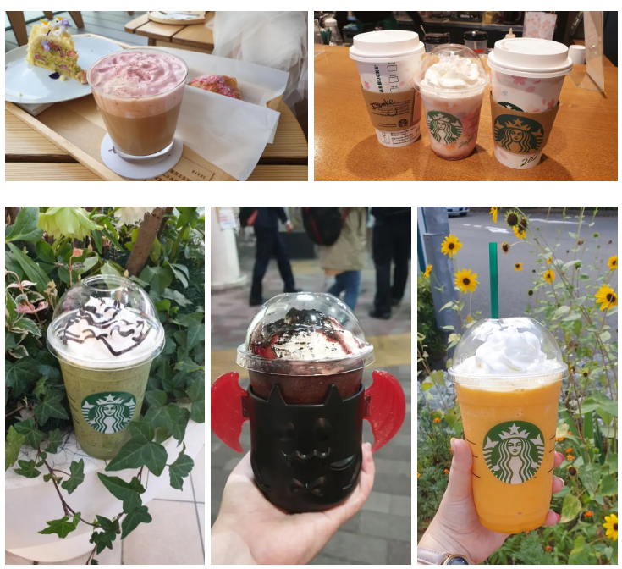
Figure 12: Japan-exclusive seasonal drinks
(Source: Mitsubori, 2025)
Cultural nuances as psychographic preferences draw attention to Starbucks Japan-exclusive seasonal beverages, including matcha latte, chestnut lattes in autumn, and cherry blossom-themed drinks in spring, aligned with the Japanese obsession with seasonal flavours (Milner, 2025). Japan’s ritualistic and cultural precision has an authentic café culture of kissaten with small social space designed as bars with diverse coffee options, integrated alcohol, simple sandwiches, hot dishes and desserts (Suehiro, 2025). The product menu shows forecasting traditionalism, yet a modern touch of royalty as per the brand value.

Positioning
From the perceptual positioning map of Starbucks UK, it is evident that Starbucks has major competitors such as Costa Coffee, Café Nero and Greggs Coffee (Locations Cloud, 2024).
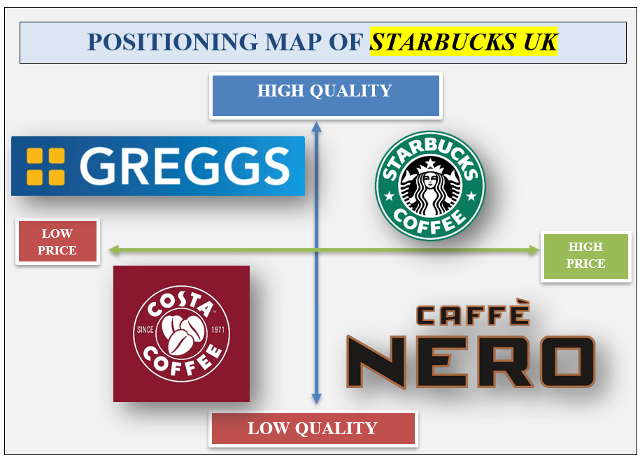
Figure 13: Perceptual positioning map of Starbucks UK
(Source: Created by learner)
From the positioning map, Starbucks is positioned in the high-quality and high-price quadrant, showcasing that the company has prices higher than its competitors. 2025's total sales of Greggs coffee grew by 6.9% to £1 billion and targeted a £2 billion turnover by 2026 (Riley, 2025). Increased sales and high profit generation by the rivalry of Starbucks, such as Gregg’s coffee, is because of its positioning with a high-quality and low pricing strategy, which helped the company to grab more attention of a large audience compared to its rivals, such as Starbucks.In this context, Starbucks needs to adopt an appropriate pricing strategy without compromising its product quality to be competitive and gain betterpositioning than its rivals in the UK.

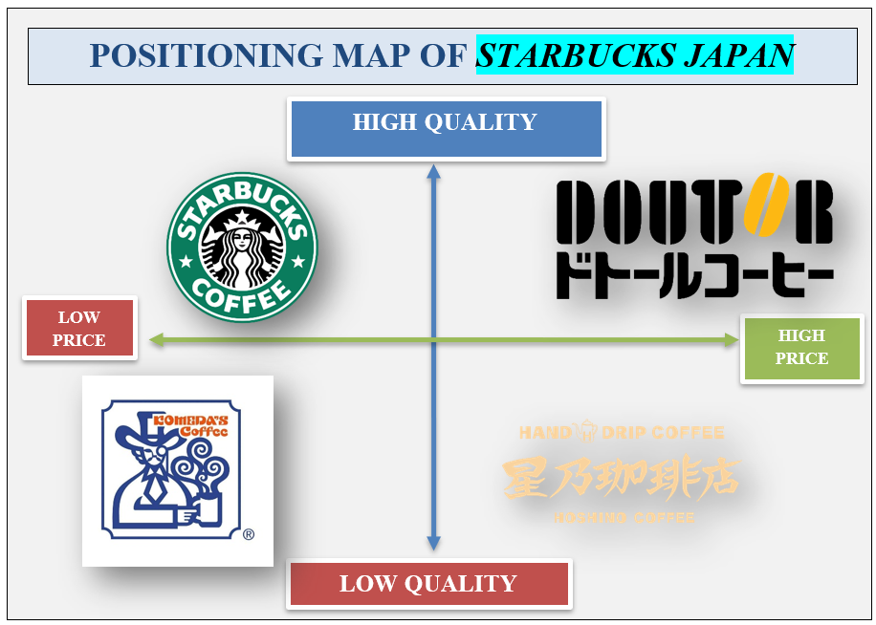
Figure 14: Perceptual positioning map of Starbucks Japan
(Source: Created by learner)
On the other hand, the biggest competitors of Starbucks in Japan include Doutor, Hoshino Coffee, and Komeda's Coffee (JW Web Magazine, 2025). From the positioning map, Starbucks is positioned in the high-quality and low pricing quadrant, highlighting that the company has its positioning with a high-quality and low pricing strategy compared to its competitors. Komeda's Coffee’s revenues are ¥ 47.06 billion, while those of Starbucks Japan are more than ¥125 billion with over 600 stores (The Wall Street Journal, 2025;Milner, 2025). From the data, it is observed that Starbucks is economically in a profitable position due to its competitive positioning strategy of product adaptation and cost differentiation strategy against its competitors.

Comparison of Marketing Mix (7Ps) strategies in the UK and Japan.
Marketing mix is referred to as the 4 or 7 Ps, which comprises the products, prices, promotion, places, people, process and physical evidence. This framework helps companies influence their targeted customers and markets by promoting their products and services. By using these tools, the companies successfully achieve their goals and objectives along with analysing the requirements of their customers, allocating effective resources, developing complete strategies and improving the brand recognition. This further helps in the increment of sales and the profitability of the companies. In this section, a comparison will take place on Starbucks within two different countries, the UK and Japan.
Marketing mix factors | Starbucks in the UK | Starbucks in Japan
Products | In the UK, Starbucks offers its customers several products, including the Latte, Cappuccinos, Frappuccino, fresh juices, along with several food items like the cheese toast, pesto paninis and ham (Starbucks, 2025). | In Japan, Starbucks offers its customers products by valuing their tradition and culture. They serve matcha latte, Sakura strawberry drinks and other Japanese food flavours along with providing their original coffee menus like the Frappuccino, cappuccino and so on (Starbucks, 2025).
Places | In the UK, Starbucks is grabbing their opportunity to expand by prioritising the high football city centres along with the drive-thru places (Starbucks, 2025). Moreover, they are committed to opening and expanding their branches more rapidly. | Starbucks tends to expand within Japan with continuous and rapid growth. After opening its first branch in Tokyo, Starbucks has expanded to 1600 locations across the country (Starbucks, 2025). This shows their development rate within the country.
Price | The pricing strategy of Starbucks in the UK is not affordable and is considered premium. Therefore, the company can introduce a section of food and coffee items with an affordable pricing range, along with maintaining its standard quality. This will attract a wide customer segment, including both the mediocre salaried people. In this way, they will be able to maintain their competitive advantage within the UK market and provide tough competition to companies like Costa Coffee, McDonald's Corp, Caribou Coffee Co Inc. and many more (Global Data, 2025). | In Japan, the pricing strategy of Starbucks is considered affordable, which makes their targeted customer feel classy about the brand and their quality, along with being able to avail themselves of the products at an affordable price. To enhance their business further, Starbucks can introduce a premium pricing range with their high-quality products to attract customers belonging to the premium class. This will help them to upgrade their competitive advantage with other companies like Tully's Coffee (Japan Today, 2025).
Promotion | Starbucks might engage the local community within the UK to ensure its CSR practice, which will further help the company in obtaining more brand recognition (Starbucks, 2025). Further promotion of the company can be done by improving the customer experience of the physical stores. By initiating digital marketing and campaigns, the promotional strategies of the company can be enhanced. | To promote in a better way, Starbucks in Japan can introduce more Japanese dishes to their menu to attract a wide range of customers. Using their seasonal products. They can also use social media and social platforms to promote their brand identity and products more strongly (Starbucks, 2025). They can also develop a unique ambience for their physical stores to make the experiences of their targeted customers better.
People | It can be seen from the records that in the UK, Starbucks has almost 4000 employees working for it. These employees are providing their customers with a high standard of experience and with a quality standard of customer service. These employees can be given more training for their development to accustom them to the changed market trends and advanced technologies. This will further help to address the resistance of the employees, along with improving their performance (Zoom info, 2025). | In Japan, approximately 5,500 employees are working for them, which is increasing over time. These employees help to manage the several functions of the company, like the operations, marketing, technical department and information technology. It can be seen that by engaging more employees, these functions of Starbucks can be obtained smoothly. Therefore, the potential and talented employees should be recruited by the company for their better development (Zoom info, 2025).
Physical evidences | The customer reviews of Starbucks in the UK are bad. Most of the customers had bad experiences with the served meals and food items from the reviews. It can be seen that customers are facing problems with the quality of the food items, along with other services like the parking, student discounts and many more (Trustpilot, 2025). Therefore, these should be improved by the company to maintain its competitiveness within the market. | In Japan, Starbucks is known to obtain bad and negative reviews about their services, especially on their plant-based food items (Trustpilot, 2025). Therefore, they should focus more on their plant-based food items.
Processes | The UK stores can improve their processes of ordering coffee and serving items to the customers by implementing artificial intelligence tools, making the process automated (Starbucks, 2025). Bills can also be paid by the automation device rather than involving the employees. This will make the ordering process smooth and hassle-free. | In Japan, Starbucks can implement a method where the customers will be able to provide them with feedback to improve their services. In this, the company will be able to provide better experiences to its customers by addressing the feedback.
Table 1: Marketing mix with 7Ps
(Source: created by the learner)
From the above, it can be seen that the major ingredients of the company in both countries are the same, like coffee, milk, and syrups used in many drinks. But the differences in their ingredients comprise the local food products, which add to the taste of the food items (The Spruce Eats, 2025). Like in Japan, matcha infuses the taste of the coffee along with the sweet and salty pineapple juice (Japan Today, 2025). On the other hand, in the UK, people prefer an English breakfast (Starbucks, 2025).

Evaluation of the performance of marketing strategies
The marketing strategies are referred to the completed framework to help understand and identify the company and its business in reaching its targeted customers. By using marketing strategies, the companies promote their business by showing their targeted customers their products and services to increase sales and profitability. Organisations can also improve their market share by implementing proper marketing strategies. However, Kumar (2024) states that the marketing strategies have some limitations when applied by organisations for their development. They can increase the cost of the operations of the business, along with a risk of failure and a waste of investment. The marketing strategies might not get aligned with the changing trends of the sectors. It can be seen that the marketing strategies of Starbucks in the UK have improved their brand identity, along with developing their business. A strong market position has also been captured by the company within the UK. They have successfully provided their customers with unique and rare products of the best quality, along with maintaining a premium pricing strategy for the company.
The company is also known to offer its guests the best series and experiences with its trained employees. Starbucks has primarily used digital platforms for the promotion of its products and has gained loyal consumers through digital marketing strategies, including social media. However, it can also be seen that Starbucks might face strong competition from its local competitors in the UK due to its high pricing range. These companies might include Costa Coffee, McDonald's Corp and many more (Starbucks, 2025). From the records, it is shown that a high number of cups of coffee are being consumed by people in the UK every day. This has increased the annual growth of the coffee market. Therefore, from this, it can be easily concluded that the marketing strategies of all the coffee businesses, along with Starbucks, are developing positively, impacting their targeted customers. On the other hand, it can be seen that in Japan, also, Starbucks has blended deeply with their culture and heritage and has incorporated their traditional essence of tsetse into their food products.
This has further helped them to connect emotionally with their targeted customers within Japan. In this way, Starbucks in Japan will be able to develop a trustworthy and transparent relationship with its consumers, and its high-quality products will also help it to achieve its long-term goals. Their expert marketing on social media has also helped them obtain more customers.
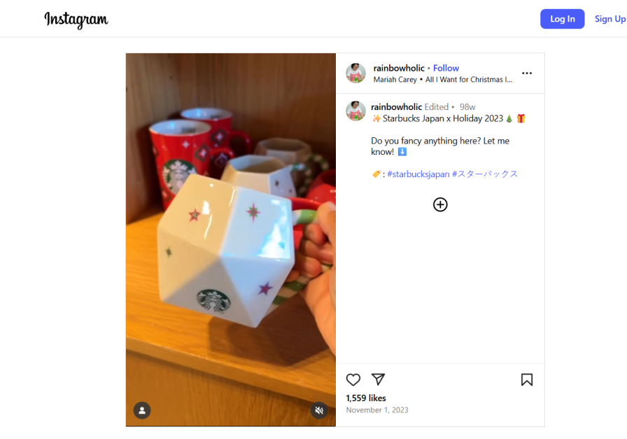
Figure 15: Advertisement of Starbucks in Japan
(Source: Instagram, 2025)
The high quality of the videos and posts also helps them attract more customers digitally. However, it can be seen that in Japan, the organisational structure of Starbucks is mostly rigid, resisting any type of changes, altering their cultural perspectives and tastes. They also face a huge challenge of translating the marketing materials, along with some restrictions in regulatory compliance.

Evaluation of marketing ethics practice
The practice of marketing ethics refers to the establishment of some moral values and applying them to the business for conducting marketing. This helps the companies to engage themselves in the fair, honest and responsible promotion of technologies and products. By practising these values, the companies will be able to impact the environment and society positively. By performing ethical practices, the companies will be able to promote and provide their customers with trustworthy advertisements, which further helps in maintaining the transparency between the company and its customers. In this way, the companies can respect their customers by keeping their data and information secure. However, it can be seen that implementing marketing ethical practices has a few limitations, which involve the high cost of the implementation of these values, and a reduction of strategic choices for these ethical practices.
According to Carter, Warren and Steinhoff (2023), the marketing ethics of Starbucks in the UK perform positive practices along with addressing the important criticism. Their ethical responsible sourcing for their raw materials for coffee is done by the program of C.A.F.E. (Starbucks, 2025). By this, the company ensures their high quality of products, which they will be serving to their loyal customers. In this way, premium payments to the farmers are made by the company, along with promoting fair practices of the labourers. The commitment of Starbucks involves their support towards their community. This develops a sense of belonging in the local community of the company, which further motivates them to nurture the spirits of the human. By incorporating ethical practices, Starbucks also tries to look after the well-being of its employees, while it faces several criticisms in the UK regarding its avoidance of tax and its controversial practices. The transparency of the company towards its customers is being maintained by their ethical practices of CSR (Corporate Social Responsibility). Starbucks' performance ethical practices have established the Starbucks College Achievement plan, which provides students with 100% coverage of tuition. From the records, it can also be seen that almost 14,000 partners have graduated from this college, and approximately 26,000 are participating in the session (Starbucks, 2025).
However, despite performing a high standard of corporate social practices, the controversy of the tax within the UK has impacted the company in considering its ethical practices. On the other hand, in Japan, Starbucks has implemented marketing ethics which align with its culture. This shows the cultural adaptation of the company within Japan by respecting and following their tradition of tea by making a matcha latte rather than replacing tea with coffee. The company is known to have adapted to the ethical consideration where they did not announce the names of their customers in their shops while serving their orders. It can also be seen that the company is sourcing ethically in Japan, with a rate of 99% which further provides an opportunity for their farmers. However, Starbucks, trying to be an ethical company, has created an unethical practice which might affect its customer base. Their excessive pricing range develops conflict with the affordability range of the local community. This can further impact the environment and social costs of Japan. Unethical labour practices can also be seen within the management of Starbucks in Japan, where discrimination can be seen in the labour wages.

Recommendation
Starbucks should focus on several strategies for improving its internal marketing. They should search for deeper locations where they will be able to target and attract more customers, as discussed by Gillespie and Swan (2021); their choices of location should prioritise the needs and demands of the customers. By providing their target customers with the menus where they will get both the taste of Starbucks and its quality, along with the cultural taste of local ingredients. Their online platforms and websites should also become more customised to offer customers availing from remote locations a high-quality experience to engage them more strongly. Starbucks can also try to implement effective loyalty programs along with smooth payment options and seamless operations for ordering through mobile apps. They should also implement cultural and heritage norms in their physical stores to welcome their guests and offer them their uniqueness. An ethical and transparent supply chain should be maintained to make their supply operations sustainable and smooth.
According to Carter, Warren and Steinhoff (2023), designing environmentally friendly designs for their stores will help the company to become more ethical and sustainable. Practising corporate social responsibility across all their stores and all the local communities should be implemented for their better development and brand recognition.

Conclusion
The report has discussed the marketing of the renowned company, such as Starbucks. Discussion has been done on the background of the company and its operations, both in the UK and Japan. Comparison has been established between their operations and marketing strategies in both of these countries. Contrast and comparison have been provided on the business of Starbucks in these two countries by understanding the impact of the external factors of both the UK and Japan on Starbucks. It has been done by implementing the PESTEL analysis. STP strategies have also been provided on these two places, along with analysing their marketing strategies by using the marketing mix of 7Ps. Further evaluation has been done on the marketing strategies of Starbucks in both the UK and Japan, along with analysing the ethical practices of the company in these two locations. Recommendations have also been provided in the report to improve their international marketing strategies.

Reference List
Bellis, J. (2025) Coffee Consumption Statistics (Simple Stats for Journalists). Available at: https://balancecoffee.co.uk/global-coffee-consumption-statistics#:~:text=For%20the%20fiscal%20year%202022/2023%2C%20the%20United%20Kingdom%20recorded,Data%20source:%20British%20Coffee%20Association. (Accessed: 28 October 2025).
Bloomberg (2025) Japan: Where High Tech Meets High Value Foreign Direct Investment. Available at: https://sponsored.bloomberg.com/article/jco/japan-where-high-tech-meets-high-value-foreign-direct-investment (Accessed: 28 October 2025).
Carter, D.B., Warren, R. and Steinhoff, A. (2023) ‘The anatomy of tragedy: Starbucks as a politics of displacement’, Accounting, Auditing & Accountability Journal, 36(1), pp.146-176.Available at: http://doi.org/10.1108/AAAJ-08-2015-2169
CBI (2022) The United Kingdom’s market potential for coffee. Available at: https://www.cbi.eu/market-information/coffee/united-kingdom/market-potential#:~:text=The%20United%20Kingdom%20is%20Europe's,of%205.2%20kg%20per%20year. (Accessed: 28 October 2025).
CCE (2025) Administrative Law and Climate Change. Available at: https://climatehughes.org/law-and-climate-atlas/administrative-law-and-climate-change/#:~:text=The%20Climate%20Change%20Act%202008%20mandates%20that%20the%20UK%20government,primarily%20focussed%20on%20other%20issues. (Accessed: 28 October 2025).
Gillespie, K. and Swan, K.S. (2021) Global marketing. Routledge.
Global Data (2025) Starbucks Corp: Competitors. Available at: https://www.globaldata.com/company-profile/starbucks-corp/competitors/ (Accessed: 28 October 2025).
GOV.UK (2025) Consumer Protection Act 1987. Available at: https://www.legislation.gov.uk/ukpga/1987/43 (Accessed: 28 October 2025).
GOV.UK (2025) Spending Review 2025 (HTML). Available at: https://www.gov.uk/government/publications/spending-review-2025-document/spending-review-2025-html#:~:text=Box%201.D:,%C2%A33.25%20billion%20Transformation%20Fund. (Accessed: 28 October 2025).
Gregory, J. (2025) Milkshakes and lattes could be covered by sugar tax. Available at: https://www.bbc.com/news/articles/cpwzekdznldo (Accessed: 28 October 2025).
Instagram (2025) Starbucks Japan x Holiday 2023. Available at: https://www.instagram.com/reel/CzFZZTlyqDy/ (Accessed: 28 October 2025).
International Monetary Fund (2025) United Kingdom Datasets. Available at: https://www.imf.org/external/datamapper/profile/GBR (Accessed: 28 October 2025).
Japan Customs (2025) Outline of Tariff and Duty Rates System. Available at: https://www.customs.go.jp/english/summary/tariff.htm (Accessed: 28 October 2025).
Japan Today (2025) Starbucks Japan adds a salty limited-edition Frappuccino to its menu for summer. Available at: https://japantoday.com/category/features/food/starbucks-japan-adds-a-salty-limited-edition-frappuccino-to-its-menu-for-summer#:~:text=The%20main%20body%20of%20the%20drink%20contains,a%20fun%20contrast%20in%20taste%20and%20texture. (Accessed: 28 October 2025).
Japan Today (2025) Starbucks vs two popular Japanese coffee shops: Which gives the best value?.Available at: https://japantoday.com/category/features/food/starbucks-vs-two-popular-japanese-coffee-shops (Accessed: 28 October 2025).
Japanese Law Translation (2025) Basic Consumer Act. Available at: https://www.japaneselawtranslation.go.jp/en/laws/view/2040/en (Accessed: 28 October 2025).
JW Web Magazine (2025) Best Coffee Shops in Japan (apart from Starbucks). Available at: https://jw-webmagazine.com/tips/best-coffee-shops-in-japan-apart-from-starbucks/#:~:text=Excelsior%20Caff%C3%A9,(mobile%2C%20laptop%2C%20etc) (Accessed: 28 October 2025).
Kehnscherper, L. (2022) Starbucks is reportedly exploring the sale of its U.K. business, its largest market in EMEA. Available at: https://fortune.com/2022/07/18/starbucks-uk-sale-emea-market/. (Accessed: 28 October 2025).
Kumar, V. (2024) International Marketing Research: A Transformative Approach. Springer Nature.
Li, S. (2023) ‘Trendy Asian desserts and urban youth identity creation: comparing young people's cultural practices and social media activities in Singapore, Bangkok and Kuala Lumpur’.
Locations Cloud (2024) Analysis of the Leading Coffee Shop Chains in the UK. Available at: https://www.locationscloud.com/research-report/analysis-of-leading-coffee-shop-chains-uk/#:~:text=Most%20Successful%20Coffee%20Shop%20Chains,of%20the%20top%203%20chains. (Accessed: 28 October 2025).
Malik, S. (2025) Analysis: UK tech sector set for AI boom as $40bn investment signals opportunity, and caution. Available at: https://www.capacitymedia.com/article-analysis-uk-tech-sector#:~:text=The%20UK's%20technology%20landscape%20is,infrastructure%20and%20data%20centre%20development. (Accessed: 28 October 2025).
Mendini, G. (2025) Starbucks in Japan: Why They are so Popular and Why You Should Visit. Available at: https://voyapon.com/starbucks-in-japan/#:~:text=Beyond%20its%20standard%20menu%2C%20Japan,pumps%20like%20in%20the%20US. (Accessed: 28 October 2025).
Milner, R. (2025) Starbucks in Japan: Why They are so Popular and Why You Should Visit. Available at: https://voyapon.com/starbucks-in-japan/#:~:text=Beyond%20its%20standard%20menu%2C%20Japan,pumps%20like%20in%20the%20US. (Accessed: 28 October 2025).
Mitsubori, C. (2025) Starbucks in Japan: Why They are so Popular and Why You Should Visit. Available at: https://voyapon.com/starbucks-in-japan/#:~:text=Beyond%20its%20standard%20menu%2C%20Japan,pumps%20like%20in%20the%20US. (Accessed: 28 October 2025).
OECD (2025) OECD Environmental Performance Reviews: Japan 2025. Available at: https://www.oecd.org/en/publications/oecd-environmental-performance-reviews-japan-2025_583cab4c-en.html#:~:text=Japan%20raised%20its%20climate%20commitments,needed%20to%20meet%20the%20targets. (Accessed: 28 October 2025).
ONS.GOV.UK (2025) Consumer price inflation, UK: August 2025. Available at: https://www.ons.gov.uk/economy/inflationandpriceindices/bulletins/consumerpriceinflation/august2025 (Accessed: 28 October 2025).
Riley, D. (2025) Greggs issues 2025 profit warning as sales impacted by heatwave. Available at: https://bakeryinfo.co.uk/finance/greggs-issues-2025-profit-warning-as-sales-impacted-by-heatwave/706371.article#:~:text=Total%20sales%20for%20the%20first,another%20%C2%A32bn%20turnover%20year. (Accessed: 28 October 2025).
Simpson, F. (2023) Starbucks' Largest UK Franchisee Reaches 100 Store Landmark. Available at: https://www.forbes.com/sites/fionasimpson1/2023/07/12/starbucks-largest-uk-franchisee-reaches-100-store-landmark/ (Accessed: 28 October 2025).
Starbucks (2023) About Starbucks. Available at: https://about.starbucks.com/press/2023/company-profile/ (Accessed: 28 October 2025).
Starbucks (2025) Coffee.Available at: https://www.starbucks.com/responsibility/sourcing/coffee/ (Accessed: 28 October 2025).
Starbucks (2025) Homepage / Starbucks. Available at: https://www.starbucks.co.uk/ (Accessed: 28 October 2025).
Starbucks (2025) It’s not just about caffeine. All Starbucks products are made from great, fresh-tasting ingredients. Available at: https://www.starbucks.co.uk/nutrition (Accessed: 28 October 2025).
Starbucks (2025) Our Company. Available at: https://www.starbucks.com/about-us/ (Accessed: 28 October 2025).
Starbucks (2025) Starbucks Global Impact Report. Available at: https://about.starbucks.com/uploads/2025/05/Starbucks-Fiscal-2024-Global-Impact-Report.pdf (Accessed: 28 October 2025).
Starbucks (2025) Sustainability: Giving more than we take. Available at: https://about.starbucks.com/stories/category/people-impact/sustainability/ (Accessed: 28 October 2025).
Stellar M R (2025) Japan Coffee Market Size, Share, Growth Trends, Industry Analysis, Key Players, Investment Opportunities and Forecast (2025-2032). Available at: https://www.stellarmr.com/report/Japan-Coffee-Market/69#:~:text=Japanese%20consumers%20usually%20drink%20coffee%20between%20waking,country%20are%20beginning%20to%20serve%20espresso%20drinks. (Accessed: 28 October 2025).
Suehiro, A. (2025) Why Starbucks in Japan Feels So Different. Available at: https://www.theculturefactor.com/country-comparison-tool?countries=japan%2Cunited+kingdom. (Accessed: 28 October 2025).
The Culture Factor (2025) Country Comparison tool. Available at: https://www.theculturefactor.com/country-comparison-tool?countries=japan%2Cunited+kingdom. (Accessed: 28 October 2025).
The Spruce (2025) What Is a Starbucks Menu Like Around the World? Available at: https://www.thespruceeats.com/starbucks-menu-guide-766068#:~:text=The%20company%20conducts%20research%20about%20the%20unique,can%20offer%20beverages%20that%20appeal%20to%20local (28 October 2025).
The Wall Street Journal (2025) Komeda Holdings Co. Ltd. Available at: https://www.wsj.com/market-data/quotes/jp/xtks/3543 (Accessed: 28 October 2025).
The Yomiuri Shimbun (2024) IMF Projects Japan’s GDP to Fall to World’s 5th After India in 2025; Japan’s Economy Continues Decline. Available at: https://japannews.yomiuri.co.jp/business/economy/20240506-184451/ (Accessed: 28 October 2025).
Theglobaleconomy.com (2025) Political stability - Country rankings. Available at: https://www.theglobaleconomy.com/rankings/wb_political_stability/ (Accessed: 28 October 2025).
Theglobaleconomy.com (2025) United Kingdom: Political stability. Available at: https://www.theglobaleconomy.com/United-Kingdom/wb_political_stability/ (Accessed: 28 October 2025).
Trading Economics (2025) Japan Inflation Rate. Available at: https://tradingeconomics.com/japan/inflation-cpi#:~:text=10%2DMonth%20Low-,Japan's%20annual%20inflation%20rate%20eased%20to%202.7%25%20in%20August%202025,%25)%20after%20being%20flat%20previously. (Accessed: 28 October 2025).
Trading Economics (2025) Japan Interest Rate. Available at: https://tradingeconomics.com/japan/interest-rate#:~:text=ETFs%20and%20REITs-,The%20Bank%20of%20Japan%20kept%20its%20benchmark%20short%2Dterm%20rate,and%20in%20line%20with%20consensus. (Accessed: 28 October 2025).
Trading Economics (2025) United Kingdom Interest Rate. Available at: https://tradingeconomics.com/united-kingdom/interest-rate#:~:text=The%20Bank%20of%20England%20is,growth%20alongside%20still%2Delevated%20inflation. (Accessed: 28 October 2025).
Trustpilot (2025) Starbucks. Available at: https://uk.trustpilot.com/review/starbucks.uk (Accessed: 28 October 2025).
Trustpilot (2025) Starbucks. Available at: https://www.trustpilot.com/review/starbucks.co.jp (Accessed: 28 October 2025).
Verdict Food Service (2025) Starbucks UK reports £35.2m loss in 2024. Available at: https://www.verdictfoodservice.com/news/starbucks-uk-35-2m-loss-2024/#:~:text=The%20company%20also%20reported%20a,macro%2Deconomic%20and%20consumer%20headwinds.&text=Starbucks%20concluded%20the%20year%20with,revenues%20to%20%C2%A3525.6m. (Accessed: 28 October 2025).
Zhang, J. and He, Y. (2024, May) 'The Effectiveness of Starbucks' Loyalty Program Across Different Cultures (UK: Edinburgh; China: Kunming)', In 9th International Conference on Financial Innovation and Economic Development (ICFIED 2024) (pp. 601-611). Atlantis Press. Available at: https://doi.org/10.2991/978-94-6463-408-2_67
Zoom info (2025) Starbucks Japan Employee Directory. Available at: https://www.zoominfo.com/pic/starbucks-japan/343804649 (Accessed: 28 October 2025).
Zoom info (2025) Starbucks UK. Available at: https://www.zoominfo.com/c/starbucks-uk/559284352 (Accessed: 28 October 2025).
Zoominfo (2025) Starbucks Japan. Available at: https://www.zoominfo.com/c/starbucks-japan/343804649 (Accessed: 28 October 2025).
Zoominfo (2025) Starbucks UK. Available at: https://www.zoominfo.com/c/starbucks-uk/559284352 (Accessed: 28 October 2025).

