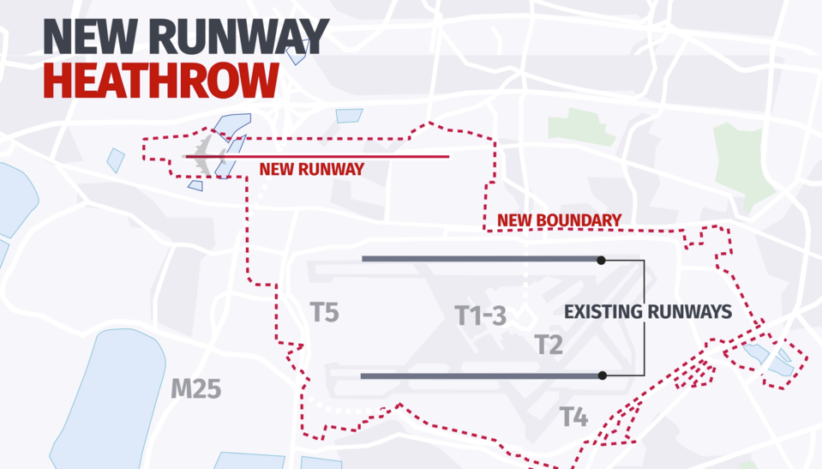
Impact of a Third Runway
  - How a third runway at heathrow would impact The British Economy, Environment and society
Daniel Stokes | Logistics and Supply Chain Management | 30/11/2017
- Introduction
- Proposal for the runway
  - Why Heathrow?
  - Gatwick’s Argument
2.1.1 Gatwick’s Promises
- Local Impact
3.1 Positive Points
3.2 House Prices
- Economic Impact
- Environment
- Conclusion
- References

1. Introduction

The objective of this report is to assess and critically evaluate the impact that a third runway would have on the UK economy, environment and society. In order to get an idea of the scale of impact, issues such as housing prices, building areas, emissions and cost need to be looked at. Will a third runway be beneficial for the British economy, or could it put the economy in a major decline, creating an increase in inflation. Although talks about an expansion started in 2000, and the White Paper was published in 2003, it only got the go ahead in 2016, with some MPs still protesting the idea (Swinford and Wilkinson, 2017). However, even after government approval, there are still arguments against the runway which will be assessed in detail as the report progresses.

2. Proposal for the runway

Even though in 2000, the Department for Transport stated, that due to the increase in airline passengers, an increase in airport capacity was needed, and the White Paper was published in 2003, the government did not back the idea for a third runway until 2006. However, with arguments within parliament, between Labour and Conservatives, approval of the runway was diminished at the start of the Conservative and Liberal Democrat coalition in 2010 (Swinford and Wilkinson, 2017). But the need for extra airport capacity was still needed, so in 2012, the coalition government asked the Airport Commission to look at options for airline capacity within the South-East of England. In 2015, after three years of reviewing, the Airport Commission recommended and backed the approval of a new runway (Swinford and Wilkinson, 2017; Heathrow.com, 2017).

2.1. Why Heathrow?
Although the third runway has been approved for Heathrow, a main cause of argument is why Heathrow and not Gatwick. Both Airports are situated in London and only 37.6 miles apart (Heathrow Airport to Gatwick Airport, 2017), and only 15-minute flight difference, from JFK International Airport, (JFK Airport to Heathrow Airport, 2017; John F. Kennedy International Airport to Gatwick Airport, 2017). Gatwick Airport put out its own arguments against Heathrow’s expansion and proposing a second runway at Gatwick. They state that “Some 320,000 people will be newly impacted by noise if Heathrow expands”, and that these places include “the densely populated London boroughs of Hammersmith and Fulham, Kensington and Chelsea, Westminster and Richmond upon Thames” (London Gatwick: Obviously, 2017).
2.2. Gatwick’s Argument
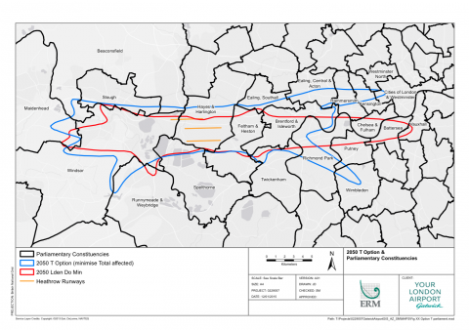
Gatwick Airport published the government version of the map of affected areas for Heathrow’s third runway (See figure.1), showing how much wider the affected area is. The residents currently affected by a two runway Heathrow are shown in the red line boundary, however, with a three runway airport the newly affected residents are shown in the blue line.
Figure.1 Government plans for Third Runway
(Gatwick Airport, 2017)
Gatwick Airport also wrote to 200,000 residents of the Heathrow area, stating that “only 18,000 people would be additionally affected by noise if Gatwick built a new runway” compared to the 320,000 affected by Heathrow’s expansion (London Gatwick: Obviously, 2017).

2.2.1. Gatwick’s Promises
Gatwick Airport made eight promises to its local people as to how an expansion there would be more beneficial to the UK than Heathrow’s expansion:
- “A new runway by 2025”
- “Growth across the UK”
- “A cap on passenger charges”
- “No Public Subsidy”
- “Legal air quality”
- “A cap on those most affected by noise”
- “Industry leading compensation”
- “Shareholder commitment” (London Gatwick: Obviously, 2017)

3. Local Impact

As previously mentioned, Heathrow have said that 750 homes in the local are will be compulsory bought. However, what about other things within the area, such as schools, parks and community centres. It seems apparent that the compulsory purchases are set for demolition in order for the planned extension, so it is probably safe to assume the same is planned for all things in that area. Residents of Harmondsworth, Sipson and Harlington had different opinions on the expansion, some positive, some negative. One 65-year-old resident from Harlington stated to the Guardian “I would lose my house, community and friends. I will also lose my allotment of 600 sq m with no compensation. Those who stay will be liable to a reduced life expectancy due to the noise and particulate pollution” (Obordo, 2017). This however is not time an expansion of Heathrow has affected residents of Sipson. One resident of the area, aged 85, told the Guardian “My family have lived in the area for generations……. When I was young we would walk across, what is now the airport, to visit relatives”. He also went on to say “They have even drawn a line around our road so about 70 homes are inside the airport. It would be better to be dead than live in that nightmare. I am old enough that I hope I never see it” (Obordo, 2017). In fact, even Heathrow themselves mention the bad impacts on the area, “Expansion will bring huge opportunities and improvements to the local area, but also unwelcome impacts for those affected by noise and other environmental factors and most particularly for those who will have to relocate their home or business to make way for an enlarged airport” (heathrowexpansion.com, 2017).

3.1. Positive views

It is not only negativity the local residents see. There are also positive views from people in the affected areas, such as one resident from Harmondsworth stated “The need for airport expansion in the south east can only be achieved by expanding Heathrow. It would also create much-needed work in the area”. Another two positive points came from air industry workers themselves. Amar Singh, a British Airways employee at Heathrow, from Sipson said “A third runway means long term prospects for employment. Though it would be built over my house I will get more money for it because of the compulsory buyout”. Another employee, for Heathrow, living in Harmondsworth, also commented on the expansion saying “Heathrow is a big hub with new jobs from the third runway bringing in thousands of pounds. Also, people will come here to rent and buy properties which will be good for the area” (Orbodo, 2017).

3.2. House Prices

With the current plans for Heathrow, experts believe that “House prices near Heathrow Airport could fall '20% or more'” (Butterworth, 2017). With 750 households within the area of compulsory purchase, there are also an additional 3,750 houses that will be given the option to sell to Heathrow. Although a 20% decline in their property value sounds bad to a homeowner, Heathrow have said, that all residents will be offered the market value of their property plus an additional 25% (Butterworth, 2017), tackling the initial 20% decline. Below is an example of how the average priced house around Heathrow, £407,666 (Cahill, 2017), would look after Heathrow’s offer.
House Price | 20% of House Price | Price After Decrease | 25% of Decreased Price | Heathrow’s offer
£407,666 | £81,533 | £326,133 | £81,533 | £407,666

This shows that, although Heathrow seem they are doing the residents of the affected area a favour, they are in fact just offering them the current value of the property.

4. Economic Impact
The economic impact with an extension has been viewed with a majority of positives, as it is the only hub airport within the UK. For example, Heathrow have stated that the expansion of the airport would be able to provide an extra 40,000 jobs for the local community, on top of the 76,500 people that they already employ. Not only this, but they also mention that the number of apprenticeships would double to 10,000 to “help tackle local youth unemployment” (Heathrowexpansion.com, 2017). With the number of unemployed UK residents sitting at 1.42 million people (data taken from July-September 2017) (Hrmguide.co.uk, 2017), an expansion at Heathrow has the potential to help the UK economy by helping to tackle unemployment within the London area.
It is not only jobs however that Heathrow are offering in support of the UK economy. It is believed that a third runway would bring in around £7bn to the UK economy, according to the BAA, British Airports Authority (News.bbc.co.uk, 2017; Getrevising.co.uk, 2017).
Another positive argument for the extension of Heathrow is Brexit. With the UK public voting to leave the European Union back in July 2016, a third runway is believed to be essential to the UK economy, as it could bring in up to an extra £24,500 per family within the UK over 60 years. Before approving the runway however, the UK government looked at how much a second runway at Gatwick would benefit UK residents. The evidence showed that Gatwick would only bring in an extra £13,000 over the same period (Martin, 2017).
However, once again there have been arguments against a Heathrow expansion, and backing one at Gatwick. In October 2017, an article was published stating “Gatwick Airport said it still has a "credible, privately-financed runway plan" after the government published new research suggesting it could provide greater economic benefits than Heathrow expansion” (AOL UK Travel, 2017). This came after fresh reports, released by the Department of Transport, shows that a predicted “the total benefits to passengers and the wider economy would be worth up to £75.4 billion at Gatwick, compared with £74.2 billion at Heathrow” (AOL UK Travel, 2017). But even though there is a difference of over £1bn, the fact that Heathrow is the UK’s only Hub airport is now more important than before due to the closure of the open market (AOL UK Travel, 2017). Another a case against Heathrow states “Economic costs have been overstated, it will cost £12billion with a return of £17billion over 70 years” (Getrevising.co.uk, 2017).

5. Environment
The environmental impact of a new runway could be seen as an outright negative factor. There are arguments that believe the environmental factor of a new runway has been overseen due to the positive impact for the economy (Getrevising.co.uk, 2017). The arguments for environmental impact however, come in abundance. The first argument is about the amount of emissions that would be caused by the increased air traffic entering and exiting the emissions. Due to the Climate Change Act of 2008, stating “the net UK carbon account for the year 2050 is at least 80% lower than the 1990 baseline” (Legislation.gov.uk, 2017), Greenpeace argue that with a third runway, the government would have to make a “take urgent steps to stop emissions rising and then begin reducing emissions in the next ten years” (Greenpeace.org.uk, 2017).
It is mentioned that aviation only accounts for 2% of carbon emissions. Greenpeace, however, that this data is misleading, as it is data from 1992. In 2000, the European Federation for Transport and Environment stated that air transport was actually responsible for between 4% and 9% of climate change, due to humans. When it comes to the UK’s climate however, air transport is responsible for 13% of the countries climate impact (Greenpeace.org.uk, 2017). With this in mind, an increase of 267,000 extra flights a year (Heathrowexpansion.com, 2017) is not in the governments best interest in reducing emissions.
Heathrow, however, do have plans to be environmentally friendly. “We know that having access to natural environment areas, parks and green spaces, is important to local communities, so our expansion plans include proposals for investment in the creation of new and enhanced areas that are four times the size of Hyde Park in total” (Heathromexpansion.com, 2017).
Heathrow claim that they will be working alongside with the local community in order to improve the environment around the airport for all local residents. These plans include:
- Sports facilities
- Formal gardens
- Mountain Bike trails
- Pastures for animal grazing
- Picnic areas
- Cross country course
- Natural ponds
- Allotments
- Bridleways
- Community buildings (Heathrowexpansion.com, 2017)

6. Conclusion
In conclusion to this, there are many ways an extension on Heathrow could impact the UK’s economy, environment and social life. Although there are both positive and negative impacts, and plan to extend will not be finalised until 2018 (Yorke, 2017), and maybe as late as 2021 (Hale, Crouch and Wheatstone, 2017). This means that an extension at Gatwick may still be a possibility, considering there are a couple of advantages Gatwick has over Heathrow. However, Heathrow seems to be the best option to expand, although the airports flight capacity is full, it is only responsible for 23% of all UK passenger flights. However, it is also responsible for over 75% of all UK long haul flights (Back Heathrow, 2017). The article also goes on to say that it is the most cost effective option by stating “Expanding Heathrow is also the cheapest way to build a hub airport in the UK. The estimated cost of adding capacity at Heathrow is £14-18bn. Compare this with building a new airport at the Thames Estuary which would cost £70-80bn (of which £25bn would require taxpayer subsidy). And this does not even include the required huge investment in rail infrastructure to connect a new airport to central London”.

7. References
AOL UK Travel. (2017). Gatwick expansion 'worth more to economy' than third Heathrow runway - AOL UK Travel. [online] Available at: https://www.aol.co.uk/travel/2017/10/25/gatwick-expansion-worth-more-to-economy-than-third-heathrow-runw/ [Accessed 5 Dec. 2017].
Back Heathrow. (2017). Heathrow is the best option for expansion. [online] Available at: http://www.backheathrow.org/why_heathrow_is_best_placed_for_expansion [Accessed 5 Dec. 2017].
Bowden, G. (2017). This Is Who Will Be Affected By Heathrow's Third Runway. [online] HuffPost UK. Available at: http://www.huffingtonpost.co.uk/entry/heathrow-third-runway-map-shows-who-will-be-affected-by-flight-path-noise_uk_580f428de4b056572d83e035 [Accessed 1 Dec. 2017].
Butterworth, M. (2017). What will happen to house prices near Heathrow Airport?. [online] Mail Online. Available at: http://www.dailymail.co.uk/property/article-3871090/What-Heathrow-expansion-plans-mean-value-homes-flight-path.html [Accessed 1 Dec. 2017].
Cahill, H. (2017). This is how the third runway at Heathrow will hit London house prices. [online] Cityam.com. Available at: http://www.cityam.com/252215/heathrow-decision-hit-london-house-prices [Accessed 1 Dec. 2017].
Gatwick Airport (2017). Version of the map with the local area broken down by parliamentary constituency.. [image] Available at: http://file:///E:/fig_xx_option_t_parliament.pdf [Accessed 1 Dec. 2017].
Getrevising.co.uk. (2017). Heathrow Airport Expansion. [online] Available at: https://getrevising.co.uk/grids/heathrow_airport_expansion [Accessed 5 Dec. 2017].
Greenpeace.org.uk. (2017). THE CASE AGAINST AIRPORT EXPANSION. [online] Available at: https://www.greenpeace.org.uk/wp-content/uploads/2017/10/case-against-heathrow-expansion.pdf [Accessed 5 Dec. 2017].
Hale, J., Crouch, H. and Wheatstone, R. (2017). What will a third runway at Heathrow mean for passengers and why is London airport expansion so controversial?. [online] Thesun.co.uk. Available at: https://www.thesun.co.uk/news/2043601/heathrow-third-runway-expansion-latest/ [Accessed 5 Dec. 2017].
Heathrow Airport to Gatwick Airport. (2017). Heathrow Airport to Gatwick Airport. [online] Available at: https://www.google.co.uk/maps/dir/Heathrow+Airport+(LHR),+Longford+TW6/Gatwick+Airport+(LGW),+Horley,+Gatwick+RH6+0NP/@51.314035,-0.6083477,10z/data=!3m1!4b1!4m14!4m13!1m5!1m1!1s0x48767234cdc56de9:0x8fe7535543f64167!2m2!1d-0.4542955!2d51.4700223!1m5!1m1!1s0x4875efde7d1f391b:0x59dda4bf018973ff!2m2!1d-0.1820629!2d51.1536621!3e0 [Accessed 1 Dec. 2017].
Heathrow Expansion: Building for the future. (2017). Environment - Heathrow Expansion: Building for the future. [online] Available at: https://www.heathrowexpansion.com/sustainability/environment/ [Accessed 5 Dec. 2017].
Heathrow Expansion: Building for the future. (2017). Facts and Figures - Heathrow Expansion: Building for the future. [online] Available at: https://www.heathrowexpansion.com/the-expansion-plan/facts-and-figures/ [Accessed 5 Dec. 2017].
Heathrow Expansion: Building for the future. (2017). Local Benefits - Heathrow Expansion: Building for the future. [online] Available at: https://www.heathrowexpansion.com/local-community/local-benefits/ [Accessed 5 Dec. 2017].
Heathrow Expansion: Building for the future. (2017). Managing Impacts - Heathrow Expansion: Building for the future. [online] Available at: https://www.heathrowexpansion.com/local-community/managing-impacts/ [Accessed 4 Dec. 2017].
Heathrow.com. (2017). Airports Commission | Our proposal | Heathrow. [online] Available at: https://www.heathrow.com/company/company-news-and-information/airports-commission/our-proposal [Accessed 1 Dec. 2017].
Hrmguide.co.uk. (2017). UK unemployment. [online] Available at: http://www.hrmguide.co.uk/jobmarket/unemployment.htm [Accessed 5 Dec. 2017].
Huffpost (2017). Heathrow Airport Third Runway Map Shows Who Will Be Affected By Flight Path Noise. [image] Available at: http://www.huffingtonpost.co.uk/entry/heathrow-third-runway-map-shows-who-will-be-affected-by-flight-path-noise_uk_580f428de4b056572d83e035 [Accessed 1 Dec. 2017].
JFK Airport to Heathrow Airport. (2017). [online] Available at: https://www.google.co.uk/maps/dir/John+F.+Kennedy+International+Airport,+Queens,+NY+11430,+USA/Heathrow+Airport,+Longford+TW6/@44.668443,-55.0008365,4z/data=!3m1!4b1!4m14!4m13!1m5!1m1!1s0x89c26650d5404947:0xec4fb213489f11f0!2m2!1d-73.7781391!2d40.6413111!1m5!1m1!1s0x48767234cdc56de9:0x8fe7535543f64167!2m2!1d-0.4542955!2d51.4700223!3e4 [Accessed 1 Dec. 2017].
John F. Kennedy International Airport to Gatwick Airport. (2017). John F. Kennedy International Airport to Gatwick Airport. [online] Available at: https://www.google.co.uk/maps/dir/JFK+International+Airport,+New+York,+NY,+USA/Gatwick+Airport+(LGW),+Horley,+Gatwick/@44.5098444,-54.867397,4z/data=!3m1!4b1!4m14!4m13!1m5!1m1!1s0x89c26650d5404947:0xec4fb213489f11f0!2m2!1d-73.7781391!2d40.6413111!1m5!1m1!1s0x4875efde7d1f391b:0x59dda4bf018973ff!2m2!1d-0.1820629!2d51.1536621!3e4 [Accessed 1 Dec. 2017].
Legislation.gov.uk. (2017). Climate Change Act 2008. [online] Available at: http://www.legislation.gov.uk/ukpga/2008/27/part/1/crossheading/the-target-for-2050 [Accessed 5 Dec. 2017].
London Gatwick: Obviously. (2017). Gatwick Guarantees. [online] Available at: http://www.gatwickobviously.com/guaranteed [Accessed 1 Dec. 2017].
London Gatwick: Obviously. (2017). 320,000 new residents affected by noise if Heathrow builds a third runway. [online] Available at: http://www.gatwickobviously.com/320000-new-residents-affected-noise-if-heathrow-builds-third-runway [Accessed 1 Dec. 2017].
Martin, B. (2017). Third Heathrow runway would 'boost each British family by Â£24,500'. [online] The Telegraph. Available at: http://www.telegraph.co.uk/business/2016/09/02/third-heathrow-runway-would-boost-each-british-family-by-24500/ [Accessed 5 Dec. 2017].
News.bbc.co.uk. (2017). BBC News - Heathrow expansion: for and against. [online] Available at: http://news.bbc.co.uk/1/hi/uk/7828694.stm [Accessed 5 Dec. 2017].
Obordo, R. (2017). Local residents on Heathrow's third runway: 'I would lose my house, community and friends'. [online] the Guardian. Available at: https://www.theguardian.com/environment/2016/oct/25/local-residents-on-heathrows-third-runway-kids-love-the-planes [Accessed 4 Dec. 2017].
Swinford, S. and Wilkinson, M. (2017). Heathrow airport expansion: What will it look like, when will it start, and why is it needed?. [online] The Telegraph. Available at: http://www.telegraph.co.uk/news/0/qa-heathrow-expansion--everything-you-need-to-know/ [Accessed 1 Dec. 2017].
Yorke, H. (2017). Heathrow doubts after new analysis shows Gatwick expansion 'better than third runway'. [online] The Telegraph. Available at: http://www.telegraph.co.uk/news/2017/10/25/heathrow-doubts-new-analysis-shows-gatwick-expansion-better/ [Accessed 5 Dec. 2017].

,

