

STRATEGIC MANAGEMENT
LCMB7003

Coca cola plc



Student Name: Harmeet Singh Aatli
Student ID: 2226228
Module Code : LCMB7003
Teacher name: Dr Gladius Kulothungan
Table of Contents
1. Introduction 3
2. Company Background 3
3. Internal Environment Analysis 5
3.1 Porter’s value chain analysis 5
3.2 VRIO analysis 7
3.3 Strengths and Weaknesses 9
4. External Environment Analysis 10
4.1 PEST Analysis 10
4.2 Porter’s Five Forces 12
4.3 Threats and Opportunities 14
5. Risk assessment and management 15
5.1 Risk assessment 15
5.2 Risk Management 17
6. Key Strategies of Coca-Cola for competitive advantage 25
7. Conclusion 27
8. Recommendations 27
References 29

1. Introduction
In order to gain a competitive advantage and improve overall performance, an organization's long-term goals, and plans are developed, put into action, and evaluated. This process is known as strategic management. It entails making choices that are consistent with an organization's mission and vision about its capabilities, resources, and external environment. This study will explore a brief background of Coca-Cola to evaluate its internal and external business factors analysis for justifying its strategic management. This study will also justify the risk management and risk assessment matrix that are closely associated with the strategic planning of Coca-Cola. Moreover, a few desirable strategies will be recommended that will be effective to improve the strategic management of Coca-Cola.

2. Company Background
The Coca-Cola Company is well-known throughout the world as one of the biggest and most illustrious beverage companies and is best known for its iconic soft drink brand, Coca-Cola. The purpose of Coca-Cola, which was founded in 1886 and has its headquarters in the United States, is to revitalize the planet by deliberate distinction. The focus of the company has been on developing well-known brands and beverage options that not only energize the body and soul but also support a resilient business and a more promising collective future that improves the well-being of people, societies, and the environment (Coca-Cola Company, 2023a).
Coca-Cola strives to provide fair chances and a feeling of community in both their workplaces and the communities they interact with by operating with a purpose-driven mindset. By making this pledge, Coca-Cola actively participates in influencing this complete brand framework's ability to improve common destiny. Coca-Cola has mobilized a workforce of more than 700,000 people to achieve its goals, generating economic opportunities that improve the financial stability of local communities throughout the world (Coca-Cola Company, 2023b).

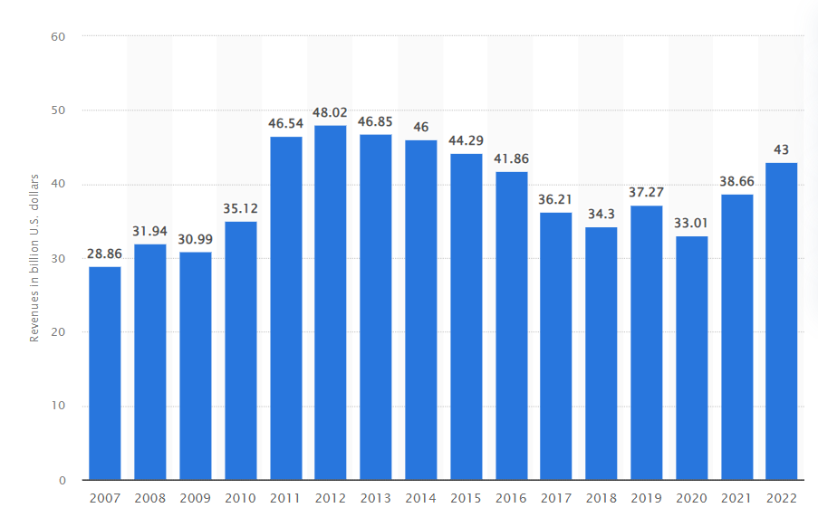
Figure 1: Revenue of Coca-Cola
(Source: Statista, 2023)
The company offers a wide variety of non-alcoholic beverages, with net operating revenues of about 43 billion US dollars worldwide, as seen in the above diagram. Juices, teas, coffees, carbonated soft drinks, energy drinks, and bottled water are all included in this varied collection. Among the long list of well-known brands, Coca-Cola, Diet Coke, Coca-Cola Zero Sugar, Sprite, Fanta, and Dasani deserve special notice. These items' global reach spans more than 200 countries, demonstrating the brand's pervasiveness. The business has a sizable distribution network that enables the accessibility of its products to a variety of markets in an effort to ensure broad accessibility.
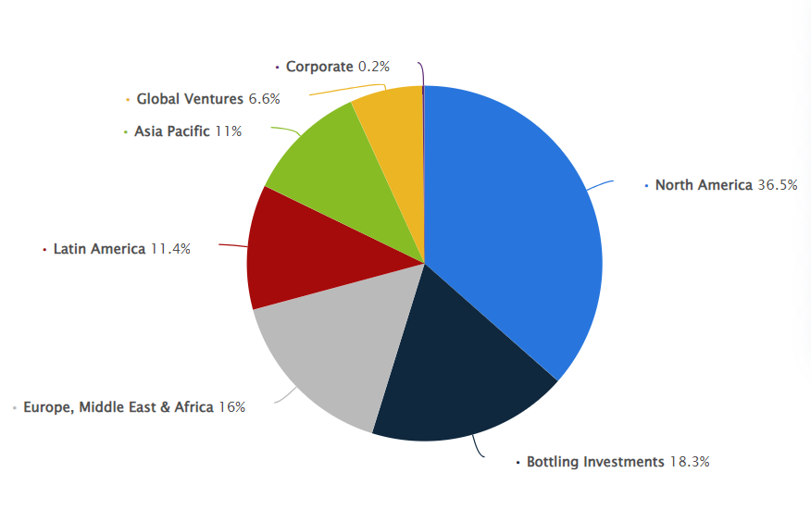
Figure 2: Revenue distribution share of the Coca-Cola Company
(Source: Statista, 2023b)
It has been observed that slightly more than 36% of The Coca-Cola Company's overall revenue in 2022 was specifically attributable to North America. Sprite, Minute Maid, and Aquarius are just a few of the many brands that fall within the scope of this American global conglomerate (Statista, 2023b). Coca-Cola has steadily maintained its place as one of the most well-known and valuable brands in the world. Coca-Cola, known not only for its beverage but also as a representation of American culture, has had a considerable impact on modern advertising and marketing techniques. The brand of the company is intrinsically related to its creative marketing initiatives, which are illustrated by campaigns like "Open Happiness" and "Taste the Feeling." Notably, the Coca-Cola brand has long been involved with prominent marketing campaigns, frequently linked to important international events like the Olympics and the FIFA World Cup.

3. Internal Environment Analysis

3.1 Porter’s value chain analysis
Analysing Coca-Cola's value chain reveals its strategic focus on a coordinated marketing strategy that includes all of its brand promotions. These include all of the primary tasks that are directly related to the production and sale of goods.

Inbound Logistics
The receiving, storing, and distributing of raw materials needed to create the goods are all included in the inbound logistics process within the Coca-Cola value chain. This procedure is comparable to the movement of raw materials from suppliers to the business. A notable feature of Coca-Cola's extensive supply chain is that it strategically focuses on gaining a competitive advantage during this first stage. This viewpoint views the value chain's suppliers as cooperative business partners (Fan et al. 2022). These partners must however follow certain guidelines that are in line with applicable laws and regulations. Coca-Cola emphasizes the significance of these rules in keeping with their dedication to moral workplace conduct and environmentally friendly initiatives.
Operations
Coca-Cola uses local channels to do its business on a global scale. Coca-Cola works with bottling partners in addition to its in-house beverage brands (Trivedi and Malik, 2022). It's crucial to remember that neither the partners nor the goods they produce are owned by Coca-Cola. The company's main business activities are the manufacture and marketing of syrups and beverage bases.

Figure 3: Factors of Porter’s value Chain
(Source: Self-Created)
Outbound Logistics
Coca-Cola makes sure that a variety of locations around the world have a constant supply of its products. They also apply the same concepts to their business clients. Punctual delivery, safe transportation, and effective distribution form the basis of a successful Coca-Cola value chain (Yenugula et al. 2023). This strategy fosters strong relationships with retailers and long-lasting customer loyalty.
Marketing and Sales
Coca-Cola is a well-known and well-recognized brand that is recognizable all over the world. The company's marketing initiatives required unique techniques in light of its prominence. The Coca-Cola logo, which is unquestionably among the most recognizable, adds to its popularity. Coca-Cola successfully uses a variety of channels, such as online platforms, social media, print media, and outdoor advertising, in its quest for consumer influence and brand establishment (Ireland et al. 2022).
Service
The Coca-Cola Company intentionally uses pre- and post-sale services to encourage customer loyalty. Coca-Cola has a great commitment to customer satisfaction, and to meet consumer needs and respond to inquiries, it operates a highly effective call center and a robust internet presence.

3.2 VRIO analysis
S. No. | Resources | Valuable | Rarity | Immitable | Organization Support | Advantage or Disadvantage
1. | Global Distribution Network | Yes | Possessed by only a few other firms | No | Yes | Temporary Advantage
2. | Large Product range | Yes | No absolutely rare, | No | Yes | Temporary advantage
3. | Brand image | Yes | Yes | No | Yes | Moderate competitive advantage
4. | Marketing skills | Yes | No | Difficult to copy because of high expenses | Yes | High Competitive advantage
5. | Skilled human resources | Yes | Yes | Yes | Yes | High competitive advantage
6. | Research and Development | Yes | Yes | No | Yes | Low competitive advantage
Table 1: VRIO Analysis
(Source: Self-Created)
Valuable
A global distribution network is valuable for serving the entire global market and maintaining a global market presence as well. Moreover, the large product range also serves a global audience with various kinds of tastes, and human resources help in managing the large system efficiently (Tien et al. 2021). Moreover, brand image and development are more valuable in improving the scope of the research and development process.
Rarity
Strong distribution channels help this organization by reacting to the global market. However, the rarity of a large product range is not observed absolutely as the business rivals of Pespsi also deal with a large product range. Coca-Cola is also focused on improving the research and development process to improve its brand image stronger and exclusively to draw customer attention.
Imitable
As a business rival, Pepsi has a strong chain of global distributors, so it is hard to copy the importance and responsibilities of global channels. It is also difficult to imitate the competitive advantage generated by skilled human resources and it needs a massive amount of expenditure (Gerhart and Feng, 2021). Thereafter, it will be more competitive and difficult to copy the marketing strategies and management skills of Coca-Cola. The brand image is impossible to imitate along with the process of R&D.

Organization Support
Brand image and distribution channels across the entire world are properly organized with a vast supply of products (Wawrowski and Otola, 2020). Moreover, the availability of marketing skills with a huge amount of research expenses has also supported the organization in developing a strong and higher growth of competitive advantage. However, the process of R&D also refers to gaining a low competitive advantage to support the organization.

3.3 Strengths and Weaknesses
Strengths
The most well-known beverage brand in the world, Coca-Cola, has a corporate value of $79.2 billion and is available in 200 countries. It won the prestigious award for outstanding brand equity in 2011. Even the most remote areas are within the company's impressive reach, which is supported by an incredibly dependable supply network. Coca-Cola efficiently utilizes its extensive global footprint because of its distinctive brand identity and preference for using well-known individuals as brand ambassadors in its marketing initiatives (Kuncoro and Windyasari, 2021).
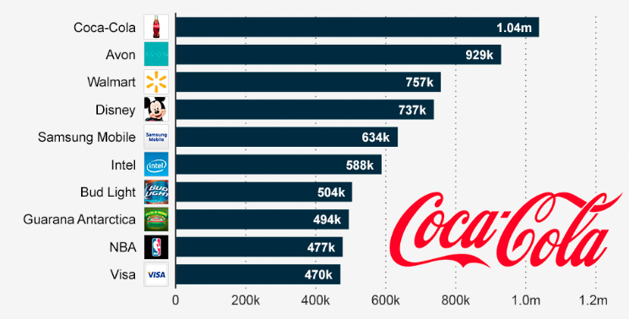
Figure 4: Ten most talked-about brands on Facebook
(Source: Statista, 2023c)
Additionally, Coca-Cola has firmly established itself as one of the best-known and most prosperous businesses on Facebook (Makharesh et al. 2022). This achievement is the result of its effective marketing plan. The business has a loyal clientele, actively participates in CSR projects related to recycling, education, health, and major international sporting events, and is in the process of switching over to sugar-free beverages including juice, water, and other goods.
Weaknesses
The market share of Coca-Cola is facing competition from PepsiCo's carbonated drinks. It's important to remember that the soft drinks produced by the corporation include high levels of sugar and other ingredients that may be harmful to your health (Kim and Adhikari, 2020). Coca-Cola has not diversified into the food sector, in striking contrast to PepsiCo, and is still primarily focused on its beverage lineup. Additionally, there have been a few signs that the firm is interested in creating drink options that are focused on health. Among their many options, Sprite and Coca-Cola stand out as two of their most well-known brands. However, Coca-Cola has come under fire for its methods of extracting groundwater, especially in regions where freshwater scarcity is a problem, as well as for its inadequate water management procedures.

4. External Environment Analysis

4.1 PEST Analysis
Factors | Effect
Political | - Moderate political stability is 0 (The global economy, 2023)  - Coca-Cola's ability to form effectively strategic business alliances with local bottlers
Economical | - The current GDP of the U.S. is 25.46 trillion U.S. dollars (Statista, 2023d)  - The inflation rate of the U.S. is 3.2% (Statista, 2023e)
Sociological | - The current population of the U.S. is 334.91 million inhabitants (Statista, 2023f)  - The majority of people in the US are showing increasing interest in healthy lifestyles
Technological | - Improved packaging design  - Using new equipment
Table 2: PEST Analysis
(Source: Self-Created)
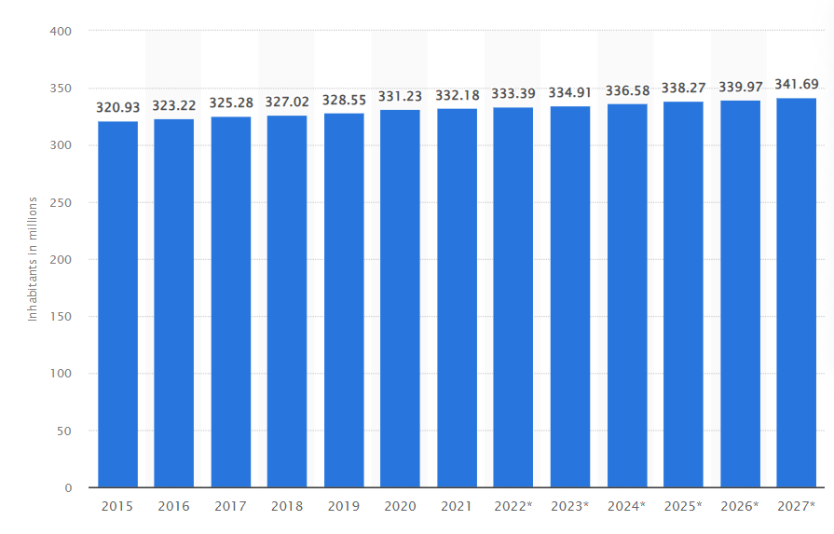
Figure 5: GDP of U.S.
(Source: Statista, 2023d)
Based on the above analysis, the political stability of the U.S. has been found as 0, and denotes that the political stability is quite moderate. Moreover, this is also effective for the development of strategic business alliances with local and foreign bottlers. Pressures from rival companies' price and product policies play an important role to develop and enhance the market share from a global viewpoint (Costa and Matias, 2020). The majority of Americans are becoming more and more interested in leading healthy lives. As a result, many consumers have switched to bottled water and diet colas like Coca-Cola Light or Zero, which has significantly impacted sales within the non-alcoholic beverage market. Moreover, the GDP growth of the U.S. significantly indicates the financial stability of the country. This also helps in developing the economic infrastructure of Coca-Cola by developing a new customer base. The above figure denoted the higher growth of population that is one of the most effective factors for business expansion.
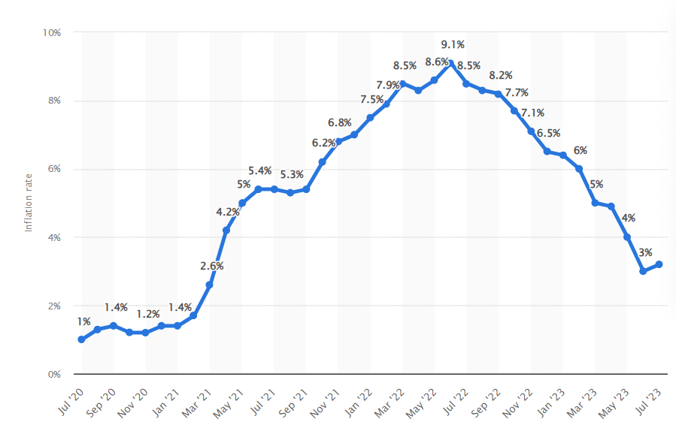
Figure 6: Inflation rate of the U.S.
(Source: Statista, 2023e)
Based on the above figure, a lower inflation rate has been identified. This indicates that a lower inflation rate of 3.2% is effective for higher growth of the product in long-term factors. According to Haudi et al. (2020), low inflation stability encourages a business organization to make riskier investments. However, Coca-Cola has also focused on the development of designing and packaging the products. The use of new technologies has significantly increased Coca-Cola's production volume compared to a few years ago.

4.2 Porter’s Five Forces
Bargaining Power of Suppliers
In order to obtain necessary labor, raw materials, and services, Coca-Cola works with a variety of vendors, allowing these middlemen to bargain on the company's behalf. Notably, sugar is a crucial component of Coca-Cola's recipe, therefore changes in the price of sugar necessarily affect the price of the finished product. The business must deal with potential cost increases brought on by subpar harvests in any given year in order to maintain pricing constancy for its product. Contractual arrangements that provide a constant supply of raw materials at a certain cost help to address this problem (Aljabhan and Obaidat, 2023). Coca-Cola benefits from the advantage of being able to switch suppliers more easily than a supplier can to locate a new customer with Coca-Cola's size in terms of purchasing by capitalizing on its huge scale. As a result, suppliers have little negotiation leverage.
Bargaining Power of Buyers
The Coca-Cola Company engages with a diverse clientele, each possessing varying levels of negotiation influence. Among these customers, direct end users hold no negotiating leverage and typically adhere to a fixed pricing structure for their purchases (Batlle et al. 2022). In contrast, fast-food chain proprietors, given the widespread consumption of Coca-Cola beverages, wield a moderate degree of bargaining power. An overarching challenge confronting Coca-Cola in this market revolves around maintaining price stability amidst fluctuating production costs. Consequently, the responsibility for absorbing these cost fluctuations falls upon either the company or its suppliers. This risk is substantial and is an accepted reality by all competitors operating within the mass market. Consequently, clients collectively maintain a moderate level of bargaining strength.

Figure 7: Factors of Porter’s Five Forces Analysis
(Source: Self-Created)
Threat of Substitute Products
Coca-Cola is up against competition from not only other soft drinks but also from substitute beverages. By providing consumers with an option that meets the same essential requirement, these substitutes pose a possible risk to their profitability (Kleisiari et al. 2021). Tea, coffee, and lemonade are some of the main competitors in this area. The threat posed by alternatives like freshly blended smoothies or juices has increased as customers' awareness of their health has expanded. Fruit juices, milkshakes, tea, coffee, and water are a few of Coca-Cola's notable rivals. Diversifying the product line with non-carbonated beverages can help to reduce this risk. Given the ease of switching and the alluring advantages offered by alternative options, the threat of substitutes still exists.
Threat of New Entrants
Coca-Cola, a well-known beverage brand around the world, enjoys wide distribution, a sizable worldwide customer base, and outstanding brand recognition (Guo et al. 2021). Local help may be available for newcomers, but going up against Coca-Cola globally is incredibly difficult. This is mainly because the market for beverages is saturated, which prevents new competitors from taking advantage of economies of scale, a substantial advantage enjoyed by well-established rivals like Coca-Cola. In addition, significant knowledge and technological constraints obstruct the creation of a soft drink formula that can compete with Coca-Cola's. There are always new players entering the beverage sector, but it is difficult to match Coca-Cola's degree of fame. It takes tremendous effort and financial investments in marketing activities to build a brand image similar to that of Coca-Cola. Given the generally high levels of client loyalty in the industry, it is difficult to quickly establish a brand with a sizable consumer base.
Rivalry Among Existing Firms
Competitive rivalry is essential for gauging market competition and comparative advantages among rivals. By managing numerous salty food brands like Doritos and Lays, Pepsi has a big advantage over Coca-Cola whereas Coca-Cola concentrates solely on beverages. If suddenly, a sudden drop in soft drink consumption occurred, Coca-Cola would be more adversely affected than Pepsi. Coca-Cola does, however, own other beverage companies that depend on consumers' continuous need for beverages even if they avoid soft drinks, such as Minute Maid and Vitamin Water. There is fierce competition in the beverage business, as seen by these two large players' comparable sizes and product offerings.

4.3 Threats and Opportunities
Opportunities
Coca-Cola can enter less developed nations to increase its market and supply chain. Additionally, this action presents a chance to advertise less well-known goods. Coca-Cola can improve its position by purchasing new businesses by utilizing its power. Another workable tactic is to enter the snacking market and expand its product line to compete with PepsiCo. Additionally, starting a strong company that specializes in healthy beverages fits with the rising trend of health-conscious consumers choosing products like water and beverages with less added sugar. Given the rising popularity of this trend, Coca-Cola can increase its revenue and market share by entering this market.
Threats
People now prefer healthier options and steer clear of aerated beverages. The economic downturn, inflation, and rivalry from potent rivals like PepsiCo, Nestle, Gatorade, Lipton, Danone, and Schweppes have all reduced Coca-Cola's market share. The pandemic's effect on sales in 2020 was less severe than anticipated, but Coca-Cola still has to deal with economic difficulties like inflation, currency fluctuations, travel restrictions, and geopolitical tensions like the rest of the world. In addition, Coca-Cola has come under fire for its environmental impact, particularly because of its packaging, which is not biodegradable. The Earth Island Institute sued Coca-Cola in June 2021, claiming that the firm engaged in misleading marketing practices that falsely represented its commitment to sustainability and the environment while really being a significant source of global plastic pollution. Additionally, the firm was charged with polluting the planet and its waters.

5. Risk assessment and management

5.1 Risk assessment
Number | Risk description | Potentiality of risk  (Scale of 1 to 5, where 3 is moderate, above 3 is high, and below 3 is low) | The impact level of the risk | Risk Severity rating (1-10 scale rating)
1 | Changes in consumer preferences | 4 | 5 | 20
2 | Economic Conditions | 5 | 3 | 12
3 | Foreign Exchange Fluctuations | 3 | 3 | 9
4 | Damage to Coca-Cola's trademark Reputation | 4 | 4 | 6
5 | Geopolitical and Security Environment | 3 | 2 | 6
6 | Product relevance and acceptability | 4 | 3 | 12
7 | Suppliers and sustainable sourcing | 5 | 1 | 5
8 | Cost and availability of sustainable packaging | 4 | 3 | 12
Table 3: Risk Assessment Table
(Source: Self-Created)
Based on the above table, the probable risk of one of the most well-known and well-established organizations, Coca-Cola has been explored. Changes in consumer preferences are one of the most effective issues that can affect production and also create a void in production (Boz et al. 2020). Moreover, changes in customer choices can lead to economic fluctuations. Moreover, it has been observed that void in production and economic shortcomings tends to the development of issues and damages in maintaining the trademark of the organization. Thereafter, issues in developing the relationship with suppliers also can be developed and affect the factors of sustainable packaging. As a result, it can be said that the consumer base will be reduced and affect the financial drawbacks of the business organization in the future.

5.2 Risk Management
Risk description | Responsible authorities | Mitigation strategy | Risk communication plan | Deadline (Months)
Changes in consumer preferences | Leaders of product-based division | Improving product innovation strategy can improve the product portfolio of Coca-Cola. Moreover, the product diversification strategy can offer a wide range of beverages, from carbonated soft drinks to juices, teas, sports drinks, water, and coffee (Samoggia et al. 2021). This will develop sales and helps in generating alternative flavors to reach the target audience. | Advertisements through online platforms and social media channels | 4 months
Poor Economic Conditions | Finance managers, executives of the organization | Creating proper budgeting allocation can reduce the excessive expenditure of the business organization (Lovallo et al. 2020). Investing in digital transformation can also enhance operational efficiency. Moreover, incorporating effective hedging strategies with different financial instruments and techniques can manage its exposure to interest rate fluctuation and currency management. | Effective communication strategy with the process es of telecommunication | 6 months
Foreign Exchange Fluctuations | Operational managers and financial managers | Using data analytics, the organization can understand the importance of foreign exchange and can predict the fluctuation rate of foreign currency (Camba and Camba Jr, 2020). Moreover, the use of a diversification strategy can improve the rate of foreign exchange by enhancing the base of foreign consumers of Coca-Cola. | Telecommunication and the email | 6 months
Damage to Coca-Cola's trademark Reputation | Operational managers and executive officers along with sales managers | An effective brand protection strategy can reduce the negative impact of the trademark reputation of Coca-cola (Krasnikov and Jayachandran, 2022). Developing a transparent relationship with both internal and external stakeholders can improve trademark reputation. Moreover, the organization needs to incorporate the intellectual property rights of Coca-Cola for enforcing the market operations. Thereafter, the damage in the business benchmark will be improved as well. | Telecommunication and direct communication strategy | 4 months
Geopolitical and Security Environment | Risk Managers | Investing in cybersecurity can develop the best practices for improving security management by protecting the information assets of the organization. Monitoring and assessing the political situation in each country and region for operating the business is effective to develop contingency planning to mitigate the potential crisis as well as emergencies. | Telecommunication and email | 6 months
Product relevance and acceptability | Product managers and risk managers | Innovating diversification in product portfolios can cater to different segments of products to reach the target audience. Moreover, conducting market research regularly and understanding customer preferences can reduce the risk of product quality and quantity. To guarantee that its products satisfy the highest standards of safety, freshness, and consistency, the company needs to use efficient quality control and assurance systems. | Telecommunication and advertising strategy through digital platforms | 2 Months
Suppliers and sustainable sourcing | Business managers and executives | Following the principles of sustainable agricultural guiding are important for developing and improving the factors of sustainable sourcing. | Direct communication | 2 Months
Cost and availability of sustainable packaging | Finance managers ad risk managers | Utilizing a variety of platforms, such as reports, websites, newsletters, etc., to openly and proactively inform its stakeholders about its suppliers and sustainable sourcing methods. Moreover, engaging with its own suppliers for understanding their needs and necessities for supporting the capacity of the suppliers and the customers. | Direct communication | 2 Months
Table 4: Risk Management Matrix
(Source: Self-Created)
The risk environment Coca-Cola is experiencing includes several difficulties that call for strategic planning and good communication. The dynamic changes in consumer preferences, which are the responsibility of the Leaders of the product-based division, are one noteworthy area of worry. A comprehensive plan that includes increased product innovation and diversification has been proposed to combat this. Coca-Cola can better respond to changing tastes and reach a wider audience by expanding its product portfolio to include a variety of beverages, from carbonated soft drinks to teas, juices, and more.
Poor economic conditions are a serious risk that is under the management of finance managers and company executives. Budgeting carefully and investing in digital transformation are some actions to reduce this (Pittaway and Montazemi, 2020). Implementing efficient hedging techniques will also aid in controlling exposure to changes in interest rates and currency exchange rates. Clear communication channels are essential to ensuring that all important stakeholders are aware of the actions being taken to address these economic difficulties, particularly in the field of telecommunications. A data-driven strategy is needed to control foreign exchange fluctuations, which are handled by operational and financial managers. The company can forecast foreign exchange swings and take the necessary action by using data analytics. Targeting overseas consumers with diversification methods can strengthen the company's stability even more.
Operational Managers, Executive Officers, and Sales Managers all have a vested interest in protecting Coca-Cola's reputation as a trusted brand. Comprehensive brand protection methods and open communication with internal and external stakeholders are the proposed course of action (Kassaneh et al. 2021). The company's reputation will be significantly protected by including intellectual property rights and efficient communication methods. Within four months, this thorough approach to risk management and communication will be put into practice. Investment in cybersecurity measures is necessary to navigate the risks associated with the geopolitical and security environment.
Planning for probable crises and catastrophes will be made possible by a proactive strategy that involves monitoring and evaluating political events. Finally, finance managers and risk managers are involved in addressing the cost and availability of sustainable packaging. Stakeholders will be made aware of the company's sustainable sourcing practices through open and proactive communication on numerous channels. The relationship between suppliers and customers will be strengthened, and capacity growth will be supported, through engaging suppliers directly and comprehending their needs. Within a two-month timeframe, these activities will be finished, enabling unified risk management and efficient communication on all fronts.

6. Key Strategies of Coca-Cola for competitive advantage
Strong Brand Portfolio
Coca-Cola has a wide variety of well-known brands that are marketed to various consumer segments and preferences. The corporation can reach a large audience and target different market segments thanks to its brand portfolio. Coca-Cola enjoys widespread recognition for its brand, which fosters consumer loyalty and faith. Its packaging, motto, and logo are all instantly recognizable and iconic (Hanna et al. 2021). Through storytelling, social responsibility, and cultural relevance, Coca-Cola also makes an investment in creating emotional relationships with its customers. Coca-Cola is regarded as a World Class Storyteller's brand that encourages joy, hope, and inclusivity.
Product diversification
Coca-Cola must create and sell its product variations, including healthier beverage and snack options while relying on its strong brand as the main competitive advantage. With this strategy, Coca-Cola will be able to sustainably and effectively increase its market share. Moreover, to suit the shifting demands and preferences of its customers, Coca-Cola continuously innovates and diversifies its product line (Hu et al. 2020). It offers a wide selection of drinks, including juices, teas, sports drinks, water, coffee, and carbonated soft drinks. Coca-Cola makes use of technology and research to develop fresh products and enhance old ones.

Figure 8: Strateies to gain competitive advantage
(Source; Self-Created)
Digital and E-Commerce Strategies
Coca-Cola has adopted digital transformation and e-commerce strategies to interact with customers directly and offer individualized experiences. This covers e-commerce platforms, internet marketing, and utilizing technology to engage customers (Juswadi et al. 2020). Coca-Cola has a vast and effective distribution system that covers practically every nation on the planet. To make sure that its products are accessible to customers, it works with regional bottlers, retailers, and distributors. Coca-Cola delivers its products swiftly and conveniently through a variety of channels, including vending machines, internet marketplaces, and mobile applications.
Low pricing strategy
By continually using a competitive pricing approach, Coca-Cola enters price-sensitive markets successfully. To enable product differentiation while keeping affordability, it sets its prices in close alignment with those of competitors. In order to promote the Coca-Cola brand and undercut the competition on price, they do this. This also shows that a low pricing strategy is one of the effective factors that make the company price-conscious and develop higher growth in the consumer base (Ma et al. 2020). Coca-Cola's extensive and effective marketing spending enables it to raise awareness, spur demand, and boost sales. To reach its target consumers, it uses a variety of media, including TV, radio, print, digital, and social media. To improve its brand's visibility and image, Coca-Cola also sponsors a variety of events in the fields of sports, music, the arts, and entertainment. Additionally, Coca-Cola interacts with its audience through interactive marketing, sweepstakes, and campaigns.

7. Conclusion
It can be concluded that this study has evaluated the strategic management of one of the most popular beverage industries named Coca-Cola headered in the U.S. This study has discussed a vivid analysis based on the overview of Coca-Cola. This study has justified the environmental analysis by discussing PEST analyses, and Porter's five forces. Based on this macro analysis, Coca-Cola’s threats and weaknesses have been signified that can help the growth of competitive advantage. Apart from that VRIO analysis and value chain has explored organizational strength and weakness. Moreover, the key strategies with probable recommendations to improve the strategic planning and growth of Coca-Cola have also been discussed in this study.

8. Recommendations
Recommendation 1: Leveraging digital transformation can enhance customer experience and improve the strategic development of the organization
Digital technologies can help Coca-Cola improve consumer satisfaction, operational effectiveness, and business insight. For instance, it can customize its marketing campaigns, optimize pricing and promotions, and understand client behavior and preferences using data analytics (Schneider and Kokshagina, 2021). Additionally, it can communicate with clients directly through digital platforms, provide individualized services, and develop loyalty programs. It can also employ digital tools to enhance the administration of its distribution system, supply chain, and product quality.
Recommendation 2: Fostering a collaborative culture can improve the organizational strategic management
Coca-Cola can enhance its strategic management by fostering an environment that values communication, creativity, and learning among all employees (Schiuma and Santarsiero, 2023). This entails giving its staff the freedom to collaborate, try out novel ideas, and learn from mistakes. It also entails supporting an inclusive and varied workforce that reflects the company's diverse clientele. Additionally, it entails creating solid alliances with its distributors, suppliers, retailers, distributors, and other stakeholders.

Recommendation 3: Ensuring business sustainability can improve the decision-making process as one of the most effective parts of strategic management
Coca-Cola can enhance its strategic management by making decisions and taking sustainable activities. This entails producing social value for its stakeholders in addition to minimizing its impact on the environment (Weston and Nnadi, 2023). For instance, it can increase the amount of recycled materials it uses in packaging, fund initiatives for water replenishment and conservation, aid small businesses and farmers in the area, and encourage customer and employee wellbeing.
Recommendation 4: Focusing on the core and experimenting with adjacencies Coca-Cola can improve its best practices as well as strategic management
Coca-Cola has a solid foundation for effervescent beverages, but it also needs to expand its offerings to meet changing consumption trends. It can achieve this through innovation and brand acquisitions in related industries including hydration, nutrition, energy, coffee, and alcohol (Libgober and Jerzak, 2023). While doing so, it should exercise restraint and rigor, making sure that the new items are consistent with the mission and values of its brand.

References
Journals
Aljabhan, B. and Obaidat, M.A., (2023). Privacy-Preserving Blockchain Framework for Supply Chain Management: Perceptive Craving Game Search Optimization (PCGSO). Sustainability, 15(8), p.6905.
Batlle, C., Schittekatte, T. and Knittel, C.R., (2022). Power price crisis in the EU 2.0+: Desperate times call for desperate measures. Available at SSRN 4074014.
Boz, Z., Korhonen, V. and Koelsch Sand, C., (2020). Consumer considerations for the implementation of sustainable packaging: A review. Sustainability, 12(6), p.2192.
Camba, A.L. and Camba Jr, A.C., (2020). The effect of Covid-19 pandemic on the Philippine stock Exchange, Peso-Dollar rate and retail price of diesel. The Journal of Asian Finance, Economics and Business (JAFEB), 7(10), pp.543-553.
Costa, J. and Matias, J.C., (2020). Open innovation 4.0 as an enhancer of sustainable innovation ecosystems. Sustainability, 12(19), p.8112.
Fan, D., Tan, Z. and Zheng, Q., (2022), July. Financial and Strategies Analysis of Coca-Cola Company in the Period of COVID-19 Epidemic. In (2022) 2nd International Conference on Enterprise Management and Economic Development (ICEMED (2022)) (pp. 985-997). Atlantis Press.
Gerhart, B. and Feng, J., (2021). The resource-based view of the firm, human resources, and human capital: Progress and prospects. Journal of Management, 47(7), pp.1796-1819.
Guo, X. and Wen, M., (2021), December. Research on Competitive Strategy of Coca-Cola Company. In (2021) 3rd International Conference on Economic Management and Cultural Industry (ICEMCI (2021)) (pp. 2879-2885). Atlantis Press.
Hanna, S., Rowley, J. and Keegan, B., (2021). Place and destination branding: A review and conceptual mapping of the domain. European Management Review, 18(2), pp.105-117.
Haudi, H., Wijoyo, H. and Cahyono, Y., (2020). Analysis of most influential factors to attract foreign direct investment. Journal of Critical Reviews, 7(13).
Hu, G., Can, M., Paramati, S.R., Doğan, B. and Fang, J., (2020). The effect of import product diversification on carbon emissions: New evidence for sustainable economic policies. Economic Analysis and Policy, 65, pp.198-210.
Ireland, R., Bunn, C., Chambers, S., Reith, G. and Viggars, M., (2022). How unhealthy commodity industries find a global audience in the English Premier League: three case studies of brand engagement. Soccer & Society, 23(4-5), pp.334-348.
Juswadi, J., Sumarna, P. and Mulyati, N.S., (2020), April. Digital marketing strategy of Indonesian agricultural products. In International Conference on Agriculture, Social Sciences, Education, Technology and Health (ICASSETH 2019) (pp. 105-110). Atlantis Press.
Kassaneh, T.C., Bolisani, E. and Cegarra-Navarro, J.G., (2021). Knowledge management practices for sustainable supply chain management: A challenge for business education. Sustainability, 13(5), p.2956.
Kim, J. and Adhikari, K., (2020). Current trends in kombucha: Marketing perspectives and the need for improved sensory research. Beverages, 6(1), p.15.
Kleisiari, C., Duquenne, M.N. and Vlontzos, G., (2021). E-Commerce in the Retail Chain Store Market: An Alternative or a Main Trend?. Sustainability, 13(8), p.4392.
Krasnikov, A. and Jayachandran, S., (2022). Building Brand Assets: The Role of Trademark Rights. Journal of Marketing Research, 59(5), pp.1059-1082.
Kuncoro, W. and Windyasari, H.A., (2021). Consumer Purchasing Decision Improvement Model through Brand Image, Religiosity, Brand Ambassador and Brand Awareness. International Business Research, 14(8), pp.1-42.
Libgober, B. and Jerzak, C.T., (2023). Linking Datasets on Organizations Using Half A Billion Open Collaborated Records: Perils and Opportunities. arXiv preprint arXiv:2302.02533.
Lovallo, D., Brown, A.L., Teece, D.J. and Bardolet, D., (2020). Resource re‐allocation capabilities in internal capital markets: The value of overcoming inertia. Strategic Management Journal, 41(8), pp.1365-1380.
Ma, J., Xu, M., Meng, Q. and Cheng, L., (2020). Ridesharing user equilibrium problem under OD-based surge pricing strategy. Transportation Research Part B: Methodological, 134, pp.1-24.
Makharesh, A.O., Alharethi, M. and Campbell, C., (2022). Ideologies and stereotypes of arab culture in the media: an analysis of coke's 2013 super bowl commercial. Journal of Management Information & Decision Sciences, 25(3), pp.1-10.
Perusset, A., (2023). A reappraisal of the marketing offerings: consumer experience from the perspective of post-structural semiotics. Social Semiotics, pp.1-15.
Pittaway, J.J. and Montazemi, A.R., (2020). Know-how to lead digital transformation: The case of local governments. Government information quarterly, 37(4), p.101474.
Samoggia, A., Landuzzi, P. and Vicién, C.E., (2021). Market expansion of caffeine-containing products: Italian and argentinian yerba mate consumer behavior and health perception. International Journal of Environmental Research and Public Health, 18(15), p.8117.
Schiuma, G. and Santarsiero, F., (2023). Innovation labs as organisational catalysts for innovation capacity development: A systematic literature review. Technovation, 123, p.102690.
Schneider, S. and Kokshagina, O., (2021). Digital transformation: What we have learned (thus far) and what is next. Creativity and innovation management, 30(2), pp.384-411.
Tien, N.H., Diem, P.T., Van On, P., Anh, V.T., Van Dat, N., Hung, N.T. and Tam, B.Q., (2021). The formation and development of CRM system at Thien Hoa electronics supermarket in Vietnam. International Journal of Research and Growth Evaluation, 2(4), pp.752-760.
Trivedi, S. and Malik, R., (2022). Social Media Marketing as New Marketing Tool. In Research Anthology on Social Media Advertising and Building Consumer Relationships (pp. 18-33). IGI Global.
Wawrowski, B. and Otola, I., (2020). Social media marketing in creative industries: How to use social media marketing to promote computer games?. Information, 11(5), p.242.
Weston, P. and Nnadi, M., (2023). Evaluation of strategic and financial variables of corporate sustainability and ESG policies on corporate finance performance. Journal of Sustainable Finance & Investment, 13(2), pp.1058-1074.
Yenugula, M., Sahoo, S. and Goswami, S., (2023). Cloud computing in supply chain management: Exploring the relationship. Management Science Letters, 13(3), pp.193-210.
Websites
Coca-Cola Company, (2023a). Purpose & Vision. Available at: https://www.coca-colacompany.com/about-us/purpose-and-vision [Accessed on 18th August 2023]
Coca-Cola Company, (2023b). Contact Us. Available at: https://www.coca-colacompany.com/about-us/purpose-and-vision [Accessed on 18th August 2023]
Statista, (2023a). The Coca-Cola Company's net operating revenues worldwide from 2007 to (2022). Available at: https://www.statista.com/statistics/233371/net-operating-revenues-of-the-coca-cola-company-worldwide/ [Accessed on 18th August 2023]
Statista, (2023b). Revenue distribution share of the Coca-Cola Company worldwide in (2022), by operating segment. Available at: https://www.statista.com/statistics/271136/coca-colas-revenue-distribution-worldwide-by-operating-segment/ [Accessed on 18th August 2023]
Statista, (2023c). Coca-Cola is the No. 1 Brand on Facebook. Available at: https://www.statista.com/chart/1377/most-talked-about-brands-on-facebook/ [Accessed on 18th August 2023]
Statista, (2023d). Gross domestic product of the United States from 1990 to (2022). Available at: https://www.statista.com/statistics/188105/annual-gdp-of-the-united-states-since-1990/ [Accessed on 18th August 2023]
Statista, (2023e). Monthly 12-month inflation rate in the United States from July (2020) to July (2023). Available at: https://www.statista.com/statistics/273418/unadjusted-monthly-inflation-rate-in-the-us/#:~:text=The%20annual%20inflation%20rate%20in,available%20funds%20to%20make%20purchases. [Accessed on 18th August 2023]
The global economy, (2023). USA: Political stability. Available at: https://www.theglobaleconomy.com/USA/wb_political_stability/ [Accessed on 18th August 2023]
Statista, (2023f). Total population of the United States from 2015 to 2027(in millions). Available at: https://www.statista.com/statistics/263762/total-population-of-the-united-states/ [Accessed on 18th August 2023]

