What is the hold-up

TASK 1

Research Question - Why veterans who are suffering with service mental health issues are referred into LPMHSS/CMHT teams instead of VNHSW

Introduction
This research aims to investigate the referral process for veterans with service-related mental health issues, specifically why they are directed to Local Primary Mental Health Support Services (LPMHSS) or Community Mental Health Teams (CMHT) instead of Veterans NHS Wales (VNHSW). The study will highlight the potential benefits of direct referrals to VNHSW and propose solutions to streamline the referral process.

Background
According to the (Census, 2021), 115,000 individuals in Wales had previously served in the UK armed forces, representing 4.5% of the population aged 16 years or older. This is higher than the 3.8% in England. Recent research indicates that 6-10% of UK military veterans are likely to suffer from PTSD, with around 22% reporting symptoms of common mental health disorders such as depression or anxiety (Stevelink et al.,2018). Despite these high rates, many veterans are reluctant to seek mental health support, with over half not engaging with healthcare professionals (Stevelink et al., 2019 ); (Greenberg et al, 2019 ) has also emphasised the high prevalence of mental health issues among military personnel and the barriers to seeking help, echoing (Stevelink et al.,2018) findings on the reluctance of service members seeking mental health support. Therefore, speeding up the wait times for treatment can be crucial into getting a veteran to engage with health professionals and getting the support they need as soon as they reach out for support (Iversen et al., 2005; Murphy, Palmer, & Busuttil, 2017).

Veterans NHS Wales (VNHSW)
VNHSW, was one of the original MoD/Welsh government-funded UK pilots based in Cardiff in 2008 for two years led by Prof. Jonathan Bisson and Neil Kitchener (NHS, 2024 ) and expanded in 2010, providing evidence-based treatments for service-related mental health conditions. The service employs a multidisciplinary team, including veteran therapists, psychologists, peer mentors, administrative staff, and psychiatrists, across various health boards in Wales. Despite its success, there has been a notable increase in referrals post-COVID-19, with primary care services being a significant source of these referrals.

Problem Statement
Analysis of VNHSW annual reports from 2019 to 2023 (NHS, 2019-2023), reveals that primary care services, such as LPMHSS/CMHT, are the largest source of referrals. This indirect referral process may contribute to delays in veterans receiving timely treatment. This research will explore the reasons behind this referral pattern and propose strategies to improve direct referrals to VNHSW.

Research Value
By addressing this issue, the research aims to reduce wait times for veterans waiting for treatment. Direct referrals from GPs to VNHSW or informing veterans about self-referral options could significantly cut down the waiting period. Recent statistics indicate that 330 patients were assessed by LPMHSS in one month, with 31 waiting up to 56 days for assessment (Welsh Gov 2024 ). A survey by Rethink Mental Illness found that 80% of patients experienced a deterioration in their mental health while waiting for support, with 64% experiencing a mental health crisis (Mark Winstanley, 2024 ).

Research Approach
I have decided to do a mixed methods approach, combining qualitative interviews with VNHSW staff and quantitative questionnaires sent to GP surgeries within the Swansea Bay University Health Board (SBUHB). Interviews with VNHSW staff will provide in-depth insights into referral issues, while questionnaires will gauge GPs' awareness and practices regarding veteran referrals.
According to Johnson & Turner, (2003), a combination of qualitative and quantitative data allows researchers to gain a complete understanding of the research problem, as qualitative data provides depth and context, while quantitative data offers breadth and generalisability. However, some scholars have raised concerns about mixed methods research. Jennifer C. Greene, (2022) discusses the philosophical incompatibilities between qualitative and quantitative approaches, arguing that their foundational assumptions can be fundamentally different, complicating their integration. Giddings, (2006) also criticises mixed methods research, describing it as "positivism dressed in drag," implying that it often fails to genuinely integrate qualitative and quantitative approaches and instead leans heavily towards a positivist framework. According to Creswell & Plano Clark (2011) using mixed methods offers flexibility and can be adapted to the specific needs of my research, making it suitable for complex research questions.

Data Collection Methods
Primary data will be collected through interviews and questionnaires. This approach ensures the data is accurate, relevant, and collected in real-time, providing control over data quality and reliability.
- Interviews:
  - Participants: Lead Therapist/Manager, therapists, and administrative staff at VNHSW.
  - Purpose: To understand the issues around referrals and gather opinions on why GPs might not refer directly to VNHSW.
  - Format: Semi-structured interviews to allow for flexibility and depth.
- Questionnaires:
  - Participants: GP surgeries within the Swansea Bay University Health Board.
  - Purpose: To assess GPs' awareness of VNHSW and their referral practices.
  - Format: Structured questionnaires with both closed and open-ended questions.

Sampling Method and Size
The sample will include three interviews with VNHSW and LPMHSS staff members. Questionnaires will be distributed to all GP surgeries within the Swansea Bay University Health Board (SBUHB). According to Saul McLeod (2018) questionnaires have provided a rapid, low-cost, and efficient way of collecting a large amount of information from many people. Ando et al,(2014); Ritchie, Lewis, McNaughton Nicholls, & Ormston, (2013)
- Interviews:
  - Sample Size: Three VNHSW staff members and one LPMHSS staff member.
  - Sampling Method: Purposive sampling to select participants with relevant experience and knowledge.
- Questionnaires:
  - Sample Size: All GP surgeries within the Swansea and Neath Locality.
  - Sampling Method: Census sampling to include all relevant GP surgeries in the area.

Task 2
Primary and Secondary research techniques
The Sequential Explanatory Design is a method popular in health research. An example of this design is the study by Albert et al (2022). The Sequential Explanatory Design is a mixed methods approach that involves two distinct phases: quantitative data collection and analysis followed by qualitative data collection and analysis. This design helps to explain and interpret quantitative results with qualitative findings. It is particularly suited for studies requiring breadth and depth, such as investigating referral issues within the Swansea Bay University Health Board (SBUHB). Although there is no direct critique of Albert, there are discussions in the literature about the challenges and limitations of the Sequential Explanatory Design in mixed methods research. For example, Mohammad Abu Sayed Toyon (2021) highlights the challenges of using the explanatory sequential design, including difficulties in sequencing data collection and analysis, and the risk of misalignment between quantitative and qualitative phases

Methodology:
- Quantitative Phase:
  - Instrument Development: A structured questionnaire will be developed to assess the awareness and practices of GPs regarding veteran referrals. The questionnaire will include both closed and open-ended questions to capture a wide range of data.
  - Data Collection: The questionnaire will be distributed to GP surgeries within the SBUHB.
  - Data Analysis: Quantitative data will be analysed using appropriate statistical techniques to identify key trends, patterns, and correlations.
- Qualitative Phase:
  - Interview Guide Development: Based on the quantitative findings, a semi-structured interview guide will be created to explore areas requiring further clarification.
  - Interviews with VNHSW Staff: Interviews will be conducted with VNHSW staff to gain insights into referral issues.
  - Data Analysis: Qualitative data will be analysed using thematic analysis to identify and interpret patterns and themes.
- Integration:
  - Data Integration: The results from both phases will be combined to give a complete understanding of the research problem. The qualitative data will help explain and add to the quantitative results.
  - Interpretation: The combined data will be reviewed to draw clear conclusions, showing how the qualitative insights help explain the quantitative findings.
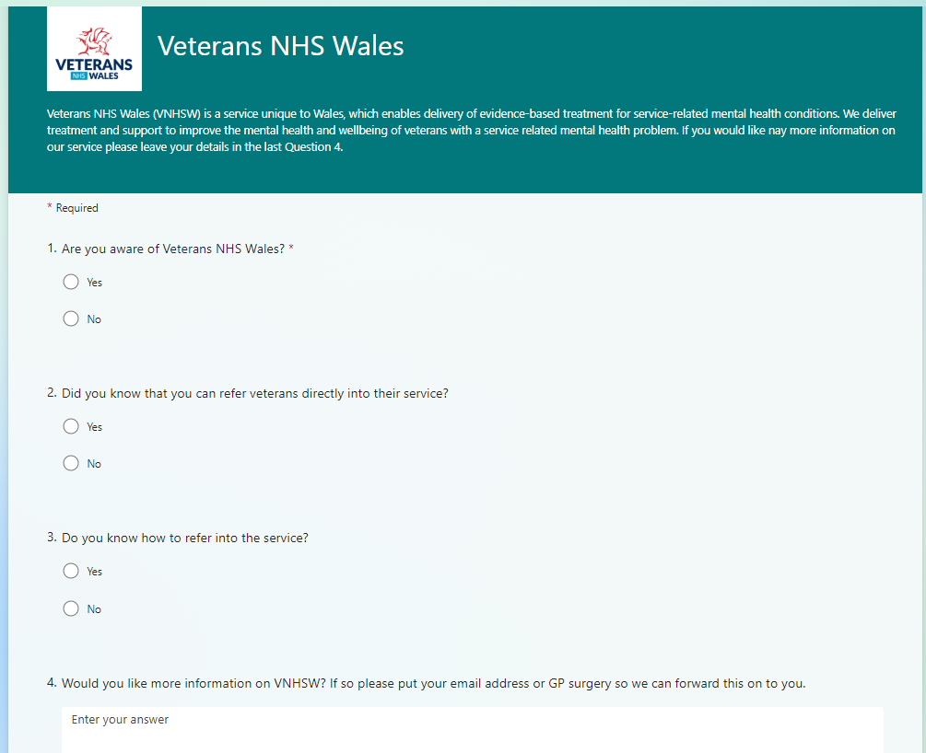
Picture 1
The Questionnaire’s that was sent out to all Swansea Bay University Health Board (SBUH) GPs.

Thematic Analysis of Questionnaire and Interview Results

Key Themes Identified
Awareness and Knowledge
- 60%of GPs aware of VNHSW; 40% are not.
- 47% knew they could refer veterans directly; Only 23% knew how.
Interest and Barriers
- High interest in more information and gaining knowledge.
- System limitations and lack of training hinder effective referrals.
Referral Process Challenges
- Complexity and delays due to multiple steps in the referral process.
- Frequent inappropriate referrals increasing workload and delaying care.
Patient Engagement
- Self-referrals engage better than those referred by professionals.
- Website usability issues hinder self-referrals.
System and Communication Issues
- Multiple systems cause inefficiency and errors.
- Safeguarding concerns not always addressed before referrals.
Awareness and Promotion
- Many professionals unaware of VNHS and their referral process.
- Need for more promotion of VNHS services.

Recommendations
- Increase Awareness Campaigns: Educate healthcare professionals about VNHSW.
- Enhance Training Programs: Train professionals on the referral process.
- Improve Referral Systems: Integrate VNHSW into existing systems.
- Provide Accessible Information: Update website and provide regular updates.
- Streamline Referrals: Allow only self-referrals or direct referrals.
- Enhance Education and Signposting: Educate referrers and patients, signpost inappropriate referrals.
- Improve Website Usability: Redesign for easier navigation.
- Increase Promotion: Promote VNHS services extensively.
By addressing these themes and implementing the recommendations, VNHS and LPMHSS can improve referral efficiency, patient outcomes and shorter waiting lists.

Task 3
Reflection on Video Feedback
The feedback from the interviews and questionnaires highlights several critical areas for improvement in the referral process for Veterans NHS Wales (VNHSW). The complexity and delays in the current referral system, coupled with the frequent receipt of inappropriate referrals, underline the need for a more streamlined and efficient process. Additionally, the engagement challenges faced by patients who do not self-refer point to the necessity of enhancing the self-referral process and making the website more user-friendly.
The lack of awareness among healthcare professionals about VNHSW and the correct referral procedures is a significant barrier. This calls for targeted awareness campaigns and better educational resources to ensure that all practices are informed about veterans' health needs and the referral process. Furthermore, the use of multiple systems within the department and across other mental health services contributes to inefficiencies and errors, highlighting the need for system integration.
By addressing these issues through streamlined referrals, improved education, enhanced website usability, and increased promotion, VNHSW can significantly improve its service delivery and patient outcomes. This reflection emphasizes the importance of continuous improvement and adaptation to better meet the needs of veterans.

Task 4
Data Analysis via poster
Conclusion
This research has highlighted significant challenges in the referral process for veterans with service-related mental health issues, particularly the indirect referrals to Local Primary Mental Health Support Services (LPMHSS) or Community Mental Health Teams (CMHS) instead of Veterans NHS Wales (VNHSW). The findings indicate that the current referral system is complex and inefficient, leading to delays in veterans receiving the specialized care they need.
Key issues identified include the lack of awareness among healthcare professionals about VNHSW, the bulky nature of the referral process, and the frequent receipt of inappropriate referrals. These factors contribute to prolonged wait times and can negatively impact the mental health outcomes for veterans.
The thematic analysis of interviews and questionnaires revealed that many healthcare professionals are unaware of how to refer veterans directly to VNHSW, and there is a significant need for better training and resources. Additionally, the current website for self-referrals is not user-friendly, further complicating the process for veterans seeking help.
To address these challenges, the research recommends several strategies:
- Streamline the Referral Process: Allow only self-referrals or direct referrals to reduce delays and improve efficiency.
- Enhance Education and Training: Implement targeted awareness campaigns and comprehensive training programs to educate healthcare professionals about VNHSW and the referral process.
- Improve Website Usability: Redesign the website to be more user-friendly, making it easier for veterans to self-refer.
- Increase Promotion: Promote VNHSW more extensively to ensure all healthcare practices are aware of veterans' health needs and the referral process.
By implementing these recommendations, VNHSW can improve the efficiency of its referral processes, reduce wait times, and enhance the overall support provided to veterans. This will ultimately lead to better mental health outcomes for veterans, ensuring they receive the timely and specialised care they deserve.

References
- Burke Johnson, R., & Turner, L. A. (2003). Data Collection Strategies in Mixed Methods Research. In A. Tashakkori & C. Teddlie (Eds.), Handbook of Mixed Methods in Social and Behavioral Research (pp. 297-319). SAGE Publications.
- Caputo, R. K. (2013). Policy Analysis for Social Workers. SAGE Publications.
- Greene, J. C. (2022). Mixed Methods in Social Inquiry. Jossey-Bass.
- Giddings, L. S. (2006). Mixed-methods research: Positivism dressed in drag? Journal of Research in Nursing, 11(3), 195-203.
- (PDF) Mixed Methods Research
- Greenberg, N., et al. (2019). Mental health outcomes at the end of the British involvement in the Iraq and Afghanistan conflicts: a cohort study. The British Journal of Psychiatry, 204(3), 243-248.
- Mark Winstanley. (2024). New survey reveals stark impact of NHS mental health treatment waiting times. Rethink Mental Illness. Retrieved from https://www.rethink.org/news-and-stories/media-centre/2024/06/new-survey-reveals-stark-impact-of-nhs-mental-health-treatment-waiting-times/
- Waiting times for a LPMHSS assessment, by LHB, age and month
- Stevelink, S. A. M., et al. (2018). Do serving and ex-serving personnel of the UK armed forces seek help for perceived stress or emotional or mental health problems? European Journal of Psychotraumatology, 9(1), 153-162. Retrieved from Mental health outcomes at the end of the British involvement in the Iraq and Afghanistan conflicts: a cohort study - PubMed
- Ando, H., Cousins, R., & Young, C. (2014). Achieving Saturation in Thematic Analysis: Development and Refinement of a Codebook. Hikari Ando, Rosanna Cousins, Carolyn Young. Retrieved from https://journals.sagepub.com/doi/full/10.2466/03.CP.3.4
- What happens to British veterans when they leave the armed forces? European Journal of Public Health. Oxford Academic (2005). Retrieved from https://academic.oup.com/eurpub/article/15/2/175/567104
- What happens to British veterans when they leave the armed forces? PubMed (2005). Retrieved from https://pubmed.ncbi.nlm.nih.gov/15755777/
- Exploring Indices of Multiple Deprivation within a Sample of Veterans Seeking Help for Mental Health Difficulties Residing in England (2017). Retrieved from https://pdfs.semanticscholar.org/82b8/cf16b4ae9cc04bbe8db1454ac0fe80ab8cbf.pdf
- Stevelink, S. A. M., et al. (2019). Mental health outcomes at the end of the British involvement in the Iraq and Afghanistan conflicts: a cohort study. The British Journal of Psychiatry, 204(3), 243-248.Do serving and ex-serving personnel of the UK armed forces seek help for perceived stress, emotional or mental health problems? - PubMed
- UK Armed Forces veterans in Wales (Census 2021). GOV.WALES. Retrieved from https://www.gov.wales/sites/default/files/pdf-versions/2023/1/1/1673870222/uk-armed-forces-veterans-wales-census-2021.pdf
- Veterans NHS Wales Annual Report 2022-2023. NHS Wales. Retrieved from https://www.veteranswales.co.uk/resources.html
- Albert, et al. (2022). Optimising care coordination strategies for physical activity referral scheme patients by Australian health professionals. PLOS ONE. Retrieved from https://journals.plos.org/plosone/article?id=10.1371/journal.pone.0270408
- McLeod, S. (2018). What Is a Questionnaire and How Is It Used in Research? Simply Psychology. Retrieved from https://www.simplypsychology.org/questionnaires.html
- Mohammad Abu Sayed Toyon. (2021). Explanatory sequential design of mixed methods research: Phases and challenges. Retrieved from https://www.researchgate.net/publication/363294843_Explanatory_sequential_design_of_mixed_methods_research_Phases_and_challenges
- Primary Research vs Secondary Research in 2024: Definitions, Differences, and Examples. Research.com. Retrieved from https://research.com/research/primary-research-vs-secondary-research
- Primary and secondary data in emergency medicine health services research – a comparative analysis in a regional research network on multimorbid patients. BMC Medical Research Methodology. Retrieved from https://bmcmedresmethodol.biomedcentral.com/articles/10.1186/s12874-023-01855-2
- Primary versus secondary source of data in observational studies and heterogeneity in meta-analyses of drug effects: a survey of major medical journals. BMC Medical Research Methodology. Retrieved from https://bmcmedresmethodol.biomedcentral.com/articles/10.1186/s12874-018-0561-3
- Saunders, M. N. K., Lewis, P., & Thornhill, A. (2019). Research Methods for Business Students (8th ed.). Pearson.
- Exploring Indices of Multiple Deprivation within aSample of Veterans Seeking Help for Mental HealthDifficulties Residing in England

Appendix A: Interview Transcripts

Interview with Victoria Williams, VNHSW Lead Therapist/Manager
Interviewer: How long have you worked in Veterans NHS Wales?
Interviewee: I started working in VNHSW in around 2011, around the March/April time.
Interviewer: What would you say are the biggest challenges you face with the referral process?
Interviewee: The referral process is slightly clunky. The biggest challenge is those referred in rather than self-referring. For example, people referred by their GP often go into primary care initially, and then from primary care, they are sent over to us. This can significantly delay the process. If it were up to me, I would only allow self-referrals or direct referrals into our service.
Interviewer: OK. And then the last question, how do you currently address receiving incorrect referrals that are more suited to other departments?
Interviewee: So we will often do the reverse. We will screen or have a discussion around the referral, its suitability for our service and if we do not think it's suitable, we will send it back to the referrer. It depends on what their level of risk is, what they are looking for, and their needs at that time. So it could be that we send them back to the referrer, to the single point of access team, or to the local primary mental health support service. It’s multifactorial depending on risk, urgency, and what they are actually looking for.

Interview with Samuel Thompson, VNHSW Therapist
Interviewer: How long have you worked in VNHSW?
Interviewee: 14 months.
Interviewer: What are the biggest challenges you face with the referral process?
Interviewee: Some of the biggest challenges are encouraging patients to opt in and engage with our service. Clients who self-refer via the website tend to do better than those referred by healthcare professionals. The website is not particularly user-friendly, which can be distracting and confusing for patients attempting to self-refer.
Interviewer: How do you currently address receiving incorrect referrals that are more suited to other departments?
Interviewee: If we get an inappropriate referral, we tend to signpost to other services. One of the concerns is alcohol dependency and how that can impact treatment. Several referrals I have received have often gone to Primary Care, family support, or substance misuse services.

Interview with Samantha Rodd, LPMHSS Manager
Interviewer: How long have you worked in LPMHSS?
Interviewee: 2.5 years.
Interviewer: What are the biggest challenges you face with the referral process?
Interviewee: There are multiple systems used within the department and other mental health services. Receiving inappropriate or wrong referrals and safeguarding concerns not being actioned prior to referrals being sent.
Interviewer: How do you currently address receiving incorrect referrals that are more suited to other departments?
Interviewee: For assessments, the deputy team manager and I will return inappropriate referrals. For therapy, the lead therapist will return the referral requesting more information or safeguarding queries to the referrer. If they are meant for other departments, they will usually be sent back to the referrer, but sometimes myself and Jade will forward these onto the relevant department, e.g., SPOA.

Appendix B: Questionnaire Results

Summary of Responses
- Awareness of VNHSW: 60% of respondents were aware of VNHSW, while 40% were not.
- Knowledge of Referral Process: 47% knew they could refer veterans directly to VNHSW, and 23% knew how to do so.
- Interest in More Information: Many respondents expressed a desire for more information about VNHSW.

Detailed Results
- Question 1: Are you aware of Veterans NHS Wales?
  - Yes: 60%
  - No: 40%
- Question 2: Did you know that you can refer veterans directly into their service?
  - Yes: 47%
  - No: 53%
- Question 3: Do you know how to refer into the service?
  - Yes: 23%
  - No: 77%

Appendix C: Table of results from GP Questionnaires
- Table 1:
Question | Yes% | No%
Are you aware of Veterans NHS Wales? | 60 | 40
Did you know that you can refer veterans directly into their service? | 47 | 53
Do you know how to refer in to the service? | 23 | 77

Appendix E: Elevator Pitch
Introduction (30 seconds): "Hi, I'm Anna, a student at the University of Wales carrying out research which focuses on why veterans with service-related mental health issues are often referred to Local Primary and Community Mental Health Teams (CMHT) instead of directly to Veterans NHS Wales (VNHSW)."
Background of Veterans NHS Wales (30 seconds): Who are VNHSW?? "Veterans NHS Wales was established in 2008 and expanded in 2010. They provide evidence-based treatments for service-related mental health conditions for veterans through a multidisciplinary team. Despite its success, referrals have increased post-COVID-19, often with primary care services being the significant source of referrals. According to the 2021 Census, 115,000 individuals in Wales have previously served in the UK armed forces, representing 4.5% of the population aged 16 years or older. Recent research indicates that 6-10% of UK military veterans are likely to suffer from PTSD, and around 22% report symptoms of common mental health disorders such as depression or anxiety."
Problem Statement (30 seconds): Indirect referrals to Local Primary and Community Mental Health Teams delay veterans' access to specialized care at VNHSW significantly impacting their mental health. Many veterans are reluctant to seek mental health support, with over half not engaging with healthcare professionals. Speeding up the wait times for treatment can be crucial in getting veterans the support they need as soon as they reach out."
Your Research + OUTCOME (1 minute): "My research investigates the referral patterns and reasons behind these indirect referrals. By analysing VNHSW annual reports and conducting interviews with VNHSW staff and GPs, we aim to uncover the barriers to direct referrals. Our mixed methods approach combines qualitative insights from interview with staff and quantitative data from GP questionnaires. For instance, my questionnaire has revealed that only 51% of GPs in the SBU area are aware of VNHSW, with only 47% knowing they could refer directly to VNHSW, However, just 23% knew how to do so. This lack of awareness contributes to the delays in veterans receiving timely care and also adds unnecessary referrals to other departments causing their wait lists to grow.
Impact (30 seconds): "MY findings suggest that direct referrals to VNHSW could reduce wait times and improve mental health outcomes for veterans, Reducing waiting lists for community mental health teams BY Informing GPs about self-referral options and streamlining the process which is crucial."
Conclusion (30 seconds): "In summary, addressing the referral process will reduce the wait times for veterans mental health services which is crucial for their well-being. Thank you for listening.

Appendix E: VIDEO FEEDBACK
- The video was informative, especially with how so many GPs did not know about our service and how to refer appropriately. It reminds me of some of the referrals we do receive where it states that they don’t have veteran status.
- I think it would be important for all practices to be aware of veterans' health needs (both physical and mental health).
- It is shocking that only 40% know how to refer, despite us being a national service.
- I wonder whether further promotion could be helpful, especially as there are significant barriers to treatment for most veterans.

Appendix F: Glossary
- VNHSW: Veterans NHS Wales
- LPMHSS: Local Primary Mental Health Support Services
- CMHS: Community Mental Health Teams
- SBUHB: Swansea Bay University Health Board
- GP: General Practitioner

