  Component One: Student Journal (learning log) 750 words +/- 10%  Contribution to Overall Module Assessment: 25% | Student No: | 2230512
 | Module Title: | Hotel Administration and Front Office
 | Module Code: | BMIH4004
 | Lecturer: | Gulia Chifari
Throughout my experience at the front office of the prominent Premier Inn, I can confidently say that I have enjoyed the opportunities to meet new people and hear about the different backgrounds each of them have, and especially about how my service helps them enjoy their own experience with the services at Premier Inn. However, throughout my experience at the hotel, especially at the front office, I, unfortunately, met some uncooperative individuals who were not as kind and understanding towards me, and decided even to be aggressive and came very close to violence when approached by myself and other front office staff. Overall, I enjoyed managing guest inquiries and check-ins as it gave me a different perspective than the one I was adapted to and helped me learn more about interpersonal communication.
In my opinion, whilst working in the front office area, I gained many opportunities to work on myself to become a better person and adapt to more employable skills such as effective teamwork, communication, and problem-solving skills. When working as a team at the front office of Premier Inn, I proved myself as a team player by taking on time-reliant tasks and providing support to my teammates from my shift on many opportunities efficiently and effectively. As a result, I have received positive feedback and constructive criticism on what I can improve to be a better team member. Additionally, in the front office, my multitasking skills were valuable, especially when I was responsible for handling incoming calls and welcoming new guests into Premier Inn. This was a difficult task for beginners at the front office, in my opinion, but I did gain a lot of insight into what I did well and what else I needed to improve on.
As a result of the placement experience, I gained a lot of understanding of the front office area’s role in providing a positive guest experience. I now know that first impressions are what create the experience of all guests in Premier Inn, especially at the front office. When interacting with guests at the front office, we must keep our personal lives out of any conversations and focus on the guests and their opinions to meet their expectations and needs as guests of a reputable hotel. This included also taking into consideration any negative opinions on inclusivity and diversity, as the majority of guests coming into Premier Inn were part of foreign cultural groups and religions that should be respected and welcomed as any other to allow them to feel comfortable as a guest of Premier Inn.
In conclusion, by taking on the opportunity to work in the front office of the reputable hotel, Premier Inn, I gained a wide insight on many responsibilities and skills that are required and developed while working there. Not only had I developed myself as a more employable and knowledgeable person. However, I also managed to learn key lessons from the front office area by interacting with many guests and staff and understanding what people expect in a conversation, especially in the services of a hotel.
Moreover, I have to admit that by working in person at such a busy hotel, my perception of the hospitality industry has drastically changed in a more positive light, as I understand how difficult and time-consuming each task and responsibility of every hotel staff member is now. During my time as a staff member of Premier Inn, I have also been provided with practical and comprehensive training and classes to learn and adapt to the expectations of an employee of Premier Inn and understand the standards of meeting and interacting with guests.
After my thorough and enjoyable experience at Premier Inn’s front office, I believe that I have gained a lot of insight into my future in the hospitality industry, especially into how, once I start my career within the industry, I am going to be able to progress further on, hopefully into a managerial position for an international branch. More specifically, once I gain more experience in the industry, I hope to take more comprehensive training sessions and seminars into what makes a hotel what it currently is in relation to the relationships between guests and staff, focusing on first impressions in the front office. Therefore, to ensure continuous growth and success, I believe that once I have progressed enough to gain enough knowledge and a stable reputation, I hope to create a start-up hotel that is more local, affordable and accessible.

Component Two
Contribution to Overall Module Assessment: 25%
Trip Advisor Review Response 150 words +/-10%
Subject: Feedback Response
Dear Sir/Madam,

I am writing to express our dearest appreciation for your positive feedback towards your experience during your stay at Premier Inn. I have seen that you have expressed your satisfaction with our housekeeping and breakfast services from our staff members and I am glad that our aims to maximise our guests’ experiences have met your expectations.

If you are further interested in Premier Inn’s services, we would be delighted to welcome you and your family back with open arms, and we recommend telling your friends about us too so they can have an amazing experience just as you!

Thank you for your time to provide useful feedback to us and we hope you continue to do so in the future.

Sincerely,
Iulia Tanase
Premier Inn

Screen shot of referenced Trip Advisor review used:

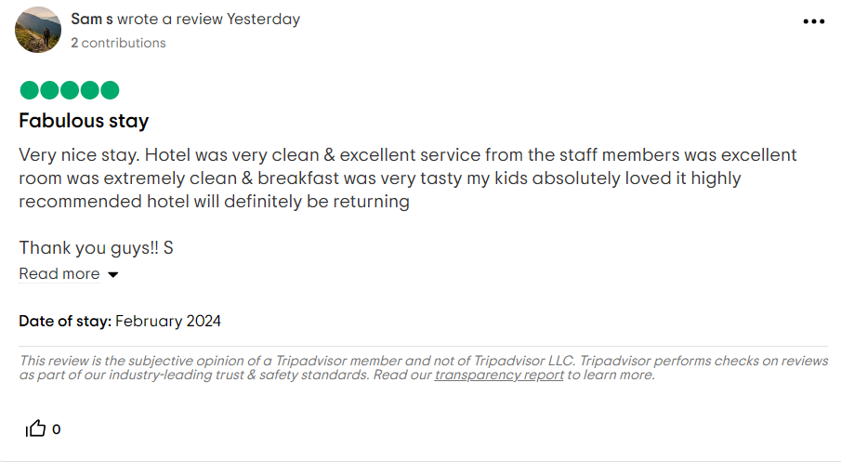
Letter of complaint response 500 words +/- 10%
Subject: Complaint
Dear Sir/Madam,

As a representative of Premier Inn, I want to start off by deeply apologising for your dissatisfaction and disappointment with our services, specifically your stay in room 330. We have thoroughly read into the areas of concern stated in your letter of complaint towards our hotel and we want to tell you that we recognise your experience fell short of your expected standards and that we have noted down how unclean your room was, including the dirty floors, stained beddings, and bathroom not being cleaned. Moreover, we had noticed you have also stated that you were unsatisfied with the unreliable Wi-Fi services, noise levels from neighbouring rooms, and terrible customer service.
I would like to notify you that we take all customer complaints very seriously when it comes to the level of satisfaction in your experience and comfort with us at Premier Inn. When it comes to the hygiene and room cleanliness during your stay at room 330, I am delighted to announce that this room, including many others along the third floor were investigated thoroughly and many employees that were in charge of these rooms received severe reprimands for their lack of diligence and care of their duties as working staff of Premier Inn. Moving forward, any further negligence shown by any employee of Premier Inn in a similar manner will be dealt with just as severely.
Additionally, as a modern hotel of the hospitality industry, we pride ourselves in the technology we promise to provide. Therefore, after the feedback we received from you about our Wi-Fi being unreliable, we decided to hire some of the best experts in the electricity and networking department to set up a better connection to the Wi-Fi to all of the rooms that reported a fault in the Wi-Fi connection. Also, when it came to the noise levels being excessive, we had begun investigation and recognised that some rooms were unfortunately missing the upgrades for noise-cancellation that the hotel planned throughout each room, so noise will not be an issue anymore.
Furthermore, we have investigated your feedback on our terrible customer service, and we wish to let you know that after identifying the staff responsible for your requests and inquiries, we have taken severe action in reprimanding the individuals. As a result of this being found out, we have also taken extra measures to ensure it does not happen again, specifically by enhancing the comprehensive training provided to staff members and focusing more on how guests can have a better experience with the customer service provided by Premier Inn. Moreover, to ensure that you have a better experience at our hotel, we plan to open opportunities for your feedback to get to us sooner so we can be aware and solve the issue sooner.

Thank you for your time in providing us with the feedback on your experience and hopefully by the next time you visit and request our services, you will be more satisfied with your stay.

Sincerely,
Iulia Tanase
Premier Inn

Component Three:
Contribution to Overall Module Assessment: 50% (1000 words +/- 10%)
Writing in essay format

Key Skill 1 – Customer Service Skills

In the hospitality industry, although there are many key skills required of employees to adapt to and use consistently, the skill of customer service is one of the most commonly used and most important throughout the front office operation in the majority of hotels within the United Kingdom. Customer service can be best described as the ability to pay attention to a customer’s needs and support them before and after their use of the hotel’s services, whilst focusing on their own satisfaction over anything else (Warren, 2008). To ensure that both the needs of guests and the hotel are consistently met, management control of employee actions and their behaviours is required to be implemented in the hospitality industry. By doing so, customer service during interactions with guests can be tracked effectively and analysed for any mistakes or weaknesses, opening up opportunities for improvement and further development in customer service strategies so that guests’ experiences increase in quality and become focused on their own individual needs, compared to the basic focus on the majority of guests. Eventually, these changes will benefit front office operations and the hotels as a whole because through the first impressions that guests have of the staff’s professionalism and attitude, their own attitude and perception will become more positive.
Key Skill 2 – Communication Skills

Alongside the effectiveness of customer service, communication is also a key skill in the interaction of staff with hotel industry guests to provide exceptional services and adapt to their expectations in the interaction and services. Communication plays a crucial role in the hospitality industry, especially during the first impressions of a hotel with the incoming guests. When it comes to the hotel industry, having trained staff members in interpersonal communication is crucial to front office operations because when a guest arrives, ready to spend their money at their establishment, working staff should be aware of how to approach the individual, maintaining an interactive but comfortable conversation to encourage extension of stay at the hotel and satisfaction towards the customer service and awareness of the hotel’s available services that they can access (Petty, 2023). When a guest approaches the front office, staff must be aware of the verbal and non-verbal communication that the guest uses in order to approach them accordingly.
This creates an opportunity to avoid any miscommunication and understand what type of state the guest is in so it is not aggravated or made to feel uncomfortable in the process of checking in, as they can always change their mind at that moment. Therefore, guests that experience good communication at the front office are more likely to give positive feedback and contribute towards a positive reputation for the hotel.
Key Skill 3 – Organisational Skills

Organisational skills in the hospitality industry, especially in the front office are the some of the most effective skills in the front office area. Organisation skills can vary from each staff member but are a necessary factor to learn when working in the front office of a hotel. Reasons for the implementation of organisation skills in the front office include the moment that guests check-in to the hotel, staff are required to accurately input data of the guests’ financial information, their identification, and restrict any further bookings into the room(s) requested by the guest(s) so there is no confusion and high expectations leading to disappointments from future guests looking for a similar room (Hcareers, 2021).
By maintaining an organised front office, working staff and management will increase the control they possess over the data they collect from guests and ensure the privacy of certain details like financial information or identification of guests present at the hotel. As a result, guests will feel more comfortable at the hotel and respect the control they also have over their privacy and the confidentiality of the hotel services. One case study of a confidentiality issue occurring due to organisational skills being weak and not taken account for would be the case of the Moroccan guest at the Hotel Panam Classic.
This case involved Mr. Morocco’s privacy request being denied in secret by working staff at the hotel, leading to his affairs and accommodation details being released to his wife, Lady Morocco (Clarke, 2019).

Key Skill 4 – Problem Solving Skills

Throughout operations at the front office of hotels such as Premier Inn, there will be many challenges for staff to encounter, from technological issues all the way to uncompliant and aggressive guests that need to be dealt with appropriately. With problem-solving skills being introduced to front office operations, working staff in that department are more likely to have an easier time when they come across certain obstacles and challenges that they would have to deal with by themselves.
In the case of Hyatt Place hotels in the United States, there was an increase in issues with the effect of information technology linked to interface issues having a negative impact on the overall guest experience. In this case, the implementation of information technology into the interface used by guests proved to be conflicting to guest expectations and needs, stagnating progress and profits of the hotel. However, they soon realised their mistakes and accepted changes in technology advancements in order to fulfil the goal of guest satisfaction (Bellary, 2010).
Therefore, by integrating problem-solving as a key skill in training and the main focus of additional classes for staff members, the hotel industry will be much more prepared to deal with surprises and difficult challenges so that guests can be prioritised at all times.

Reference List

Bellary, V. (2010) ‘A case study on the effect of information technology related interface issues on overall guest experience in Hyatt Place hotels in the U.S.’. UNLV Theses, Dissertations, Professional Papers, and Capstones. 429. [Online]. Available at: http://dx.doi.org/10.34917/1651752 (Accessed at 22/02/2024)
Clarke, J.E., Rigg, J. and Mayo, C. (2019) ‘The case of the Moroccan guest: a breach of guest privacy at Hotel Panam Classic’. Journal of the International Academy for Case Studies. Vol. 25(5). [Online]. Available at: https://www.abacademies.org/articles/The-case-of-the-moroccan-guest-a-breach-of-guest-privacy-at-hotel-panam-classic-1532-5822-25-3-151.pdf (Accessed at 22/02/2024)
Hcareers. (2021) ’12 Necessary and Essential Skills of Front Desk Professionals’. [Online]. Available at: https://www.hcareers.com/article/career-advice/12-necessary-and-essential-skills-of-front-desk-professionals (Accessed at 22/02/2024)
Petty, L. (2023) ‘What is the Importance of Effective Communication in the Hospitality Industry?’. High Speed Training. [Online]. Available at: https://www.highspeedtraining.co.uk/hub/communication-in-the-hospitality-industry/ (Accessed at 22/02/2024)
Warren, G. (2008) ‘Managing employee customer service interpersonal exchanges in the hospitality industry: A New Zealand hotel case study’. Auckland University of Technology, School of Hospitality and Tourism. [Online]. Available at: https://hdl.handle.net/10292/276 (Accessed at 22/02/2024)

