
BA Leadership and Management

Developing Workplace Critical Thinking
BMSW5101
Management essay

Lecturer: Zahra Mohammadnazari
Student: Nicoleta Damian (2120244)

Executive Summary
Tesco Stores is a large UK-based retailer in food industry.
A well known fact is that greater companies seek right management in order to succeed and keep high standards in the marketplace. Efficient management being a key factor in all operations areas.
The following essay pages explain Tesco Company from all aspects including its background and main operations. In order to fully analyse the potential of the retailer, detailed discussion based on various management theories, the theory used by Tesco, advantages and disadvantages, and the way this theory easy internal conflict resolution management.

Table of Contents
Executive Summary 2
Introduction 4
Tesco Background 4
Tesco products 5
Target Market 6
Profit margin 7
Main operations and employees 8
Overview of theory of management exercises 9
Moyo theory in practice at Tesco 13
Advantages and disadvantages of Elton Mayo Human Relations Theory 14
Tesco’s nature of conflicts and conflicts management 14
Conclusive summary 16
Reference list 17

Introduction
Tesco is a major seller of foodstuffs and miscellaneous goods.
Tesco requires prompt, reliable and well-trained personnel to help its growing. They are privileged by the business in their several positions and at distinct stages, recognising that staff stimulus is primordial for the continuous development of the company.
Tesco operates through Mayo's Theory in order to demonstrate that the key to success is interpersonal connections.
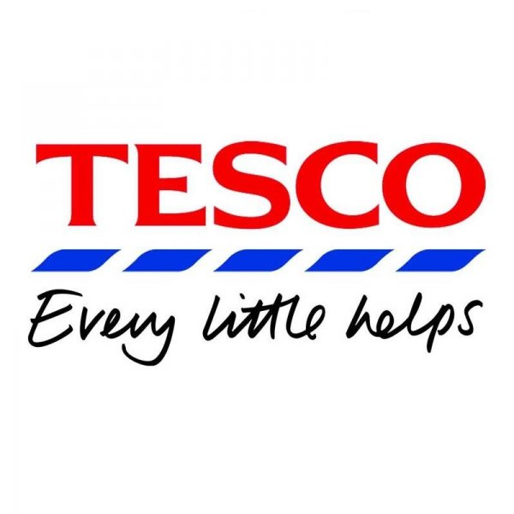
A the individual's character, growth, or general well-being are improved by this theory. It raises employee efficiency levels, guaranteeing that the leadership receives high-quality output.

Tesco Background
Whenever it regards food purchases, Tesco is doubtless one of the known ones retail companies in the Great Britain. Some might not know, that the company additionally fronts on to competition from various companies, inclusive of both general-purpose and grocery stores. The British universal has gained notoriety both via internal expansion and, most famously, by a number of tactical acquisitions.
Jack Cohen produced Tesco PLC in 1919 in London. At the time Cohen arrived home from a conflict, he opened a small shop-stand where he was selling foodstuffs and earned a interest of one pound on an overall of four pounds in selling.
Prior setting up the initial Tesco store in 1929, which distributed dry food and tea, Cohen began offering teas using the Tesco business name during the middle period of the ‘20s. Between the 1930s - 1940s, Cohen extended his firm by obtain additional shops and put money into self-service option in stores. With the name Tesco Stores, the business began merchandising in the London Stock Exchange. The goods for sale of the store has begun trading on the interchange by the wider symbol TSCO and is an element of the FTSE 100 Component guide.
Possessing greater than 6,800 stores all over Europe and Asia, the business is presently is included in the most prominent marketers in worldwide.
Firm’s accessions have given outstanding to its expansions. During the ‘50s, Tesco began buying supplementary firms, continuing doing so nowadays.

Tesco products
Tesco’s ranges of production has expanded to balance a variation of needs, besides to its firstly concentrations on aliments. It possesses shops in multiple formats, consisting of larger, smaller, online, and one-stop, which are distinguished by sizes and diversity of goods sold. Tesco provides immense alternatives of alimentary and not only items, consisting of fresh food, drinks, bakeries, groceries, home and entertainments, furnishings, baby items and toys, apparel, home appliances, chilled food, pet items , beauty/wellness products, electronics and household appliances.( Tesco, 2022)
At Tesco Bank in the UK, customers can get advisory, retail banking, and insurances. In addition, Tesco is offering its clients fuel stations and clothing products.
Tesco is prominent for selling excellent and qualitative goods. Considering they have superb connections across its suppliers, theirs products must be adequately priced. Tesco is unwilling to renounce to quality for everything, which includes the cost. They provide stock conforming their clientele.

Target Market
A marketing mix is an essential instrument to assess the current or potential marketing strategies for an item. The marketing strategy includes of the Four P in marketing:
•Prices
•Products
•Promotions
•Places.
Tesco has a privileged marque reputation and brings value to customers. It targets saving looking people who are caring about deals or reductions, and values varieties. In the 1990s, Tesco repositioned itself to be one offering convenient “Tesco Value” products, superior assortment under its Tesco Finest line.
Tesco has aimed to hit meddling ground through its marketing strategy by giving "valuable offerings” adjoining conventional choices out of the "finest line”. They planned its stores to offer all sorts of what customers asked for at the cost they afford and made that clear. ( Bradley, 2012)
Tesco constantly expands the selection in an attempt to serve to newcomers. Tesco announced a newly category of farm-fresh products in 2016, through very awaited step. Items being poultry, pork or beef, fruits engaged in a remarkable takeover as a way to attract consumers that were anterior price-conscious and have not buy Tesco stock. Goods

were 15% higher in price before the rebranding.

Profit margin
Tesco company said that their legit earnings for first part of fiscal 2022–2023 year went up by almost 7% (32.5 billion pounds).
Revenue for the company grew by three and a half percentage on a persistent-rate basis to 28 billions sterling pounds in prior half a year, except gasoline and TVA.
Considering that, Tesco's revenue from operations dropped by ~44% to £736 millions from £1.3 billions comparing same time preceding year.
Calculated operating earnings same time went down by ~10% at an averaged tariff to 1.31 billions sales.
Additionally, the business's adjusted profits per share, or EPS, fell by 67.9%, from £0.11 over the prior-year timeframe to £0.03. (Tesco, 2022-2023)
“All of us understand that our consumers are going through difficult circumstances and monitoring each penny in order to make ends meet," Tesco CEO Ken Murphy said.
“So, using the strong combination of the Aldi Price Matching , Lower Everyday Price or Clubcard Prices, collectively encompassing over 8,000 items, weeks in and weeks out, our team works tirelessly to maintain the overall price of the regular shopping as inexpensive as appropriate.
"Regardless of such uncertainty as inflation, we have established goals. We intend to keep trying to meet the requirements of every one of our stakeholders since Tesco possess the ideal lasting approach in place.
Furthermore, we will continually prioritise provision worthy to our clientele and helping them through manners we are capable to.”( Murphy, Tesco CEO)
Tesco stated that, in spite of struggles in the marketplaces arised from increased costs, it kept its projected profits inside its earlier level.
The corporation forecast a net income for the whole year ranging from £2.4 to £2.5 billions, adapted for retailing.

Main operations and employees
Tesco consists of the following types of operations:
- Operations. The productivity elements of Tesco' actions are service-orientated
- Outbound logistics; based on delivering the products to its customers, home delivery or pick up service.
- Support Activities
- Company Infrastructure; functions and cash control.
- Human resource management; recruitment and training of employees.
- Technology development; innovation and provision of products ranges and solutions.
UK Operations are based on six different types of stores, including: Superstore, Extra, Metro, Express, Homeplus, One Stop. Important to mention Online Shopping, which became highly successful.
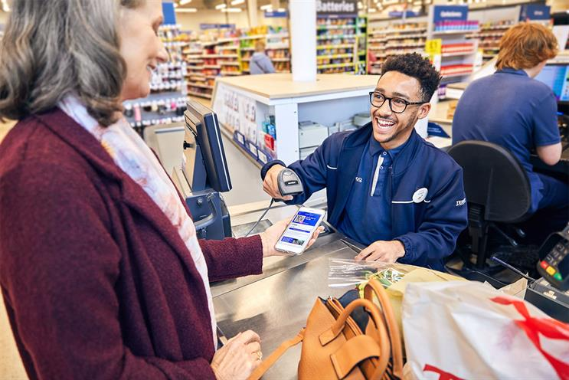
The company currently operates with around 423.000 employees, working through all company’s sectors.(Tesco, 2012)

Overview of theory of management exercises
Tesco needs handled , multiskilled, easy-going, and aware of customer’s demands staff to assist corporation’s expanding. In return, Tesco's workers get ssistance through the company in a range of aptitudes from store operators to departmental managers, from warehousing employees o office and logistics specialists. Tesco focuses on how primordial employees’ engagement is to the business’ everlasting achievements.
The research analyse investigates how Tesco motivates its staff by boosting their expertness, agilities, and grade of job engagement by way of training and growing career also by giving out pertinent and appropriate rewards and appreciation.
Motivating components can come from the want to be secure (inside needs), or from praises or rewards (external needs).
Staff motivation has been the theme of numerous theories. Salary being one of principal motivators. The acknowledgment of effort, a feeling of accomplishment, autonomy, chance for progress, challenge, plus satisfaction are further motivational aspects.
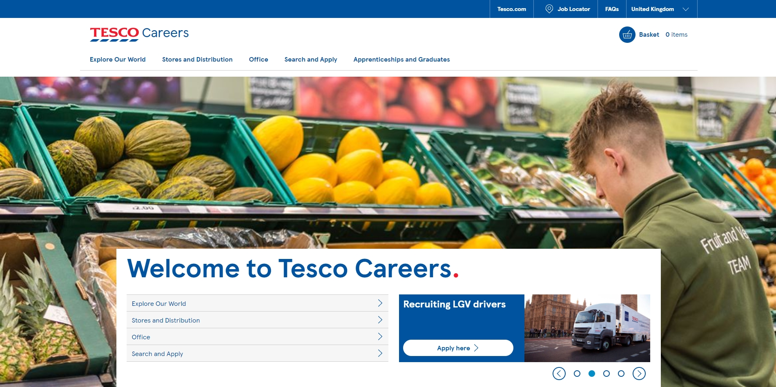

Benefits of motivated staff
A enthusiastic team will invest heavily effort and perform more in shorter time period, minimising labor expenses. It effects the client more since it needs less control and brings satisfaction in their performance. (Zao, 2014)
Committed personnel are more able to be focused, being less tended to errors, accidents, or disagreements. Also, employees get more loyal to the company and have lowered absences. The conversation would be true if a crew lacked motivation as they are unhappy with their place at the job. Creating a severe impact on either productivity and the effectiveness when performing their duties.
Appreciation of employees
Tesco has realized the valuability of development the appreciation and esteem. It also came across how increasing staff enthusiasm creates expressing people greater manners, maintaining achievable objectives,and developing an attractive workplace.
Driven employees at Tesco “perform in collaboration with colleagues to accomplish individually along with collective objectives," the company said. It shows that workers put costumer’s requirements first, respect everybody appropriately, and are willing to solicit input from others.
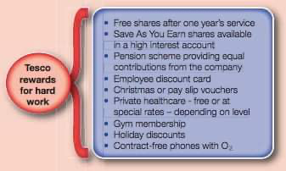
One of the firstly created theories of motivations was presented in 1911, experimented by the engineer Frederick Taylor. Taylor’s research studies showed that individuals performed just if they were paid. Working on a factory during the first period of the car assembly industry was monotonous and dependable on the amount of production. Working staff were paid " piece wage," or for every item manufactured.
The company prospered from compensation the employees regarding their outcomes. Increased production became a result, even though there were some chances for employees to think individually or perhaps use inventiveness at workplace. It developed employee’s capacity to grow still being handy for the company.( Bendix, 1956)

Rewards and staff satisfaction vs Mayo Theory
The social relationships style of thinking emerged as a result of Mayo Management Theory. It claims as the value of interpersonal connections, job happiness, and personnel enjoyment outweigh all other financial and working environment considerations. (Mayo, 1933)
Staff may and are inspired to improve their productivity through a series of non-financial sources. The goal to help someone could constitute a significant factor, along the want to promote individually or receive promotions. For example, a individual could be inspired to play professionally sport not for the money, but rather due their enjoyment for sport.
Tesco solicits company employees participation in a personnel fulfilment questionnaire named Viewpoint every year, that permits individuals sharing theirs thoughts in nearly all aspects of daily work. Tesco applies the research data to guarantee its workers the right stimulation to keep their motivation up. Some of the benefits offered to employees are:
• A leisure holiday has 4 up to 12 weeks off from working plus guarantee professional return afterwards.
•The work leave scheme enables workers to get up to 5 years off with the advantage of returning.
•Retirement plan is a honorable program offers definite long-term advantages.
An individual can be encouraged to alternate and improve their behavior by intern or extern reasoning. An inner component could represent the ambition to develop a newer talent, per example. The individual benefits in this case.
Selling targets or bonuses are some examples of extern elements.
No salary increase in case targets are not achieved can constitute a higher demoralising incentive.
Early in the 1930s, theorist Elton Mayo proposed how elements like the following could help to increase engagement at their job:
•improved communications
•effective cooperation
•demonstrating consideration for others
• including everyone
in making decisions
•guaranteeing their welfare
• keeping employment exciting and non-repetitive.
Mayo founded his theorems during employee interviews at the Western Electric Company's Hawthorne plant in Chicago.Hawthorne theory consists primarily of his work. He claimed that duties which were tedious and repetitive decreased people’s motivation. Mayo believed that showing personnel importance, offering employees certain discretions, while considering their interpersonal requirements will build stimulus. (Mayo, 1945).
Communications
The Mayo principle is definitely used at Tesco on a corporation basis. Staff incentives are highly impacted by communications. The workplace intranets, announcements,
1:1 conversations with managers, either bigger official frameworks like assessments might be taken into consideration.
Daily Team Meetings are put in place by management informing personnel about events and and give their Value Awards. Any personnel may hand out one of the distinctions to colleagues as meaning of expressing appreciation and recognize accomplishments.

Moyo theory in practice at Tesco
Tesco encourages motivation by plenty of possibilities for study and promotion. Everybody has accessibility to management training enabling individuals to advance inside the organisation additional to the training required to succeed in their jobs appropriately. Tesco supplies career counseling services to aid employees " accomplish the exceptional."
Tesco hired 3000 supervisors in 2009, where 80% came from within. The organization emphasizes the growth of the full individual and developed a program of 360 degree review furthermore to a yearly professional conversation with each worker. This interpersonal advancement solution provides the staff comments from a few persons they interact with regularly. Personnel may learn how colleagues receive their behaviour, ,skills , even limitations at job by doing so.
The scheme's approach aims to "Bring Others with Yourself" and "To Capture the Hearts and Thoughts of People" for developing individuals and accomplish tasks quickly.

Advantages and disadvantages of Elton Mayo Human Relations Theory
Pros:
The theory has potential for everyone at Tesco. It encourages productive dialogue and well-organized cooperation. It raises performance levels, placing a greater weight on employees' worth and enjoyment than on financial gain.
Cons:
As a result of the increased accountability and workload, pressure levels rise. The employees are offered wider freedom, therefore there is less supervision upon them. Numerous aspects are important for an employee's drive to operate; personal social ties cannot constitute the main motivator.

Tesco’s nature of conflicts and conflicts management
Most of Tesco's internal conflicts began when a specific modification was applied. Mitchell (2005) asserts that when there is change, there are generally victims and victorious although the former are frequently not particularly
satisfied. Tesco's disputes with the staff started in 2004 at the time they reduced sick payment as a solution to minimise the frequency of not planned absences.
Workers at Tesco had to pick between work while ill or receiving a significantly lower wage resulting from company's determination to restrict sick leave.
Meanwhile, the organisation succeeded in decreasing in worker unscheduled absences.
Conflicts among Tesco and regional retailers, clientele, and various organizations as well developed from business’ interest to buy different stores regarding its expansion. The UK Competition Commission looked into the retailer in 2006 to see if it seemed appropriated for it to be such a presiding status as it rendered smaller company proprietors impossible to function efficiently.
Constructive conflicts administration can be used to resolve the majority of inside disputes at Tesco. Tjosvold (2008) argues that not all disagreement is harmful and that, if handled correctly, it may actually enhance teamwork either inside and across businesses.
Tesco's inner battle among its workers has thus far been handled improperly, leading the increase in tensions while a negative influence on the business's reputation among members and customers. According to Valentine, Godkin, and Varca's (2009) concepts, Tesco has not practiced good levels of mindfulness in its interactions involving its workers, suppliers, and regional merchants.
According to Valentine et al. (2009), awareness is the capacity to analyze
both inner and outside circumstances in a way that will produce significant insights.
Controversy serves as a catalyst for the recognition and resolution of issues, according to Tjosvold (2008). On this occasion, practical conflict management approaches may allow staff become extra productive and innovative.
Group negotiation and mediation are the most effective conflict resolution strategies when negotiating with vendors and local merchants. The business must also establish a collaborative relationship-based environment of effective conflict control.

Conclusive summary
Elton Mayo's idea is applied at Tesco to encourage staff members through training and development programmes and communication. Direct communication with management , internal network, bulletins, or formal processes like assessments will help. Leaders give staff updates on the day's events as well.
Meanwhile, Tesco Supermarkets has struggled with disputes for a relatively lengthy duration, but by using effective conflict management strategies, it has been able to resolve some of its issues. Its marketability and productivity have both benefited from this.

Reference list
Bendix, Reinhard ( 1956). Taylor and Mayo compared. In J. C. Wood & M. C. Wood (Eds), George Elton Mayo. London. ( Accessed: March 8, 2023)
Bradley, A. 2012, ‘Case study: Tesco.com, United Kingdom’, Dematic Logistics Review,16-17. (Accessed: March 2, 2023)
Mayo, E. (1919) Democracy and Freedom: An Essay in Social Logic. Melbourne: Macmillan. ( Accessed: March 11,2023)
Mayo, E. (1922a) `Industrial Peace and Psychological Research. I. ( Accessed: March 11,2023)
Mayo, E. (1933) The Human Problems of an Industrial Civilization. New York: Macmillan. ( Accessed: March 11,2023)
Mayo, E. (1945) The Social Problems of an Industrial Civilization. Boston, MA: Harvard University Press. ( Accessed: March 11,2023)
Mitchell, C. (2005). Conflict, Social Change and Conflict Resolution: An Inquiry. Berlin: Berghof Handbook for Conflict Transformation (online). Web. (Accessed: March 6, 2023)
Our history (no date) Tesco PLC. Available at: https://www.tescoplc.com/about/our-history/ (Accessed: March 2, 2023).
Singsit, J. (2022) Tesco reports 6.7% rise in statutory revenue for H1 2022/23, Retail Insight Network. Available at: https://www.retail-insight-network.com/news/tesco-revenue-h1-2023/ (Accessed: March 2, 2023).
Taylor, F.W. (1911) The Principles of Scientific Management. (Accessed: March 10, 2023)
Taylor, F., W., The Principles of Scientific Management, Dover Publications, 1998. (Accessed: March 10, 2023)
Tesco 2012, Creating good jobs and careers: Health and safety. Web. (Accessed: March 10,2023)
Tjosvold, D. (2008). The conflict-positive organization: it depends upon us. Journal of Organizational Behavior, 29: 19–28. ( Accessed: March 2, 2023)
Valentine, S., Godkin, L. & Varca, P. (2009). Role Conflict, Mindfulness, and Organizational Ethics in an Education-Based Healthcare Institution. Journal of Business ethics, 455-469 ( Accessed: March 7, 2023)
Zao, S. 2014, ‘Analyzing and evaluating critically Tesco’s current operations management’, Journal of Management and Sustainability, vol 4, 184-187. (Accessed: March 7, 2023)

