

Melanie Okine
1907289
BMSW4004
Problem solving and Decision Making
Magdalena Wronska

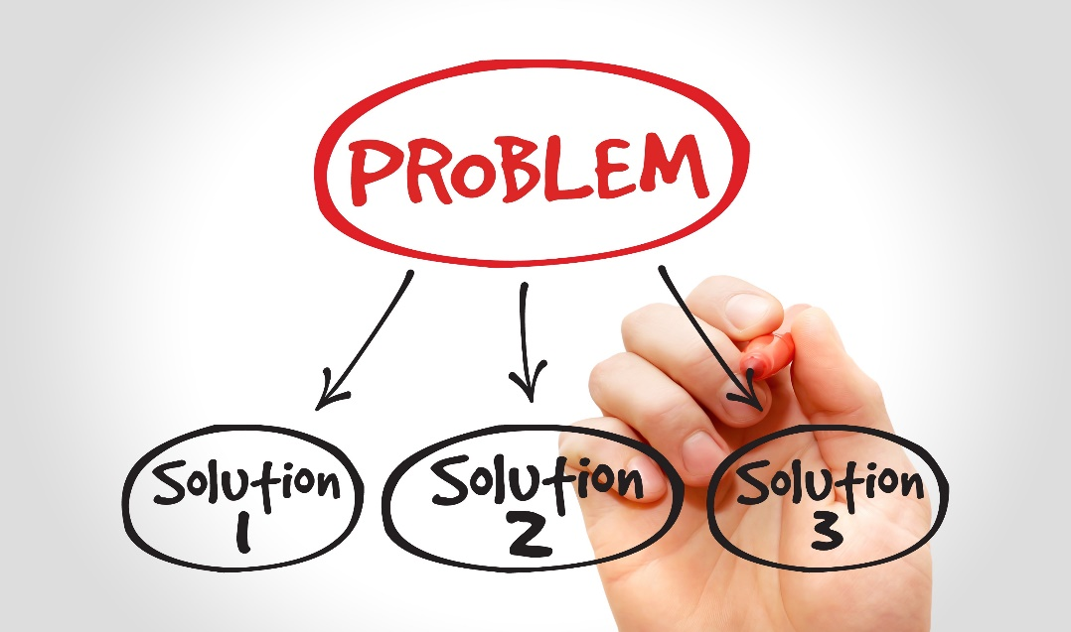

Contents
Introduction 3
Definition of the problem within the workplace 4
Analysis of the problem 4
Alternative solutions for limited flexibility 5
Implementation of solutions 7
Evaluation 7
Conclusion 8
References 9
Appendix 10

Introduction

Finding solutions to complex problems within the workplace where job dissatisfaction is an issue using the PESTLE analysis which is an external analysis; Political, Economic, Social, Technological, Legal and Environmental focusing on the individual aspects that can affect your business (Kenton, 2020).
Cause and effect analysis, which can be demonstrated in the form of the fishbone diagram focuses on the 6 M’s: Method, Machine, Materials, Manpower, Measurement and Management; the 4 P’s: Place, Procedure, People and Policies; the 4 S’s: Surroundings, Suppliers, Systems and Skills. Brainstorming is also vital in the decision-making process. The use of various decision-making tools and perspectives is of paramount importance in order to produce the best solution (Lin, 2018) and then implementing them accordingly.

Definition of the problem within the workplace

The most common problem within CGL is the need for flexibility, this has resulted in copious amounts of stress and the inability to complete tasks timely and effectively resulting in extensive backlog and tasks not being fully completed. This has contributed to not only employee dissatisfaction, but also to the dissatisfaction of clients. Additionally, it has caused an abundance of frustration within clients as their requirements have not been met in their timescales and to their satisfaction.
Flexibility is an important occupational aspect that employees are required to exhibit, as there are times when they need to complete some of their colleagues’ tasks and take on some of their clients when they are unable to be present and undertake their duties. As some clients require immediate assistance and cannot always wait for their own keyworkers, and it is crucial because there are medications that need to be prescribed and cannot be put on any unnecessary hold; also, employees have to deal with clients with very complex, unique needs so the importance of seeing them is paramount. Furthermore, staff need to be flexible to do home visits as and when it is required; this can put a lot of pressure on employees as there is such an enormous workload to be completed in a considerably tight timeframe.
The current Covid-19 pandemic has drastically impacted the population as a whole as millions of people are instructed to work from home and there is limited space and resources available; as a result, there is a need for even more flexibility. As the work undertaken at CGL is extremely sensitive and confidential, some tasks cannot be performed from home, resulting in a greater responsibility for those in the office as some may have health conditions and cannot be present in the office whatsoever; hence, the necessity for employees in the office to be even more pliant with their time and duties.

Analysis of the problem

To investigate the primary problem in the workplace, a survey was distributed to all employees; majority of employees stated the obligation to possess a lot of flexibility in their job was the main issue within the workplace. Once the problem was identified, the next step was to analyse and dissect the problem of flexibility. The first step would be to break the problem down into easily attackable sections. The next idea to be considered would be the most important factor of all. Firstly, the need for flexibility, the clients being the top priority and how they need to be assisted. What can be done at home and what needs to be done in the office, what are the highest priorities, medium priorities and lowest priorities. Then, it would be beneficial to split tasks into four sections. The first section is Urgent/Important; this section would consist of the most urgent and important tasks that have fast-approaching deadlines that cannot be altered; these would be the first major tasks that need to be completed. Next, there would be the section of Not Urgent/Important, these would be the tasks that are deemed important but not urgent enabling employees to dedicate additional time on these tasks without having to worry about the stress of upcoming deadlines. The next section would be Urgent/Not Important; the tasks under this area need to be completed urgently, however they are not as important as the previous section. Lastly, Not Urgent/Not Important; these tasks can be easily eliminated (Vrabie, 2014). Also, there would be a need to consider the external factors that are contributing to this primary problem, the best way to approach this would be by conducting a PESTLE analysis; this consists of investigating Political, Economic, Social, Technological, Legal and Environmental factors (Simon, 2020). Covid-19 would be identified in this analysis as it is an enormous external factor that has significantly impacted workplaces globally, not only at CGL; Covid-19 has given rise to numerous rules being imposed by the Government; social distancing, lack of space and transportation issues amongst a wide range of other factors have been influenced. (White, 2017).

Alternative solutions for limited flexibility

It would be advantageous to begin by having three different sections consisting of high priority, low priority and medium priority; these can be easily established with careful analysis of all the information, this may be time consuming, but it will allow for maximum efficiency in the long run. Then, considerations of who is most needed in the office on certain days and are the volunteers able to carry out their duties at home, making space for more qualified workers to be on site to complete tasks effectively. Is there any way to make more space, can the staff and meeting rooms be converted into spaces to hold more employees in the office, can the organisation source more computers? Can laptops be distributed so that working from home can be made more secure and less susceptible to breaches of confidentiality, allowing staff to undertake all necessary tasks without coming into the office? What can be conducted online, what needs to be done face to face and who is best suited to facilitate these tasks? Is putting out a recruitment advertisement to employ additional staff viable, can the existing employees and volunteers undergo training with aims to work at a faster pace enabling them to take on some of the clients and workload? These are all options that need to be explored and critically evaluated further.
Therefore, after careful analysis of all these factors the idea would be to start working towards finding the best solutions that will suit all concerned. One way this can be facilitated is by conducting a brainstorming session as this is a widely used and successful thinking technique (Adair, 2013, p. 57). This technique was first introduced in the 1930’s so it has been utilized for ample time and is a very effective way to generate ideas. This allows everyone’s creativity to come to life without fear of criticism, all employees are able to come together and collectively project their ideas no matter how unusual their ideas may seem; all ideas can be adapted and built on to create perfect solutions to various issues. (Adair, 2007, pp. 67-70).
Also, to complement this, an Ishakawa fishbone diagram can be drawn, putting all of the potential causes of the problem onto the diagram; with the input of all employees, they can generate many more causes to the problem than management can do alone, as they are the ones actively fulfilling the job and therefore, will have great knowledge regarding the problems that they are facing due to the initial issue of the need for a higher level of flexibility (Morgan, 2017, p. 299).
All of the causes identified would then be placed directly onto the diagram; at the mouth of the fish would be the root problem, and in this case that would be the need for a high level of flexibility, with all of the causes branching off in the shape of the fishbone. (Lin, 2018).

Once all the causes are established, individuals can collectively work on finding solutions for these problems. After deciding that these were the techniques that were going to be used, an email was sent out to all the employees at CGL, a notice was also put up in the staff room and supervisors and line managers were tasked to remind employees of the upcoming dates and times of the brainstorming sessions; it was then decided that three brainstorming sessions should be facilitated. From each of these brainstorming sessions plentiful causes were identified, which enabled
everyone to produce multiple solutions. After each brainstorming session it was decided that two solutions would be taken from each group, which totalled to six solutions in all.
To decide on which of these solutions were the most viable, a PMI for each of these solutions was then put into place; PMI stands for plus, minus and interesting. This is a technique used to evaluate the effectiveness of each solution enabling the company to find the best ones to implement resulting in a higher success rate.
Each solution will be split into three sections: the plus being the positives, the minus being the negatives and the interesting. Next, would be to rate each positive from plus 1-10, the negatives from minus 1-10 and the interesting would also be plus 1-10. Once this has been completed and all the information has been inputted into the table and it has been rated from 1-10, the next task is to add it all together to get the total, and this was done on all six solutions that were chosen from the outcome of the brainstorming sessions. From the six chosen, the three solutions that rated the highest would the ones that would be actively implemented.

Implementation of solutions

All three solutions were then taken to the board and once they were agreed upon they were discussed in the morning briefing meeting where management was able to receive feedback from all staff members in the office and those at home online. After lengthy discussions, everyone agreed that these could be implemented successfully. The managers for each team were then given the task to obtain all the resources necessary for these to be executed. The first being working from home on a rota basis, the second being to train up the volunteers through e-learning and shadowing enabling them to fulfil some of the duties and thirdly was the online groups, completing assessments over the phone and doing keywork sessions over the phone where possible.
Once these were all tangible and all resources were sourced to facilitate, a decision implementation plan was drawn; this would include the action required, who or what department would be responsible for each task, the priority of each task, the status of each task and any notes relating to each task. These were then all put onto a Gantt chart to ascertain time frames; when they would start, when they would be completed and the duration of each task. Once all of this was completed, a memo was then sent out to all employees informing them of everything that had been implemented.

Evaluation

Halfway through each task a feedback form was handed out to all employees to determine if everything was going according to plan and if anything needed improving or if it was not working at all. After receiving back all the completed feedback forms, everything appeared to be on the right track although a few slight improvements were necessary which were able to be executed in a timely manner. On completion of these, satisfaction surveys were handed out and the results that came back were outstanding, proving the implementation of the solutions to be a success.

Conclusion
Problems in the workplace exist on a vast scale, however with careful and strategic planning and implementation solutions can be successfully obtained resulting in a happier workplace environment and reducing the stress levels promoting healthy wellbeing. The use of various techniques: brainstorming, cause and effect analysis, PESTLE analysis, implementation plans, Gantt charts, feedback forms and satisfaction surveys resulted in the smooth investigation, transition and running of solutions to every apparent problem. There are countless problems, but where there are problems, many solutions can be found.

References

Adair, J. (2007) Decision Making & Problem Solving Strategies. London: Kogan Page Limited.
Adair, J. (2013) Decision Making & Problem Solving Creating Success. London: Kogan Page Limited.
Kenton, W. (2020) PEST Analysis. Available at: https://www.investopedia.com/terms/p/pest-analysis.asp (Accessed on 24 August 2020).
Lin, A. (2018) Tulip. Available at: https://tulip.co/blog/lean-manufacturing/fishbone-ishikawa-diagram-for-root-cause-analysis/#:~:text=The%20Fishbone%20Diagram%2C%20also%20known%20as%20the%20Ishikawa,Diagram%20is%20an%20effective%20technique%20for%20causal%20analysis. (Accessed: 29 August 2020).
Morgan, P. (2017) The Business Student’s Guide not Study and Employability. London: Sage Publicationns Ltd
sigma.com/tools-templates/cause-effect/cause-and-effect-aka-fishbone-diagram/ (Accessed on 29.09.2020).

Simon, K. (2020) THE CAUSE AND EFFECT (A.K.A. FISHBONE) DIAGRAM. aVAILABLE AT: https://www.isix How to improve your time management skills with the urgent-important matrix

Vrabie, A. (2014) Sandglaz Blog Archive. How to improve your time management skills with the urgent-important matrix. [blog]. 3 June. Available at: https://blog.sandglaz.com/the-urgent-important-matrix/ (Accessed: 29 August 2020).
White, S. (2017) How to do Pestle Analysis a Killer guide/Allassignmenthelp.com-Best Academic Helper US and Australia. [blog]. 5 July. Available at: https://www.allassignmenthelp.com/blog/how-to-do-pestle-analysis-a-killer-guide/

Appendix



