Strategic Management

Tesla’s Entry into the U.S. Auto Industry

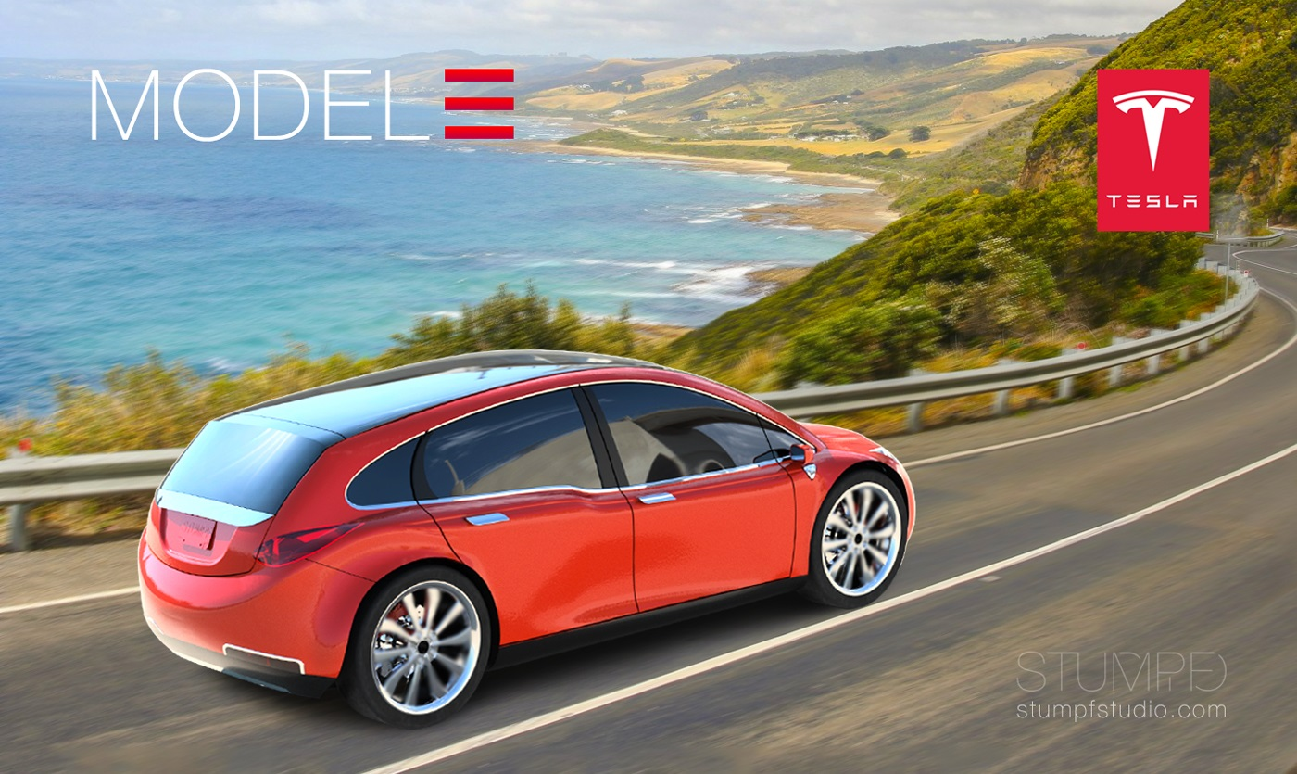

Strategic Management (LCMB7003)
Name: Curtis McKenzie
Student Number: 1808750
Lecturer: Gladius David Kulothungan
Date: 3/05/2022



This Photo by Unknown Author is licensed under CC BY-SA

Table of content

Introduction 2
Organisational background and performance 2
Market analysis of automotive industry 4
Tesla’s Entry into the U.S. Auto Industry 10
Strategic planning of the organisation Tesla 12
Technology at Tesla 14
Conclusion 16
Reference List 17

Introduction
Strategic management is the process of setting the goals procedures and corporate objectives to make the company more competitive. Through strategic management practice, the organisations try to establish the company in the market and gain high market share by providing the best quality products and services across the target markets, so that the customer’s base can also be strengthen in long run. Through this study, it is possible to analyse the strategies of the organisation by applying different theoretical principals and models of strategic management. The organisation considered in this study is Tesla, where the organisation aims at entering USA market through automotive industry expansion and providing the best quality automotive cars to the customers. Such initiative of Tesla provides a scope to the company to run their operations efficiently and establish their position in the auto industry of the USA. The strategic models are implemented in this case, to evaluate the strategies of Tesla as well as the market condition of the auto industry over the period of time. Tesla is a famous car manufacturing company that focuses on setting appropriate objectives and conducting in depth critical analysis and ensure strategic formation through utilising the organisational resources and capabilities. The organisation tries to expand their operations through manufacturing the electric cars and ensure sustainable market development. in the recent era of globalisation, the demand for electric cars is increasing and it further influence the company to manufacture electric cars for serving the customers in a better way with a safe and sustainable product.

Organisational background and performance
Tesla is an American electric vehicle and clean energy company, based in Texas. It designs and manufactures the electric cars, battery energy storage from home to grid scale, solar panels, and solar roof tiles as well as other related products and services. The organisation is efficient to manage their manufacturing units by enhancing business creativity and implementing latest technology. The organisation becomes world’s most valuable companies and remains the most valuable automaker with a market capitalisation of nearly US $ 1 trillion. The organisation is successful in maximising their sales volume battery electric vehicles and plug in electric vehicles capturing 23% of the battery electric market and 16% plug in market in 2020. Hereby, Tesla is successful to expand their business with the best quality products and services. Through the subsidiary Tesla energy, the organisation also develops the Photovoltaic system in the United States. Tesla Energy is also one of the largest global suppliers of battery energy storage systems, with 3.99 GWh installed in the last year 2021. The organisation has been founded in the year of 2003 and the organisation serves different are like North America, Oceania, East and West Asia as well as Europe (Tesla, 2022a).
There are more than 655 retail stores, through which the organisation can expand their operations and enhance sales volume, so that the profit and revenue of Tesla will be maximised in long run. In the recent era of globalisation, the people are concerned about protecting the natural environment and for which they try to use the sustainable products and surmises. Total revenue of the firm in the last year was US $53.8 billion and the operating income was US $6.52 billion. The brand is financial stable to run their business activities and retains more customers in long run. Net income of the firm was US $5.52 billion in 2021, and total asset was more than US $62.1 billion. The organisation is hereby efficient to maximise their revenue and total asset which further influence the organisational managers to make creative decision and run the business sustainably for gaining the best competitive advantage in the electric car industry. The company focuses on developing product portfolio and manage it efficiently by implementing latest technology, executing electric batteries and plug in process for the cars. The products include Model S, Model 3, Model X, Model Y, power wall, power pack, Mega pack as well as Tesla energy software, Solar Panel and Solar Roof. All the products are sustainable, and the organisation can provide green environmental footprint (Tesla, 2022a).
The product portfolio further influences the customers to make fair decision for the products and be responsible to create safer world in near future. On the other hand, the services of the organisation are such as vehicle servicing, software updates, up-gradation of latest technology, premium connectivity, charging and insurance. All the services are efficient to ensure customer relationship management, where the organisational representatives can meet the client’s requirement through providing continuous support. The organisational production output must be evaluated for under4standing the operational activities of Tesla and as per the annual report of Tesla, there was 930422 vehicles have been manufactured in the last year 2021. Additionally, 3.99 GWh battery energy storage systems have been delivered to the customers along with 345 MW solar products. Hereby, the organisation is running their operations sustainably and manufactures the sustainable products which secure future sustainable development. Tesla is successful to maintain strong employee base, there are more than 99290 employees, who are efficient to contribute in achieving the organisational success the employee base is strong at Tesla, where all the workers are technical skilled and they are proficient to run the operations, production of the cars and maintain warehouse so that the aim of serving the customers with the best quality products can be fulfilled (Tesla, 2022b).

Market analysis of automotive industry
The passenger cars and the demand for the electric cars are growing at a rapid rate over the period. In 2008, due to Great Recession, the sales volume for the vehicles has been dropped tremendously, but later the phase, US economy was in the phase of recovery. There was high disposable income, increasing opportunities for credit which further influence the customers to make effective purchase decision for the automotive products and services. The Americans prefer big cars and 7 million new cars sold in the United States in 2016. There are different car manufacturing companies, and they launch new cars with innovative specifications that further influence the clients to make effective purchase deal (Siegfried, 2021). There are increasing numbers of car manufacturing companies, running their operations across the USA market where the sales volume of the customers is increasing over the period. As per the figure below, General Motors is grabbing the marketing opportunities and in 2020, the market share of the company was 16.88% where Ford’s markets hare was around 14.29% and Toyota with 13.87%. There are other competitive brands that are operating with their quality products and services and the companies are such as FCA, Honda and Hyundai as well as Nissan, Volkswagen, Tesla, BMW. All the companies are well known firm operating across the international markets due to high growth of the auto industry; the organisations are trying to expand their operations across the globed. Tesla also focuses on expanding their services around the USA market with the best product portfolio management (Rastvortseva and Shchitova, 2020).
Figure 1: Competitive brands in auto industry of the USA
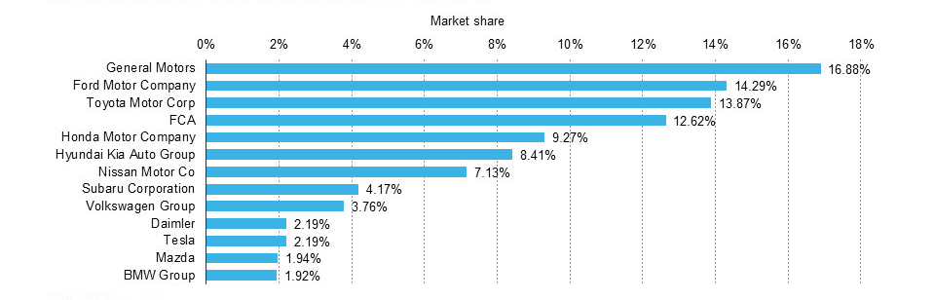
(Source: Serohi, 2021)
In addition to this, the US connected car sales are also increasing over the years, with technical up-gradation and business creativity. There is latest technology in the cars, where Tesla also focuses on developing connected cars of providing the best quality and sustainable products to the customers. The technologies are shred and upgraded to manage the product innovation, where the customers get the best quality automotive products and services (Serohi, 2021).
Figure 2: US connected car sales
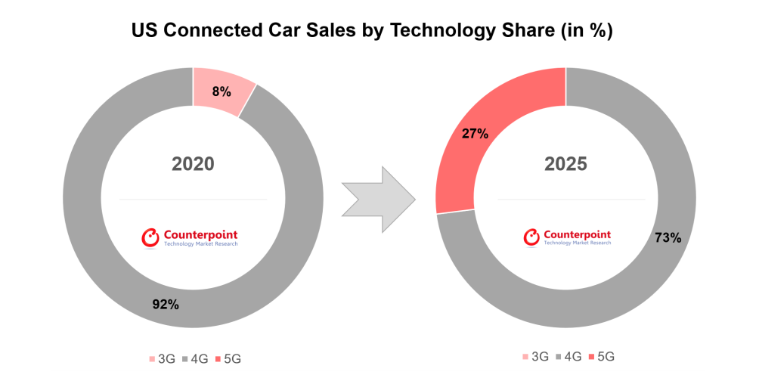
(Source: Serohi, 2021)
With technological innovation and business creativity, the organisations in automotive industry are trying to develop post effective practice to manage the production process of the vehicles. In this regard, the organisations try to reduce the price of the products and maximising the production outcome to ensure good economies of scale. Such initiatives further improve the organisational efficiency to serve the customers with the latest products and services. As per the figure below, the price of the batteries is being deteriorated over the period of time, which further influences the buyers to make effective purchase decision for the battery cars. There is increasing demand for the electric cars and such price reduction is beneficial for the organisation to manage their manufacturing process innovatively and deliver the products at affordable price.
Figure 3: Battery price keep tumbling

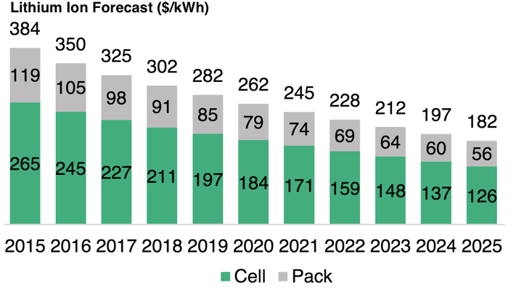
(Source: Lang, Reber and Aldori, 2021)
Car market is expanding with latest technology and creativity in designing the cars. Electric car demand is also increasing where the buyers become concern about using the electric vehicles for reducing greenhouse emission (Lang, Reber and Aldori, 2021). In this regard, as per the market analysis, it has been explored that, automotive market is growing rapidly by value, and by 2030, USD 5.29 billion value will be created. The automotive block chain market is projected to reach by 31% and it is associated with increasing the product quality efficacy along with reduced cost of the vehicles. It is the fastest growing industry with technologically advanced block chain solutions and significant importance of investing in automotive industry solutions.
Figure 4: Car market value chain

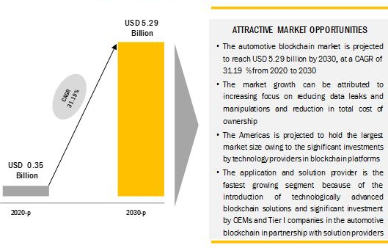
(Source: Bogers et al., 2019)
As per the figure above, the car manufacturing companies are growing with a rapid rate for providing the best quality products and services. In this regard, there would be approximately 50% growth in the automotive industry by its volume, where the production and sales volume for the electric cars will be doubled (Bogers et al., 2019). The customers prefer to purchase electric cars for choosing sustainable solutions and creating safer world in near future. Such purchasing decision making practice further ensures high growth of the electric car industry in the recent years. there are other competitive firms operating in the market with good brand value, such as Mercedes-Benz ($34 billion brand value), BMW ($31 billion brand value), Ford ($14 billion), Toyota with $45 billion, Honda with $26 billion and Audi ($14 billion).it is difficult for the organisation Tesla to run their operations efficiently and gain high market shared. The other organisations are also strong to operate across the global electric car industries. As per the Porter’s five forces analysis, the major forces are threat of new entrants, threat of substitute products, competitive rivalry, and bargaining power of the customers and the bargaining power of the suppliers (Morgan, 2017).
In this regard, there is intense competition in the automotive industry for which their competitive rivalry is operating efficiently to gain better competitive advantage as compared to other car manufacturing companies. On the other hand, the threat of new entrants is medium for Tesla, as the organisation is also ready successful to establish their brand and expand their services with designing and delivery of the best quality products. Japanese companies Toyota and Honda are efficient to expand their services across the USA along with the Korean company Hyundai. On the other hand, the companies like Toyota, Daimler, Nissan, and BMW are also proficient to run their operations and expand by opening new factories across the USA. The bargaining power of the customers is medium along with medium power of the suppliers to bargain as the organisation tesla has strong customers base and they are also successful to retain the supplier for running their operations sustainably. However, due to existing competitive brands, there is medium switching cost of the customers and suppliers for which the bargaining power of the stakeholders is being deteriorated.
Through the market analysis, it is possible to analyse the buyer pattern of the customers, where the product specification, the requirements of the clients and technical updates can be reviewed. As per the figure below, the major factors of making buying decision for the electric cars are such as safety, design of the car, price, spaciousness, personal preferences, stability for everyday use, driving comfort, high quality, and fuel efficacy as well as good warranty and customer’s services.
Figure 5: Customer purchase decision making practice
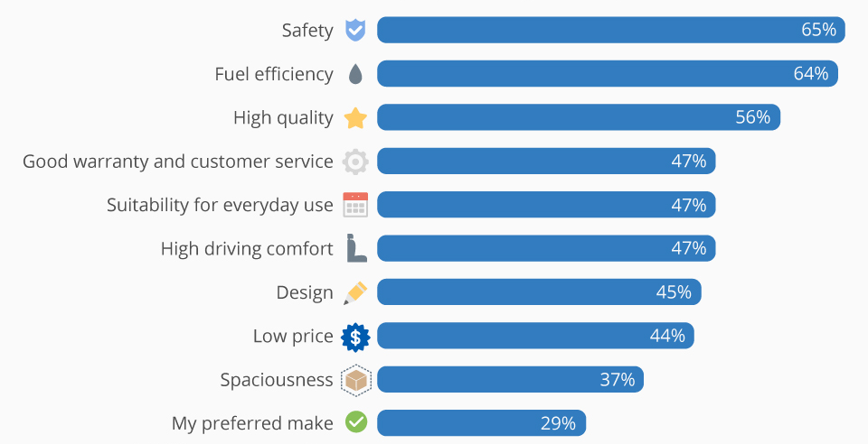
(Source: Thomas and Maine, 2019)
The organisations in the automotive industry are concerned about the specifications of the cars to target the audiences. as per the customer behavioural practice, there are five stages for making the purchase, which are identifying town requirements, search new information, evaluative alternative products, and services, making the purchase and post purchase evaluation. The clients are hereby trying to identify the needs and preferences in order to search further information related to the products (Thomas and Maine, 2019). It is important to gather the information about the fuel efficiency of the car, latest design, and price level of the cars as well as internal space, comfort ability during driving, additional features of the cars, latest technology used to manufacture the products, safety, warranty, and customers services. After evaluating alternative products delivered by other competitive brands, the clients make the purchase decision. Post purchase evaluation is also important, where the organisations must provide good customer services, meet their expectations, and fulfil their requirements (Tesla, 2022b).
Hereby, the automotive market is rapidly growing and there is sustainable growth and development of the car manufacturing companies. Recently, the people across the globe are updated with latest technology and they are concerned about environmental protection and healthy living. hence, the product preferences have been changed over time, where the demand for the electric cars is increasing at a high rate and it further influence the car manufacturing companies like Tesla, Volkswagen, BMW, and Honda to renovate the cars with latest design and technology in order to meet the customer’s preferences. Such initiatives further increase the competitive threats among the companies, where there is increasing availability of the electric car products across the US market (Fisher and McCabe, 2019). The US market is rapidly growing with strong customer’s base. The customers prefer big cars with innovative specification, where they can access all the information about the electric cars available in the market. Though there are high threat of substitute products and intense competition, the organisations can run their business creatively and retain the target audiences with the latest products and services. For example, Tesla is also efficient to run their operations with continuous innovation and brand creativity. There are different car models, with quality battery and plug in electric cars. The customers can choose the products available in the market after in-depth research so that they can enjoy the best products at its best price. In such market condition, tesla tries to expand their operations across the USA by establishing factories and the store expansion, so that brand visibility can be ensured. The customers can review the products and services of Tesla and make effective purchase decision for getting the best electric cars and contributing positively to environmental footprint (Tesla, 2022b).

Tesla’s Entry into the U.S. Auto Industry
Tesla was found in California in 2010 and it moved its corporate headquarters and opened a powertrain development facility in Palo Alto. In December 2021, Tesla officially reallocated its headquarters to Texas. Retail store of the company was established in Los Angeles in 2008, and the brand was successful in expanding their operations in major US cities of September 2020. The organisation operates through 130 stores and galleries in the United States. Tesla's first assembly plant occupies the former NUMMI plant in Fremont, California, known as the Tesla Factory. The battery production facility was opened on Nevada in 2016 that produces power packs, mega packs and power walls, battery cells in the partnership with Panasonic. For further expansion of the company, as part of the acquisition of Solar City in 2016, Tesla acquired Giga New York located in Buffalo, New York. The organisation is also efficient to diversify their products and services for gaining high market share in the United States (Shiddiq, 2020). In 2017, the factory started to manufacture the solar shingles for Tesla Solar Roof. In order to assemble photovoltaic modules at the plant, the organisation has developed partnership with Panasonic. As per the figure below, the organisation is also efficient in innovating their product and services. Tesla has been successful to improve the innovative car making activities by more than 17% to target the audiences and providing safe and newly designed cars.
Figure 6: Tesla out innovate the traditional carmakers
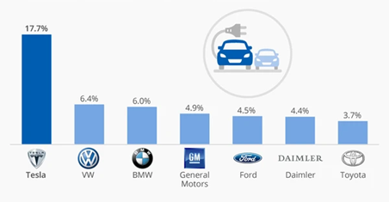
(Source: Thomas and Maine, 2019)
For developing sites of Gigafactory 5, the organisation picked Austin in 2020 with the aim of opening factory. Giga Texas has been planned for the major factory for the Tesla cube truck and Tesla Semi. It is beneficial for the company to produce the Model 3 and Model Y cars for the eastern United States. Moreover, the company acquired a former JC Penny distribution centre in 2021 for building a mega factory to produce mega packs that the next generation mega packs to use prismatic lithium iron phosphate batteries. As per the research, by 2030, 95% of U.S. passenger miles could be served by on-demand autonomous electric vehicles and it would be possible to drop the private car ownership in the USA by 80%. The shift to mobility-as-a-service is effective that ensure less importance of private car ownership in the country (MacDuffie, 2018). Connectivity is being ensured by the organisation for developing integrated services, with digital connectivity. Connected cars have variety of sensors and signals that are helpful for the customers to interact with other vehicles and ensure safe driving. The major elements of such cars are such as human machine interfaces, adaptive driver assistance systems, infotainment, touch screen sensor and communication practices (Tesla, 2022b).
In addition to this, the organisation is efficient to manage their operations across the USA, through establishing the factories and opening new stores in the areas for targeting the audiences in long run. Connected car revenue was expected to surge from $53 billion in 2017 to $156 billion by 2022 and it further influence the organisation Tesla to develop the connected car system through partnership with other car manufacturing companies. Panasonic is the current partners; it aims at developing former partnership, with Daimler AG, Mobileye, and Toyota. Through service innovation, the organisation is also efficient to expand their operations across the USA, in 2014; Tesla launched the "Destination Charging location" network that provides chargers in hotels, shopping centres, resorts and restaurants. Destination chargers are installed free of charge by Tesla-certified contractors. Car navigation system and destination charging are helpful to satisfy the clients (Akakpo et al., 2019). Insurance is another service, that the organisation provides insurance to all the customers. Vehicle servicing practice and connectivity are also beneficial for Tesla to develop the organisational practice and renovate the products and services for satisfying the consumers across the USA. Such initiatives of Tesla are effective for entering into USA market and gain highly competitive advantage over other firms. It is possible for the organisation to invest in business and renovate their products and services to create customer’s values (Tesla, 2022b).

Strategic planning of the organisation Tesla
In order to expand the organisational operations across the international markets, the companies in automotive industry focus on renovating the business and implementing the latest technology. Through 4P marketing strategic planning, it is possible to analyse the business strategy of Tesla, and as per 4P, the factors are products, pricing, places, and promotion.
- Product and pricing
During the establishment of tesla, 2003, the electric vehicles were very expensive and in 2006, Elon Musk declared that the organisational ain strategy is to first produce high price and low volume vehicles, which includes sports cars and for the customers who are less price sensitive. Progressive arrangements, technical innovation and creativity of Tesla further help the brand to reduce the price of the batteries and manufacture high volume cars further. Tesla's first vehicle, the Roadster, was low-volume and the price was about $ 1000000, and the next model of Tesla are Model S and Model X, which are confortable and affordable for the customers. This is also luxury vehicles, and the most recent model of test is Model 3, and it launched Model Y where the price ranges are lower than others (Perkins and Murmann, 2018). The company is successful to maintain high volume market by selling over 100,000 vehicles each quarter. Hereby, as per Porter’s generic strategy, the organisation aims at product innovation to maintain profit portfolio of the brand.
The company is successful to diversify their products and implement product differential strategy by continuous creativity in manufacturing the cars and utilising upgraded technology to launch the electric cars at affordable price. Such initiatives are beneficial for the organisation to expand their services across the USA market and gain highly competitive advantage. There is intense competition in the US automotive market, and Tesla focuses on both the business strategies of product diversification and practicing tactics so that it is possible for serving the customers with the best quality and designed electric vehicles at effective price. Cost leadership strategy along with product diversification practice is hereby the best strategic planning of the brand to target the audiences and maximise their revenue in long run (Välikangas, 2018). The pricing strategy is suitable for maintaining high volume production and increasing economies of scale. Additionally, technology is playing a crucial role which influence the organisation to design the best quality electric vehicles, battery, and other solar products along with the services like charging points, software updates, insurance, and vehicles servicing, which make the brand innovative in the automotive industry (Tesla, 2022b).
- Places and promotion
For brand expansion, Tesla not only focuses on auto dealership to sell their vehicles, but also it sells the cars through the organisational website and network of the company owned stores. This is the first manufacturing company that sells the vehicles directly to the consumers and provide the best services to all the buyers around the US (Teece, 2018). The company designs their website and there is a feature called gallery, where the company aims to educate and inform customers about their products. In total, Tesla operates 400 stores and galleries in more than 35 countries and the stores are in retail shopping districts, inside the shopping malls, near auto dealership and high traffic areas. Hereby, the organisation promotes their brand through store expansion and promoting the organisational website. Physical stores are situated across the SA where the company can display the products and interact with the customers directly in the store. On the other hand, the strategy of selling the products directly through the organisational official website is also one of the best practices to engage with the buyers across the social communities and retain them for long run (Tesla, 2022b).
The front desk staff members of tesla are efficient to connect with the customers through the website activities, where the online buyers can review the products, access the services, get continuous support in choosing the best quality cars as per their personal choice and preferences. Such activities further create strong client base by ensuring loyalty and trust among the buyers. The organisation is hereby efficient to strengthen their customer’s base and retain the target audiences for the best electric vehicles at effective price range (Jing, 2020). It also focuses on strengthening the distribution channel and dealership for successful placement of the organisational products and services. Tesla utilizes its media presence and website to offer their online purchasing experience, and this further helps them to customise the products and deliver the best quality products to the clients. CEO Elon Musk engages with his loyal 17.9 million followers in twitter, and it is advantageous for the brand to promote the products and services across the markets through sharing true information related to the brand (Tesla, 2022b).

Technology at Tesla
- Battery
In order to expand the business of Tesla efficiently across the US and global automotive markets, Tesla focuses on technical innovation, which provides an opportunity to be creative and launch the best electric vehicles for satisfying the clients. Vehicle battery of Tesla is the one of the innovative parts of the business, where it contains small, cylindrical, lithium-ion commodity cells that is used in consumer electronics (Cooke, 2020). This version of cells is designed to be cheaper to the manufacture and it is also lighter standard cells by removing some of the safety features. Advanced thermal management system and intumescent chemical are effective to produce the battery and prevent fires. The batteries are placed under the vehicle floor, and it also saves the interior and trunk space but increases the risk of the battery damages by crashes or fire. The Model S was retrofitted with a multi-part aluminium and titanium protection system to reduce the possibility of damage. To expand their services in USA, Panasonic are Tesla’s suppliers of cells in the USA, and it operates with the company on producing cylindrical 2170 batteries at Giga Nevada. It is maintained efficiently with technical innovation and quality production, so that the customers can use their vehicles comfortably (Zhilkin and Kiryukhina, 2021). As of January 2021, Panasonic has the capacity to produce 39 GWh per year of batteries at Giga Nevada. The company launched its battery recycling operation at Giga Nevada in 2019 which is considered as innovative strategy for Tesla to create strong customers base and secure future sustainable development (Tesla, 2022b).
- Autopilot and self-driving
Tesla has developed autopilot which is an advanced drier assistance system that requires active driver supervision. Since 2014, the cars are shipped with sensors and software that supply the autopilot. Upgrading the sensor and software are hereby latest innovation of Tesla, through which the organisation has also launched HW2 in 2016 that includes eight cameras, forward facing radar and twelve ultrasonic sensors. HW3 was released in the early 2019 with powerful computerised system; employing a customer Tesla designed systems (Ingram, 2018). In 2019, Tesla announced the auto pilot software for the cars as standard feature moving forward. The self-driving software is being implemented with auto park, auto lance change, summon, smart summon and navigate on autopilot. Full self-driving (FSD) is an optional upcoming extension of Autopilot for enabling the fully autonomous driving. However, The National Transportation Safety Board has called for changing the design to ensure it cannot be misused by the drivers. Hereby, tesla is efficient to manage their operations and manufacture high quality electric cars and renovate the cars through autopilot technique, which includes quality radar, cameras, and ultrasonic sensor. On the other hand, the organisation is efficient to develop the motors for the electric cars. It designs three phase four pole alternating current induction motor with copper root, which is used in different cars like Model S and Model X. The permanent magnet motors increase efficiency, especially in stop-start driving (Tesla, 2022b).
The business strategic planning is effective to meet the mission of the organisation, which is to accelerate the world’s transition to sustainable energy. The organisation focuses on managing the operations through creating integrated business. The workers are managed efficiently and currently there are more than 99,290 in 2021. The organisation is successful to maximise the revenue and profitability, through continuous improvement and employee’s management. the training and developmental program is organised for supporting the workers as well as the corporate managers at tesla try to develop partnership working practice, to manage the whole operations in an integrated way. The corporate governance is managed well, where there is the practice of equality and diversity, harmony, and freedom to work, managing the employees by work life balance, respect, and trust among the stakeholders, creating values for all the staff members working in the factories (Yavorsky, 2020). Such initiatives are beneficial for Tesla to create good working environment for the staff and continuously encourage them to show creativity and use latest technology for meeting the organisational mission. The products and service range are effective for maintaining sustainable solution, which is also beneficial for Tesla to expand their services and provide green environmental footprint. In the recent era of globalisation, the demand for the electric cars is increasing at a rapid rate and it further provides the market opportunities for Tesla which includes technical innovation, rise in production of electric cars and power battery as well as solar panel and others, to create values of the customers. Confortable cars, internal space, effective features including sensor auto pilot services, navigation and cameras ensure safe driving and retain the target audiences for making good purchase decision for their quality electric cars (Tesla, 2022b).

Conclusion
Through the discussion, it can be evaluated that, the organisation is able to maintain financial stability and enhance business creativity and technical innovation for further growth. The incorporation of electric vehicles in the market as well as technically advance battery use for the cars is the main success factors of Tesla. As per the financial performance, the organisation is also able to maximise their profitability and develop total asset, which further influence the company to expand their services and manufacture the best quality electric cars and other solar products. The organisational mission of accelerating the world’s transition to sustainable energy will be fulfilled through product quality management, service efficiency, technically advanced cars and battery, solar panel as well as social contribution. The organisation is also efficient to manage their resources and develop organisational infrastructure for manufacturing the products safely. The customer’s safety and conformability are also managed well, where the staff members are proficient to deliver quality services to all the clients and provide the best electric cars as per their personal choice and preferences. Through continuous improvement, technical innovation and managing the quality of the cars, the organisation would be able to gain highly competitive advantage in the USA and run their business operational activities profitably. It would be beneficial for the organisation to focus on more research and developmental programs to renovate the services and continuous production process of electric cars with latest features in it so that tesla would be able to gain high market share in automotive industry.

Reference List
Akakpo, A. Gyasi, E.A. Oduro, B. and Akpabot, S. 2019. Foresight, organization policies and management strategies in electric vehicle technology advances at tesla. In Futures Thinking and Organizational Policy (pp. 57-69). Palgrave Macmillan, Cham.
Bogers, M. Chesbrough, H. Heaton, S. and Teece, D. 2019. Strategic management of open innovation: A dynamic capabilities perspective. California Management Review, 62(1), pp.77-94.
Cooke, P., 2020. Gigafactory logistics in space and time: Tesla’s fourth gigafactory and its rivals. Sustainability, 12(5), p.2044.
Fisher, M., and McCabe, M.B., 2019. Tesla: Accelerating to Market. Journal of Strategic Management Education, 15.
Ingram, N. 2018. Tesla Motors: A Potentially Disruptive Force in a Mature Industry. International journal of management and applied research, 5(1), pp.8-21.
Jing, N. 2020. Research on Tesla’s Customer Care Innovation. In 2020 Management Science Informatization and Economic Innovation Development Conference (MSIEID) (pp. 469-478). IEEE.
Hooley, G. et al. (2020) Marketing strategy and competitive positioning 7th ed. Harlow: Person.

Lang, J.W. Reber, B. and Aldori, H. 2021. How Tesla created advantages in the ev automotive paradigm, through an integrated business model of value capture and value creation. Business & Management Studies: An International Journal, 9(1), pp.385-404.
MacDuffie, J.P., 2018. Response to Perkins and Murmann: Pay attention to what is and isn't unique about Tesla. Management and Organization Review, 14(3), pp.481-489.
Morgan, P. (2017). Business student's guide to study and employability. London: Sage Publications Ltd.

Perkins, G. and Murmann, J.P., 2018. What does the success of Tesla mean for the future dynamics in the global automobile sector? Management and Organization Review, 14(3), pp.471-480.
Rastvortseva, S. and Shchitova, S., 2020. FEATURES OF SHAPING THE COMPANY'S COMPETITIVENESS IN THE GLOBAL AUTOMOTIVE MARKET. Journal of Regional and International Competitiveness, (1), pp.71-82.
Serohi, A., 2021. E-mobility ecosystem innovation–impact on downstream supply chain management processes. Is India ready for inevitable change in auto sector? Supply Chain Management: An International Journal.
Shiddiq, M., 2020. Case Study of Tesla, Inc. as Dynamic Organization in Automotive Industry and How It Acts Amidst COVID-19 Epidemic. Inc. as Dynamic Organization in Automotive Industry and How It Acts Amidst COVID-19 Epidemic (April 30, 2020).
Siegfried, P., 2021. Finance Methods in the Automotive Sector–Business Agility in the Age of Digital Disruption. Available at SSRN 3979890.
Teece, D.J., 2018. Tesla and the reshaping of the auto industry. Management and Organization Review, 14(3), pp.501-512.
Tesla, 2022a. About us. [online] Available at: https://www.tesla.com/ABOUT (Accessed: on 20 March 2022).
Tesla, 2022b. Tesla Annual report 2021. [online] Available at: https://annualreport.stocklight.com/NASDAQ/TSLA/21598537.pdf (Accessed: on 20 March 2022).
Thomas, V.J. and Maine, E., 2019. Market entry strategies for electric vehicle start-ups in the automotive industry–Lessons from Tesla Motors. Journal of Cleaner Production, 235, pp.653-663.
Välikangas, L., 2018. Forum on Tesla and the global automotive industry. Management and Organization Review, 14(3), pp.467-470.
Yavorsky, D.R., 2020. Consumer Search in the US Auto Industry. University of California, Los Angeles.

Zhilkin, O. and Kiryukhina, S., 2021. Automotive industry: trends in the implementation of modern corporate strategies. In SHS Web of Conferences (Vol. 114). EDP Sciences.

"When something is important enough, you do it even if the odds are not in your favour."
Elon Musk CEO and Product Architect of Tesla




























17.9
14.7 13.5 12.9
9.8
8.6
3.7 3.5
3.1
2.3
2
1.9 1.9
1.2
0.9
0.2

