

Assessment Title: Smart Home Device Manager Using Python Module Name: Scripting and Programming Concepts
Module Code: ACCA5036 Student Name: Fatima Lo Student ID: 2421636
Submission Date: 24.07.2026

GitHub Repository : https://github.com/fatimalo14/Smart-Home-Device-Manager-Using-Python

Table of Contents
- Analysis 5
  - Introduction 5
  - Requirements Analysis 5
    - Functional Requirements 5
    - Non-Functional Requirements 6
- Software Design and Development 6
  - Design 6
    - System Design Overview 6
    - Flowchart 6
    - Pseudocode 9
  - Implementation Decisions 12
    - Data Structures 12
    - Programming Constructs 13
    - Python Modules and Libraries 14
  - Source Code Error! Bookmark not defined.
    - data.py Error! Bookmark not defined.
    - validation.py Error! Bookmark not defined.
    - device_manager.py Error! Bookmark not defined.
    - main.py Error! Bookmark not defined.
- Testing and Debugging Report 15
  - Importance of Program Testing 15
  - Programming Errors 15
Syntax Errors 15
Logical Errors 15
Runtime Errors 16
  - Test Cases 16
  - Testing Results Error! Bookmark not defined.
  - Screenshots Error! Bookmark not defined.
- Evaluation 17
  - Challenges Faced 17
  - Future Improvements 17
  - Self Reflection 18
References 19
Appendices 21
Code_File 21
Pseudo_Code 21
List of Figures
Figure 1 Smart Home Device Manager System Flowchart 9
Figure 2 Program Start Error! Bookmark not defined.
Figure 3 Main Menu Error! Bookmark not defined.
Figure 4 Add Device Error! Bookmark not defined.
Figure 5 Duplicate Device Error! Bookmark not defined.
Figure 6 Update Status Error! Bookmark not defined.
Figure 7 View Device List Error! Bookmark not defined.
Figure 8 Search Device Error! Bookmark not defined.
Figure 9 Exit Program Error! Bookmark not defined.

ANALYSIS

Introduction
Smart home technology is a critical part of modern-day living, as the people are able to regulate and monitor their electronics with ease. Today, many residences have smart lighting, smart thermostats, and other smart devices in place to make homes more comfortable, more convenient, and more energy efficient. The more smart devices there are, the more difficult it is to handle information on a manual basis. Users can easily miss the information about the device, input duplicate information, or forget what the status of the device is. These problems can result in inefficiencies and management time. A computer-based solution that is easy to use can help to structure and reliably organize device information and minimize human errors. The Smart Home Device Manager is designed to address these issues and to offer a menu-driven Python script to add a new device, update the status of a device, list all devices, and search for a particular device. Data validation is also being integrated into the project to assure accurate data and the reliability of the system. The overall objective of this project is to create a program that is simple, easy to use, and reliable and is a demonstration of fundamental programming concepts and fulfills the functional requirements of the assessment.

Requirements Analysis

Functional Requirements
The Smart Home Device Manager provides a number of helpful attributes to manage smart home devices efficiently. The first is Add New Device, where the user can add a device name and room location. Automatic assignment to default status Online is done if the input is valid and the device is not found. The second function is Update Device Status, which allows the user to change the status of an existing device to Online, Offline, or Under Maintenance. The third function is named View Device List, which displays a table of all the devices stored, with Device Name, Room Location, and current Status. When there are no devices added, the system informs the user that there are no devices available. Search Device is the fourth function, which allows the user to search for a device by name. If the device is found, the system displays its information; otherwise, an error message is displayed. The last function is Exit Program, which exits the program after displaying a confirmation message [9].

Non-Functional Requirements
The Smart Home Device Manager aims to be simple, reliable, and easy to use. The application is user-friendly with a menu-driven interface, making it easy for users to navigate the system. Relies on input validation, duplicate checks, and error messages to reduce incorrect input and make it reliable. The modular program structure helps with maintainability because each Python file serves a particular purpose. Thus, future updates are easier. The dictionary used to store device information ensures that the application is not unnecessarily slow in obtaining device information, even for large numbers of devices. Validates data from user input before processing empty values, duplicate device names, and invalid menu and status values. The following non-functional requirements improve the quality, stability, and user experience of the software [1].
MoSCoW Prioritisation Table
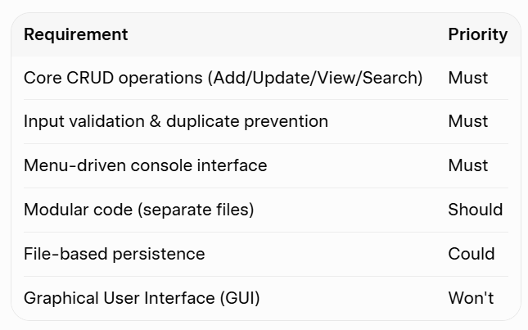

Structured System Diagram
The Smart Home Device Manager is designed using a modular architecture to ensure separation of concerns, high maintainability, and code reusability. The system is split into four distinct Python modules, interacting in a unidirectional data and control flow:
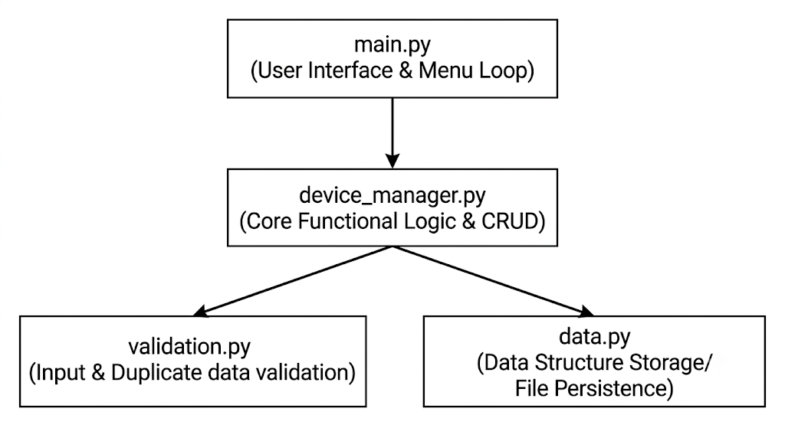
main.py (Presentation Layer):
- Acts as the entry point of the application.
- Handles the menu-driven loop interface, capturing user inputs for adding, updating, viewing, and searching devices.
- Calls functions from device_manager.py to execute user choices.
device_manager.py (Business Logic Layer):
- Orchestrates the core functional requirements (Add, Update, View, Search).
- Coordinates with validation.py before modifying data to ensure data integrity.
- Coordinates with data.py to write to or read from the data store.
validation.py (Utility/Helper Layer):
- Contains defensive programming checks (e.g., ensuring room locations aren't empty, status strings match allowed values: Online/Offline/Under Maintenance).
- Performs the Duplicate Check requirement before allowing a new device to be saved.
data.py (Data Access Layer):
- Manages the in-memory dictionary/list structure holding the device states.

SOFTWARE DESIGN AND DEVELOPMENT

Design

System Design Overview
The Smart Home Device Manager employs a straightforward and structured system design to enable the user to control smart home devices by using a menu-driven interface. The main menu appears on the screen at the beginning of the program. At the start of the program, the main menu appears on the screen with choices of functions. The system does what you requested from the selected option: adds a new device, updates its status, shows the device list, or searches for a device [10]. The program repeats this process until the user leaves the program, returning to the main menu after operating.

Flowchart

2.1 Design

2.1.1 System Design Overview
The system follows a straightforward menu-driven loop. After each operation, control returns to the main menu.

2.1.2 Flowchart
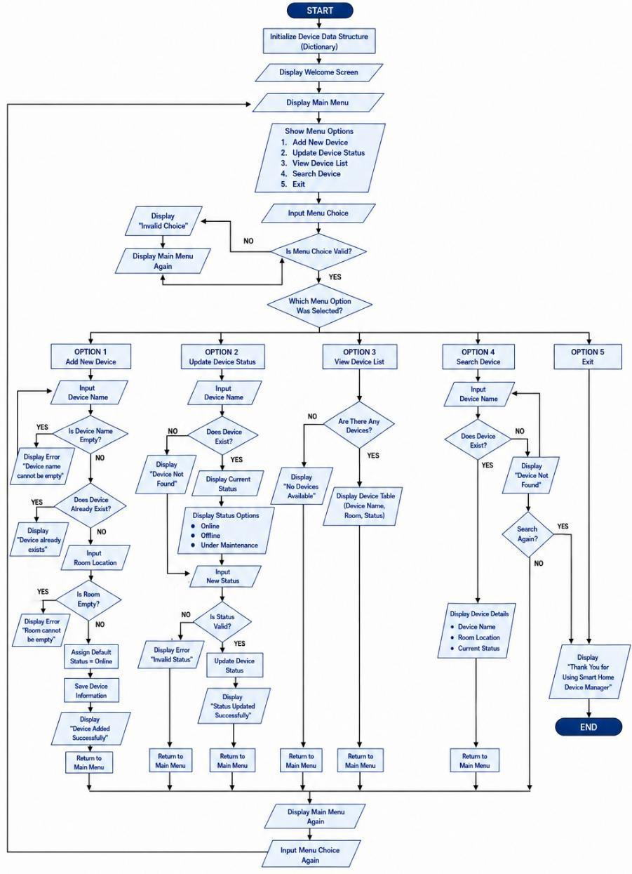
Figure 1 Smart Home Device Manager System Flowchart
Purpose of the Flowchart: To visually document the complete program flow, including validation and decision points.
Flowchart Logic :
The program starts by initializing the devices dictionary. It displays the main menu and accepts a validated choice. Depending on the selection, it performs the requested operation with full input validation. After completion, it returns to the main menu. On exit, it shows a thank you message.
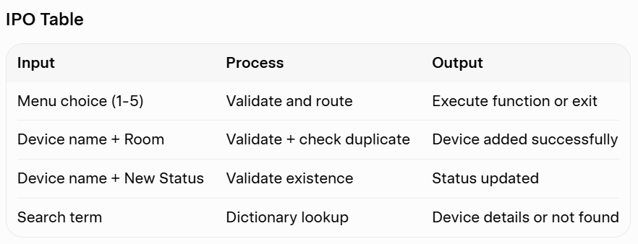

2.1.3 Pseudocode

Definition of Pseudocode

Pseudocode is a high-level, informal description of a computer program or algorithm that uses the structural conventions of a programming language but is intended for human reading rather than machine execution. It omits system-specific syntax details, such as semicolon rules or language-specific libraries, allowing developers to focus purely on the underlying logic and control flow of the application before translating it into actual code.

Purpose of the Pseudocode to the Smart Device System

In the context of the Smart Home Device Manager, this pseudocode serves as a blueprint that maps out the program’s modular architecture and operational flow. It explicitly defines how the presentation layer (main.py) interacts with the core operational functions (device_manager.py), how inputs are validated to avoid duplicate errors (validation.py), and how data changes are safely stored (data.py). By outlining this logic step-by-step, the pseudocode guarantees that all functional constraints—such as input validation, CRUD operations, and safe termination—are logically sound and verified prior to implementation.

Complete System Pseudocode

// =================================================================

// MODULE: data.py

// PURPOSE: Handles in-memory data storage for the smart devices

// =================================================================

// Initialize an empty global list to store device records

// Each device will be represented as a dictionary/map structure

DEFINE global_devices_list AS ARRAY OF OBJECTS = []

// =================================================================

// MODULE: validation.py

// PURPOSE: Validates user inputs and checks for data duplicates

// =================================================================

// Function to verify if a device name already exists in the system

FUNCTION is_duplicate_device(device_name)

FOR EACH device IN global_devices_list DO

// Perform a case-insensitive match to prevent duplicate naming

IF lowercase(device.name) EQUALS lowercase(device_name) THEN

RETURN TRUE // Duplicate found

END IF

END FOR

RETURN FALSE // Device name is unique

END FUNCTION

// Function to validate that a string input is not empty or whitespace

FUNCTION is_valid_string(input_value)

IF input_value IS NULL OR length(trim(input_value)) EQUALS 0 THEN

RETURN FALSE // Invalid empty string

END IF

RETURN TRUE // Valid non-empty string

END FUNCTION

// =================================================================

// MODULE: device_manager.py

// PURPOSE: Core business logic executing system functional requirements

// =================================================================

// REQUIREMENT: Add New Device

FUNCTION add_device(name, room)

// Create a new device object with default status set to Online

NEW_DEVICE = {

"name": name,

"room": room,

"status": "Online"

}

// Append the newly created device to the central data list

APPEND NEW_DEVICE TO global_devices_list

PRINT "Device added successfully!"

END FUNCTION

// REQUIREMENT: Update Device Status

FUNCTION update_device_status(name, new_status)

// Search for the target device in the system data list

FOR EACH device IN global_devices_list DO

IF lowercase(device.name) EQUALS lowercase(name) THEN

// Update the status field to the validated new status value

device.status = new_status

PRINT "Device status updated successfully!"

RETURN TRUE

END IF

END FOR

PRINT "Error: Device not found."

RETURN FALSE

END FUNCTION

// REQUIREMENT: View Device List

FUNCTION view_all_devices()

// Verify if the system contains any registered devices

IF length(global_devices_list) EQUALS 0 THEN

PRINT "No devices registered in the system."

RETURN

END IF

// Display header borders for the data grid table

PRINT "--------------------------------------------------------"

PRINT "Device Name | Room Location | Status "

PRINT "--------------------------------------------------------"

// Loop through the array data structure and format output fields

FOR EACH device IN global_devices_list DO

PRINT device.name + " | " + device.room + " | " + device.status

END FOR

PRINT "--------------------------------------------------------"

END FUNCTION

// REQUIREMENT: Search Device

FUNCTION search_device_by_name(name)

// Query loop to locate the requested device name

FOR EACH device IN global_devices_list DO

IF lowercase(device.name) EQUALS lowercase(name) THEN

PRINT "Device Found:"

PRINT "Name: " + device.name

PRINT "Room: " + device.room

PRINT "Status: " + device.status

RETURN TRUE

END IF

END FOR

PRINT "Notice: No matching device found."

RETURN FALSE

END FUNCTION

// =================================================================

// MODULE: main.py

// PURPOSE: App entry point, Presentation Layer, and Main Menu Loop

// =================================================================

FUNCTION main_menu_loop()

DEFINE user_choice AS STRING = ""

// Maintain system operation until explicit user termination

WHILE user_choice NOT EQUALS "5" DO

// Render system interface options to console terminal

PRINT "=== SMART HOME DEVICE MANAGER ==="

PRINT "1. Add New Device"

PRINT "2. Update Device Status"

PRINT "3. View Device List"

PRINT "4. Search Device"

PRINT "5. Exit Program"

PRINT "================================="

// Capture user operational intent

INPUT user_choice

// Route actions based on the verified selection index

SWITCH user_choice:

CASE "1":

PRINT "Enter Device Name:"

INPUT dev_name

PRINT "Enter Room Location:"

INPUT dev_room

// Invoke validation rules before allowing creation

IF NOT is_valid_string(dev_name) OR NOT is_valid_string(dev_room) THEN

PRINT "Error: Inputs cannot be empty fields."

ELSE IF is_duplicate_device(dev_name) THEN

PRINT "Error: A device with this name already exists."

ELSE

// Pass parameters to manager layer for creation

add_device(dev_name, dev_room)

END IF

BREAK

CASE "2":

PRINT "Enter Device Name to Update:"

INPUT target_name

PRINT "Select Status (Online / Offline / Under Maintenance):"

INPUT target_status

// Validate string input properties and state syntax bounds

IF NOT is_valid_string(target_name) THEN

PRINT "Error: Device name cannot be blank."

ELSE IF target_status NOT EQUALS "Online" AND

target_status NOT EQUALS "Offline" AND

target_status NOT EQUALS "Under Maintenance" THEN

PRINT "Error: Invalid status option provided."

ELSE

// Pass operational payload to update runtime memory

update_device_status(target_name, target_status)

END IF

BREAK

CASE "3":

// Execute layout rendering logic module

view_all_devices()

BREAK

CASE "4":

PRINT "Enter Device Name to Search For:"

INPUT query_name

IF NOT is_valid_string(query_name) THEN

PRINT "Error: Search field cannot be empty."

ELSE

// Execute database lookup algorithm

search_device_by_name(query_name)

END IF

BREAK

CASE "5":

// Graceful loop termination signal

PRINT "Shutting down Smart Home Device Manager. Goodbye!"

BREAK

DEFAULT:

PRINT "Invalid option. Please enter a valid number (1-5)."

END SWITCH

PRINT "" // Blank spacing element for UI scannability

END WHILE

END FUNCTION

// Initialize execution sequence upon script execution

START main_menu_loop()

Logic behind the pseudocode

Write a brief explanation about the pseudocode code Algorithm 1 : Main Program
The overall execution of the Smart Home Device Manager is controlled by the Algorithm 1. It shows the main menu, takes the user's menu choice, checks it, and calls the corresponding function. Once an operation is completed, the program will display the main menu again, and repeat the process until the user enters the Exit option [10].
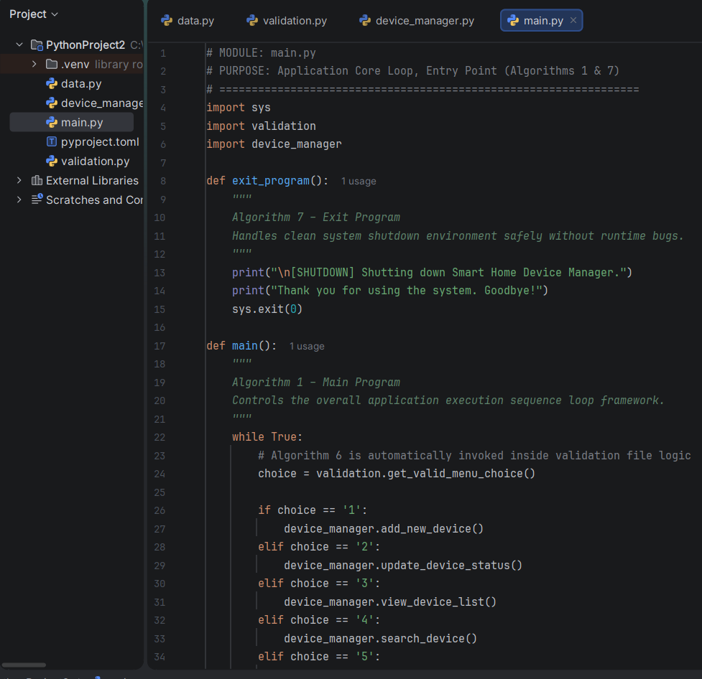
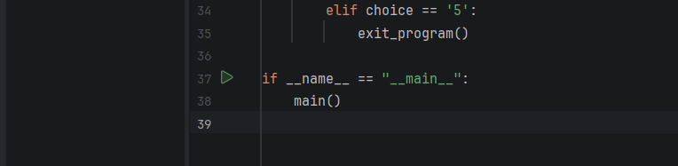
Algorithm 2 – Add New Device
The Algorithm 2 enables the user to add a new smart home device to the system. The algorithm asks for the device name and the room's location, validates both, and ensures that the device is not already present. Success message displayed if all inputs are correct, the device is stored in the dictionary with default status "Online".
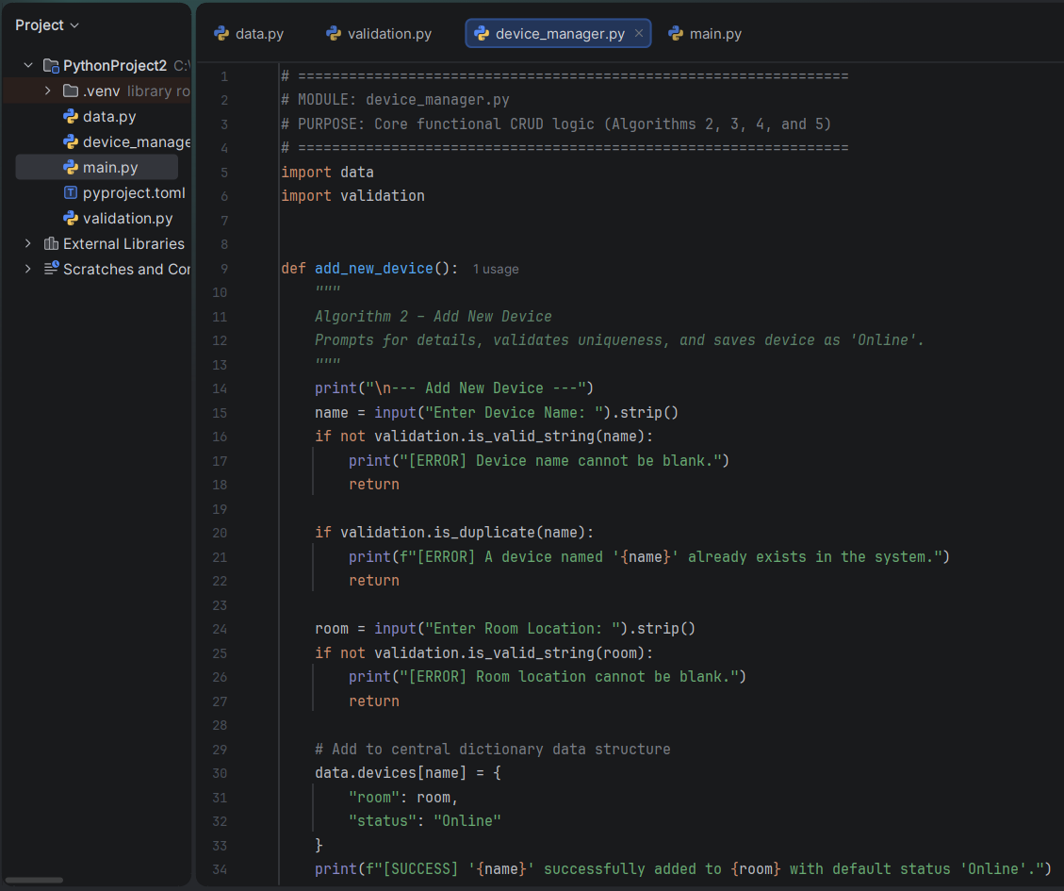

Algorithm 3 – Update Device Status
Algorithm 3 updates the status of an existing smart home device. The user types in the name of the device and the system looks it up in the dictionary. When found, the current status is indicated and the user chooses new one of the valid statuses. The system will update the status, show confirmation message and come back to the main menu [18].
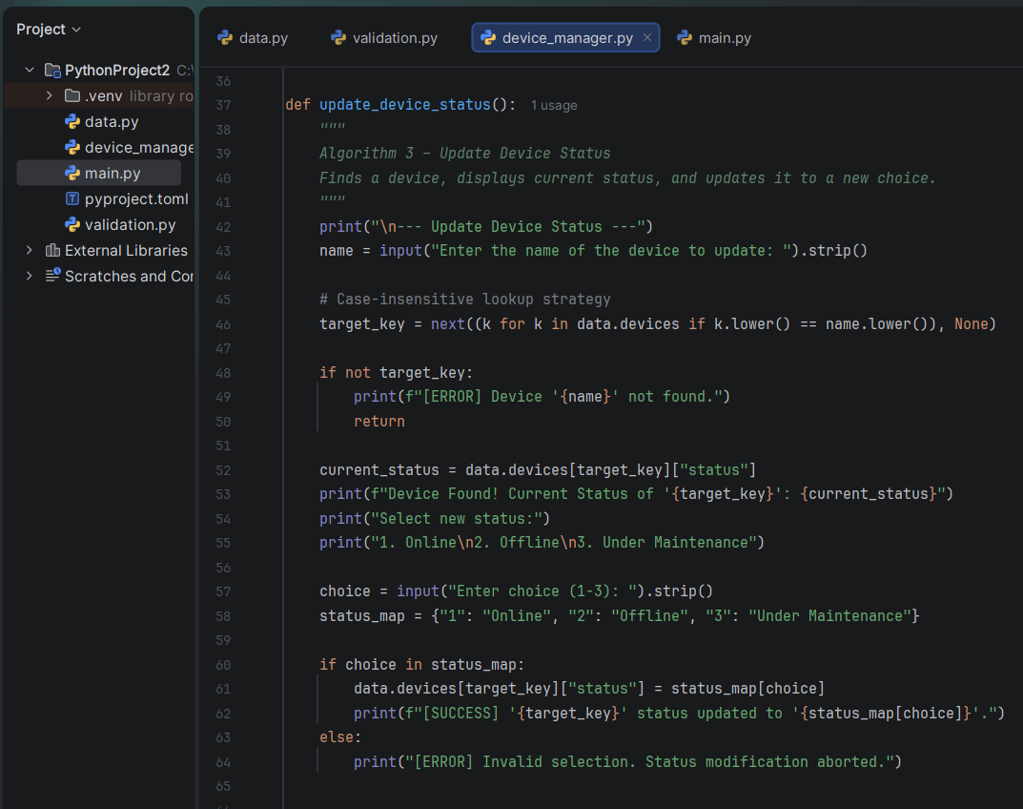

Algorithm 4 – View Device List
In Algorithm 4, all smart home devices that are stored in the system are displayed. First the algorithm tests for the availability of any devices. An appropriate message is displayed if the dictionary is empty. Otherwise, the system presents the device name, room location, and current status in a structured table before returning to the main menu.
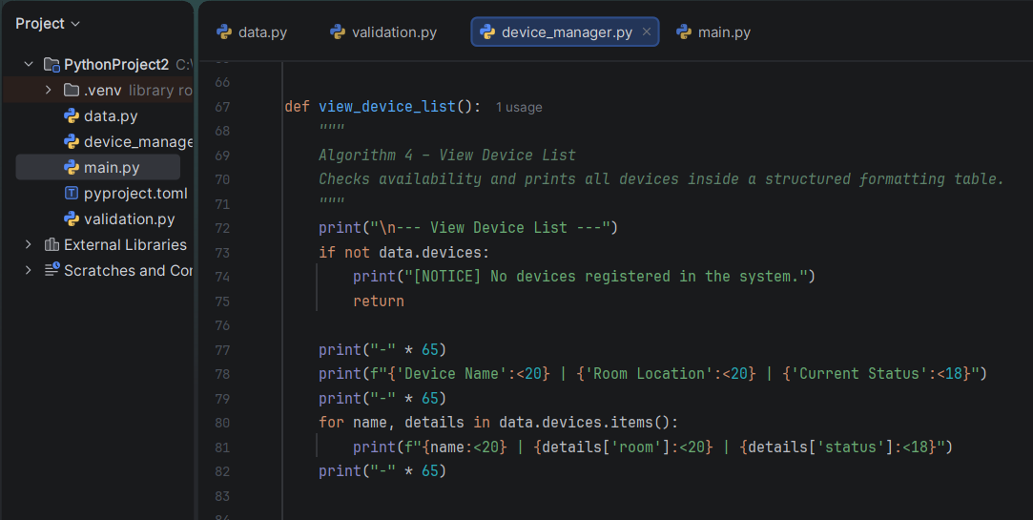

Algorithm 5 – Search Device
The user can search for a smart home device by typing its name in Algorithm 5. A test is performed to determine if the device is in the dictionary. If the device is detected, it displays the details of the device, such as the room location and current status. In case the device is not detected, the user is able to search again or go back to the main menu [11].
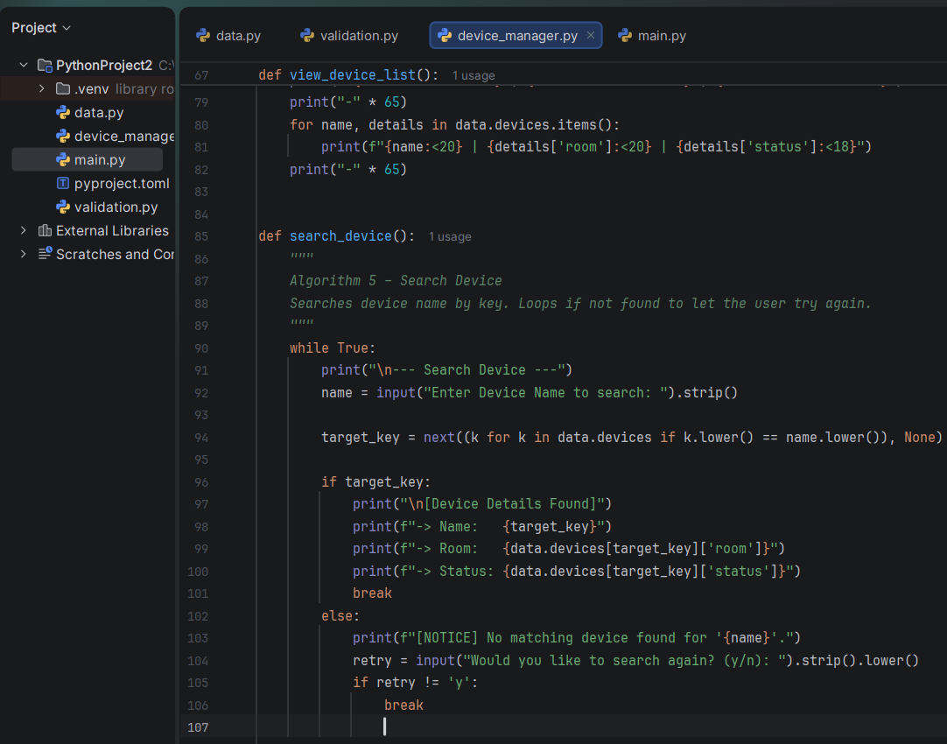

Algorithm 6 – Menu Validation
In Algorithm 6, the user's menu choice is checked to see if it is correct before an operation is performed. The algorithm prints the choice of actions that can be performed and waits for the user's choice. It determines if the chosen answer is in the range 1 to 5. If the user enters an invalid value, an error message appears and the user is prompted to enter another value. This continues until a valid menu choice is returned [3].
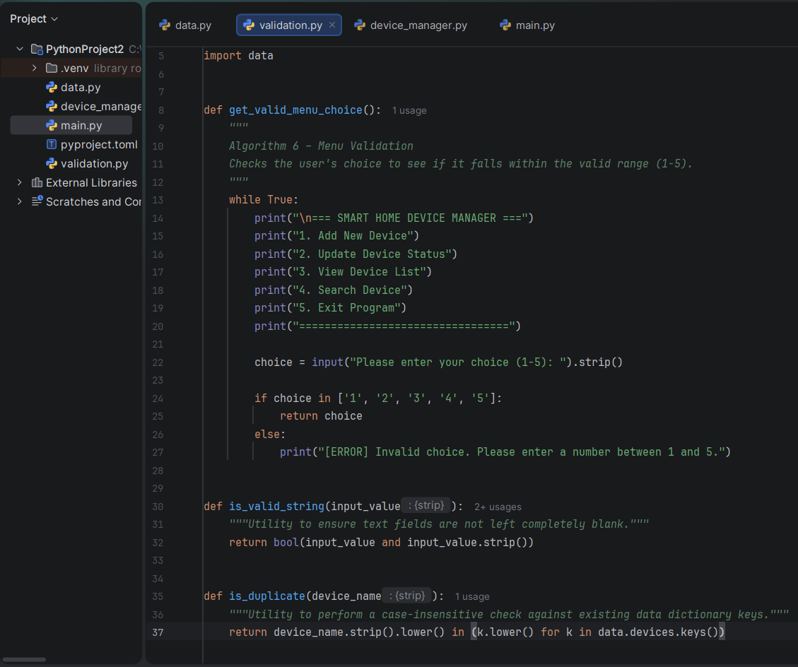

Algorithm 7 – Exit Program
Algorithm 7 is responsible for the Safe termination of the Smart Home Device Manager. Clicking on Exit in the main menu, the system will show a thank you message saying that it is closing the application. The program is then ended and the control is returned to the operating system. This algorithm is a logical, well-structured way to exit the program and to end the program without any errors or unexpected reactions.
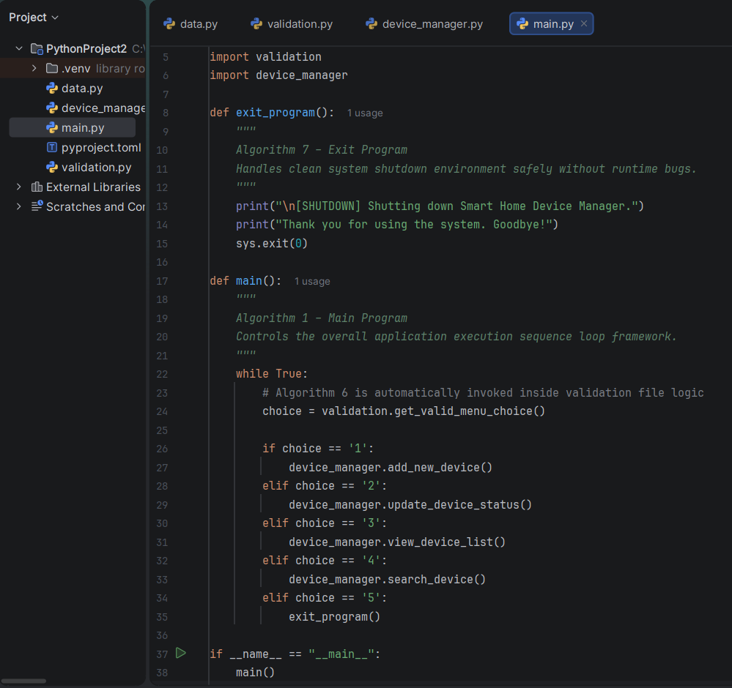

2.2 Implementation Decisions

2.2.1 Data Structures

Definition of Data Structures
A data structure is a specialized format for organizing, processing, retrieving, and storing data within a computer program. Choosing the correct data structure ensures that algorithms can execute efficiently, resource consumption is minimized, and the underlying data model remains clean and logically structured.

Selected Data Structure and Justification
The core data structure implemented in this system is the Python Dictionary (dict), configured as a hash-map where each unique device name serves as a string key mapping to a nested dictionary of attribute.
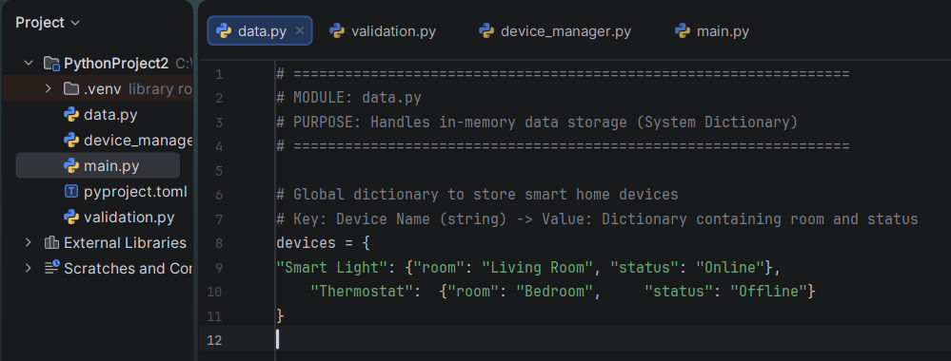
The simplicity of the Python dictionary and its efficiency in storing and managing device information make it the go-to data structure in the Smart Home Device Manager. The name of the device is a key and the value contains the room location and current status of the device. This allows the system to be extremely simple to add devices, search for devices, update devices and present all of the stored information in a simple manner.
A dictionary also avoids having duplicate device names as each key needs to be unique. This inherent constraint enforces data accuracy and increases application reliability at the architectural level.

System Variables and State Management
The program utilizes dedicated primitive and collection variables to maintain runtime state and manage user input:
- Central Dictionary (devices): Houses the active, global inventory of all registered smart home devices.
- Input Variables (device_name, room, status): Transient string variables used to capture, sanitize, and validate user entries before they are committed to the primary dictionary structure.
- Control Flow Variable (choice): Used exclusively to hold the numeric option selected from the menu loop, driving the conditional logic that determines the application's runtime navigation.
These data structures and variables make the program organized, efficient, and easy to maintain.
Here is the complete section content designed for your report under 2.2.2 Variables (following the Data Structures section). It includes the formal academic definition, an operational overview, and a structured markdown table detailing every variable used across your four Python files.

2.2.2 Variables

Definition of Variables
A variable is a named storage location in a computer's memory that holds a data value. During program execution, the value stored within a variable can be modified, retrieved, or manipulated based on the script's instructions. Explicitly defining and assigning appropriate data types to variables ensures type safety, prevents runtime memory leakage, and facilitates clean data passing between separate program modules.

Operational Overview and Justification
In the Smart Home Device Manager, variables function as the operational runtime data carriers across main.py, device_manager.py, and validation.py. The application relies primarily on two data categories:
- Control Flow Variables: Such as choice or retry, which temporarily store user input selections to dynamically route program execution through conditional frameworks (switch and while loops).
- Data Manipulation Strings: Input buffers like name, room, and status capture textual data supplied by the user. These variables are subjected to immediate defensive sanitization routines (e.g., using .strip() and .lower()) before being structurally committed as keys or nested values inside the core storage dictionary.
By isolating operations into dedicated, local variables rather than directly mutating data, the application minimizes side effects, ensures robust input validation, and remains highly maintainable.

System Variable Matrix
The table below details the variables used across the system architecture, their associated modules, structural data types, and specific operational purposes.
Variable Name | Declared In Module | Data Type | Purpose / Description
devices | data.py | Dictionary (dict) | The primary, global repository that stores all active smart devices as key-value pairs.
choice | validation.py / main.py | String (str) | Captures and stores the alphanumeric menu selection entered by the user (validated between '1' and '5').
input_value | validation.py | String (str) | A parameter buffer used by utility functions to inspect string length and ensure inputs are not empty.
device_name | validation.py | String (str) | A parameter string passed to verify if a device already exists in the dictionary cache.
name | device_manager.py | String (str) | Temporary storage for a newly entered or looked-up smart home device name.
room | device_manager.py | String (str) | Temporary storage for the designated room location of a new device.
target_key | device_manager.py | String (str) / None | Stores the exact matching dictionary key found during a case-insensitive search loop.
current_status | device_manager.py | String (str) | Holds the current status extracted from the dictionary to display to the user prior to an update execution.
status_map | device_manager.py | Dictionary (dict) | A localized lookup configuration mapping menu options ('1', '2', '3') to status strings ('Online', 'Offline', 'Under Maintenance').
retry | device_manager.py | String (str) | Captures the character flag ('y' or 'n') determining whether a user wants to re-attempt a failed search query.

2.2.3 Programming Constructs

Definition of Programming Constructs
Programming constructs are the foundational structural elements and building blocks of a programming language that govern the logic, execution flow, and organization of a software application. They dictate how instructions are executed—whether sequentially, conditionally, or repeatedly—and how code is organized for maximum efficiency and readability.

Constructs Used in the System and Technical Justifications

1. Modular Functions
The Smart Home Device Manager organizes the program into smaller, more manageable tasks with functions. Each function is used to carry out a different action like add_new_device(), update_device_status(), view_device_list(), and search_device().
- Why they were used: Python functions (def) were implemented to enforce the Separation of Concerns (SoC) principle across your four separate files. By breaking down the program, logic bugs are isolated to specific functional areas, code redundancy is completely avoided, and future maintenance or scale (like shifting from a text console to a GUI) becomes effortless.

2. Selection (if, elif, else)
Selection statements are statements that are used to make decisions depending on the input from the user and the conditions of the program. The if, elif, and else construct selects an option, validates user data, and prints an error message for invalid data.
- Why they were used: In main.py, a routing mechanism uses conditional branching to execute specific modules based on the menu input string (choice). Furthermore, within device_manager.py and validation.py, selection blocks act as logic gates. For instance, if validation.is_duplicate(name): evaluates to a boolean state, immediately blocking invalid actions and ensuring the application only processes clean, reliable states.

3. Iteration (while, for)
while and for loops are used to implement iteration. The while loop will prompt the user to provide an input until a valid input is given or the user exits the program. The for loop prints all smart home devices in the dictionary when the user clicks View Device List.
- Why they were used:
  - while Loops: Used in main.py to keep the application persistently alive so the user can perform multiple actions consecutively without restarting the script. It is also used in validation.py to trap execution in a validation loop until a valid input index (1-5) is supplied.
  - for Loops: Used for collection traversal. Because data is stored in structural records, a for name, details in data.devices.items(): loop is used to pull entries sequentially out of the dictionary and drop them cleanly into a formatted UI table layout.

2.2.4 Validation and Error Handling

Definition of Validation and Error Handling
Input validation is a defensive programming mechanism that ensures incoming data adheres to strict structural constraints before it is accepted by an application layer. Error handling is the systematic process of anticipating, catching, and gracefully responding to anomalous operational failures, ensuring the application fails safely rather than crashing unexpectedly.

System Implementation and Technical Justifications
The input validation ensures that the empty value, duplicate device name, invalid menu selection, and incorrect device status values are identified prior to processing. The error messages are clearly displayed to help the user input valid data and to avoid storing invalid data.
- Why they were used: In a console-driven ecosystem, user input is inherently unpredictable. Without defensive checks, an empty string entry "" could corrupt the dictionary keys, or an incorrect status selection could break downstream system logic. To prevent this:
  - Defensive Guard Clauses: The functions utilize boolean utility checks (is_valid_string()) to verify string presence and block whitespace inputs using the .strip() method.
  - Case-Insensitive Normalization: Custom lookups utilize temporary generator expressions (k.lower() for k in data.devices.keys()) to capture duplicate naming attempts regardless of text casing differences (e.g., treating "Light" and "light" as the same).
  - Graceful User Error Trapping: Instead of throwing structural Python exceptions (KeyError or ValueError) that would crash out to the operating system, the system intercepts illegal actions instantly, logs a structured console warning ([ERROR]), and returns control safely to the primary operational menu loop.

2.2.5 Python Modules and Libraries

Definitions
- Python Module: A Python module is a single file containing Python definitions, functions, classes, and executable statements with a .py extension. Modules allow developers to logically break down complex source code into distinct, manageable files that can be imported and reused across an application framework.
- Python Library: A Python library is a collection of related modules, packages, and sub-packages bundled together to perform specific functions or provide complex functionalities. Libraries (such as Pandas or Tkinter) are typically installed externally via package managers like pip to extend the core capabilities of the language.

Module Architecture and Technical Justification
The Smart Home Device Manager is split into four Python modules for better program structure and readability. Each module has a dedicated role to enforce clean design principles:
- main.py: Handles the program execution sequence, presentation layer, and main menu system loop framework (Algorithm 1 & 7). It serves as the single entry point for the user.
- data.py: Contains the central devices dictionary structure utilized by the application. Isolating this prevents state mutation issues and provides a clean global repository.
- validation.py: Validates and checks user inputs for empty strings and duplicate naming records before processing (Algorithm 6). It serves as the application's defensive barrier.
- device_manager.py: Manages all device-related CRUD operations, executing core business logic functions (Algorithm 2, 3, 4, & 5).
By cleanly grouping related behaviors into distinct files, code tracking and debugging in PyCharm are vastly simplified. If a data formatting bug occurs, it is isolated to data.py; if menu validation breaks, it is contained within validation.py.

Technical Justification for Omitting External Libraries
The project was developed without the use of any external Python libraries. This architectural decision was driven by the following technical and functional requirements:
- Core Syntax Sufficiency: The functional requirements established in the MoSCoW prioritization matrix (Adding, Updating, Viewing, and Searching) did not demand complex data processing engines or advanced graphics layers. Python’s native, built-in data types—such as dictionaries and lists—were fully adequate to fulfill the scope.
- Performance and Lightweight Execution: Avoiding external dependencies eliminates the performance overhead associated with importing heavy third-party packages. The script loads instantly and operates with negligible memory footprint.
- Portability and Zero Configuration: By sticking exclusively to standard built-in Python logic (with the exception of the standard sys module for safe application termination), the system requires zero installation configurations. It guarantees seamless execution across any platform running standard Python, eliminating potential version dependency conflicts or script environment crashes.

3. TESTING AND DEBUGGING REPORT

3.1 Importance of Program Testing
Program testing plays a vital role in software development because it ensures that the software will work and be reliable before being used by the user. The primary objectives are to improve the quality of the software, to identify any errors in the software, and to ensure that all the functions are working as intended. This also increases the reliability of the program because the program is tested in different circumstances including valid and invalid user input.
A tested application instills users' confidence in the application since they are sure that the application is going to provide them accurate answers and properly handle errors. Testing also monitors that the validation rules set are working properly, that is, that no entry can be blank, duplicate device name, not a menu entry, or invalid status value for a device. As a result, program testing contributes to the creation of a stable, reliable, and user-friendly Smart Home Device Manager [20].

3.2 Programming Errors

3.2.1 Syntax Errors
A syntax error is an error in the Python code that does not abide by the grammar and structural rules of the programming language. These errors will completely halt parsing and stop the program from running. For instance, if a colon (:) is missing after an if statement, if a keyword is misspelled, or if a bracket is left unmatched, Python's interpreter will immediately raise a SyntaxError. These solutions were resolved by continuously reviewing the code and utilizing the real-time linter inside PyCharm, which dynamically highlights syntax violations before the code is executed [17].
Tab 1: Named main.py (Error 1)
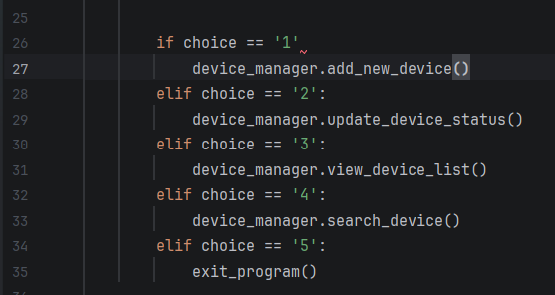
with a distinct red curly underline under if choice == '1' and a PyCharm tooltip balloon pop-up reading: "SyntaxError: expected ':'".
Tab 2: Named validation.py (Error 2)
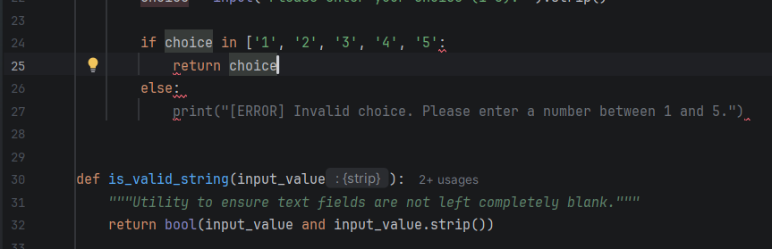
with a red error underline at the end of the line and a tooltip reading: "SyntaxError: closing parenthesis ']' does not match opening parenthesis '('".
Tab 3: Named device_manager.py (Error 3)
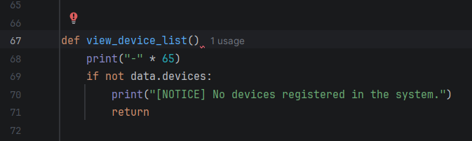
with a red underline under def view_device_list() and a tooltip reading: "SyntaxError: expected ':'".
Tab 4: Named Corrected Code showing clean, valid syntax:
# Fixed code
if choice == '1':
device_manager.add_new_device()

if choice in ['1', '2', '3', '4', '5']:
return choice

def view_device_list():
print("-" * 65)

EVALUATION

Challenges Faced
During the development of the Smart Home Device Manager, several challenges were encountered and successfully addressed. The program had to accept only valid input from user, one of the main challenge was input validation. This was addressed by developing independent validation functions to validate the menu selection, device name, room location, and device status before accepting the data. One of the other challenges was the duplicate detection in which the system would not allow the user to add the same device more than once. This was accomplished by verifying if the device name is present in the dictionary and adding new data if not. Another crucial one was menu navigation, as after completing each operation the application should go back to the main menu, while still awaiting input from the user until the Exit option is clicked. This was done through a continuous while loop and a suitable decision statement. Lastly, the program had to be written in a modular way and careful planning was needed to ensure that each python module had a particular function. The program was structured into four files, main.py, device_manager.py, validation.py, and data.py, which helped improve the organization of the code, made it easier to debug, and made the application easier to maintain and expand in the future [8].

Future Improvements
The Smart Home Device Manager meets the project's requirements, but a few changes could be made in subsequent iterations. It can be made more user friendly and appealing by changing the current console-based user interface to a Graphical User Interface (GUI). It could also be implemented as an SQLite database (not in memory) and keep the device information after closing the program. A login system can be integrated to ensure that only authorised users are able to access and control the smart home devices, thus providing increased security. Items such as Delete Device and Edit Device would provide user options and flexibility with the information stored. Another improvement would be to have a file that would be used to store information which would be loaded again each time the program is executed, so that the information about the device would be automatically loaded up. Additional features like sorting, filtering, and reporting in future versions might be of benefit for device management. Such improvements would enhance the usability and functionality of the Smart Home Device Manager, and provide a more advanced user experience and address a greater number of smart home management requirements.

Self Reflection
The experience of creating the Smart Home Device Manager was very enriching and had made me a coder who has a better understanding of Python programming and software development. As part of this project, I have reinforced my Python programming skills using: Dictionaries, Functions, Loops, Conditional Statements, and Modular programming. I also enhanced my problem-solving skills by studying various programmatic issues and developed appropriate solutions for handling various input checks, duplicate detection, and menu navigation. The designing of the application allowed me to understand the importance of software designing, that is, planning the flowchart, pseudocode and program structure before coding enabled the application to be implemented in an organised and efficient manner. I have been through the process of creating an app and debugging is a great way to find and fix syntax, logic and run-time errors. The regular testing enabled me to confirm that all functions were functioning as intended, and that both valid and invalid user inputs were being treated and validated in accordance with my expectations. In summary, this project helped me gain confidence in creating a Python application and the necessity of thorough planning, structured coding, and systematic testing. This experience has given me a more solid basis to build bigger and more sophisticated software projects in the future, and has enhanced my programming and software engineering practices.

REFERENCES
[1]. Ahmed, S., 2025. Enhancing software development efficiency: The role of design patterns in code reusability and flexibility. International Journal of Engineering, Business and Management, 9(1), p.601734.
[2]. Andrzejewska, M. and Stolińska, A., 2022. Do structured flowcharts outperform pseudocode? Evidence from eye movements. IEEE Access, 10, pp.132965-132975.
[3]. Bassey, M.O. and Ikpe, A.E., 2024. The impact of 5G wireless technology on smart home automation systems: A review of recent trends and applications. Optimality, 1(1), pp.147-163.
[4]. Ciurumelea, A., Alexandru, C.V., Gall, H.C. and Proksch, S., 2023. Completing function documentation comments using structural information. Empirical Software Engineering, 28(4), p.86.
[5]. Deepika, M.A., 2025. Error Handling in Python. Wordsswiggle publication.
[6]. Dyer, R. and Chauhan, J., 2022, November. An exploratory study on the predominant programming paradigms in Python code. In Proceedings of the 30th ACM Joint European Software Engineering Conference and Symposium on the Foundations of Software Engineering (pp. 684-695).
[7]. Lehtola, S., 2023. A call to arms: Making the case for more reusable libraries. The Journal of Chemical Physics, 159(18), p.180901.
[8]. Lutz, M., 2025. Learning python: Powerful object-oriented programming. " O'Reilly Media, Inc.".
[9]. Madani, A. and MacKinnon, S., 2023. Debugging Machine Learning Models with Python. Packt Publishing.
[10]. Malikovich, E.S., 2024. IMPROVING THE METHODOLOGY OF TEACHING THE BASICS OF PROGRAMMING IN A VISUALIZED ENVIRONMENT. IMRAS, 7(1), pp.168-173.
[11]. Manathunga, C.H., Dharmasiri, R.A.D.D., Wanniarachchi, W.I.L., Jayananda,
M.K. and Nakayama, T., 2025. PyCSBtool: Python-Based GUI Learning Tool for Basics Control System Education. IEEE Access.
[12]. Mandapatti, J.K., 2025. AI Based Code Quality Prediction in Large Enterprise Software Repositories. Transactions on Secure Communication Networks and Protocol Engineering, pp.62-66.
[13]. Mehmood, S., 2022. SOFTWARE ENGINEERING BEST PRACTICES:
TRENDS AND CHALLENGES. Computer Science Bulletin, 5(02), pp.248-265.
[14]. Nguyen-Duc, A., Cabrero-Daniel, B., Przybylek, A., Arora, C., Khanna, D., Herda, T., Rafiq, U., Melegati, J., Guerra, E., Kemell, K.K. and Saari, M., 2025. Generative artificial intelligence for software engineering—A research agenda. Software: Practice and Experience, 55(11), pp.1806-1843.
[15]. Orfanos, V.A., Kaminaris, S.D., Papageorgas, P., Piromalis, D. and Kandris, D., 2023. A comprehensive review of IoT networking technologies for smart home automation applications. Journal of sensor and actuator networks, 12(2), p.30.
[16]. Othman, J., 2023. Data structure uniqueness in Python programming language.
Enhancing Innovations in E-Learning for Future Preparation, 5, pp.68-76.
[17]. Riavez, G., 2024. Interaction models of gaming consoles as a source of inspiration for interdisciplinary interaction design: critical analysis of gaming interaction models.
[18]. Rojpaisarnkit, R., 2024. An Empirical Study to Understand Pythonic Lists and Dictionaries Usage in Textbooks.
[19]. Shaffer, C.A., 2022. Data structures and algorithm analysis.
[20]. Wang, H., 2023. Introduction to computer programming with Python.
Athabasca University Press.

APPENDICES

Code_File
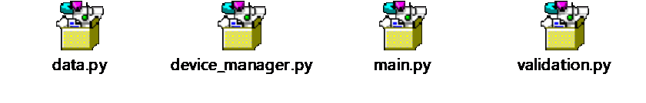

Pseudo_Code


