Anthropological perspectives on art cover a range of different approaches for the study and enjoyment of art from the Ancient Near East. Art as symbolic communication is undoubtedly one of the most useful anthropological approaches for looking at art from Assyria and the Achaemenid Empire, as the imagery used by both cultures was embedded with messages intended for a wider audience. There are strong similarities between the communicated messages of both cultures, with three main communicated themes seen in a variety of different examples from Assyria and Persia: the power of the king, the importance of the Empire, and finally, evidence of an overall narrative of the intended image of the kings. Through the use of this anthropological approach, we can understand these different messages from the kings, which were intended for a variety of different audiences.

This anthropological approach highlights in both Assyrian and Persian art an overall narrative of a strong and powerful Empire being displayed for the viewer, both for their respective cultures and visitors to the various palaces built under the kings. The imagery of the reliefs on the Achaemenid Behistun inscription is a good example of this narrative. The relief shows Darius I on the left-hand side, with two figures carrying weapons (a bow can be seen in one figure’s hand). The figure of Darius has one of his feet on a figure on the floor, believed to be his rival, Gaumāta. In front of Darius is a line of men, with hands bound behind their backs and also bound by their necks, forming a line to be inspected by Darius (Appendix image 1). This is a clear message of power that Darius had over his enemies within the Achaemenid Empire, with him quite literally crushing his enemies underfoot. Above the image is a winged disc, a visual representation of the most important god, Ahura Mazda, showing that Darius’ actions were supported and blessed by the gods. This also gives religious significance to the communication across the Empire - Darius is the most powerful leader and is supported by the gods. This image was part of a larger network of reliefs also seen at Susa and Persepolis, which had the “purpose of communicating and disseminating a specific ideological agenda” (Colburn, 2014, p775). At Persepolis, a similar image of Darius (or Xerxes, depending on the interpretation) is shown. On the staircase of the Apadāna, a series of registers show a wide range of different peoples approaching a central panel (Appendix image 2 and image 3), which originally held an inscription outlining the successes of the Great King. The figures are shown to be carrying a range of different tributes to the king, and the same image of a winged disc representing Ahura Mazda is sited above the middle panel. The message being communicated to the viewer is that of a united empire, willingly coming to give honour to the Great King, all of which is blessed by the gods. In the case of both the Behistun and Persepolis reliefs, “we are dealing with art, and art designed to portray kingship as the king wished it to be viewed” (Tucker, 2015, p21), clearly showing us the usefulness of this anthropological approach for understanding the overall narrative the Persian kings wished to give.

This approach also allows us to understand the overall narrative that can also be seen in various reliefs of the Assyrians, who preceded the Achaemenid Empire. According to various scholars, the reliefs at palaces in cities such as Nineveh and Nimrud were designed to give messages “to a broader audience of commoners and foreigners” (Thomason, 2016, p145), which often show a similar style of imagery to the Persians who most likely took inspiration from the Assyrians, with reliefs “showing sieges, transport of booty, processions of prisoners, marching Assyrian soldiers and presumably the royal chariot” (Nadali, 2008, p87) demonstrating an image of unrelenting power. For example, a Gypsum wall panel relief discovered at Nineveh shows Sennacherib overseeing the capture of Lachish. Sennacherib is sitting on a throne with attendants behind him. While sitting on the throne, prisoners can be seen to be brought before him and executed (Appendix image 4), demonstrating power over conquered people - similar in some ways to the image of Darius at Behistun. The Assyrian kings saw as part of their role as king to “control and tame the outside, non-native elements of the realm” (Thomason, 2016, p141). As a result, “Assyrian representations of war are considered to have functioned primarily as propaganda” (Collins, 2014, p621), showing an almighty king subjecting other nations and rebels and bringing order to the world. However, a difference is the intention of the propaganda, beyond giving a simple narrative of events. According to Winter (1993), the reliefs were designed to create a sense of menace and fear in the viewer in order to stop future rebellions, while Darius “eschews the violent imagery of the earlier monuments in order to make an ideological statement about the nature of Achaemenid imperialism” (Colborn, 2014, p775) to show a happy and willingly controlled Empire, not controlled by fear, unlike the earlier Assyrians. The power of the kings of both Assyria and Persia is an important message communicated through their respective art, as portraits of any individual “concretize the individual portrayed” (Winter, 2009, p257), allowing for their desired image to be presented to the viewer, which in this case is of power over their people and other nations.

Using this approach, we can see that the statue of Darius I at Susa is an excellent example of the desired image of the king being presented to their subjects. The incomplete statue shows Darius I standing, with one arm crossed over his body, holding in his hand what is believed to be a stem of a flower. There are a series of Egyptian hieroglyphs etched onto the base of the statue, with individual figures kneeling above these with their hands held in an upward position, with open palms facing the feet of Darius (Appendix image 5). The hieroglyphs show the names of the 24 countries subject to the Achaemenid Empire. The palm-up stance of the figures gives the impression that the countries are willingly holding Darius up, demonstrating support for the Great King as well as the Empire, whilst being knelt on the ground also demonstrates subjugation and, therefore, power of the king over his people. It is speculated that the statue “draws heavily on Egyptian representations of kingship in order to present Darius as a royal figure” (Colborn, 2014, p787), giving a more nuanced approach to his image - fitting it with the intended audience. The inclusion of the Egyptian hieroglyphs has led to the belief that the statue was originally erected in Egypt before being moved to Susa at an undetermined date and for unknown reasons. The image of Darius here demonstrates his “right to exercise power and assert his status” (Morgan, 2017, p788) as he is literally overpowering the subjugated nations on the statue by towering over them (the statue is over 3 metres tall). The positioning of the figures on the base of the statue also “reflects the hierarchical relationship between king and subject” (Tucker, 2015, p31), communicating that the king is the almighty power of the Achaemenid Empire. This is further reflected in the relief on the northern staircase of the Apadāna at Persepolis. The registers show the various peoples of the empire coming to the Great King in supplication, reinforcing his position at the centre of the Empire and, therefore, in complete control. Similar imagery is also seen at Naqš-i Rustam in the reliefs of Xerxes I’s tomb (Appendix image 6). In the registers, you can see individuals supporting the weight of Xerxes I standing on a platform above them, showing the importance of the Empire to the king’s power. In contrast, for the Assyrians, the Empire is communicated as almost an object to be conquered and tamed; on Xerxes’ tomb, it is instead “effortlessness to the work of the subject nations” (Tucker, 2015, p34), as they are only using their fingers to hold up the platform on which Xerxes stands. The image of a winged Ahura Mazda can also be seen on the relief, facing Xerxes accepting his tribute on death, again demonstrating the religious importance of Darius’ actions in expanding the Empire. The relief has been carved deeply into the rock’s surface above the tomb, which would have taken a great deal of time and labour to complete, further communicating the power and resources of Xerxes.

Similarly, the Assyrians used a variety of wall reliefs in a range of different palaces for the same communicated purpose, again showing the usefulness of this anthropological approach. The majority of reliefs across these palaces “feature depictions of the Assyrian army on campaign…accumulating foreign prisoners and booty, and the Assyrian king receiving the tributaries” (Cifarelli, 1998, pp210). This gives the impression of a king “in his office of kingship” (Winter, 2009, p269) - i.e. an idealised version of the king at the peak of their power. According to Brereton (2019), the Assyrian kings, including Ashurbanipal, wanted to represent themselves as heroic kings destined to control the world. As a result, the reliefs “glorify their king’s military successes”, including “the humiliation, torture and death” of various enemies (Collins, 2014, p620). There is no doubt that the image of a warrior king warring against his enemies is the most significant theme in Assyrian palace art (Collins, 2014). For example, the Battle of Til-Tuba is shown on a wall relief in the Northwest Palace of Nimrud (Appendix image 7). The highly detailed relief shows the battle between the invading Assyrians under Ashurbanipal and the Elamites, who were defeated, with the Elamite king and his son dying in battle. The absolute chaos of the battle is clearly seen in the relief, with dead bodies scattered across the relief, some killed in battle and others being crushed by horses and chariots. The Assyrians are shown to be routing the Elamites, who have been forced into the river at the right-hand side of the relief, drowning in the process. While the scene itself is chaotic and the overall narrative not necessarily clear at first view, the Assyrians are shown to be in complete control throughout, never panicking and clearly overpowering their enemy. In other words, the “Assyrians are dominant, and the foreigners are subjugated, or in the throes of subjugation” (Cifarelli, 1998, p213). This is a motif seen in earlier Assyrian art, such as the Balawat Gates (Appendix image 8), which show Shalmaneser III capturing cities in Hamath. This time is embossed bronze which was part of a larger gate at Balawat. We can clearly see in the upper register a series of Assyrian chariots (distinguished by their headgear), again crushing their enemy under the wheels of the chariots. The archers are poised, ready to fire at anyone who dares to face them in battle. The Assyrians are calm, controlled and victorious. Their success is being communicated as inevitable, unavoidable. As a result, we can see a “selected historical reality intended to intimidate and astonish the viewer” (Collins, p619), and the message being communicated to all - whether Assyrian or a visitor would “readily have perceived the message of power” (Russell, 1998, p663).

The materials in which these different battle scenes have been depicted are also part of the message being communicated to the viewer. The Assyrian wall reliefs at the various palaces, including the one located at Nimrud, were carved into gypsum walls. Gypsum is a natural material with a quality of lustre - reflecting light shining onto it. Gypsum itself is “valued for ornaments and jewellery” (Britannica Encyclopaedia, 2019) due to this lustre quality, as it would give the reliefs a sheen and almost sparkle-like quality. This is impressive to look at and communicates a sense of luxury. While being an aesthetic quality of its own, it would also communicate that the king was wealthy enough to afford such beautiful wall reliefs to be carved throughout his palace. The wall reliefs covered almost every inch of the king’s throne room, so the sheer amount of gypsum being used would be overwhelming. Adding into this the use of natural lighting, or perhaps candles, the glistening surface would have been spectacular to look at. It was designed to “deeply impress the spectators” (Portuese, 2021, p69). Gypsum is also easy to carve into but, at the same time, difficult to handle due to its soft but brittle nature. The skill required of the artist in the Assyrian court to create these great scenes would need to be very high to avoid damaging the scene. This again highlights the power of the king, as he would be able to afford the required skillset of the artist to create these incredible scenes, outlining the usefulness of this anthropological approach.

A different example illustrating this point is the White Obelisk, which was discovered in the ruins of Nineveh. The obelisk shaft is carved with scenes in relief in eight horizontal registers (Appendix images 9 and 10). While its dating is much disputed, the scenes contained are typical of Neo-Assyrian sculpture. The scenes show a king “subduing rebellious cities, securing booty, receiving praise from his countrymen, and giving thanks for the goddess Ishtar” (Pittman, 1996, p339). What is of interest here are two things. Firstly, the imagery of a victorious king over foreign enemies fits with the overall communicated theme of an all-powerful king seen in the previously covered Assyrian (and Persian) imagery. Secondly, the main body of the obelisk is 9 feet 6 inches in height and is carved from white limestone. White limestone is similar to gypsum, and it is prized for its luminosity and the uniformity of its tone. The luminosity of the stone would again be beautiful to look at and gives an impression of power and purity due to the pure white tone. While it is easy to carve, the stone is able to take on smaller details than over rocks which would show the increased expense of the carving as the obelisk is extremely detailed, like other Assyrian works previously discussed.

One of the most significant themes highlighted by using this anthropological approach is of the Assyrians, and Persian kings communicated their power through the use of lions and lion hunts. Lion hunts were extensively used as part of wall reliefs for various Assyrian kings. Often these images of royal lion hunts were interspersed with scenes of royal campaigns (Thomason 2016), showing a clear link between the two as “the royal hunt was analogous to battle and how the slain animal was analogous to the subjugated enemy” (Chow, 2020 p83), meaning the lion and the enemy, whether rebels or other foreign powers are the same in terms of danger to the Assyrian people - both were to be overpowered and destroyed by the king. While the design of the lion changes from king to king (Albenda, 1974), the same message is being communicated. Two main narratives of lion hunts seem to be shown. Firstly, lions are shown to be dangerous animals, with snarling teeth, large claws and poised to attack. The king slaying these lions shows “his prowess as a brave hunter” (Brereton, 2019), and the use of a “bow, spear, or dagger demonstrated the royal individual’s exceptional bravery” (Albenda, 2008, p62). For example, a wall relief from the Northern palace of Nineveh shows Ashurbanipal directly facing a lion, using his dagger to kill the lion. The lion is carved with enormous detail, the mane carefully and realistically illustrated. The lion’s claws are clearly visible, and the mouth is open in a snarl, ready to maul the king. The lion is standing on its hind legs, with the carving showing the powerfully muscular body in great detail (Appendix image 11). Ashurbanipal himself is shown to be extremely calm, communicating his prowess and ability to protect his people. A second relief found at the Northern Palace of Nineveh shows Ashurbanipal on his chariot, slitting the throat of a lion at close hand with his dagger. The lion is seen to be in agony at its death, while Ashurbanipal calmly takes the lion’s life (Appendix image 12). This repeated image of lions being killed directly by the king was so prevalent because lions were recorded to “[obstruct] roads, and harass[ed] herdsmen” (Brereton, 2019), which meant that it was the king’s duty to protect his people from such danger. The second common motif shows an organised royal hunt with many fallen lions. These lions were always “doomed in the hunt [and] are displayed in two aspects of their death, either dying or dead” (Albenda, 1974, p10). An example of this can be seen at the North Palace of Nineveh, where a wounded lion, shot with several arrows, lies wounded on the ground, unable to escape (Appendix image 13). Their bodies are also often shown under the wheels of chariots (Albenda, 1974). They could be argued to show the relentless power of the Assyrian kings, where even lions cannot escape their fate - much like Assyria’s enemies.

The Achaemenid kings also used lions in their art to communicate a sense of their power, borrowing imagery from the earlier Assyrians in an attempt “to recover the strong aura and prestige of the great Assyrian kings” (Danrey, 2004, p138). Lions are shown on the Northern staircase of the Apadāna at Persepolis attacking bulls. This imagery was used to “emphasise the king’s role as the protector of the viewer who had to pass by the dangerous scenes and the threatening lions as they ascended the stairs” (Pak-Shiraz, 2017, p762), in a similar protective role of the earlier Assyrian kings. Lions were also used across a range of different art pieces in the Achaemenid Empire, including a decorative gold applique in the shape of a lion's head (Appendix image 14). The lion is shown to be a fierce creature, with an open mouth in a snarling position, showing off its sharp teeth. The lines on the face are carefully used to emphasise the snarl and the possible danger of the lion. The fact that such an applique was used as decoration in gold shows the importance of the lion motif to the Persians but also communicates their wealth as a form of power through the use of gold to create the art. The image of the lion in decorative art objects was also used before the Achaemenid Empire and is shown in a golden cup, known as the Kalar Dasht, found at Mazandaran (Appendix image 15). It is dated to the late 2nd millennium BC. The lions are extraordinarily designed to be emerging from the cup itself, almost into a 3D object on their own separate from the cup, with detailed etching used on their bodies to show their fur. Their faces are also carefully moulded in gold, showing their eyes, whiskers, nose and mouths. Whilst this object is well before the Achaemenid Empire and the Assyrian Empire, it demonstrates the importance of the lion in art in this region of the Ancient Near East, becoming an often repeated motif to communicate wealth (through the use of gold) and more importantly the power of the kings as overcoming the lions and finally protecting their people from danger.

In conclusion, we have seen how useful this anthropological approach has been for understanding how both the Assyrians and Achaemenids used art in their palaces to communicate different messages to their audience, with these images often linked. Through the use of battle scenes and lions, the Assyrian kings were able to communicate a clear statement of power over their subjugated enemies while at the time protecting their people from danger - whether human or animal. Likewise, the Achaemenid kings of Darius and Xerxes used art to portray themselves as all-powerful over their Empire, but with an altered message from the Assyrians. While the Assyrians portrayed themselves as ruthless and the Empire as being completely controlled by them, the Achaemenids tried to communicate that their Empire was less about subjugation but instead almost a partnership between King and people. This demonstrates why the anthropological approach of art as being a method of communication is so helpful in studying the Ancient Near East, as we can understand the similar messages being put forward by the Assyrians and Achaemenids whilst also identifying their subtle differences.

Appendix
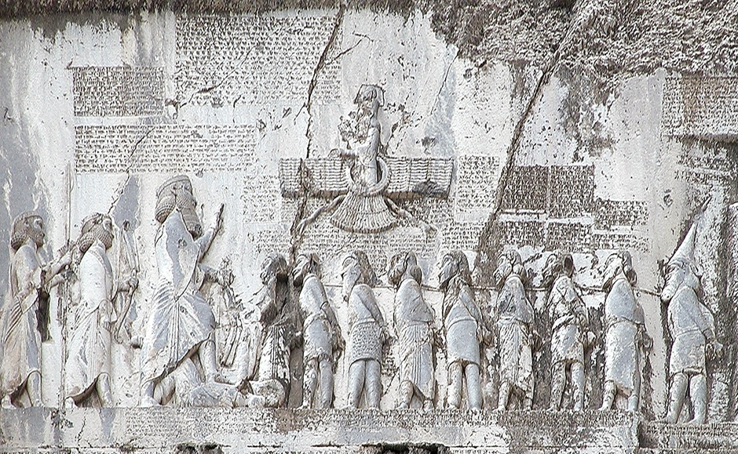
Image 1 Image 2
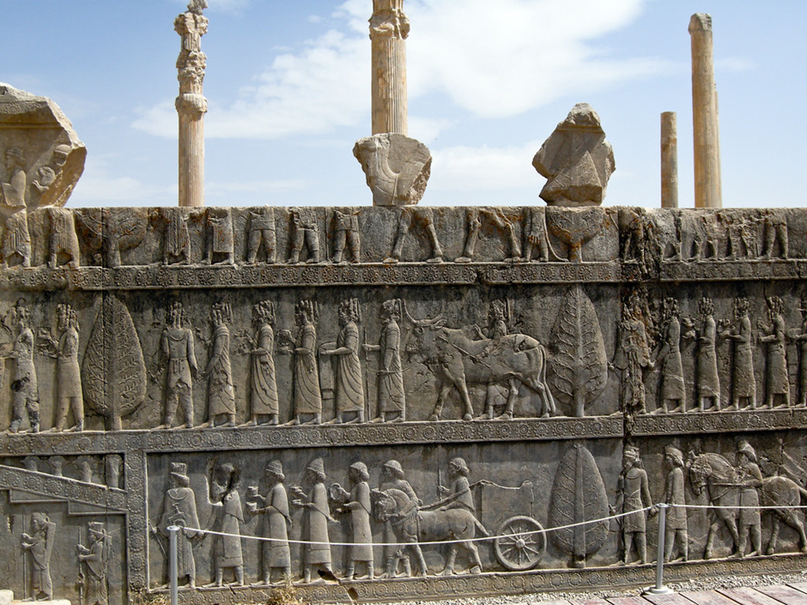

Image 3
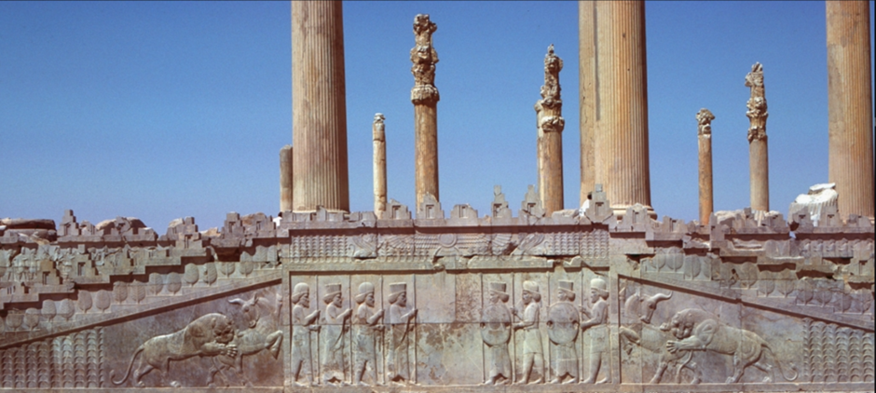

Image 4 Image 5
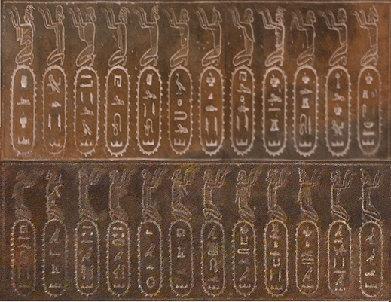
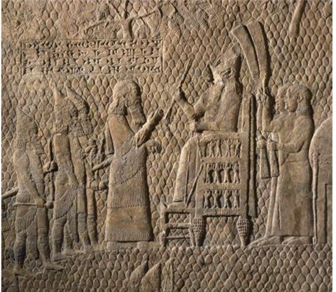

Image 6
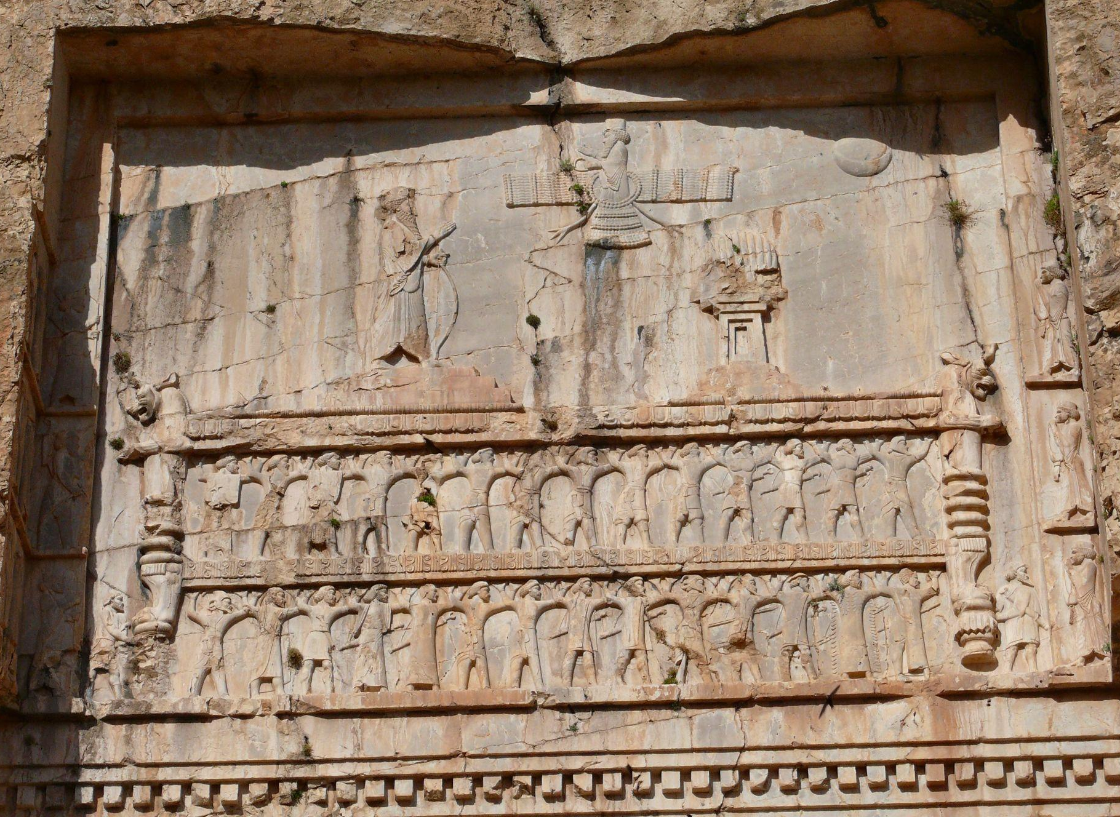

Image 7
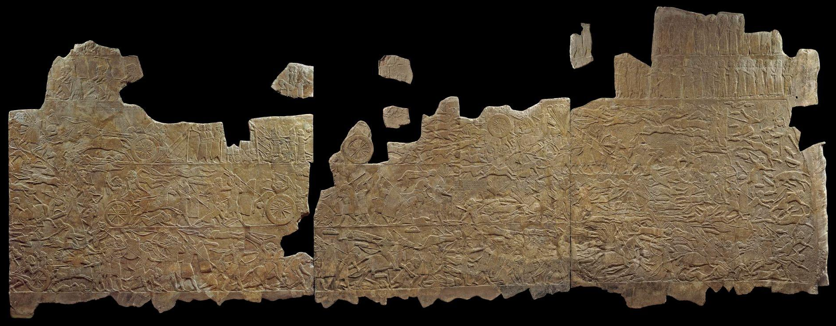

Image 8
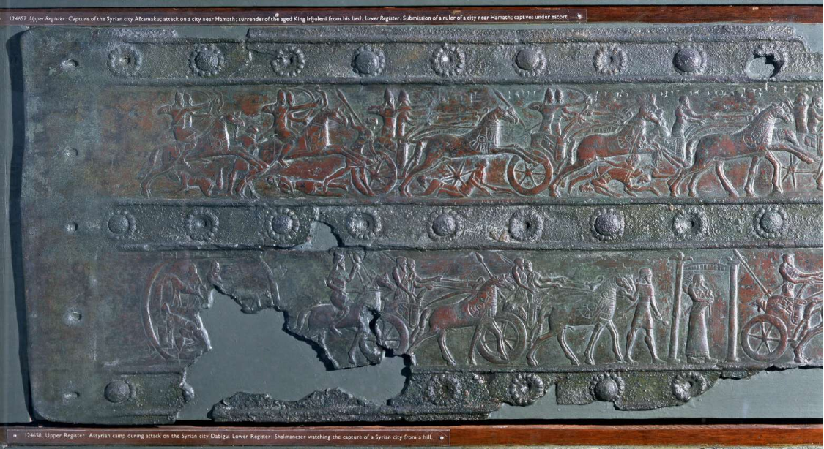

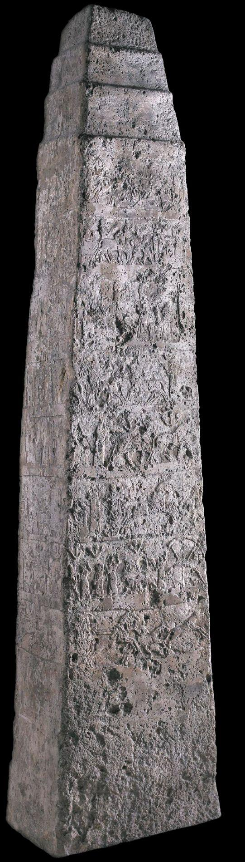
Image 9 Image 10
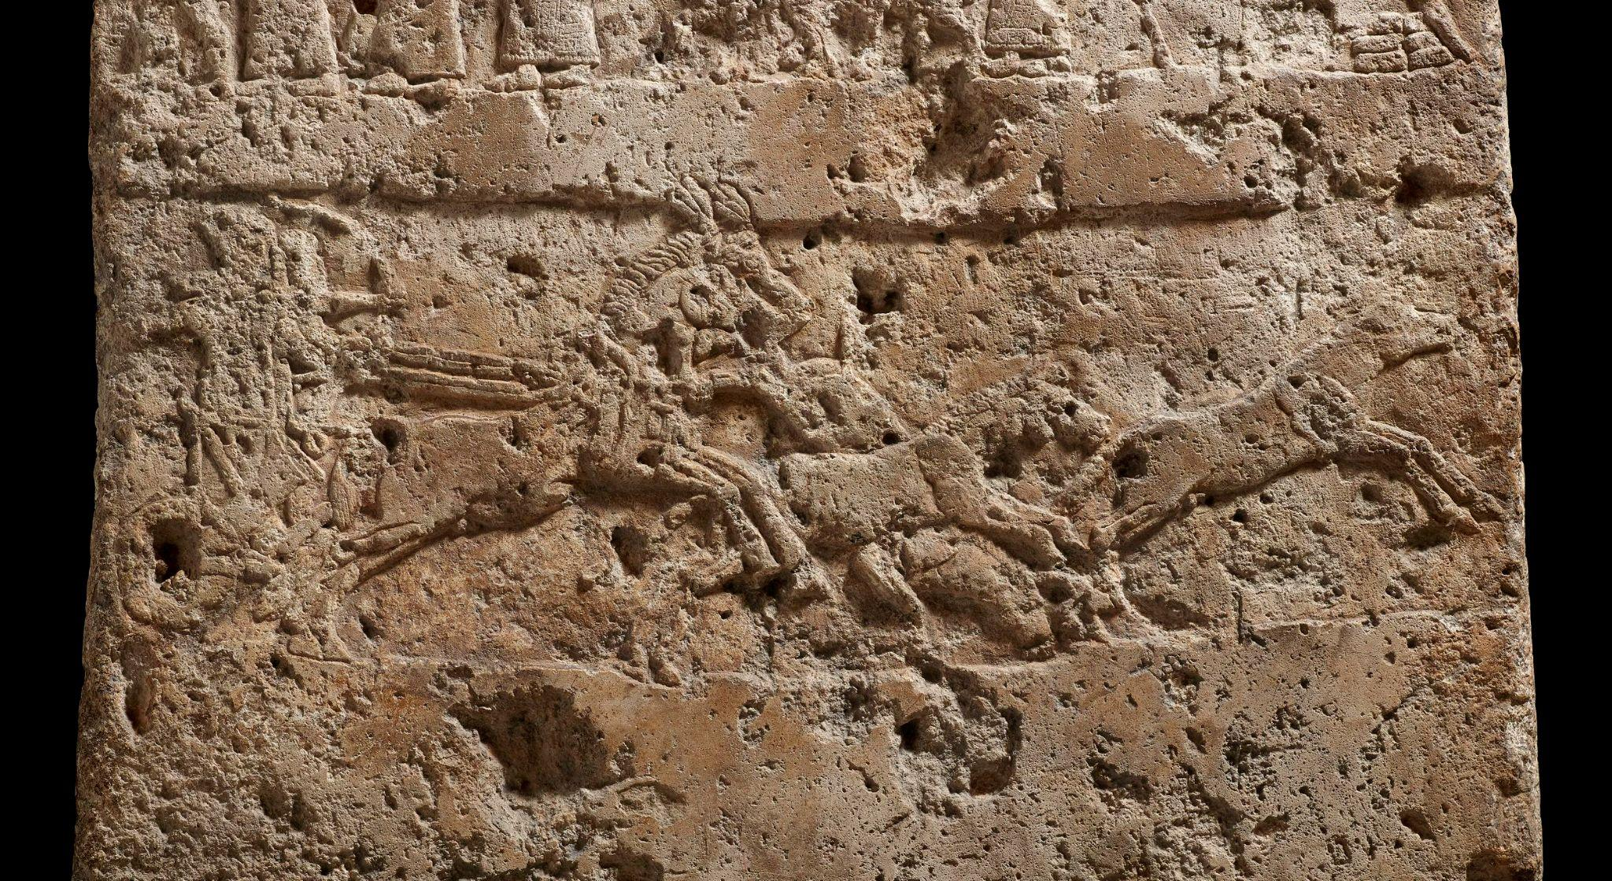

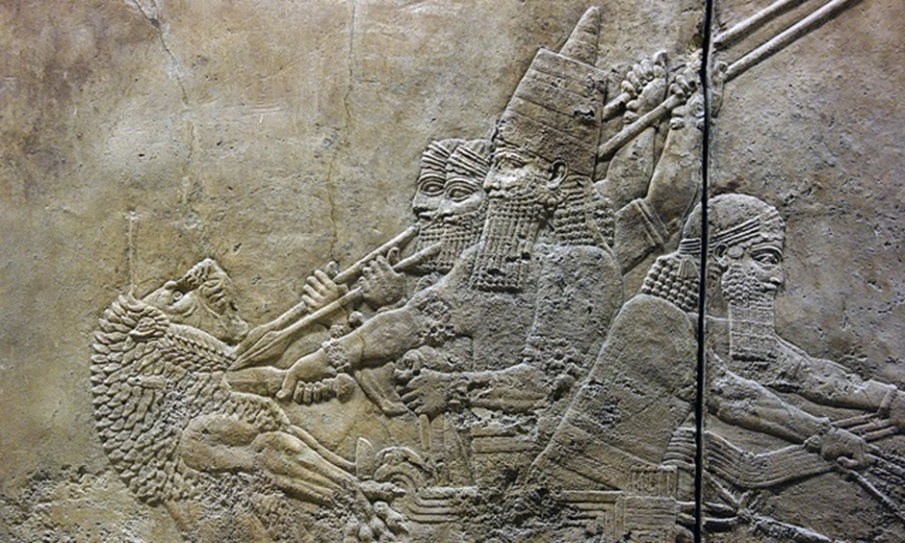
Image 11 Image 12
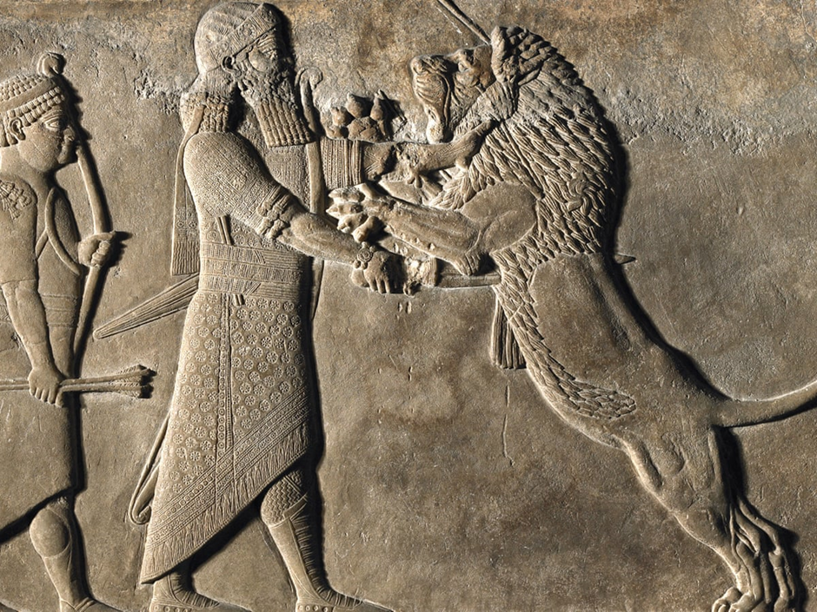

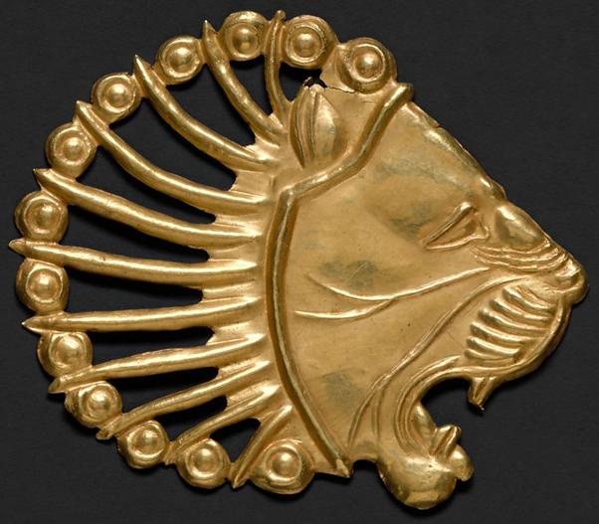
Image 13 Image 14
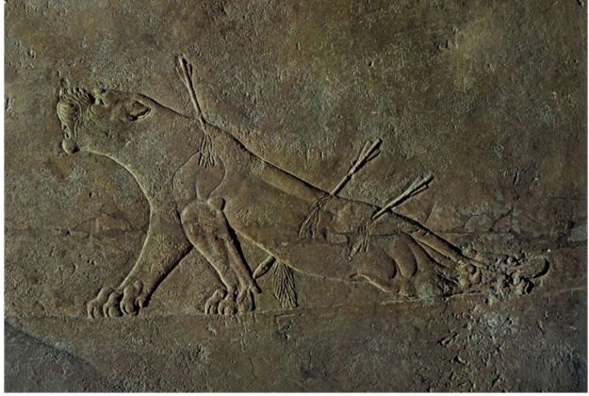

Image 15
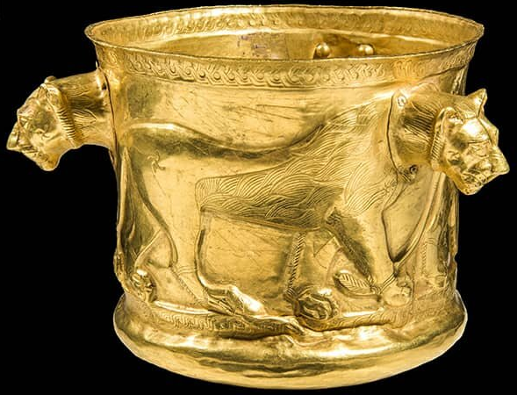

Bibliography
Books
Benzel, K. et al. (2010), Art of the Ancient Near East, New York: Metropolitan Museum of Art
Colborn, H. (2014) ‘Art of the Achaemenid Empire, and Art in the Achaemenid Empire’, in Brown, A. & Feldman, M. H. (ed.) Critical Approaches to Ancient Near Eastern Art, Boston/Berlin: Walter de Gruyter Inc.
Collins, P. (2014), ‘Gods, Heroes, Rituals, and Violence: Warfare in Neo-Assyrian Art’, in Brown, A. & Feldman, M. H. (ed.) Critical Approaches to Ancient Near Eastern Art, Boston/Berlin: Walter de Gruyter Inc.
Harper, P. O et al. (1992), The Royal City of Susa: Ancient Near Eastern Treasures in the Louvre, New York: Metropolitan Museum of Art
Hawthorn, A. & Loisel, A-C. R. (ed) (2019), Distant Impressions: The Senses in the Ancient Near East, The Pennsylvania State University Press
Kuhrt, A. (2010), The Persian Empire: A Corpus of Sources from the Achaemenid Period, Routledge
Root, M. (1979), The King and Kingship in Achaemenid Art, Belgium: Université de Liège
Morphy, H. & Perkins, M. (2006) The Anthropology of Art: A Reader, Oxford: Berg

Tucker, W. D. T Jr. (2015) Constructing and Deconstructing Power in Psalms 107 - 150, Atlanta: Society of Biblical Literature

Journal articles
Albenda, P. (2008), ‘Assyrian Royal Hunts: Antlered and Horned Animals from Distant Lands, Bulletin of the American Schools of Oriental Research, Feb. No. 349 pp61-78
Albenda, P. (1974), ‘Lions on Assyrian Wall Reliefs’, Journal of Ancient Near Eastern Society, No.6 pp1-27
Chow, C. T. (2020), ‘Sword Carry in the Art of Ashurnasirpal II: Displays of Divine Authority, Iraq, Vol. 82 pp73-93
Cifarelli, M. (1998), ‘Gesture and Alterity in the Art of Ashurnasirpal II of Assyria, The Art Bulletin, Vol. 80 No.2 pp210-228
Danrey, V. (2004), ‘Winged Human-Headed Bulls of Nineveh: Genesis of an Iconographical Motif’, Iraq, Vol. 66 pp133-139
Lincoln, B. (2013), ‘Religion, Empire, and the Spectre of Orientalism: A Recent Controversy in Achaemenid Studies’, Journal of Near Eastern Studies, Vol. 72 No.2 pp253-265
Morgan, J. (2017), ‘Who has the Biggest Bulls? Royal Power and the Persepolis Apadāna’, Iranian Studies, Vol.50 No.6 pp787-817
Nadali, D. (2008), ‘Assyrian High-Relief Bricks from Nineveh and the Fragments of a Royal Name’, Iraq, Vol.70 pp87-104
Olmstead, A. T. (1938), ‘Darius and His Behistun Inscription’, The American Journal of Semitic Languages and Literatures, Vol.55 No.4 pp392-416
Ornan, T. (2004), ‘Expelling Demons at Nineveh: On the Visibility of Benevolent Demons in the Palaces of Nineveh, Iraq, Vol. 66 pp83-92
Pak-Shiraz, N. (2017), ‘Visualising Iran: From Antiquity to the Present, Iranian Studies, Vol.50 No.6 pp761-764
Pittman, H. (1996), ‘The White Obelisk and the Problem of Historical Narrative in the Art of Assyria’, The Art Bulletin, Vol. 78 No. 2 pp334-355
Portuese, L. (2021), ‘Fear, Concern and Care in the Northwest Palace of Ashurnasirpal II’, Die Welt des Orients, Vol 51. No.1 pp28-57
Root, M. (2002), ‘Medes and Persians: The State of Things’, Ars Orientalis, Vol.32 pp1-16
Russell, J. M. (1998), ‘The Program of the Palace of Assurnasirpal II at Nimrud: Issues in the Research and Presentation of Assyrian Art’, American Journal of Archaeology, Vol. 102 No. 4 pp655-715
Sathe, V. (2012), ‘The Lion-Bull Motifs of Persepolis: The Zoogeographic Context’, Iranian Journal of Archaeological Studies, pp75-85
Thomas, D. A. (2008), ‘Assyrian Monsters and Domestic Chimeras’, Studies in English Literature 1500-1900, Vol.48 No.4 pp897-909
Thomason, A. (2016), ‘The Materiality of Assyrian Sacred Kingship’, Religion Compass, Vol.10 No.6 pp133-148
West, M. (2002), ‘Darius’ Ascent to Paradise’, Indo-Iranian Journal, Vol.45 No.1 pp51-57
Winter, I. J. (2009), ‘What/When is a Portrait? Royal Images of the Ancient Near East’, Proceedings of the American Philosophical Society, Vol. 153 No. 3 pp254-270
Winter, I. J. (1993), ‘Seat of Kingship/A Wonder to Behold: The Palace as Construct in the Ancient Near East’, Ars Orientalis, Vol. 23 pp27-55
Websites
The Metropolitan Museum of Art (2004) The Achaemenid Persian Empire (550–330 B.C. Available at: https://www.metmuseum.org/toah/hd/acha/hd_acha.htm (Accessed 06 March 2022)

Oriental Institute of The University of Chicago (https://oi.uchicago.edu/collections/photographic-archives/persepolis/apadana (Accessed 10 March 2022)

Brereton, G. (2019) British Museum ‘Lion Hunting: The Sport of Kings’ Available at: https://blog.britishmuseum.org/lion-hunting-the-sport-of-kings-2 (Accessed 30 March 2022)

Britannica, The Editors of Encyclopaedia. "gypsum". Encyclopaedia Britannica, 11 Jan. 2019, Available at: https://www.britannica.com/science/gypsum (Accessed 09 April 2022)

