Professional Career Development Assignment (BMSK4005_Card)
(A reflective review of my learning journey through personal development.)

Mohammed Sumon (1712721)

Submission Date: 22/06/2018
University of Wales Trinity Saint David
Executive summary:
The purpose of this report is to analyse my understanding on the techniques and styles used to develop good skills for professional career development. Also, this report provides an analysis and evaluation of my learning journey through personal development, to show my knowledge and understanding of the skills which contribute towards working effectively.

Table of Contents
Executive Summary............................2
Introduction....................................4
1. Findings and Reflection.....................6
2. Self Analysis/Awareness...................7
2.1 Swot....................................... 7
2.2 Skills Analysis.............................7
2.3 Johari Window...........................10
2.4 VARK/Learning styles....................13
2.5 GO MAD..................................15
2.6 Personal Development Plan...............17
3. Barriers to Learning + Development + How to overcome them ............................19
4. How to Monitor Progress..................20
5. Conclusion..................................22

Introduction
Professional career development is important for career development because it allows more productivity and encourages in earning a higher income. It plays a significant part in supporting you to achieve your goals and by improving your skills and knowledge, you are more likely to have a better and successful career. It is more likely to have a successful fulfilling career as when you are constantly advancing yourself, your career will be more engaging.
The skills I need to have to be able to work effectively and be employment ready, firstly, is the willingness to learn and have a desire to stay on top of the current trends and changes relevant to my profession because it is valued by employees both large and small. Secondly, I need interpersonal and communication skills because employers want to hire employees who also have a clear view of the bigger picture, those that have a vision for the future of the business and the industry they are working in and can communicate this to their colleagues and teams. I also will need organisational skills as during unstable and unpredictable times, budgets will tighten and cost consciousness will remain a focus.
As the aim of this report is to show how I have developed the skills and knowledge stated above, this is what is explained next.
I have developed the willingness to learn as my family and friends have motivated me and encouraged me to help myself by taking part in these courses and developing a possibility of a successful professional career in future. I have developed organisational skills as in my previous job and business I had to improve on my academic skills which keep my organisational skills on track.

1. Findings
My learning journey about personal career development has taught me that a career development is a lifelong process. Developing a personal career requires a standard of knowledge which shows an understanding of how to set up a career and how to maintain it. I need to acknowledge the potential risk factors which may come in the process of building my personal career.
I have also learnt through a friend’s journey that I have to fully understand my goal and my outcome to assure myself that I know what I want. In order to do this, I need to plan out and think about what is required through the process of crafting my career.

2. Self Analysis/Awareness
2.1
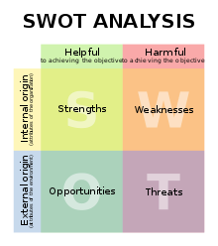
Strength:
I have the willingness to learn and find out how I can better myself to open doors of a path to success in building my career. This is an advantage to me which others may not have as the more I attempt in trying to understand something, the more confidence I am going to have in executing a thought which would help gain in my career. I am also an organised person which prefers to keep themselves and their work in a manner which can be considered as being professional. This helps me to keep myself on track and avoid losing focus on things which may be more crucial than to do things that may waste valuable time. I am useful when it comes to crafting and working with mechanical and housework faults. I have quality management skills which enable me to take the lead which also comes under leadership skills.
Weakness:
I am weak in aspects of adaptability where I am in need of recreating my mindset to adapt to new situations and places where I need to think differently. This is because I am slow when it comes to wording and expressing myself, which prevents me to think in an open minded manner and gain ideas in a short amount of time. To adapt myself I need to understand how I will be changing myself according to what is needed but instead I find it hard, thinking about the way I will be conducting myself.
Opportunity:
I have many opportunities in which I can improve myself, for instance, if I be aware of what others are trying to present in front of me and consider their ideas. If I respect and consider the ideas of others regarding my career, then I could most possibly figure out ways of doing developing my professional career and improve things. It will also help my industry in growing and think of more strategic contacts to help me and offer a good advice system as others convey a lot of help through their suggestions.
Threats:
Currently, at work, I face obstacles of trying to convey myself as I struggle in pronouncing long words in English as well as understand them myself. This is a threat because if people don’t understand me then I will not be able to express myself, also my colleagues and workers may be confused and not understand what I am trying to say which means they cannot do what I am trying to ask them.

https://en.wikipedia.org/wiki/SWOT_analysis

2.3 Johari window
Is a psychological useful tool for understanding and training:
- self-awareness
- personal development
- improving communications
- interpersonal relationships
- group dynamics
- team development; and
- inter group relationships

It is one of the few tools out there that has an emphasis on “soft skills” such as behaviour, empathy, and co-operation; inter group development and interpersonal development. It’s a great model to use because of its simplicity and also because it can be applied in a variety of situation and environments.

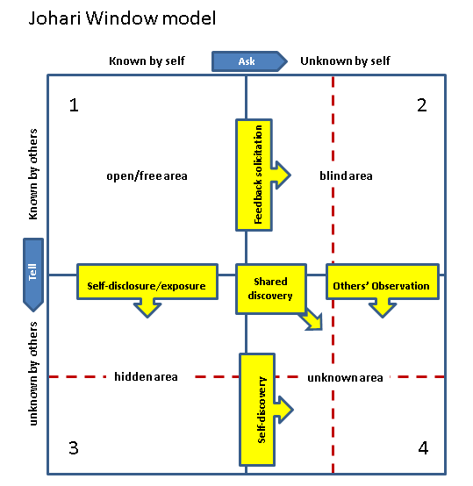
By filling in this template I can find out aspects of myself which are open, for example, communication in a free manner and socialising with people is something which is within my personality, this helps me to find out more information and what is taking place in my surroundings to gain knowledge from others. The blind area is investigating what I need to improve on, by seeking advice and feedback from my colleagues and peers. The hidden area reminds me about my self-disclosures which may benefit me from exposing; this can be my hidden talents or qualities which will help me impress managers or peers. The unknown area is data and knowledge which no one is aware of but can be discovered through others’ observations, shared discovery and self-discovery. By communicating with I can find out unknown sources of information, which may be in their knowledge which comes under others’ observation and shared discovery. Also, I can use the internet, books and newspapers to help me expand my knowledge which is called self-discovery.

Reference of Johari window:
Luft, J.(1969), The Johari Model ;Of Human Interaction, https://www.businessb alls.com/self-awareness/johari-window-model-and-free-diagrams-68/ ,ucla

2.4 VARK/Learning Styles
A concept in psychology and education and are intended to identify how people learn best. The VARK model of learning styles suggests that there are four main types of learners. These four key types are:
- Visual
- Auditory
- Reading/writing
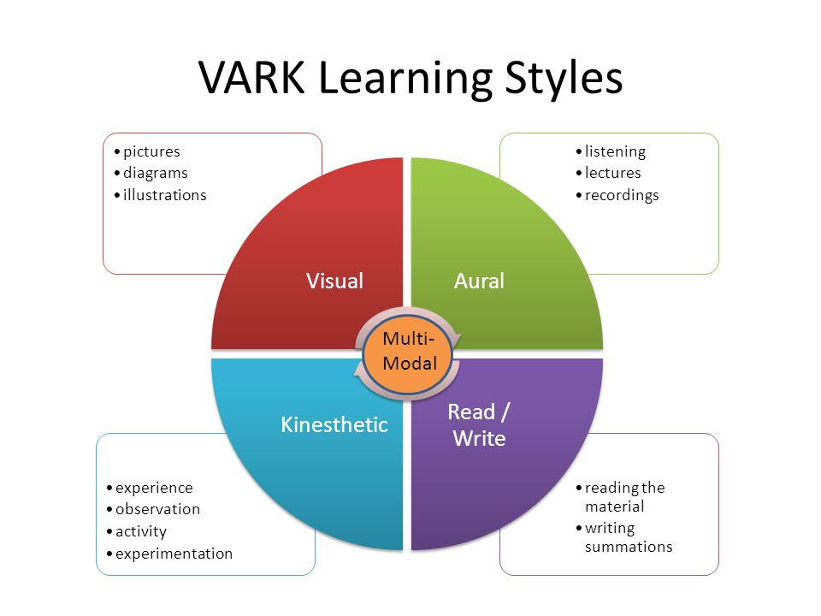
- Kinaesthetic
The VARK learning style is a questionnaire which analyses the type of learner you are. Visual learners are learners which understand from watching like information presented through videos and illustrations. Auditory learners are those who learn from speaking and listening to others from things like lectures. Learners which learn best from Reading and writing can read and write summaries. Lastly, kinaesthetic learners learn best from experience and observations.
According to the questionnaire I am a visual learner who prefers to watch and observe information as it sinks in better for me.

Reference of VARK/ learning styles:
Cherry, k. (2018), Overview of VARK learning styles, https://www.verywellmind.com/vark-learning-styles-2795156, Verywell mind

2.4 GO MAD
The GO MAD Results Framework and solution focused thinking methodology enables people to accelerate results and improve productivity. It can increase sales, reduce costs, save time, improve performance and help you develop as a leader to engage others in contributing to business success.
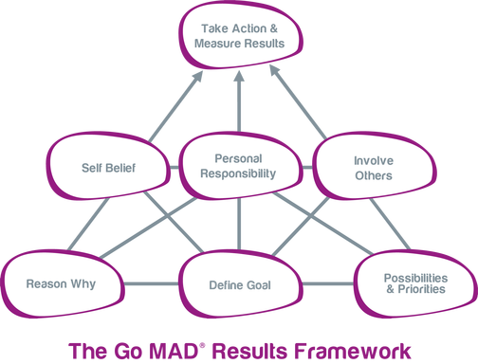

GO MAD can help managers in many ways. For example, it can help to solve problems quicker day to day, achieve performance targets, gain and maintain buy-in when involving others, build better project plans and manage teams through change.
Reference of GO MAD:
GO MAD Thinking, (2018), https://www.gomadthinking.com, Leicestershire

2.5 Personal Development Plan
PDP is the process of:
- Creating and coming up with goals about what you want to achieve or where you want to go, in the however short or long period you want to.
- Assessing current realities and situations
- Identifying needs for skills, knowledge or capability
- Selecting appropriate development activities to meet those needs.
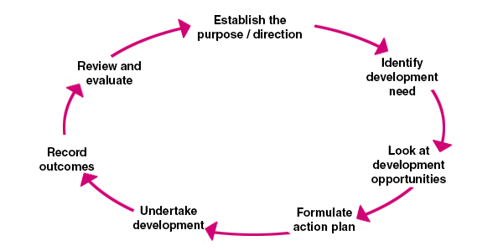

Reference of Personal Development Plan:
Personal Development Planning, (2015), https://www.managers.org.uk/knowledge-bank/personal-development-planning, chartered management institution
I want to improve on my academic skills which will keep my organisational skills on track. My goal is to learn the academic way of business management and employment. Also, I need to achieve a skilful CV for a better job in the future for good earning. I need help to develop key skills for the job I am most keen of doing which is becoming a part of the plumbing and electrician industry. To do this, I need to join the right course which applies with this job and help myself understand the terms required for it.

3. Barriers to Learning + Development + How to overcome them.
I think that I have a bit of a language and communication barrier as sometimes I do not understand what people are trying to convey and start suggesting things myself and get muddled up and confused. To overcome this, I can spend more time focusing on trying to improve my speaking and understanding of some aspects in the English language as I am mostly fluent in it but sometimes struggle in understanding long complicated words and sentences and words that I am not particularly familiar with.
There’s also an emotional barrier like lack of self-esteem or confidence due to low skills levels; negative personal experience of learning as I had not finished my full schooling period. To overcome this I can use this course and develop myself an understanding of many things to help me in my future career.
In addition, most of the time I am very busy at work and looking after the family which prevents me from having the time in being able to learn and develop new skills and knowledge. To overcome this barrier I can create a timetable or some sort of arrangement to keep a track of all my work and make time for learning and developing new skills and knowledge.

4. How to monitor progress
At home it’s worth keeping a file of both your own notes on your performance and copies of any documents to do with your achievements, such as emails keeping positive feedback from colleagues and clients, or reports on successful projects. You will be able to give examples of times where you have gone beyond expectations and made impressive achievements that should be recognised. This will impress your boss and put you in a good position for a promotion or rise. Also, such information will help you when you decide to move on as you can add these achievements to your CV.
I can also ask for my bosses feedback and comment and improve on my targets that are given for example if I have a meeting then I can improve my discussion skills by asking a more experienced person on how my performance was.
You can keep a record by writing some personal notes as it will give you something to refer to if there is a problem. If you fail to meet your targets, you need to know why it has occurred so that you can use the best action to change achieve your targets. You can refer to your records where you have noted what went wrong and your thoughts to why it went wrong so you can prevent it from happening again. In contrast, you can keep a note of what went well. That way you can keep a record to what hasn’t worked and what has so you can try it again.
5. Conclusion
In conclusion, as a manager I can use the GO MAD and VARK learning style as it can help me because if I complete and understand the frame work then I can acknowledge my goals and problems and solve them in a short amount of time, to improve output of meetings and to increase personal and team confidence. Also for my team members I can use the VARK learning styles to identify how they can learn best so they can develop their skills in their own suitable ways this will enhance my staff’s and my own communication skills and improve team performance, along with increasing the range of strategies that are used for communicating within the business.

