Certificate of Higher Education in
Skills for the Workplace

Student Name: | Joynul Islam
Student Number: | 1605529
Module No: | EMPL4012_LON
Module Title: | Researching & Analysing Data

1

Table of Contents
Table of Contents 2
Working from Home 3
Title of the Report 3
Question 3
Benefits of Working from Home 3
Disadvantages of Working from Home 4
Current Situation 5
Conclusion 6
References 8

Working from Home
Due to the advancement of modern technology, which has become very common in the present world of business where employees are having the opportunity of walking by sitting at home or not going to the office (Liu, Liu, & Zeng, 2011). Work at home is one of the most common results of the advancement of modern technologies. Like all the other advancement there are some problems that have also been created due to the advancement of modern technology in the implementation of work at home strategy.

Title of the Report
In numerous numbers of perspectives, there are certain problems that have taken place in the present working condition the employees of different organizational context working by sitting at home. In this report, we are going to discuss about the performance efficiency of the employees of the organization at the time of working by sitting at home. So, the purpose of our research is to understand the efficiency of the employees of the organization by sitting at home in comparison with the efficiency of the organization who is working by sitting at the office premises. So our research topic is:
Efficiency of the employees in the strategy of “Work from Home”
For any kind of research, understanding the research topic is very important.

Question
For instance, in this report we have a research topic of the performance efficiency of the employees who are working at home. So the question for our research is:
“Does it very much helpful for the organization to give the opportunity to the employees of the organization working by sitting at home in terms of efficiency measurement”

Benefits of Working from Home
Working from home can help the employees of an organization in numerous numbers of ways. For instance:
Flexibility: At the time of working from home, employees of the organization are getting numerous numbers of flexibility in doing that task properly. Sometimes it has become very much easier for the employees of the organization to be very much effective and efficient in their work due to lots of time and space in their home for working.
Less Distraction: At the time of working in the office there are numerous numbers of people who are communicating with the employees for which it has become very much difficult for them to focus on their activities. But at the time of working at home it has become quite easier for the employees of the organization to concentrate properly.
Family Life: Being very much closed to the family will help the employees of the organization to be charming all the time which will help the employees of the organization to increase their efficiency at the highest level.
More Productivity: Due to the mental satisfaction by being with their family it has become very much easier for the employees of the organization to be more efficient in nature. Besides, the people are very much comfortable in their home the time which makes them very much comfort in their work according to their own way.
Life balance: It has become very much easier for the people to balance their personal and professional life properly by working from the home as sometimes it has become very much important for the people to provide all the necessary time to their family.

Disadvantages of Working from Home
But there are some large problems that may arise at the time of working from home. Some of them are:
Isolation: Isolation is one of the most significant disadvantages of working at home where the employees are working in a lonely environment where there is no one to help at the time of facing any problem regarding the work (Liu, Liu, & Zeng, 2011). Besides, it has also become very difficult for the employees to be creative and innovative by taking help from others by sitting at home.
Family Distractions: Sometimes being with family can distract the work of the employees of the organization as it is very difficult to escape from communication by working at home.
Endless Work: At the time of working in the office premises people are thinking about going back to home and they are trying to provide all of their efforts with in the office time so that they can go back to the home on time. At the time of working from the home it has become very much difficult for the employees of the organization to keep their concentration all the time at work for this reason it has become very much difficult for them to complete the entire task on time.
Lack of Self Discipline: By sitting at home it has become very much difficult for the employees and all the people of the world to maintain discipline properly as the daily routine has been broken quite easily as there is no rush to go to the office.
These are the benefits and disadvantages that creating different kinds of impact on the opinion of working from home.

Current Situation
In United Kingdom, around 4.2 million people in 2014 are working from home then going to the office which was 3.4 million in 2005. The number of people working from home is increasing day by day. Besides, it has become very much effective for the organization in terms of costs and other expenses at the time of making the office premises comfortable for work.
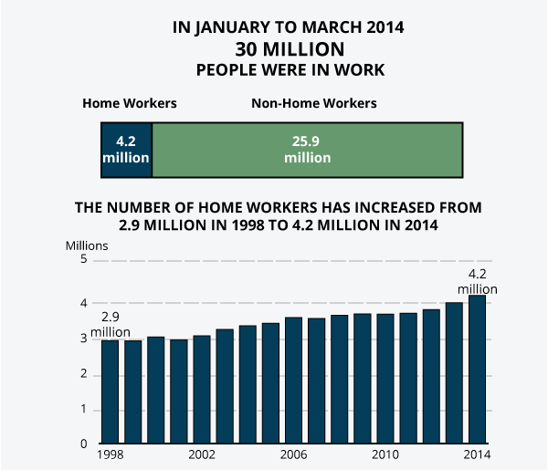
According to the evidence, it has quite clear that working from home has a great reflection in the performance of the employees of the organization which is very effective in nature.
Besides, by working at home it helps the employees of the organization in various ways to reduce the cost of different types like text for telephone calls, electricity, and so on. The communication costs have also gone down due to lack of communication between house and office. Besides, working from home is time saving processes which give the opportunity to the employees of the organization to be more effective and deficient in doing the activities properly.
Besides, there are numerous numbers of freelancing jobs are available for the people which they can do by sitting at home (Sulich, 2016). In the recent time freelancing has become one of the most important and prominent sources of earnings were numerous numbers of people. It makes the life of the people so much easier to work and earn enough money by sitting at home to live their life properly.
So, from this point of view, it is quite easier for any business organization to go for working from home policy to make their employees very much motivated to work efficiently for the organization by sitting at home with spending quality time with their families. On the other hand, sometimes it has become very much difficult for the employees of the organization to have the quality of work by sitting at home it is because there is no one to help them property at the time of facing any kind of trouble (Nixon, 2010). In addition with this, it has become very much difficult to provide all the necessary visions to the employers regarding the activities they are doing at the time of promotion or other incentive plan by walking from home. Moreover, getting all the necessary supports regarding the activities of the organization is not always so much easier for working from home. Furthermore, it is not always possible for the employees of the organization to do some corporate meeting by sitting at home for which it is very important for the organization to have their employees on the office on time (Pipko, 2002). The maintenance of the corporate culture in any business organization is very important without which it has become very much difficult for the organization to do that task properly by maintaining excellent corporate environment.

Conclusion
In conclusion, it can be easily said that working from home culture is not very much bad for the organization and the employees of the organization as well but it is very important for any business organization to maintain a proper organization of culture for which it is very important for them to ensure all the employees of the organization are coming to the office premises on time. But if we look only to the productivity of the employees of the organization then it is not that much effective to force the employees of the organization towards the office premises whereas it can possible to get the best performance of them by letting them work from their home. So, there is a mixed prospective that we can see in terms of having people work in home which the organization has to control and maintain properly for the purpose of keep the strategy effective and efficient in terms of having quality support from the employees of the organization to complete the task properly.
On the other hand it is also very much important for the organization to maintain work environment inside the organization premises to make the employees of the organization productive and efficient in terms of having any kind of problems to solve (Pipko, 2002). So, according to the help of modern technology it can be possible for any business organization to keep the employees the excellent opportunity to work for them by sitting at home but sometimes is has become very much important and essential for the organization to get their employees in the organization of premises for the assurance of quality of works. So, the idea working from home can be a sort of mixed activities according to the organizational situation for which an organization can let their employees working for them by sitting at home and sometimes they can call them to the organizational premises to ensure the effectiveness of their works.

References
Liu, J.; Liu, X.; Zeng, X. (2011). "Does transactional leadership count for team innovativeness?". Journal of Organizational Change Management. 24 (3): 282–298.
Sulich, Adam (2016-02-06). "Mathematical models and non-mathematical methods in recruitment and selection processes". Reviewed papers form 17th international conference. Mekon 2015. 1. ISBN 978-80-248-3684-3.
Nixon, Judy (2010). "Exploring SWOT analysis - where are we now?: A review of academic research from the last decade". Journal of Strategy and Management.
Pipko, Simona (2002). Baltic Winds: Testimony of a Soviet Attorney. Xlibris Corporation. p. 451. ISBN 9781401070960. Retrieved 2015-08-24.

