Ryan Jones (2009252)
2009252@student.uwtsd.ac.uk
Networking Operating Systems and services
Build and deploy a Type 2 Hypervisor

Contents
Table of Figures 1
Abstract. 3
Introduction. 3
Research on Hypervisor. 3
Hypervisor choice. 11
Downloading the Hypervisor, Server and Operating Systems. 14
Setting up the Network 15
Research on IP Addressing. 16
IP address and configurations. 19
Network Testing and troubleshooting Techniques. 19
Testing the Network. 23
Conclusion 25
Reference 26

Table of Figures
Figure 1. Type 1 and Type 2 Hypervisors and how they are different [3] 5
Figure 2. Server rest environment [7] 6
Figure 3. Four Hypervisors Webserver Benchmark results [7] 6
Figure 4. Four Hypervisors Mail Server Benchmark results [7] 6
Figure 5. Four Hypervisors File Server Benchmark results [7] 7
Figure 6. Four Hypervisors Random File Access (RFA) Benchmark results [7] 7
Figure 7. Test environment PC [8] 7
Figure 8. File Server results [8] 8
Figure 9. Varmail test results [8] 8
Figure 10. Random File Access test results [8] 8
Figure 11. Oracle VM architecture [8] 11
Figure 12. VM software of type 2 Hypervisor with two servers and two OS installed 13
Figure 13. What are the differences [14] 13
Figure 14. Windows 10 Vs Windows 11 [16] 14
Figure 15. NOSS Network Topology for Swansea and London 14
Figure 16. IP Packets [18] 15
Figure 17. The basic format of typical IP addresses [B] 16
Figure 18. The structure of an IPv6 header [19] 16
Figure 19. The difference between Private and Public IP addresses [17] 17
Figure 20. A local area network (LAN) such as home WiFi network [22] 17
Figure 21. SW-DC and SW-PC Ping Request Fail 22
Figure 22. Firewall Inbound Rules 23
Figure 23. Firewall Outbound Rules 23
Figure 24. SW-DC and SW-PC Ping Request Successful 24
Figure 25. LW-DC and LW-PC Ping Request Successful 24

Abstract.

NOSS is a multinational corporation that operates in both Swansea and London. The task requires the creation of a virtualized network (VM) and installing critical network services for the corporation. To set up a virtualized network it is necessary to undertake research to establish the different types of hypervisors available and their features to establish which hypervisor is the most suited to the task. Once determined, this report will show the implemented network and how IP addresses are used to configure the network. The network created will be tested with a particular focus around connectivity, allowing troubleshooting techniques to be applied. The report will conclude by determining the overall effectiveness of the network and any improvements that could be implemented now, or in the future.

Introduction.

The task requires a Virtualized network to be built, deployed, configured, and managed. “Network virtualization is a method of combining the available resources in a network to consolidate multiple physical networks, divide a network into segments or create software networks between VMs” [1]. This enables communication and elimination of the physical device reduces delay around data transfer [1]. The increased use of virtualised networks is arguably down to the security and cost savings associated by its use [2]. The flexibility it provides around network configuration and increased control of network segmentation also attract many companies to opt for their use, as company size is not a barrier. Also, by removing physical networks, you are also removing the potential for hardware error thus minimising error [2]. To build a virtualized network the typology needs careful consideration, the first thing to be considered is which hypervisor is to be used and why. Reasons will be clearly outlined for the choice of hypervisor selected, before demonstrating the application of the typology and how addressing impacts upon this and the network configuration. The network and its connectivity will finally be tested, and conclusions made around its effectiveness.

Research on Hypervisor.
The technology that enables virtualization is what is known as the Hypervisor [3]. The Hypervisor enables the physical hardware to operate multiple virtual machines on the same system, ultimately optimizing the resources whilst managing the transactions between the physical and virtual networks [3].
The growing popularity of cloud technology has been one reason for the drive around virtualization as the key technology to achieve the best utilization of resources and the best return on investment [4]. Virtualization, however, is not a recent concept and dates back several decades. Gerald Polek and Robert Goldberg were computer scientists famously known for setting out the required architecture to support efficient virtualization [5]. To achieve virtualization would be impossible without the use of a hypervisor and there are two main types which can be applied.
Type 1 Hypervisor: often referred to as “Bare Metal” due to the nature of its architecture as it runs directly from the hardware of the host machine [3]. Common examples outlined by [6] of Type 1 Hypervisors are:
- Itrix Hypervisor (XENSErver)
- VMware vShpher/ESXi
- Microsoft Hyper-V
- Red Hat Enterprise Virtualization
- Kernel-based Virtual Machine (KVM)
These Hypervisors are often the choice of corporations that deal with a large volume of data as they are very efficient and operate at high speeds [6].
The key features are:
- Architecture: Installed directly on the host hardware, without the need for an underlying operating system.[3], [6].
- Features: Efficient resource utilization, high performance, and minimal overhead. Examples include VMware ESXi, Microsoft Hyper-V Server, and Xen [3], [6].
- Hardware Requirements: Typically require less resource overhead as they have direct access to the hardware. Can only function with the use of hardware acceleration software as without this the number of guests VM’s would be restricted and reduce performance [3], [6].
- Advantages: Better performance, lower resource consumption, and enhanced security. [3]
- Scalability: Well-suited for enterprise-level deployments with high scalability requirements [6].
- Security: Generally considered more secure due to the direct interaction with hardware and less risk of access for exploitation [3], [6].
- Compatibility: Limited compatibility with certain hardware configurations [6].
As highlighted by [3], The architecture of a type 1 Hypervisor is viewed as the better performer in its efficiency due to the direct access to the hardware that it has. This feature also enables increased security in comparison to that of a type 2 Hypervisor due to each VM being isolated the vulnerabilities to security threats are more guarded.
Type 2 Hypervisor: otherwise referred to as “Hosted” based on the architecture as they are installed on an existing operating system and therefore are reliant on the operating system of the host machine [3].
Common examples as outlined by [6] of Type 2 hypervisors include:
  - Microsoft Virtual PC.
  - Oracle Virtual Box.
  - VMware Workstation.
  - Oracle Solaris Zones.
  - VMware Fusion.
  - Oracle VM Server for x86.
  - CentOS Virtualization.
The key features are:
- Architecture: Installed on top of a host operating system [3], [6].
- Features: Easy to set up as do not require any separate management machines. Good for development and testing environments. Examples include VMware Workstation, Oracle VirtualBox, and Microsoft Hyper-V (when installed on a Windows OS) [3], [6].
- Hardware Requirements: Higher resource overhead as the host OS must manage the hypervisor. Whist type 2 hypervisors will access acceleration technologies if such support is not an option the host OS which provide enhanced connections [3], [6].
- Advantages: Simplicity, flexibility, and compatibility with a wide range of hardware. Allows access to a multiple operating system [3], [6].
- Scalability: May not be as scalable as Type 1 hypervisors for large-scale deployments. Likely issues around latency. [6].
- Security: Generally considered less secure compared to Type 1 hypervisors due to risk of compromising any guest OS within the hypervisor if attacked [3], [6].
- Compatibility: More compatible with various hardware configurations.[3].
The main difference between Type 1 and Type 2 hypervisors is that Type 1 runs on bare metal and Type 2 runs on top of the operating system which is illustrated by the below diagram:

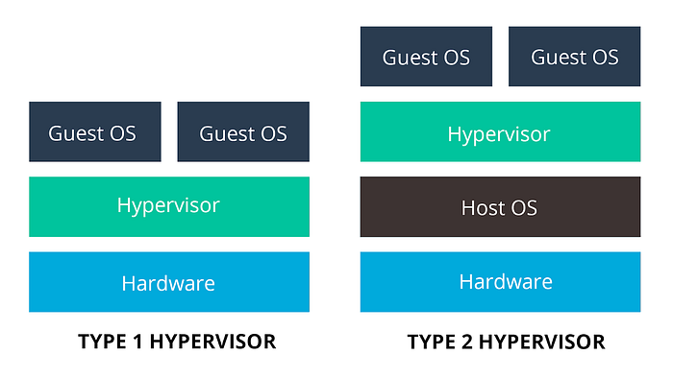
Figure 1. Type 1 and Type 2 Hypervisors and how they are different [3]

Whichever Hypervisor is used has its own advantages and disadvantages and virtualization essentially allows one single computer to host multiple virtual machines with each one having the potential to run separate operating systems [5]. Type 1 Hypervisors are argued to be superior to enterprise environments because they are deployed directly on hardware and provide increased security and performance [6]. Type 2 hypervisors are more appropriate for development and testing scenarios because they’re deployed over an already existing operating system, offering simplicity and flexibility but at the cost of an increased resource and security concerns [6].
The purpose of both Hypervisors is essentially the same, [3] highlights that the need to rely on the host OS for all activities creates a delay and therefore impacts on poor performance. The choice of a hypervisor depends on specific requirements, such as performance, security, scalability, and intended use. As highlighted, each hypervisor solution has its strengths and weaknesses; therefore, it is essential to align the choice with the organization's needs and infrastructure.
Research around Type 1 Hypervisors [7] shows results relating to performance tests which utilize the Filebench benchmark. This looks at storage and the benchmark generating different environments to assist with testing. Using the following identical hardware to create what would be a for benchmark measurement when comparing 4 type 1 hypervisors.
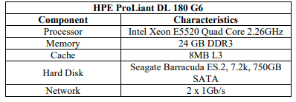
Figure 2. Server rest environment [7]
The study focuses on whether increasing the number of VM instances causes performance to decrease.
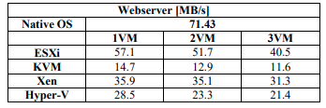
Figure 3. Four Hypervisors Webserver Benchmark results [7]
It is clear from the produced results when applying the dominant read component that ESXi was determined as the best performer with KVM clearly the worst when measuring workload.
The next results explored were in relation to Mail Server workload.
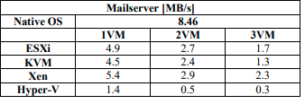
Figure 4. Four Hypervisors Mail Server Benchmark results [7]
The Mail server workload produce results indicating that Xen is the best performer whilst Hyper-V shows the poorest performance. The next results explore Fileserver.
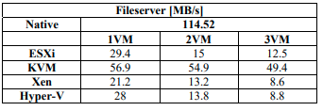
Figure 5. Four Hypervisors File Server Benchmark results [7]
When analysing results for the fileserver workload considering all data transfers it is KVM which performs the best with a marked performance difference from the other three where there is a small difference but with Xen showing the worst results.
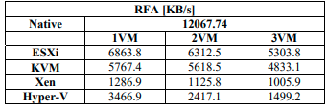
Figure 6. Four Hypervisors Random File Access (RFA) Benchmark results [7]
The random file access shows that ESXi performs the best, with KVM not far behind. XEN is evidently the poorest performer.
In looking at performance overall it is most evident in the fileservers that performance decreases when increasing the number of VM instances. ESXI is shown by this case study as the best option overall based on the results and HYPER-V as the worst.
A research study focusing on Type 2 Hypervisors [8]. Filebench was also utilised as it designed to measure storage space and performance of file system with the following test environment:
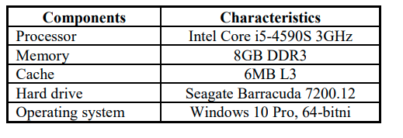
Figure 7. Test environment PC [8]

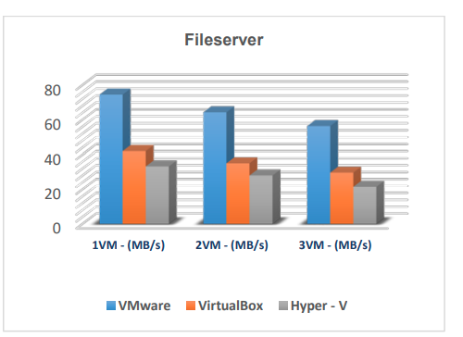
Figure 8. File Server results [8]
VMware is the best performer in testing fileserver workloads. This is the same as notes below when testing is undertaken for varmail workload. This includes random reading in addition to random reading making MS Hyper V the poorest performance.
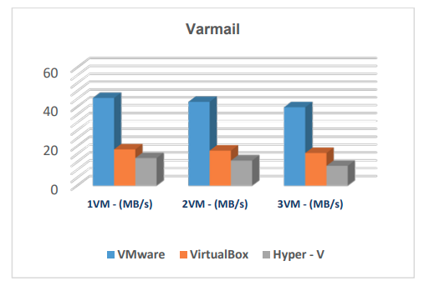
Figure 9. Varmail test results [8]
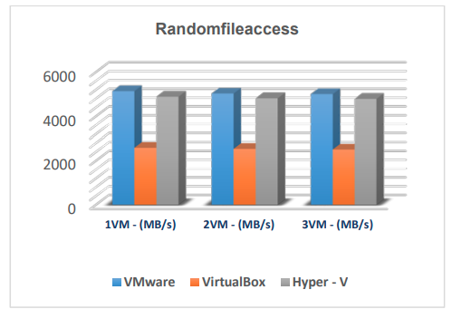
Figure 10. Random File Access test results [8]
The installation of use of any of these Hypervisors is free of any cost. The case study results highlight that VMware is by far the best performer in all areas. VirtualBox performs better than MS Hyper-V with many sequential features, but where workloads have random dominance MS Hyper-V is the preferred option over VirtualBox [8].
Hypervisor Solutions in the Market:
VMware vSphere/ESXi:
This is known as the leader in type 1 Hypervisors due to its free edition and 5 commercial editions that are available.
Features: High performance, advanced management tools, and extensive ecosystem. Widely used in enterprise environments and led the marker with features such as memory overcommitment, fault tolerance and storge v Motion [9]
Security: Provides various security features, including secure boot and vSphere Trust Authority.
Microsoft Hyper-V:
Regarded as one of the top 3 type 1 hypervisors. It is available in a free edition and 4 commercial editions making it a flexible and appealing choice [9]
Features: Integrated with Windows Server, Hyper-V offers features like Live Migration and Hyper-V Replica. Dynamic memory, high availability, scale and includes 2 windows OS rights in the standard edition [9]
Security: Implements security features such as Shielded VMs for protecting virtual machines [9].
Xen:
Is a type 1 hypervisor which is an open source and offers commercial solution.
Features: Open-source hypervisor, known for its paravirtualization capabilities. Used in various environments, including cloud computing. Memory optimization, live storage migration, conversation tools and power management [9], [7].
Security: Emphasizes security through its architecture and community-driven development [9].
KVM (Kernel-based Virtual Machine):
This is an open-source type 1 hypervisor. This can be added to most of the Linux Operating Systems and most which offer KVM also offer additional tools [9].
Features: Part of the Linux kernel, offering virtualization capabilities for Linux systems [7].
Security: Benefits from the security features of the Linux kernel [7].
Oracle VirtualBox:
Notably supports Windows as a guest and host OS in addition to Linux due to it originally targeting desktop -based virtualization [10].
Features: User-friendly, supports various host operating systems, and is suitable for development and testing [8].
Security: May not be as secure for production environments compared to enterprise-grade hypervisors [8].
Research carried out by the Tolly group which concluded that the Oracle VM server can support a variety of workload efficiently in a virtualized environment [10].
Citrix Hypervisor (formerly XenServer):
Features: Based on Xen, optimized for virtual desktop infrastructure (VDI) and cloud environments [7].
Security: Includes features like Direct Inspect APIs for enhanced security [9].
Each hypervisor method supports full virtualization. As outlined in the research undertaken, the main advantages obtained by applying virtualization are around cost reduction and storage space. The process enables better security and resistance to failures and makes administration easier [8]. The choice of which method to apply will be dependent upon the need to the user, i.e. Is it flexibility in operation or better performance and security.

Hypervisor choice.

In considering all the research and the task in hand to set up a virtualised network for NOSS, Oracle VM was chosen as it is associated with numerous benefits. Despite VMware being the clear best overall performer, Oracle VM is a free, open-source Hypervisor which also support Microsoft. It is considered an extremely powerful program, specifically when applying on systems with intel or AMD processors [8]. Technical requirements for Oracle VM are highlighted by as follows:
- 32-bit or 64-bit operating system with AMD or Intel processor [8]
- 512MB or more RAM (depending on the number and type of operating systems being virtualized. The RAM memory space allocated to the virtual machine environment can go up to half capacity, as the software itself will not allow more than half of the base system's RAM.[8]
- available hard disk space for the virtual machine environment [8]
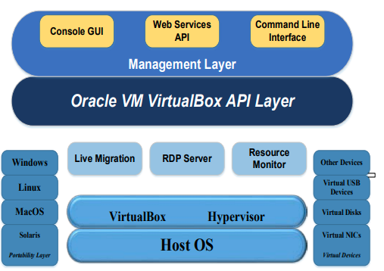
Figure 11. Oracle VM architecture [8]
One of the key reasons for choosing Oracle VM is its tight connectivity with the larger Oracle. As an organisation that relies heavily on Oracle's suite of enterprise applications, including databases, middleware, and business applications, Oracle VM ensures seamless compatibility and optimal performance for these workloads [11]. Ultimately it is a cross-platform hypervisor which can be accessed via Windows, macOS and Linux [12],[8]. The benefit of which is installing a new operating system without it being installed on your actual bare metal hardware.
The user-friendly management console enables easy provisioning, monitoring, and orchestration of virtualized resources, that allows streamline workflows and maximise resource utilisation, creating a unified platform for end-to-end infrastructure management in both physical and virtual environments. Essentially Full stack Management [11]. This enables older operating systems to be installed in addition to new software [12]. Oracle VM's centralised administration and automation capabilities improve operational efficiency while reducing administrative costs.
Oracle VM provides the flexibility to accommodate a wide range of applications while maintaining high levels of performance and resource efficiency. Testing cross-platform application can be done simply with the use of Oracle VM [12]. Advanced features, such as live migration, high availability, and disaster recovery, provide continuous operation and resilience, minimising downtime and increasing productivity [10].
Security is an important factor that affected the decision to use Oracle VM software. Oracle VM offers a strong defence against cyber threats and data breaches, thanks to built-in security features including role-based access control (RBAC), encryption, and virtual firewall capabilities. Oracle VM protects sensitive information and vital assets by integrating comprehensive security measures at the hypervisor level, as well as guaranteeing compliance with regulatory and industry standards. It allows the user to learn cybersecurity and apply your skills directly [12].
Oracle VM provides a strong value proposition with its competitive pricing model and flexible licencing choices. By leveraging Oracle VM's open-source base, as well as Oracle's expertise and support services, I can save significantly without losing performance or functionality. This cost-effectiveness allows me to better allocate resources, invest in key initiatives, and promote innovation inside the organisation.
[11] outlines how Oracle VM supports up to 384 physical CPUs and 6TB memory with each guest VM supporting up to 256 virtual CPUs and 2,000,000MB memory, to accommodate the most demanding enterprise and cloud applications.
The main advantages for choosing Oracle VM are outlined as:
- Free and feature rich. Unlike other Hypervisors the Oracle VM offers enhanced features such as snapshotting and data encryption for free which makes them a more attractive choice than the alternative hypervisors such as VMware [12].
- Open source: able to view and edit allowing the user to customize safely [12].
- Popular: attracts a large number of users and therefore lots of guidance and support available around its use and widely used in IT industry [12].
In summary, the decision to utilize Oracle VM software was driven by its seamless integration with the Oracle ecosystem, enterprise-grade features, robust security, centralized management capabilities, and cost-effectiveness [10], [12]. Oracle VM's advanced virtualization platform can create a resilient and scalable IT infrastructure that meets the evolving needs of NOSS as an organization while maximizing value and efficiency.

Downloading the Hypervisor, Server and Operating Systems.

The Oracle VM software was downloaded and installed onto a PC as the first step in creating a network for NOSS. The next step involved installing Windows Server 2022 twice which created the DC servers. Windows 10 was then installed creating PC’s. The result is detailed below:
- SW-DC – Windows Server 2022
- LW-DC – Windows Server 2022
- SW-PC – Windows 10
- LW-PC – Windows 10
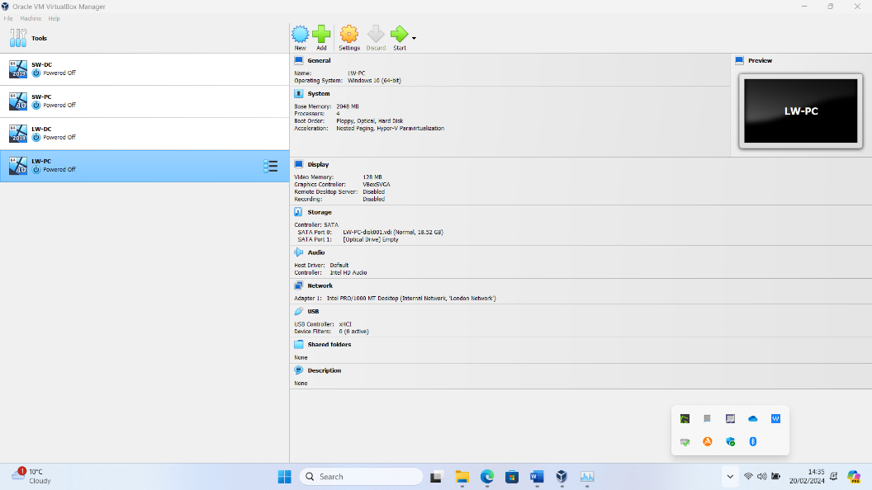
Figure 12. VM software of type 2 Hypervisor with two servers and two OS installed
Windows Server 2022 was chosen as it includes improved security features such as, hybrid Azure integration, and container support. It also offers enhanced networking and storage capabilities. Whilst the 2019 version may be sufficient for some, corporations seeking the latest in security and hybrid cloud may find 2022 more appealing [13].

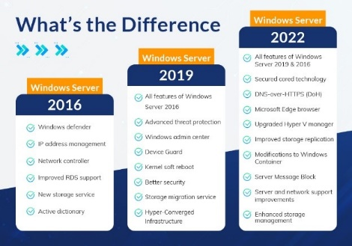
Figure 13. What are the differences [14]

Windows 10 was used as it offers strong, built-in, and continuing security measures meaning that the operating system stays efficient, productive, and secure. Windows 10 is adaptable to an individual, whether you have specific preferences or a distinct working style [15].

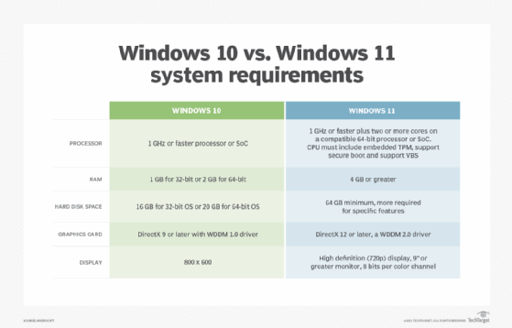
Figure 14. Windows 10 Vs Windows 11 [16]

Setting up the Network

The NOSS Topology that is used for both Swansea (SW) and London (LD) is shown below:

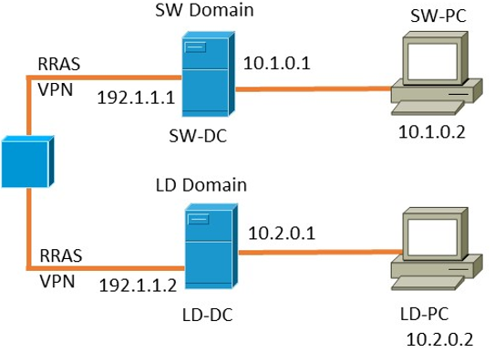
Figure 15. NOSS Network Topology for Swansea and London
When configuring one or more VM's to sit on an Internal network the domain needs to be linked to the PC to facilitate communication. This allows all traffic on that network to stay within the host meaning it is only visible to VM's on that virtual network. To ensure this Topology design was followed for NOSS, two internal networks were created within the Oracle VM software, namely:
- Internal Network – “Swansea” – SW-DC / SW-PC
- Internal Network – “London” – LD-DC / LD-PC
The final step within this process required me to log on to both servers and PCs to setup the network cards. Once created I renamed these to InLan, this was then used for the Internal network.

Research on IP Addressing.
The journey of data from one computer to another on the Internet involves a sophisticated interplay of protocols, addressing, routing, and physical infrastructure. “An internet Protocol (IP) address is a unique numerical identifier for every device or network that connects to the internet” [17]. This online device address creates a seamless process enabling global connectivity that characterizes the modern digital era, allowing users to access information and communicate across vast distances in real-time. Essentially every time someone requests to access a website a connection to a network router is made making the connection to the server. Each device – the computer, router and server have a unique IP address which makes the transfer of data possible [17]. Data and information travels across the internet from one IP address to another in what is referred to as packets. By utilizing IP addresses, the internet ensures that data packets are correctly routed and delivered across the network.
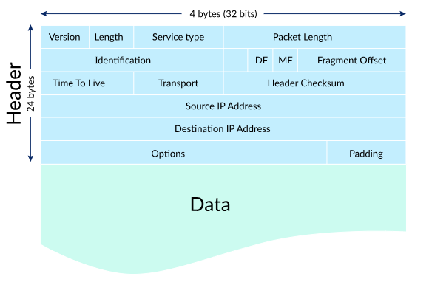
Figure 16. IP Packets [18]
There are two versions of IP addresses namely, IPv4 and IPv6 [17].
IPv4 – consists of a 32-bit long IP address is divided into 4 octets which refer to the network or host ID, the binary bits are separated by a dot and is numeric and offers 12 header fields [B], [17].
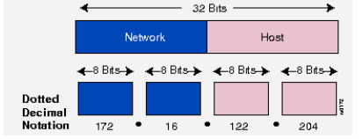
Figure 17. The basic format of typical IP addresses [B]
IPv6 - represents eight groups of four hexadecimal digits separated by colons as opposed to decimals [17]. It is essentially the newer version of the IPv4 [19] designed to overcome its limitations, namely creating a more streamlined, increased capacity and more efficient version.
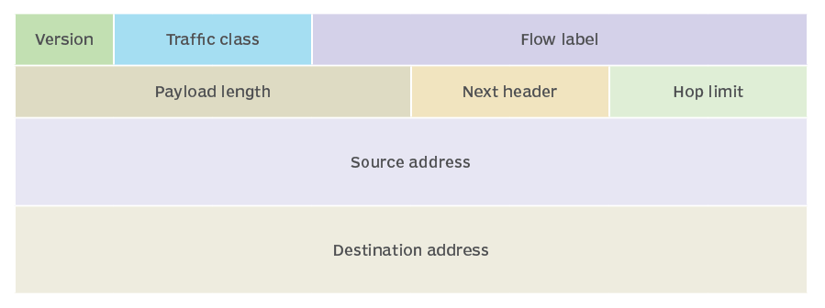
Figure 18. The structure of an IPv6 header [19]
Due to internet scalability problems the number of IP address via the IPv4 space will eventually be exhausted [20]. The IP address space allocation has not been undertaken as efficiently as they could have been. The maximum potential is further impacted by the traditional classifications of A, B and C [20].
There is different type of IP addresses. Private IP addresses are used on internal networks and devices are likely to include smartphones, smart TVs and printers [17]. Public IP addresses on the other hand enable a router to link with an outside network and cover an entire network. The multiple devices accessing the same connection will therefore share the same IP address [17]. The main differences are shown below:

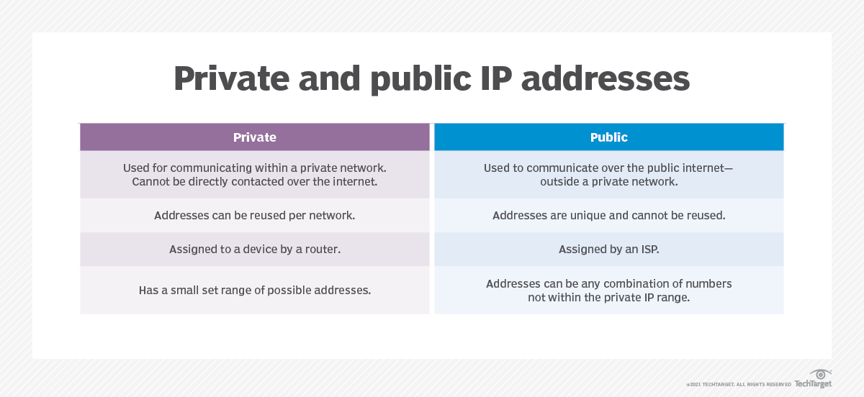
Figure 19. The difference between Private and Public IP addresses [17]
There are dynamic and static IP addresses. Dynamic addresses change and results in a new IP address being assigned to a device each time it connects to the internet and the addresses are reused. Static never change once assigned and ensure continuous access to the internet by the server. Dynamic IP addresses are common and offer additional protection around cyberattacks due to the fact the IP address is constantly changing [17].
Subnetting attempts to tackle some of these issues by supporting a three level, as opposed to two level hierarchy [20]. Essentially allowing the network to be expanded without the need to change the network IP address [21].
Routers and switches play vital roles in the Internet's infrastructure, serving distinct purposes in facilitating the transmission of data between various networks. Each device possesses specific functionalities that contribute to the effective and dependable transfer of data. Routers essentially select the path of the data by connecting to the internet between networks using systems such as LAN’s. Switches on the other hand are not necessary for the internet and they are used for interconnecting devices on larger scale businesses. [22]
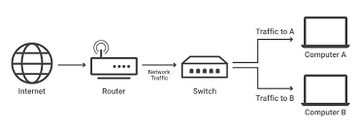
Figure 20. A local area network (LAN) such as home WiFi network [22]
Collaboratively, routers and switches ensure the smooth and reliable flow of data between diverse networks on the Internet. Routers handle inter-network communication by making decisions based on IP addresses, while switches facilitate intra-network communication by forwarding the data to the correct device known as physical addresses/MAC as they are used within a network as opposed to what [22] refers to as ‘internet traffic’. Collectively, these devices establish the foundation of the Internet's infrastructure, enabling the worldwide connectivity that characterizes contemporary communication.

IP address and configurations.

As highlighted in the network topology, the IP address used followed the IPv4 version: 10.*.*.* . These IP addresses are private meaning they cannot be used outside the network. I have used 255.255.0.0 as the subnet to overcome scalability issues with this version as this will provide an increase in the capacity for the host to 65534. NOSS is a multinational corporation, therefore the assumption is that there will be many network devices within the corporation, this could include, laptops, mobile phones, printers, and photocopiers. Should NOSS not operate on such a large scale then the subnet could be changed to decrease capacity.
The below shows the IP and subnet assigned to each device as part of the network configuration:
Device IP Subnet Default gateway
SW-PC 10.1.0.2 255.255.0.0 10.1.0.1
SW-DC 10.1.0.1 255.255.0.0
LW-PC 10.2.0.2 255.255.0.0 10.2.0.1
LW-DC 10.2.0.1 255.255.0.0

Network Testing and troubleshooting Techniques.

Network testing is the process of evaluating the performance, functionality, reliability, security, and other characteristics of computer networks. It involves various techniques and methodologies to ensure that networks meet specified requirements and perform optimally under different conditions. Network testing is undertaken at introduction stage but as networks change and evolve over time it is equally as important to undertake these and monitor the networks performance over time which allows any problems to be detected and troubleshooting to be applied [23]. It helps maintain a robust and reliable network infrastructure that supports the needs of users, applications, and the organization. Key objectives include:
- Performance evaluation: Measures network performance in line with expectations and is measured around speed, throughput, latency, and bandwidth [23].
- Reliability and availability: Provides an evaluation on this area including the ability to recover from failures [23].
- Security assessment: Evaluates vulnerabilities of the network and assesses security measures such as firewalls [23].
- Quality of service (QoS): Users will have different expectations and needs and therefore it is important to test functionality and if the network is able to prioritise and vary the delivery accordingly [23].
- Load testing: Essentially how well the network copes and performs due the busiest time (peak usage) [23].
By conducting a network performance test, organizations can identify potential issues and look to resolve these. There are strategies outlined by [23] which can be applied include checking and verifying network connections and applying any hardware updates. Key aspects of networking testing to ensure the best delivery are as follows:
- Ping Testing: Ping testing involves sending ICMP (Internet Control Message Protocol) packets to a target device and measuring the round-trip time for responses. It's a basic method to check the reachability and latency of network devices as any dropped packets indicates a network problem exists [24].
- Bandwidth Testing: Bandwidth testing evaluates the maximum data rate that a network can support. This is crucial for ensuring that network resources can handle expected levels of traffic. Bandwidth utilisation forms part of this as these needs careful management to ensure network performance is balanced with risks around congestion [23]. The test consists of transferring a specific amount of data and obtaining a measurement of the time it takes the sample data to transmit which will be given in Mbps or Gbps which reflects the networks capability around data traffic. There are factors that should be considered when interpreting results such as internet connectivity and network congestion [23].
- Throughput Testing: Throughput testing measures the amount of data transferred over a network within a specified period and provide a measurement in bits per second (bps). Tools like iPerf and Netperf are commonly used for throughput testing and high throughout is required for those applications that deal with large volumes of data transfer. Throughput testing differs from bandwidth testing in that it measures the data transfer in actual terms as opposed to the maximum capacity [23].
- Load/stress Testing: Load testing involves applying simulated loads to a network to assess its performance under various levels of stress, often undertaken as part of scalability which helps organisations plan for growth. This helps identify bottlenecks and capacity limits. Stress testing goes a step further by pushing the network beyond its normal operating conditions to determine its breaking point and failure modes. It is not about the function of a network but rather about the network stability and strength. It measures several factors such as latency, packet loss, response time [25], [23].
- Latency Testing: Latency testing measures the delay between the transmission and reception of data packets. In basic terms the time it takes to deliver data form the source to destination. High latency can degrade network performance, especially for real-time applications like VoIP and online gaming so lower latency is what is most desired [23].
- Packet Loss Testing: Packet loss testing evaluates the percentage of packets lost during transmission undertaken by measuring in a percentage the difference between how many packets were sent to how many were received. Excessive packet loss can indicate network congestion or hardware issues. Keeping this to a minimum is essential to optimise efficiency [23]. Testing in this area can assist with identifying the area that is problematic and then applying a solution such as a hardware upgrade which will improve user’s experience and performance [23].
- Security Testing: Security testing involves assessing the network's resilience against various cyber threats, including penetration testing, vulnerability scanning, and firewall testing. Penetration testing can often be used to exploit the network to establish the level of vulnerability and generates steps to remedy any that are found [26].
- Quality of Service (QoS) Testing: QoS testing verifies that the network can prioritize traffic according to predefined criteria, such as ensuring that VoIP packets receive higher priority than file downloads due to them being considered of greater importance. These are then benchmarks against industry standards to measure performance and look at where improvement may be required [23].
Networking troubleshooting refers to not only discovering but correcting problems identified within the network. These could relate to performance, security, data latency or any of the above issues identified. The larger the organization the more resource around troubleshooting may be in place such as troubleshooting tools, but quite often these are now embedded within a network management system [27].
Trouble shooting will ned to occur when some of the following issues are present:
- Connection failures: This could relate to cables not being attached properly [27].
- Security lapses: Could relate to exploitation of a system via cyber-attack [27].
- Application failures: For example, a update not being installed [27].
- Policy failures: Multiple policies in place that may conflict or contradict [27].
- Endpoint issues: Issues around connectivity [27].
Troubleshooting process are applied to deal with identified issues which could be tested to attempt an issue and may be a process of trial and error. Processes that can be applied are as follows:
- IP -configuration checks – assigning a new IP address can often resolve network issues [27].
- Ping and Tracert testing- if an IP address is not the problem, then these testing techniques can be used to test connections with the remote servers [27].
- DNS checks- this test if results generate certain results such as “no response from server” indicate problems with a server [27].
- Service provider checks- this relates to outages which are known to occur and will impact on a network’s performance [27].
- Virus and malware checks- security tools will be required as often such vulnerabilities are not easy to identify but will cause network performance [27].
- Database logs- if these become full or exceed capacity then performance will become slower [27].
NOSS, like most corporations will be reliant on needing a high performing network to mange the business and customer interface. Network testing and monitoring is a crucial part of ensuring that this is in place [23]. The application of continuous testing and troubleshooting to first find the problem, establish the cause, fix the problem, and test the solution has resolved the problem are pivotal to ensuring NOSS has an efficient and reliable network.

Testing the Network.

The IP addresses for both the Swansea branch; SW-DC and SW-PC were tested via a doss command known as a Ping test to establish if they could communicate with each other. This test unfortunately showed the server, and the PC could not contact one another as per the screenshot below:
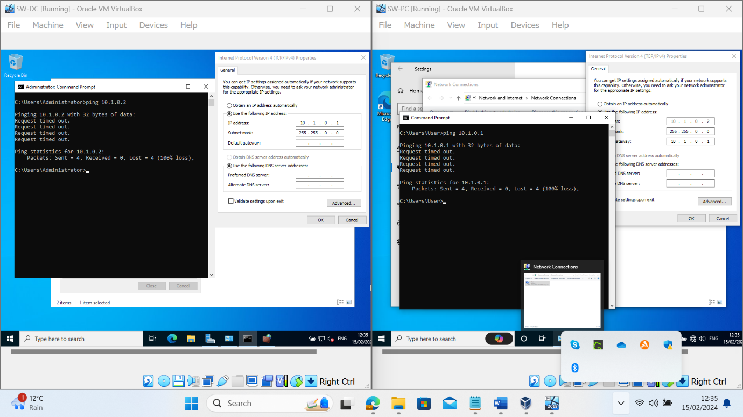
Figure 21. SW-DC and SW-PC Ping Request Fail
After researching what the problem might be I noticed that Inbound and Outbound “File and Print Sharing (Echo Request)” were not enabled. To rectify this, I made a change to the firewall and enabled the “File and Print Sharing (Echo Request)”. This had to be done for Inbound and Outbound Rules, on SW-DC and SW-PC.
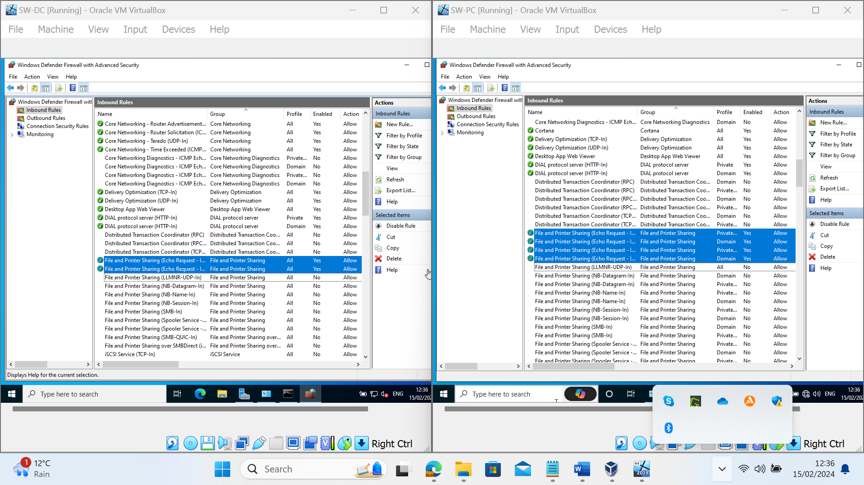
Figure 22. Firewall Inbound Rules
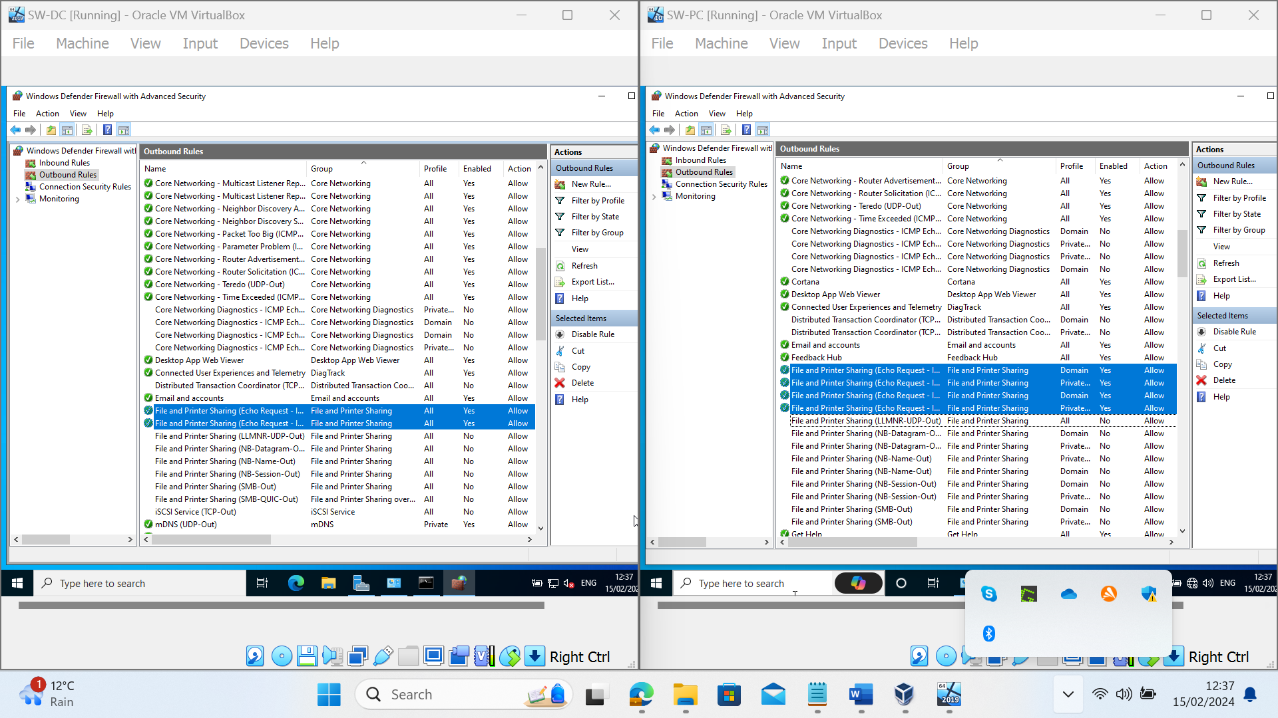
Figure 23. Firewall Outbound Rules
These changes were also made on LW-DC and LW-PC. After applying the changes to the Firewall, I then ran another ping test. The ping test showed both server and PC could communicate with each other, indicating a successful result as shown below.
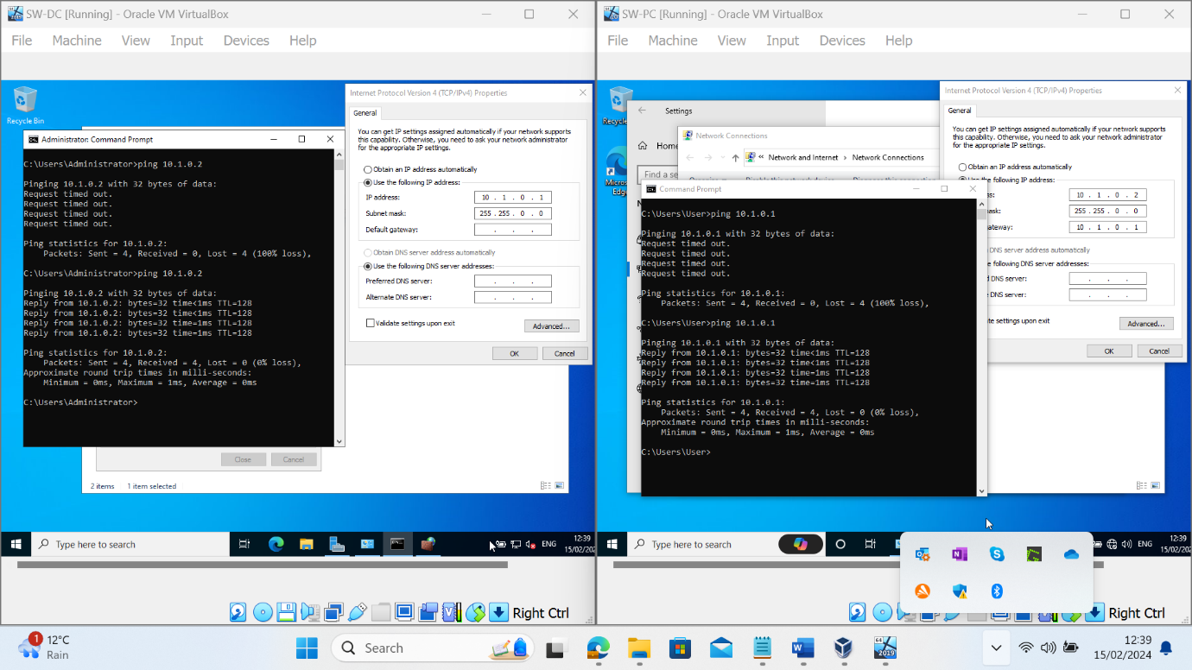
Figure 24. SW-DC and SW-PC Ping Request Successful
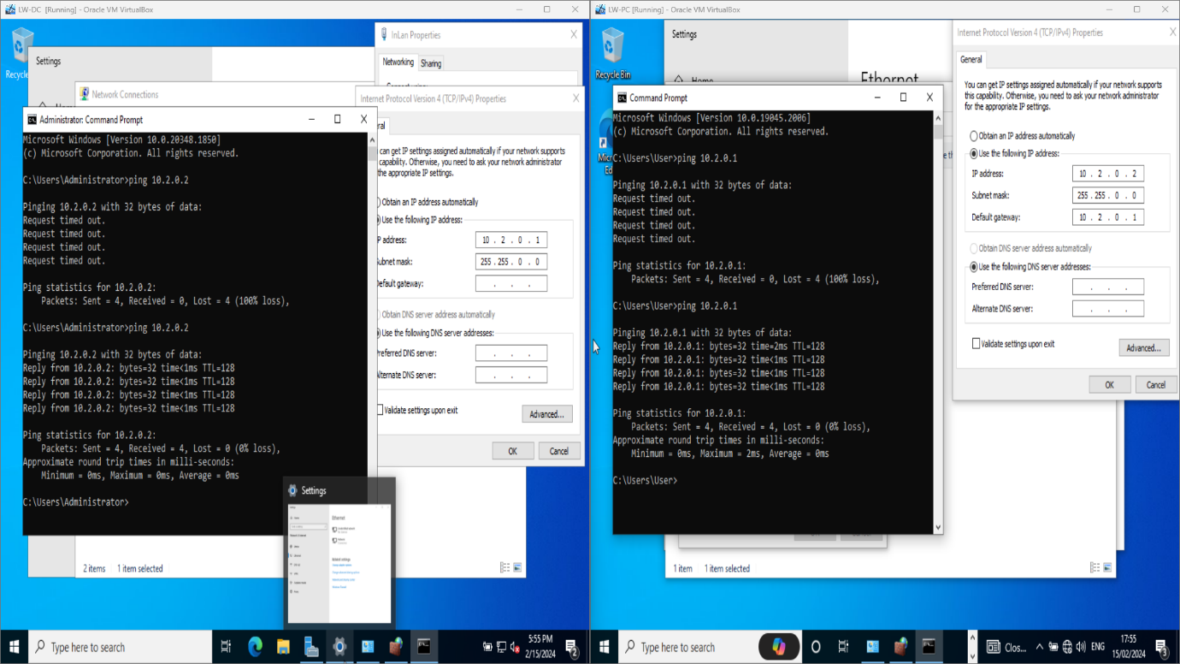
Figure 25. LW-DC and LW-PC Ping Request Successful

Conclusion

This report highlights that there are many benefits associated with different type of hypervisors. The report has clearly set out what hypervisors are the architecture of each type and their compatibility. It explores how IP addresses impact upon effectiveness and troubleshooting that can be applied and what this shows. The research undertaken enabled a ping test to be applied and what steps to apply to essentially troubleshoot and resolve the issue. In this case this required changes to the firewall, both inbound and outbound. One of the main conclusions that can be reached is the importance of using the correct hypervisor to match the needs of the company and what it is that needs to be achieved. Whilst the Ping test following troubleshooting has essentially been successful, further research would be needed around the performance of the hypervisor should this be applied on a larger scale. This would then inform future recommendations and determine the efficiency of the chosen hypervisor for NOSS.

Reference

[1] “What is Network Virtualization? Everything You Need to Know.” [Online]. Available: https://www.techtarget.com/searchnetworking/What-is-network-virtualization-Everything-you-need-to-know. [Accessed: 12-Feb-2024]

[2] “The advantages of network virtualisation,” 2022. [Online]. Available: https://www.telefonica.com/en/communication-room/blog/the-advantages-of-network-virtualisation/. [Accessed: 12-Feb-2024]

[3] “Type 1 and Type 2 Hypervisors: What Makes Them Different | by ResellerClub | ResellerClub | Medium” [Online]. Available: https://medium.com/teamresellerclub/type-1-and-type-2-hypervisors-what-makes-them-different-6a1755d6ae2c. [Accessed: 17-Feb-2024]

[4] “Virtualization in Cloud Computing: Moving from Hypervisor to Containerization—A Survey | Arabian Journal for Science and Engineering” [Online]. Available: https://link.springer.com/article/10.1007/s13369-021-05553-3. [Accessed: 17-Feb-2024]

[5] “- VleReader” [Online]. Available: https://r1.vlereader.com/Reader?ean=9781292061955#. [Accessed: 18-Feb-2024]

[6] “What is a Hypervisor?” [Online]. Available: https://www.liquidweb.com/blog/what-is-a-hypervisor/. [Accessed: 18-Feb-2024]

[7] “File System Performance Comparison in Full Hardware Virtualization with ESXi, KVM, Hyper-V and Xen Hypervisors” [Online]. Available: file:///C:/Users/user/Downloads/aece_2021_1_2.pdf. [Accessed: 18-Feb-2024]

[8] “Comparison of type-2 hypervisor performance on the example of VirtualBox, VMware Workstation player and MS Hyper-V” [Online]. Available: https://www.etran.rs/2022/zbornik/ICETRAN-22_radovi/066-RTI2.4.pdf. [Accessed: 18-Feb-2024]

[9] K. Ward, “The Top 5 Enterprise Type 1 Hypervisors You Must Know,” ActualTech Media, Apr. 12, 2021. https://www.actualtechmedia.com/io/top-5-enterprise-type-1-hypervisors/

[10] “Analysis of Virtualization Technologies for High Performance Computing Environments | IEEE Conference Publication | IEEE Xplore” [Online]. Available: https://ieeexplore.ieee.org/abstract/document/6008687. [Accessed: 18-Feb-2024]

[11] “Oracle VM Server for x86 Virtualization and Management” [Online]. Available: https://www.oracle.com/a/ocom/docs/ovm-server-for-x86-459312.pdf. [Accessed: 19-Feb-2024]

[12] “Oracle VM Server for x86 Virtualization and Management” [Online]. Available: https://www.oracle.com/a/ocom/docs/ovm-server-for-x86-459312.pdf. [Accessed: 19-Feb-2024]

[13]“Windows Server 2022: Brilliant & Dynamic Powerhouse,” 2023. [Online]. Available: https://www.serverconsultancy.co.uk/upgrading-to-windows-server-2022-2/. [Accessed: 22-Feb-2024]

[14] “Windows server 2022 vs. 2019 vs. 2016 - What are the Differences?” [Online]. Available: https://www.directdeals.com/windows-server-2022-vs-2019-vs-2016-what-are-the-differences. [Accessed: 22-Feb-2024]

[15] “Why you should upgrade to Windows 10 - Microsoft Support” [Online]. Available: https://support.microsoft.com/en-gb/windows/why-you-should-upgrade-to-windows-10-fa938f9a-749a-ebb1-2c39-ddd815414b21. [Accessed: 22-Feb-2024]

[16] “What is Microsoft Windows 10? Definition from WhatIs.com,” SearchEnterpriseDesktop. https://www.techtarget.com/searchenterprisedesktop/definition/Windows-10
‌
[17] “What is an IP Address? | Definition from TechTarget.” [Online]. Available: https://www.techtarget.com/whatis/definition/IP-address-Internet-Protocol-Address. [Accessed: 19-Feb-2024]
[18] “IP packets (article) | The Internet | Khan Academy.” [Online]. Available: /_render. [Accessed: 19-Feb-2024]

[19] “What are Network Packets and How Do They Work?” [Online]. Available: https://www.techtarget.com/searchnetworking/definition/packet. [Accessed: 19-Feb-2024]

[20] “Understanding IP Addressing” [Online]. Available: https://www.osburn.com/ip/. [Accessed: 19-Feb-2024]

[21] M. Padole, P. Kanani, L. Raut, D. Jhaveri, and M. Nagda, “An insight into IPAddressing,” Oriental journal of computer science and technology, vol. 10, no. 1, pp. 33–40, Feb. 2017, doi: https://doi.org/10.13005/ojcst/10.01.05.

[22] Cloudflare, “What is a network switch? | Switch vs. router | Cloudflare,” Cloudflare, 2023. Available: https://www.cloudflare.com/learning/network-layer/what-is-a-network-switch/

[23] “Network Testing: How to Test Network Performance.” [Online]. Available: https://obkio.com/blog/network-testing/. [Accessed: 21-Feb-2024]

‌ [24] L. Zelleke, “Conduct a Network Stability Test in 2024 - Step by Step Instructions,” 2019. [Online]. Available: https://www.comparitech.com/net-admin/how-to-network-stability-test/. [Accessed: 21-Feb-2024]
[25] “Difference between Load Testing and Stress Testing,” 2019. [Online]. Available: https://www.geeksforgeeks.org/difference-between-load-testing-and-stress-testing/. [Accessed: 21-Feb-2024]

[26] Network Security Testing: Top 5 Methodologies You Must Know,” 2021. [Online]. Available: https://www.getastra.com/blog/security-audit/network-security-testing/. [Accessed: 21-Feb-2024]
[27]“What Is Network Troubleshooting?,” Cisco. https://www.cisco.com/c/en/us/solutions/enterprise-networks/what-is-network-troubleshooting.html
‌

‌

