
School of Engineering
Application of CAE process
Koa Brook
2203480
Motorcycle Engineering Beng
15/12/2024
Structural and fluid analysis
ACHA6010

Contents
FEA Analysis Report Structure 4
1. Introduction 4
1.1 Objectives of the Study 4
1.2 Overview of the Real-World System 4
2. Modelling and Assembly 5
2.1 Software and Tools 5
2.2 Assembly 5
3. Kinematic Simulation and Static Structural Analysis 6
3.1 Material Properties 6
3.1.1 Aluminum, 6061, T6 6
3.1.2 Aluminum, 6005, T5 6
3.1.3 Aluminum, 2618, T6 6
3.2 Kinematic Analysis 7
3.2.1 Rigid dynamics 7
3.2.2 Steady-state Thermal 7
3.2.3 Static Structural 7
3.3 Results and Insights 7
3.3.1 6061 T6 7
3.3.2 6005 T5 7
3.3.3 2618 T6 7
3.4 Material Selection 8
4. Optimization and Improvement 9
4.1 Component Design/Modification 9
4.2 Modified Piston results 9
4.2.1 Gudgeon pin to Skirt Support Reduction 9
4.2.2 Skirt material Reduction 9
4.2.3 Skirt and Support Reduction 10
5. Validation Testing 11
5.1 Base Simulation Comparison 11
5.1.1 Base sim 11
5.1.2 Modified Piston 11
5.3 Analysis 11
6. Discussion of CAE Tools 12
6.1 Role in Engineering Design 12
6.2 Advantages and Benefits 12
6.3 Limitations and Challenges 12
7. Conclusion 14
8. References 15

FEA Analysis Report Structure

1. Introduction
This report aims to analyse the accuracy of FEA (finite element analysis) software through the testing of CAD made mechanical assembly. The assembly use will consist of a piston, guidon pin, con-rod and crankshaft. A motion study will be conducted on the entire assembly, then using results from that combined with other studies will give results for the stress and deformation of the piston. The piston will be the studies focus as it will display clear results as it has the most extreme forces acting upon it. This process will be repeated using different aluminum alloys, the one that undergoes the least stress, and deformation will be used in three other studies that aim to reduce the mass of the piston as much as possible. The mass reduced will be based upon the non-dependent sections of the component that have the least stress, and deformation. The results of these tests will be analysed and compared to the results of the initial piston design. All loads, forces and pressures will be based on maximum values so the piston can be tested in a worst-case scenario (maximum combined forces acting upon it), this will give clear and accurate results.

1.1 Objectives of the Study
The objective of this study is to learn and understand the accuracies and limitations of FEA. Static structural studies will be analysed focusing on stress and deformation using visual results to determine accuracy. Thermal studies will be analysed using visual temperature gradient results as well as considering the expansion due to this in the static structural. The motion study will be the base for the other studies focusing on analysing the motion results, with the resultant forces being included in the static structural study. To understand the accuracy of the studies the results from the pistons with removed materials will be analysed and compared to the initial studies to identify if the initial stress analysis was correct.

1.2 Overview of the Real-World System
The piston is in vertical motion converting the forces to the con-rod through contact with the guidon pin, which is fixed concentrically in both the piston and con-rod. The con-rod moves vertically and partially rotates about the guidon pin, allowing it to transfer the load to the crankshaft as the con-rod is concentrically connected to a section of the crankshaft. The crankshaft rotates due to this load. The downwards load on the piston is because of the combustion pressure in the cylinder of the piston, the momentum of this force allows the crankshaft to continue its rotation, pushing the piston upwards. The momentum and maintaining velocity results in the motion loads acting upon the components, the pressure of combustion resulting in pressure loads that act only upon the crown of the piston. Combustion also results in thermal loads that alter the young’s modulus of the material, and therefore the resultant stresses and deformation. Oil is used to lubricate the system reducing friction, this also creates temperature loads. In a real-world scenario, there are other rotational components attached to this system which add-on to increase inertia and therefore the motion loads.

2. Modelling and Assembly

2.1 Software and Tools
The component models were made, edited and assembled in SolidWorks (Dassault systems (2023)) ( Andrew Noble (2024)), then had to be exported as STEP files so they’re compatible with the ANSYS systems. ANSYS Granta EduPack (Ansys, inc. (2023)) was used to acquire the material data required for the study. The material data and the component models are imported into ANSYS Workbench (Ansys, inc. (2023)). The components are connected in the rigid dynamics (motion loads) simulation, as well as the material data. The result from this is chosen at a maximum load point. The geometry and materials are used in the thermal study, the results of both studies as well as the geometry and materials data are used in the static structural simulation. The pressure acting on the piston crown is combined before running the simulation. The resultant stresses and deformation is shown on the piston and is color coded based on the magnitude.

2.2 Assembly
The crankshaft has a revolute joint with the ground, restricting its motion freedom so that it can only rotate about its Z-axis. The con-rod is connected to the crank at one end and the guidon pin at another, both using revolute joints. These joints allow the con-rod to rotate about each of its attached components, allowing it to maintain physical connections when the piston is in vertical motion. The guidon pin is connected concentrically to its slot in the piston allowing it to remain in contact and transfer loads between the piston and con-rod. The piston has a translational joint to ground so that it can move in the X-axis (vertically) only.

3. Kinematic Simulation and Static Structural Analysis
This section will review and analyse the three material simulations. Each alloy will be compared to predict which will undergo the least stress. Youngs modulus will be researched as well as how it changes with temperature. After this the kinematic simulation results for each will be compared, to determine which is the most suitable for the reduced mass studies.

3.1 Material Properties
This section covers the properties of all three materials used in the piston kinematics simulation. The Youngs modulus should allow for a prediction of which material will undergo the least stress in the FEA studies. The yield strength should allow for a difference in deformation prediction to be made. “The maximum deformation for the three types of material is almost similar at each mode and varies from 8.287 mm at 1st mode to 10.818 mm at 10th mode” (Krishna, B.V.R.V., Mudgala, S. and Seth, D. (2021)). Based of this papers conclusion we would expect some difference in deformation however it should be significantly small.
Figure 1 (Ansys, inc. (2023))

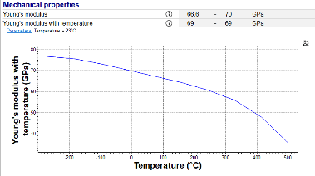
3.1.1 Aluminium, 6061, T6
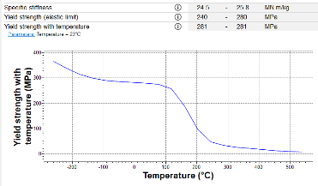
The Young’s modulus of this alloy starts at 77GPa at -273°C and decreases exponentially. This means that with every unit increase in temperature the change in Young’s modulus increases to a point where it is extremely susceptible to deformation. The yield strength graph, taking the shape of a reverse sigmoid curve, shows that the stress required to deform the metal starts to significantly decrease after 100°C.
Figure 3 (Ansys, inc. (2023))
Figure 2 (Ansys, inc. (2023))

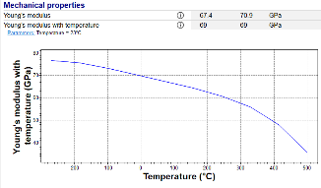
3.1.2 Aluminum, 6005, T5
Figure 4 (Ansys, inc. (2023))
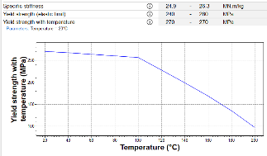
The Young’s modulus of this alloy starts at 77GPa at -273°C and decreases exponentially. The profile and positioning are nearly identical to the 6061 T6. The yield strength can be separated at 100°C to two linear graphs, compared to 6061 T6 from 100-200°C it takes less stress to deform.
Figure 5 (Ansys, inc. (2023))

3.1.3 Aluminum, 2618, T6
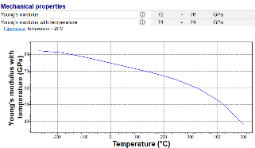
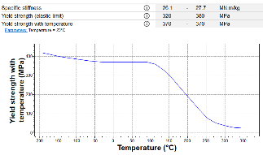
Young’s modulus of this alloy starts at 83GPa at -273°C and decreases exponentially. It has the same shape as the others, however, is less likely to deform due to stress across the temperature range. The yield strength graph, taking the shape of a reverse sigmoid curve, shows that the stress required to deform the metal starts to significantly decrease after 100°C. Like the Young’s modulus the graph is at a higher position compared to the 6061 T6, so it requires more stress to deform this alloy. This material is predicted to undergo the least stress and least deformation out of the three selected aluminum alloys
Figure 6 (Ansys, inc. (2023))

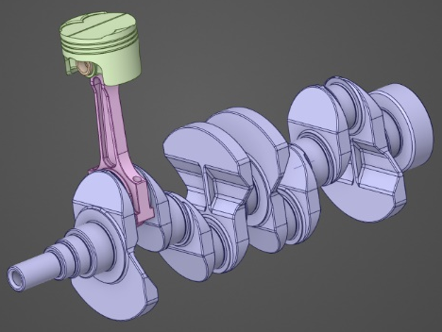
3.2 Kinematic Analysis
Figure 7

3.2.1 Rigid dynamics
The assembly is connected using joints that restrict the degrees of freedom of each component so that the motion simulation accurately represents and therefore behaves like a real-world scenario. A angular velocity of 7000 RPM (733.038 rad/s) is applied to the crankshaft. Force measurements on the piston are taken from the simulation, and the maximum force is recorded and used (7282.8N) in the final simulation.
Figure 8

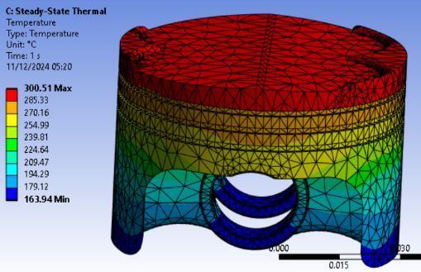
3.2.2 Steady-state Thermal
Heat transfer coefficient and temperature is introduced for each section of the piston. This allows the simulation to use the correct values for Young’s modulus and yield strength for the final simulation. It also allows the simulation to include thermal expansion.

3.2.3 Static Structural
This is the final simulation which includes factors from the other simulations. This simulation also includes pressure on the piston crown from combustion, the pressure used is from an engine simulation of a McLaren 570s (components would be under a high load due to it being a performance vehicle). 120 bar pressure was used.

3.3 Results and Insights
Figure 10

3.3.1 6061 T6
Figure 9
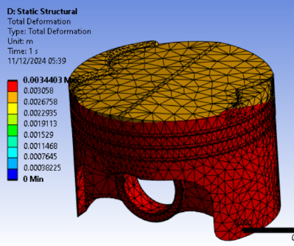
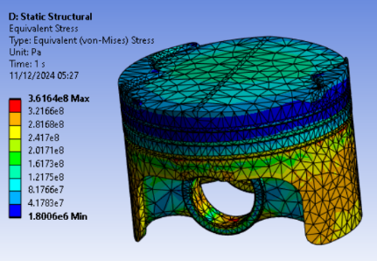
Out of the three studies the 6061 T6 experiences low stress and high deformation. The stress results show us that the piston experiences the most stress at the skirt, and minimal stress at the compression ring grooves.

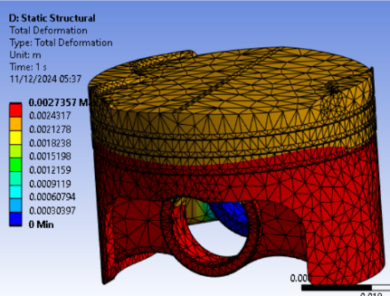
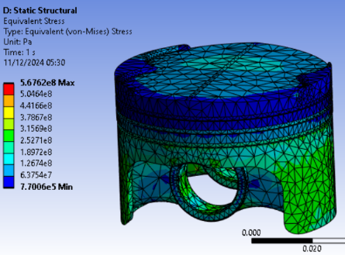
3.3.2 6005 T5
Figure 11
Figure 12
When the piston is made from the 6005 T5 it undergoes slightly higher stress than the 6061 T6. However, it undergoes less deformation that the 6061 T6 overall.
Figure 14
Figure 13

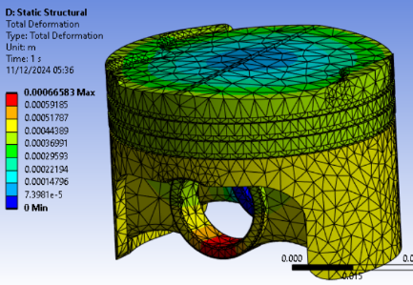
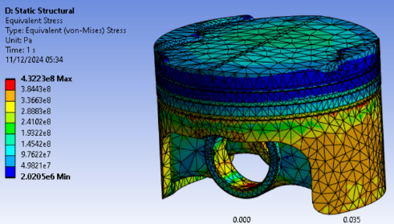
3.3.3 2618 T6
2618 T6 similar stresses to the other two studies, closest to the 6061 T6. This material undergoes the least deformation, this is to be expected due to the increased yield strength compared to the other materials.

3.4 Material Selection
The 2618 T6 visual displays a larger difference in deformation, this will allow for more obvious deformation results for the material reduction studies. It also displays a large difference in stress across the component, this is like the 6061 T6. However, the 6061 T6 results don’t show a large difference in deformation across the piston which makes it less suitable for the material reduction study as it is already under relatively high loads of stress equally distributed, the same can be said for the 6005 T5 deformation case. The 2618 is expected to give the most ideal visual results for the FEA analysis.

4. Optimization and Improvement
Using the results from the kinematics simulation the mass of the piston will be reduced, the mass reduced will be from low stress areas according to the simulation results. These sections will be reduced manually using SolidWorks (Dassault systems (2023)), as the ANSYS feature could potentially remove important sections of the component. This will be done with three different modified pistons to better understand the accuracy.
Figure 15

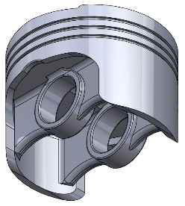
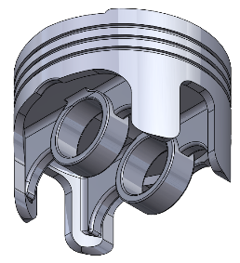
4.1 Component Design/Modification
The supports between the guidon pin mount and the inside of the skirt have a relatively low stress acting upon them in each simulation, this would be an ideal section to remove material from as it would affect the stress acting on the skirt and on the guidon pin mount. The skirt would be another section where material could be removed, tensional stress could be reduced. If both were done together the reduced supports would minimize stress transferred to the skirt and would therefore be transferred to other sections of the piston. With the higher concentrations of stress, due to the reduced material, an increase in deformation is expected. As can be seen the supports have been lowered where they connect to the gudion pin, reducing the material that stress can be transfurred through. Inbetween each support skirt material has been removed, this reduces the material that the stress across the skirt can distribute through.

4.2 Modified Piston results
Here the results for the modified piston will be reviewed, focusing on the difference in stress and deformation to the initial piston design. All pistons’ results used are based on aluminum 2618 T6 and will be compared to the initial piston design using the same alloy.

4.2.1 Gudgeon pin to Skirt Support Reduction
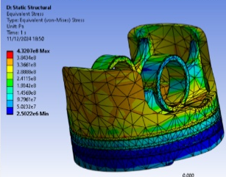
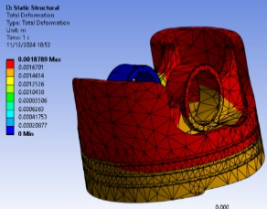
Comparatively out of the three models this one is in between in the case of stress magnitude. However, this simulation shows the highest deformation out of the three studies. The deformation is centered around the supports and its connecting sections the skirt and guidon pin mount.
Figure 19
Figure 18
Figure 17
Figure 16

4.2.2 Skirt material Reduction
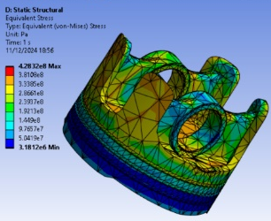
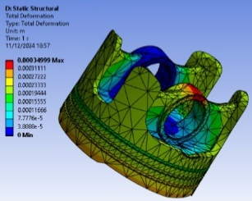
This piston undergoes the most stress out of the three simulations, due to there being significantly less materials to distribute the load. The reduced skirt experiences less deformation than the support reduction piston simulation. This could be due to the reduced materials causing a reduction in tension across the skirt.

4.2.3 Skirt and Support Reduction
Figure 21
Figure 20
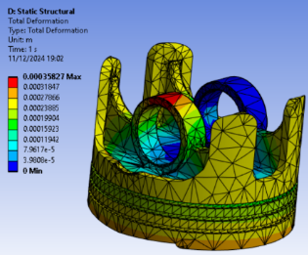
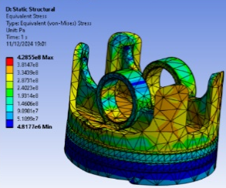
The model shows similar skirt stress to the other modified piston simulations, however, shows slightly less stress at the guidon pin mount. The deformation of this piston is similar to that of the skirt reduction piston, so the reduced supports has little impact on deformation.

5. Validation Testing
The base material simulation will be compared to piston with the most modified mass, so that the changes in stress and deformation due to reduced mass can be analysed. All simulations use a piston material of aluminum 2628 T6. As the modified piston has less material it is expected that an increase in deformation and stress concentration will be observed.

5.1 Base Simulation Comparison

5.1.1 Base sim
The skirt sees a stress of $0.29-0.34$ Gpa, and a deformation of $4.4-5.2×{10}^{-1}$mm. The supports see a stress averaging around $0.15$ Gpa, with a deformation of $4.4 × {10}^{-1}$mm. The guidon pin mount experiences $0.24-0.38$ Gpa, along with a deformation of $5.2-6.7 ×{10}^{-1}$mm.

5.1.2 Modified Piston
The skirt sees a stress of $0.29-0.38$ Gpa, and a deformation of $2.6×{10}^{-1}$mm. The supports see a stress averaging around $0.052-0.24$ Gpa, with a deformation of $1.6-2.6 × {10}^{-1}$mm. The guidon pin mount experiences $0.052-0.24$ Gpa, along with a deformation of $2.8-3.6 ×{10}^{-1}$mm.

5.3 Analysis
The modified piston experiences higher stresses at the skirt and support however experiences slightly lower stresses at the guidon pin mounting. The base simulation sees relatively higher deformation in comparison to the modified piston. The increased stress was predicted due to reduced material, as similar forces are acting upon less material. The reduced deformation is unexpected as there is increased stress, and the same alloy is used.

6. Discussion of CAE Tools
An overview and analysis of the tools and features used in the testing, this will include the benefits and disadvantages of the programs. This section will also identify the role FEA has in engineering and in what cases it is used and why. This will include how it affects engineering businesses as well

6.1 Role in Engineering Design
FEA allows engineers to digitally stress test designed components, this allows them to see deformation of the component, stress concentration, fatigue and other potential failures. This allows engineers to refine components design before making a prototype, reducing the time from designing a component to stress testing it. This significantly reduces the requirement for practical stress testing as all models can be tested digitally to find the most suitable one for the application, this reduces cost and material usage. Worst case scenarios can be tested to understand how a component behaves as well as component assemblies. Fatigue tests allow engineers to determine the life cycle of a component and predict after how many cycles it would fail, reducing the need for fatigue test equipment which uses large amounts of energy and therefore has high costs related. “In order to realize and test only the most promising scaffolds towards bone regeneration, an in- novative pre-processing and pre-testing design procedure - com- bining in a systematic way CAD, Taguchi method and FEA - was proposed in order to analyse the effect of geometry and mate- rial on the compressive behaviour of the scaffold.” Gregorio Marchiori, Matteo Berni, Marco Boi, Mauro Petretta , Brunella Grigolo , Devis Bellucci , Valeria Cannillo , Chiara Garavelli , Michele Bianchi (2019). This paper comments on how CAD, and FEA can be used to find the most suitable components before testing and manufacture as well as that it can reduce costs.

6.2 Advantages and Benefits
Various different scenarios can be tested both individually and combined to analyse the overall performance of a component. As it is a program it reduces the need for expensive testing equipment. Different materials can be tested as well as customized ones (if the required data is imported), reducing the cost to find the ideal material. If a component has sections where the properties differ this can be applied before testing where the software will take it into account in the simulation. Motion forces can be calculated by the simulation itself as well as deformation, as long as the change in Youngs modulus against the change in temperature is included in the material data, at specific operating temperatures.

6.3 Limitations and Challenges
The systems have some limiting factors however, this can alter results or make results difficult to obtain. When running the analysis, the results are shown using a mesh on the component, the results show the desired output across the mesh. The more detailed the mesh the more detailed and accurate the results. However more detailed meshes take longer to solve, to a point where it is impractical so a compromise on mesh size must be made. When conducting a motion study for an assembly the number of components as well as the number of points where data is recorded are limiting factors and increase the simulation time. More complex simulations with more factors to consider take longer to solve, so in some simulations factors that have little effect may not be considered for inclusion in the simulations. “The outputs of the simulations were highly dependent on the mesh refinement, except in the case of the reaction force at the upper surface of the cylinder, which was consistently calculated in all cases (max deviation 3.7% between finest and coarsest mesh).”( Stokes, I.A. et al. (2010)). This paper reviews the limitations of FEA and support the notion that the generated mesh in the simulations is a major limiting factor in the accuracy of the results. “Increasing the time step changes the track settlement up a certain time step value. The value of the time step beyond which the effect diminishes is found to be dependent on the train speed, where a time step value of 0.1 s was found to be reasonable for a train speed up to 100 km/h and 0.01 s for a train speed between 150 and 350 km/h.”( Alzabeebee, S. (2022)). This section of the article mentions how the time step can alter the simulation, in the simulation studied earlier in this paper (piston) the time step in the motion sim alters the position and therefore the force acting upon it.

7. Conclusion
Simulations show the stress acting on a component with accuracy depending on mesh sizing and how different materials exhibit different stresses, allowing for a material analysis and selection. Temperature analysis can be conducted to analyse the dispersion of temperature across the component with accuracy dependent on mesh sizing. Motion simulations can display accurate force loads and motion and are not constrained by meshes, however the more points that it records data the more time it takes. Depending on loads and the number of cycles a component goes through fatigue simulations can also take a while to run. FEA simulations allow for reduced cost when selecting a material and designing a component to understand how it behaves without having to manufacture a physical component. Practical tests are still required, however the number of tests trying to optimize the design and material are net required. Visual results make it easier to compare designs and asses where material can potentially be reduced. This lowers the mass of the component which can lower motion loads due to reduced inertia.

8. References
- Andrew Noble (2024), assembly and components (piston base model, guidon pin, connecting rod, crankshaft).
- Stokes, I.A. et al. (2010) 'Limitation of finite element analysis of poroelastic behavior of biological tissues undergoing rapid loading,' Annals of Biomedical Engineering, Limitation of Finite Element Analysis of Poroelastic Behavior of Biological Tissues Undergoing Rapid Loading - ProQuest
- Alzabeebee, S. (2022) 'Calibration of a finite element model to predict the dynamic response of a railway track bed subjected to Low- and High-Speed moving train loads,' Transportation Infrastructure Geotechnology, Calibration of a Finite Element Model to Predict the Dynamic Response of a Railway Track Bed Subjected to Low- and High-Speed Moving Train Loads - ProQuest
- Krishna, B.V.R.V., Mudgala, S. and Seth, D. (2021) 'A comparative dynamic analysis of rotor involving three engineering materials applying finite element analysis (FEA) simulation,' Materials Today Proceedings, A comparative dynamic analysis of rotor involving three engineering materials applying finite element analysis (FEA) simulation
- Ansys, inc. (2023), Granta EduPack, Workbench, Ansys | Engineering Simulation Software
- Gregorio Marchiori , Matteo Berni , Marco Boi , Mauro Petretta , Brunella Grigolo , Devis Bellucci , Valeria Cannillo , Chiara Garavelli , Michele Bianchi (2019) Design of a novel procedure for the optimization of the mechanical performances of 3D printed scaffolds for bone tissue engineering combining CAD, Taguchi method and FEA Design of a novel procedure for the optimization of the mechanical performances of 3D printed scaffolds for bone tissue engineering combining CAD, Taguchi method and FEA
- Dassault systems (2023) SolidWorks The Proven Solution for 3D Design and Product Development | SOLIDWORKS

