Activity 3 – Bureaucratic Orientation Scale
Answer each question ‘mostly agree’ or ‘mostly disagree’. Assume that you are trying to learn something about yourself. Do not assume that your answer will be shown to a prospective employer.
Mostly agree Mostly disagree
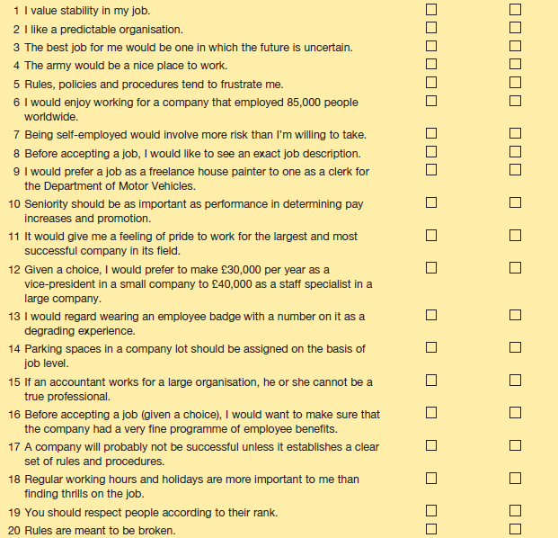
Source: Adapted from DuBrin, A. J. Human Relations: A Job-Oriented Approach, Reston Publishing/Prentice Hall (1978), pp. 296–7.

Task - Scoring and Interpretation
Give yourself a plus one for each question that you answered in the bureaucratic direction:
1 Mostly agree 8 Mostly agree 15 Mostly disagree
2 Mostly agree 9 Mostly disagree 16 Mostly agree
3 Mostly disagree 10 Mostly agree 17 Mostly disagree
4 Mostly agree 11 Mostly agree 18 Mostly agree
5 Mostly disagree 12 Mostly disagree 19 Mostly agree
6 Mostly disagree 13 Mostly disagree 20 Mostly disagree
7 Mostly agree 14 Mostly agree

Although the bureaucratic orientation scale is currently a self-examination and research tool, an extremely high score (15 and over) suggests that you would enjoy working in a bureaucracy. An exceptionally low score (5 or lower) suggests that you would be frustrated by working in a bureaucracy especially a large one.

