

Master of Business Administration (MBA)
Module Name: International Business Concepts
Module Code: LCMB7034
Assignment Title:
Global Competitiveness and Market Attractiveness of the Fast Fashion Industry in the UK: A Strategic Evaluation of Zara’s Market Position
Student Name: Hamza khan
Student ID: 2504521
Lecturer: Akshay Narayanan
Word Count: 5037
Submission Date: 27 April 2026

Contents
SECTION 1 – REPORT 4
1. INTRODUCTION 4
2. INDUSTRY AND COUNTRY OVERVIEW 5
2.1 Industry Overview 5
2.2 Country Environment 7
2.3 Key Players and Competition 8
3. PORTER’S DIAMOND ANALYSIS 9
3.1 Introduction to the Model 9
3.2 Factor Conditions 10
3.3 Demand Conditions 11
3.4 Related and Supporting Industries 11
3.5 Firm Strategy, Structure and Rivalry 12
3.6 Government and Chance 12
3.7 Critical Evaluation of the Model 12
4. ANALYSIS OF ZARA IN THE UK MARKET 13
4.1 Company Overview 13
4.2 Market Attractiveness: PESTEL Analysis 14
4.3 Cultural and Consumer Behaviour Analysis 16
4.4 Entry Strategy and Market Presence 17
4.5 Challenges and Risks 17
4.6 Strategic Evaluation 18
5. CONCLUSION 19
SECTION 2 - REFLECTIVE ACCOUNT 20
1. Description 20
2. Feelings 20
3. Evaluation 21
4. Analysis 21
5. Conclusion 22
6. Action Plan 22
7. References 22

SECTION 1 – REPORT

1. INTRODUCTION
The fast fashion market has witnessed massive growth in the last ten years and the apparel market is estimated to be worth more than $1.7 trillion worldwide due to the fast cycle of production, digital retail and growing demand of consumers in low-priced trend-driven clothes. The fashion industry in the United Kingdom injects about 60 billion in the economy making it the most competitive retail market in the European region (Farahani et al., 2022). Nevertheless, structural issues are becoming more and more characteristic of the industry, such as stiff pricing competition, supply chain instability and increasingly high regulatory and consumer demands regarding sustainability and ethical manufacturing (Lyu, 2024). Although the non-slowness and low cost have long been seen as the main competitive advantage of fast fashion companies, the policy is currently becoming uncertain under the influence of environmental consequences and changing consumer demands (Taplin, 2014).
In this report, the competitiveness of the UK fast fashion industry is critically analyzed and the strategic position of Zara in the fast fashion industry is evaluated in this context. The analysis uses major international business theories such as the Diamond Model of Porter and PESTEL analysis to analyse the interplay between macro-environmental and firm-level strategy.

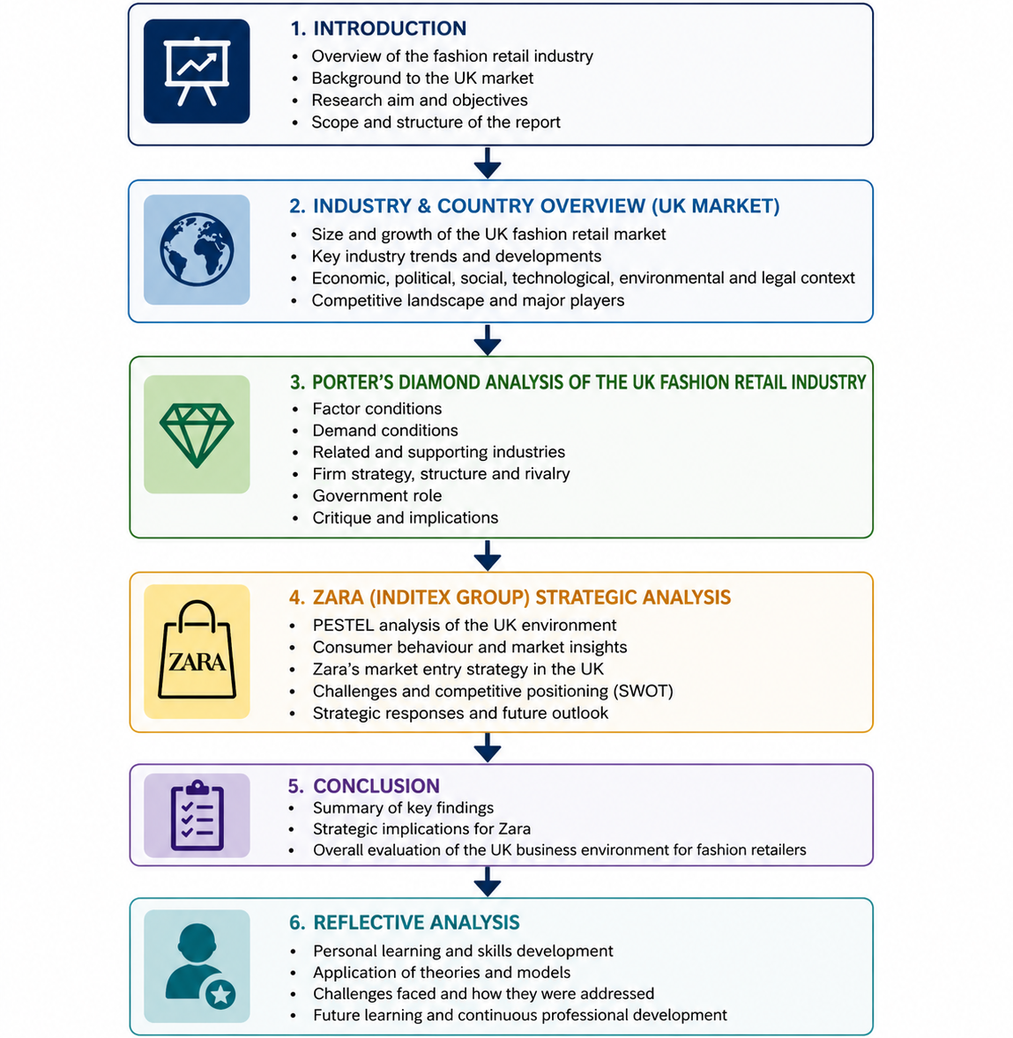
Figure 1: Structure of the Report.

2. INDUSTRY AND COUNTRY OVERVIEW

2.1 Industry Overview
Fast fashion industry has become a powerful part of the global apparel industry estimated to be worth over $1.7 trillion. This has been propelled by the fast production cycles, rising digitalisation and the fact that consumers have demanded to wear cheap, trendy, and fashionable clothes (Stefańska, 2021). Fast fashion companies usually have very quick supply chains that keep product-to-retail time to as short as two to four weeks, which allows them to refresh the product continuously and turnover high inventory. The fashion industry also plays a major role in the United Kingdom economy by contributing around 60 billion every year to the GDP, creating employment to more than 800,000 people (Barnes & Lea‐Greenwood, 2006). The UK is one of the most competitive countries in the world in terms of fashion which is highly developed, with a high number of international brands and domestic retailers. Moreover, this growing e-commerce penetration has revolutionized the retail sector with over 30 percent of the overall retailing activity being online fashion sales (Ologunebi, 2023).
Though the growth is high, structural issues are being encountered in the industry. The competitive environment is changing due to the rising costs of production, disruption of the supply chain, and growing regulatory and social pressure on sustainability (Shabir & AlBishri, 2021). The classical fast fashion paradigm, founded on cheap and high-volume manufacturing, continues to be criticised on environmental grounds, such as waste of textiles and carbon emissions (Jiang, 2022). This implies that although the industry is still economically important and growth-focused, the sustainability requirements and changing consumer expectations are making it more and more reliant on how firms can adjust in accordance with their demands (Sekaran et al., 2023).
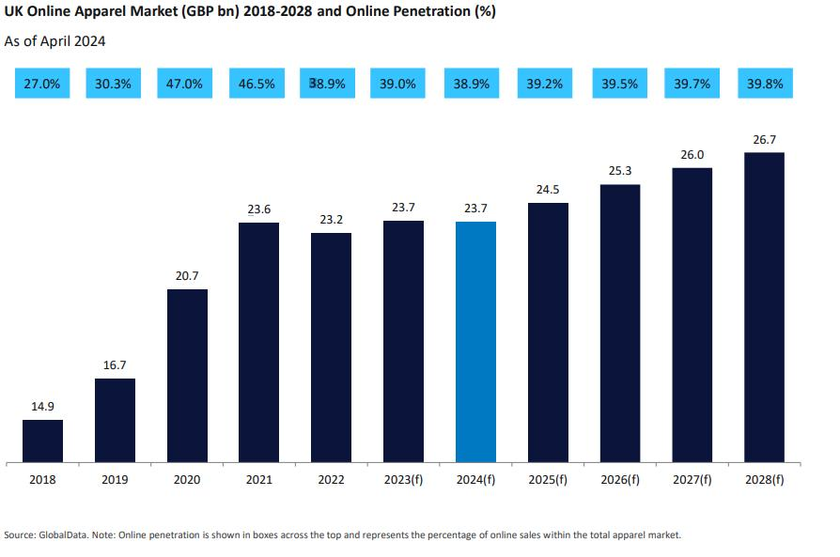
Figure 2: UK Online Apparel Market Growth and Online Penetration (2018–2028).
Table 1: Global vs UK Fast Fashion Industry Overview
Factor | Global Market | UK Market
Market Size | ~$1.7 trillion apparel market | ~£60 billion fashion industry
Growth Drivers | Digitalisation, affordability, globalisation | E-commerce growth, trend demand
Production Model | Fast turnaround (2–4 weeks) | Import-reliant, retail-driven
Key Trend | Sustainability pressure increasing | Ethical awareness rising

2.2 Country Environment
The United Kingdom is a highly competitive business environment with well-developed infrastructure and a logistics network, a developed digital economy. The political and legal environment in the country is stable and creates a favourable business climate to international businesses, but, new regulatory challenges, especially the trade barriers, the cost of imports, and the supply chain management have emerged due to the recent events like Brexit (Andreadakis & Owusu-Wiredu. 2023). Economically, there have been inflationary pressures and rising living costs that have greatly affected consumer purchasing behaviour. The market is increasingly price-sensitive and this has reinforced the market position of low-cost retailers like Primark. Simultaneously, UK is among the largest e-commerce markets in Europe, and more than 80 percent of consumers shop online, further increasing the pace of transition towards online retail platforms Perry & Towers, 2009).
The UK market is experiencing a significant change socially. Although the demand in fast fashion is high because of its low cost and availability, there is an increasing concern on sustainability, sourcing ethics, and labour (Kim & Woo, 2021). This brings a contradiction in the consumer behaviour because people still buy fast fashion products, yet they are worried about their effect on the environment (Yu et al. (2019). All in all, the UK environment has its opportunities and threats. Although the market size and digital maturity provide a lot of growth opportunities, economic uncertainty, regulatory shifts, and changing consumer expectations demand companies to pursue more flexible and responsible approaches (Boote & Lotfi, 2023).
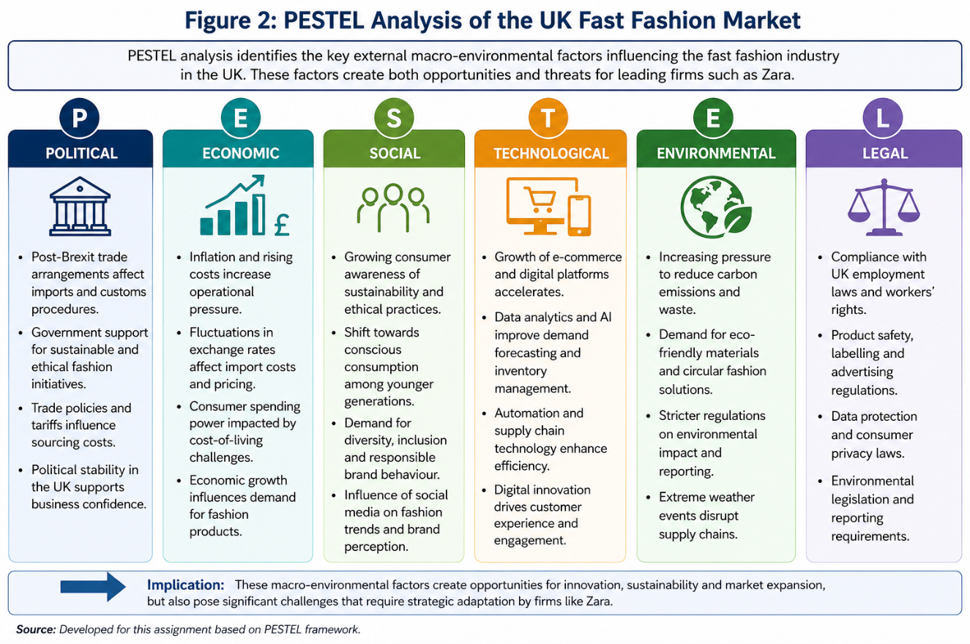
Figure 3: PESTEL Analysis of the UK Fast Fashion Market.

2.3 Key Players and Competition
The fast fashion market in the UK is typified by stiff competition presence of various global and local companies, which have different strategic approaches to market share. Zara is an affiliate of the Inditex group that distinguishes itself by the vertically integrated supply chain which allows it to develop products very quickly and act quickly in response to new fashion trends (Camargo et al., 2020). This will enable Zara to stay competitive in terms of speed and product relevancy. Primark on the other hand, operates under the cost-leadership strategy that is based on providing very low-priced products to appeal to price-sensitive customers. Although this method allows it to sell in large quantities, it is usually low margin and has been criticized as far as sustainability practices are concerned (López et al., 2021).
The hybrid strategy adopted by H&M balances affordability with growing investment in sustainability-related efforts, yet the company is not as fast as Zara in its supply chain. Moreover, ASOS is a digital-first business model, which aims at young consumers via an online platform and uses data analytics to forecast trends in fashion (Rafee, 2024). But it is not without its challenges; it has high return rates and costs involved in the running of e-commerce (Domingo & Cristina, 2011). Such a competitive diversity suggests that the UK fast fashion market does not have a dominant strategy. Rather, companies have to compete based on speed, cost-effectiveness, digital innovativeness, and brand positioning. This means that competitive advantage is dynamic and needs to be constantly adjusted to fluctuating market conditions (Vu & Pham, 2016).
Table 2: Competitive Positioning of Key Firms
Company | Strategy | Strength | Weakness
Zara | Fast response / vertical integration | Speed, trend responsiveness | High costs, sustainability pressure
Primark | Cost leadership | Low prices, high volume | Low margins, limited online presence
H&M | Hybrid strategy | Brand reputation, sustainability focus | Slower response than Zara
ASOS | Digital-first | Strong online presence | High returns, intense competition

3. PORTER’S DIAMOND ANALYSIS

3.1 Introduction to the Model
The Diamond Model of Porter gives an opportunity to analyse the competitive advantage of countries and study the ways the domestic conditions influence the performance of an industry. The model concentrates on 4 major determinants namely factor conditions, demand conditions, related and supporting industries and firm strategy, structure and rivalry (Fainshmidt et al., 2016). Besides this, chances and government have a major role in determining the state of competitiveness. Using this model on the UK fast fashion industry would enable one to critically analyze the factors that have led to its international status (Sagheer et al., 2009).
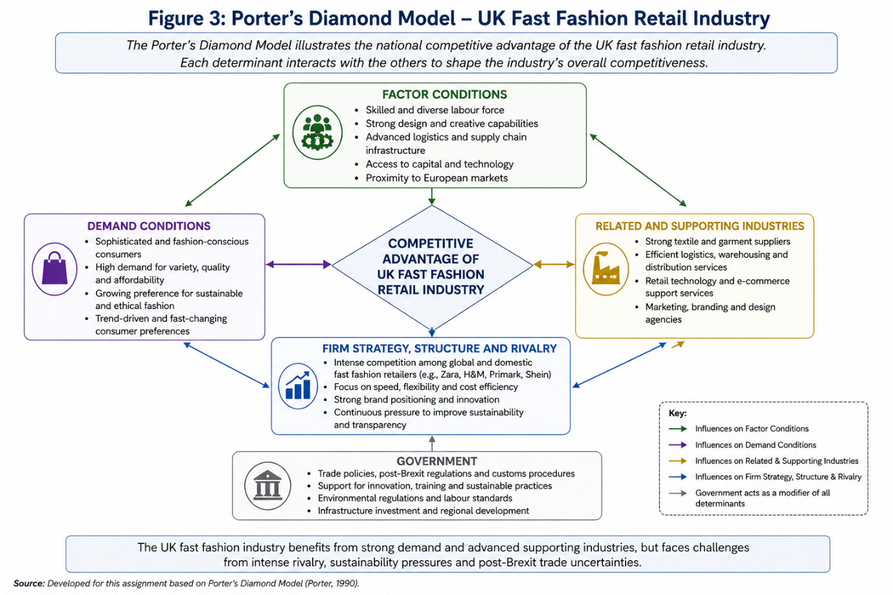
Figure 4: Porter’s Diamond Model – UK Fast Fashion Industry

3.2 Factor Conditions
Factor conditions are the presence of industry sustaining resources like labour, infrastructure and technology. The United Kingdom enjoys the advantage of having a highly skilled workforce, well developed retail infrastructure and high digital capabilities and all these play a part in ensuring the efficiency of the fast fashion industry (Mutz & Shumate, 2021). The developed system of logistics in the country facilitates quick distribution and inventory control which is crucial to fast fashion companies with brief production cycles (Tsai et al., 2021). Nevertheless, the UK is highly reliant on imported raw materials and foreign manufacturing, especially, the foreign countries like Bangladesh and China. This dependency makes them more susceptible to supply chain weaknesses, escalating transport expenses and political instability (Jin & Moon, 2006). There is also the factor of labour costs in the UK being far beyond those of developing economies and therefore restricts the viability of using local production. This implies that although developed infrastructure and technological capacity enhance competitiveness, structural relationships on international supply chains is a major constraint (Jin & Moon, 2006).

3.3 Demand Conditions
Demand conditions are the sophistication and nature of domestic consumers and this factor determines firm innovation and competitiveness. The UK market is highly fashion conscious with a population that requires regular product changes and quick adaption to the trends (Viardot, 2014). This puts a lot of pressure on companies to establish agile and responsive supply chain systems. Moreover, the UK consumers are more and more interested in digital platforms and social media, making trends on the rise and spread even faster (Patichol et al., 2014). This increases the relevance of r.eal-time information and digitalisation in the development of competitive strategies. Nonetheless, a contradiction in the demand conditions is increasing. Though consumers still consume the fast fashion products because they are affordable and convenient, the trend is also towards being aware and concerned about sustainability and ethical production (Do, 2021). This two-sidedness poses strategic dilemmas to firms, because they need to strike a balance between cost-efficiency and responsible practices. This implies that not only can demand conditions in the UK drive innovation but it can also put pressure on structural transformation in the industry (Mann & Byun, 2011).

3.4 Related and Supporting Industries
The existence of related and supporting industries, such as suppliers, logistics providers and digital platforms, has a strong impact on competitiveness of the fast fashion industry (Zhang, 2023). UK enjoys a well-developed retail ecosystem, which is facilitated by a developed e-commerce infrastructure, payment systems and marketing platforms. Also, the existence of global supply chain networks helps companies to source materials and produce goods effectively in various regions (Teo et al., 2020). Operational efficiency is further boosted by integration of technology especially in data analytics as well as inventory management. Nonetheless, the dependency on the foreign suppliers subjects companies to risks related to the supply chain disruptions, political unrest and environmental policies (Wilson, 2020). The growing need to achieve transparency and ethical sourcing imposes further strain on the supply networks as well. This implies that, though supporting industries make processes efficient and scalable, they are complex and vulnerable due to their globalisation (Gümüş & Hızıroğlu, 2015).

3.5 Firm Strategy, Structure and Rivalry
The fast fashion market in the UK is highly competitive, with different strategies adopted. Companies like Zara are interested in speed and vertical integration, which allow them to respond quickly to demand (Öndoğan et al., 2022). Competitors such as Primark, in contrast, use a cost-leadership approach, whereas ASOS utilizes online platforms to attract online consumers. Such intense competition stimulates the ongoing innovations and enhancement of efficiency because businesses have to evolve all the time in order to sustain a market share (Watchravesringkan et al., 2010). Competition is also heightened by the existence of international and local competitors which leads to strategic differentiation. Price pressures and decreased profit margins have also been caused by increased competition. Alongside, the increased significance of sustainability has opened up new horizons of competition as companies have to invest in ethical conduct and transparency. This implies that although heavy competition promotes competitiveness, it also poses serious strategic as well as cost pressures to companies that are in the industry (Kharub & Sharma, 2017).

3.6 Government and Chance
The policies and external factors created by the government are critical in determining industry competitiveness. The laws regarding labour regulations, environmental sustainability and consumer protection affect business in the UK (Knošková & Garasová, 2019). The new trade policies after Brexit have brought new barriers and expenses especially to those firms that depend on imports (Ndou & Obi, 2013). Furthermore, unexpected factors like the COVID-19 pandemic have demonstrated the weakness of supply chains in the world, affecting the processes of production and distribution. This implies that, though government control brings stability and order, it may limit flexibility especially in sectors that are reliant on international trade (Rojas, 2007).

3.7 Critical Evaluation of the Model
Although the Diamond Model by Porter offers a helpful theory to study the issue of the national competitiveness, it cannot be applied in the globalised industries. The model is mostly concerned with domestic factors but the fast fashion business is largely reliant on global supply chains and worldwide manufacturing networks (Mahirwe & Wei, 2018). Moreover, the model fails to comprehensively capture the contribution of digitalisation and technological innovation which have taken centre stage in competitive advantage. This implies that though the model is still applicable, it should be implemented taking into account the current global dynamics (Chong, 2019).
Table 3: Summary of Porter’s Diamond Analysis
Factor | Strength | Weakness | Impact
Factor Conditions | Advanced infrastructure, skilled workforce | High labour cost, import dependency | Mixed impact
Demand Conditions | Fashion-conscious consumers | Sustainability contradiction | Drives innovation
Supporting Industries | Strong logistics & digital ecosystem | Supply chain risks | Enhances efficiency
Rivalry | Intense competition | Price pressure | Encourages innovation
Government | Stable regulations | Trade barriers (Brexit) | Constraining factor

4. ANALYSIS OF ZARA IN THE UK MARKET

4.1 Company Overview
Zara, which is a flagship brand of the Inditex Group, is commonly regarded as a global leader in the field of the fast fashion industry, having an operation in more than 90 countries with a high international presence. The vertically integrated business model is the core competitive advantage of the company because it enables the company to control the processes of design, production and distribution (Gabriel & Bitsch, 2023). This allows Zara to react quickly to new fashion trends, frequently launching new products in a few weeks. Zara has been a high-quality fast fashion retailer in the UK market, which targets fashionable shoppers who are willing to pay moderate prices to obtain trendy designs. In contrast to most of its competitors, Zara does not depend on outsourcing to such an extent that its production is somewhat based in Europe, which provides a higher degree of flexibility and quality control (Huang & Ruan, 2014). Nevertheless, Zara, despite its leadership in the market, is becoming more challenged with the issues of sustainability, pressure on costs, and competition with low-cost carriers and digital-first companies. This underscores the necessity to critically analyze its strategic performance in the UK environment (Tiwari et al., 2022).

4.2 Market Attractiveness: PESTEL Analysis
The UK market has a complicated combination of opportunities and threats to Zara, defined by political factors, economic factors, social factors, technological factors, environmental and legal factors. The UK has a sound political environment with a stable administration system and a well-developed regulatory framework that favors business activities (Walters, 2006). Nevertheless, Brexit has greatly changed the trade relations making importations more expensive and complicated in terms of administration to companies that rely on international supply chains. In the case of Zara, which uses international sourcing, these developments pose operational difficulties and possible cost increases. The UK is also one of the largest consumer markets in Europe, economically, but increasing inflation and cost of living has decreased disposable income (Lawless, 2020). This has made consumers more price sensitive which is an advantage to low cost competitors like Primark. Since Zara has a slightly higher price point, it is under pressure to prove its value proposition whilst remaining profitable. The social factors are very critical factors in determining the performance of Zara in the market. The UK consumers are fashion conscious and are sensitive to trends, and are very likely to suit Zara fast-response model. Sustainability, ethical sourcing and environmental impact are however becoming increasingly aware. This causes an irony, with consumers buying fast fashion items at the same time as they condemn their ethical connotations (Bailey & Propris, 2017).
The UK is extremely high-tech in terms of digital environment, with e-commerce and mobile shopping being very popular. Zara has focused a lot on the merging of online and offline retailing channels, which improves the customer experience and efficiency of operations. Nonetheless, threats posed by online competitors like ASOS pressure Zara to innovate on a regular basis. One of the most serious challenges is the environmental factors (Ly, 2021). Fashion industry is also facing criticism due to its role in pollution, wastage and carbon emission. Sustainability has been implemented by Zara, such as environmentally friendly collections and recycling programmes, yet it is commonly criticised as not enough compared to the magnitude of its activities. Strict labour and environmental rules in the UK are legally enforced and demand transparency and compliance by the firms, which adds to the cost of operations (Brosnan et al., 2016).
Moreover, Zara is faced with reputational risks due to global attention on supply chains practices, which would be harmful should ethical standards be compromised. On the whole, the PESTEL analysis suggests that the market in the UK has good opportunities due to its size and number of consumers, but it is also associated with high challenges connected to the cost pressure, sustainability expectations and regulatory requirements (McColl & Moore, 2011).

Table 4: PESTEL Analysis of Zara in the UK
Factor | Evidence | Impact on Zara
Political | Brexit trade barriers | Increased costs & complexity
Economic | Inflation, reduced income | Higher price sensitivity
Social | Trend demand + sustainability awareness | Strategic contradiction
Technological | High e-commerce adoption | Opportunity + competition
Environmental | Sustainability pressure | Reputational risk
Legal | Strict regulations | Higher compliance cost

4.3 Cultural and Consumer Behaviour Analysis
The consumer behaviour in UK is very important in determining the strategic positioning of Zara. The trend-driven fashion that is influenced by social media, celebrity culture and the digital platforms characterise the market. This is in line with the capability of Zara to speed up the conversion of runway designs into low-cost products, which strengthens its competitive edge (Oh & Kim, 2007). But consumer behaviour is more and more complex and contradictory. Although the need in affordable and often changing clothing remains, the issue of environmental sustainability and responsible production practices are gaining increased popularity. Wastage, labour conditions and carbon emissions are some of the issues where consumers are increasingly aware of and this has contributed to further questioning of fast fashion brands. This paradox presents a strategic dilemma at Zara (Sheehan & Foss, 2017).
On the one hand, it is based on its business model, which relies on high turnover and frequent consumption. Conversely, it should be able to respond to evolving consumer perceptions by fostering sustainability and transparency. The inability to cure these issues can lead to a loss of reputation and consumer confidence. As such, it is imperative to comprehend and address the changing consumer behaviour in order to remain competitive in the UK market (Uchańska-Bieniusiewicz & Obłój, 2023).

4.4 Entry Strategy and Market Presence
Zara has penetrated and grown in the UK market by adopting a direct investment strategy, which has seen it open physical retail outlets in prime locations and combine them with its online system. This would enable Zara to have complete control of its brand image, pricing and customer experience. The firm has a business plan of performing the omnichannel experience in a way that the physical stores serve as the retail shop as well as the distribution center of online orders (Ruan et al., 2022). This improves efficiency and facilitates quick turnover of products. Nonetheless, there are also heavy fixed costs entailed in this strategy especially in the management of high-end retail stores. Moreover, the growing trend towards online shopping also questions the traditional role of brick-and-mortar stores and Zara needs to keep on changing its retail strategy. Although the direct investment strategy offers a firm a great level of control and branding, it also makes the firm vulnerable to operational risks especially in a fast-paced retail scenario (Kim, 2013).
Table 5: Entry Strategy Evaluation
Strategy | Advantage | Risk
Direct investment | Full control, strong brand image | High operational cost
Omnichannel model | Integrated experience | Requires continuous innovation

4.5 Challenges and Risks
Zara encounters a number of challenges in the UK fast fashion market. Strong competition with low-cost retailers, as well as digital-first companies, is one of the main challenges. The competitors like Primark are pulling in price-sensitive consumers, and the online market is dominated by ASOS, which puts Zara on the hybrid form. Also, the issues of sustainability are a major threat. The heightened regulatory demands and consumer expectation necessitate heightened transparency levels and ethical practices. The current business model of Zara, which is based on fast production and consumption, is not only hard to align with the sustainability objectives, but it is also difficult to reconcile (Brosnan et al., 2016). Another significant threat is supply chain disruptions. Uncertainties in the world such as the geopolitical tension and logistic constraints may affect the production schedules and cost. Moreover, the economic uncertainty and inflation decrease consumer purchasing power and thus Zara will find it tough to continue its pricing policy. These issues underscore the difficulty of doing business in the UK market and the necessity to constantly adapt strategies (Yao et al., 2022).
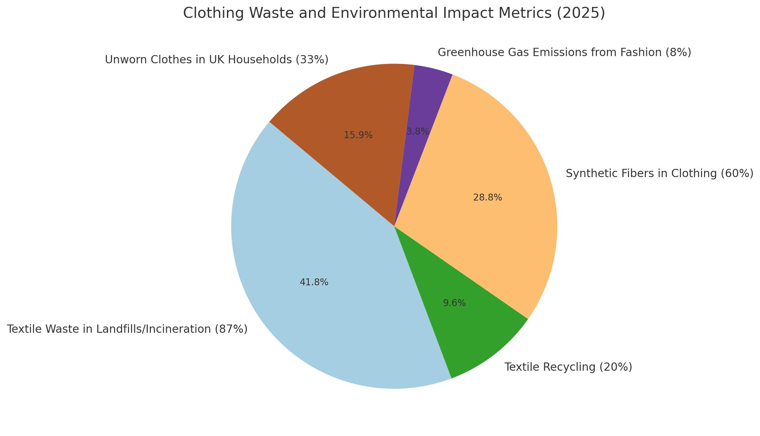
Figure 5: Environmental Impact and Clothing Waste in the Fashion Industry.

4.6 Strategic Evaluation
The main competitive advantage of Zara is grounded on the speed, flexibility and the ability of responding to consumer trends. Its supply chain is vertically integrated enabling it to be superior to its competitors regarding product turnaround and responsiveness to the market. Nevertheless, structural changes in the industry are increasingly becoming a challenge to this advantage. Competitive dynamics are being transforming by rising sustainability issues, digital disruption and economic pressure (López & Fan, 2009). Although Zara has been trying to mitigate on these problems such as the introduction of sustainable collections, and increasing digital capabilities, these strategies might not be enough to be competitive in the long term. In addition, there is a rapid adjustment of the local and international competitors, eroding the relative advantage of Zara. To illustrate, digital-first companies are using data analytics to forecast trends better, and low-cost retailers still have a dominant market share in price-sensitive segments (Viardot, 2014). This implies that the existing strategy of Zara, though successful in the short run would need major change to be sustainable in the future. The company will need to strike the right balance between efficiency and sustainability, innovation and cost containment and global standardisation and local adjustments (López et al., 2021).
Table 6: SWOT Analysis of Zara
Strength | Weakness
Fast supply chain | High cost structure
Strong brand | Sustainability concerns

Opportunity | Threat
E-commerce growth | Intense competition
Sustainability innovation | Changing consumer behaviour

5. CONCLUSION
The case study of the fast fashion industry in the UK shows that competitiveness is formed due to a complex interplay of economic, technological, cultural and regulatory factors. As the industry presents a high growth potential, it is now becoming characterised by structural issues such as sustainability pressures, increased costs of operation and changing consumer expectations. These dynamics suggest that the traditional models of fast fashion, based on cost efficiency and speed, are not as sustainable in the long term. The use of the Porters Diamond Model shows that the UK has good demand conditions, good infrastructure and high level of competition which helps in innovation and development of the market. The industry, however, is dependent on supply chains around the world and subject to regulatory restrictions, which restrict its stability and resilience overall.
Zara has strengths and weaknesses in its strategic placement in this environment. Its vertical supply chain and speed of response has a clear competitive edge but the competitive edge is getting threatened by digital disruption, sustainability issues as well as increased competition. Although Zara has made efforts to adjust its strategy, the analysis indicates that this might not be enough in terms of the structural changes that are impacting the industry. On the whole, the results suggest that the success of the UK fast fashion market on the long-term basis should be conditioned by the transition to the more sustainable and adaptive business models. Not only are firms required to ensure that they maintain operational effectiveness but also ensure that their strategies are in tandem with the changing environmental, social and technological situations to ensure that they remain competitive in a world that is becoming very complex.

SECTION 2 - REFLECTIVE ACCOUNT

1. Description
The task included the in-depth analysis of the fast fashion industry in the United Kingdom, with a special emphasis made on the strategic positioning of Zara in the intricate global business setup. It involved the utilization of major theoretical frameworks, such as Porters Diamond Model and PESTEL analysis, to analyze the competitiveness at the industry level and strategy at the level of firms. The method of conducting the research was to collect data in a variety of academic journals, industry-reports and market statistics to have an informed and evidence-based analysis. Moreover, the assignment presupposed the incorporation of critical thinking skills to consider not only the advantages of Zara business model, but also its disadvantages in the context of a changing global environment. The report was organised and clear which is further supported by the use of tables and structured analysis.

2. Feelings
At first, the task seemed to be complicated because it was necessary to combine several theoretical models and use them in the context of a real business. It was rather unclear how to get out of the descriptive analysis and create a more critical and analytical technique. Nevertheless, confidence increased with time as the research was going on. The steps of working with the academic literature and the real-life data contributed to the creation of the more understandable vision of the industry dynamics. At the later points in the assignment, the feeling of confidence in the critical application of theories and the construction of structured arguments had more significance.

3. Evaluation
The possibility to combine various information sources to form a detailed image of the fast fashion industry was one of the main strengths of this assignment. The application of the frameworks, including Porters Diamond and PESTEL, offered the systematic method of studying the complex issues, enabling to make a systematic assessment of both macro environmental factors and the strategy of the firm. Also, the comparative analysis to competitors added weight to the overall argument since it showed that the competitive position of Zara cannot be analyzed in the vacuum. Tables and organized presentation also contributed to clarity and made the analysis more accessible. Nevertheless, certain limitations existed. The problem was to make the analysis critical and not descriptive especially when one has large volumes of data to analyze. Sometimes, a propensity to explain instead of considering the implications of concepts occurred. Moreover, it was essential to synthesize various viewpoints presented by various sources to ensure that the argument is not fragmented.

4. Analysis
This assignment has greatly helped me to both critically and practically apply theoretical frameworks. The application of the Diamond Model by Porter was a useful way of understanding the effect of factors on an industry at the national level on industry competitiveness, but it also revealed the shortcomings of the conventional models in accounting for the dynamics of globalised industries. This further strengthened the need to not only implement theories but also challenge their usefulness in the modern society. Likewise, PESTEL framework was useful in determining the major external forces that influence the activities of Zara. Nevertheless, the discussion has shown that these elements are not independent but rather interrelated and a more integrated way of strategic decision-making is needed. This emphasised the role of synthesis in the analysis of complex business environments. The other learning aspect was that of identifying inconsistencies in the industry, specifically how consumer demand of low-cost fashion and growing concerns about sustainability are conflicting. This observation highlighted how business strategy is often about balancing competing priorities, as opposed to getting simple solutions. Moreover, the assignment also enhanced my critical assessment skills in evaluating information since it was possible to compare various sources and determine the points of conflict and agreement. The process enhanced my analytical skills and I was able to come up with more balanced and nuanced arguments. On the whole, the experience has demonstrated the need to go beyond the surface analysis to more critical analysis and evaluation, which is required during postgraduate work.

5. Conclusion
Drawing a conclusion, this assignment helped to understand the intricacies of the international business strategy in the field of fast fashion. It proved the necessity of combining theoretical learning with practical practice and the significance of critical thinking and the ability to think independently. The process helped to develop the essential skills, such as research, analysis and structured argument. It also solidified the significance of taking into account various ways of thinking when assessing complicated business situations. On the whole, the assignment has enhanced my knowledge of the operations of firms in international markets and the difficulties they encounter in ensuring competitiveness.

6. Action Plan
I hope that in the future I will be able to continue to expand my skills at critically evaluating and synthesising information based on a broader scope of academic sources. This will entail a closer engagement with current studies and making sure that the arguments can be backed by different points of view, but not using the same sources. I will also enhance my capacity to combine theory and practice by using frameworks in a dynamic way as opposed to a linear fashion. This will assist in creating more advanced and complex analysis. I would also like to improve my writing skills in academics taking into consideration clarity, coherence and accuracy in developing arguments. This involves making sure that the paragraphs serve a distinct purpose in the whole argument. Lastly, I will still be working on my skills in recognizing contradictions and complexities in business settings as this is a requirement to create quality and critical work at the level of postgraduate education.

7. References
Andreadakis, S. and Owusu-Wiredu, P. (2023) ‘Fashion footprint: How clothes are destroying our planet and the growing impacts of fast fashion’, IntechOpen. Available at: https://doi.org/10.5772/intechopen.1002000
Atik, D. and Ertekin, Z.Ö. (2022) ‘The restless desire for the new versus sustainability: The pressing need for social marketing in fashion industry’, Journal of Social Marketing, 13(1), pp. 1–19. Available at: https://doi.org/10.1108/jsocm-02-2022-0036
Bailey, D. and De Propris, L. (2017) ‘Brexit and the UK automotive industry’, National Institute Economic Review, 242, pp. R51–R59. Available at: https://doi.org/10.1177/002795011724200114
Barnes, L. and Lea-Greenwood, G. (2006) ‘Fast fashioning the supply chain: Shaping the research agenda’, Journal of Fashion Marketing and Management, 10(3), pp. 259–271. Available at: https://doi.org/10.1108/13612020610679259
Boote, A.O. and Lotfi, M. (2023) ‘How do environmental impact and gender inequality characterise fast fashion supply chains?’, Academy of Management Proceedings, 2023(1). Available at: https://doi.org/10.5465/amproc.2023.12101abstract
Brosnan, S., Doyle, E. and O’Connor, S.M. (2016) ‘From Marshall’s triad to Porter’s diamond: Added value?’, Competitiveness Review, 26(5), pp. 500–516. Available at: https://doi.org/10.1108/cr-05-2015-0037
Bryson, J.R., Sundbo, J., Fuglsang, L. and Daniels, P. (2020) ‘Reading and managing service businesses: An integrated case study approach’, in Reading and Managing Service Businesses. pp. 261–278. Available at: https://doi.org/10.1007/978-3-030-52060-1_14
Camargo, L.R., Pereira, S.C.F. and Scarpin, M.R.S. (2020) ‘Fast and ultra-fast fashion supply chain management: An exploratory research’, International Journal of Retail & Distribution Management, 48(6), pp. 537–553. Available at: https://doi.org/10.1108/ijrdm-04-2019-0133
Chong, K.L. (2019) ‘Review of problems in the development of rail tourism in Taiwan: On the example of the Alishan Forest Railway’, GeoJournal of Tourism and Geosites, 26(3), pp. 943–955. Available at: https://doi.org/10.30892/gtg.26321-409
Cristina, C.D. (2011) ‘Analysis of value chain and sources of differentiation in international fashion markets’, European Research Studies Journal, 14(1), pp. 15–28. Available at: https://doi.org/10.35808/ersj/307
Das, D. (no date) Exploration of the unique firm resources described by Indian apparel export firms for their competitive advantages. Available at: https://doi.org/10.32469/10355/43990
Do, K.D. (2021) ‘Evaluating the competitiveness of the Vietnam textile and garment industry’, Journal of International Business and Management. Available at: https://doi.org/10.37227/jibm-2021-08-1176
Duy, N. and Quang, T.N. (2024) ‘Fast fashion issue in Vietnam: Legal aspects and environmental protection’, PJC, 16(2), pp. 1119–1136. Available at: https://doi.org/10.62271/pjc.16.2.1119.1136
Fainshmidt, S., Smith, A. and Judge, W.Q. (2016) ‘National competitiveness and Porter’s Diamond Model: The role of MNE penetration and governance quality’, Global Strategy Journal, 6(2), pp. 81–104. Available at: https://doi.org/10.1002/gsj.1116
Farahani, R.Z., Asgari, N. and Wassenhove, L.N.V. (2022) ‘Fast fashion, charities, and the circular economy: Challenges for operations management’, Production and Operations Management, 31(3), pp. 1089–1114. Available at: https://doi.org/10.1111/poms.13596
Filho, W.L. et al. (2022) ‘COVID-19 and sustainability in textile, apparel and fashion use: An assessment of trends’, Textile Research Journal, 93(3–4), pp. 674–690. Available at: https://doi.org/10.1177/00405175221114167
Filieri, R. (2015) ‘From market-driving to market-driven’, Marketing Intelligence & Planning, 33(3), pp. 238–257. Available at: https://doi.org/10.1108/mip-02-2014-0037
Gabriel, A. and Bitsch, V. (2023) ‘Everywhere the same? Competitiveness of two regional vegetable production clusters in Southern Germany’, International Food and Agribusiness Management Review, 26(1), pp. 139–158. Available at: https://doi.org/10.22434/ifamr2021.0119
Gümüş, A. and Hızıroğlu, M. (2015) ‘Measuring and explaining Turkey’s competitiveness in services using Balassa Index and Diamond Model’, Journal of Business Research-Turk, 7(2), pp. 195–195. Available at: https://doi.org/10.20491/isader.2015215739
Hayes, S. and Jones, N. (2006) ‘Fast fashion: A financial snapshot’, Journal of Fashion Marketing and Management, 10(3), pp. 282–300. Available at: https://doi.org/10.1108/13612020610679277
Huang, S. and Ruan, B. (2014) ‘The main factors to be considered by TNCs when choosing emerging markets’, Modern Economy, 5(9), pp. 925–931. Available at: https://doi.org/10.4236/me.2014.59085
International Business Practices (2012) pp. 127–164. Available at: https://doi.org/10.5040/9781501371585.ch-005
Jiang, B. (2022) ‘How consumers’ response on CSR affects brand competitiveness in the fast fashion industry: Case study of Zara and H&M’, Academic Journal of Business & Management, 4(1). Available at: https://doi.org/10.25236/ajbm.2022.040117
Jin, B. (2004) ‘Apparel industry in East Asian newly industrialised countries’, Journal of Fashion Marketing and Management, 8(2), pp. 230–244. Available at: https://doi.org/10.1108/13612020410537915
Jin, B. (2004) ‘Apparel industry in East Asian newly industrialised countries’, Journal of Fashion Marketing and Management, 8(2), pp. 230–244. Available at: https://doi.org/10.1108/13612020410537915
Kharub, M. and Sharma, R.K. (2017) ‘Comparative analysis of competitive advantage using Porter’s Diamond Model’, Competitiveness Review, 27(2), pp. 132–160. Available at: https://doi.org/10.1108/cr-02-2016-0007
Kim, B. (2013) ‘Competitive priorities and supply chain strategy in the fashion industry’, Qualitative Market Research: An International Journal, 16(2), pp. 214–242. Available at: https://doi.org/10.1108/13522751311317602
Kim, S. and Woo, H. (2021) ‘Global fashion retailers’ responses to external and internal crises during the COVID-19 pandemic’, Fashion and Textiles, 8(1). Available at: https://doi.org/10.1186/s40691-021-00260-x
Knošková, Ľ. and Garasová, P. (2019) ‘The economic impact of consumer purchases in fast fashion stores’, Studia Commercialia Bratislavensia, 12(41), pp. 58–70. Available at: https://doi.org/10.2478/stcb-2019-0006
Komal, S. (no date) Evaluating and prioritising supply chain management strategies in the UK textile industry. Available at: https://doi.org/10.7190/shu-thesis-00645
Lawless, M. (2020) ‘Brexit and trade on the island of Ireland’, Revue de l’OFCE, 167(3), pp. 95–119. Available at: https://doi.org/10.3917/reof.167.0095
Liu, S., Huang, Y. and Pan, Q. (2024) ‘Analysing the strategic impact of Zara’s branding strategies on consumer engagement and market position’, SHS Web of Conferences, 185, 03018. Available at: https://doi.org/10.1051/shsconf/202418503018
López, C. and Fan, Y. (2009) ‘Internationalisation of the Spanish fashion brand Zara’, Journal of Fashion Marketing and Management, 13(2), pp. 279–296. Available at: https://doi.org/10.1108/13612020910957770
Ly, B. (2021) ‘Competitive advantage and internationalisation of a circular economy model in apparel multinationals’, Cogent Business & Management, 8(1). Available at: https://doi.org/10.1080/23311975.2021.1944012
Lyu, W. (2024) ‘Investment value analysis of enterprise: Taking Zara as an example’, Advances in Economics, Management and Political Sciences, 98(1), pp. 260–264. Available at: https://doi.org/10.54254/2754-1169/98/2024ox0145
Mahirwe, A.M. and Wei, L. (2018) ‘Investigation of competitive advantage of the dairy industry cluster’, American Journal of Industrial and Business Management, 8(5), pp. 1358–1388. Available at: https://doi.org/10.4236/ajibm.2018.85092
Mann, M. and Byun, S. (2011) ‘Accessing opportunities in apparel retail sectors in India: Porter’s Diamond approach’, Journal of Fashion Marketing and Management, 15(2), pp. 194–210. Available at: https://doi.org/10.1108/13612021111132636
McColl, J. and Moore, C. (2011) ‘An exploration of fashion retailer own brand strategies’, Journal of Fashion Marketing and Management, 15(1), pp. 91–107. Available at: https://doi.org/10.1108/13612021111112368
Mutz, K. and Shumate, S. (2021) ‘Inditex and sustainability: Are Inditex’s commitments enough to make the company a sustainable fashion brand?’, Rowdy Scholar Journal, (3). Available at: https://doi.org/10.25261/rowdyscholar_sum_2021_km
Ndou, P. and Obi, A. (2013) ‘An analysis of the competitiveness of the South African citrus industry using Porter’s diamond model’, International Journal of Agricultural Management, 2(3), pp. 160–168. Available at: https://doi.org/10.5836/ijam/2013-03-05
Oh, H. and Kim, E. (2007) ‘Strategic planning for the US textile industry in the post-quota era’, Journal of Fashion Marketing and Management, 11(2), pp. 246–269. Available at: https://doi.org/10.1108/13612020710751419
Ologunebi, J. (2023) ‘An analysis of customer retention strategies in e-commerce fashion business in the UK: A case study of Primark’, SSRN Electronic Journal. Available at: https://doi.org/10.2139/ssrn.4628521
Öndoğan, E.N., Öndoğan, Z. and Topuzoğlu, B. (2022) ‘Investigation of sustainability practices of global fashion brands’, Ege Academic Review. Available at: https://doi.org/10.21121/eab.1104962
Patichol, P., Wongsurawat, W. and Johri, L.M. (2014) ‘Upgrade strategies in the Thai silk industry’, Journal of Fashion Marketing and Management, 18(1), pp. 20–35. Available at: https://doi.org/10.1108/jfmm-09-2011-0059
Perry, P. and Towers, N. (2009) ‘Determining the antecedents for a strategy of corporate social responsibility in the UK fashion industry’, Journal of Retailing and Consumer Services, 16(5), pp. 377–385. Available at: https://doi.org/10.1016/j.jretconser.2009.05.003
Rafee, R.A. (2024) ‘Implementation of Porter’s generic strategies in the UK fashion retail e-commerce’, AJBAIS, 4(2), pp. 67–72. Available at: https://doi.org/10.69593/ajbais.v4i2.70
Rojas, T.D. (2007) National forest economic clusters. Available at: https://doi.org/10.2737/pnw-gtr-703
Ruan, T., Sang, D. and Zeng, Q. (2022) ‘Research on Zara’s business environment and marketing strategies in China’, Advances in Economics, Business and Management Research, 656. Available at: https://doi.org/10.2991/aebmr.k.220603.106
Safeer, A.A. et al. (2019) ‘Challenges and solutions to improve export competitiveness: Pakistani garment industry’, Journal of Competitiveness, 11(3), pp. 128–143. Available at: https://doi.org/10.7441/joc.2019.03.08
Sagheer, S., Yadav, S.S. and Deshmukh, S.G. (2009) ‘Framework for assessing competitiveness of India’s agrifood chain’, International Journal of Emerging Markets, 4(2), pp. 137–159. Available at: https://doi.org/10.1108/17468800910945774
Sekaran, A., Dadwal, S.S. and Ali, A. (2023) ‘Industry 5.0 and ESG initiatives in supply chain sustainability’, in [Book chapter], pp. 151–171. Available at: https://doi.org/10.4018/978-1-6684-6403-8.ch008
Shabir, S. and AlBishri, N.A. (2021) ‘Sustainable retailing performance of Zara during COVID-19 pandemic’, Open Journal of Business and Management, 9(3), pp. 1013–1029. Available at: https://doi.org/10.4236/ojbm.2021.93054
Sheehan, N.T. and Foss, N.J. (2017) ‘Using Porterian activity analysis to understand organisational capabilities’, Journal of General Management, 42(3), pp. 41–51. Available at: https://doi.org/10.1177/0306307017690518
Stefańska, M. (2021) ‘Product life-cycle and fast fashion’, in [Conference/Book], pp. 199–208. Available at: https://doi.org/10.18559/978-83-8211-074-6/iii5
Taplin, I.M. (2014) ‘Global commodity chains and fast fashion: How the apparel industry continues to reinvent itself’, Competition & Change, 18(3), pp. 246–264. Available at: https://doi.org/10.1179/1024529414z.00000000059
Taplin, I.M. (2014) ‘Global commodity chains and fast fashion’, Competition & Change, 18(3), pp. 246–264. Available at: https://doi.org/10.1179/1024529414z.00000000059
Teo, P.C. et al. (2020) ‘Competitiveness of handicrafts industry: Sri Lanka case’, International Journal of Academic Research in Business and Social Sciences, 10(6). Available at: https://doi.org/10.6007/ijarbss/v10-i6/7275
Tiwari, S. et al. (2022) ‘Bridging tea with tourism: Evidence from India and Sri Lanka’, Tourism Review, 78(1), pp. 177–202. Available at: https://doi.org/10.1108/tr-06-2022-0280
Tsai, P., Chen, C. and Yang, H.-C. (2021) ‘Using Porter’s Diamond Model to assess competitiveness of Taiwan’s solar industry’, SAGE Open, 11(1). Available at: https://doi.org/10.1177/2158244020988286
Uchańska-Bieniusiewicz, A. and Obłój, K. (2023) ‘Disrupting fast fashion: A case study of Shein’s innovative business model’, International Entrepreneurship Review, 9(3), pp. 47–59. Available at: https://doi.org/10.15678/ier.2023.0903.03
Viardot, É. (2014) ‘Always trust the customer’, in [Book chapter], pp. 68–94. Available at: https://doi.org/10.4018/978-1-4666-4357-4.ch007
Vu, H.T. and Pham, L.C. (2016) ‘Dynamic approach to assess competitiveness of Vietnam’s garment industry’, SpringerPlus, 5(1). Available at: https://doi.org/10.1186/s40064-016-1912-3
Walters, D. (2006a) ‘Demand chain effectiveness – supply chain efficiencies’, Journal of Enterprise Information Management, 19(3), pp. 246–261. Available at: https://doi.org/10.1108/17410390610658441
Walters, D. (2006b) ‘Effectiveness and efficiency: The role of demand chain management’, The International Journal of Logistics Management, 17(1), pp. 75–94. Available at: https://doi.org/10.1108/09574090610663446
Wang, Z. (2023) ‘The reasons of Primark brand loyalty in the post-epidemic era’, Highlights in Business Economics and Management, 23, pp. 590–596. Available at: https://doi.org/10.54097/p8f3e715
Watchravesringkan, K. et al. (2010) ‘Competitive position of Thailand’s apparel industry’, Journal of Fashion Marketing and Management, 14(4), pp. 576–597. Available at: https://doi.org/10.1108/13612021011081751
Wilson, S. (2020) ‘Building apparel manufacturing competitiveness through policy’, Journal of Fashion Marketing and Management, 24(2), pp. 277–302. Available at: https://doi.org/10.1108/jfmm-10-2019-0243
Yao, L. et al. (2022) ‘Quantifying the competitiveness of cultural industry and its impacts on Chinese economic growth’, Sustainability, 15(1), 79. Available at: https://doi.org/10.3390/su15010079
Yu, M., Cao, D. and Tan, J.Y. (2019) ‘CSR-consumption paradox: Examination of UK apparel companies’, Journal of Fashion Marketing and Management, 23(1), pp. 124–137. Available at: https://doi.org/10.1108/jfmm-02-2018-0021
Zhang, L. (2023) ‘Zara brand strategy analysis based on customer perceived value’, Advances in Economics, Management and Political Sciences, 41(1), pp. 9–18. Available at: https://doi.org/10.54254/2754-1169/41/20232024

