Digital Transformation Abstracts
18-03-23



Neri, A., Negri, M., Cagno, E., Kumar,V., & Garza-Reyes, J. A. (2023). What digital-enabled dynamic capabilities support the circular economy? A multiple case study approach. Business Strategy and the Environment,1–19.https://doi.org/10.1002/bse.3409NERIET AL.19

What digital-enabled dynamic capabilities support the circular economy? A multiple case study approach
Alessandra Neri, Marta Negri, Enrico Cagno, Vikas Kumar, Jose Arturo Garza-Reyes
First published: 17 March 2023

https://doi.org/10.1002/bse.3409

SG Note: Not yet published. See sep cut and paste for better diagram or click on DOI and full paper to get HTML. PDF available but diagrams not so good.

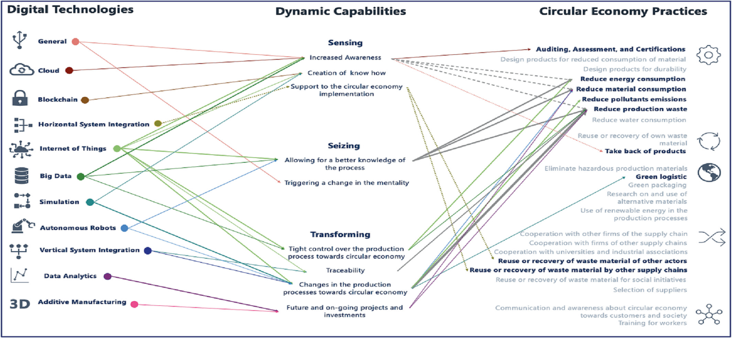

Rusch, M., Schöggl, J.-P., & Baumgartner, R. J. (2023). Application of digital technologies for sustainable product management in a circular economy: A review. Business Strategy and the Environment, 32(3), 1159–1174. https://doi.org/10.1002/bse.3099.
Digital technologies (DTs), such as the Internet of Things, big data, artificial intelligence, or blockchain, are considered as enablers for a more sustainable and circular economy. So far, literature on these topics has mostly focused on specific DTs and subareas of sustainable product management (SPM). The aim of this paper is to provide a more comprehensive overview of current and potential examples of DT applications in SPM (e.g., product design/assessment, supply chain management, and business models). The collected examples (n = 146) were analyzed based on a systematic literature review, using quantitative and qualitative content analysis. Deductive and inductive analyses of the examples revealed the potential of DTs in terms of their usability along the product life cycle, their role as enablers for circular economy strategies and in specific SPM activities. DT application often entails only incremental improvements, for example, increased efficiency of existing processes, with more radical forms of improvement remaining relatively scarce. There is clear room for greater adoption and optimization of DTs, in various areas of SPM, so as to accelerate the transition towards a more sustainable and circular economy.
Cut and paste

2.3 Digital technologies
DTs have already encouraged a paradigm shift in industrial production (Kristoffersen et al., 2019). In general, the availability of technical solutions can be considered as a facilitator in the economy's dematerialization (EC, 2020). The development towards a CE is thus also reliant on a wide array of technologies (de Jesus & Mendonça, 2018; Pagoropoulos et al., 2017). According to the EU's CE action plan (EC, 2020) and the European Circular Economy Research Alliance (Berg et al., 2020), the use of IoT, big data, AI, and blockchain offers great potential for increasing the sustainability and circularity of products and resources. We thus focus on these four technologies in the present study.
- The IoT provides new communication capabilities, increasing device interconnectedness, and leads to the formation of new information networks (Garrido-Hidalgo et al., 2019). IoT is one of the most crucial Industry 4.0 applications improving CE performance parameters and helping to achieve CBMs (Chauhan et al., 2021). As identified by Atzori et al. (2010), the IoT can be realized in three paradigms: internet oriented (middleware), things oriented (sensors), and semantic oriented (knowledge), and their alignment is central to the usefulness of the IoT (Gubbi et al., 2013).
- AI generally refers to technologies that are capable of performing certain tasks as well as, or better than, humans (Vinuesa et al., 2020), such as machine learning and deep learning (Copeland, 2016).
- Big data analytics refers to the strategy of analyzing large quantities of data that can be distinguished by their volume, variety, velocity, veracity, variability, and value (Sivarajah et al., 2017).
- The most recent DT is blockchain technology, a distributed ledger database that records transaction data and other information. It is characterized as a chain of time-stamped and cryptographically secured digital information that facilitates reliable, decentralized data sharing (S. Li et al., 2020
Notes from article:

RESOLVE Framework?-
Circular Economy (CE) concept and the six corresponding CE strategies from the ReSOLVE framework.
In a CE, material flows are supposed to preserve their highest value as long as possible and to circulate in loops within the economy in order to minimize waste and negative environmental impacts (Kirchherr et al., 2017).
The ReSOLVE framework (EMF, 2015) can help operationalize the concept of a CE by categorizing the different business opportunities needed in the generation of circularity strategies. This framework, used in one of the analyses in this paper, includes the following circularity strategies: regenerate, share, optimize, loop, virtualize, and exchange.
Ellen MacArthur Foundation. (2015). Growth within: a circular economy vision for a competitive Europe. Ellen MacArthur Foundation, SUN, McKinsey Center for Business and Environment.
  - Google Scholar
European Commission. (2020). A new Circular Economy Action Plan—For a cleaner and more competitive Europe, Pub. L. No. COM(2020) 98 final. European Commission.

Rowan, N.J. The role of digital technologies in supporting and improving fishery and aquaculture across the supply chain – Quo Vadis? (2023) Aquaculture and Fisheries, 8 (4), pp. 365-374. DOI: 10.1016/j.aaf.2022.06.003
Fish constitute important high protein products to meet the demands of an increasing global population. However, the continued depletion of wild fish stocks is leading to increased strain on the aquaculture sector in terms of sustaining the supply of fish and seafood to global markets. Despite the fact that aquaculture is more diversified than other agriculture sectors, there are significant pressures on the industry to continue innovating in order to enable sustainability including increased fish production, improved appropriate selection of species, disease mitigation, reduced wastage, preventing environmental pollution and generating more employment globally. This viewpoint article addresses how digital transformation can help support and meet expansion needs of the fisheries/aquaculture industries that includes exploiting and harnessing ICT, IoT, Cloud-edge computing, AI, machine learning, immersive technologies and blockchain. Digital technologies are bringing significant operational benefits for global food chain, improving efficiencies and productivity, reducing waste, contamination and food fraud. The focus on digital technologies has recently evolved to Industry 5.0 where AI and robotics are coupled with the human mind in order to advance human-centric solutions. This viewpoint describes the role of Quadruple helix Hub (academic-industry-government and society) in delivering a convergent holistic approach to meeting the diversity of fishery industry needs by connecting and placing fisheries centrally in a defined ecosystem of stakeholders. This includes specialist training, testing technologies, providing access to finance and fostering disruption through aquaculture accelerator initiatives such as that provided by Hatch Blue. Connecting digital Innovation Hubs trans-regionally, nationally and internationally will also help mitigate against significant risks for the fisheries and aquaculture industry including climate change, global pandemics and conflicts that can jeopardize fish and seafood production and supply chains. There is also a commensurate need to avail of digital technologies in order to increase awareness of key industry issues across the value chain, such as through social marketing. Thus, addressing key challenges by way of the global digital transformation of fishery and aquaculture industry will meet several sustainable development goals of the United Nations catered around the application of disruptive technology
11-03-23

Gabriele Contessa (2022) The Robot Apocalypse Is Already Here.The Philosophers' Magazine. Issue 96, 1st Quarter, Pages 54-58. https://doi.org/10.5840/tpm20229612
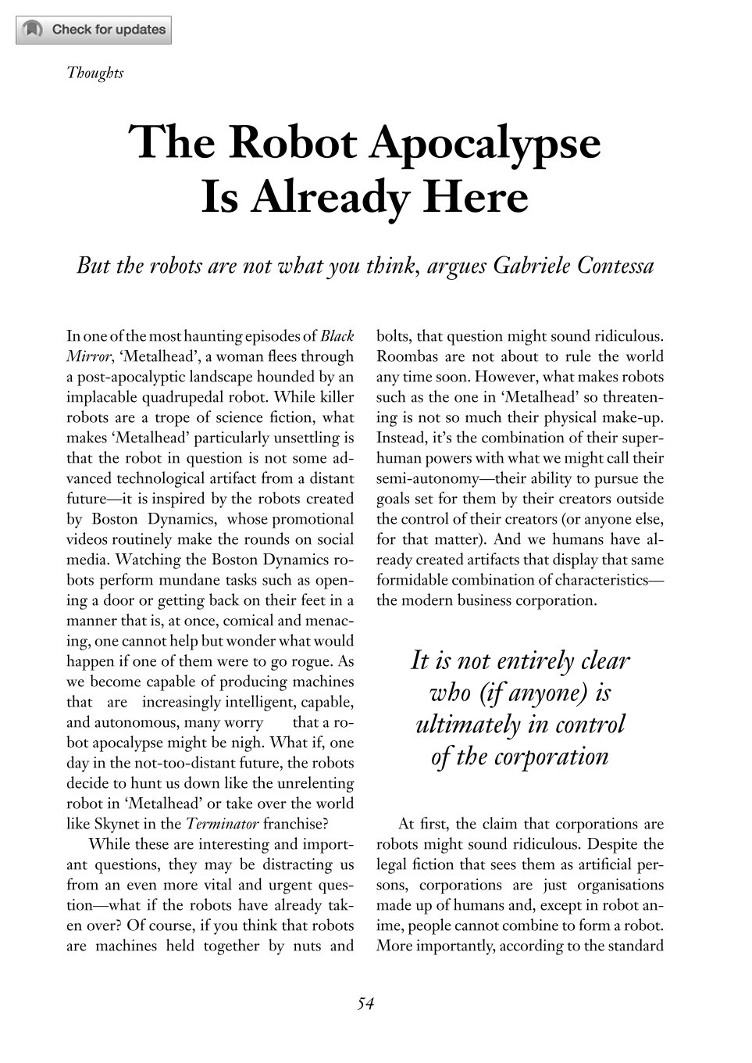
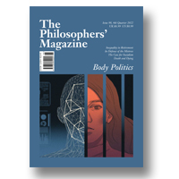

Woodrow Harzig, Evan Selinger (2022) Facial Recognition As Oppressive Technology. The Philosophers' Magazine Issue 98, 4th Quarter. Pages 82-88 https://doi.org/10.5840/tpm20229869

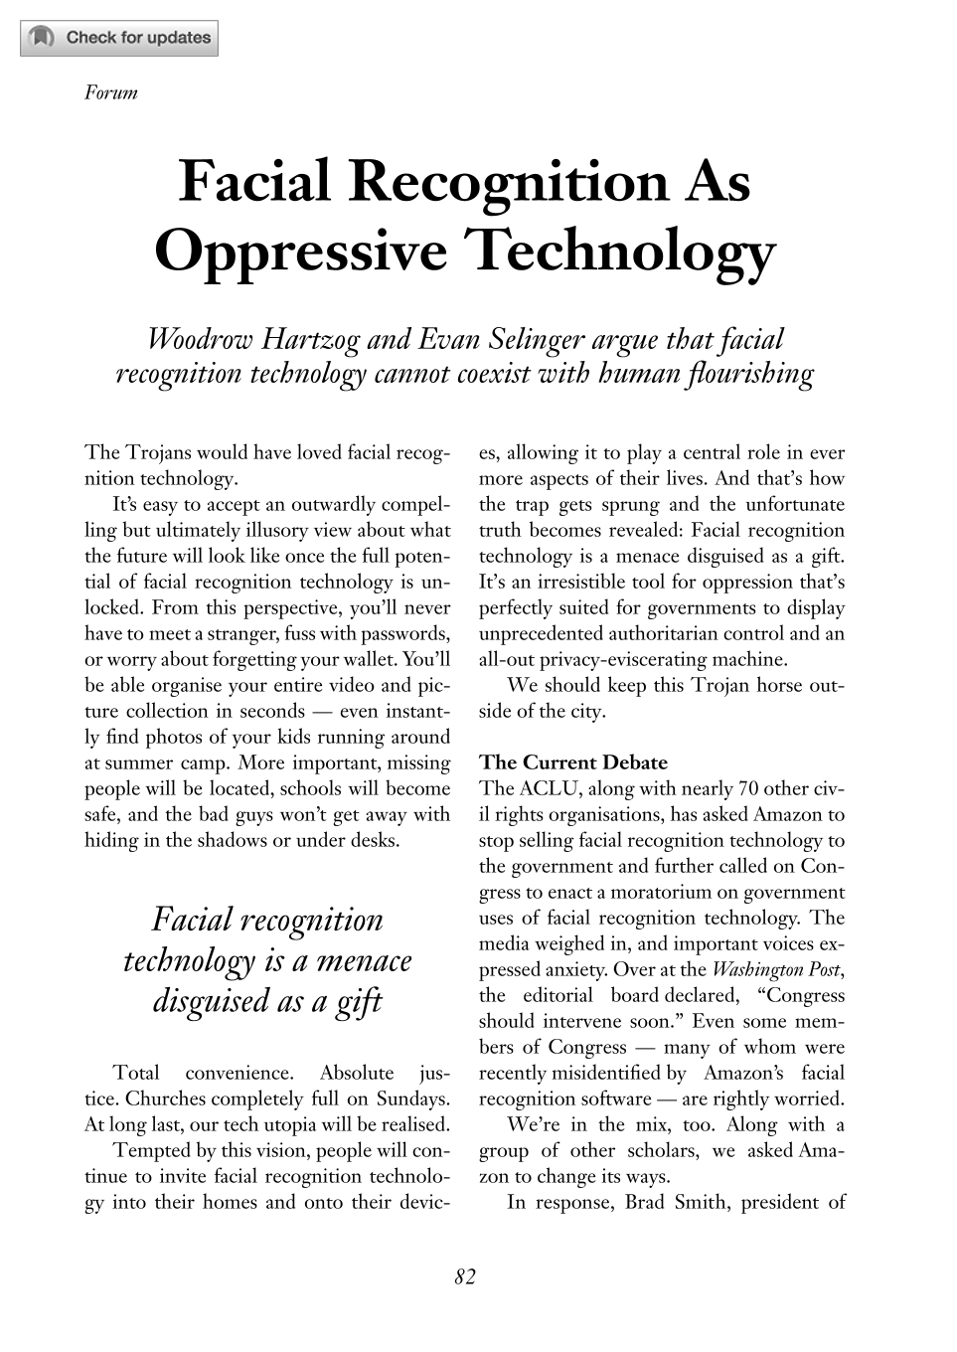

10-03-23

Digital Business
Volume 2, Issue 2, 2022, 100019


Mastering the digital transformation through organizational capabilities: A conceptual framework
Jens Konopik ª, Christoph Jahn ª, Tassilo Schuster ª, Nadja Hoßbach ª, Alexander Pflaum ^{b}
As digital transformation is changing entire industries, organizations are struggling to keep up with these changes. Scholars are viewing organizational capabilities as a central mean for organizations to master digital transformation. Based on a comprehensive literature review, this study identifies a broad set of relevant organizational capabilities and introduces a conceptual framework in which organizational capabilities are clustered into seven relevant themes for managing digital transformation. These capabilities are then embedded in the logic of the dynamic capability theory, highlighting the development of organizational capabilities throughout the digital transformation process. The results reveal that a differentiated perspective on the digital transformation process is beneficial to account for changing needs of organizational capabilities during the transformation process. Just as organizations themselves change during the process, various capabilities at different time points are needed to support and enable organizations during digital transformation. The developed conceptual framework gives organizations guidance for the development of organizational capabilities throughout the digital transformation process.
(2023), "Toward effective digital transformation: The role of organizational capabilities", Strategic Direction, Vol. 39 No. 2, pp. 39-42. https://doi.org/10.1108/SD-12-2022-0161
This paper aims to review the latest management developments across the globe and pinpoint practical implications from cutting-edge research and case studies.

This briefing is prepared by an independent writer who adds their own impartial comments and places the articles in context.
Organizations and other entities that achieve digital transformation (DT) become better positioned to meet emerging challenges in the digital age.

Different organizational capabilities that include an appropriate organizational culture, a workforce equipped with digital skills, modern ICT infrastructure, effective knowledge management and strong leadership support are critical if DT is to prove successful.

The briefing saves busy executives, strategists and researchers hours of reading time by selecting only the very best, most pertinent information and presenting it in a condensed and easy-to-digest format.

https://www.bcg.com/capabilities/digital-technology-data/digital-transformation/overview?utm_source=search&utm_medium=cpc&utm_campaign=digital&utm_description=paid&utm_topic=digital_transformation&utm_geo=global&utm_content=digital_transformation_group&gclid=Cj0KCQiAx6ugBhCcARIsAGNmMbjB7hYs7exEfOEcOb5UwtI7kNBLeSzehce0A5P5Y4VGXA7ciepCZqgaAqLpEALw_wcB
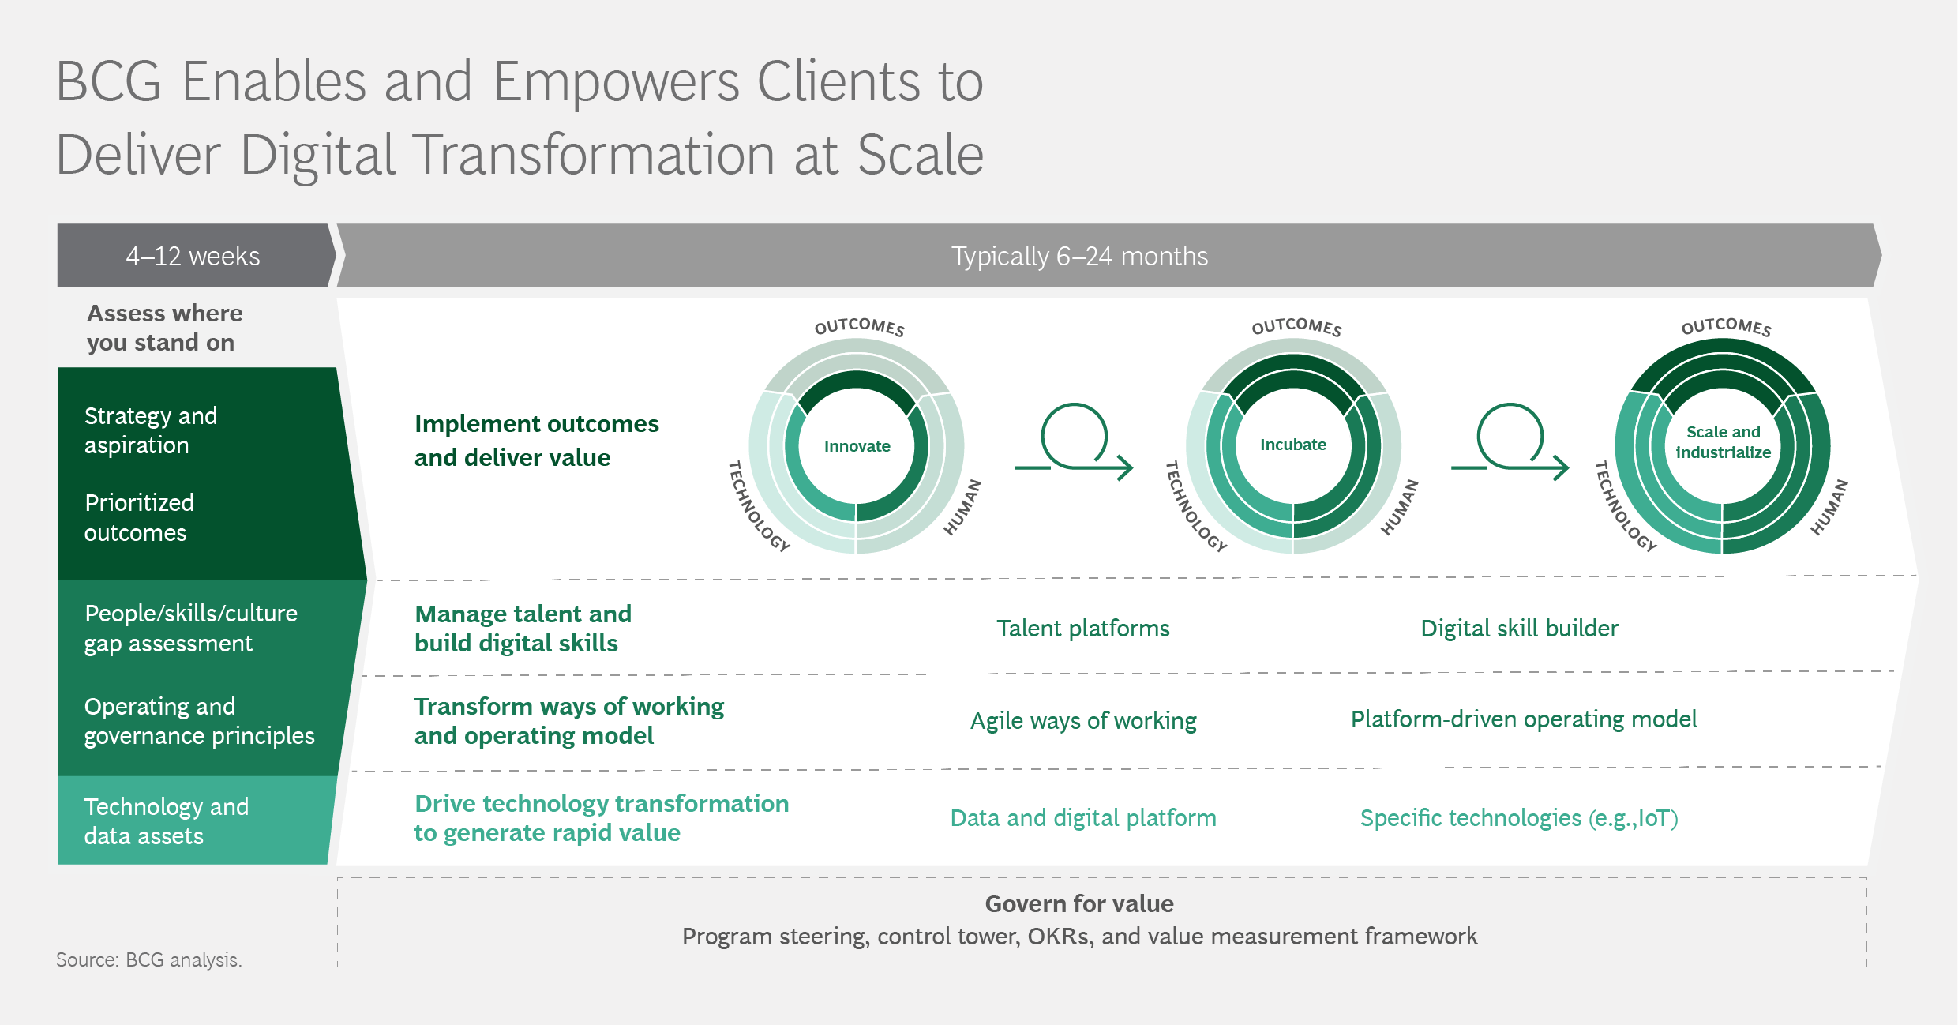

TORTORELLA, G., PRASHAR, A., ANTONY, J., MAC CAWLEY, A.F., VASSOLO, R. and SONY, M., 2023. Role of leadership in the digitalisation of manufacturing organisations: IMS. Journal of Manufacturing Technology Management, 34(2), pp. 315-336.
This study examines the moderating role of leadership behaviours on the relationship between Industry 4.0 (I4.0) maturity and operational performance in manufacturers.
For that, 189 leaders from manufacturing organisations located in India and Brazil that are undergoing I4.0 implementation were surveyed. The collected data was analysed using multivariate data techniques, which allowed to verify the validity of our research hypotheses. This study was grounded on the concepts from the socio-technical systems (STS) theory.
The findings indicated that task-oriented leadership behaviours positively moderate the relationship between technologies for digitalisation and operational performance. A similar effect was found for the interaction between change-oriented leadership behaviours and strategy for digitalisation. In turn, the moderating effects of relations-oriented and change-oriented leadership behaviours were negative when considering the I4.0 maturity dimensions of employee and culture for digitalisation and technology for digitalisation, respectively.
This study offers arguments to better understand the role of leaders' behaviours in the digitalisation of organisations. Changing behaviours is usually a long-term and time-consuming activity. The identification of the leadership behaviours that are more likely to support digitalisation allows companies to anticipate potential issues and prioritise efforts to assertively develop leaders.
Toward effective digital transformation: The role of organizational capabilities. 2023. Strategic Direction, 39(2), pp. 39-42.

LEE, W.C. and BERNARD CHENG, Y.T., 2023. Workplace learning strategies, enablers, and challenges in the context of digital innovation. Journal of Workplace Learning, 35(2), pp. 192-209.
The purpose of this study is to scrutinise individual learning strategies in their workplace when they were experiencing digital innovation. Moreover, the respective enablers and challenges of each category of strategies were explored to conceptualise supporting features needed in the digital learning environment.
This study adopts a qualitative inquiry to understand employees’ workplace learning strategies and the respective enablers, and challenges in each category of strategies. Twenty employees across different industries were interviewed, and a two-cycle inductive coding analysis was adopted to identify the categories of learning strategies.
Four categories of workplace learning strategies were identified: self-driven, social-leveraged, enterprise-oriented and information and technology-enhanced (IT-enhanced) strategies. Enablers and challenges of each category were also presented in this study.
The findings provide insights for individuals to establish a repertoire of learning strategies. The inadequate use of IT-enhanced strategies is additionally addressed.
This study examined workplace learning strategies in the context of digital innovation. Based on the empirical findings and existing literature, this study proposes a framework with the supporting features for a digital learning environment.

DEMIR, M. and GÜNAYDIN, Y., 2023. A digital job application reference: how do social media posts affect the recruitment process? Employee Relations, 45(2), pp. 457-477.
This study aims to determine the influence of candidate employees' social media accounts (SMAs) on human resource (HR) professionals' hiring decisions as a job application reference in the tourism industry.
Using a qualitative approach, semi-structured interviews were conducted in tourism businesses, such as hotels, travel agencies, restaurants, bars, and ground-handling service companies. In-depth, open-ended interviews with 16 questions were conducted to gather data face to face between October 15 and December 20, 2021, with 38 HR professionals. The research questions were analyzed using thematic analysis and discussed under three main themes.
The findings of this study showed that HR managers in the tourism industry generally prefer to examine candidates' SMAs rather than traditional references because they can quickly and cheaply screen many applicants.
Social media (SM) is increasingly used as a crucial channel in recruitment within organizations. This paper contributes by filling a gap in HR management, which empirical studies on the influence of job applicant's SMAs on recruiters' hiring decisions have been limited so far.

ODEH, R.B.M., BADER, Y.O., JARADAT, M.O., MASA'DEH, R. and MUHAMMAD, T.A., 2023. The transformational leadership role in achieving organizational resilience through adaptive cultures: the case of Dubai service sector. International Journal of Productivity and Performance Management, 72(2), pp. 440-468.
This empirical research draws on the existing theory of transformational leadership, adaptive culture and organizational resilience, and investigates the effect of the elected TQM leadership style “transformational leadership” through the mediating effect of adaptive culture on organizational resilience, that is the key of survival during crises like the recent COVID-19 pandemic, which has severely impacted the business globally.
This study exploited a cross-sectional online questionnaire of a random sample of Dubai service firms, with the unit of analysis being at the firm level. In total, 379 usable responses were received. Regression analysis was conducted to test hypotheses.
The overall findings of this study supported that transformational leadership is positively associated with both adaptive culture and firm's resilience and significantly impacts them. Adaptive culture was found partially mediating the effect of transformational leadership on organizational resilience.
The research findings provide important insights to practitioners (managers and leaders) to better improve their transformational qualities, as these qualities are expected to improve the organizational adaptive cultures and capacity of resilience.
To the best of the authors' knowledge, this is one of the first studies to examine the transformational leadership effect on organizational adaptive culture and firm's resilience. This investigation expands the boundaries of leadership style theory into new arenas, attempting to partially address the identified knowledge gap in this vein.

Leading teams in the digital age: Four perspectives on technology and what they mean for leading teams
Lindsay Larson, Leslie A. DeChurch

The Leadership Quarterly Volume 31, Issue 1, February 2020, 101377

https://doi.org/10.1016/j.leaqua.2019.101377
Digital technologies are changing the nature of teamwork in ways that have important implications for leadership. Though conceptually rich and multi-disciplinary, much of the burgeoning work on technology has not been fully integrated into the leadership literature. To fill this gap, we organize existing work on leadership and technology, outlining four perspectives: (1) technology as context, (2) technology as sociomaterial, (3) technology as creation medium, and (4) technology as teammate. Each technology perspective makes assumptions about how technologies affect teams and the needs for team leadership. Within each perspective, we detail current work on leading teams. This section takes us from virtual teams to new vistas posed by leading online communities, crowds, peer production groups, flash teams, human-robot teams, and human-artificial intelligence teams. We identify 12 leadership implications arising from the ways digital technologies affect organizing. We then leverage our review to identify directions for future leadership research and practice.
FECIORU, C., 2022. Digital leadership – a totally new approach or just another change management fad? A brief literature review. Manager, (35), pp. 7-15.
Digital transformation and digital leadership are ubiqutous terms that have recently invaded the public space in TV shows, in business press, also in academic books and articles. The term transformation in itself is not new -for decades now consulting companies and academics have coined terms like corporate transformation or „business process re-engineering" (Hammer, 1990) to brand and to customize some specific organizational interventions' frameworks used on commercial basis. Data collected so far suggests that digital transformation is not fundamentally different from the change management interventions that were so popular before the 1990s and even more so in the 1990s. What is different is the massive presence and impact of the technology in every aspect of organizations today. As noted by David Rogers from Columbia University, „Digital transformation is fundamentally not about technology but about strategy" (Rogers, 2016, pp. 239)
KLEIN, M., 2020. LEADERSHIP CHARACTERISTICS IN THE ERA OF DIGITAL TRANSFORMATION. Business & Management Studies: An International Journal, 8(1), pp. 883-902.
Digital transformation provoked by Industry 4.0 should not be just seen as a technological issue, it causes also fundamental changes in processes and in organizations of companies. Notably a new understanding of leadership can be counted on to them. The so-called “digital leaders” are expected to act rapidly and flexible in networked and distributed organization structures on the one hand and on the other hand they have to manage the digital transformation of the organization. Since most of the companies are still in the beginning of their digital transformation, there is a lack of a common understanding and a standard model of digital leadership. Most of the existing research works are visionary and predict the requirements for digital leadership on anticipated technological, economical and organizational changes; only few of them report about changes in leadership based on implemented cases. The objective of this study is to sum up main characteristics of the leadership in the era of digital transformation by applying content analysis of literature review as the method.
SADARIC, A. and ŠKERLAVAJ, M., 2023. Giving Sense to Change Leadership: Towards a Narrative-Based Process Model. Economic and Business Review, 25(1), pp. 41-63.
Introduction: Recent studies on change agency and organizational change failure have significantly broadened the organizational behavior perspective on individual change experiences, however, the underlying mechanism for change leaders' influential behavior remains a relatively underspecified area. Objectives: Our central theoretical contribution focuses on the ways in which linking the findings from different research areas that deal with storytelling and persuasive communication can contribute to understanding the underlying mechanism of change leaders' influential behavior. Methods: We examine the various strands of research in management concerned with change leadership and persuasive communication, and propose a multidisciplinary perspective from developmental psychology, linguistics, political science, consumer psychology, and religious studies. Results: Our approach draws on the key theoretical perspectives from the social cognitive theory and commensurable interdisciplinary findings as the basis for a narrative-based process model of change leaders' influential behavior. Our model includes propositions about the change leader's interpretation of ideological change as well as the change leader's process of sensemaking and sensegiving. Conclusion: We argue that the change leader's persuasive communication efforts are based on the leader's narrative intelligence and influence, which promote the change recipient's attachment formation.
DEWIE, T.W., RAHMAN, Z., A’RASY FAHRULLAH, MUHAMMAD FAJAR, W.R., IKA DIYAH, C.A. and KAUTSAR, A., 2022. A study of artificial intelligence on employee performance and work engagement: the moderating role of change leadership. International Journal of Manpower, 43(2), pp. 486-512.
This paper aims to explore employee perceptions of companies engaged in services and banking of the role of change leadership on the application of artificial intelligence (AI) that will impact the performance and work engagement in conditions that are experiencing rapid changes.
This study has used a quantitative research approach, and data analysis uses an approach structural equation modeling (SEM) supported by program computer software AMOS 22.0. A total of 357 respondents were involved in this study, but only 254 were qualified. In this study, the respondent is an employee of companies engaged in the services and banking sector in the East Java, Indonesia region.
The results reveal that AI has a significant positive effect on employee performance and work engagement. Change leadership positively moderates the influence of AI on employee performance and work engagement.
The development of this model has a novelty by including the moderating variable of the role of change leadership because, in conditions that are experiencing rapid changes, the role of leaders is essential. After all, leaders are decision-makers in the organization. The development of this concept focuses on studies of companies engaged in services and banking. Employee performance is an essential determinant in the organization because it will improve organizational performance. In addition, the application of AI in organizations will experience turmoil, so that the critical role of leaders is needed to achieve success with employee work engagement

ABDALLAH, Y.O., SHEHAB, E. and AL-ASHAAB, A., 2022. Developing a digital transformation process in the manufacturing sector: Egyptian case study. Information Systems and eBusiness Management, 20(3), pp. 613-630.

Digital transformation is of crucial importance in the manufacturing industry, especially after the COVID-19 pandemic because of the increasing need for remote working and socially distanced workplaces. However, there is a lack of a clear and well-defined process to implement digital transformation in manufacturing. This paper aims to identify the most critical stages to implementing digital transformation in the manufacturing sector. Twenty-one structured interviews with experienced specialists in digitalisation in the manufacturing sector in the Egyptian economy were held and used the Best–Worst Method to analyse the data as an analysis tool for a multiple criteria decision making (MCDM) approach. The digital transformation process comprises eight stages covering technology, management, communications, and customer elements. The main contribution of this work stage is the balance between the different elements of digital transformation—digital technologies, leadership and strategy, people and business processes—to create an integrated 8-step process of digital transformation in the manufacturing sector of developing economies such as the Egyptian economy.

KATHLEEN, M.P., 2021. Navigating the digital revolution and crisis times: humanitarian and innovation-inspired leadership through the pandemic. Journal of Strategy and Management, 14(3), pp. 360-377.
This article examines the leadership vision, values and vigilance of an emerging markets logistics firm in managing customer and humanitarian concerns and critical supply chains during the COVID-19 pandemic. The study explores how an emerging markets firm has contributed to global supply chain mobility and vaccine distribution in the pandemic – keeping cargo moving – drawing on vision, values and vigilance, including attention to the innovation momentum of the firm.
The article concentrates on an exemplar firm, leader and management team to illustrate challenges of helmsmanship during the pandemic for an emerging markets firm, Agility, that operates worldwide in numerous developed and developing economy markets. The article develops a case study analyzing how Agility has met the simultaneous challenges for innovation and transformation in the digital revolution and navigation through the crisis times of the global pandemic. The analysis derives from direct management communications, corporate documents and media sources.
The vision, values and vigilance of the leadership, with emphasis on digital innovations and disruptions, digital supply chains, humanitarian partnerships, focusing both globally and on emerging markets, and nurturing smaller as well as larger businesses, have enabled the firm to thrive. Given the importance of global supply chains during COVID-19, Agility is a pivotal example of partnering with governments and pharmaceutical companies worldwide in delivering the new array of vaccines, as well as personal protective equipment and other medical supplies, in the battle against the pandemic. Agility in addition illustrates the strategic value of partnering with other logistics firms in humanitarian collaborations as well as in business strategy transactions.
The article contributes to the emergent research stream on leadership, innovation and internationalization in the Arabian Gulf Cooperation Council and Middle East North Africa (GCC/MENA) region and more generally on the strengths and proficiencies of emerging market firms and leaders. Future research could examine additional firms, industries or regions of the world during the pandemic or other crisis contexts. Further data sources and analyses can be used in validating and extending the findings.
Digital supply chains, humanitarian partnerships and an emphasis on digital communications, storage and transportation innovations can benefit firms from all regions of the world during the global pandemic and other crises, as well as in normal operations.
Emerging markets represent the majority of global population and economic growth, as well as of pandemic cases and mortality risk, signifying the importance of leadership, collaboration and innovation around issues such as vaccine delivery into emerging markets regions of the world.
The article takes a revelatory case perspective in the pandemic crisis context from a unique foundation of immersive field research and data access in the GCC/MENA) region.

OKTAYSOY, O., TOPCUOGLU, E. and KAYGIN, E., 2022. A Study on Digital Leadership Scale Adaptation. International Journal of Organizational Leadership, 11(4), pp. 407-425.
In recent years, the speed of digitalisation in nearly all fields has led organizations to actively use digital tools, practice working methods that are compatible with daily requirements, and adjust themselves to the process compositionally. The concept of digital leadership can be defined as the result of this necessity. Digital leaders focus on basic dynamics of the present world, can achieve digital transformation, and equate learning culture and the structure of an organization with digital standards. In this respect, to measure digital leadership understanding in Turkey, the present study adapted the scale, developed by Zeike et al. (2019) to Turkish and analyzed its reliability and validity. In the study, the first test was conducted with 135 teachers working in Kars, while the second test was conducted with 334 academicians. The adaptation of the scale into Turkish was achieved in the research by making the analyses of normality, correlation, and exploratory factor analysis through the SPSS program and by making confirmatory factor analyses through the AMOS program. The reliability and validity of the scale obtained were achieved by gathering it under a single dimension.

Yu, J., Ma, Z. and Song, W. (2022), "New venture top management team's shared leadership and its indirect effect on strategic performance: findings from SEM and fsQCA", Leadership & Organization Development Journal, Vol. 43 No. 3, pp. 435-456.
https://doi.org/10.1108/LODJ-05-2021-0234
The purpose of this study is to empirically explore the relationship between a new venture top management team's (NVTMT’s) shared leadership and strategic performance in opportunity recognition and entrepreneurial bricolage by drawing on the upper echelons theory.
Data were collected from 344 new manufacturing ventures located in Eastern China. The hypotheses were tested using structural equation modelling (SEM) through the AMOS 23.0 software package. The confluence of the contextual factors of the new venture is examined by a fuzzy-set qualitative comparative analysis (fsQCA).
The results indicate that NVTMT shared leadership has an indirect and positive effect on strategic performance through opportunity recognition, especially in a highly uncertain environment, while the mediating effect of entrepreneurial bricolage is not significant. Furthermore, although the SEM results show that the impact of NVTMT shared leadership on entrepreneurial bricolage is negative, the fsQCA shows that NVTMT shared leadership can significantly and positively affect entrepreneurial bricolage in an environment with high uncertainty, ultimately enhancing strategic performance.
This study contributes to the shared leadership literature by proposing a model on how shared leadership shapes the strategic performance of new ventures via opportunity recognition and entrepreneurial bricolage. The findings not only enrich relevant research on the upper echelons theory, but also help in understanding the patterns of contextual conditions that facilitate the value-adding properties of NVTMT shared leadership

08-03-23
Reis, J., Amorim, M., Melão, N., Matos, P. (2018). Digital Transformation: A Literature Review and Guidelines for Future Research. In: Rocha, Á., Adeli, H., Reis, L.P., Costanzo, S. (eds) Trends and Advances in Information Systems and Technologies. WorldCIST'18 2018. Advances in Intelligent Systems and Computing, vol 745. Springer, Cham. https://doi.org/10.1007/978-3-319-77703-0_41
The aim of this paper is to provide insights regarding the state of the art of Digital Transformation, and to propose avenues for future research. Using a systematic literature review of 206 peer-reviewed articles, this paper provides an overview of the literature. Among other things, the findings indicate that managers should adapt their business strategy to a new digital reality. This mainly results in the adaptation of processes and operations management. Scholars, for the other side, are also facing challenges, as prior research may not have identified all the opportunities and challenges of Digital Transformation. Furthermore, while the Digital Transformation has expanded to all sectors of activity there are some areas with more prospects of being developed in the future than others.

