Management & Organisational Behaviour (M5X01924_BIRM)

Using appropriate theoretical framework, you are required to analyses the effects of structure, culture and leadership upon organizational performance.

Celia McClelland 1813622

Dr.Olu Agebite




What is the 3-Pronged Approach ?
Dickens(1991) states that “this approach aims to analyses a business’s needs which is adapting to the new trends. This strategy analyses the businesses objectives and what research needs to be done to provide solutions to help them meet the company’s needs, by offering 3 different methods”. Figure 1 below shows the methods which can be put into place on which this practice focuses on.
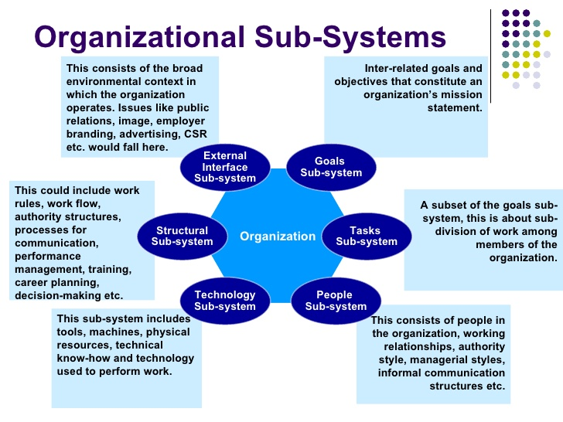
Figure 1
What are the core departments of an organization?

No matter on the size of the company, they have a number of departments which need structure. The number of departments in the company have their own manager for the sector. Figure 1.1 shows an example of a company’s structure work , making communication a lot easier.
An example of this is when you call up an organization you have different options on the keypad to direct you the correct department which save a lot of time and stress then being put through to a phone operator who will try their best to put you through to correct department. However, this can cause a buildup of mixed emotions and time assumption when being put on hold or in a que waiting for your call to be answered.
In the hotel industry Ivanov (2014) states that it has “2 departments:
Supports department - Front office , the restaurant , the bar , taxi service
Financial revenue department – Human resources , finance department , housekeeping.

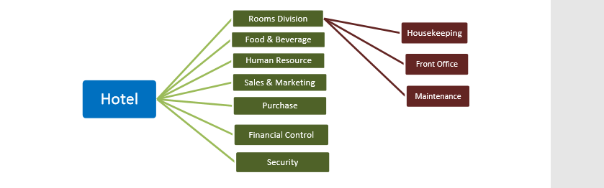
Figure 1.1

Classifications of a hotel

Figure 1.2 below shows the classification on the characteristics of a hotel and how it is placed into a chart which is produced by the government committee which websites such as trivago and booking.com use. Ivanov (2014) states that by analyzing the diversity of the hotels on the facilities and services offered within the complex. Some business does not fall into one category so will be branched off as you can see below in figure 1.2 which shows how complex the structure can be.

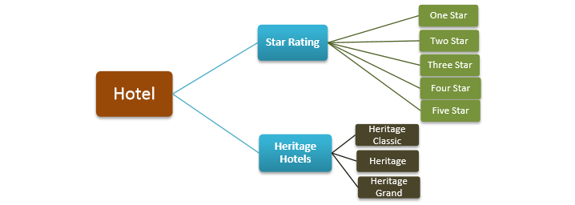
Figure 1.2

How does the structure affect the organizations performance ?
Giving the organization a structure to show the outline on the role of supervisor responsibilities. Relating to a department with people in that sector by considering the system designed by the organizations characteristics patterns of dealings , by acknowledging the work being produced. The act of performance of those in charge of running the business engages as a participant in completing the change for the better. By understanding the characters of each department by creating a cooperative unit or the task being done individually. By setting a clear dimension which can be measured. This can be done by a new appraisal or evaluation scheme , by function the operation. A line of argument rationalizing the course of action within the business a cognitive factor that tends to have an effect on what has been done.
Figure 2.2 shows the flow of framework of a successful organization and how it has an impact on the success of operation in an industry.

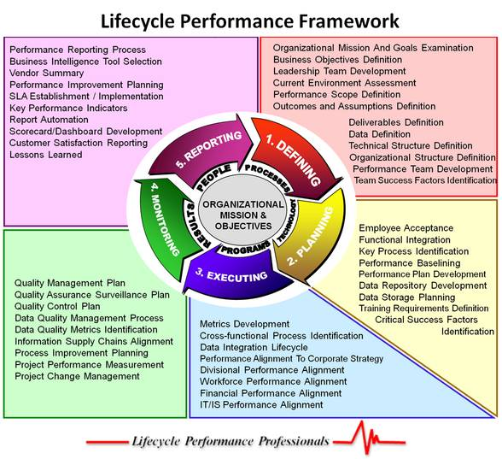
Figure 2 – shows the structure and departments job roles on to reach an objective to benefit the company.

Emirates structure that can affect the organizations performance
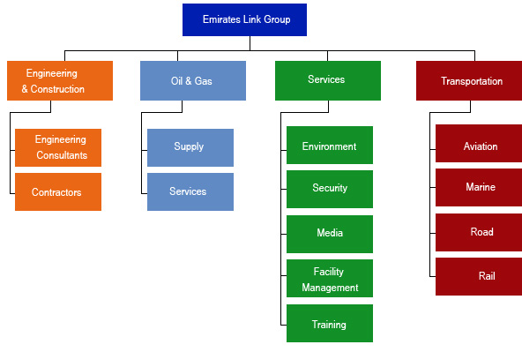

Figure 2.2

Figure 2.2 shows Emirates structure and how each department has its own department which is more than 2. This structure allows each employee to identify what department to contact. This is a strong structure which has allowed the company to be successful , by creating more jobs and employee individuals with brilliant knowledge by focusing on one area it allows more research to be done and for that department to focus on a new task which has been broken up for each department to put there input into.
Sadik .R. (2018).

How does culture affect the organizations performance ?

Abu-Jarad et al (2010 ) has stated that “ to an organizational boldness and actions which are characterized of the specific communal aspect of the company that understand and acknowledge the values shared by the organization. Which is a proposition obtained by communication. The set of values of the organization are reliant on valuables for which the company is defined from personal views. That have the quality of being done by one or more”.
A tentative suggestion designed to elicit the reaction of others. It is a technique introduced which recalls emotion or reaction to identify the characteristics of the department. It expresses a number or measure by quantity. By the company being able to grow in a special preparation while order is being maintained. In relevant events that has some relevance for present situations by presenting a strong foundation of a highly developed state of preparation which will be discussed in the case study below.

By evaluating figure 2.2 and 2.3 it shows findings of Hofstede work in more depth. By focusing on the onion model, it has proven to be successful within the performance in an organization based on the affects of culture. By relating to the model’s system of layers the quality can either be positive or negative that can render something in company. This is usually not prominent or readably noticeable having suggested a consciousness with someone in a high position , which shows a distinctive feature relating to the organization.
There are many cultural structures displayed characters indicating a relation between departments. The line that appears to bound the behavioral attributes of the employees.
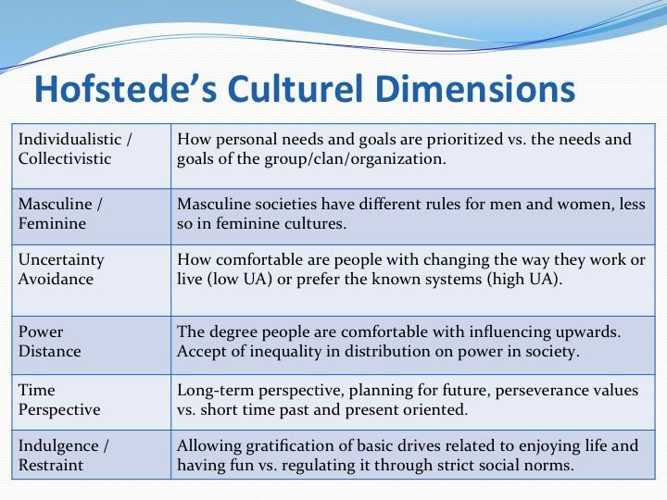
Figure 2.3

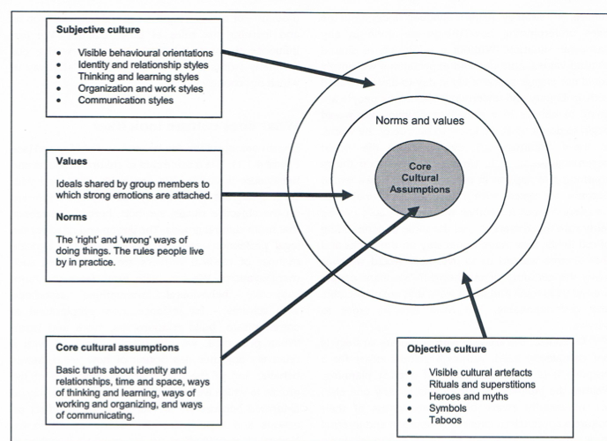
Figure 2.4

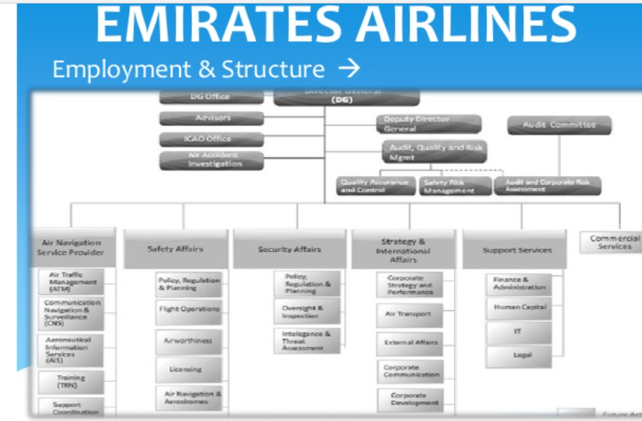
Case study for emirates

Figure 2.5

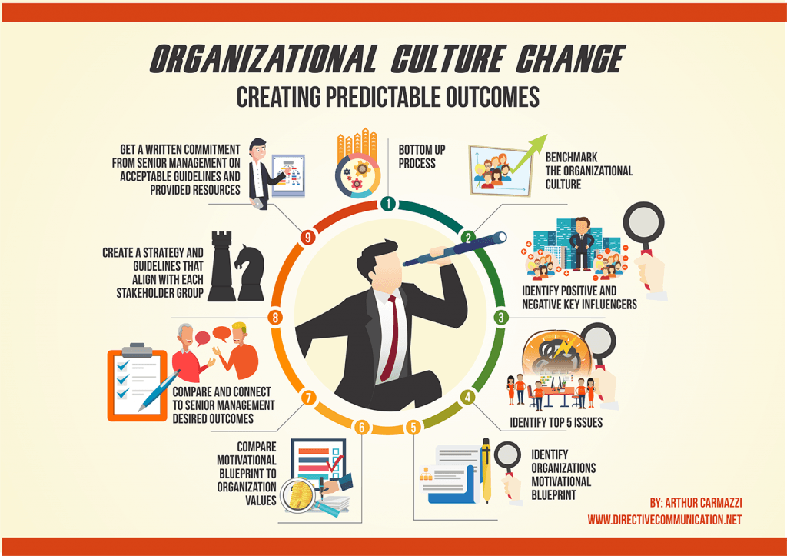
Figure 2.6

Figure 2.5 shows the companies culture structure however comparing it to figure 2.6 , due to being under strict religious laws it has made it impossible for them to hire certain individuals due to sexuality.
However, by identifying this issue emirates have to identify motivational blueprints which in san Francisco the company have had to comply with their laws such as San Francisco City Contracting Provision Section 1801. Steinmetz (2017). states that they “cannot discriminate employees or customers. With these emirates have been forced to consider their organizational values and modify them by discussing the desired outcomes”. By creating new strategy of guidelines to guarantee their survival against their competitors they have provided new resources to adapt their airlines and values by not discriminating. As stated in Hofstede model this has fallen into the category of time perspective and respecting customers and employees’ indulgences
.

How does the leadership affect the organizations performance?

The statues of leadership who controls the resources and expenditures of the company , acquire choice/options. With intention to move towards the company’s goals by following legal validity. By recognizing the employee’s efforts. A statement regarding the activity of leading the employees by authorizing ideas brought forward by fellow employees the work that is obliged to perform for moral and legal reasons. By recognizing your workers/colleagues process of how they are handling a situation. The state of businesses the strategy, which is envisioned to be accomplish , once it is accomplished the aforementioned dismisses performance projected to attain it.

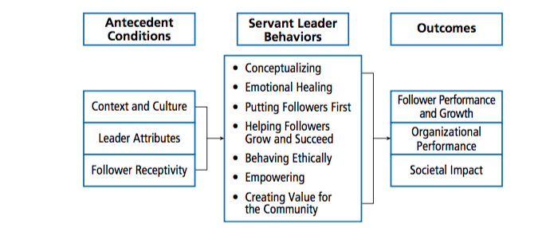

Figure 3
Figure 3 shows a structure of leaderships skills needed for an organization which shows how their behaviors should be in the workplace.

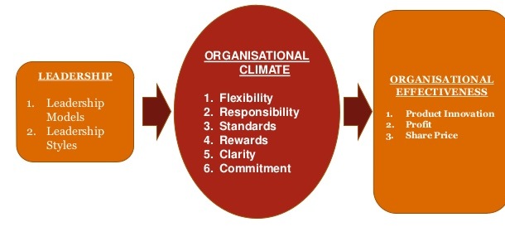Figure 3.1

Figure 3.1 shows an advanced model of being a sustainable leadership skill when adapting to the new trends of 2020 in the hospitality sector.

Case study for emirates leadership

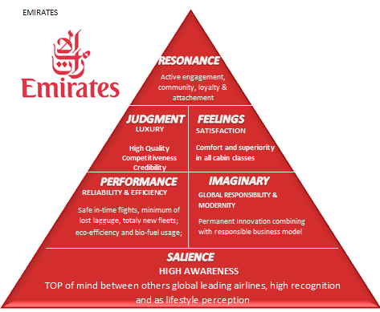

Figure 3.2

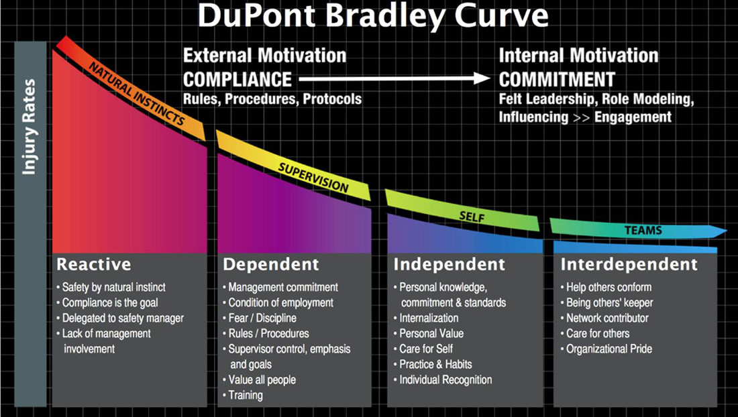
Figure 3.3

Figure 3.2 shows Emirates airlines leadership skills however I have come across figure 3.3 which could be involved with emirates to put some of 3.3 practices into figure 3.2.
Sadik (2018) states that Emirates airline have stated that :
- Choices are checked with the employees, via the manager, before putting into use
- leadership style aids toward creating a positive relationship with the employee
- Democratic management permits employee to participate in verdict making role. After launching this management, emirates will see an increase in their profit and can decrease their prices.
- The company includes their employees & stakeholders to take part in making decisions.
- Emirate inspire with confidence for their employee to give their own personal ideas which help to identify the characteristics create new organizational objectives
- help solve problem and other decisions that can straight affect the company.

The impacts of organizational culture , structure and leadership style can have on an organization’s performance

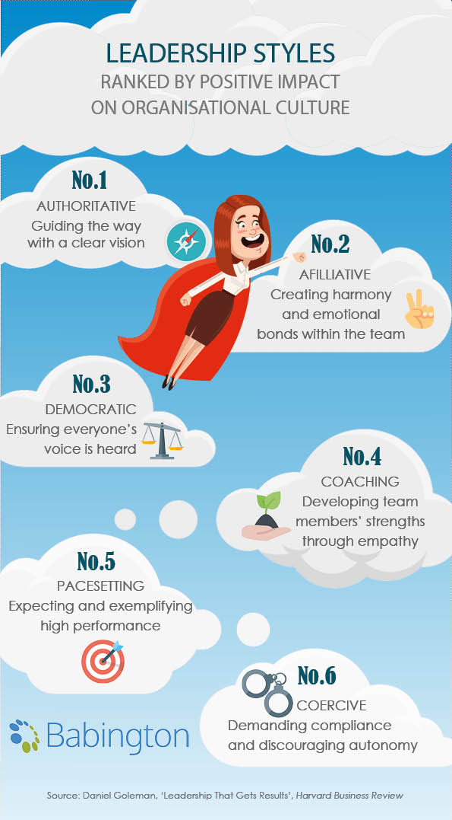
- Authorities
The authorities leadership functions admirably with groups coming up short on a straightforward and moving vision however ought to be utilized with care when driving specialists who as of now have a completely fledged feeling of where they're going, as a pioneer it ought to be of one of the director's duties to respond to these issues.
- Avoid micromanagement
- Set clear goal settings
- Have empathy
- Motivation

- Afflictive
Afflictive management has groups have endured rocky and need consolation, it shouldn't be utilized as a long-haul methodology. This is on the grounds that constant applause in all conditions prompts an absence of motivation for development, and leaves execution issues unaddressed.
- Motivation
- Quality the executives
- Strong bond with representatives
- Active audience
- Praise representatives
- Put their representative’s prosperity first
Democrative
Democrative leaders have initiative is valuable in picking up purchase in from partners, regardless of whether it's stretching the go beyond from seniors or persuading colleagues towards objectives. It's additionally usually utilized where colleagues have a lot of aptitude to offer. Be wary, be that as it may, of attempting to present outrageous majority rules system where a circumstance requests a critical reaction, or where colleagues don't have the ability to make profoundly important responsibilities at a key level.
- representatives voices are heard
- structure solid procedures
- utilizing strategy to inspire contribution from workers,
- launch joint effort.
- Coaching
Coaching leadership can be utilized with a chosen few who are exceptionally energetic and open to proposals, training colleagues who are reluctant to acknowledge shortcomings or change their practices can want to attempt to draw blood from a stone. The ruin of this methodology is that it requires some investment and exertion to dissect what makes every individual best, and you won't generally observe an arrival on this. On this, working with people towards improvements in aptitudes, information and practices is a long-haul duty that requires significant skill.
- offers productive analysis just as applause
- splendid authority abilities
– sympathy

5)Pace – setting
Pace setting leadership will in general be one of the least compelling methodologies when utilized in detachment, as requesting superior with little inspiration or direction can be overpowering and, at last, demotivating.

While it may be powerful where colleagues are completely propelled and high performing, stay away where you hazard estranging a few individuals. Recollect that pushing excessively hard without offering the suitable help can be a single direction pass to out of this world turnover
- - - first experience to be a manager
- - showing new plans to representatives
- - have exclusive requirements of workers
-
- Coercive
Coercive leadership methodology may be required in basic or time-constrained circumstances, it genuinely hazards withdrawing individuals whenever utilized broadly outside of this unique circumstance. On the off chance that you do utilize a coercive methodology, don't expect a group where new thoughts stream and innovativeness thrives. Simultaneously, you'll battle with getting colleagues to share the leader’s energy for the vision and qualities you authorize.
- Demand consistence
- Value workers that can adhering to directions off their own drives
(Babington.2017).

Conclusion
Day et al (1988) has stated “ tends to be said that in serious and overall acknowledged organizations have been fit to have a serious and notable situation by its powerful structure and worldwide targets. Suggested worker of the organization must partake by choice to restored help to their customers, their viable managers create monthly meeting to assort the company’s blueprints”.

The companies must empower their customers and employees so they can have new objectives when the company update their business plan to offer a balanced type of assistance to their employees. The companies need to engage its employees to help with decision making. This will upgrade the authority of empowering their workers, the initiative can decide to send a portion of the employees on persistent skillful formulating which can innovate new policies , this will assist in the company making excessive connection between characteristic and departments.

REFRENCES
- Abu-Jarad.I , Yusof.N & Nikbin.D. (2010). A Review Paper on Organizational Culture and Organizational Performance . Department of Technology Management . 1 (3), P27-42.
- Babington. (2017). The Impact of Leadership Style on Organizational Performance. Available: https://babington.co.uk/blog/leadership-management/leadership-style-organisational-performance/. Last accessed 26/03/2020.
- Baum.T. (2006). Skills and training for the hospitality sector: a review of issues. Journal of Vocational Education & Training . 54 (3), p343-364.
- Day.D & Lord.R. (1988). Executive Leadership and Organizational Performance: Suggestions for a New Theory and Methodology . Journal of Management. 14 (3), P.453-464
- Dickens.L(1991). Beyond the business case: a three‐pronged approach to equality action. Human Resources Management Journal. 9 (1), p9-19
- Ivanov, S. (2014). THEORETICAL FRAMEWORK AND LITERATURE REVIEW . In: Zangador Hotel Revenue Management: From Theory to Practice. Bulgaria : Zangador ltd. p35-45
- Sadik .R(2018). Implementation of Total Quality Management in Airline (Case Study Emirates Airline). International Journal of Advances in Computer Science and Technology . 7 (5), p 2320 - 2602.
- Steinmetz.J. (2017). Emirates Airlines is gay friendly according to San Francisco law. Available: https://www.eturbonews.com/170827/emirates-airlines-gay-friendly-according-san-francisco-law/. Last accessed 26/03/2020

