Critical Reflection
- Introduction

In this major project, we have done a lot, of course we have learned a lot of lessons, and made a few mistakes. I think that in terms of division of labor, the distribution is not ideal. First of all, I think that in terms of division of labor, the distribution is not ideal. The division of labor is too scattered, resulting in a less uniform style for everyone, and the final effect is not perfect. If I were the team leader, I would first set up an art team leader and let him unify the style and color tone of the entire animation. Next, make all 2D type original paintings, including scenes, characters, props, etc., and then assign them to the team members to make models and materials. And assign a single person to be the camera team leader, let him manage the storyboard, shots, and lighting issues. After he made a unified command, he was then assigned to the team members to work. In this way, in the production, the file transmission, format, and art style can be unified as much as possible, rather than scattered, which makes the final finishing work extremely complicated, and the software used by each person is different. The file compatibility is also different. These factors also led to a very serious problem, the division of labor was very confusing, and a sofa made three to four versions. The labor force was seriously wasted, and some people didn't even do anything in the end because they didn't have the command of the team leader. These are the experiences I have absorbed and learned in the team. Next, let’s talk about my personal mistakes and conclusions.

2.1 Original painting part

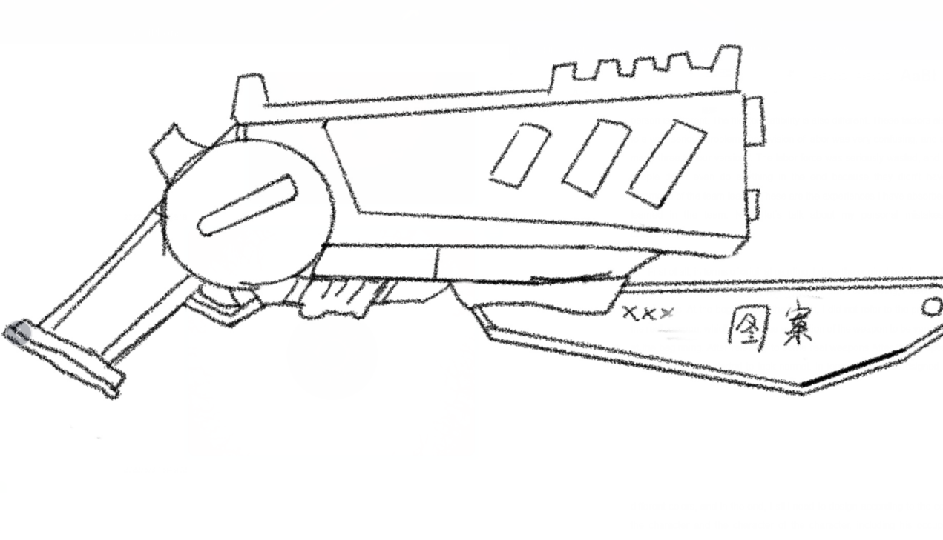
First of all, in terms of original painting, I drew the original painting materials of key props. This is a very important part. In terms of drawing, I also had a lot of problems. At the beginning of the sketch, I did not refer to the proportion of the real weapon, which caused the proportion of the weapon to be very strange at the beginning. After referring to some real weapons After the weapon, my original art design started to look normal. In terms of color, I designed many different colors, and in the end, I still need to design according to the color of the character and the character of the character, including his occupation, personality, these things, it seems that it does not matter. But in fact, it is indeed one of the elements of the quality of an animation.

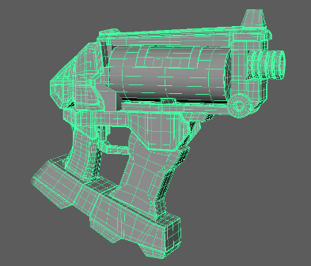
2.2 Modeling part

In terms of modeling, there were a lot of problems with splines, including changing silhouettes after being rounded, and inverting normals. These things are easy to solve, and I solved them in a very short time. Secondly, the importance of modeling topology and quadrilateral surfaces also reminds me all the time that as a modeler, I need to lay a solid foundation for the entire early stage, and I must strictly follow the requirements during production, and there must be no mistakes, otherwise in the later stage will pay quite a price. I made three different versions of the model of the pig head grenade. There were some problems in the explosive part of the pig head grenade. The topology failed due to the asymmetry of the axis, so I made it again to get the correct version.
In order to express the texture of the props, excessive smoothness will cause the silhouette of the model to change, so it is very important to do a good spline for a good model. Therefore, in the production of hard surface models, the standard of lines and shapes are necessary conditions for making a qualified model. On the parts of the props, the parts that can be made separately should be made separately as much as possible, and finally merged together to make UV and textures, which will be more convenient and space-saving. At the same time, the model needs to keep the four-sided surface as far as possible, and do not have the five-sided surface and the reversed surface, which will have a great impact on the texture, and even need to remake the model.
Although there were a lot of problems, I was able to complete the production and materialization of these models on time. After talking to the team. They decided to make liquid flow and glow effects in gun magazines and chemicals. I reworked and textured the chemical potion model again to complete a new model. In the high-poly part, in order to restore the original painting design, I tried many times, and finally got a model with relatively fine lines and models. After making the model, I will use the software substance 3D painter to draw the texture. Before this, the UVs of the model must be unfolded to facilitate the later materials.

These valuable experiences also guide me step by step to make fewer mistakes in the future.

2.3 UV part

In terms of exhibition UV, I used maya for exhibition UV operation at first, but the UV displayed was not ideal. Later, I used UNFOLD 3D to make UV, and the effect became better. In terms of materials, in order to better meet the needs of animation, it cannot be too simulated, and there needs to be some stylized things, so the texture drawing is more cartoon-like.
In the material part, the most error-prone place is the seam between UVs. I used maya to give the material at first, but there are too many materials, which makes it difficult to use in UE. So, I chose to combine the entire model and use SP to paint the texture. The seams of the texture will cause many problems. The best solution is to hide the seams in an invisible position at the beginning. There is no way to repair the seams slowly in the software. After dealing with these seams, the effect became better. This model uses multiple layers to bring out material details, wear, elevation, and color. I try to make the texture on a model, so that teammates can more easily extract the material to the props.
To make different materials on the same map, you need to use masking technology to mask a part of the material and only make another part of the map. In this way, the material presents a different effect for each part.

2.4 rendering part

In terms of rendering, I think the teamwork is very poor. Especially when it comes to render settings and renderer selection. I think the rendering should be handed over to one person, and then assigned to each team member to render directly after the adjustment is completed, instead of each person having to set a series of settings such as light source and renderer by themselves after getting the animation. Secondly, some team members did not complete their rendering work within the stipulated time, which led to the confusion of the entire division of labor and the reduction of post-production time. This is very fatal for our entire group. So, as one of the supervisors, I directed some of the crew to work overtime and assigned some shots to them and myself. Took some extra work they didn't finish.
In the rendering of UE5, I failed several times, including the camera movement and the rendering of the scene, I used ray tracing at first. However, after turning on ray tracing, in some scenes with shadows, the shadows have problems, and the light cannot be well represented in the shadows. So I deleted the rendering again, turned off ray tracing, set it up again, and finally finished rendering in ue5.
Maya rendering uses the Arnold renderer. This is a relatively easy-to-use renderer, but I have learned a lot about textures, including the path method of materials. Textures made in SP need to be uploaded to the correct path to get the correct effect. Properly make textures to get better results.

2.5 post-production part

In terms of post-production, because other team members did not leave much time with me, I only had about a day of post-production time, so the production was in a hurry, but before production, I used play blast and storyboards to complete the film Made some sound effects and editing storyboards, so it wasn't particularly rushed. After the production, the sound effects and music were not made entirely by myself, which is a pity for this part. In terms of sound effects, I also tried a lot of methods, and even wanted to make it myself, but unfortunately, my own musical literacy was not enough, and the music I produced was not very good, so I finally chose to use music with open copyrights on the website to make it.
Everyone gave me different colors in the video, I used the color matching technique in PR to unify the colors. Compare the two videos in the software, adjust the color in the LUT, and finally make the color similar.
The combination of two different BGMs brings a sense of rhythm to this animation. The joy in the early stage and the tension in the later stage are also an indispensable part of adding fun to the animation. I took inspiration from a lot of movies and animation to place this music. Secondly, in the post-production part, I found that there was a problem with color matching, and there was no special effect at all. In terms of time, I was not sure about making special effects in Houdini or other special effects software. So, I asked other team members and got a response. Haolang Yan took over the part of making special effects. I started editing in sync, delivered the edited and color matched video to him, and he did the special effects. If I have the same task in the future, I will choose to think about the composition of the special effects from the beginning, and arrange the corresponding division of labor for them to make this key part.
3. Conclusion

Through this major project, I have gained a lot of experience and learned a lot of things, which not only exist at the technical level, but also include teamwork and cooperation.
At the technical level, I learned how to better the whole process of making models, and also learned how to unwrap UVs, use materials, and restore the design and production of original paintings. In terms of rendering, including lens language, lens dynamics, and even empty shots, all have their own importance, as well as lighting rhythms, which all need to be controlled or even set in advance. In terms of the final cut and the sound, I think I did a good job, editing is not just about throwing everything together, first to make sure the story, second, the rhythm, and the sequence of the shots are important, in this major project, I also gained a lot of experience that I didn't have before.
In terms of the team, I also earnestly completed the tasks assigned by the team leader, and even helped other team members in other aspects. I think I have done all my personal tasks. At the same time, I also learned a lot about team communication, and when making these things, a team leader is very important. Everyone's division of labor also needs to be reasonably customized, otherwise it will be a mess.
In this team work, the team members played a great role, and of course there were also team members who were not officers. Difficulties such as jet lag, communication, and file transfer did affect our production, but we still tried our best to overcome these difficulties and complete this animation. This assignment will also provide me with a lot of useful knowledge and experience in the future. I am very grateful for this opportunity. I will also use these experiences in my work and life to make better works.

