
LCLM4005 – Employability and Career Development
Component 2 Assessment
Comparison of Job Advertisements, Reflective Self-Assessment and Personal Development Plan
Submission Date: 23 March 2026


Table of Contents
1. Introduction 2
2. Task 1: Comparison of Job Advertisements 3
3. Task 2: Reflective Self-Assessment and Evidence of Employability Readiness 5
3.1 SWOT Analysis: Strengths 6
3.2 SWOT Analysis: Weaknesses 7
3.3 SWOT Analysis: Opportunities 8
3.4 SWOT Analysis: Threats 9
4. Evidence of Employability Readiness 10
5. Task 3: Employment Goals & Personal Development Plan 11
References 12

Introduction
The section critically compares two customer-facing roles that were identified from recent job advertisements. The Receptionist role is compared to the Customer Sales Apprenticeship role at Sky. While the functions employ different skills and techniques, they both exist within the context of the customer and the organisation, a vital part of employability in the service industry (Cottrell, 2019).
Both of these roles will need both interpersonal and organisational competences that current employers expect in dynamic, customer-oriented environments. To be a receptionist is to run the front desk and co-ordinate the administration largely. When it comes to the customer sales apprenticeship, the job involves selling efforts and engaging with customers telephonically. However, it is important to note that regardless of the context, both roles demand similar transferable skills, which are critical for employability (Jackson, 2015).
This comparison will review the essential skills needed for both roles, outline any similarities, and assess the significance of communication as a core employability skill in customer-facing roles.

Task 1: Comparison of Job Advertisements
According to the two roles, one key skill is communication, and it is shared by both. It is an important skill, as both roles involve having direct contact with customers, which may affect the delivery of information and the overall experience. Employees should communicate effectively in order to understand the needs of customers, respond accordingly, and avoid misunderstandings which can create dissatisfaction.
Receptionists must communicate clearly and professionally to make visitors feel welcomed, comfortable and supported when they first arrive at the business. In comparison, in the Customer Sales Apprenticeship, communication is linked to sales, as employees must explain the product and persuade the customer. As noted by Cottrell (2019), communication is about exchanging information that develops personal and professional relationships, while also supporting the organisation.
According to Jackson (2015), teamwork, problem-solving and customer satisfaction all benefit from effective communication, which is widely considered a key employability attribute. Hence, one can say that communication is central to both positions and to the success of customer-centric occupations.

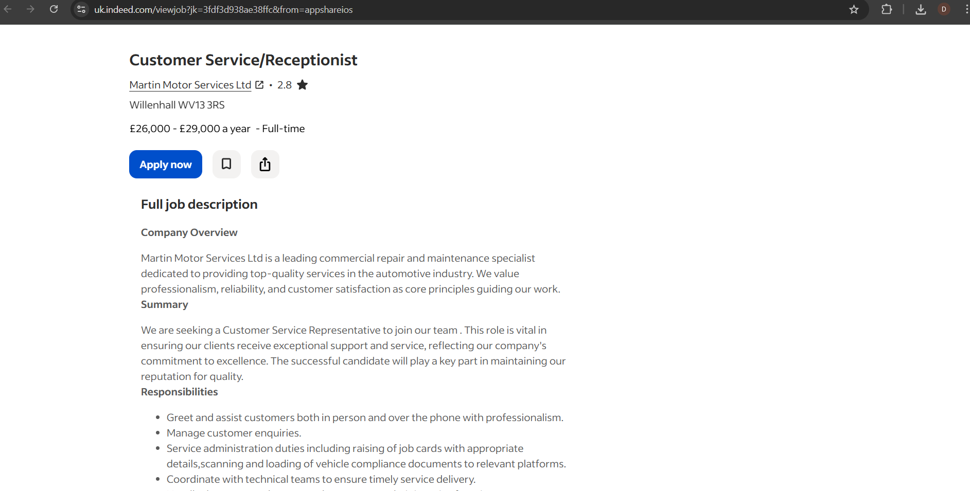
Figure 1: Receptionist Job Advertisement (Indeed, 2026)

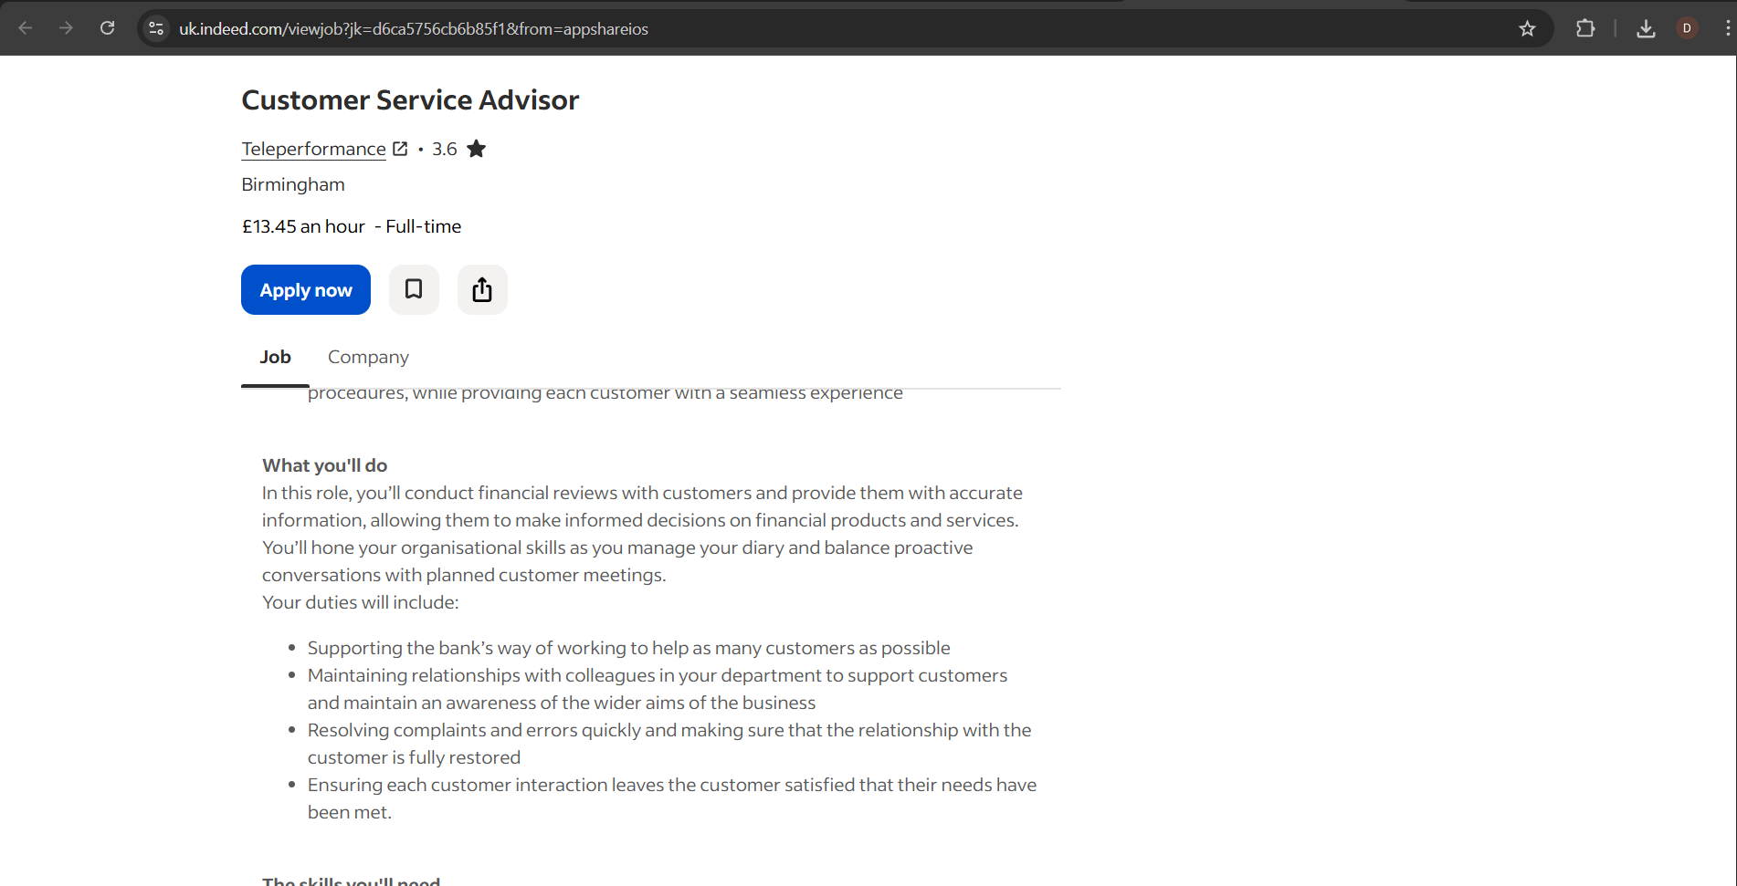
Figure 2: Customer Sales Apprenticeship Job Advertisement (Indeed, 2026)

Task 2: Reflective Self-Assessment and Evidence of Employability Readiness
In this section, I reflect on my skills, knowledge and overall readiness for employment. I will carry out a SWOT analysis to assess my strengths, weaknesses, opportunities, and threats. It allows a systematic way of identifying internal (strengths, weaknesses) and external (opportunities, threats) factors or issues that can influence career progression (Gürel and Tat, 2017).
Self-assessment is critical for employability because it helps you understand where you are now and what you need to improve to meet employer needs. According to Cottrell (2019), awareness of oneself is a key aspect of knowing one’s strengths and weaknesses. It helps in making logical and confident career decisions.
This section will therefore examine my strengths, weaknesses, opportunities and threats, and will provide evidence of my employability readiness through my academic background and work experience.

SWOT Analysis: Strengths
One of my greatest strengths is communication. I believe I have developed this strength from my work experiences and even daily interactions. To illustrate, I had to communicate with different people while working in positions like Domino’s delivery and warehouse operative roles, including customers and team colleagues. This has made me more confident when speaking and better able to understand the needs of others. Communication is a key employability skill, which supports teamwork as well as enhances customer satisfaction (Jackson, 2015).
I’m also good at working with others in a team. While in warehouse and security positions, I had to work with others to carry out tasks to the best of our abilities and keep the environment safe and organised. This experience helped me understand how teamwork plays a vital role in improving performance in the workplace.
I also think being flexible is one of my strengths. Throughout my experience, I have worked in several types of roles. This has allowed me to adjust quickly to new environments and responsibilities. I can adapt to difficulties with ease, which is important in modern work environments where task and responsibility requirements vary (Cottrell, 2019).

SWOT Analysis: Weaknesses
The most challenging weakness that I believe I have is my lack of business or office experience. Although I picked up some valuable skills from my past jobs, I haven’t worked in an administrative role or one on the customer-based office side. I may lack confidence to apply for such roles because I may not be fully aware of the expectations and responsibilities.
Another one of my weaknesses is that I sometimes lack confidence in new situations. For instance, I may take some time to get used to a new role or when dealing with challenges. In the beginning, I may struggle to perform my best, even though I usually improve with experience. Confidence develops over time, through experience and self-awareness. Therefore, according to Cottrell (2019), this is something that we can improve.
I need to work on better management of time. It gets hard to balance work and studies along with personal life at times, which can lead to stress and inefficient completion of tasks. I need to work on my planning and organisation skills in order to accomplish this more effectively.

SWOT Analysis: Opportunities
One opportunity that I have is my university course, which helps me develop the knowledge and skills needed for a job in the future. I’m studying business and what employers expect from candidates. Through my studies, I’m understanding this better. I can boost my employability with this opportunity as well as prepare for a role in customer service or administration.
I can additionally apply for apprenticeships or beginner roles. The opportunities will help me to have real work experience in an organisation that will help me to overcome my inexperience. According to Jackson (2015), gaining work experience helps develop employability skills and enhance job prospects.
I have the chance to improve my skills through training as well as self-development. One way to expand the learning of these skills is by practising it in real life or engaging in online courses. It will enhance my future readiness of getting a job and my chances of getting a job.

SWOT Analysis: Threats
A potential threat that I face is the intense competition in the job market. I may struggle to get roles because many candidates can have better experience or qualifications than me. It could impact my employability, especially if I wish to pursue a job in admin or customer services.
One other threat would be that I do not have any experience in a more professional office setting. Employers may prefer candidates who already have experience in similar roles even though I have transferable skills. As a newcomer in my career, it might restrict my choice.
The job market may have fewer positions or set higher standards which will mean that you may not get a job despite possessing the right qualification. I must enhance my abilities continuously and acquire relevant experience for remaining competitive in my field. According to Jackson (2015), one’s employability is dependent on one’s ability to continually develop and adapt to changing job market.

Evidence of Employability Readiness
The job experience and my academic study reflect my employability readiness. I’ve had jobs like Domino’s delivery, warehouse operative and security, which have helped me show my communication, teamwork and responsibility skills to employers. For instance, during my time at Domino’s, I had to interact face-to-face with customers, which enhanced my confidence and clarity. When working warehouse jobs, I worked with other individuals to get the job done efficiently.
My studies at the university support my employability. My time at university is giving me insight into business and showing me what employers want. It strengthens my ability to link theories with practical circumstances and enhances my overall work readiness.
Moreover, I have demonstrated a willingness to adapt and evolve myself. I know my weak points and I am making an effort to improve upon them, like my time management and confidence issues. As per Jackson (2015), employability depends not only on current skills but also on the ability to learn and develop. As a result, the combination of my practical experience, classroom learning and self-development shows I am becoming more employable.

Task 3: Employment Goals & Personal Development Plan
Considering the weaknesses from my SWOT analysis, it has been decided to set employment goals (both short-term and long-term). A short-term goal of mine is to obtain experience in an office administration/customer-based role. The fact that I do not have any experience of working in an office environment makes me a little lost in various other functions while applying for the same. Receiving this insight will equip me to know what is expected at work and practise.
A further short-term goal is to manage my time better. I plan to achieve this by practising communication in real life and planning my daily activities more effectively. These goals matter because they will help me do a better job both professionally and scholastically.
In the long term, I want a permanent job in administration or customer service and upgrade to a management level. I intend to seek development and construction of professional career that aligns with my career aspirations. Setting clear goals for oneself and working towards those goals is crucial (Cottrell, 2019).
To help achieve these objectives, I have drawn up a personal development plan. Over the next three to six months, I will apply for entry-level roles and apprenticeships to gain experience. Using planning tools such as the calendar and the task list every day will improve my time management skills. Besides, I will work on my self-confidence, speaking more in school and the workplace (if possible).
I will track the number of job applications I complete each week, employer feedback and my improvement in being more confident and better at organisation. I will also use resources such as online courses, university support and job websites to improve my skills and increase my chances of employment.

References
Cottrell, S. (2019) Skills for Success: Personal Development and Employability. 3rd edn. London: Red Globe Press.
Gürel, E. and Tat, M. (2017) ‘SWOT analysis: A theoretical review’, Journal of International Social Research, 10(51), pp. 994–1006.
Jackson, D. (2015) ‘Employability skill development in work-integrated learning: Barriers and best practice’, Studies in Higher Education, 40(2), pp. 350–367.

