Managing Projects in the Organisation
BMSK 5004

Student Name: Mustafizur Rahman
Teacher Name: Paul Ranson
Student ID: 1711957
Group: 1

Executive Summary
This report highlights background of A-Z projects and severe risks associated with the project. Providing severe sponsorship and type of funding system for developing societal perspectives are major strategic operational methods followed by senior personnel of the company. Key technique related to Delphi technique can be used for finding out current stage and required steps to be done for the project regarding change of vintners Antiques from the point of Shirley to destination point spark hill. Product type of technique related to project management is effective tool which is basically used for managing both indirect along with type of unstructured activities.

Contents
1. Introduction 7
2. Over viewing framework of A-Z projects. 7
3. Steering group 7
3.1 Communicating with the steering group: 8
4. Identifying risks related in project management. 8
5.1. User Stories 9
5.2. Delphi Technique 10
5.3. Microsoft type of planner tool 10
5.4. Product project technique 11
5.5. Gantt chart 13
6. Project plans for stakeholder communication 14
7. Personal reflection 15
8 Waterfall concept. 17
9. Conclusion 18
10. Reference list 19
Appendices 21
Appendix 1: Project Mapping in Microsoft Planner 21

List of tables.
Table 1: Steering group roles defined…………………………………………………… ... .7
Table 2: assessment of different risks associated with project of transition……………...8
Table 3: technique regarding Delphi for finding out most significant requirements……..10
Table 4: Communication plan for the project………………………………………………..16
Table 4: Self-development plan……………………………………………………………….17

Table of Figure
Figure 1 : product type of management technique regarding project……………………….12
Figure 2: triangle type of iron for managing steps of project…………………………………13
Figure 3: Gantt chart……………………………………………………………………………...14

Introduction
The current project aims to formulate a sustainable project for Vintners Antiques, at Spark Hill, by A-Z Project Company. The project is distinctly related to warehouse and logistics management, harbouring cost-effectiveness along with measurable and accountable project propositions. A-Z Project Company is preparing project for Vintners Antiques.

Over viewing framework of A-Z projects.
Company has achieve highest level of success in UK competitive type of market for considering and including ideas regarding management as well as marketing strategy to severe fields including tourism and retailing (A-Z Projects, 2020).
The current project has acquired seminal importance since the warehouse or logistics management at Vintners Antiques has been problematized by multiple issues. While the Company has been underperforming financially, the warehouse at Spark Hill is far from being ideal, being constantly thwarted by lack of electricity, phone and internet connection and office space. Being used for storage for a number of years, the outmoded and erroneous warehouse management at Spark Hill has been hindering Organizational sustainability and growth.

Steering group


Doreen Suha Dennis Omer

Doreen: should be the sponsor | Suha : should be the users expert
Dennis: should be the commercial | Omer: should be the specialist
Table 1: Steering group roles defined
(Source: Roberts 2012)

3.1 Communicating with the steering group:
In a project communicating with is very essential, these groups can help with the choice, definition, and management of projects. Project steering group are like a part of a larger project governance structure that has the duty of managing the project managers progress when it comes to meeting project goals and deadlines. The technique that is going to be used to communicate with the steering group is telephone conversations, skype talks, and by internet.

Identifying risks related in project management.

Risk | The way of raising risks | Impact | Likelihood | Mitigation strategy
Recruitment of unskilled type of staffs | Lack of analytical skills and recruitment strategy regarding recruitment of skilled staffs | High | Moderate | Making proper planning sheet including effective recruitment technique
lack of resources including net capital and skilled project coordinator | This is caused due to improper preparation of operational sheet. | High | High | This can be mitigated by maintaining an effective interaction technique with all project stakeholders
Delay of estimated project deadline | This is caused due to improper project implementation sheet and operation procedure and unscheduled work process | Moderate | Low | This risk can be mitigated by strengthening monitoring and controlling activities.
Stuffed atmosphere in logistics or warehouse | lack of office space | Very high | High | Expanding internal space in accordance with variety of items and operations.

Table 2: assessment of different risks associated with project of transition
(Source: Bowersand Khorakian, 2014)

Considering the issues currently faced by Vintners Antiques, warehouse or logistics management is in need of constant renovation, cleaning and up gradation processes. Understandably, this calls for sustainable technological innovation. However, considering the decline of traditional business frameworks and models, logistics or warehouse management could potentially be thwarted due to unclarified project objectives.

- Tools and strategic techniques for managing project

User Stories
This is most significant tool for managing project as it always focuses on remaining stages and required resources for specific project (User stories, 2020). In the project regarding transition from the point of Shirley to the destination called Spark Hill. The user stories can be considered for the part of reminder which would alert project manager (Koripadu and Subbaiah, 2014).
User stories would be highly imperative in the current context of warehouse and logistics management since it provides encompassing audio-visual analysis. Consequently, the incorporation of natural language would play a vital role in terms of software development and management in warehouse and logistics management (User stories, 2020). The family-run business model in the current context calls for agile software management and development for agile software management and development. Since the business of Vintners Antiques would incorporate wide range of associates as well as stakeholders, the project personnel of A-Z Project Company would be required to formulate effective communication to optimize satisfactory performance (Koripadu and Subbaiah, 2014). In the context of the current project, the user stories are supposed to be Independent, valuable, negotiable and testable. Through effective user stories, the project as well as the Organizational associates can be provided with accurate benefit statements of warehouse and logistics management.

Delphi Technique
The Delphi-technique is a form of advanced and effective communication processes amongst large-scale project managerial attributes. Since this is a systematic, interactive and structured communication process, it can be potentially instrumental in mitigating the performance gaps of various project deliverables and objectives. Precisely, such techniques are essentially based on expert opinions, critical and strategic problem-solving (Habibi et al.2014). Critical or situational analysis is potentially instrumental within this method, also termed as being Estimate-Talk-Estimate method.

Problem: Transition from Shirley to SparkHill
Must-haves | Wants | Nice
- Finding out required resources including plumbing and strong connection of internet  - Electronic devices including laptop along with telephone line and strong web-based server system  - The need to ensure the safety and quality of employees and products. | - System of shelving and type of reception  - Strong internet-based camera for system of surveillance  - Strong availability of vans for transformation of materials  - The need to set up proper phone or internet communication and expand office space. | - System of shutter  - Wider range of resources as well as greater number of customers and buyers.
Mission: finding out all necessary items on regular basis and improving procedure of . managing project

Table 3: technique regarding Delphi for finding out most significant requirements
(Source:created by author )

Microsoft type of planner tool
Microsoft Project planner would be highly imperative in the current of warehouse and logistics management. Precisely, such tools could potentially turn out to be influential amidst diversified work rudiments and demands. According to Roberts (2011) Consequently, it would be important for managing the workflow efficiently. It is to be noted that most modern-day organizations like A-Z Project Company or Vintner Antiques are essentially project-centric in nature
(Refer to appendix).
However, critical functionalities like warehouse or logistics management are often thwarted due to conflicting business propositions and interests. Consequently, a Microsoft Project planner can act as a standardized tool for ensuring proper assigning of roles and responsibilities, especially in ana age of increased online activities (Planner Tool, 2020).

Product project technique

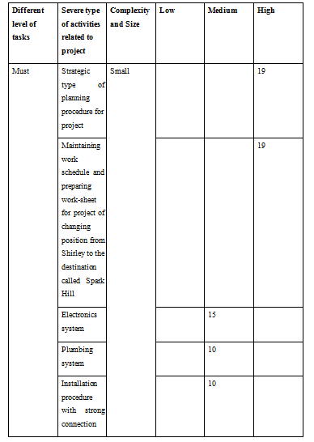
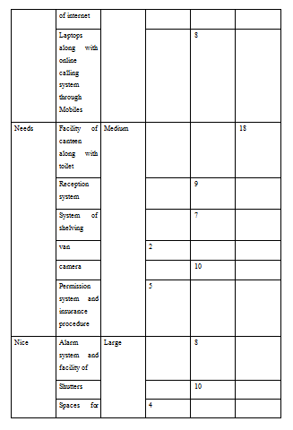
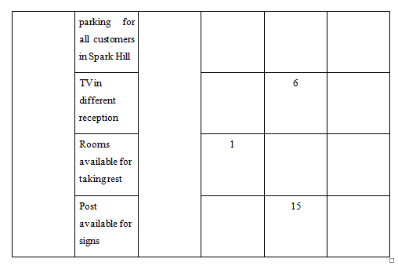
Figure 1 : product type of management technique regarding project
(Source: Meredithet al. 2017)

  - Iron Triangle
The iron triangle, being essentially linked with the critical aspects of Project Scope, Quality, Cost and Time, is imperative for ensuring a comparative assessment of all relevant project determinants. It is to be noted in this context that optimization of logistics and warehouse management would attract additional or hidden costs due to the prevailing problems of Vintner Antiques. Since each aspect would critically determine the outcomes and implications of other factors, this calls for effective and critical documentation and monitoring, long with proper record-keeping and review processes.
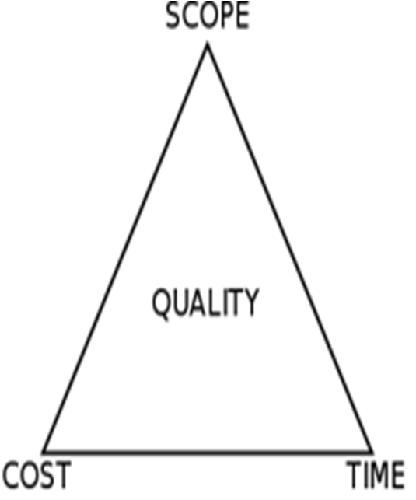
Figure 2: triangle type of iron for managing steps of project
(Source: Heagney . 2011)

Gantt chart
The formulated Gantt chart provided above aims to provide an accurate timeframe, this is only indicative in nature. Consequently, the current project rudiments could potentially be transformed in light of critical-macro environmental factors. Thus, the project t leaders of A-Z Project Company are supposed to adopt visionary and discretionary approaches in this respect.

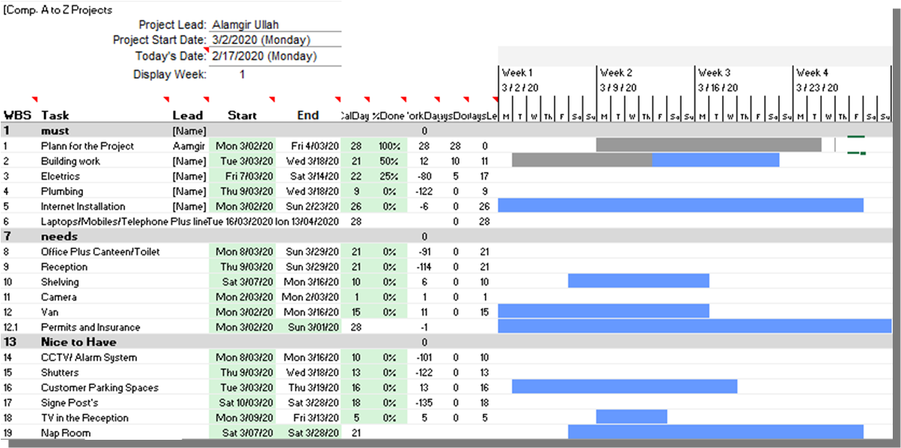
Figure 3: Gantt chart

(Source: created by author)

Project plans for stakeholder communication

Stakeholders associated with this project | Communication plan with the stakeholders | Frequency of communication | Effect on the project
Project Head | Mediums of Verbal Communication | Regular Basis | Conducting proper discussion with the project head
Sponsors of the project | Mediums of Non-Verbal Communication | Once in every Week | The support from the sponsors is vital for the completion of this project.
Clients | Verbal and Non-Verbal Communication mediums | Weekly basis | Interacting with the clients will give a clear picture about the thinking of the clients.
Government Authority | Verbal mediums of communication | Monthly basis | Consulting with the government authorities will provide important information’s regarding the legal aspects of the project which is essential (Buttet al. 2016).
Coordinator of the project | Nonverbal Modes of Communication | Weekly basis | It is important to communicate with the project co coordinator
Managers of the project  ((MD Afjol Mia and Safiur Rahman along with Alamgir Ullah, Mustafizur Rahman) | Verbal modes of communication | Regular basis | Interaction with the different project managers will help to identify the daily work progress (Mirand Pinnington, 2014).
Table 4: Communication plan for the project
(Source: Project Manager, 2019)

Personal reflection
The project handled by me regarding Change of Location of Vintners Antiques from Shirley to Spark Hill demonstrates the skills required for proper management of the project. Leadership based management skills are effective in managing the basic activities of the project in terms of controlling of members and stakeholders (Wright and Lawlor-Wright, 2018). Financial management linked criteria also helps in management of the project. Cost management - based skills and skills in critical thinking along with risk analysis-based skills help the project in determination of constraints and judging the overall performance of business. Resource allocation skill in terms of preparation of worksheet charters increases confidence to work collaboratively in the business project. Preparation of budgets before operation of tasks in regular fashion is an effective personal skill. Thus, in future I should concentrate on two major perspectives such as preparation of operation schedule of project and fixing cost for individual task which would assist me improving project process and delivering best quality project (De los Ríos-Carmenadoet al.2015).
While technological sustainability and innovation are undoubtedly significant in sustainable and encompassing project management, sustainable project management is essentially reliant on effective communication. In a broad-spectrum view, it also indicates at clinical human resource or performance management.
- Self-development plan
Different varieties of tasks | Ways of completing tasks in terms of management | Required resources for development of inner capabilities | Time period to be estimated
Proper in-depth scrutiny of project requirements | I can Find out the most influencing factors for evaluation of necessities in terms of capital and skilled labour personnel. | Project management-based articles and books | 3 weeks
Monitoring of stockholding activities in project relevant to interpersonal skills | I can monitor the activities of project to judge and record the basic elements of the project | Project management-based tools and journal articles | 2 weeks
Determination of goals of project in context of plans-based exercises which links with targets | Definition of proper and ideal business goals is a good aspect of planning and project can be scheduled in advance to judge the project performance | Articles, books and journals | 4 weeks
Feedbacks or case study analysis | analysing similar industrial trends | latest updates and Business knowledge and information, demographic assessment | 6 weeks

Table 5: Self-development plan
(Source: Ahernet al.2014)

Waterfall concept.
The project in the case study was accomplished by using the Waterfall concept. Waterfall concept is a true project management method, where stakeholder and customer obligations are assembled at the starting of the project, and then a subsequent project plan is created to adapt those needs. The waterfall method was first created by Winston W. Royce in 1970, and it was quickly adopted in a variety of businesses due to its obvious sequencing and simplicity of achievement. According to Mooz and Forsberg (2001) waterfall concept is the key to successfully managing project.

Conclusion
Thus, it can be concluded that managing specific project effectively by utilizing all required resources and tools are foremost way to ensure fulfilment of request of client. Development of proper strategic plan along with strategic implementation plan is most essential steps.
By accomplishing this project it can stated that this aided in achieving substantial awareness, understanding and knowledge associated with project management, this report has also enhanced me realising the importance of self-improvements plans and implementation of concepts.

Reference list
- Ahern, T., Leavy, B. and Byrne, P.J., (2014). Complex project management as complex problem solving: A distributed knowledge management perspective. International Journal of Project Management, 32(8), pp.1371-1381.

- Bowers, J. and Khorakian, A., (2014). Integrating risk management in the innovation project. European Journal of innovation management.12 (4), pp.23-56.

- Butt, A., Naaranoja, M. and Savolainen, J., (2016). Project change stakeholder communication. International Journal of Project Management, 34(8), pp.1579-1595.

- De los Ríos-Carmenado, I.G.N.A.C.I.O., Lopez, F.R. and Garcia, C.P., (2015). Promoting professional project management skills in engineering higher education: Project-based learning (PBL) strategy. International journal of engineering education, 31(1), pp.184-198.

- Habibi, A., Sarafrazi, A. and Izadyar, S., (2014). Delphi technique theoretical framework in qualitative research. The International Journal of Engineering and Science, 3(4), pp.8-13.

- Joseph, Heagney . 2011. Fundamentals of project management. Ama com Publisher.

- Koripadu, M. and Subbaiah, K.V., (2014). Problem solving management using Six Sigma tools & techniques. International Journal of Scientific and Technology Research, 3(2), pp.91-93.

- Lehtonen, M., (2014). Evaluating megaprojects: From the ‘iron triangle’to network mapping. Evaluation, 20(3), pp.278-295.

- Meredith, J.R., Mantel Jr, S.J. and Shafer, S.M., (2017). Project management: a managerial approach. John Wiley & Sons: New Jersey.

- Mir, F.A. and Pinnington, A.H., (2014). Exploring the value of project management: linking project management performance and project success. International journal of project management, 32(2), pp.202-217.

- Mooz, H. and Forsberg, K., 2001, July. 4.4. 3 a visual explanation of development methods and strategies including the waterfall, spiral, vee, vee+, and vee++ models. In INCOSE International Symposium (Vol. 11, No. 1, pp. 610-617).

- Planner Tool. (2020). Organize teamwork with Microsoft Planner. Available: https://products.office.com/en-in/business/task-management-software. Last accessed 10th March 2020.

- Project Manager (2019). What Is a Project Management Communication Plan? Available: https://www.projectmanager.com/blog/project-management-communication-plan. Last accessed 10th March 2020.

- Roberts, Paul. Effective project management: Identify and manage risks plan and budget keep projects under control. Kogan Page Publishers, 2011. pp 139-160.

- Wright, A. and Lawlor-Wright, T (2018). Project success and quality: balancing the iron triangle. Abingdon: Routledge. p1-189.

Appendices

Appendix 1: Project Mapping in Microsoft Planner


