

Automated Window Shades

by
Jennifer Hill

Supervisor: Stephen Mosey
Second Marker: Jenifer Prince Devaraj

Project submitted as part of the requirements for the award of BEng (Hons) Electrical and Electronics Engineering

April 2025

DECLARATION

I, Jennifer Hill declare that I am the sole author of this Project; that all references cited have been consulted; that I have conducted all work of which this is a record, and that the finished work lies within the prescribed word limits.

This work has not previously been accepted as part of any other degree submission.

FORM OF CONSENT

I Jennifer Hill hereby consent that my Project, submitted in candidature for the Beng (Hons) Electrical and Electronic degree, if successful, may be made available for inter-library loan or photocopying (subject to the law of copyright), and that the title and abstract may be made available to outside organisations.

ABSTRACT

This project is presenting the design and development of a Programmable Logic Controller (PLC) based automated window shade system to regulate indoor light and temperature environments. Using Allen Bradley hardware programmed with Logix Designer and Red Lion HMI configured with Crimson 3.2 to control motors for blind movements based on environment variable feedback. For the purpose of simulation the potentiometers will be used to provide the variables for the temperature and lighting inputs. The blind is mounted on a custom made wooden frame and controlled by 2 stepper motors, one for tilt and the other for height.. Reed switches will be used for calibration points with LEDs used for confirming triggers. A small fan is mounted and simulate an extractor fan to aid in temperature management. The system was tested using the action research methodology, refining control logic for responsiveness.

CONTENTS PAGE
Contents
ABSTRACT 2
CONTENTS PAGE 3
Table Of Figures 6
CHAPTER 1 - INTRODUCTION 7
Background 7
Aim 7
Objectives 7
Report Structure 7
CHAPTER 2 - RESEARCH & REVIEW OF LITERATURE 8
Introduction 8
PLC-based automation projects. 8
Previous works on environmental control using sensors. 9
Applications of Red Lion HMIs in automation. 9
CHAPTER 3 - RESEARCH AND DEVELOPMENT METHODOLOGY 10
Introduction: Action Research 10
About Action Research 10
Why Action Research 10
How was it used? 10
Research Onion Layers 11
Evaluation Criteria 11
Testing Analysis 12
Development Methodology 12
Software development 12
Software Tools 12
Hardware Tools 12
Justifications for choices: 12
PLC Advantages: 13
PLC Disadvantages and Workarounds: 13
Software 13
Logix Designer 13
Crimson 3.1 14
CHAPTER 4 - DESIGN & IMPLEMENTATION 15
Hardware Design 15
Frame 15
Stepper Motor 1 16
Stepper Motor 2 17
PLC Logic and Control Flow 18
Analog Voltage input data Scale 18
Simulating Stepper Motor Pulses 20
HMI Screens and Interface Design 20
Simulated Sensor Inputs 20
4.6 Testing and Iterative Refinement 21
Table 4.2 – Test Scenarios and Outcomes 21
Design Decisions 21
4.2 PLC Logic and Control Flow 22
4.3 HMI Screens and User Interface 23
4.4 Mechanical and Electrical Setup 23
4.5 Testing and Iterative Development 23
4.1. Design Section 24
4.1.1. Requirements Gathering 24
4.1.2. Use Case or Functional Diagram: 24
4.1.3. Control Logic Design: 24
4.1.4. HMI Design: 24
4.1.5. Safety & Fault Handling: 25
4.2. Implementation Section 25
4.2.1. PLC Code Snippets: 25
4.2.2. Testing Strategy: 25
CHAPTER 5 – EVALUATION 26
5.1 Objectives vs. Outcomes 26
5.2 Performance Metrics 27
5.3 HMI Usability Evaluation 27
5.4 Comparison with Literature 27
5.5 Unexpected Observations 28
5.6 Limitations 28
CHAPTER 6 - CONCLUSIONS AND RECOMMENDATIONS 29
6.1 Summary of Achievements 29
6.2 Key Takeaways 29
6.3 Recommendations for Improvement 29
6.4 Future Work Suggestions 30
CHAPTER 7 – REFLECTION 31
7.1. Technical Skills Gained: 31
7.2. Project Management: 31
7.3. Soft Skills: 31
7.4. Personal Growth: 31
CHAPTER 8 – REFERENCES 31

Table Of Figures

Figure 1: Wooden frame, shown with attached blind, 2 stepper motors and extraction fan (in the process of testing and improving system) 15
Figure 2: Motor Attachment to the rotating rode that pulls the tilt string 16
Figure 3:Motor 1 secured to the shelf on the outside of the wooden frame. With indicating LEDs triggered by limit switches. 16
Figure 4: Stepper Motor 2 attached with an L bracket to the right handside of the wooden frame 17
Figure 5: Stepper Motor 2 showing attached to the gear system that pulls the string adjusting the height of the blinds 17
Figure 6: Synchronous wheel with teeth and belt used to wrap the pull the height string 18
Figure 7: Shows the valid formats and min./max. data ranges for the 1769-IF8 Analog Input Module[27] 18
Figure 8: Function Block Diagram on Logix Designer showing analog input voltage scaled through the SCL instruction 19

CHAPTER 1 - INTRODUCTION

Background

In commercial and industrial environments, managing indoor lighting and comfort for occupant productivity and well-being. Window blinds are usually controlled manually, which can be inefficient and inconsistent, especially in large spaces.
Persistent exposure to Ultraviolet (UV) radiation can damage sensitive equipment, materials and products used in environments such as manufacturing, laboratories and storage areas. For that reason, an intelligent solution that effectively controls sunlight exposure is important.

Aim

To develop an automated window shade system controlled by a PLC and HMI

Objectives

- Simulate environmental sensor input

- Program blind response logic use a Programmable Logic Controller (PLC)

- Provide a user interface with a HMI

- Test and evaluate control ability

Report Structure

- Chapter 2: Literature review

- Chapter 3: Methodology

- Chapter 4: Design and Implementation

- Chapter 5: Evaluation

- Chapter 6: Conclusions and Recommendations

- Chapter 7 Reflection

CHAPTER 2 - RESEARCH & REVIEW OF LITERATURE

Introduction

This section goes over some back round research and literature that is relevant to the development of a Programmable Logic controller (PLC) systems and automated window shade systems. The investigation of existing approaches to the window shade system using PLCs and Human Machine Interfaces (HMI) in industrial automation and sensor driven control systems to have more precise and efficient control and monitoring. Especially with UV radiation impacting indoor environment.

PLC-based automation projects.

[1] PLCs have long been the preferred solution for automation in manufacturing and
Building management systems. In his 2022 paper, Jiang highlights the role of PLC
technology in improving automation systems' stability, reliability, and responsiveness. The
study emphasizes that PLC-based control systems offer better performance than traditional
relay control systems and are easier to expand and reconfigure, which directly supports the
scalability aspect of this project.

[1]Jiang talks about common challenges in traditional electrical control systems, such as wiring complexity, limited fault tolerance, and little centralized control, and how PLCs help these issues through integrated design, diagnostics, and programmability. These findings support the grounds for using a PLC for this project, especially in terms of system flexibility, upgradeability, and fault handling.

Also, Jiang talks about integrating PLCs with cloud computing and remote monitoring
for improved system responsiveness and wider applicability. Although this project doesn't
include cloud integration, the architecture has been designed to allow future upgrades,
making it forward-compatible in line with Jiang’s recommendations.

[2] Zhang et al.'s work shows the effectiveness of using PLCs for environmental
control in building automation, their system is focused on temperature and humidity,
the basic principles are directly applicable to your project, which aims to control
window blinds based on UV exposure and temperature. The study highlights the PLC's
capability to process real-time sensor data and control actuators, ensuring responsive and reliable operation.
Moreover, the inclusion of an HMI in their system underscores the importance of user interaction in automated systems. Your project similarly benefits from integrating a Red Lion HMI, allowing users to monitor environmental conditions and manually adjust blind positions as needed.

Previous works on environmental control using sensors.

[3] In the paper by Morales-Herrera et al. (2017), the authors emphasize that sensors are
foundational to modern control and automation systems. They describe control systems as
dynamic entities composed of five core elements: sensors, transducers, transmitters,
controllers, and final control elements (actuators). With these, sensors have an important role because they are responsible for detecting light, temperature, pressure, etc. into understandable outputs that inform the users.

The integration of sensors into industrial and commercial systems has seen rapid
development due to their critical role in ensuring system stability, precision, and
responsiveness. The authors highlight how sensors now go beyond basic data acquisition
they are embedded into intelligent devices capable of localized analysis, selective sampling,
and wireless communication. These advancements enable real-time feedback and data-
driven decision-making, which is essential in environments where conditions change
dynamically, such as in rooms exposed to sunlight and thermal fluctuations.

A particularly important concept discussed is sensor fusion, which involves combining data
from multiple sensor sources to replicate environmental understanding or improve system
precision. For example, fusing data from indoor and outdoor UV sensors can allow a control
system to accurately assess the lighting load on a window and adjust blinds accordingly to
protect sensitive equipment, reduce glare, or regulate indoor temperature.

Sensor fusion also supports fault tolerance, where inconsistent or missing sensor data can be
compensated for by other inputs, thus increasing system reliability. This is especially
valuable in systems like automated window blinds where safety and consistent operation are
important, even in the face of partial sensor failure.

Applications of Red Lion HMIs in automation.

[4] Red Lion Controls is known for producing robust and highly configurable HMI panels used in industrial applications worldwide. Their Crimson software allows seamless integration with a wide range of PLCs, including Allen Bradley, Siemens, and Modbus-compatible systems. Red Lion HMIs are frequently used in process monitoring, alarm visualisation, and manual overrides in systems that require human supervision alongside automated control.

The flexibility and personalisation of Red Lion HMIs make them idea for real-time feedback, parameter adjustments, and multi-sensor visualisation functions that are central to this project’s user interface design.

CHAPTER 3 - RESEARCH AND DEVELOPMENT METHODOLOGY

Introduction: Action Research

The project will use Action Research methodology to design, implement, test and refine the automated window blind system being controlled by a PLC and sensor input. The iterative approach means continuous system performance improvements from the real-time environment feedback and function testing.

About Action Research

Action Research is defined by cycles of planning, implementation, evaluation and refinement, each cycle involves developing control logic, simulating the operation, testing the software and hardware (PLC, motors and potentiometers) and refined by analysing control and performance.

Why Action Research

This project needs practical experimentation with the hardware and short response time to the change in input variables (brightness, temperature and UV). Indoor lighting conditions and occupant preferences make action research a good fit for gradually improving the system control and reliability.

How was it used

The methodology steps:

- Diagnosing
- Action planning
- Action Taking
- Evaluation
- Modify

Research Onion Layers

- Research Philosophy: Pragmatism [9[

It combines the practical implementation and observation that reflects real-world applications, but can prove impractical in terms of dedicated time and space but can be mitigated with strong focus

- Approach: Inductive

Insights can be developed from observation and testing. It can be difficult to analyse and document results but aids adaption of designs.

- Strategy: Actions research

As summarised earlier

- Choice: Mono Method

Focuses on system behaviours and, again, real-time actions for direct performance observations although has less range of specific data from repeated testing under lots of different conditions.

- Time Horizons: Cross-sectional

The project relates more with the short-term testing with the development project timeline

- Data Collection and Analysis:

Hardware testing, stepper motor calibration and PLC logic programme refinement.

Evaluation Criteria

- System response to input variables

- Blind positions in reactions to inputs.

- HMI usability

- Consistency in operation over cycles

Testing Analysis

Repeated trials in controlled purposeful movements.

Development Methodology

Software development

Interactive aligns with action research by being updating from trial and error to be continually improved. However, it can lead to scope drifting over time and use, which might just be the leading difficulty.

Software Tools

- Logix Designer for Allen Bradley PLC programming (industry standard)

- Crimson for Red Lion HMI design (works well with the Logix software)

These tools and used across the industrial automation industry for their reliability and scalability

Hardware Tools

- Allen Bradley PLC- CompactLogix L24ER-QB1B: Real time control

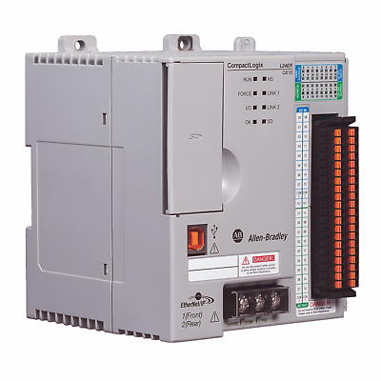
Figure 1: Allen Bradley PLC- CompactLogix L24ER-QB1B

Red Lion HMI: Model - CR1000-07000-00210 (7” HMI): User interface, manual overrides and fault detection [4] [5]
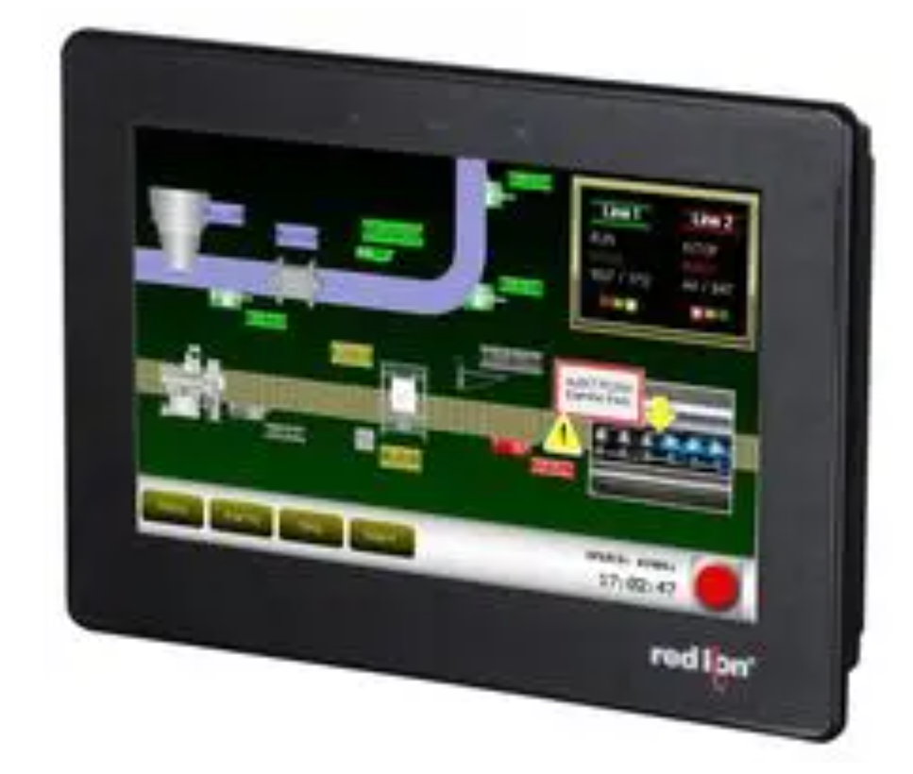
Figure 2: Red Lion HMI Screen
- Potentiometers: Accurately replicates potential environmental readings from any sensors

- 2 Stepper Motors Nema17: For controlling blind tilt and height

- 2 Stepper Motor Driver DM542: to feed the stepper motors with working pulse

- Peli Case: For safe transportation and containment.

- Cables and connector blocks

The components just listed are important to for project simulations.

Justifications for choices:

- Ladder logic: because of ease of use and is aligned with industry standards.
- Software: The Logix Designer and Crimson for their compatibility.

PLC Advantages:

They offer several key advantages:

- Industrial Strength- They are designed to work in demanding environments such as temperature variations, supply fluctuation interference that might disrupt delicate system control.
- Reliability- they are reliable when it comes to fault tolerances when compared to microcontroller/ single-board computer with file systems that can become corrupted.
- Scalability- Can monitor and control multiple systems at a time
- Safety- Built-in features like watchdog timers and fault diagnostic setups.

PLC Disadvantages and Workarounds:

PLCs do have their disadvantages:

- Complex Programming- It can be difficult to work with unfamiliar logic, thankfully the software has built in function blocks, instructions and ladder templates with available manual and online support to help with faster development.
- Cost: The price can be more expensive than microcontroller solutions but is an investment for long term use, minimal maintenance and scalability.

Software

Logix Designer

The RSLogix5000 (or Studio 5000) software suite was used for PLC programming. It supports ladder logic, structured text, and function block diagrams, providing flexible programming environments suited to industrial automation. Logix designer allows the developers to build scalable and modular programs that can be easily maintained and expanded.

Crimson 3.1
Crimson 3.1 is Red Lion’s graphical software platform used to configure and program Red Lion HMIs. It allows seamless integration with the PLC through Ethernet/IP or Modbus protocols and supports data mapping, real-time visualisation, alarms, and user input controls.
In this project, Crimson 3.1 was used to:
Create real-time displays of sensor readings.
Enable manual override controls for blind position and extractor fan.
Configure alert and diagnostic screens.
Test and simulate interface responses prior to deployment

CHAPTER 4 - DESIGN & IMPLEMENTATION

The chapter talks about the design and implementation of the prototype automated window bind system. It uses four potentiometers to simulate sensor readings into an Allen Bradley PLC programmed with the software Logix Designer v34 and a Red Lion HMI using Crimson v3.2.
The mechanical setup has a wooden square frame holding with the blinds hanging and a stepper motor on both sides of the frame on a ledge for support when pulling the strings to control the blind setting. Also a 24V fan to represent an extractor fan for temperature control aid.

Insert Figure 4.1: System Architecture Diagram

Description: A block diagram illustrating the interconnections between the PLC, HMI, potentiometers, stepper motors, reed switches, LEDs, and the extractor fan.

Hardware Design

Frame

Wooden frame with stepper motors and the PELI Case with the Programming hardware inside and HMI screen on the face of the lid.

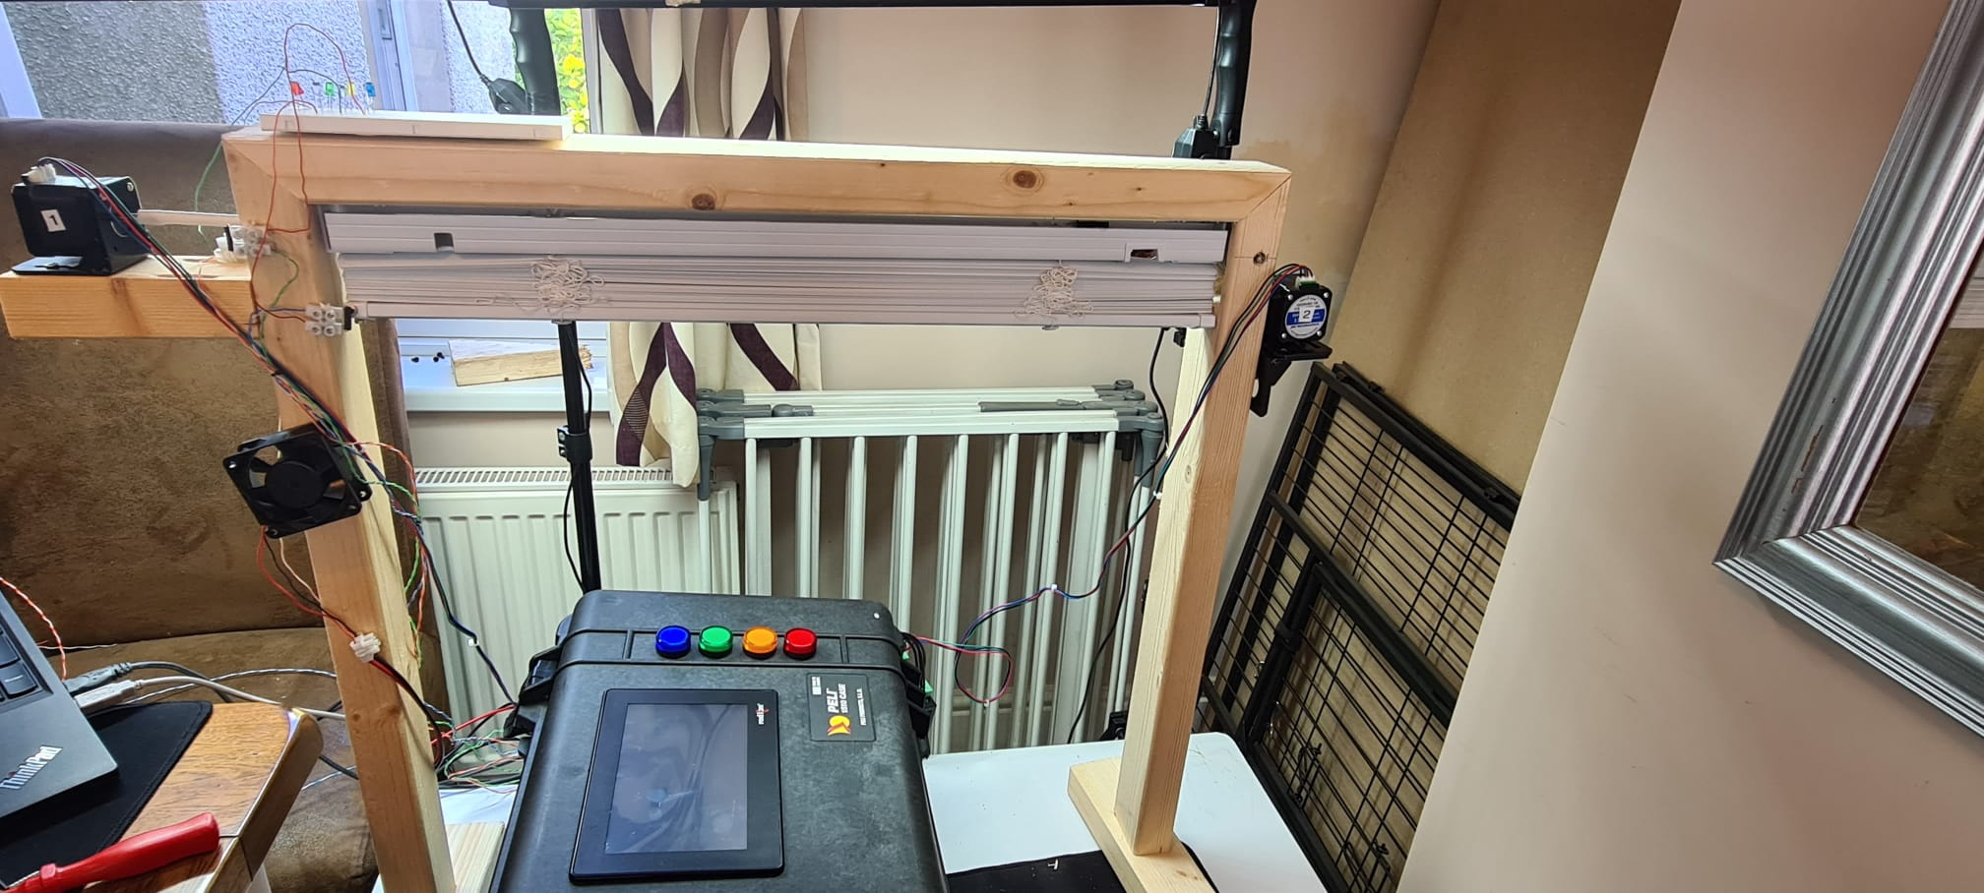
Figure 3: Wooden frame, shown with attached blind, 2 stepper motors and extraction fan (in the process of testing and improving system)

Stepper Motor 1

-Attachment to blind tilt mechanism:

Stepper Motor 1 is secured to a shelf piece on the outside of the frame with the shaft inserted into 3 core flex insulation, connected to the rod inside the top of the frame. The reason for the temporary connection is in case of the stepper motor continuously rotating during the testing of the programming, it is thought best to have flexibility in the mechanical section of the system.
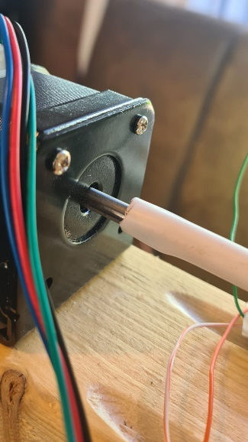
Figure 4: Motor Attachment to the rotating rode that pulls the tilt string

-Secured to shelf installed on the outside of the frame

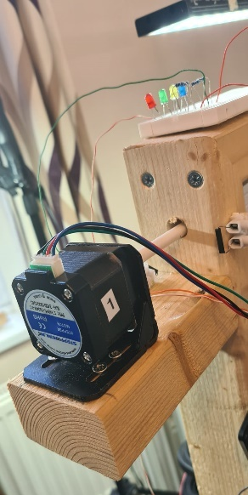
Figure 5:Motor 1 secured to the shelf on the outside of the wooden frame. With indicating LEDs triggered by limit switches.

Stepper Motor 2

-Attached to the right-hand side of the wooden frame with an L-shade bracket.

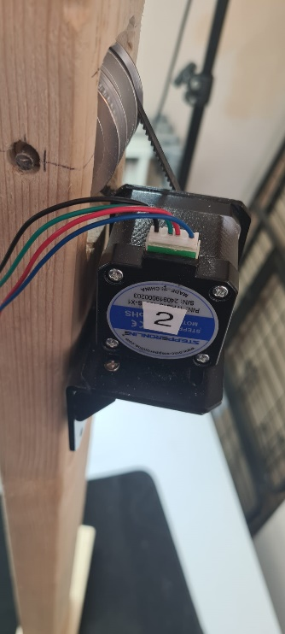
Figure 6: Stepper Motor 2 attached with an L bracket to the right handside of the wooden frame

-Attached with the gear wheel and belt to pull the height string of the blind, with little chance of tangles and loose string.

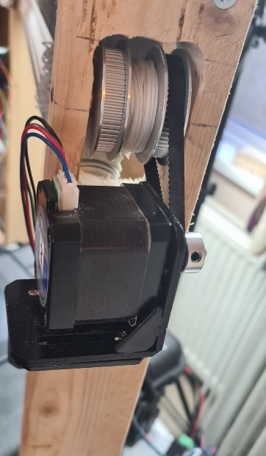
Figure 7: Stepper Motor 2 showing attached to the gear system that pulls the string adjusting the height of the blind

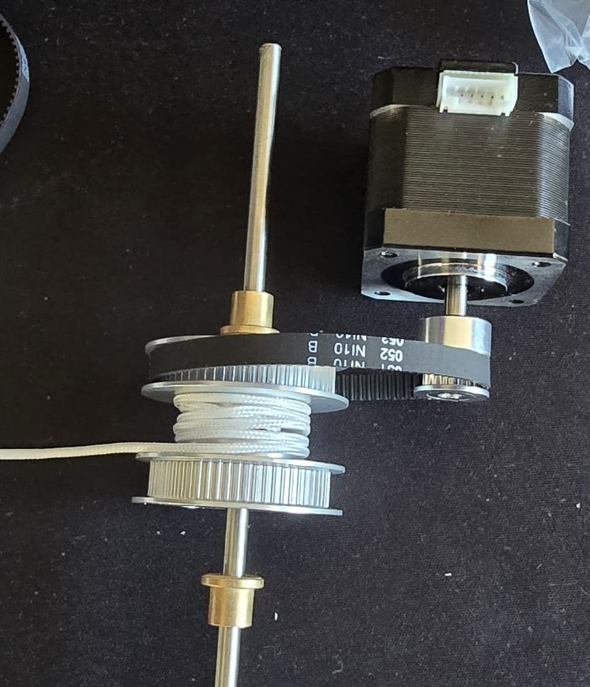
Figure 8: Synchronous wheel with teeth and belt used to wrap the pull the height string

PLC Logic and Control Flow

The system was programmed using ladder logic and Function Block Diagram in Logix Designer v34. The PLC logic included the following key elements:

Analog Voltage input data Scale

Reading analogue input from potentiometers and converting in the function block diagram sub-routine to scale the raw number, that Allen Bradley PLCs specifically translate input analogue ranges (see fig 7 below[27]):
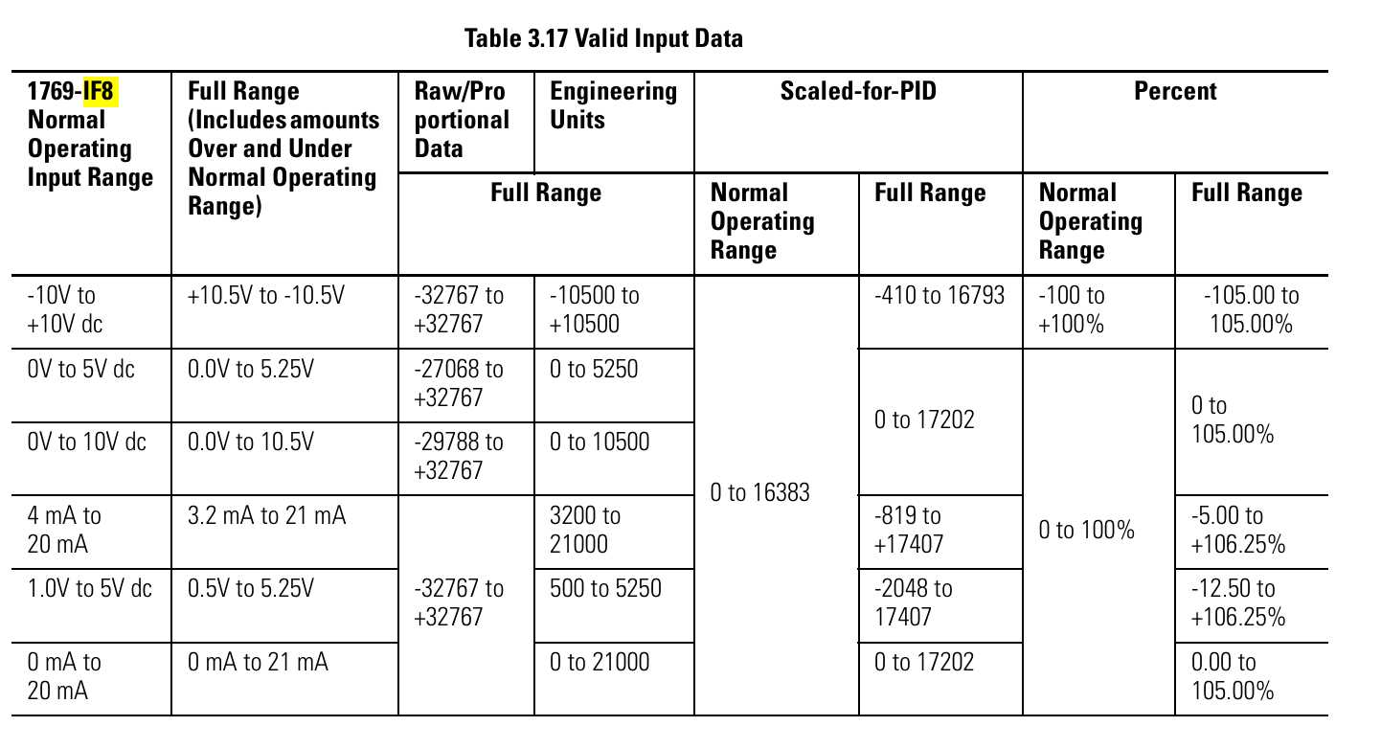
Figure 9: Shows the valid formats and min./max. data ranges for the 1769-IF8 Analog Input Module[27]
Using this table and examining the data input on the Logix Designer software when the PLC is online. Unfortunately, the Logix Designer Vers 34 software does not support the ladder logic instruction that supports scaling the raw values into scaled ranges eg. 0-100 instead of -29788 to +32767 (shown on the table above fig7 in the 0v to 10v row/ raw data).

So to rectify this, a new Subroutine, created under the main task, formatted to a Function Block Diagram[23] had to be created to use the SCL (Scale) instruction, see fig8 below:

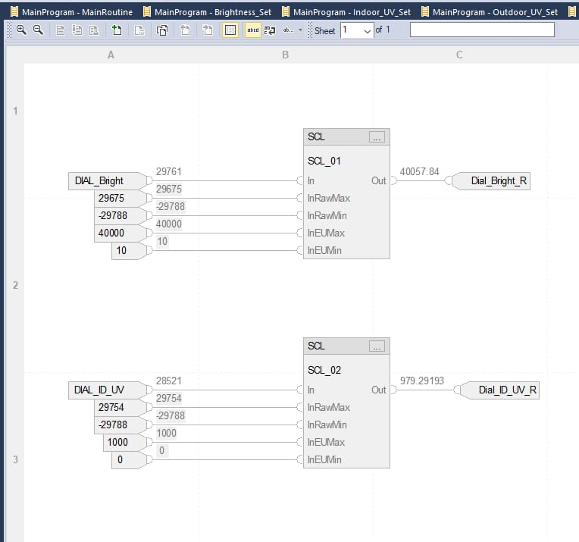
Figure 10: Function Block Diagram on Logix Designer showing analog input voltage scaled through the SCL instruction [23]
This shows the DIAL_Bright and DIAL_ID_UV tags on the left are receiving the raw data, the InRawMax, InRawMin, etc below it is the scale requested so the output translates into a suitable value range. Now the receiving data is suitable, the tags on the left can be used to link back to the ladder logic diagrams to program control to the motors, timers, switches etc.

Simulating Stepper Motor Pulses

To drive a stepper motors, a minimum threshold of frequency pulses are needed. Usually, when using PLCs systems there are motion control modules that can be purchased to have the best speed/ motion control but they can be quite expensive and arguably excessive for a light load i.e. blind control.

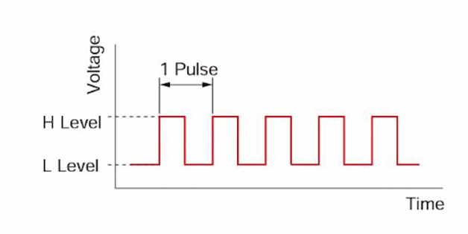
Figure 11: Pulse width modulation graph

Considering the stepper motor drive needs to have a feed similar to the voltage pulse shown above in fig11. By using just a digital output from the PLC flashing on and off would be a viable method.[22]

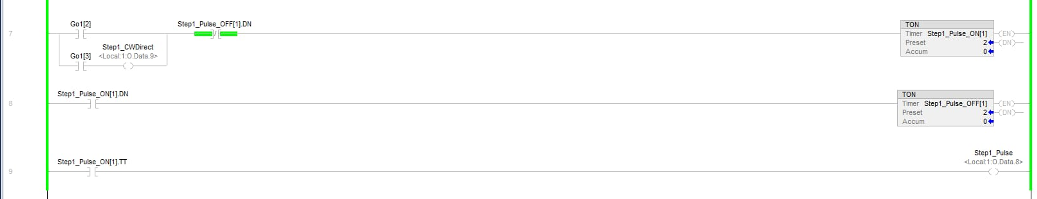
Figure 12: Logix Designer ladder logic showing stepper motor timer pulse control

The original purpose of the researched ladder logic [22] is to flash the LEDs on and off in a controlled manner at 500ms ON and 500ms OFF and repeat. The stepper motor sequence is set at 2ms ON and 2ms OFF which creates the even pulse feed to the driver feed.

HMI Screens and Interface Design

The Red Lion HMI was programmed using Crimson 3.2. It featured:
Real-time readings of the four simulated sensors.
Manual override buttons for blind tilt and height.
Calibration feedback via reed switch indicators.
Fan status display and temperature alert indicator.

Figure 4.8 – HMI Main Screen (insert screenshot)

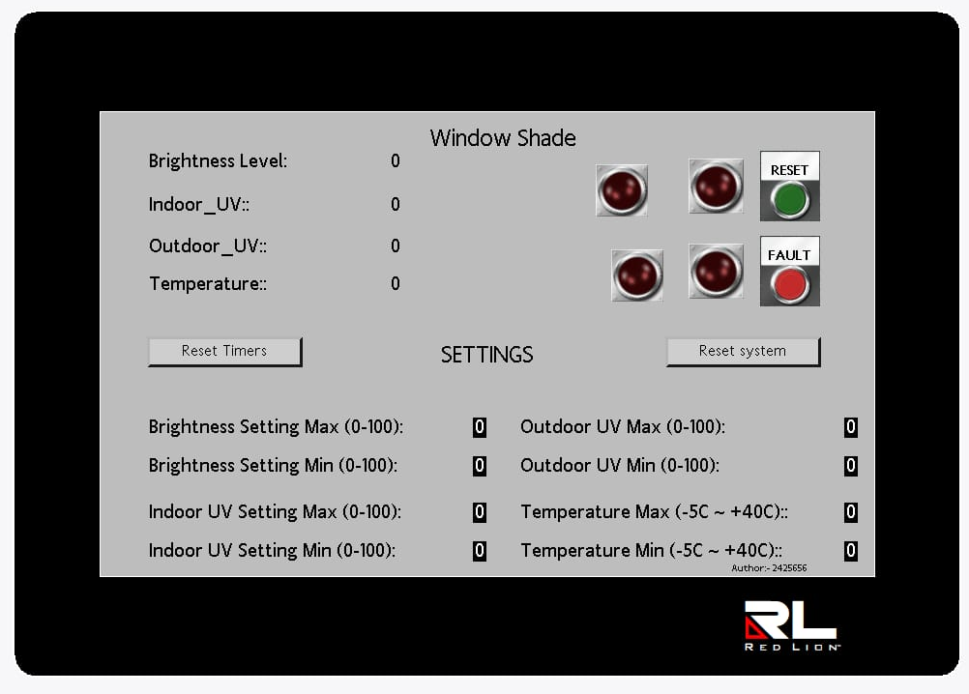
Figure 13: Image of the HMI screen showing LEDs the simulated values (top Left) from the potentiometers, reset timer and reset system buttons

Simulated Sensor Inputs

Potentiometers were used to mimic real sensor behaviour during development. Each potentiometer was connected to an analogue input on the PLC and scaled to represent the respective environmental parameter.

Potentiometer Data Input Rangle:

Potentiometer | Represents | Voltage Range | Scaled Sensor Value
P1 | Brightness | 0–10V | 0 –100%
P2 | UV Outdoor | 0–10V | 0 –100%
P3 | UV Indoor | 0–10V | 0 – 100%
P4 | Temperature | 0–10V | -5C – 40C

Table 1:Potentiometer Scale

Design Decisions

The main goal of this project was to create a window blind system that automatically adjusts itself according to changes in the environment including light levels UV rays and indoor temperature. To achieve accurate control during the early stages of development and testing we used potentiometers to mimic sensor inputs. This method allowed for adjustments to the control logic and hardware reaction without relying on changing real-world environmental conditions.

The system is meant for business or industrial settings and was created to be flexible and able to grow. The components were chosen because they are important for the industry and can easily work with Allen Bradley PLC hardware and Red Lion HMI technology.

Key decisions:

Logix Designer is popular for programming Programmable Logic Controllers (PLCs) because it works well with Allen Bradley systems and is widely used in many industries.

Using of Crimson 3. The HMI screen design is preferred because it works well with Red Lion displays.

Choosing stepper motor of precise control of the blind height and angle.

Wiring reed switches and LEDs in, to have physical limit and calibration references.

Adding a 24V fan to simulate an extractor fan.

Testing and Iterative Refinement

The system was tested using the action research model. Testing involved observing responses to potentiometer adjustments and confirming motor or fan activation. Any unexpected behaviours were corrected in ladder logic and retested.

Unit Testing
Validated motor operation in both directions.
Confirmed reed switch triggers and LED feedback.

System Testing

- Tested full adjustment cycle from sensor trigger to blind movement.
Verified calibration sequence at power-up.
Ensured fan activated when temperature exceeded set value.

Table Test Scenarios and Outcomes

Test | Condition | Expected Outcome | Result
T1 | UV High | Tilt blinds | Pass
T2 | Temp High | Fan activates | Pass
T3 | Manual Override | Blind moves to position | Pass
T4 | Power Cycle | System homes to switch | Pass

CHAPTER 5 – EVALUATION

Objectives vs Outcomes

The main aim of the project was to design, implement and evaluate the automated window shade controlled by a PLC, responding to changes in environment conditions

These outcomes were met:

- Simulate sensors input with potentiometers (simulating Brightness, outside and inside UV sensors and temperature)
- HMI providing user system and fault feedback

These outcomes were partially met:

- Program logic response – Full calibration on start-up to prove full function.

CHAPTER 6 - CONCLUSIONS AND RECOMMENDATIONS

Summary of Achievements
Key achievements include:

- Design and construction of a functional prototype incorporating a wooden frame, stepper motors, reed switches, and a simulated sensor input system using potentiometers.

- Development of PLC logic using Logix Designer software for real-time control, positioning logic and extractor fan activation.

- Configuration of a Red Lion HMI using Crimson 3.2 to allow user visualisation of simulated sensor inputs.

- Integration of calibration points through reed switches and LEDs to provide physical limit references

Key Takeaways

From the development and evaluation stages, several important insights were gained:

- Modular design is essential: Using potentiometers for simulated input allowed controlled, repeatable testing, proving valuable for debugging and logic refinement.

- HMI integration adds usability: The Red Lion interface provided a simple yet powerful means for users to visualise sensor data.

- PLC ladder logic is adaptable: The logic handled varied input conditions and allowed modification through successive testing iterations.

Recommendations for Improvement

Although the system performed well in certain areas, several other were identified for enhancement:

- Replace Potentiometers with Real Sensors

- Improve Mechanical Precision: Slack in the string and gearing mechanisms introduced minor inconsistencies in blind height adjustment.

CHAPTER 7 – REFLECTION

Technical Skills Gained:

PLC ladder logic, HMI development, sensor calibration.

Soft Skills:

Communication, troubleshooting, adapting to limitations.

Personal Growth:

Confidence in industrial system design, dealing with unexpected failures.

CHAPTER 8 – REFERENCES

[1] H. Jiang, “Research on electrical automation control system based on PLC technology Academic Journal of Engineering and Technology Science 6.3 (2023): 72-76. [Online]. Available: https://francis-press.com/uploads/papers/6NJITD7QGMXx0mKKEC0pnugiTSJ9xnSHERRdetBr.pdf

[2] W. Weizhen and J. Lai, “Application of PLC Technology in Industrial Automation Control,” in Proc. 3rd Int. Conf. Artif. Intell., Syst. Comput. Technol. (AISCT), Xinyu, China, 2019, pp. 182–186. [Online]. Available: https://webofproceedings.org/proceedings_series/ECS/AISCT%202019/AISCT037.pdf

[3] R. Morales-Herrera, A. Fernández-Caballero, J. A. Somolinos, and H. Sira-Ramírez, “Integration of sensors in control and automation systems,” J. Sensors, vol. 2017, Art. no. 6415876, Mar. 2017. [Online]. Available: https://doi.org/10.1155/2017/6415876

Red Lion HMI: Model - CR1000-07000-00210 (7” HMI)

[4] Red Lion Controls. (n.d.). CR1000 7" HMI Panel, 800 × 480 pixels [Online]. Available: https://uk.farnell.com/red-lion-controls/cr10000700000210/hmi-panel-7in-800-x-480-pixels/dp/2915471

[5] Red Lion Controls, “CR1000 7” HMI Panel Datasheet,” Part datasheet, 2019. [Online]. Available: https://www.farnell.com/datasheets/2633007.pdf

Fan

[6] NMB Technologies Corp., “2410ML-05W-B60-B00 DC Fan” [Online]. Available: https://www.micro-semiconductor.com/products/NMB-Technologies-Corp/2410ML-05W-B60-B00
[7] NMB Technologies Corp., “2410ML Series DC Fan Datasheet,” Part datasheet, [Online]. Available: https://www.micro-semiconductor.com/datasheet/7b-2410ML-04W-B79-E00.pdf
[9] 15Writers. (n.d.). “Research Onion Explained” [Online]. Available: https://15writers.com/research-onion/
[10] SolisPLC. (n.d.). “PLC Programming Comparison Instructions – GRT (Greater Than)” [Online]. Available: https://www.solisplc.com/tutorials/plc-programming-comparison-instructions-grt-greater-than

[11] Rockwell Automation, “1771 I/O Modules Technical Data,” Publication 1771-TD036_-EN-P, 2012. [Online]. Available: https://literature.rockwellautomation.com/idc/groups/literature/documents/td/1771-td036_-en-p.pdf

[12] PLC247.com. (n.d.). “MicroLogix 1400 – Stepping Motor Control Tutorial” [Online]. Available: https://plc247.com/micrologix-1400-stepping-motor-control-tutorial/#google_vignette

[13] Rockwell Automation, “Timer On Delay (TON) Instruction,” FactoryTalk Design Studio Help [Online]. Available: https://www.rockwellautomation.com/en-gb/docs/factorytalk-design-studio/current/contents-ditamap/instructions/instruction-set/timer-and-counter-instructions/timer-on-delay--ton-.html

[14] Skysmotor, “DM542 Stepper Motor Driver Datasheet,” [Online]. Available: https://www.skysmotor.co.uk/images/upload/File/DM542.pdf

[15] Rockwell Automation, “1769 Compact I/O Modules Installation Instructions,” Publication 1769-IN067_-EN-P, [Online]. Available: https://literature.rockwellautomation.com/idc/groups/literature/documents/in/1769-in067_-en-p.pdf

[16] SolisPLC. (n.d.). “CompactLogix 1769-IF8 Analog Input Module RSLogix 5000 Configuration Tutorial” [Online]. Available: https://www.solisplc.com/tutorials/plc-programming-compactlogix-1769-if8-analog-input-module-rslogix-5000-configuration-tutorial

[17] SolisPLC. (n.d.). “PLC Sequencer Programming Tutorial on SQI/SQO Instructions in RSLogix 5000” [Online]. Available: https://www.solisplc.com/tutorials/plc-sequencer-programming-tutorial-on-sqi-sqo-instructions-in-rslogix-5000-ladder-logic

[18] Rockwell Automation, “Sequencer Output (SQO) Instruction,” Studio 5000 Logix Designer Help [Online]. Available: https://www.rockwellautomation.com/en-us/docs/studio-5000-logix-designer/37-00/contents-ditamap/instruction-set/sequencer-instructions/sequencer-output--sqo-.html

[19] Rockwell Automation, “Logix5000 Controllers I/O and Tag Data Programming Manual,” Publication 1756-PM004_-EN-P, 2012. [Online]. Available: https://literature.rockwellautomation.com/idc/groups/literature/documents/pm/1756-pm004_-en-p.pdf

[20] SolisPLC. (n.d.). “Building a Retentive Timer Using TON Instruction in RSLogix Studio 5000” [Online]. Available: https://www.solisplc.com/tutorials/building-a-retentive-timer-using-ton-instruction-in-rslogix-studio-5000

[21] Rockwell Automation, “Logix5000 Controllers Common Procedures Manual,” Publication 1756-RM003_-EN-P, [Online]. Available: https://literature.rockwellautomation.com/idc/groups/literature/documents/rm/1756-rm003_-en-p.pdf

[22] Contact and Coil, “Patterns of Ladder Logic Programming – Flasher” [Online]. Available: http://www.contactandcoil.com/patterns-of-ladder-logic-programming/flasher/

[23] SolisPLC. (n.d.). “PLC Function Block Programming for Analog Input Scaling – FBD Tutorial” [Online]. Available: https://www.solisplc.com/tutorials/plc-function-block-programming-for-analog-input-scaling-fbd-tutorial-in-rslogix-5000

[24] SolisPLC. (n.d.). “RSLogix 5000 Analog Input Programming, Wiring, Scaling Tutorial” [Online]. Available: https://www.solisplc.com/tutorials/rslogix-5000-analog-input-programming-wiring-scaling-tutorial-for-plc-analog-input-signal-example#scaling-an-analog-signal-in-rslogix-5000-through-cpt

[25] Rockwell Automation, “Configure an Event to Trigger an Action – Button Behaviors,” Studio 5000 View Designer Help [Online]. Available: https://www.rockwellautomation.com/en-us/docs/studio-5000-view-designer/10-00/studio-5000-view-designer-help-ditamap/-st5k--view-designer-help/configure-an-event-to-trigger-an-action/button-behaviors.html

[26] Rockwell Automation, “Logix 5000 System Redundancy White Paper,” Publication LOGIX-WP003_-EN-P, [Online]. Available: https://literature.rockwellautomation.com/idc/groups/literature/documents/wp/logix-wp003_-en-p.pdf

[27] Rockwell Automation, “MicroLogix 1400 Programmable Controllers User Manual,” Publication 1769-UM002_-EN-P, [Online]. Available: https://literature.rockwellautomation.com/idc/groups/literature/documents/um/1769-um002_-en-p.pdf

[28] Red Lion Controls, “Crimson 3.x Allen-Bradley L5K Plus Driver Integration” [Online]. Available: https://support.redlion.net/hc/en-us/articles/5673999588749-Crimson-3-x-Allen-Bradley-L5K-Plus

[29] SolisPLC. (n.d.). “PLC Programming Comparison Instructions – GRT (Greater Than)” [Online]. Available: https://www.solisplc.com/tutorials/plc-programming-comparison-instructions-grt-greater-than

[30] SolisPLC. (n.d.). “PLC Programming Comparison Instructions – LES (Less Than)” [Online]. Available: https://www.solisplc.com/tutorials/plc-programming-comparison-instructions-les-less-than

APPENDICES

