PG1 - FULL RESEARCH PROPOSAL

This form is to be completed by both the student and supervisory team within THREE months for full-time students and SIX months for part time students, after the commencement of the research degree or Part Two. Return the completed form to the Academic Office pgresearch@uwtsd.ac.uk.

Student Details
Student Family / Surname:

Student Given / First name:

Student Number

UWTSD Institute |  | IMH
UWTSD Partner Institute (if appropriate)
Start Date
Mode of Study |  | Part time ☐ | Full time ☒
PhD  by Research | PhD  Practice Based | PhD by  Published Works | Professional Doctorate  (including DBA, DProf, Ed D) | MPhil by Research | MPhil  Practice Based
☐ | ☐ | ☐ | ☒ | ☐ | ☐
MA by Research | MSc by Research | MRes
☐ | ☐ | ☐

Proposed Research

Current Proposed Title (20 / 30 words):
CHINESE ONLINE LITERATURE: A CRITICAL ANALYSIS OF CUSTOMER ENGAGEMENT AND VALUE PERCEPTION FROM THE PERSPECTIVE OF VALUE CO-CREATION IN THE AGE OF DIGITALIZATION AND GLOBALIZATION
Background & Context (approx. 500 words)

Social Context and Practical Research Background

COVID-19 pandemic drives quarantines and stay-at-home mandates go with people's daily life worldwide. Social and physical isolation transfers human life to the internet and virtual space in an unprecedented way, and thus promotes various technology-based activities, such as economical transaction, education, and entertainment (King et al,2020; Onyema et al, 2020; Meng et al, 2021; Chow, 2021). The changes in the way of people communicate and interact call for further online involvement and engagement. Chinese internet literature implies, for the its consumer, the possibility of higher participatory creativity, stronger sociality, and more customer engagement at the virtual communities. In some degree, Chinese web novels are products co-designed and finally co-produced by both providers and consumers. Thus, this dissertation focuses on the customer’s online experiences and perceived value as well as interaction between service providers and customers in the consuming process of Chinese internet literature, trying to investigate the factors that influence those customers’ individual well-being, such as initiatives and self-motivated labour.

Academic Research Context
Online literature in the West is very marginal with a specific audience and little cultural impact (Hocks, 2015; Tian, 2019), but in China, it attracts a large proportion of the total population and is a very mainstream culture (CNNIC 2010). Thus, online literature has become one of the main driving forces of the cultural and creative industries (Tian, 2019, p.6).

In terms of the origin of consuming literature in China, it can trace back to the centrally controlled system of cultural production introduced by the Chinese government, which restricted access to literature that was not considered politically sound or morally uplifting, such as fantasy, romance novels or ghost stories (Ren, 2012, p.118). Michel Hocks (2015) further interprets the commercialization of Chinese literature in the 1990s as a consequence of "the withdrawal of state support for the literary system" and "the relaxation of state control over publishing houses" (p.27). With the emergence of internet technology, Internet literature has become a new label full of potential, one through which regular publishers, ambitious amateur writers, and IT businesses can collectively hype and market their cultural products (Kong, 2005, p.180).

Regarding the research context, from the beginning of the 21st century, various literature on relationship marketing began to examine the issue of "customer engagement" (Kumar,2013). Pansari and Kumar argue that customer engagement is the mechanism by which users add value to the company, either directly or indirectly (2017, p.295). If this participatory nature is taken a step further, the "producer-consumer" emerges. The concept of "prosumer" first appeared in chapter 10 of Alvin Toffler's The Third Wave, published in 1980, as a synthesis of Producer and Consumer, signalling that the clear-cut boundaries between producer and consumer would be broken down and that the two roles would be merged into one (Toffler, 1980). A chapter in Wikinomics is dedicated to "prosumer", distinguishing between "customer-centricity" and "prosumer", emphasizing that the former means " companies decide what the basics are and customers get to modify certain elements ", while the latter means " customers participate in the creation of products in an active and ongoing way. " (Tapscott and Williams, 2008, p.125-126). In a digital content marketing strategy that emphasizes customer engagement and user-generated content, the emergence of virtual communities of consumers and producers highlights the value creation process through information sharing and collaboration between users and businesses (Tapscott and Williams, 2008, p.148). In the era of Industry 4.0, as customers can participate as equals in product development and economic activities, attaching importance to the consumer community will be a strategic shift for business entities to remain competitive in the next decades, and not be eliminated in the future (Tapscott and Williams, 2008, p.149).

Customers become “prosumers” by cocreating goods and services rather than simply consuming the end product. This brings the theory of co-creation of experience and value co-creation, which will be mentioned below.

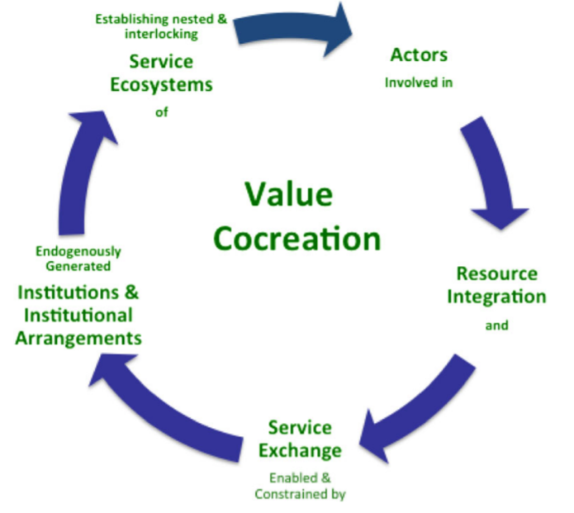

Figure 1: The narrative and process of S-D logic (Source: Vargo S L, Lusch R F., 2016)

Prahalad and Ramaswamy, in 2000, formally introduced the concept of value co-creation, which they believe refers to the co-creation of value by producers and consumers, with the co-creation experience of consumers being the basis of value (Prahalad and Ramaswamy). Later on, Vargo and Lusch introduced this concept into their S-D logic (service dominated logic), which is a shift from viewing the value creation concerning linear value chains, where physical products with embedded value are provided to waiting markets for consumption, to taking them in terms of dynamic and processual, value-creating constellations (Normann and Ramirez,1993; Ng and Vargo, 2018) or systems (Maglio and Spohrer,2008; Vargo and Lusch, 2011; Ng et al., 2011). In their study, Vargo and Lusch revised the propositions of S-D logic to 11 and extracted 5 axioms from them, in which Axiom Status 2 (PF6) highlights the network relationship perspective. As a result, the study of value co-creation theory gradually shifted to a pluralistic as well as a network perspective and evolved from a service-dominant logic to a service science and service ecosystem (Vargo and Lusch, 2016).

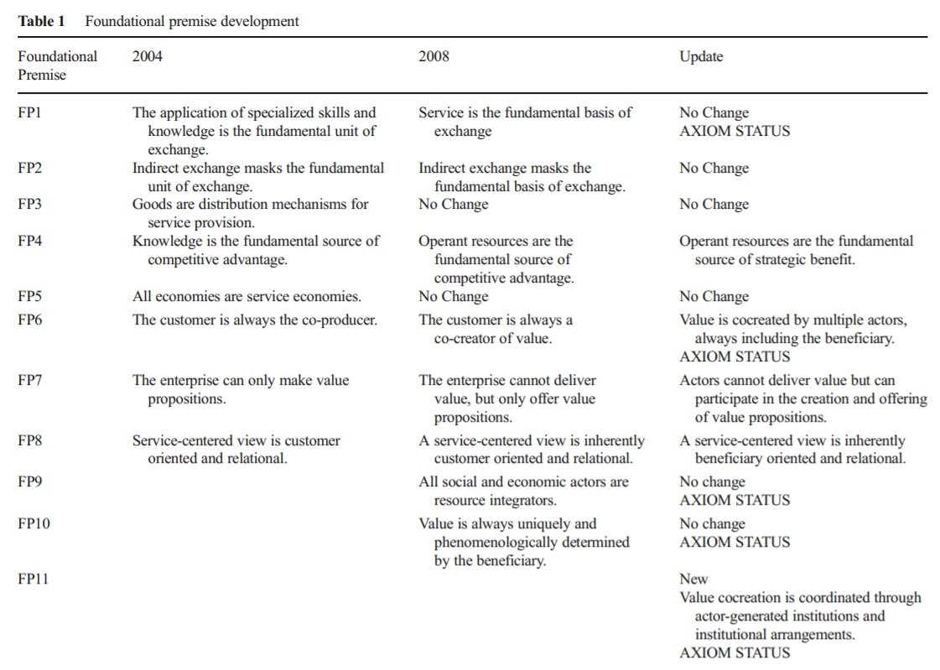

Figure 2: Foundational Premise development (Source: Vargo, S. L. and Lusch, R. F., 2016)

Notably, the network has a purpose, not in the sense of collective intent but rather in the sense of individual survival/wellbeing. These theories fits well as we try to understand how wellbeing of individual is both contingent on and contributes to a dynamic network, in which the resources of the actors are being continually updated (Vargo and Lusch, 2017). This “purposeful” activity moves away from the primacy of conflict and toward the primacy of cooperation and coordination, which will be a major underlying theme for the next 10 years (Vargo and Lusch, 2017).

Conceptual Model:
This research attempts to combine business administrative concepts(S-D logic and value co-creation) with social science theories (Baudrillard’s consumerism and Meyrowitz’s media theory), but make the latter take the position of being less prominent auxiliary notions.

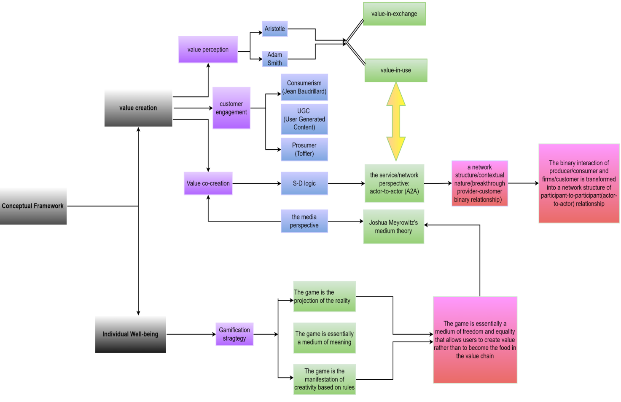
Figure 3: conceptual framework of this research
Aims and Objectives (approx. 250 – 500 words)
Chinese internet literature production is characterized with strong socialization and high engagement. In this industrial context, market logic and commercial incentives have tended to bring literary production more into line with popular culture, and many worry that Chinese literature is suffering "the loss of its humanistic spirit" (Wang, 2001; Kong,2005). For instant, Hocks (2015) is less optimistic about this production and claims that the new literary area provided by the Internet is not a space for "high" culture. Yet one could also argue that the Internet, undoubtedly, has heavily influenced the literary industry in terms of its production and business patterns (Wang,2017) and has opened up space for greater diversity in public discourse and a kind of cultural pluralism (Kong,2005). After all, sharing and co-production is the essence of Internet literature (Zhao and Jiang, 1999), declaring that the Internet "provides people with unprecedented opportunities to express themselves freely" (Wang, S.,2000) and that it has "altered the whole process of literary production and communication" (Wang, M., 2000). Essentially, Chinese online literature is not about a kind of highbrow art, but about a sort of high engaged cultural and literary production, emphasizing consumers' participation and co-production in the process of value creation. This value-in-context (value-in-use) meaning of value concerns service-dominant logic (Vargo and Lusch, 2008) and service science.

Service science is the study of service systems and of the co-creation of value within complex constellations of integrated resources (Spohrer et al., 2007, 2008). It centres on the participants, processes, and resources that interact to create value in service systems. So value and value creation are at the heart of service and are critical to understanding the dynamics of service systems and to furthering service science, while Vargo and Lusch’s S-D logic is foundational to service science and to the study of value-creation in service systems (Maglio and Spohrer, 2008; Spohrer et al., 2008). When value creation is seen from S-D logic, the dyad of producer–consumer fades away and all participants involve in a complex value creation process and contribute to this co- creation of value for themselves and for others (Vargo, S. L. et al., 2008).

Vargo and Lusch’s literature of conceptualization (including S-D logic and 11 fundamental premises) is waiting for being investigated by extended empirical research in a variety of industrial contexts and disciplines (Wibowo, et al., 2021). Chinese online literature is such a typical industrial context which can be used to test this new logic, and bridge theory and practice on a realistic basis. Therefore, the aim of the doctoral research is to figure out what the value is for consumers of Chinses online literature and how this value is co-created through interaction and integration of resources within and among service systems. To achieve these aims, the following objectives were established.

1) To explore what experiences of Chinese web-novel consumers have in the process of consuming online literature.
2) To figure out how customers have been empowered to engage in value co-creation in the co-production of Chinese web-novels in the era of Web 2.0.
3) To analyse what role of direct interactions for value co-creation opportunities in the digital community of consumers of Chinese web-novel.
4) To understand what the implication and significance is for consumers to activate their subjective initiative and self-motivated labour through co-production of web novels online, which concerns the issue of individual well-being.

Proposed plan of work including timetable
Proposed plan of work

This plan should indicate that the research will be completed by the end of the fee paying period (the minimum period of candidature.

Planned Development (e.g. submission of form, completion of chapter, submission of thesis) | Target Date
Submission of research proposal | Jan. 2022
Literature review (drafts) | Feb. 2022
Literature review (final) | Aril. 2022
Methodology | Jul. 2022
Data collection | August. 2022
Data analysis | Nov. 2022
Discussion and Findings | Jun. 2023
conclusion | Aug. 2023
Footnotes, Appendices and references | Sep. 2023
Submission of dissertation | Sep. 2023

Proposed methodology (approx. 500 words):
In terms of the positioning of this research, the philosophical underpinning lies in social constructionism. By stressing the intersubjectivity and interaction between the researcher and subjects, as well as between subjects themselves, this research grounds in the perspective of interpretivism (social constructivism is often described as interpretivism) (Denzin and Lincoln, 2011; Metrens, 2019), with phenomenological design involved.

Research philosophical assumptions:
Since this research targets exploring customers’ immersive experience coming from strong engagement, which drives them to take an initiative to take part in value co-creation along with producers. The researcher has to understand and interpret the meaning constructed by these participants against their recognition of the world (Creswell and Poth, 2016).

Regarding paradigm interpretive framework, this research adopts social constructionism:
1) Ontologically, this research tries to integrate Joshua Meyrowitz’s medium theory, which has combined Marshall McLuhan's work on changes in media of communication and Erving Goffman's work on social life(Lindlof,1996), to media scenarios change human's behavior mode and the composition of social reality. In terms of the viewpoint of the nature of reality, this research targets the customers who share the same interpretative community. The recognition of value or value creation is a subjective process. The creativity emerges and proceeds in the virtual world, where is a meaning-laden space.
2) Epistemologically, S-D logic, the critical theoretical framework of this research, emphasizes the interactive nature of value creation, upholding value is co-constructed by multiple participants, always including the beneficiary (the customer) (Vargo and Lush, 2016). The researcher regards that customer engagement has been brought about by common experiences and interactions with one and another in the process of perceived value constructing and upgrading. Therefore, the researcher plans to get to understand the interaction by stepping into the Chinese web novel community and contacting those consumers as an "insider".

3) Axiologically, the researcher believes that consumers of Chinese online literature have composed a typical community in which it is easier to understand the significance of these more community, more constructive, and much more free economic participation activities, as well as the relationship between brand communication scenarios, stakeholder behaviors, social media, and virtual communities, as well as relevant ethical issues in the process of value co-creation in the digital era.

Research methodological approach:
The transcendental phenomenology is an appropriate methodological approach since this research aims to describe and explain consumers’ personal experiences and customers’ engagement in reading and consuming web novels, the literary products, involving individual sensemaking and recognition towards the consuming process and commercial activities.

This academic inquiry is in the stance of Straussian school, “allowing the guidance of predefined research questions and pre-existing theoretical frameworks” (Su, 2017, p.22). Specifically, this descriptive study will be a positivist qualitative one, using both inductive and deductive reasoning, incorporating diverse forms of data sets coming from semi-structured interviews of customers, a website exploring, observations, videos, and online documents. This combination of diverse forms of data tries to create a "thick description", capturing both rich context and detailed content of the targeted phenomena (Geertz, 1973), which can enhance external validity, or in the terminology of qualitative inquiry, transferability.
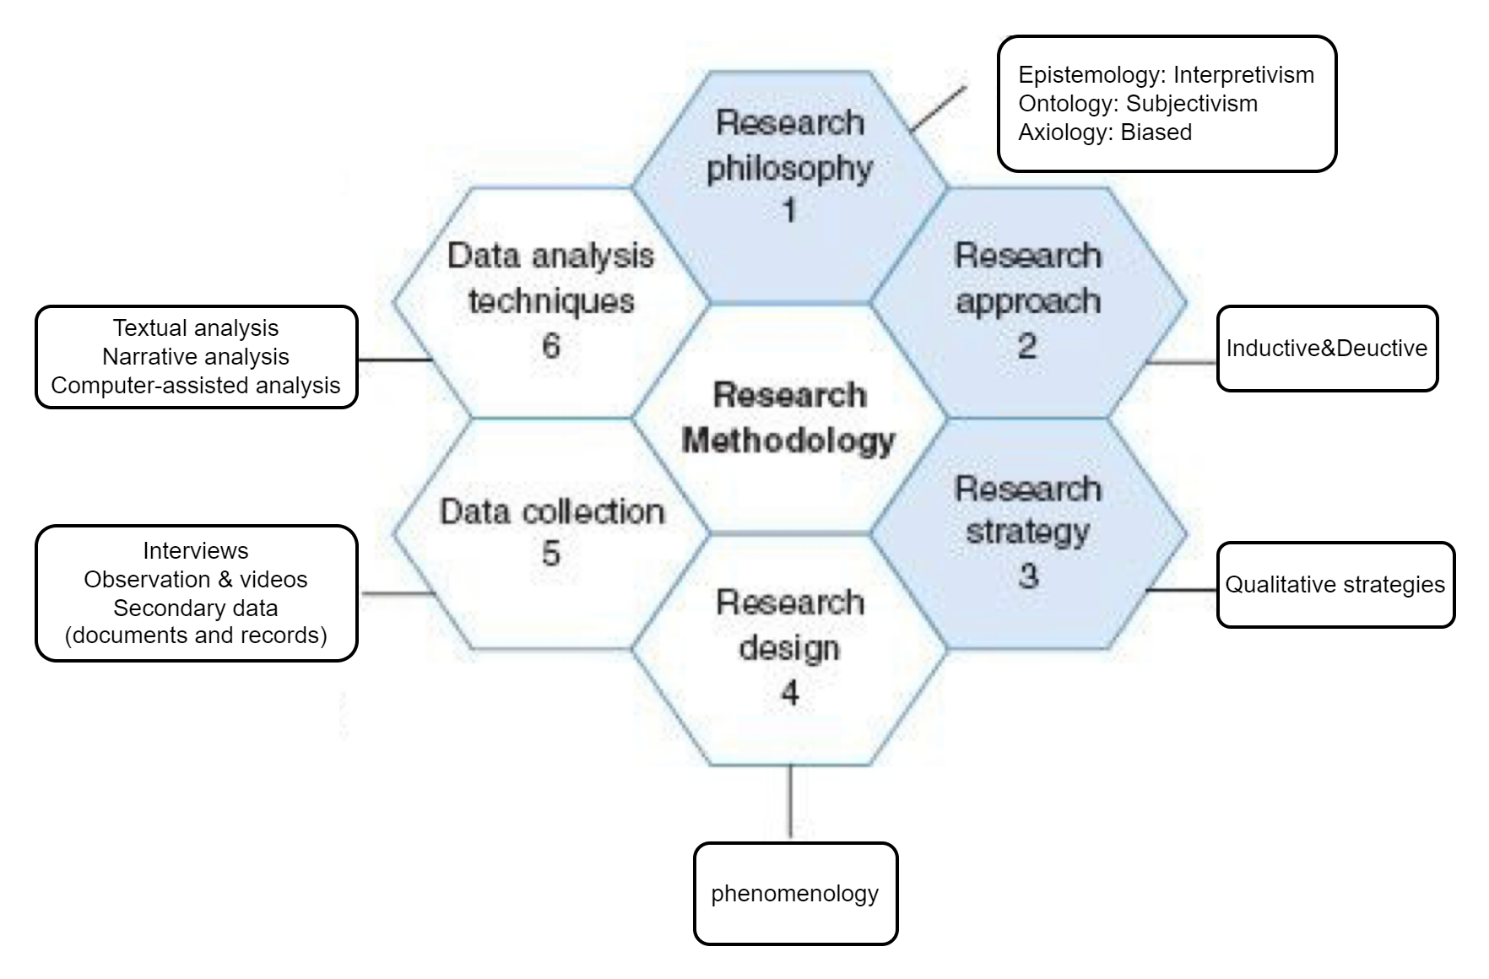
Figure 4: Research Methodology of this research, adapted from “The Honeycomb of Research Methodology” (Wilson, 2014)

Introductory bibliography:
Chow, A.R. (2021) ‘Why TIME is Launching a New Newsletter on the Metaverse’, Time. 18 November. Available at: https://time.com/6118513/into-the-metaverse-time-newsletter/ (Accessed: 8th December 2021)

CNNIC (2010) ‘Report on users of online Chinese literature’, China Internet Network Information Centre.

Creswell, J. W. and Poth, C. N. (2016) Qualitative inquiry and research design: Choosing among five approaches, Sage publications.

Denzin, N. K. and Lincoln, Y. S. (2011) ‘Introduction: The discipline and practice of qualitative research’, The SAGE handbook of qualitative research, Thousand Oaks, CA: Sage publications.

Geertz, C. (1973) ‘Thick Description: Toward an Interpretive Theory of Cultures’, The Interpretation of Culture: Selected Essays, New York: Basic Books, pp. 3-30.

Hockx, M. (2015) Internet literature in China. New York: Columbia University Press.

Hollebeek, L. D.and Macky, K. (2019) ‘Digital content marketing's role in fostering consumer engagement, trust, and value: Framework, fundamental propositions, and implications’, Journal of Interactive Marketing, 45, pp.27-41.
King, D. L., et al. (2020) ‘Problematic online gaming and the COVID-19 pandemic’, Journal of Behavioral Addictions, 9(2), pp.184-186.

Kong, S. (2005) Consuming literature: Best sellers and the commercialization of literary production in contemporary China. CA:Stanford University Press.

Kumar V. (2013) Profitable customer engagement: Concept, metrics and strategies. India: SAGE Publications.

Lindlof, T. (1996) ‘No More Secrets: A Retrospective Essay on Joshua Meyrowitz's No Sense of Place’, Journal of Broadcasting & Electronic Media, 589, pp.589–596.

Lusch, R. F., Vargo, S. L., and Gustafsson, A. (2016) ‘Fostering a trans-disciplinary perspective of service ecosystems’, Journal of Business Research, 69(8), pp. 2957–2963.

Maglio, P. and Spohrer, J. (2008) ‘Fundamentals of service science’, Journal of the Academy of Marketing Science, 36(1), pp. 18-20.

Meng, J., Liu, Y. and Keane, M. (2021) ‘Restoration of mobility through mobile health: the digital health code as a technology of governance’, Asian Journal of Communication, 31(5), pp.391-403.

Mertens, D. M. (2019) Research and evaluation in education and psychology: Integrating diversity with quantitative, qualitative, and mixed methods. CA: Sage publications.

Moustakas, C. (1994) Phenomenological research methods. Sage publications.

Ng, C.L.I. and Vargo, S. L. (2018) ‘Service-dominant (S-D) logic, service ecosystems and institutions: bridging theory and practice’, Journal of Service Management, 29(4), pp.518-520.

Ng, I.C.L., Maull, R. and Smith, L. (2011) ‘Embedding the new discipline of service science’, in Demirkan, H., Spohrer, J. and Krishna, V. (eds). The Science of Service Systems. Springer.

Normann, R. and Ramirez, R. (1993) ‘From value chains to value constellations: designing interactive strategy’, Harvard Business Review, pp. 65-77.

Onyema, E. M., et al (2020) ‘Impact of Coronavirus pandemic on education’, Journal of Education and Practice, 11(13), pp.108-121.

Pansari A, Kumar V. (2017) ‘Customer engagement: the construct, antecedents, and consequences’, Journal of the Academy of Marketing Science, 45(3), pp. 294-311.

Prahalad, C. K. and Ramaswamy, V. (2000) ‘Co-opting customer competence’, Harvard business review, 78(1), pp.79-90.

Prahalad, C. K. and Ramaswamy, V. (2004) ‘Co‐creating unique value with customers’, Strategy & Leadership, 32, pp.4-9.

Ren, X., and Montgomery, L. (2012) ‘Chinese online literature: creative consumers and evolving business models’, Arts Marketing: An International Journal, 2(2): pp. 118-130.

Su, N. (2017) ‘Positive Qualitative Methods’, in Cassell, C., Cunliffe, A.L. and Grandy, G. (eds.) The SAGE handbook of qualitative business and management research methods. Sage, pp.17-31.

Spohrer, J. and Maglio, P. P. (2008) ‘The emergence of service science: Toward systematic service innovations to accelerate co-creation of value’, Production and Operations Management 17(3), pp.1–9.

Spohrer, J., Maglio, P. P., Bailey, J. and Gruhl, D. (2007) ‘Steps toward a science of service systems’, Computer 40, pp.71–77.

Spohrer, J., Vargo, S. L., Caswell, N. and Maglio, P. P. (2008) ‘The service system is the basic abstraction of service science’, Proceedings of the 41st Annual Hawaii International Conference on System Science, January, pp. 104.

Tian, X. (2019) ‘Fantasy is More Believable: The Shadow Civil Sphere in Chinese Online Fiction’, in Alexander, J., et al.(eds.) The Civil Sphere in East Asia. Cambridge: Cambridge University Press, pp. 167-187.

Toffler, A. (1980) The third wave. New York: Bantam books.

Vargo, S.L. and Lusch, R. F. (2016) ‘Institutions and axioms: an extension and update of service-dominant logic’, Journal of the Academy of marketing Science, 44(1), pp. 5-23.

Vargo, S. L. and Lusch, R.F. (2008) ‘Service-dominant logic: Continuing the evolution’, Journal of the Academy of Marketing Science 36 (1), pp.1-10.

Vargo, S. L., Akaka, M. A., and Vaughan, C. M. (2017) ‘Conceptualizing value: A service-ecosystem view’, Journal of Creating Value, 3(2), pp.1–8.

Vargo, S. L., Maglio, P. P., and Akaka, M. A. (2008) ‘On value and value co-creation: A service systems and service logic perspective’, European management journal, 26(3), pp. 145-152.

Vargo, S. L., and Lusch, R. F. (2017) ‘Service-dominant logic 2025’, International Journal of Research in Marketing, 34(1), pp.46-67.

Vargo, S.L. and Lusch, R.F. (2011) ‘It’s all B2B … and beyond: toward a systems perspective of the market’, Industrial Marketing Management, 40(2), pp. 181-187.

Wang, M. (2000) ‘Preface to Zhongguo wangluo yuanchuang zuopin jingxuan’ ,in Meng, W. and Renfa, Z. (eds.) Selection of the Best Internet Literature. Changchun: Shidai wenyi chubanshe,2000.

Wang, S. (2000) ‘Zhe zhihou yiqie jiang bian’ (Everything Will Be Different from Now On), in Cun, C. (ed.) Wo ai shang na ge zuo huai bu luan zhong de nuzi (Falling in Love with that Sedentary Woman). Guangzhou: Huacheng chubanshe,2000, pp.291.

Wang, Xiaoming (2001) ‘Kuangye shang de feixu’ (Ruins in the Wilderness), in Fanhua, M. (ed.) Jiushi niandai wencun (Collections of Writings on Literature from the 1990s), vol.1., Beijing: Zhongguo shehui kexue chubanshe, pp.27–41.

Wang, Y. (2017) ‘Globalization of Chinese online literature: Understanding transnational reading of Chinese Xuanhuan novels among English readers’，Inquiries Journal, 9(12). Available at: http://www.inquiriesjournal.com/articles/1716/globalization-of-chinese-online-literature-understanding-transnational-reading-of-chinese-xuanhuan-novels-among-english-readers (Accessed: 30th December 2021)

Wibowo, A. J. I., et al. (2021) ‘17 years of service-dominant logic: Vargo and Lusch’s contributions’, Business: Theory and Practice, 22(2), pp.482-492.

Wilson, J. (2014) Essentials of business research: A guide to doing your research project. Sage.

Zhao, Chengyu, and Shuyuan, Jiang(1999) ‘Wangluo wenxue: xin wenming de haojiao haishi xin ping zhuang jiu jiu’ (Internet Literature: A Clarion Call for a New Civilization or Old Wine in New Bottle), Zhonghua dushu bao, 2nd December.

Facilities and resources available for the investigation: please indicate if you expect to need any special resources
Facilities and Resources:
This research needs to be conducted with the support of libraries, Nvivo software, an online research assistant service provided by the university (CUIT) where the researcher works, and "Moby Dick", a comprehensive service platform dedicated to serving Chinese pan-Internet companies going overseas.

The researcher has full rights to access these facilities, including resources of two libraries from CUIT (both physical and virtual) and UWTSD (virtual); The software, Nvivo, is ready in computer; The relevant editors, the author who have composed articles concerning the latest commercial news of “Wuxia World” and Chinese web novels in “Moby Dick”, have been selected and added in the researcher’s Wechat; research assistant service is available 24 hours a day.

During the epidemic, there is no need to travel long distances to attend the necessary academic and related business meetings, as most meetings are already wired live within China. For example, the researcher had attended the 2021 Global Traffic Conference (GTC2021) held in Shenzhen city on October 29th this year online in China.

Ethical considerations:
In the process of data collection, the researcher plans to do a focus group arrangement and semi-structured interviews among the customers of Chinese web novels. Since web novels are mainly popular among young people, and the researcher is a teacher working in a university in China, she has a relatively easier channel to get access to those consumers. That those university students are participants having the capacity to consent to their participation makes data collection possible.

Regarding the website exploring, "Wuxia World", the most famous web novel website in the North American market, can be taken as the primary database where the researcher can dig out effective documents, such as customers' comments and communication at the reading forum. "Deathblade”, the senior co-operator with this website and prosumer, has a channel on Youtube with self-publishing, which is another important source of data. All of these secondary data are public and free with lower ethical risks.

The biggest challenge for the researcher lies in obtaining consent from the founder of “Wuxia World” to accept an interview. At present, the researcher has successfully joined his WeChat circle of friends. The results are as follows: confirmed the identity of Deathblade's senior collaborator; obtained his preliminary permission to be interviewed.

Intellectual Property IP
It is anticipated that Intellectual Property (IP) will be produced as a result of this research.
Tick √
 | YES | NO
Is the IP already subject to a separate agreement with a third party (e.g. employer, sponsor or external funder)? If so please provide details below | ☐ | ☑
Is the research dependent upon background IP owned by:  If so, please provide details below | UWTSD  ☐ | A third party  ☐
Text box will expand

Tick √
I understand that: | YES | NO
If any party other than the student is likely to be involved in the development of IP a separate IP agreement will be needed and it may be necessary for the student to assign the IP rights to the University. | ☐ | ☑
If there are no third parties involved in the creation of the IP the student is deemed to own the IP, however should the student wish to commercially exploit their IP and require the assistance of the University to do so, they will be required to assign their IP to the University. https://www.uwtsd.ac.uk/iiced/protecting-innovation-and-creativity---intellectual-property/ | ☐ | ☑
Student Signature

Signature or Print Name: |  | Date:  31st Dec, 2021

Supervisory Team

Has the student proposed a viable research project that is appropriate for this programme that should be supported by the Institute?
Supported: ☐ Not Supported: ☐

Authorisation

Director of Studies | Signature or Print Name: | Date:
Institute Manager of Research Degrees | Signature or Print Name: | Date:

