ACDB 4011: FLAME TEST
POTENTIAL HAZARD:
Chemical | Hazards
Hydrochloric acid solution  (1 M HCl) | 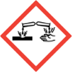  Causes severe skin burns and eye damage.    Harmful if swallowed.
Barium chloride (BaCl₂) | 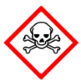  Acute toxicity (oral, dermal, inhalation), category 3.  Irritant.
Calcium chloride (CaCl₂) | Causes serious eye irritation.
Lithium chloride (LiCl) | Causes serious eye irritation.  Harmful if swallowed.  Causes skin irritation.
Strontium chloride (SrCl₂) | Serious eye damage.
Strontium nitrate (Sr(NO₃)₂) | 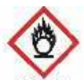  May intensify fire; oxidiser  Harmful if swallowed. Causes serious eye irritation. Can cause respiratory irritation
Potassium chloride (KCl) | Causes serious eye irritation.
Potassium nitrate (KNO₃) | May intensify fire; oxidiser
Sodium chloride (NaCl) | Not classified as a hazardous chemical
Copper chloride (CuCl₂) | Harmful if swallowed or in contact with skin.  Causes skin irritation and serious eye damage.  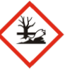  Very toxic to aquatic life with long-lasting effects.

FLAME TEST

AIM OF THE EXPERIMENT: A flame test is a procedure used to determine qualitatively the presence of certain metals in chemical compounds. The aim of today’s experiment is to:
- perform a flame test on different metal salts and identify metal ions responsible for each colour by comparing it to the colour in the reference table.
- provide an explanation of the observations based on scientific evidence and understanding. Evaluate the suitability of this method for metal identification.

INTRODUCTION:
Many metal ions, when heated, produce a flame of distinctive and unique colour that can be used to identify such metal atoms.
Atoms can exist in a ground state and an excited state. In the natural, ground state the electrons in the atom occupy the lowest energy levels. If a specific quantized amount of energy is provided by heat or electricity, the electrons from the ground level are promoted to a higher energy level, called an excited state. The excited electrons do not leave the atom! As they cannot remain in the excited state, they rapidly fall back from higher energy level to lower. In doing so they release the previously gained energy and emit photons of light that can be seen as a coloured flame. This instantaneous and complete transition is represented in Figure 1.
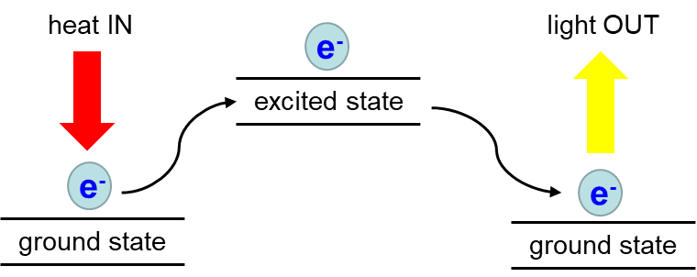
Figure 1: The transition of an electron from/to the ground state through the excited state initiated by the absorption of heat and resulting in the emission of light.
Since metal ions can emit a photon of unique colour corresponding to specific wavelengths in the visible spectrum of light (Figure 2), emission spectra are used as a tool to identify the elements by their distinctive colours (Table 1).
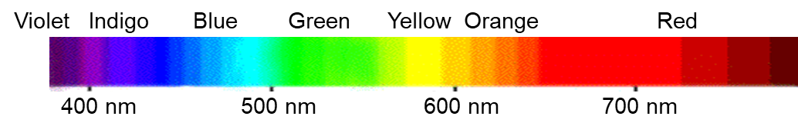
Figure 2: Colours and wavelengths of visible electromagnetic spectrum.
The energy difference between the high energy level and the low energy level is related to the frequency of the emitted light (Eq. 1).
$E=h ×f$ Eq. 1

where ΔE is the energy difference between the energy levels, h is a Planck constant (h = 6.63 × 10⁻³⁴ Js), and f is a frequency of light in Hz (s⁻¹). Frequency, , and the wavelength, λ are inversely proportional (Eq. 2):
$c=f ×$ Eq. 2
where c = 3.0 × 10⁸ ms⁻¹ is the constant speed of light.
The colour of the light depends upon the metal in the salt.
metal ion | Flame colour | Metal ion | Flame colour
barium, Ba²⁺ | GREEN | potassium, K⁺ | LAVENDER
calcium, Ca²⁺ | ORANGE | sodium, Na⁺ | YELLOW
lithium, Li⁺ | RED/PINK | copper, Cu²⁺ | BLUE/GREEN
strontium, Sr²⁺ | RED
Table 1. Metal ions and corresponding flame colours.
This technique of using certain chemical compounds to colour flames is widely used in pyrotechnics to produce the range of colours seen in fireworks displays.

PROCEDURE
Put on the lab coat, safety goggles, and gloves. Make sure that long hair is tied.
In this experiment, you will identify metal ions in 8 unknown salt samples by observing the colour each of them gives to the flame. Please note that one sample contains a mixture of sodium and potassium that can be identified using the cobalt glass.
IMPORTANT: Record all your observations, in the data sheets at the end of this script.
Lab tools and supplies:
- Bunsen burner
- Heat-resistant mat
- Matches
- Metal rod
- 1 M solutions of unknown metal salts labelled A-H
- Beaker with 1 M HCL
- Beaker with deionised water (DI water)
- Blue cobalt glass

Procedure:
- Set up a Bunsen burner on the surface of the heat-resistant mat. Light it and open the air vent to obtain a non-luminous flame with two blue cones. Ensure that the safety yellow flame is on when the Bunsen burner is not in use.
- To clean the wire, dip it into the 1M HCl and heat it in the hottest part of the flame. This step is usually repeated several times until no colour is shown. If the flame’s colour changes, there is still an impurity on the wire. Dip it again in the acid and return it to the flame until the wire is clean.
- Dip the wire in DI water and heat as before to remove any residue of HCl from the cleaning step. Repeat steps 3 and 4 before/after each test!
- Cool down the wire and dip it in the solution of an unknown metal salt/mixture. Heat the wire in the hot part of the flame. Record your observation of the coloured flame in the table below. Use the cobalt glass to identify the mixture of sodium and potassium.
- Repeat steps 2-4 for all other unknown samples.
- Record the colour of the flame for DI water and 1 M HCl.
DATA SHEET to RECORD OBSERVATIONS, CALCULATIONS and RESULTS
STUDENT’S NAME: ____________________________________________________
PARTNERS’ NAMES: ____________________________________________________

REPORT IS DUE MARCH 14th (21st with DD), 2025 submitted via Moodle

Observations and Identification:
Complete the table below. Based on the observed colour of the flame and Table 1, identify the metal ion in each unknown salt. Using the electromagnetic spectrum in Fig 2, estimate and report with the appropriate unit the wavelength for each observed colour. Identify the solution containing mixture of sodium and potassium:
Unknown metal salt | Colour of the flame | Identity of metal | Wavelength
DI water |  | ------ | ------
1 M HCl |  | ------ | ------
A
B
C
D
E
F
G
H

LAB REPORT:
- Introduction (100-150 words)
  - State the purpose of the experiment.
  - Write the hypotheses that are going to be tested.
  - Define the variables and/or terms and show the equations that will be used in the report.

- Results (150-250 words)
  - Present the experimental data in a clear and organised manner.
  - Use tables, graphs or figures to illustrate the results effectively (if relevant).
  - Briefly describe the key findings and patterns observed in the data.

- Discussion (150-250 words)
  - Interpret the experimental results and explain their significance.
  - For light emitted from TWO metals of your choice, explain the relationship between wavelength, frequency and energy.
  - Describe the relevance of the experiment to OME and relate the findings to the existing scientific knowledge and literature (OME specifically).
  - Where else, besides of fireworks, the phenomenon observed in this experiment can be applied?
  - Address any limitations or potential sources of error in the experiment.

- Conclusions (50-100 words)
  - Summarise the main findings and evaluate whether they support the hypothesis or not.
  - Suggest potential directions for future research based on the findings.

- References (IEEE)

- Appendix
  - Materials and methods (50-150 words)
    - List all materials and equipment.
    - Describe the experimental procedure in a detailed and stepwise manner. (You can use bullet points).
    - Why do you use cobalt glass?
      - Scan of the original data sheet

When calculations are part of the report, you are expected to use the correct number of significant figures and show all units !

MARKING:

Engagement with Literature Skills – max 15%
Knowledge and Understanding Skills – max 20%
Cognitive and Intellectual Skills – max 25%
Practical Application Skills – max 25%
Transferable Skills – max 15%

For more details on what criteria will be used, please refer to the assignment brief in Moodle.

