Sustainability within the hotel industry

Student ID:2117337
Student name: Antonela costiuc
Module code: BMIH4006
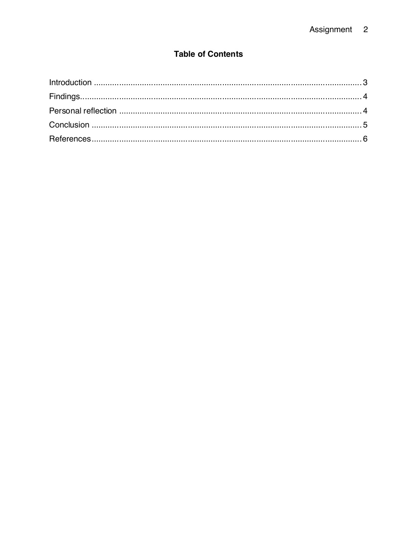
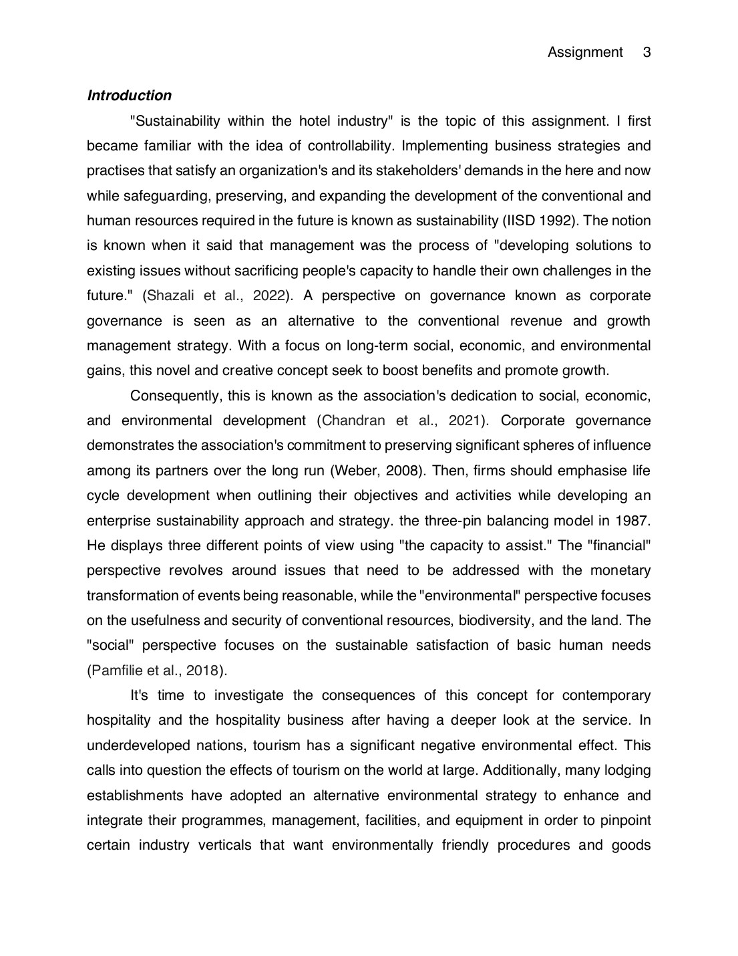
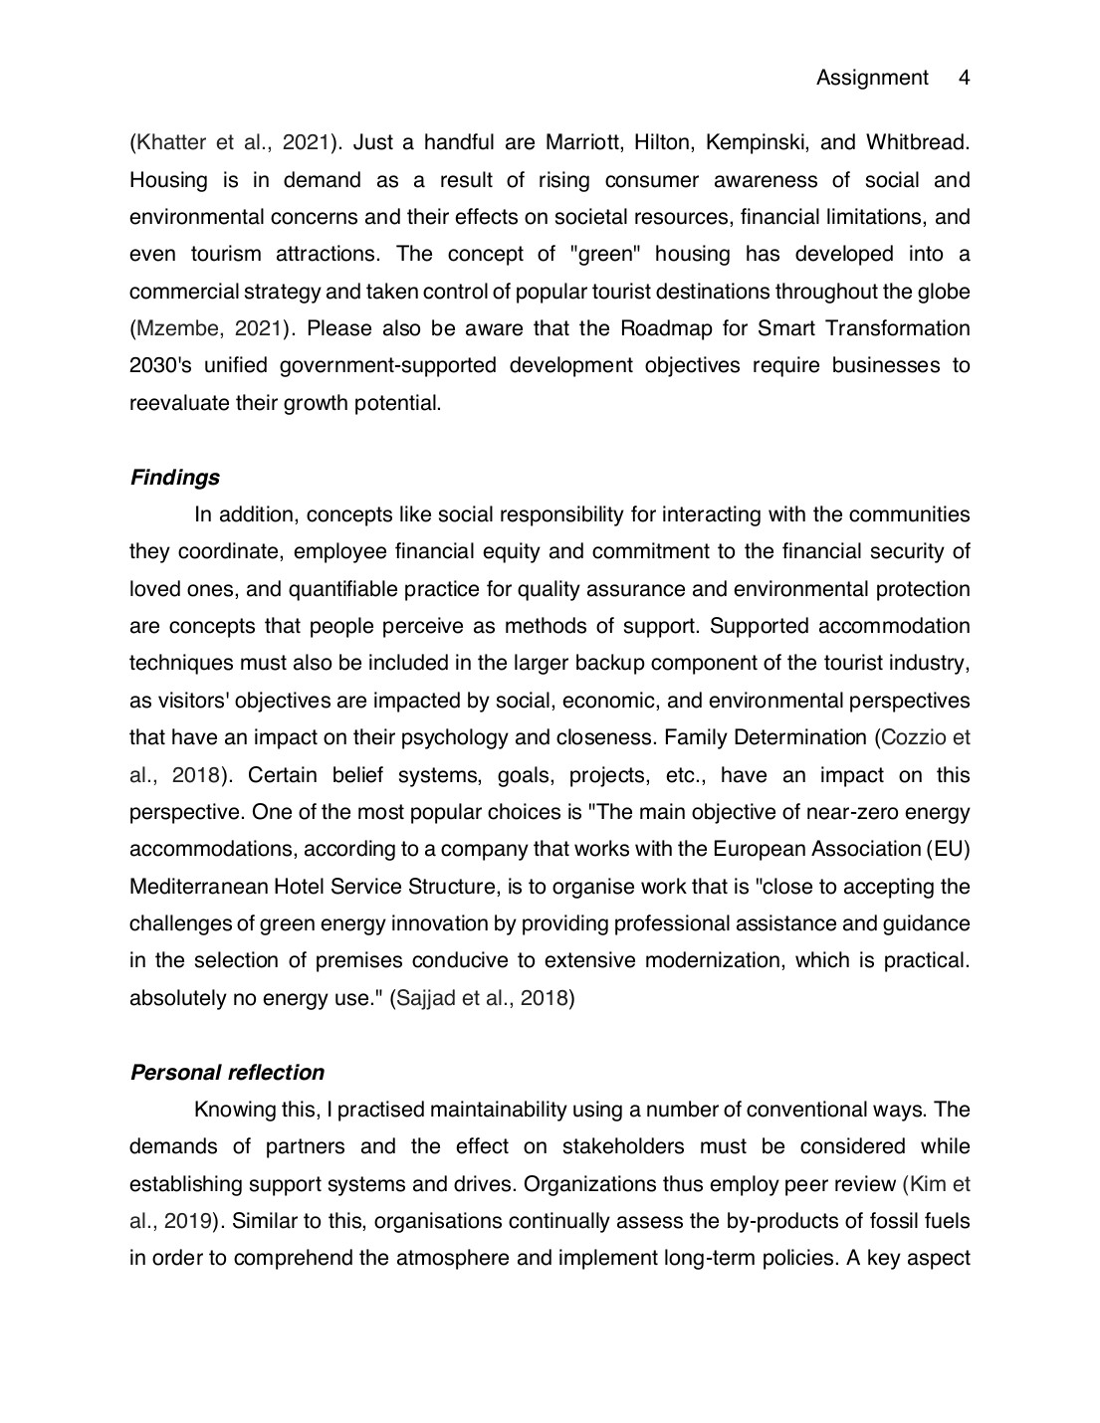
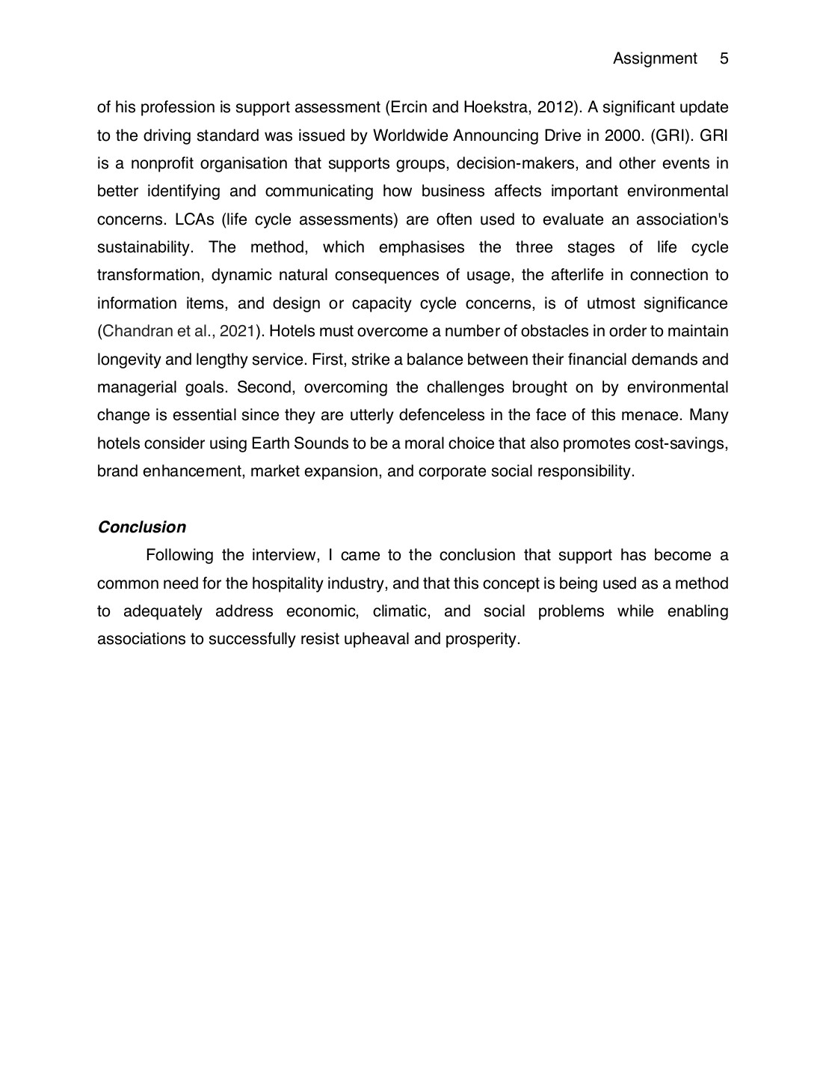
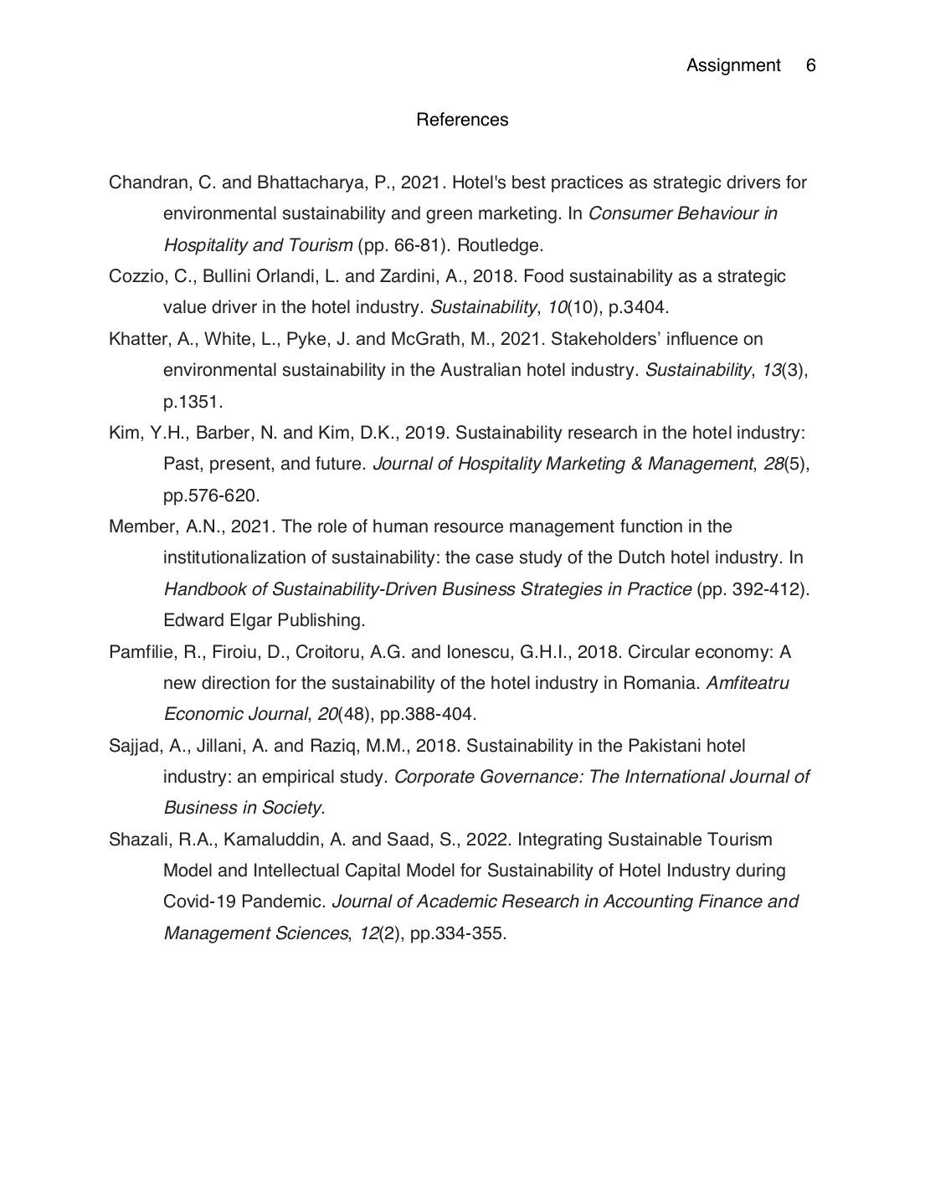

7882
GRADEMARK REPORT
FINAL GRADE /0 | GENERAL COMMENTS  Instructor
PAGE 1
PAGE 2
PAGE 3
PAGE 4
PAGE 5
PAGE 6

