Digital Skills – DS2 Scenario 3
Student ID: 2541234
FreshBite Meals

Fresh, Healthy & Delicious

Breakfast
Porridge Bowl — £3.80
Breakfast Wrap — £4.20
Fresh Fruit Pot — £2.50
Lunch
Chicken Salad Box — £6.00
Veggie Pasta Bowl — £5.50
Soup of the Day — £3.90
Snacks
Granola Bar — £1.80
Greek Yoghurt Cup — £2.20
Banana Bread Slice — £2.50
Drinks
Fresh Orange Juice — £2.80
Iced Coffee — £3.20
Herbal Tea — £2.00
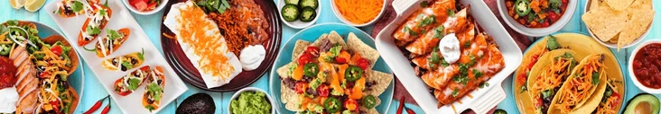

Digital Skills Reflection
Why I chose Microsoft Word
I chose to create the menu in Word because it is less suited to creating a graphic design of a menu. Software like Adobe or Canva could produce a much more visually creative menu. However, I chose Word because it offers all the features needed to create a clear, well-organized, and professional one-page menu. This allows for formatting of text, tables, titles, and also spacing and page layout while remaining simple to use. For this task, Word was a practical choice because the main objective was to present the menu in a clear way rather than creating a very detailed graphic design.

Digital tools and features used
To create the menu, I used several features available in Microsoft Word, including:
- Headings to separate each menu category
- Font formatting such as bold text and different font sizes and types to highlight essential information
- Page margins and spacing to improve readability
- Simple colours to make the menu more visually appealing

Why the design is right
Although Microsoft Word is not the right application to create a professional graphic design for a menu, it allowed me to create a clear, organized, and customer-friendly menu. Keeping the design simple so that the information is as easy to read as possible while still giving the menu a clean and professional look. The headings help separate each section, and the consistent formatting makes the document look very well-organized.

Evaluation
Overall, I believe that the final menu meets all the brief’s requirements and thus includes all the menu items and prices provided by the manager, uses clear headings, and presents the information in a professional format. The end result is very easy to read, professional, and suitable for a local food business.

