Module Name: Software Solution for Business

Module Code: (ACCA4026_LON)

Group Number: 4

Assignment Title: Component 1- Coursework: Portfolio

Student Name: MUHAMAD SOBAAN

Student ID: 2436564

Lecture’s Name: RAJEEV NATH

Date of Submission: 15/12/2025

Introduction
Software solutions for business help organisations carry out daily tasks more efficiently by using digital tools for communication, data management, and collaboration. They improve productivity, support better decision-making, and allow businesses to adapt to modern working practices such as remote and hybrid work (Laudon and Laudon, 2023).


Fig 1: e-commerce website template developed using Shopify [1]
E-commerce website builders are platforms that allow users to create, customise, and manage online stores without needing extensive coding skills. These tools typically provide a combination of drag-and-drop design interfaces, integrated payment systems, inventory management tools, security features, and marketing capabilities. As a result, even users with minimal technical experience can launch a professional online store. More advanced users and developers, on the other hand, can take advantage of extensible features, plugins, APIs, and custom code options to build highly tailored e-commerce experiences.

The contemporary market for e-commerce software is diverse, offering solutions that range from fully hosted, all-in-one services to open-source systems that provide maximum flexibility and control. Hosted platforms, such as Shopify or BigCommerce, handle infrastructure, security, hosting, and updates for the user, significantly reducing technical complexity. These solutions appeal to businesses seeking convenience and reliability, as well as those wanting to rapidly scale without managing backend operations. They often include built-in tools for payment processing, abandoned-cart recovery, analytics, marketing automation, and multi-channel retailing across social platforms, marketplaces, and in-person point-of-sale systems.

WooCommerce:
In contrast, open-source or self-hosted solutions such as WooCommerce or Magento (Adobe Commerce) allow businesses to retain full control over their website’s codebase, hosting environment, and data. These platforms are highly customisable and suitable for organisations with specific functional requirements or those wishing to avoid the ongoing subscription fees common in hosted solutions. However, they usually require more technical expertise and may involve additional responsibilities such as security management, plugin updates, and server maintenance. Despite these challenges, open-source solutions remain popular due to their flexibility, wide ecosystem of extensions, and the ability to create unique digital experiences that align closely with business needs.

The importance of selecting the right e-commerce builder cannot be overstated. The chosen platform directly influences a business’s operational efficiency, online store performance, customer experience, and long-term growth potential. Each solution offers a different balance of usability, scalability, cost, design flexibility, and control. Therefore, understanding the strengths and limitations of contemporary e-commerce website builders is vital for informed decision-making.

This report examines two widely used and contemporary e-commerce solutions Shopify and WooCommerce to evaluate their features, advantages, and challenges within the current digital commerce landscape. By comparing these platforms, businesses can gain clearer insight into which system aligns best with their strategic goals and technical capabilities.

Task 2. Mind-map of contemporary software applications:
a. Description of Mind Mapping and Its Benefits in Business Operations
Mind mapping is a visual technique used to organise information, present ideas, and illustrate relationships between concepts. It typically begins with a central theme placed at the centre of the diagram, with branches extending outward to represent subtopics, categories, or related ideas. Each branch may then divide into smaller branches, creating a structured yet flexible representation of complex information. Unlike linear note-taking which lists ideas in order mind maps mirror the way the brain naturally processes information by using associative thinking, visual cues, and hierarchical structure. This makes them particularly useful for problem-solving, planning, and exploring ideas in a more intuitive format.
One of the key benefits of mind mapping in business is that it enhances clarity when dealing with complex tasks or multifaceted problems. By visually displaying the connections between different pieces of information, mind maps help teams break down challenges into manageable components. This can be especially helpful during strategic planning, process improvement initiatives, or brainstorming sessions where large amounts of information must be analysed quickly.
Mind mapping also improves creativity and innovation. Because ideas are not restricted to linear order, users are free to generate and connect concepts more organically. This often leads to new insights or solutions that may not emerge through traditional notetaking. For example, marketing teams may use mind maps to explore customer needs, design campaigns, or plan new product launches.
In addition, mind mapping supports better communication and collaboration within organisations. When used in group meetings, mind maps help visualise discussions in real time, ensuring that all team members share a common understanding of the topic. This reduces miscommunication and promotes collective decision-making. Digital mind-mapping tools such as Mind Meister, Mind, and Microsoft Visio—allow remote teams to collaborate simultaneously, which is increasingly important in hybrid and globalised workplaces.

Mind maps also improve productivity by helping workers structure tasks and workflows. Employees can use them to outline project stages, prioritise responsibilities, or organise research. Because the visual layout simplifies complex information, mind maps support faster learning, easier recall, and more efficient planning. Overall, the combination of visual structure, flexibility, and collaborative potential makes mind mapping a valuable tool for modern business operations.
Mind Map of Contemporary Software Applications Used in Daily Business Operations
To visually represent the range of contemporary software applications used in daily business operations, a mind map is included below. The mind map provides a structured overview of key software categories that support communication, project management, finance, customer relations, human resources, data management, e-commerce, and cybersecurity. Visual representations such as mind maps help improve understanding by showing relationships between different business systems in a clear and organised manner (Marr, 2021).

Figure 1: Mind Map of Contemporary Software Applications for Business Operations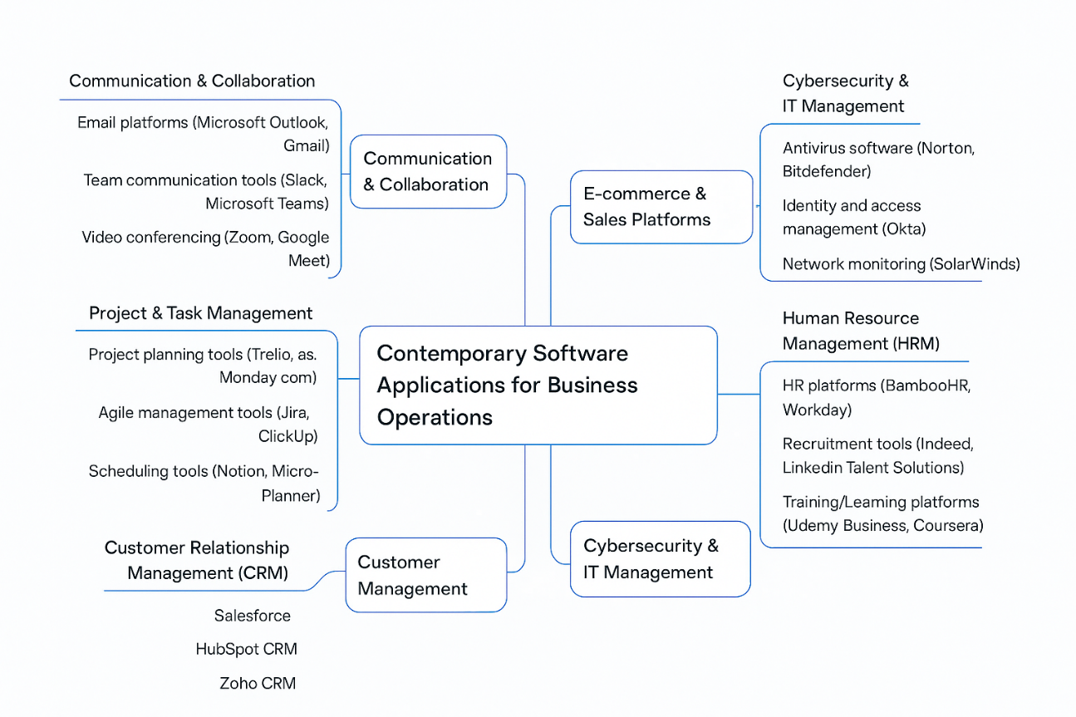

Figure 1 illustrates the central role of contemporary software applications in business operations, with major functional areas branching out from a central concept. These areas include communication and collaboration tools, project and task management systems, finance and accounting software, customer relationship management platforms, e-commerce solutions, data management and analytics tools, human resource management systems, and cybersecurity and IT management applications.
The mind map demonstrates how modern organisations rely on integrated software solutions to enhance efficiency and coordination across departments. For example, communication and collaboration tools such as Microsoft Outlook, Gmail, Slack, Microsoft Teams, Zoom, and Google Meet support internal and external communication. Project and task management tools such as Trello, Asana, Jira, and Notion assist teams in planning and monitoring work activities. Financial operations are supported through accounting and payroll software such as QuickBooks, Xero, and ADP, while CRM platforms such as Salesforce and HubSpot enable effective customer engagement and sales management (Laudon & Laudon, 2022).
Furthermore, the inclusion of cybersecurity and IT management tools highlights the growing importance of protecting digital assets and ensuring secure system access in modern business environments. Overall, the mind map reinforces the idea that contemporary businesses depend on a combination of specialised software applications to achieve operational effectiveness and strategic goals.

Task 4: Communication and Collaboration Applications
a) Analysis: One Communication App and One Collaboration Tool
Microsoft Teams – Communication Application
Microsoft Teams is a popular communication tool that allows people to chat, call, video meet, and share files all in one place. It is closely connected to Microsoft 365, which makes it easy for users to open and work on documents like Word, Excel, and PowerPoint without leaving the app. Many organisations use Teams to reduce long email chains and instead keep conversations and meetings organised in channels. Features such as screen sharing and PowerPoint Live help teams run meetings smoothly, especially when working remotely or in hybrid settings.
Benefits for business
For businesses, Microsoft Teams is useful because it brings messaging, meetings, and file sharing into a single platform. Employees can collaborate on documents during meetings, which saves time and improves teamwork and communication (Microsoft, 2024).

Although Teams offers a free version, some advanced options like phone system features and higher-level security controls are only available with paid plans. Because the platform is widely used, users also need to be careful about suspicious links or files shared in chats (Microsoft Support, 2024).
Miro – Collaboration Tool
Miro is an online whiteboard that helps teams share ideas visually. It is often used for brainstorming, planning projects, and running workshops. Users can add sticky notes, diagrams, shapes, and text to a large digital canvas, and multiple people can work on the board at the same time. This makes Miro especially helpful for remote teams who need to collaborate creatively. Miro also connects with tools like Microsoft Teams, allowing ideas from brainstorming sessions to be shared easily with the rest of the team.
Benefits for business
Miro helps teams think creatively and stay engaged by allowing everyone to contribute ideas visually. Boards can be saved and revisited later, which supports both live collaboration and ongoing project planning (Miro, 2025).

Miro works best as a brainstorming and planning tool rather than a full project management system. While the free version is suitable for small teams, larger organisations may need to pay for additional features and controls.
b) Practical Tests (Free Versions)
Test 1: Microsoft Teams – Screen Sharing and PowerPoint Live
Objective:
The aim of this test is to show how Microsoft Teams can be used to host an online meeting and share a presentation with participants.

Steps:
First, log in to Microsoft Teams using either a web browser or the desktop application. Start a new meeting by selecting the “Meet now” option. Once the meeting has started, click the “Share” button and choose PowerPoint Live to present a slide deck. During the presentation, use the chat panel to allow participants to ask questions or share comments.

Expected screenshots:
The screenshots should include the meeting screen with the controls visible at the bottom, the share menu showing the PowerPoint Live option, the presentation being shared during the meeting, and the chat panel open while the presentation is in progress.
Brief description:
These screenshots demonstrate how Microsoft Teams enables users to present slides and communicate with participants at the same time without leaving the meeting interface (Microsoft, 2024).
Test 2: Miro – Real-Time Collaboration on a Board
Objective:
The purpose of this test is to demonstrate how Miro supports real-time visual collaboration between multiple users.
Steps:
Begin by creating a free account on the Miro website and opening a new board. Select a brainstorming or mind map template and add sticky notes and text to the board. To show collaboration, invite another user to the board or open it in a second browser window and make edits at the same time.
Expected screenshots:
The screenshots should show a new board or template selection screen, a board containing several sticky notes and ideas, two cursors visible to indicate real-time editing, and the share or export options for the board.
Brief description:
These screenshots show how Miro allows multiple users to work on the same board at the same time, making it an effective tool for brainstorming and team planning activities (Miro, 2025).
Conclusion
In conclusion, the software tools discussed in this assignment play an important role in supporting modern business activities. E-commerce platforms such as Shopify and WooCommerce make it easier for businesses to sell online, while tools like Microsoft Office, communication apps, and collaboration platforms help teams work more efficiently. Overall, choosing the right software can improve productivity, communication, and decision-making, allowing businesses to operate more effectively in today’s digital environment. WooCommerce (2024)

References
BigCommerce (2024) What is an e-commerce platform?. Available at: https://www.bigcommerce.com/articles/ecommerce/ecommerce-platform/ (Accessed: 10 December 2025).
Magento (2024) Adobe Commerce overview. Available at: https://business.adobe.com/products/magento/magento-commerce.html (Accessed: 10 December 2025).
Shopify (2024) Shopify e-commerce platform. Available at: https://www.shopify.com (Accessed: 10 December 2025).
Statista (2024) Global e-commerce market size. Available at: https://www.statista.com/topics/871/online-shopping/ (Accessed: 10 December 2025).
WooCommerce (2024) WooCommerce features. Available at: https://woocommerce.com/features/ (Accessed: 10 December 2025).
References
BigCommerce (2024) What is an e-commerce platform?. Available at: https://www.bigcommerce.com/articles/ecommerce/ecommerce-platform/ (Accessed: 10 December 2025).
Magento (2024) Adobe Commerce overview. Available at: https://business.adobe.com/products/magento/magento-commerce.html (Accessed: 10 December 2025).
Shopify (2024) Shopify e-commerce platform. Available at: https://www.shopify.com (Accessed: 10 December 2025).
Statista (2024) Global e-commerce market size. Available at: https://www.statista.com/topics/871/online-shopping/ (Accessed: 10 December 2025).
WooCommerce (2024) WooCommerce features. Available at: https://woocommerce.com/features/ (Accessed: 10 December 2025).

