Module: Psychology in Health and Social Care
Module: BMHP4019
Lecturer: Rebecca Kavanagh
AND Dr. Mark Gallgher-Read
1918664 Ishrat Ishaq

Contents
Summary 3
Social Identity Theory 4
Theory of planned behaviour 5
Theory of Planned Behaviour continued: 5
Frustration Aggression Hypothesis 6
Birmingham Crime Statistics Comparison 7
Conclusion 7
References 8

Summary
In this report it states how social influence can affect a young person’s behaviour and the future goals. Up to date statistics show the crime rates, within young offenders, peer pressure that can lead to a form of bulling it can be a root cause of the offending. The theory of Eric Erickson is highlighted in this report and stages what follow from birth to adulthood. How frustration and aggressive hypothesis is a point that can say a lot about an individual and it can be a turning point for young people. The recommendation that could be applied to help this individual.

Social Identity Theory
This is an individual who is finding it hard to settle down and focus on himself. Social and peer pressure is something that is getting the individual to behave this way. He needs to see how things can be different if he were to abandon his company which he calls his friends.


(Hogg, Vaughan,2013)

Social behaviour is analysed when an individual’s feelings, thoughts, and ability to achieve a set goal. It becomes harder and harder to focus when there is a lot of influence from other groups or a certain group of people (Allport,1955a,p.5).
There needs to be informed consent put into place for this individual so that it would be easy for him to feel free to participate and speak to a member of the support group who is leading the research. It should not be a pressured and difficult environment for this individual to be able to follow rules or practices that would be held for them.
Physical and cognitive development in adolescence is a big transition period from childhood into adulthood. Having a new experiment to test and see where it might lead to is the same as an individual who is change from this moment onwards, they are wanting to experience all sorts of ideas and adventurous minds. In this chapter of life, one is making hasty judgments not thinking of the long- or short-term consequences, substantially altering the judgment of adulthood (Boyd ,Bee 2013).
Humans become naturally sociable and friendly towards one another’s company. According to Aristotle human nature allows us to live together an individual centred approach (Brown, 2006). Having to make tough decisions and deal with change, this individual is finding it challenging this is called dissonance, it gives a feeling of discomfort variations the belief of one’s mind and attitude towards others who want to help and see a young and bright individual to reach the full potential in life (Festinger et al, 1950).

Theory of planned behaviour
There are certain stages one goes through in a lifetime. Eric Erickson believed that there are eight stages humans go through.
Trust vs mistrust
Autonomy vs shame
Initiative vs Guilt
Industry vs Inferiority
Identity vs Role confusion
Intimacy vs Isolation
Generativity vs Stagnation
Ego integrity vs Despair.
This individual is going through his fourth stage Identity vs role confusion. He does not seem to be seeing the obstacles in his path which are holding him back from achieving his goals. The need to become aggressive and lash out at the very people who are trying to help him, is a sign of peer pressure and the feeling of being rejected by the group. This is going to be a tough progress route but with the right support and help this individual will be able to continue with the studies and leave a unworthy group behind, making new friends should be a positive outcome. A young person needs to work towards developing their sense of identity and reducing the Role Confusion in own’s life. This will help in long term goals and beyond (Erickson 1974).

Theory of Planned Behaviour continued:
Social identity theory has a key effect on social psychologists who see the relationship between social classes and self-concept. This can be split into two parts social identity which is the group membership and then comes personal identity, this is a term which is of distinctive on personal connection and traits. Individuals have many different identities which one they choose to use and where depends on one’s choice of social grouping. Social identity is particularly important to a person and how they see the self-concept of how groups can behave bias, solidarity and stereotype and prejudice (Citrin, Wong and duff 2001).
How people behave in each situation depends on specific subject and the prototype, the status of the group or groups at the given time can say a lot in society and the relationship, of the group at the time (Tajfel and Tuner 1979).
There are two different types of traits According to Allport the first one is called common trait: this goes for all cultural , ethnic, or linguistic backgrounds. One can be placed anywhere along the line and have aggressiveness within. The second trait is: Individual trait this is unique set of personal dispositions and ways of organising the world based on life experience (Allport 1961).
There also are three other types of component types which have become more widespread in the 20th century they assess an individual’s belief: Affective, Cognitive and Behavioural they show an effect on how one could respond to situations, objects and personal and an activity. It could be a person is frightened of an animal due to having a bad experience in past, the effects of this experience could last for a long time. One could have had an emotional moment in life, for example going through a divorce or a breakup with a long-term relationship this would affect a lot of things, work, social life and even family. Not wanting to meet and communicate with people, it would have a negative effect on one’s self esteem.

Frustration Aggression Hypothesis
The hypothesis of frustration and aggression is seen as a way for one to show emotions and attitude towards a specific subject. It has changed a lot over the years and has changed psychologists’ perceptions and views on this sensitive area. The frustration and aggression hypothesis were enhanced by (Dollard et al 1939) it has seen the same level of advancement; the formulation is known for its central notion. It has grown from psychoanalysis and is a dominant stimulus response positioning of the pre-war period. It is an important part of life and shows all the different emotions and the cycle a human being goes through, needing attention and care at a hard point in life could be the very key to success and freedom from the negative people in an individual’s life.
In peers a form of bulling can happen not only at school but even after that time it can go into adolescent or even into adulthood. Current studies show that adolescent aggression can be associated with having experienced some kind of pressure or a personal bulling experience Agnew’s (1992).

Birmingham Crime Statistics Comparison
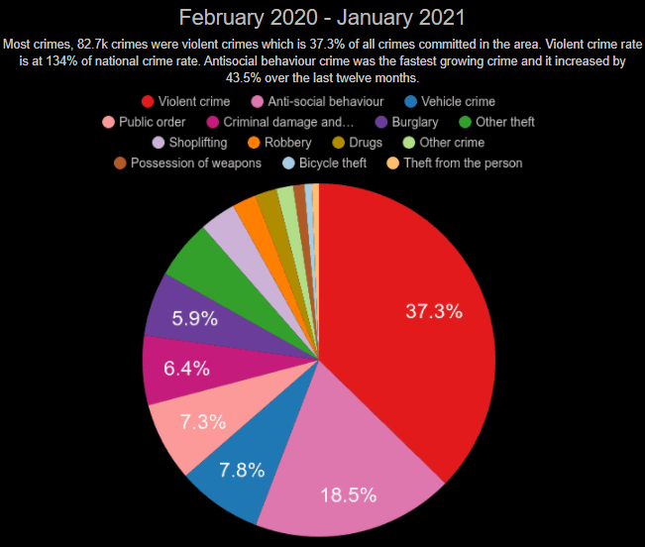
(Plumplot, 2012)

Young offenders who have history of reoffending have a depravation and not enough support, so they tend to go back to certain groups to feel that they are having the help and support to be able to live the life and have a standard in society (Matsuda, 2009).
Being in a juvenile centre is considerably different to being in an adult prison. Having influence from the adult prison can affect the experience of the young offenders it can have a big impact on the individual and the life that might be lead after the time in prison it could mean that the individual can carry on with offending in the future.
Too much time is spent on punishing young people and the real focus is not engaged, this could be unpaid work, enforcement action this could lead to negative thinking to the young offender and will go to committee further crimes in the future.
There could be various programmes for the young offenders to be able to access and make a difference in the individuals life. Also, it would help the community to feel safe and see changes, this could be getting families involved and young children to communicate and share information if the families and the young offenders are feeling happy to do so. Young offenders be a threat to the community if this is the case, they would be sent to a secure centre near to home if possible (GOV UK, 2021).

Conclusion
Throughout this report it specifies about the thoughts and the feelings of young people. How using a certain method could help brighten one’s future and make them feel worthy. Not needing to join people who would influence them to carry on with offending and not seeing what impact this has on an the individual but also the larger community. The recommendation would be to have organizations who could help these young people to be able to make a small change to have a better future. If using a theory like Eric Erickson it would help the process of not being aggressive and having to feel that lashing out is the right to show your emotions. This could be used to help young people a lot through life changes and at different stages of life.

References
Boyd, D ,G. Bee, H, L (2013) Lifespan Development. Sixth Edition.(Publisher Pearson Education). Available at: [https://r1.vlereader.com/Reader?ean=9781292034829].(Accessed 01 March 2021).
Brown C,(2006). Social Psychology. (Publisher Sage London). Available at:[https://web-a-ebscohost-com.ezproxy.uwtsd.ac.uk/ehost/ebookviewer/ebook/bmxlYmtfXzI1MTIwM19fQU41?sid=6eb4493a-d417-4f2b-bb2c-55ca2e367aa9@sdc-v-sessmgr02&vid=0&format=EB&lpid=lp_vii&rid=0]. (Accessed 3 March 2021).
Berkowitz L (1978). Whatever Happened to the Frustration-Aggression Hypothesis? (Publisher Sage Journals). (Available at) [https://journals.sagepub.com/doi/abs/10.1177/000276427802100505?journalCode=absb]. (Accessed 5 March 2021).
Gillibrand R, Lam V, O’donnell V L. (2016). Development Psychology. (Second Edition). (Publisher Pearson Education, Limited). (available at) [https://ebookcentral.proquest.com/lib/trinity/reader.action?docID=5175099].(Accessed 3 March 2021).
Gross R, Naish F (2015). The Science of Mind and Behaviour. (Seventh Edition). (Publisher Hodder Education Group). (Available at:[https://ebookcentral.proquest.com/lib/trinity/detail.action?docID=2066675&pq-origsite=primo]. (Accessed 05 March 2021).
GOV.UK. (2021). Youth Crime Prevention Programmes. (Available at) [https://www.gov.uk/youth-crime-prevention-programmes]. (Accessed 7 March 2021).
Hogg,M.A,Vaughan,G.M (2013).Social Psychology (Publisher Pearson Education). Available at: [https://r2.vlereader.com/Reader?ean=9780273764601]. (Accessed 01 March 2021).
HM Inspectorate of Probation. (2016). Desistance and Young People. (Available at) [https://www.justiceinspectorates.gov.uk/hmiprobation/wp-content/uploads/sites/5/2016/05/Desistance_and_young_people.pdf]. (Accessed 7 March 2021).
Matsuda K N. (2009). The Impact of Incarceration on Young Offenders. (Available at) [https://www.ojp.gov/pdffiles1/nij/grants/227403.pdf]. (Accessed 6 March 2021).

Patchin J W, Hinduja S.(2010). Youth and Society. Traditional and Nontraditional Bulling Among Youth: A Test of General Strain Theory. (Available at) [https://journals.sagepub.com/doi/abs/10.1177/0044118x10366951]. (Accessed 6 March 2021).
Plumplot (2012). Birmingham Crime Stats February 2020- January 2021.(Available at) [https://www.google.com/search?q=crime+rates+in+birmingham+2019-2020&tbm=isch&ved=-cCegQIABAA&oq=crime+rates+in+birmingham+2019-2020&gs_lcp=CgNpbWcQAzoECAAQQzoHCAAQsQMQQzoICAAQsQMQgwE6BQgAELEDOgIIADoGCAAQCBAeOgQIABAYOgYIABAKEBhQr78FWJHRB2DA1QdoAHAAeAGAAb0BiAHEN5IBBTUyLjI3mAEAoAEBqgELZ3dzLXdpei1pbWewAQDAAQE&sclient=img&ei=hOVCYLnAFcKSateJuugN&bih=758&biw=827&safe=strict#imgrc=3Ok526ZTAnRAFM]. (Accessed 6 March 2021).

